UNIFIED MENTOR INTERNSHIP

~ Data Analyst

*Data Visualization of Bird Strikes between 2000 – 2011*

*Wireframe document By Tirumala*

*Homepage*

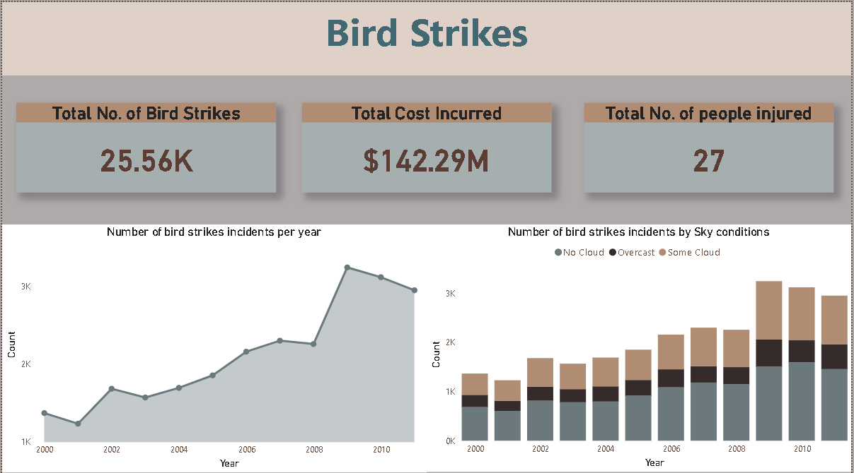

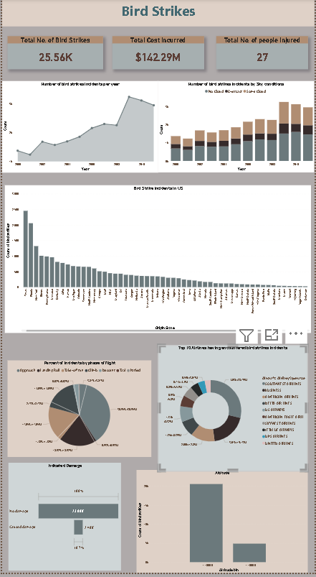

# Visuals Depicting the Number of Bird Strikes:

* 1. Bird Strikes in US

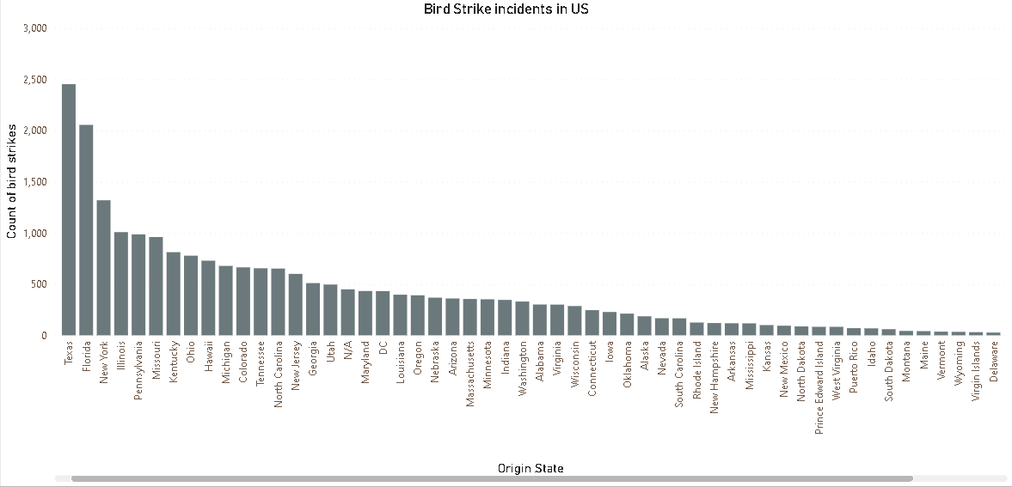

* 1. Top 10 US Airlines in terms of having encountered bird strikes

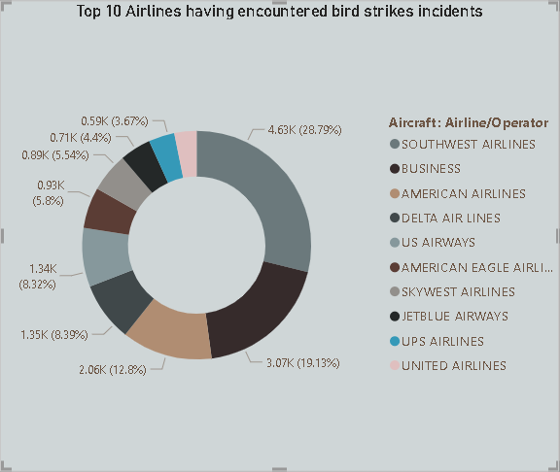

* 1. Airports with most incidents of bird strikes

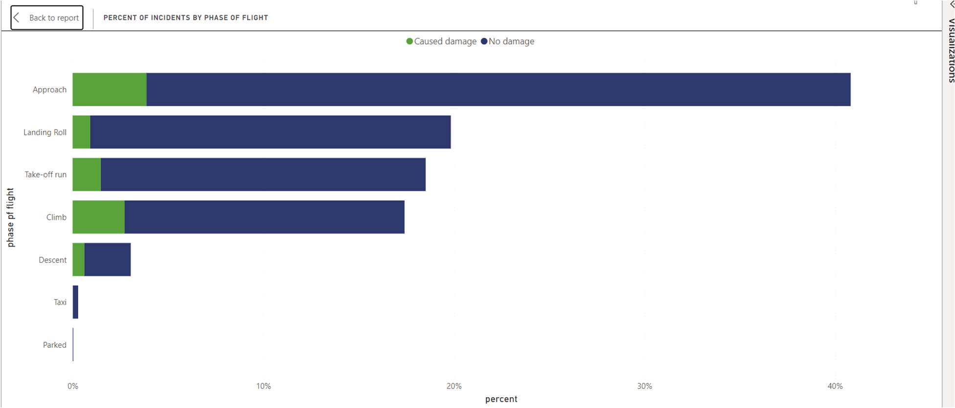

# Yearly Cost Incurred due to Bird Strikes

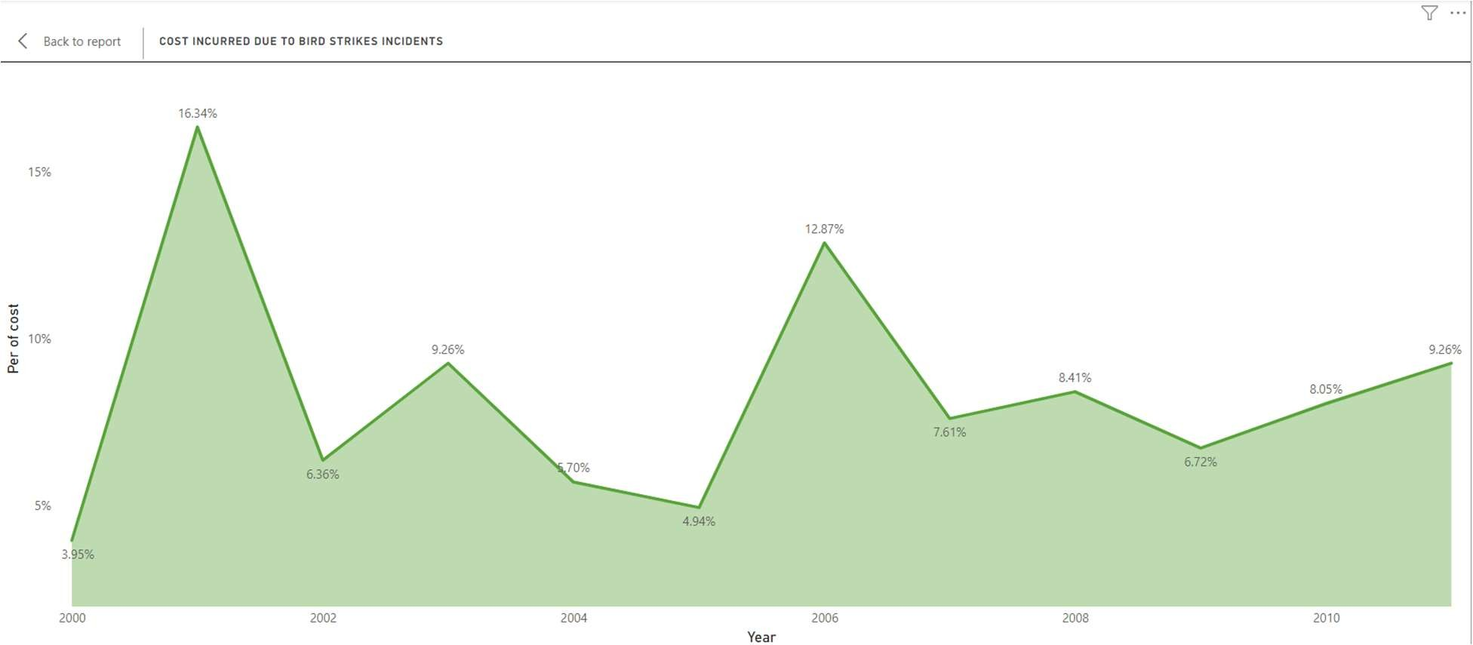

1. When do most bird strikes occur?
   1. Altitude of airplanes at the time of strike

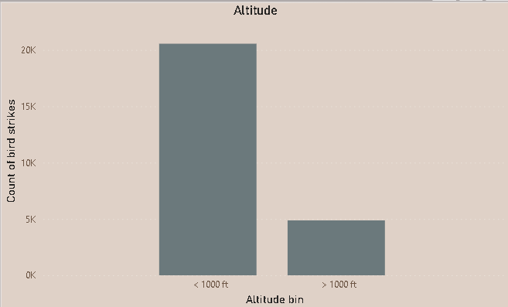

* 1. Phase of flight at the time of strike

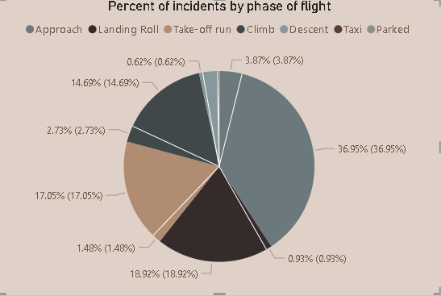

# Effect of Bird Strike

* 1. Impact on Flight

