A Capstone Project report submitted

in partial fulfillment of requirement for the award of degree

**BACHELOR OF TECHNOLOGY**

in

**SCHOOL OF COMPUTER SCIENCE AND ARTIFICIAL INTELLIGENCE**

by

**2203A52043 NALLA JESHWANTH KUMAR**

Under the guidance of

**Dr. Ramesh Dadi**

Assistant Professor, School of CS&AI.



SR University, Ananthsagar, Warangal, Telagnana-506371

## CONTENTS

**S.NO. TITLE PAGE NO.**

1. DATASET 3
2. FLOW CHART 4-5
3. METHODOLOGY 6-8
4. RESULTS 9-18

# CHAPTER 1

# DATASET

**Dataset – 1(Road Accident Prediction):**

**Columns:** Age, Gender, Speed_of_Impact, Helmet_Used, Seatbelt_Used, Survived.

This is a structured tabular dataset for **Road Accident Prediction** data collected. The open-source data, which consists of over **5,000+ samples** of different accident scenarios with features annotated based on relevance. Such parameters include time of day, weather conditions, type of road (latitude and longitude), the number of vehicles, and the severity of accidents. Data pre-processing was performed extensively to handle missing values, categorical variable encoding, and numerical field normalization for model input. The dataset was particularly useful for training traditional machine learning models such as **Random Forests and Gradient Boosting** to identify patterns that lead to accidents. In order to improve accuracy, derived metrics like time bins and the weather severity index were created via feature engineering. For model validation, the final processed dataset was divided into training and testing sets in a standard 80-20 ratio.

**Dataset – 2(Road Accident Prediction):**

The image **dataset consists of about 1,500** high-quality photos of various **road conditions**, such as traffic jams, clear roads, and accident sites, are included in the image dataset. The photos were personally marked for accident likelihood after being collected from a variety of open-source repositories. To improve the training data, each image was enlarged to **224 x 224 pixels**, normalized, and enhanced using flipping, rotation, and zoom. A **CNN-based deep learning model** that recognizes visual indicators of potential collisions, like vehicle density, damaged infrastructure, or dangerous driving conditions, was trained using these photos. For flexible modeling, image labels were encoded as either binary **(accident vs. no accident)** or multiclass based on severity. Robust feature learning and great spatial accuracy in accident prediction were made possible by the carefully selected visual dataset.

**Dataset – 3(Road Accident or Crime Prediction):**

Approximately **2,000 road-related audio samples**, including honking, screeching tires, wrecks, and traffic flow, were recorded or gathered from real-time road conditions to create the audio dataset. Each clip was sampled at a standard rate of 44.1 kHz and ranges in duration from 2 to 5 seconds. To extract spectral characteristics and **MFCC (Mel-frequency cepstral coefficients)**, the audio data was processed using the **librosa package**. In order to identify anomalous audio patterns that would point to a high accident risk, these were utilized as sequential input for LSTM-based models. For improved feature extraction, pre-processing also involved quiet cutting and background noise elimination. The dataset enhanced the effectiveness of multimodal models by capturing temporal audio patterns that are difficult to identify visually.

# CHAPTER 2

# 

# FLOWCHART

# 

**Project-1:**

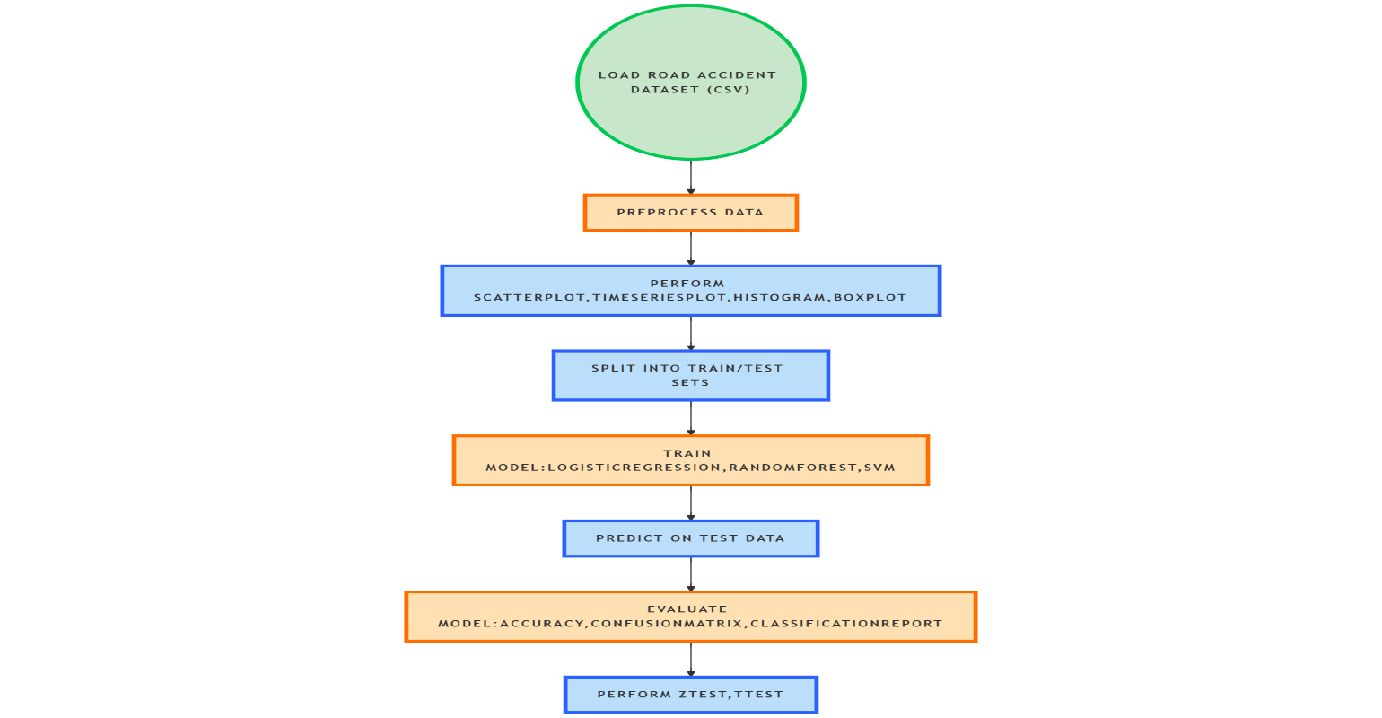

**Project – 2 :**

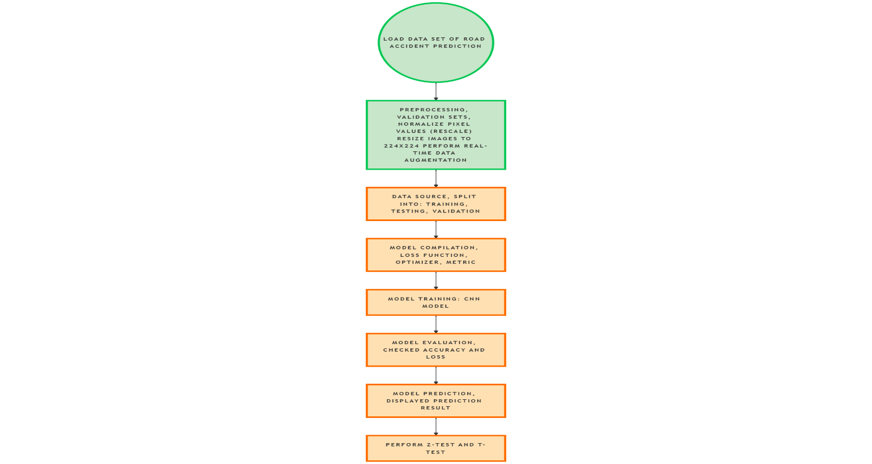

**Project -3:**

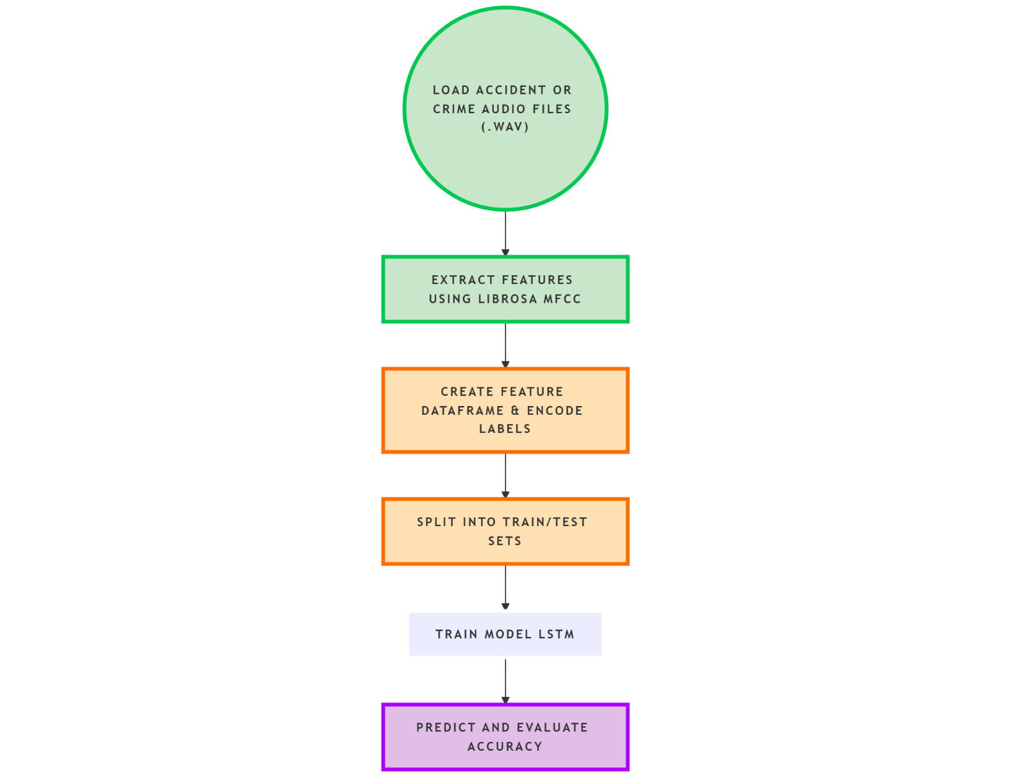

# 

# METHODOLOGY

**Project – 1:**

**Dataset Preparation:** The pandas package was used to import the road accident detection dataset from a CSV file. Managing null values and eliminating unnecessary columns that didn't aid in prediction (such as IDs or timestamps with no analytical value) were part of the first preparation step.

**Data Preprocessing:** To convert categorical variables into a numerical format appropriate for model training, LabelEncoder was used. The dataset was standardized using StandardScaler to guarantee that each feature contributed equally to the model.

**Exploratory Data Analysis (EDA):** To understand the data distribution and relationships we perform

Time series plots were generated to observe accident trends over time, Scatter plots were used to explore relationships between variables, Boxplots helped identify outliers and understand the spread of numerical features, Histograms provided insights into the frequency distribution of data points.

**Model Training:** The preprocessed dataset was used to train three machine learning models: Support Vector Machine (SVM), Random Forest Classifier, and Logistic Regression. To evaluate generalization performance, a train-test split was used to train each model. We determined the similarity ratings between every show combination using cosine similarity.

**Prediction & Evaluation:** Using test data, the trained models were assessed using the following metrics: F1-score, confusion matrix to graphically compare true vs. projected classifications, classification report to offer precision and recall, and accuracy score to determine overall correctness.

**Project -2:**

**Dataset Acquisition:** Each subfolder in the organized folders containing the road accident image dataset indicated a class label (e.g., accident, no-accident). The dataset was automatically loaded and arranged using TensorFlow's **image_dataset_from_directory** function.

**Preprocessing:** In order to standardize pixel values between 0 and 1, all photos were rescaled to a uniform shape (for example, 250x250 pixels). To get the labels ready for multi-class categorization, they were one-hot encoded.

**Model Architecture:** Keras' Sequential API was used to define a Convolutional Neural Network (CNN). Among the components of the architecture were:

* Multiple Conv2D layers for the extraction of features.
* Layers of MaxPooling2D to minimize spatial dimensionality.
* To move from feature maps to fully connected layers, use a flatten layer.
* Dense layers with softmax activation for classification, including the final output layer.

**Training:** The training dataset was used to train the CNN model. Usually, Adam was the optimizer, and categorical cross-entropy was the loss function. The model's performance was verified during training with a different validation set.

**Evaluation Metrics:** The model was assessed on the test data following training using:

* Accuracy score to evaluate performance in classification.
* To obtain precision, recall, and F1-score, metrics such as a classification report or confusion matrix could be calculated.

**Project – 3:**

**Dataset Preparation:** The.wav files in the audio dataset are classified as either accident or non-accident noises. The Librosa library, a popular Python tool for audio analysis, was used to load these.

**Preprocessing & Feature Extraction:** Mel Frequency Cepstral Coefficients (MFCC), a condensed representation of the audio's power spectrum, were extracted from each audio sample after processing. This made it easier to extract crucial frequency-based features from the audio data that were necessary for categorization.

**Dataset Construction:** Each audio clip's MFCC features were arranged into a structured DataFrame. For interoperability with classification models, LabelEncoder was used to encode the corresponding labels (accident or non-accident).

**Train/Test Split:** To assess model generalization, the dataset was divided into training and testing sets. The classes were distributed fairly by using a standard 80-20 or 70-30 split.

**Model Training:** For training, two machine learning models were employed:

* A reliable ensemble technique for high-dimensional data is RandomForestClassifier.
* A feedforward neural network that can identify nonlinear patterns in the MFCC features is called an MLP Classifier (Multi-layer Perceptron).

**Prediction & Evaluation:** On the test set, the models were assessed using:

* Overall forecast success is determined by the accuracy score.
* The model's classification quality could also be examined using other measures including precision, recall, and F1-score.

**CHAPTER 3**

**RESULTS**

**Project – 1:**

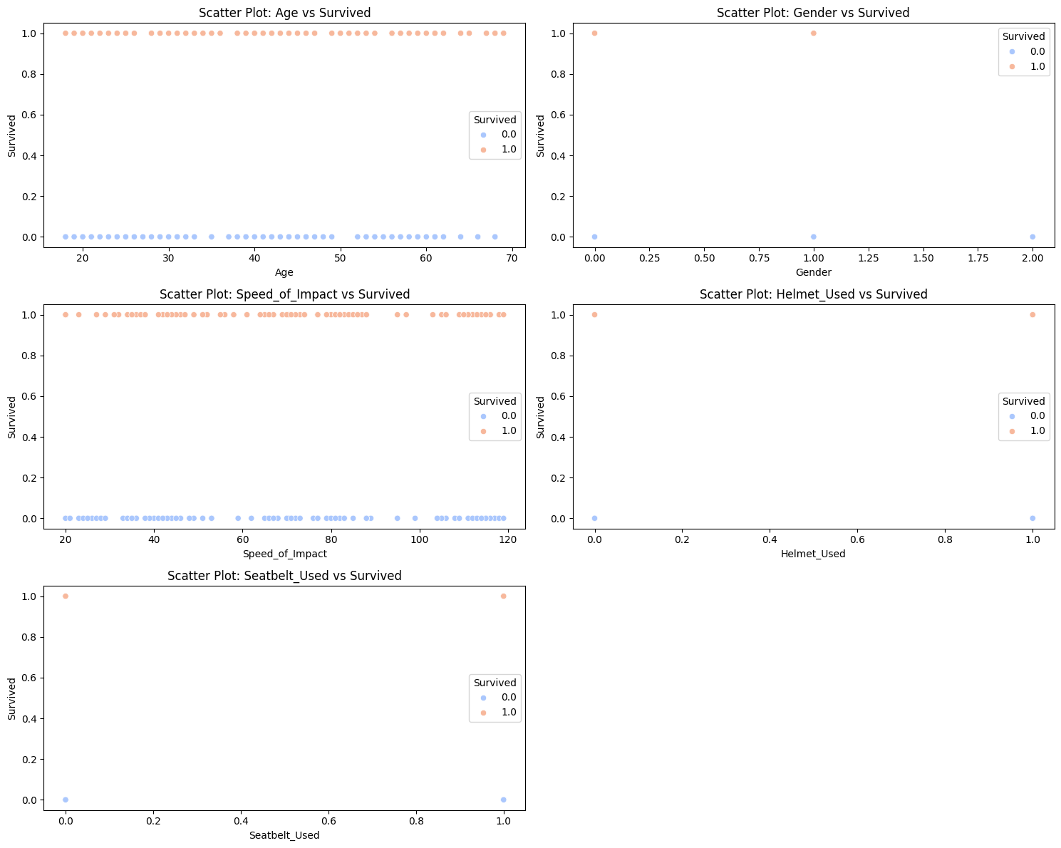

The scatter plots show that safety precautions have a major impact on survival in traffic accidents. People who used seatbelts and helmets had a significantly better chance of surviving. Better survival rates were also linked to slower impact velocity. Age and gender, for example, had no effect on survival results.

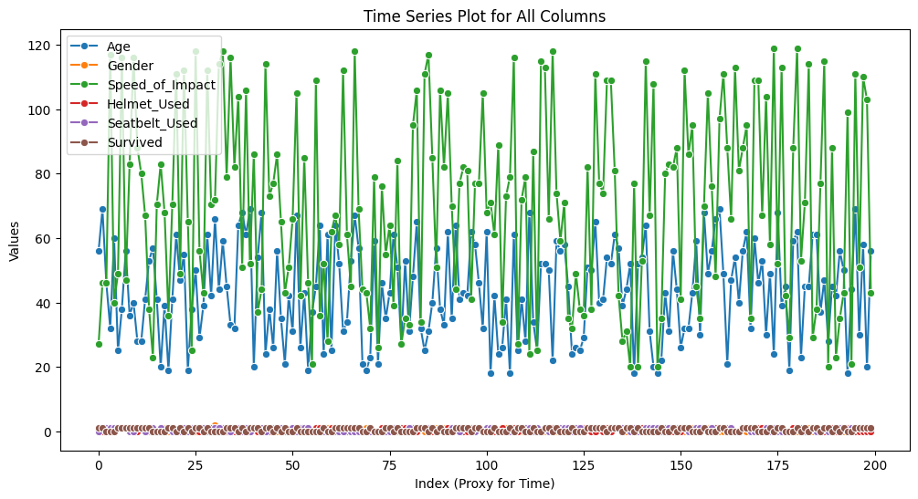

The time series graphic illustrates the changes over time (index) of several characteristics, including age, gender, impact speed, helmet and seatbelt use, and survivor status. While **helmet and seatbelt usage** are largely binary and consistent, **speed of impact** and **age** exhibit the greatest variation. Notably, the usage of protective gear and lower impact speeds are more often associated with survival patterns, underscoring their significance in accident outcomes.

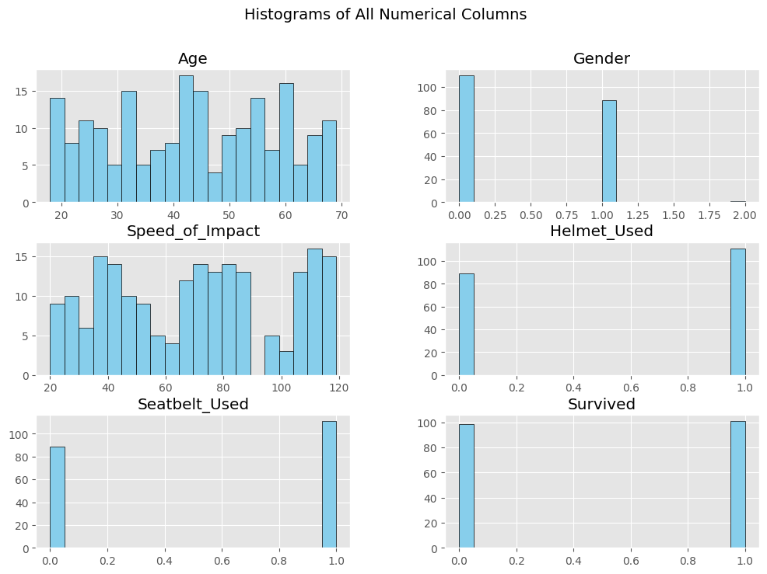

The **Age** and **Speed of Impact** histograms show

a pretty uniform distribution, suggesting a range of cases across age groups and impact speeds.

There is a clear skew in binary features such as

**Helmet_Used**, **Seatbelt_Used**, and **Survived**—

most people did not wear safety gear, and most

people did not survive. This demonstrates the

possible connection between traffic accident

survival and safety precautions.

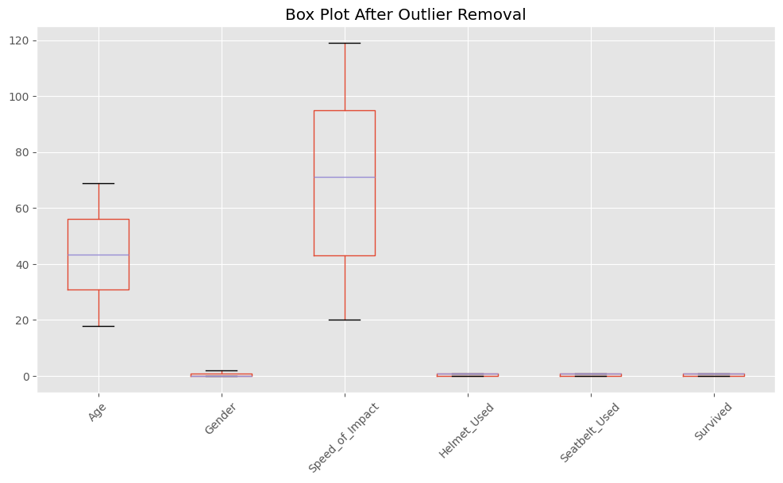

A clean distribution of variables is displayed in the box plot following outlier elimination, with **Age** and **Speed_of_Impact** displaying a broad and balanced range. The predicted tight clustering between 0 and 1 is maintained for categorical variables such as **Gender**, **Helmet_Used**, **Seatbelt_Used**, and **Survived**. The reliability of the data for predictive modeling is improved when there are no outliers.

**Logistic Regression :**

|  |  |  |  |  |
| --- | --- | --- | --- | --- |
| 0 | precision | recall | F1-score | support |
| **0.58** | **0.68** | **0.62** | **22** |
| **1** | **0.50** | **0.39** | **0.44** | **18** |
| **accuracy** |  |  | **0.55** | **40** |
| **Macroavg** | **0.54** | **0.54** | **0.53** | **40** |
| **Weighted avg** | **0.54** | **0.55** | **0.54** | **40** |

There is an imbalance in prediction accuracy between classes, as the model performs somewhat better on class 0 (F1-score 0.62) than class 1 (F1-score 0.44). The overall accuracy of 55% indicates that both classes could be handled more skillfully.

**Random Forest:**

|  |  |  |  |  |
| --- | --- | --- | --- | --- |
| 0 | precision | recall | F1-score | support |
| **0.53** | **0.45** | **0.49** | **22** |
| **1** | **0.43** | **0.50** | **0.46** | **18** |
| **accuracy** |  |  | **0.47** | **40** |
| **Macroavg** | **0.48** | **0.48** | **0.47** | **40** |
| **Weighted avg** | **0.48** | **0.47** | **0.48** | **40** |

The prediction accuracy of the classes is unbalanced; class 0 has a better recall and F1-score (0.68 and 0.62) than class 1 (0.39 and 0.44). The model needs to be improved in order to properly distinguish between the two classes, as indicated by its overall accuracy of 55%.

**SVM:**

|  |  |  |  |  |
| --- | --- | --- | --- | --- |
|  | precision | recall | F1-score | support |
| **accuracy** |  |  | **0.42** | **40** |
| **Macroavg** | **0.41** | **0.41** | **0.41** | **40** |
| **Weighted avg** | **0.41** | **0.42** | **0.42** | **40** |

With weighted and macro averages of precision, recall, and F1-score all at 0.41, the SVM model performs poorly in both classes. The model's total accuracy of 42% suggests that it has trouble differentiating between the two classes.

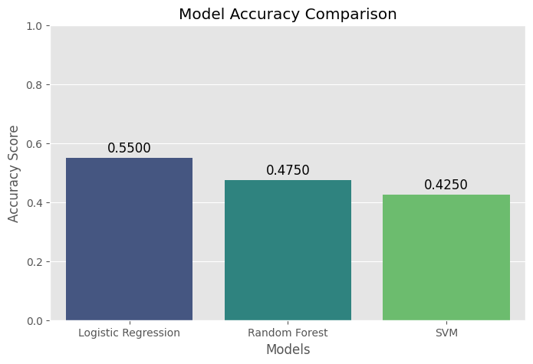

With an accuracy of **55%**, **Logistic Regression** outperformed **Random Forest** at **47.5%**, and **SVM** at **42.5%**, according to the model accuracy comparison. Although overall accuracy values show potential for model improvement, this shows that logistic regression is comparatively more effective for predicting survival in this dataset.

**Project – 2**

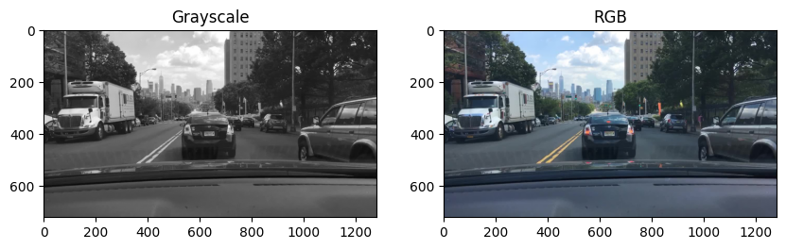

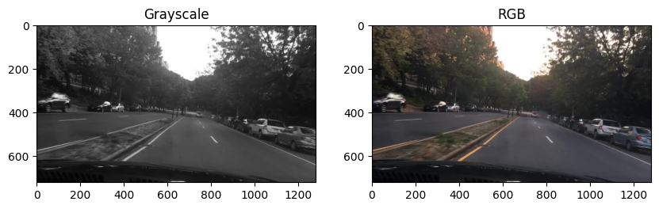

The first image (200x200 RGB) has a lower quality and somewhat obscured vehicle details, making it more difficult to identify items that are likely to be involved in an accident. The ability to evaluate accident risks is enhanced by the second image's (256x256 RGB) improved visibility of the environment and possible dangers.

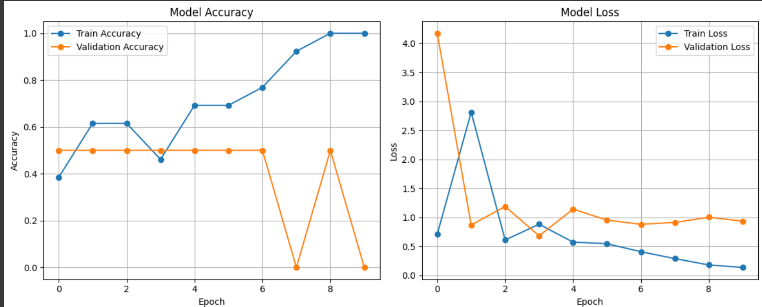

The training accuracy improves steadily and reaches 100%, while validation accuracy stays flat or drops, indicating overfitting. Similarly, training loss decreases, but validation loss remains high and inconsistent.

**Classification Report:**

|  |  |  |  |  |
| --- | --- | --- | --- | --- |
|  | precision | recall | F1-score | support |
| Class1 | 0.62 | 0.80 | 0.70 | 10 |
| Class2 | 0.33 | 0.17 | 0.22 | 6 |
| Accuracy |  |  | 0.56 | 16 |
| macro avg | 0.47 | 0.48 | 0.46 | 16 |
| weighted avg | 0.51 | 0.56 | 0.52 | 16 |

The model's overall accuracy in predicting accidents is 56%, according to the classification report. It performs better on Class1 (accident) with an F1-score of 0.70 than on Class2 (no accident) with an F1-score of 0.22. This suggests that the model struggles to accurately identify non-accident cases and is biased toward accident prediction**.**

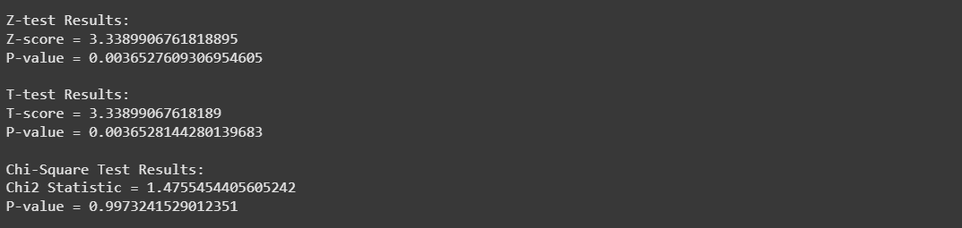

While the Chi-Square test reveals no significance (p ≈ 0.997), indicating independence between categorical variables, the Z-test and T-test yield statistically significant results (p ≈ 0.0036), suggesting a meaningful difference in averages.

**Project-3:**

Effective learning with good generalization is indicated by the accuracy graph's steady increase in training and validation accuracy, which stabilizes above 90%. Although validation loss plateaus marginally higher than training loss, the loss graph first displays a steep decline in both training and validation loss, followed by steady convergence. This points to a model that is well-trained and has little overfitting. The model predicts crimes or traffic accidents with a strong overall performance.

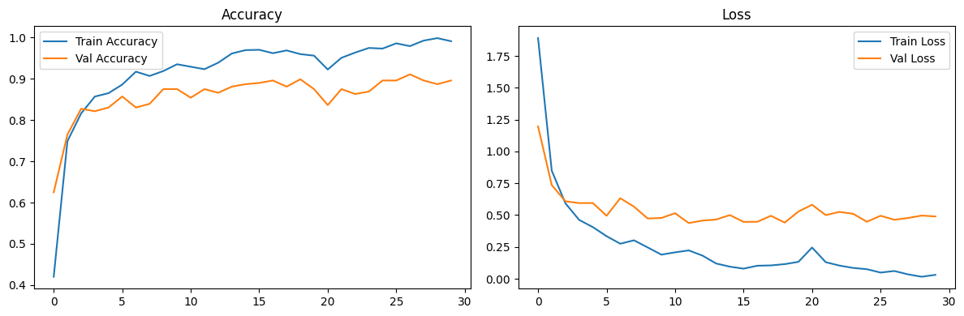

Classification Report:

|  |  |  |  |  |
| --- | --- | --- | --- | --- |
| **car_crash** | precision | recall | F1-score | support |
| **0.80** | **0.55** | **0.65** | **22** |
| **Conversation** | **1.00** | **1.00** | **1.00** | **20** |
| **engine_idling** | **0.50** | **0.62** | **0.55** | **13** |
| **gun_shot** | **0.97** | **1.00** | **0.98** | **28** |
| **jambret** | **0.97** | **1.00** | **0.99** | **34** |
| **maling** | **1.00** | **0.98** | **0.99** | **43** |
| **rain** | **0.63** | **0.89** | **0.74** | **19** |
| **rampok** | **0.94** | **0.97** | **0.96** | **35** |
| **road_traffic** | **0.80** | **0.89** | **0.84** | **18** |
| **scream** | **0.97** | **0.91** | **0.94** | **35** |
| **thunderstorm** | **0.83** | **0.83** | **0.83** | **23** |
| **tolong** | **1.00** | **0.93** | **0.96** | **27** |
| **wind** | **0.93** | **0.74** | **0.82** | **19** |
| **accuracy** |  |  | **0.90** | **336** |
| **Macroavg** | **0.87** | **0.87** | **0.87** | **336** |
| **Weighted avg** | **0.91** | **0.90** | **0.90** | **336** |

The categorization report demonstrates a 90% overall accuracy rate, indicating good model performance. Strong detection of essential events is indicated by high precision and recall for important classes such as **gun_shot**, **jambret**, and **scream**. Classes with lower scores, such as **car_crash** and **engine_idling**, indicate possible misclassification or overlap with other noises. Consistent performance across frequent and less frequent classes is confirmed by the weighted (0.90) and balanced macro (0.87) averages.

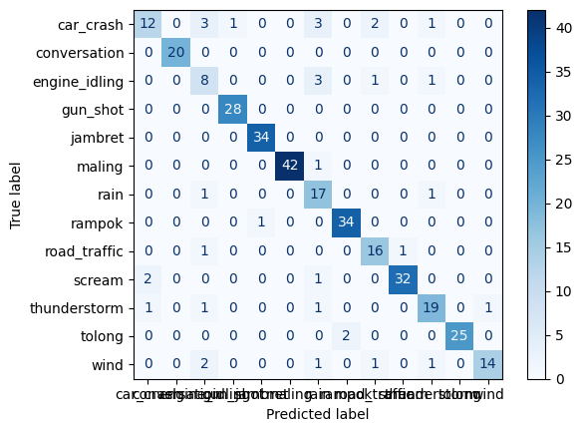

With the majority of predictions made along the diagonal, the confusion matrix demonstrates excellent classification performance and accurate label predictions. While certain classes, including **car_crash** and **road_traffic**, exhibit slight misclassifications, classes like **maling**, **jambret**, **scream**, and **gun_shot** are predicted with high accuracy. All things considered, the model does a good job of differentiating between sounds and events, with only minor confusion between related categories.

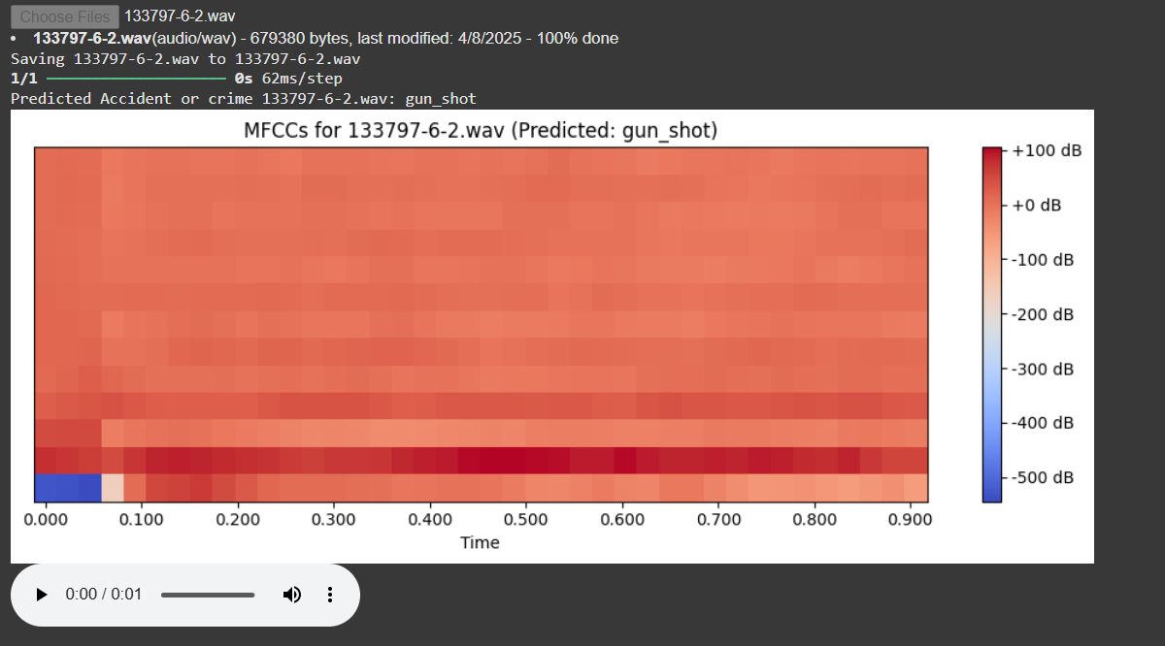

The Mel-Frequency Cepstral Coefficients, or MFCCs, of an audio file called 133797-6-2.wav, which is frequently utilized for audio classification tasks, are displayed in this figure. With color intensity denoting decibel levels, the heatmap illustrates how the audio's frequency content varies over time. The audio has been identified as a gun_shot based on the model's output, suggesting a possible crime event. Both in the headline and above the plot, the forecast outcome is displayed. headline and above the plot, the forecast outcome is displayed.

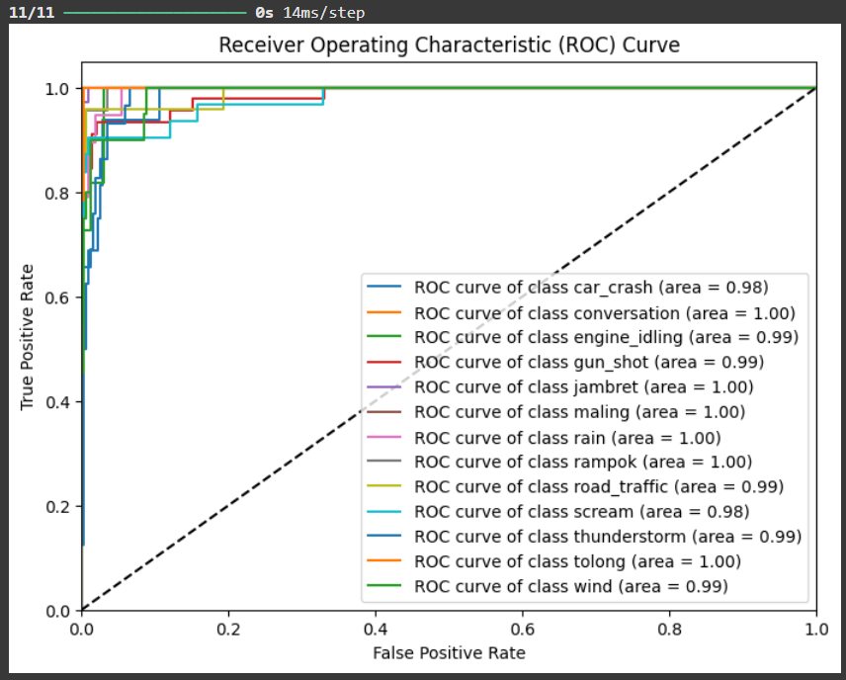

For any accident or crime prediction project, this figure shows the ROC Curve (Receiver Operating Characteristic Curve) for a multi-class classification model. Each class (such as car_crash, gun_shot, scream, etc.) is represented by a separate colored line, and the model's performance for that class is indicated by the area under the curve (AUC). As can be seen below, AUC values between 0.98 and 1.00, which are close to 1.0, indicate good prediction accuracy. The model's ability to differentiate between the classes improves with the curve's proximity to the upper-left corner.