**Assignment -4**

**Name: G.Raviteja**

**Ht.no: 2203A51721**

**Batch: 12**

**Course name: NLP (Natural Language Processing)**

1. Load data fromkeras.datasets and perform following computational analysis

(a) Preprocessing of the Data

(b) Divide data into training and testing data set

(c) Build the Recurrent Neural network (RNN) Model

(d) Training the RNN Model

(e) Evaluate the model on the test dataset to see how well it generalizes.

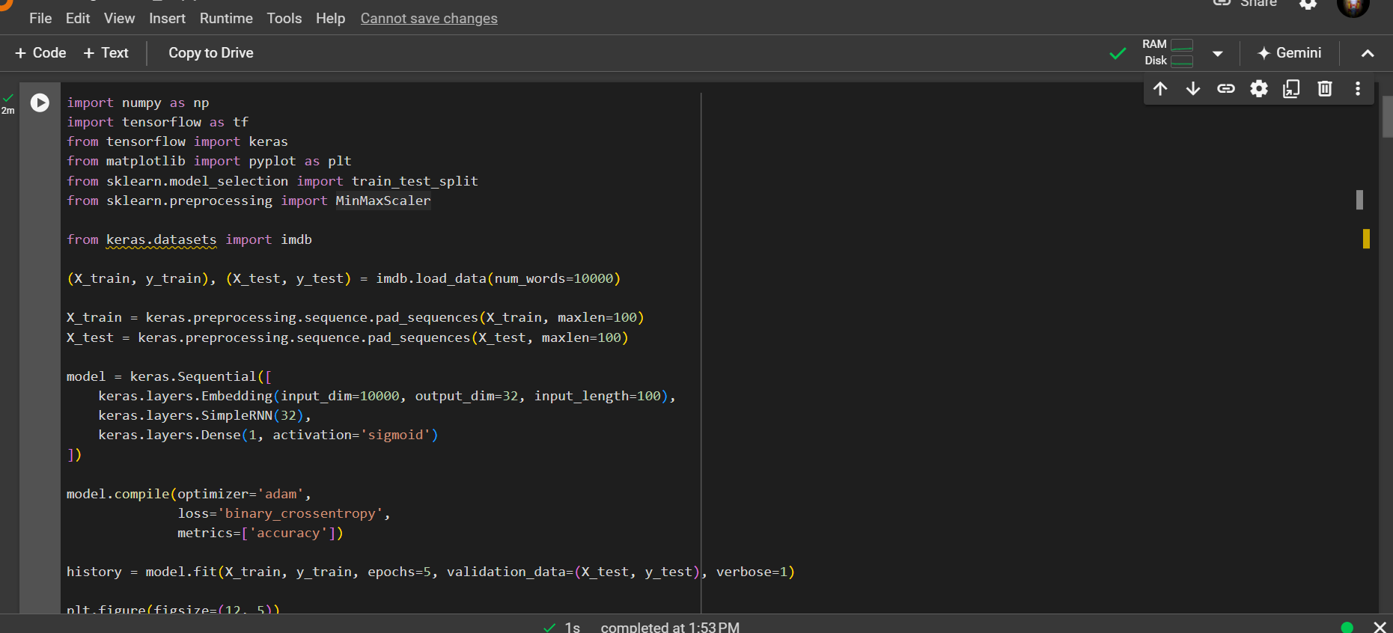

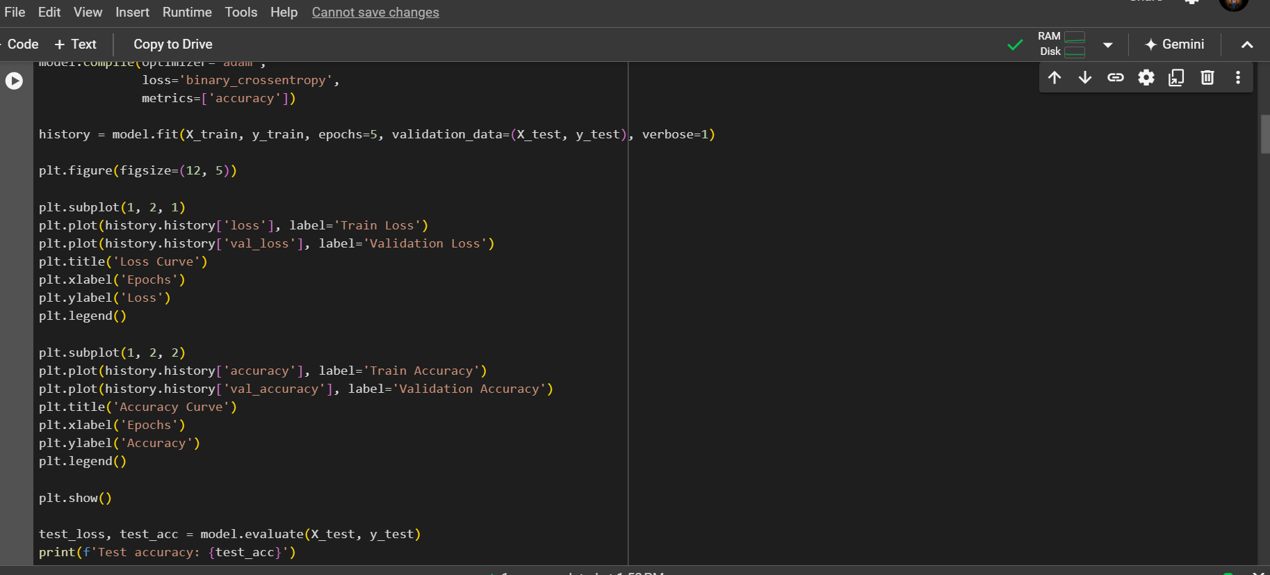

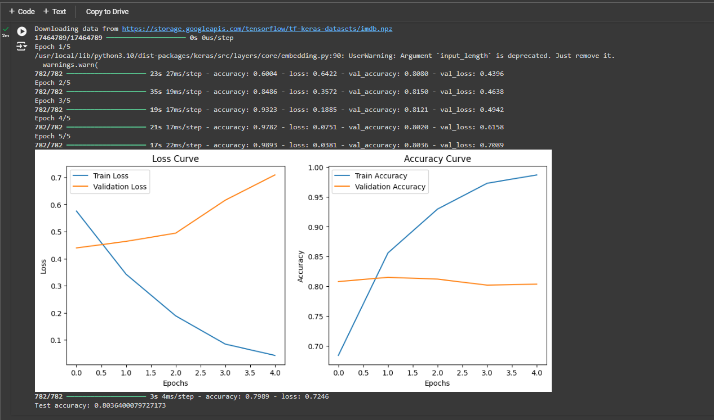

2. Develop LSTM (Long Short-Term Memory) by utilizing data set from https://www.kaggle.com/code/amirrezaeian/time-series-data-analysis-using-lstm-tutorial Links to an external site. or take any time series data.

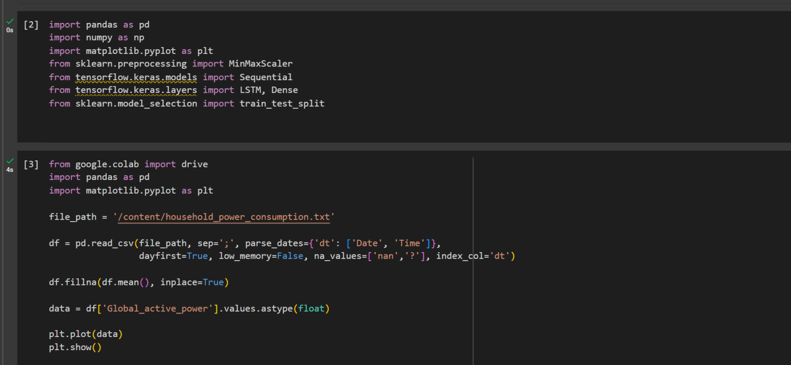

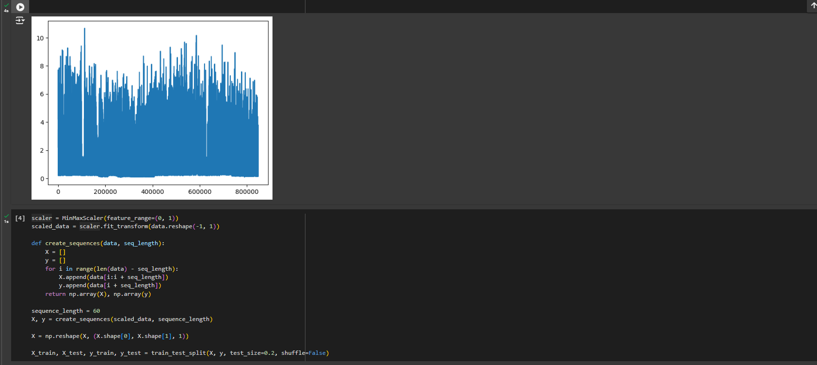

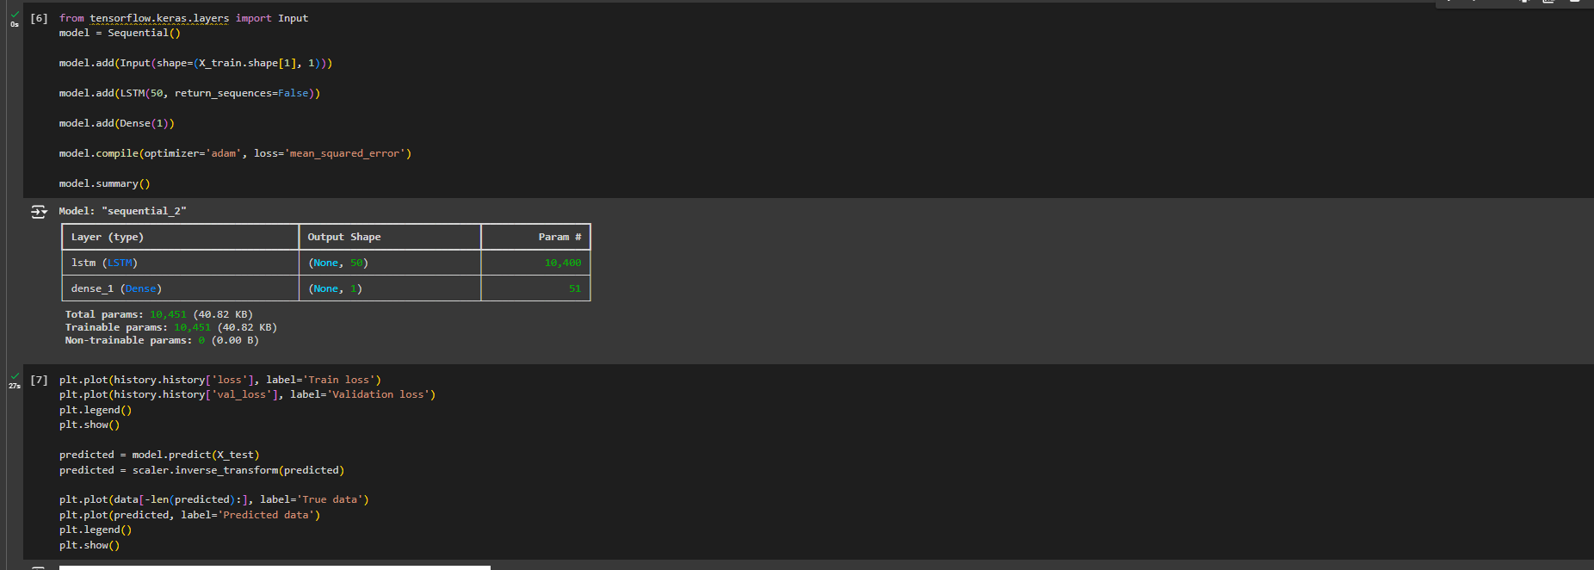

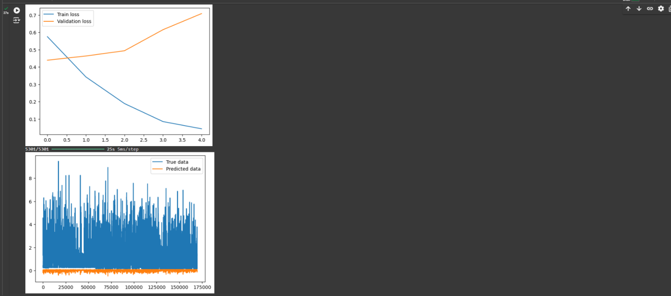

3. Demonstrate Vanishing and Exploding Gradients on deep neural network.

