Cosine Similarity - Indirect Questions
library(ggplot2)
library(tidyr)
library(dplyr)
##
## Attaching package: 'dplyr'
## The following objects are masked from 'package:stats':
##
## filter, lag
## The following objects are masked from 'package:base':
##
## intersect, setdiff, setequal, union
knitr::opts_knit$set(root.dir = "C:/Users/lon09/New folder")
files <- list(
"Question 1" = "Indirectq1_cosine_evaluation.csv",
"Question 2" = "Indirectq2_cosine_evaluation.csv",
"Question 3" = "Indirectq3_cosine_evaluation.csv",
"Question 4" = "Indirectq4_cosine_evaluation.csv",
"Question 5" = "Indirectq5_cosine_evaluation.csv",
"Question 6" = "Indirectq6_cosine_evaluation.csv"
)
# Combine all 6 questions into one dataset
all_data <- data.frame()
for (question_name in names(files)) {
df <- read.csv(files[[question_name]])
df <- df[trimws(tolower(df$Run.time)) != "mean", ]
colnames(df) <- c("Run", "NonChunking", "EqualChunking", "ManualChunkingOverlap", "LangChain", "LangChainOverlap")
df[, -1] <- lapply(df[, -1], as.numeric)
df$Question <- question_name
all_data <- rbind(all_data, df)
}
# Reshape to long format
all_long <- pivot_longer(all_data, cols = c("NonChunking","EqualChunking","ManualChunkingOverlap","LangChain","LangChainOverlap"),
names_to = "Version", values_to = "Cosine")
all_long$Version <- factor(all_long$Version,
levels = c("NonChunking","EqualChunking","ManualChunkingOverlap","LangChain","LangChainOverlap"))
# Boxplot
ggplot(all_long, aes(x = Version, y = Cosine, fill = Version)) +
geom_boxplot(outlier.colour = "red", outlier.shape = 16, alpha = 0.7) +
theme_bw() +
theme(legend.position = "none", axis.text.x = element_text(angle = 25, hjust = 1)) +
labs(title = "Cosine Similarity by Version - All Indirect Questions",
x = "Chunking Version", y = "Cosine Similarity Score")
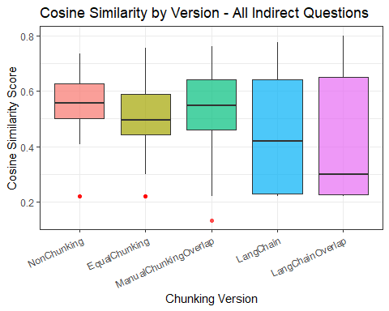
# ANOVA
m <- aov(Cosine ~ Version, data = all_long)
summary(m)
## Df Sum Sq Mean Sq F value Pr(>F)
## Version 4 0.990 0.24758 9.223 4.92e-07 ***
## Residuals 295 7.919 0.02684
## ---
## Signif. codes: 0 '***' 0.001 '**' 0.01 '*' 0.05 '.' 0.1 ' ' 1

