

**CS19611 - MOBILE APPLICATION DEVELOPMENT REPORT**

                                              BMI CALCULATOR

*Submitted by*

**LOGESHWARAN T 220701097**

*in partial fulfilment for the course for the degree of*

**BACHELOR OF ENGINEERING**

**In**

**COMPUTER SCIENCE AND ENGINEERING**

RAJALAKSHMI ENGINEERING COLLEGE RAJALAKSHMI NAGAR

THANDALAM CHENNAI-602105

MAY 2025

**RAJALAKSHMI ENGINEERING COLLEGE CHENNAI – 602105**

**BONAFIDE CERTIFICATE**

Certified that this project report titled **"BMI CALCULATOR"** is the bonafide work of **Logeshwaran T(220701145)**, who carried out the work under my supervision. Certified further that to the best of my knowledge, the work reported herein does not form part of any other thesis or dissertation based on which a degree or award was conferred earlier.

**SIGNATURE SIGNATURE**

**DR. P. KUMAR Dr. V. KARTHICK**

**Head of the Department Associate Professor**

Computer Science and Engineering Rajalakshmi Engineering

Rajalakshmi Engineering College Chennai - 602105

Chennai – 602105

Submitted to Project and Viva Voce Examination for the subject

CS19611 –Mobile Application Development Laboratory held on .

Internal Examiner External Examiner

**ACKNOWLEDGEMENT**

Initially we thank the Almighty for being with us through every walk of our life and showering his blessings through the endeavor to put forth this report. Our sincere thanks to our Chairman **Mr. S. Meganathan, B.E, F.I.E.,** our Vice Chairman **Mr. Abhay Shankar Meganathan,B.E.,M.S.,** and our respected Chairperson **Dr. (Mrs.) Thangam Meganathan, Ph.D.,** for providing us with the requisite infrastructure and sincere endeavouring in educating us in their premier institution.

Our sincere thanks to **Dr. S. N. Murugesan, M.E., Ph.D.,** our beloved Principal for his kind support and facilities provided to complete our work in time. We express our sincere thanks to our **DR. P. Kumar** Professor and Head of the Department of Computer Science and Engineering for his guidance and encouragement throughout the project work. We convey our sincere thanks to our internal guide and Project Coordinator, **Dr. V. Karthick**, Rajalakshmi Engineering College for his valuable guidance throughout the course of the project.

LOGESHWARAN T (220701145)

**TABLE OF CONTENT**

|  |  |  |
| --- | --- | --- |
| **CHAPTER No.** | **TITLE** | **PAGE No.** |
|  | Abstract | 5 |
|  | Introduction | 6 |
|  | Literature Survey | 7 |
|  | Proposed System | 8 |
|  | Module Description | 9 |
|  | Implementation and Results | 10 |
|  | Conclusion and Future Enhancements | 11 |
|  | References | 11 |

**CHAPTER 1**

**ABSTRACT**

Body Mass Index (BMI) is a widely used statistical measurement that helps determine whether an individual has a healthy body weight in relation to their height. It is a simple calculation involving the individual’s weight and height, which is then used to categorize them into various groups such as underweight, normal weight, overweight, or obese. The BMI Calculator project aims to provide an efficient and accurate digital tool to compute BMI and offer insightful health categorizations. In recent times, awareness about health and fitness has significantly increased, necessitating reliable tools that can help individuals monitor and maintain their physical well-being.

The significance of the BMI Calculator lies in its preventive health function. It educates users about the importance of maintaining a healthy body weight and how deviations may lead to health conditions such as heart disease, diabetes, and hypertension. Unlike manual calculations which are prone to error and misinterpretation, this digital tool automates the process and offers accuracy, speed, and clarity. It can be implemented as a web-based application, a mobile app, or integrated into larger health-monitoring systems. Additionally, the system may include educational tips and recommendations based on the BMI category to encourage better health practices.

This project not only addresses the growing need for personal health management tools but also highlights the potential of digital applications in promoting wellness and disease prevention. Furthermore, it serves as an excellent educational and analytical tool for students, professionals, and healthcare providers by offering statistical insights and user data trends.

**CHAPTER 2**

**INTRODUCTION**

**2.1 GENERAL**

   The **BMI Calculator** mobile app simplifies the manual effort students often invest in calculating their BMI. This application automates the process using real-time input processing and enhances user awareness with color-coded feedback. With this app, users can better understand their progress.

**2.2 OBJECTIVE**

* To create a user-friendly mobile app for calculating BMI.
* To give visual performance feedback using color indicators.
* To improve accessibility of BMI tracking for students.
* To help users easily identify areas needing improvement

**2.3 EXISTING SYSTEM**

   Traditional BMI calculation requires manual computation or external web-based tools. These solutions often lack personalization, mobile convenience, or visual feedback. The proposed BMI Calculator overcomes these limitations with a simple, interactive, and mobile-first design.

**CHAPTER 3**

**LITERATURE SURVEY**

The Body Mass Index (BMI) Calculator is a health-based digital tool designed to provide a numerical representation of a person's body fat based on their weight and height. In the contemporary world, where sedentary lifestyles and fast food culture have become the norm, tracking one's health has never been more important. General health assessments require tools that are both efficient and accessible, and the BMI Calculator fulfills this need by offering a non-invasive, easy-to-use platform for understanding body weight in context. The idea behind the BMI concept is not new—it has been widely used since the 19th century when it was first introduced by Belgian mathematician Adolphe Quetelet. Over time, it has evolved into a key health indicator utilized by healthcare professionals around the world.

Generally, BMI values are categorized as follows: a BMI below 18.5 is considered underweight, between 18.5 to 24.9 is considered normal, 25.0 to 29.9 is overweight, and 30.0 and above is obese. While BMI does not directly measure body fat, it provides a strong correlation that helps identify potential weight-related issues. For the average individual, this calculation can be an early step in understanding the risk for conditions like cardiovascular diseases, metabolic syndromes, and even certain types of cancer. What makes BMI particularly relevant today is its widespread use in both clinical settings and personal health assessments.

A general BMI Calculator project includes not only the computation module but also features that enhance user interaction and interpretation. This might include visual representations, category indicators, and even historical tracking of BMI values. Whether used in schools to educate children about healthy living, in clinics to support patient assessments, or by individuals for personal monitoring, the general utility of a BMI Calculator spans across a wide spectrum of demographics. Additionally, it aligns with global health objectives such as those set by the World Health Organization (WHO), promoting awareness about obesity and related disorders.

**CHAPTER 4**

**PROPOSED SYSTEM**

**4.1 SYSTEM OVERVIEW**

The BMI Calculator is developed using Android Studio. Users input their subject marks, and the system automatically computes the BMI. The BMI is then evaluated, and the background color of the result screen dynamically changes.

**4.2 SYSTEM ARCHITECTURE**

* Launch the app.
* Input subject marks in designated fields.
* Tap "Calculate bmi."

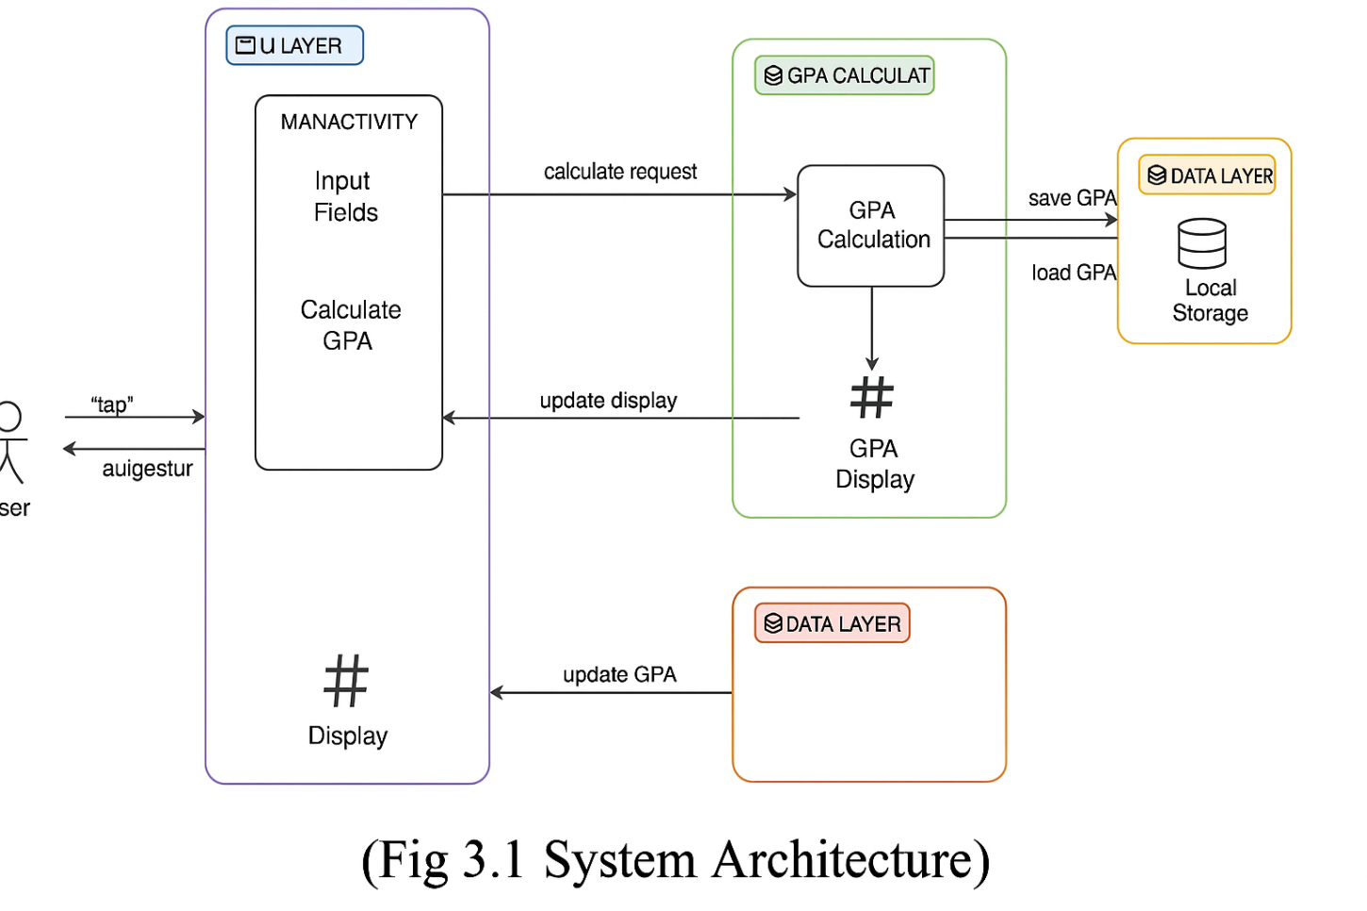

**CHAPTER 5**

**MODULE DESCRIPTION**

**5.1 MODULES**

**Input Module:**  
Allows users to enter marks in different subjects.

**BMI Calculation Module:**  
Calculates GPA using a standard algorithm (total grade points / total credits).

**Feedback Module:**  
Changes background color based on BMI value.

**UI Module:**  
Handles layout and responsiveness using XML.

**5.2 ACTIVITY DIAGRAM**

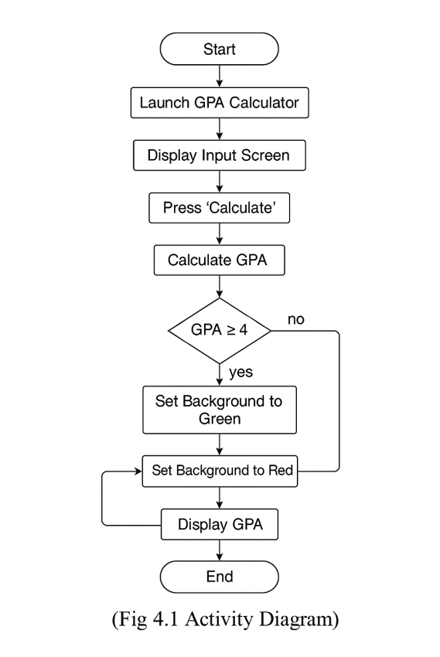

**CHAPTER 6**

**IMPLEMENTAION AND RESULTS**

**6.1 TOOLS USED**

* Android Studio – Development environment.
* Java – Logic implementation.
* XML – User interface layout.

1. **OUTPUT SCREENSHOTS**

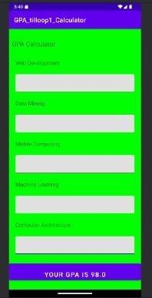                       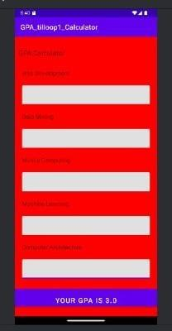

  (Fig 6.1 GPA Output(green screen))              (Fig 6.2 GPA Output(Red Screen))

**CHAPTER 7**

**CONCLUSION AND FUTURE ENHANCEMENT**

**6.1 CONCLUSION**

The **BMI Calculator** offers a simple yet effective solution for students to track their academic performance. The visual feedback mechanism enhances user experience and serves as a motivator to improve. The app’s intuitive design and accuracy make it a useful academic companion.

**6.2 FUTURE ENHANCEMENT**

* Add grade input system (A, B, C, etc.) with credit system.
* Enable saving and viewing BMI history.
* Introduce dark mode and theme customization.
* Cloud sync to backup BMI records.
* Export results as PDF or share with advisors.

**REFERENCES**

* Android Developer Documentation
* UI Design Principles – Material Design
* Educational Feedback Systems – IEEE Journals
* Java Programming for Android (2024)