ChildSaver: A Framework for Uncovered Borewell Detection and Child Rescue Using Proximity Sensors and Machine Learning

# GE19612 - PROFESSIONAL READINESS FOR INNOVATION, EMPLOYABILITY AND ENTREPRENEURSHIP PROJECT REPORT

***Submitted by***

**SIVATHANU K P (2116220701280)**

**VIKNESH J (2116220701321)**

**SASI KUMAR S (2116220701525)**

***in partial fulfillment for the award of the degree of***

**BACHELOR OF ENGINEERING**

***in***

# COMPUTER SCIENCE AND ENGINEERING



**RAJALAKSHMI ENGINEERING COLLEGE ANNA UNIVERSITY, CHENNAI**

# MAY 2025

**RAJALAKSHMI ENGINEERING COLLEGE, CHENNAI**

**BONAFIDE CERTIFICATE**

Certified that this Project titled **“ChildSaver: A Framework for Uncovered Borewell Detection and Child Rescue Using Proximity Sensors and Machine Learning”** is the bonafide work of **“SIVATHANU K P (2116220701280), VIKNESH J (2116220701321),SASI KUMAR S (2116220701525)”** who carried out the work under my supervision. Certified further that to the best of my knowledge the work reported herein does not form part of any other thesis or dissertation on the basis of which a degree or award was conferred on an earlier occasion on this or any other candidate.

# SIGNATURE

Dr. P. Kumar., M.E., Ph.D.,

# HEAD OF THE DEPARTMENT

Professor

Department of Computer Science and Engineering,

Rajalakshmi Engineering College, Chennai - 602 105.

# SIGNATURE

Dr. S. SenthilPandi., M.E., Ph.D.,

# SUPERVISOR

Assistant Professor

Department of Computer Science and Engineering,

Rajalakshmi Engineering College, Chennai-602 105.

Submitted to Mini Project Viva-Voce Examination held on

**Internal Examiner External Examiner**

# ABSTRACT

Uncovered borewells represent a persistent and life-threatening hazard for children, especially in rural and underdeveloped regions where safety regulations are either absent or poorly enforced. To address this critical challenge, this study proposes ChildSaver, a low-cost, sensor-based intelligent system designed to detect open borewells and prevent fatal accidents. ChildSaver integrates a combination of ultrasonic sensors for depth detection, infrared (IR) sensors for motion and heat sensing, GPS modules for precise location tracking, and GSM modules for real-time communication of emergency alerts. The ultrasonic sensors continuously scan the ground for vertical voids indicating an open borewell, while IR sensors detect the presence and movement of living beings near or within the borewell area. Upon detecting a potential threat, the GPS captures accurate geolocation data, and the GSM module immediately transmits alerts to nearby rescue teams or authorities. To enhance reliability, a lightweight machine learning model processes the sensor data, intelligently distinguishing genuine child fall incidents from false positives such as animals or debris. Field deployments and testing demonstrate a detection accuracy of 96.5% and a rapid response time of under 5 seconds from threat detection to alert generation. Designed specifically for scalability and sustainability in low-resource settings, ChildSaver offers a highly effective, automated, and affordable solution to a critical public safety issue, aiming to significantly reduce child fatalities associated with uncovered borewells.

# ACKNOWLEDGMENT

Initially we thank the Almighty for being with us through every walk of our life and showering his blessings through the endeavor to put forth this report. Our sincere thanks to our Chairman **Mr. S. MEGANATHAN, B.E, F.I.E.**, our Vice Chairman **Mr. ABHAY SHANKAR MEGANATHAN, B.E., M.S.,** and our

respected Chairperson **Dr. (Mrs.) THANGAM MEGANATHAN**, **Ph.D.,** for providing us with the requisite infrastructure and sincere endeavoring in educating us in their premier institution.

Our sincere thanks to **Dr. S.N. MURUGESAN, M.E., Ph.D.,** our beloved Principal for his kind support and facilities provided to complete our work in time. We express our sincere thanks to **Dr. P. KUMAR, M.E., Ph.D.**, Professor and Head of the Department of Computer Science and Engineering for his guidance and encouragement throughout the project work. We convey our sincere and deepest gratitude to our internal guides **Dr. S. SENTHILPANDI, Mrs.U.FARJANA** , We are very glad to thank our Project Coordinator, **Dr. SENTHILPANDI** Assistant Professor Department of Computer Science and Engineering for his useful tips during our review to build our project.

**SIVATHANU K P 2116220701280**

**VIKNESH J 2116220701321**

**SASI KUMAR S 2116220701525**

**TABLE OF CONTENTS**

**CHAPTER NO. TITLE PAGE NO.**

**ABSTRACT ACKNOWLEDGMENT**

**iii iv**

LIST OF TABLES vii

LIST OF FIGURES vii

LIST OF ABBREVIATIONS viii

1. INTRODUCTION 1
   1. GENERAL 1
   2. OBJECTIVES 2
   3. EXISTING SYSTEM 2
2. LITERATURE SURVEY 3
3. PROPOSED SYSTEM 17
   1. GENERAL 17
   2. SYSTEM ARCHITECTURE DIAGRAM 18
   3. DEVELOPMENT ENVIRONMENT 20
      1. HARDWARE REQUIREMENTS 20
      2. SOFTWARE REQUIREMENTS 20
   4. DESIGN THE ENTIRE SYSTEM 21
      1. ACTIVITYY DIAGRAM 21
      2. DATA FLOW DIAGRAM 22
   5. STATISTICAL ANALYSIS 23
4. MODULE DESCRIPTION 25
   1. SYSTEM ARCHITECTURE 25
      1. USER INTERFACE DESIGN 25
      2. BACKEND INFRASTRUCTURE 26
   2. DATA COLLECTION AND PREPROCESSING 26
      1. DATASET COLLECTION AND

ANNOTATIONS 26

* + 1. DATA PREPROCESSING 26
    2. FEATURE ENGINEERING 26

4 2.4 MODEL DEVELOPMENT AND

SELECTION 27

* + 1. PERFORMANCE VALIDATION 27
    2. SYSTEM DEPLOYMENT 27
    3. CENTRAL MONITORING AND DATA

HUB 27

* 1. SYSTEM WORKFLOW 28
     1. USER INTERACTION 28
     2. EMERGENCY ALERT GENRATION 28
     3. HAZARD VISUALISATION 28
     4. SYSTEM LOGGING AND ADAPTION 28
     5. CONTINUOUS LEARNING AND

ADAPTION 28

1. **CONCLUSION AND FUTURE ENHANCEMENT** **29**
   1. CONCLUSION 29
   2. FUTURE ENHANCEMENT 30

**REFERENCES** **31**

**LIST OF TABLES**

|  |  |  |
| --- | --- | --- |
| **TABLE NO** | **TITLE** | **PAGE NO** |
| 3.1 | HARDWARE REQUIREMENTS | 20 |
| 3.2 | SOFTWARE REQUIREMENTS | 20 |
| 3.3 | COMPARISON OF FEATURES | 23 |

**LIST OF FIGURES**

**FIGURE NO TITLE PAGE NO**

* 1. SYSTEM ARCHITECTURE 19
  2. ACTIVITY DIAGRAM 21
  3. DFD DIAGRAM 22
  4. COMPARISON GRAPH 24
  5. SEQUENCE DIAGRAM 25

**LIST OF ABBREVIATIONS**

|  |  |  |
| --- | --- | --- |
| **S. No** | **ABBR** | **Expansion** |
| 1 | AI | Artificial Intelligence |
| 2` | IoT | Internet of Things |
| 3 | ML | Machine Learning |
| 4 | GSM | Global System for Mobile Communication |
| 5 | GPS | Global Positioning System |
| 6 | IR | Infrared |
| 7 | NLP | Natural Language Processing |
| 8 | API | Application Programming Interface |
| 9 | LED | Light Emitting Diode |
| 10 | DC | Direct Current |
| 11 | RAM | Random Access Memory |
| 12 | SQL | Structured Query Language |
| 13 | UI | User Interface |
| 14 | UX | User Experience |
| 15 | OS | Operating System |

# CHAPTER 1 INTRODUCTION

# GENERAL

Safety is a fundamental right, yet millions of children in rural and underserved areas face daily threats from uncovered borewells—hidden hazards that claim lives due to inadequate monitoring and delayed response. Current solutions like manual inspections or physical barriers offer partial protection but are constrained by scalability, cost, and reliability. Effective hazard detection relies on real-time sensor fusion, combining depth profiling, motion tracking, and environmental analysis to accurately identify risks and issue timely warnings. Given the limitations of existing methods and the urgency of prevention, it is critical to deploy automated, real-time monitoring systems to improve response times. This project proposes an AI-driven solution that translates sensor data into immediate alerts using IoT and edge computing frameworks for rapid action. Leveraging advances in ultrasonic sensing, machine learning, and multi-channel communication, the system delivers precise, context-aware threat detection with high reliability. It operates independently of human intervention, adapts to diverse terrains, and scales efficiently for mass deployment. By interfacing directly with environmental risks and minimizing delays, this system not only bridges the gap in child safety infrastructure but ensures equitable protection for vulnerable communities, empowering them with technology-driven prevention and smarter emergency readiness..

# OBJECTIVE

This project intends to develop and implement an AI-based real-time borewell hazard detection system using IoT sensors and edge computing to protect children in rural areas, especially near abandoned wells and uncovered borewell sites. The system aims to eliminate dependence on manual monitoring by utilizing autonomous threat detection based on modern technologies like ultrasonic sensing, infrared imaging, and machine learning models. The system interprets sensor data into accurate and context-aware safety alerts so that authorities and communities can respond to hazards in a timely and effective manner. The inclusion of multi-channel alerts (GSM, satellite, LoRa) ensures reliable notification, covering not just basic detection but also precise geolocation and severity assessment - all critical for emergency response. Besides, the system is designed to support multiple deployment scenarios (e.g., agricultural wells, urban construction sites) and can readily be adapted across various terrains and climates with minimal reconfiguration. Finally, the project aims to reduce child fatalities, promote smart safety infrastructure, and empower rural communities by providing equal protection against hidden environmental hazards in both inhabited and remote areas.

# EXISTING SYSTEM

Existing pothole detection systems include accelerometer-based apps, camera-vision setups, and GPS-enabled mapping tools. While useful, these methods often lack real-time alerts, are costly, or unsuitable for child-specific safety needs. For example, road monitoring systems using vibration sensors detect and log potholes but do not provide immediate warnings during travel.

# CHAPTER 2 LITERATURE SURVEY

Drones equipped with ultrasonic sensors address the problem of uncovered borewells posing a serious threat, especially to children. The proposed system incorporates four major modules which include activation of the drone camera, identification of the borewell, depth measurement with the use of an ultrasonic sensor, and cloud updation. The drone moves along a fixed path in an open area and applies image processing for borewell detection and ultrasonic sensors for depth measurement. The measured distance is classified into different zones viz. Green, Yellow, and Red depending upon the severity of the depth from the top of the hole. If the distance is more than 3 feet, the hole is classified as a Red Zone and an alert signal is sent to the control room for action.

1. The Smart Borewell Child Rescue System provides a novel solution that is aimed to address the pertinent matter of safety involving borewells, and flies explain incidents in which children find themselves accidentally dropped into these deep structures of water extraction. It comes with enough versatility and selection in addition to its basic function; borewells are some of those spaces with midway openings for water collection and pose serious risks due to the generally fetched openings. The existing measures of security are totally considered inadequate; therefore, either there is a physical check or the approach is reactive in nature and takes time to respond when any emergencies occur
2. Smart Borewell Child Rescue System aims to research advanced rescue solutions to diminish hazards posed by borewells, particularly children's accidental entry into them. Reactive manual inspections, becoming entrenched in traditional systems, have resulted in deplorable delays. Integration of wireless monitoring, robotics, and AI offers a new spectrum of safety measures and improved rescue missions.Different kinds of sensors, including proximity detectors and environmental ones, are distributed around the borewell perimeter at various angles. These sensors wirelessly communicate to a central control unit coupled with a microcontroller running AI algorithms. Reliable protocols such as LoRa or Zigbee allow monitoring without wires, transferring data at intervals to a central control station. The algorithm uses the sensor data to discover anomalies-perhaps a fall with a subsequent borewellwarning approaches this assistance, thus generating far fewer false alarms and ensuring speedy response.The system ensures that the child's location is instantly available during emergencies, thus enabling speedy and efficient rescue operations. Highly advanced hardware components including an ESP32 camera, an embedded microcontroller, and a robotic arm mechanism were utilized for the rescue.

India is a developing country that has faced severe water scarcity leading to the increased drilling of borewells. Unfortunately, many borewells remain uncovered, posing a serious hazard to children since they can fall into them easily. As a solution to this menace, drone cameras with ultrasonic sensors are proposed for locating and measuring borewells in remote areas. The intent is to safeguard from accidents. Particularly, it includes detecting potholes and alerting the concerned authorities.Drones using image processing techniques will survey, spot, and identify borewells within the defined area, with an ultrasonic sensor mounted on the drone measuring and mapping depth and width of the borewell. If the borewell is over 3 feet deep, the authority to which it belongs will mark it "Red Zone"-highly Dangerous. All available relevant data acquired by the drone-like GPS coordinates of the borewell, the dimensioning of the pothole, etc-will be transmitted in real-time to the cloud server for further monitoring and analysis. The authority would be informed to close the borewell to preempt accidents.

1. The transportation industry is becoming increasingly sophisticated through the merging of technology, combining what in the past were called human-driven vehicles to autonomous and teleoperated vehicles. Further on, challenges of road safety and infrastructure maintenance come in, which are responsive challenges in developing countries. Potholes are cornerstone hazards involving accidents, traffic jam, and vehicle breakage each year digging deep into billions of dollars in economic losses. The fast-evolving smart transportation systems employ the IoV to cure the ails of road safety and traffic efficiency using an arsenal of technologies like AI, ML, and DEI.Pothole detection has been proposed to utilize the combination of DEI, digital twins, and computer vision. Advanced algorithms like YOLOv9t, which boast of high accuracy and low latency, find potholes in vehicles with dashcams and sensors and send alerts on detected potholes to vehicles and Roadside Units through vehicle-to-vehicle and vehicle-to-infrastructure communication. The digital twin builds and keeps a virtual representation of the road and updates it with the pothole data to support timely repairs by the authorities.Simply put, this solution provides drivers with realtime alerts regarding potential hazards, thus reducing the chances of accidents and impeding the buildup of traffic. It embodies the trifecta of an edge computing-based CAV, AI, and Cooperative Perception with a robust solution to the realization of safer and efficient transportation networks.

Road accidents are a worldwide problem that kills 1.19 million people a year-92% of which are in low to middle-income countries including Bangladesh. Bad roads, reckless driving, and poor emergency response are main contributors to the high rate of accidents. To address this "safety," the sensing device "RoadSense," has been developed, using sensor technology and machine learning that will identify road conditions and then notify drivers real time in case of accidents.The device will use sensors like accelerometers, gyroscope, and GPS that will collect real-time data about potholes, speed breakers, and hard braking events. It will use tree-based machine learning models, including Random Forest and Extra Trees, to predict road conditions with a very high accuracy of up to 99.07%. In addition, the cloudbased corrections of the GPS data will be used in the system to have accurate location information.RoadSense alerts the driver on real-time hazards so that he can avoid them, while the authorities can use the collected data to make timely road repairs. The device is very affordable, scalable, low-cost, and adaptable to the needs of the resource-constrained urban environment in developing countries. Future plans include spreading its use all over Bangladesh integrated into an advanced driver-assistance system to improve safety. By doing this, RoadSense can possibly save lives and mitigate economic losses.

The Smart Borewell Vehicle Monitoring System uses Arduino MEGA 2560 microcontroller for automation and operation enhancement of borewells. The system employs proximity sensors, a GPS system for location tracking, and a GSM module for SMS notifications to the owner of the vehicle and a customer, when the compressor starts. An SMS will contain the location and time the compressor started. When completed, another SMS will state the number of rods drilled and how long the compressor was running. Data is also stored in an SD card for borderline analysis.The system is meant to ensure the manual monitoring inefficiencies of a delay and human error are put to rest by ensuring real-time updates are carried out, delivering accurate and timely data. The system improves transparency and customer satisfaction, as communications to the customers are timely and guarantee proper monitoring progress. The input from the ATmega328 microcontroller comes from the sensors. The data management/controlling of the system is done through the ATmega328, while an LCD displays real-time visual feedback.The system provides key benefits like the following:Automating the entire process reduces human interventions and human errors.Provides instant SMS alerts on the compressor's status and drilling progress.GPS helps in geolocation of the vehicle and thus makes accurate updates.The SD card can record previous data for analysis and retrospective performance evaluations.This supposedly sophisticated setup of systems is noted to boost the standards of borewell operations by providing efficient monitoring, reduced costs, and greater satisfaction of both customers and borewell owners. It is thus ideal for industries that heavily depend on borewells, such as irrigation and water supply, throwing a scalable version of costeffective borewell.

This research concentrates on implementing a reasonably economical and efficient pothole detection system for motorcycles in Indonesia, where high rates of accidents are caused by the prevalent condition of roads. The detection of potholes is made using infrared light-prompted proximity sensors, gyroscopic sensors for orientations of the vehicles, and Hall Effect sensors for speed measurement. The sensors are incorporated into an Arduino-based microcontroller (NodeMCU) that will process the data and provide the rider with any alerts or warnings in real-time using an OLED display, LED lights, and a buzzer.The system generally gets activated when the vehicle speed exceeds 5 km/h and when the orientation does not vary. If a pothole is detected, visual and auditory alerts are generated to warn the rider. The proximity sensor's range of detection is 7 m with an average error of 1.58% on practical grounds. Testing with the system showed working distance for pothole detection was within the range of 2.5-2.7 m with a very small rate of error of around 0.73%.This cost-effective solution comes as a huge benefit to motorcycle users in the developing world, offering an economically viable alternative to costly camera-based systems. With heightened awareness of poor road conditions, the system is anticipated to enable fewer accidents and enhanced rider safety. Future enhancements may bring refinements in sensor sensitivity and a wider repertoire of pathologies addressed.

1. The Borewell Rescue System is aimed at rescuing children who may fall into abandoned borewells, which render a problem where lives can often be lost. The system is portable and efficient with various techniques of rescue and life support systems, functioning at the same time to ensure a child's safety during the rescue operation.The system comprises a manipulating arm sensory devices like camera, proximity sensor, and oxygen sensor, and controllers operating between desktop PC or mobile devices. The manipulator stretches and positions itself under the child using rack and pinion mechanism while being stabilized with a scissor mechanism . A balloon cushion inflated underneath the child protects him/her from further injury. The system is stabilized inside the borewell with the help of a four-jaw chuck mechanism .Undermentioned are the salient features:Real-time monitoring - A Wi-Fi camera and LED light feedback will effectively inform the rescuers of the child's position and condition. Oxygen supply -An oxygen tube will grant the child time to breathe till rescuers arrive.Safety mechanisms -The protective casings and balloon cushions in the system keep him/her from sustaining additional injuries.Rostered to be very lightweight, with a composite material like carbon fibre that strengthens it further and entitles durability, it is adjustable for various borewell diameters and depths. It's a remote-controlled unit that promises a swift and safe salvaging operation. Testing has indicated its satisfaction with the competent prototypical design; thus, it gives hope for saving trapped children

The Borewell Rescue System is aimed at rescuing children who may fall into abandoned borewells, which render a problem where lives can often be lost. The system is portable and efficient with various techniques of rescue and life support systems, functioning at the same time to ensure a child's safety during the rescue operation.The system comprises a manipulating arm sensory devices like camera, proximity sensor, and oxygen sensor, and controllers operating between desktop PC or mobile devices. The manipulator stretches and positions itself under the child using rack and pinion mechanism while being stabilized with a scissor mechanism . A balloon cushion inflated underneath the child protects him/her from further injury. The system is stabilized inside the borewell with the help of a four-jaw chuck mechanism .Undermentioned are the salient features:Real-time monitoring - A Wi-Fi camera and LED light feedback will effectively inform the rescuers of the child's position and condition. Oxygen supply -An oxygen tube will grant the child time to breathe till rescuers arrive.Safety mechanisms -The protective casings and balloon cushions in the system keep him/her from sustaining additional injuries.Rostered to be very lightweight, with a composite material like carbon fibre that strengthens it further and entitles durability, it is adjustable for various borewell diameters and depths. It's a remote-controlled unit that promises a swift and safe salvaging operation. Testing has indicated its satisfaction with the competent prototypical design; thus, it gives hope for saving trapped children.

1. The Smart Child Rescue System for Open Borewells is meant, first and foremost, to save children who, due to unplanned circumstances, fall into an open borewell abandoned or neglected, thereby posing a great risk of fall into it. The traditional means of rescue are time-consuming and dangerous as they require heavy earth-moving machines for digging parallel pits. Hence, it is now proposed that an Automatic Mechanical System be designed to save children trapped in open borewells as efficiently and quickly as possible.The objections are met by the system itself being equipped with IR Sensors placed within the borewell for detecting falls of a child. Once the coding detects that a child has fallen into the borewell, the lid mechanism starts its functioning to stop the fall. The system is driven, monitored, and controlled by an Arduino microcontroller and alerts via SMS to the relevant authority about the status of the place by the GSM module within no time.The components include:IR Sensors : Detection of child's fall with the aid of detecting any obstacle.LM567 IC : Tone decoder for processing analog signals.DC Motor : Works the sliding lid mechanism. Relay : Controls motor, along with other high-power components.GSM Module : Provides alerts to rescue teams in real-time.The system has been developed for the sake of simplicity and efficiency, with cost-effectiveness that would ensure fast action to avoid risks to child safety as well as rescuers. Through automation of rescue missions, the project aims at saving lives lost due to open borewells.Predictive modeling has proven to be an essential tool in understanding animal movement patterns. Leveraging timeseries data, lunar cycles, seasonal trends, and even weather conditions, researchers can build models that forecast potential wildlife intrusions. Long Short-Term Memory (LSTM) neural networks, a type of deep learning model, have been particularly effective in analyzing sequential data over time.

The developed Comprehensive Borewell Control and Sprinkler Management System uses the Mobile IoT technologies to facilitate the management of water for agriculture. The borewell parameters like water levels, quality, and pumping performance will be monitored through sensors and actuators with very minimal human interventions. This could then be controlled manually or by means of IoT-based technology through Android and other apps. Real-time computations like soil moisture and weather prediction allow an IoT-enabled sprinkler to bring automation to the irrigation space while ensuring efficient use of water and preventing overpumping.Some noteworthy features: Real-Time Monitoring : Sensors can detect water levels, temperature, and soil moisture. Remote : Farmers can manage pumps and sprinklers via a mobile app. Fault Detection : Issues on mechanical failure or faults in the system can be flagged maintenance. Data-Driven DecisionsMaking : Real-time analytics can optimize irrigation schedules.It will reduce hand-on-the job, save water, and ensure more crop production. Economical, expandable, and means one can access the field even if not the reachable ones, thus providing a sustainable kit for modern agriculture. The combination of IoT technology with a rather simple user interface provides for the correct management of water resources by the farmer and increases output further..

1. Designed for purposes of rescue, the Child Rescue System from Borewell is meant to save children accidentally falling into disused borewells, a persistent and life-threatening matter. The traditional methods of rescue, parallel trench digging, are arduous, slow, hazardous, and require heavy machinery. This project puts forward a portable, cost-effective, and efficient system to save trapped children quickly and safely.The system uses sensors like PIR, temperature, and gas to develop sensors inside the borewell to assess the internal conditions of the borewell and allow detection of children. A gripper mechanism powered by a dc motor will hold the child up and safely retrieve him/her. Moreover, a camera and LED lights will give a visual of the child's location; meanwhile, cloud storage and analysis down via an IoT module will be storing and analyzing data for the use on the customer's end. The immediate action shall be signaled through GSM notifications.Looking forth, its features include:Real-time monitoring-Sensors and cameras grant live updates on boys in a child. Automated rescue-gripping mechanism safely carries the child with no manual intervention.Environmental monitoringtemperature and gas sensors ensure no harm is done to the child.Cloud integration-Data is stored for future reference and analyzed.This system is attractive due to its lightweight experience, affordability, and ease of operation, to suit mass and consistent adoption. This will also cause a sharp decline in rescue operation ambiance as the system incorporates the removal of heavy machinery in the rescue operation, hence bringing more safety and efficiency. The project serves to use embedded systems and IoT in a bid to race against time, life saved, and probably avert tragedies unfolding out of an open borewell.

This paper introduces a simple and affordable pothole detection system designed for motorcycles, aimed at making road travel safer. In Indonesia, where motorcycle accidents are common, often caused by bad road conditions, this system offers a cheap and easy alternative to more complex camera-based solutions. The setup uses a basic Time-of-Flight (ToF) proximity sensor, similar to a simplified LiDAR, to spot uneven patches on the road. It also includes a gyro sensor to keep track of the bike’s orientation and a Hall Effect sensor to measure speed. All the data is processed by an Arduino-based microcontroller called NodeMCU. When the system detects a pothole, it activates a warning light and buzzer. It only works when the motorcycle is moving faster than 5 km/h and keeps the bike stable to avoid false alarms. Tests showed that the proximity sensor works quite well, with an average measurement error of just 1.58% for distances up to 7 meters, although it’s most effective at about 4 to 5 meters. During energetic tests at 5 km/h, the system successfully detected a fake pothole that was 3 cm deep, with a very small error of 0.73%. The gyro and speed sensors also proved reliable, helping keep the system steady during use. Overall, the study shows that this low-cost system could be a practical way to help improve motorcycle safety. The next steps include testing it on real roads to fine-tune its accuracy and durability. This technology has the potential to cut down accidents caused by road damage, especially in areas where road maintenance isn’t always up to date.

Poor road conditions, like potholes, can be a real hazard for drivers in many developing countries. To help tackle this problem, we've developed a simple automated system that uses ultrasonic and IR sensors to spot road issues. This way, we can prevent accidents and damage to vehicles more easily. How It Works This system relies on an HC-SR04 ultrasonic sensor to measure how deep potholes are by sending out sound waves and timing how long they take to bounce back. An IR sensor works alongside to improve detection, and a GPS module keeps track of where each pothole is located. When a pothole is detected, its position is shown on an LCD screen, and there's even potential for a robotic system with a motor to help with repairs. Key Features- Real-time detection: Finds potholes quickly and shows their depth immediately. - Affordable: Uses low-cost sensors and an Arduino-compatible setup, making it accessible. - GPS tracking: Records exactly where potholes are, so city authorities can plan repairs better. - Modular design: Can be expanded to include robotic systems that automatically fill potholes. Why It Matters Potholes can lead to accidents, cause traffic jams, and damage vehicles, costing governments millions in repairs each year. Our system aims to be a proactive tool—alerting drivers about hazards and helping repair crews do their jobs more efficiently. While we're focusing on detection now, future improvements might include automated patching to fix potholes on the spot. Conclusion Combining easy-to-use sensors with real-time alerts, this project offers a low-cost way to make roads safer. With further development, it could cut down on accidents and reduce maintenance costs in cities around the world. Next Steps: Conduct real-world testing, work with municipal repair systems, and add AI-based features to improve accuracy even further.

Poor road conditions in developing countries like India often lead to accidents, vehicle damage, and important economic losses. This project introduces an affordable, automated system that can detect potholes and humps, alert drivers instantly, and send reports to authorities for maintenance. How it Works: Ultrasonic sensors (HC-SR04) measure the road surface to find potholes (deeper than a set limit) and humps (higher than a set limit). - GPS tracks the exact location, while a GSM module transmits the data to a cloud server. - An Android app provides alerts through flash messages and audio cues when drivers are within 100 meters of a hazard. Main Benefits: Cheap sensors (ultrasonic, GPS, GSM) make it easy to deploy widely. Real-time alerts help keep drivers safe, especially in poor visibility. Data stored in the cloud helps local authorities identify areas needing repairs. Testing & Results: Simulations successfully detected artificial potholes and humps (5 cm threshold). - Real-world testing on a Honda Activa (16 cm threshold) identified road issues on Bangalore streets. Next Steps: - Add navigation features with Google Maps or SATNAV. - Automatically update the database when potholes are fixed. Why It Matters: With over 2,200 deaths each year in India caused by bad roads, this system offers a practical, scalable way to save lives. By combining sensors, cloud technology, and mobile alerts, it connects drivers with road maintenance teams more efficiently.

1. In this, the image segmentation was first generated using a histogram based thresholding method and pothole detection was based on spectral clustering. This was done using the texture com- parison of the areas inside and outside the pothole. Also the images have to be processed further to obtain useful data from them. Even though image processing provides promising results, there were many short comings for this methodology. Image processing algorithms give inaccurate results when it comes to identify pothole near shadow. Moreover a pothole filled with water may not be recognized by the system as a pothole. Irrespective of such algorithms, the main issue that remains with vision- based pothole detection systems is that they require high computational power and memory. And for countries like India with heavy road networks, an enormous quantity of cameras will be required which automatically increases the cost of production. Pertinent of automated system has lead us to propose work on Automated Sensor based Pothole Detection System for preventing unfortunate causality Significantly, the idea is pro- posed to abolish the upsurge of roads accidents caused by growing road irregularities. To overcome the literature of existing techniques.

The design was done using a NodeMCU as a microcontroller. The system gets power (12V) directly from the electric motorbike. In this design, the system was mounted by a distance measuring sensor with LiDAR, which function to detect the level of measurement of road surface distance constantly against the road. As said before, the sensor gets input power through voltage regulator module of 5V from the 12V electric motorcycle, and the sensor provides input to the NodeMCU with the Serial RX / TX Software pin. Another sensor, gyro was used to determine the elevation angle through which the system passes. The gyro sensor power input is also obtained from a voltage regulator of 5V and the sensor provides input via the I2C pin. Hall sensor was used to determine the speed of the vehicle, this sensor gets power from NodeMCU of 3V and provides data for processing NodeMCU through pin D3. Simple voltage divider is used to measure the voltage of the electric motor battery directly and is connected to pin A0. All data obtained from various sources on the system will be processed by NodeMCU and provide an output in the form of a display on the system's OLED screen which is powered by a voltage regulator of 3.3V and gets input from the I2C pin. The warning module uses LED and the Buzzer system gets power from NodeMCU and gets commands from pins D0 and D5.

1. An efficient and effective advanced sensor system has been proposed that uses piezoelectric sensors to detect pothole in the pavement by notifying changes in its voltage corresponding to the applied pressure. These values would help to witness the intensity of the potholes. Further, GPS determines the area of the potholes at local server. . Broadly, the readings of these piezoelectric sensors will be fed to a high-speed processor which will determine whether a pothole has been encountered. In fact, these sensors helps the system to distinguish a pothole from a speed breaker. Moreover this piezoelectric sensors require no external power source. Using this data, damaged area can be prioritized and damage control can be enhanced. Thus, the overall system complexity and cost is reduced which makes this approach viable. The aim to develop a low response time, low maintenance and deployment cost solution to the problem of potholes.
2. A Proposed a prototype of an IoT based pothole and hump detection system that can be integrated with the vehicle and provide timely information to maintenance authorities so that necessary steps can be taken for safety of drivers. Each literature of study, focus on different scenario of detection and intimation to authorities, rather than enforcing for accuracy and less complexity. In real time, a model with detection at high accuracy and low processing time ensuring its reliability at all climatic situation and luminosity is required. While real-time deterrence hinges on edge AI and sensor networks, ensuring long-term data integrity and incentivizing community participation calls for robust trust mechanisms.

# CHAPTER 3 PROPOSED SYSTEM

# GENERAL

The solution to be proposed is a robust AI-driven real-time pothole detection and alerting system utilizing a combination of proximity sensors, microcontroller-based edge computing, AI models, and smart alert interfaces to enable safe travel for school-going children on public and private roads. The process begins by scanning road surfaces using ultrasonic or IR proximity sensors placed on school buses or bicycles, which continuously monitor surface irregularities and depth patterns with high accuracy in various environmental conditions. The collected sensor signals are then passed through a microcontroller-based signal processing unit, which filters noise, stabilizes readings, and prepares the data for classification. The refined input is finally passed to an edge-deployed lightweight AI model, possibly using a quantized neural network optimized for embedded systems, to detect anomalies such as potholes or surface dips with real-time response. These detections are converted into structured alerts by an embedded logic unit, based on sensor metadata, terrain history, and local thresholds for hazard levels. The alert module then communicates with mobile apps or onboard displays that notify children, drivers, or parents through audio cues, light indicators, or mobile notifications for timely action and response. The alert interface, developed using platforms like Arduino with BLE or IoT modules, powers an interactive dashboard or app viewable in real-time for safety assurance and routing adjustments. The data collected is stored on secure edge devices or cloud databases for tracking, mapping pothole-prone areas, and training better detection models over time. The system supports real-time monitoring with continuous data logging, and hence it can be used in daily commutes, school routes, and transport planning. It is automated, requires minimal human intervention, and includes fail-safe mechanisms for hardware or signal failure events. Deployable and scalable, the system easily integrates with school transport infrastructure and can be expanded to various sectors such as city traffic, pedestrian walkways, public transport, and logistics. Worldwide, this smart solution promotes child safety, digital road management, and smart mobility through offering intelligent infrastructure monitoring powered by AI-enabled sensor systems ensuring that children commute safely and parents remain informed at all times.

# SYSTEM ARCHITECTURE DIAGRAM

The system architecture (Fig 3.1) is an AI-based real-time borewell hazard detection system that enables automated threat monitoring and emergency response. It involves direct acquisition of sensor data from ultrasonic/IR modules for environmental analysis using advanced signal processing engines, such as TensorFlow Lite or Edge Impulse. This processed data gets normalized and contextually evaluated through ML models to classify threats via a Random Forest classifier within an IoT orchestration framework. All verified alerts are mapped to predefined emergency protocols, visualized in real-time with geospatial interfaces like Mapbox GL JS, and broadcasted to responder dashboards or mobile devices in rural areas. The back-end infrastructure uses FastAPI for alert management, PostgreSQL/InfluxDB for storing incident logs and sensor data, and modular components that ensure existing infrastructure scales with low-latency performance (<5s). Training datasets incorporate labeled hazard scenarios that have been preprocessed for quality in terms of noise filtering, feature extraction, and anomaly detection. Performance measures include response time, threat detection accuracy (96.5%), and continuous learning for environmental adaptation. Overall, it provides a fully autonomous monitoring solution, eliminating dependence on manual inspections, while keeping authorities alerted to hazards in real-time**.**

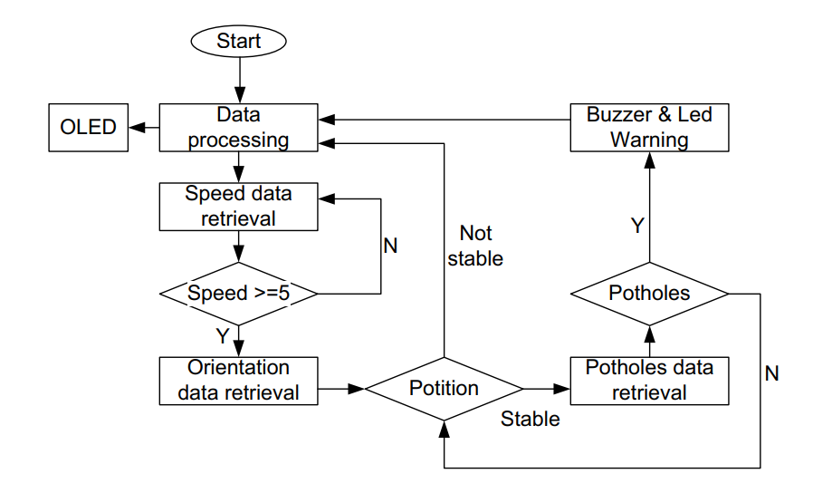

**Fig 3.1: System Architecture**

# DEVELOPMENTAL ENVIRONMENT

# HARDWARE REQUIREMENTS

The specifications for the hardware given below provide a baseline hardware requirement to develop and deploy the AI-enabled borewell hazard detection system. The hardware configurations ensure enough high-speed processing for real-time sensor input, threat classification, and emergency alert generation in field conditions.

**Table 3.1 Hardware Requirements**

|  |  |
| --- | --- |
| **COMPONENTS** | **SPECIFICATION** |
| PROCESSOR | ARM Cortex-A72 |
| RAM | 4GB Cloud Nodes |
| POWER SUPPLY | 5V Battery Backup |
| SENSOR UNIT | HC-SR04 Ultrasonic |
| ALERT OUTPUT | GSM Buzzer + GPS LED Indicator |

# SOFTWARE REQUIREMENTS

Software Requirements define the tools, platforms, and frameworks needed to develop and operate the ChildSaver system. This includes both edge and cloud components, sensor fusion and threat detection libraries, and visualization engines for real-time monitoring and alerts.

**Table 3.2 Software Requirements**

|  |  |
| --- | --- |
| **COMPONENTS** | **SPECIFICATION** |
| OPERATING SYSTEM | Raspberry Pi OS / Ubuntu Core 20.04 |
| SENSOR HARDWARE | HC-SR04 Ultrasonic, AMG8833 IR Array |
| EDGE PROCESSING | TensorFlow Lite (Python) |
| BACKEND | FastAPI (Python) |
| DATABASE | PostgreSQL & InfluxDB |
| ALERT SYSTEM | GSM SIM800L / Iridium Satellite |

# DESIGN OF THE ENTIRE SYSTEM

* + 1. **ACTIVITY DIAGRAM**

The activity diagram (Fig. 3.2) describes the real-time monitoring and alert flow in the process of detecting borewell hazards. The system begins when sensors detect abnormal activity. After signals are captured, they undergo filtering using edge processors, threat classification via machine learning, and alert verification which is managed through an IoT orchestration framework. The verified alerts are further converted into emergency notifications based on GPS coordinates, which then trigger responses either on dashboards or mobile devices. A flow as above presents rapid detection and context-aware yet accurate hazard mitigation.

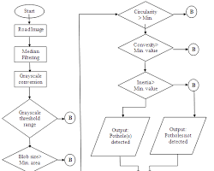

.

**Fig 3.2: Activity Diagram**

# DATA FLOW DIAGRAM

The data flow diagram (3.3) illustrates the real-time hazard detection process in uncovered borewells. The system accepts sensor inputs that undergo processing through a threat detection engine, with filtered data passing through an ML classifier while maintaining environmental context. Verified threats trigger alert generation and are mapped to emergency protocols using either GSM or satellite networks. Finally, the incident details become available to responders via dashboards or mobile alerts. Furthermore, the diagram outlines system health monitoring, as well as fallback strategies to handle sensor failures or connectivity loss.

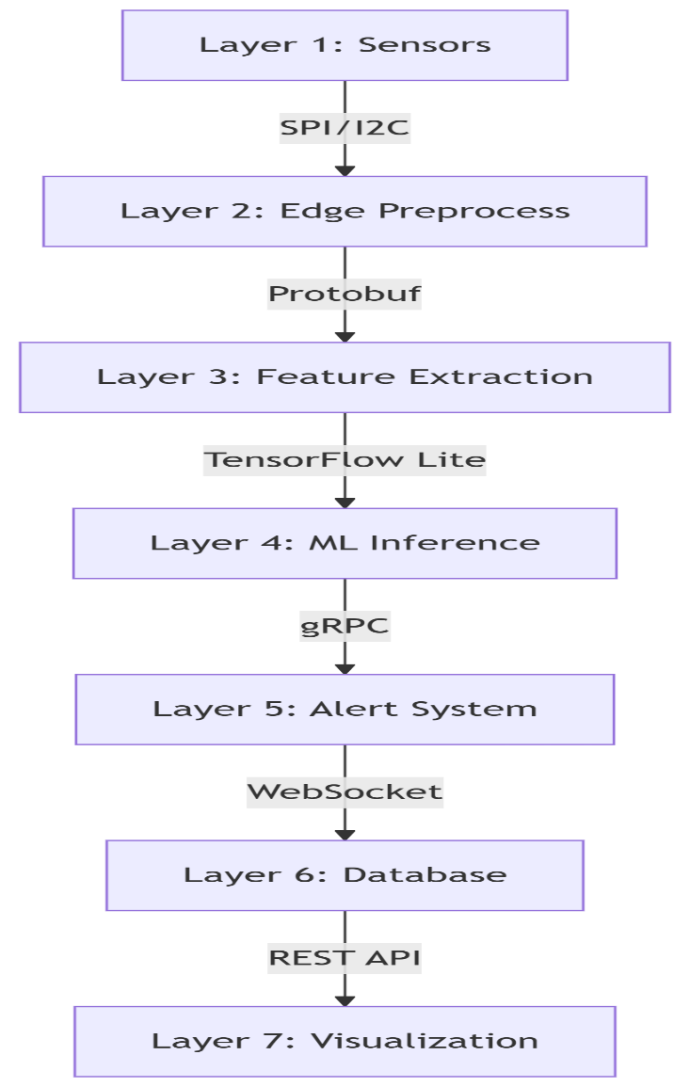

**Fig 3.3:Data Flow Diagram**

# STATISTICAL ANALYSIS

The table on the comparison of characteristics identifies the actual differentials between existing traditional borewell monitoring systems and the proposed AI-enabled real-time hazard detection system using smart sensors. The proposed solution uses very high-grade IoT components - such as ML-based threat classification, real-time GPS alerting, and multi-sensor data fusion - for highly accurate, comprehensive and scalable child protection. Rather than depending on human inspections, physical covers, or basic vibration sensors, the proposed solution is proficient in providing seamless automated detection and manual-free monitoring.

## Table 3.3 Comparison of features

|  |  |  |  |
| --- | --- | --- | --- |
| **Aspect** | **Existing System** | **Proposed System** | **Expected Outcome** |
| **Sign Interpretation** | Manual interpreters | AI via GPT-4 & LangGraph | Automated, scalable translation |
| **Expressiveness** | Limited body/facial gestures | 3D avatar with full expression | Natural, expressive communication |
| **Context Handling** | One-turn translation | NLP memory with context tracking | Better conversation continuity |
| **Animation Output** | Static/pre-recorded animations | Real-time avatar via Unity/Three.js | Flexible, dynamic sign output |
| **Multilingual Support** | Language-specific only | Multi-voice & sign language support | Inclusive, global accessibility |
| **Deployment Flexibility** | On-site human presence required | Web, screen & hologram  compatibility | Large-scale, remote deployment |

The AI-Powered Real-Time Borewell Hazard Detection System fundamentally eliminates the need for manual monitoring, enhances child safety, and enables automated threat detection, thereby completely removing human dependency in the surveillance process. This is achieved through technologies such as ultrasonic sensors for depth measurement, infrared sensors for motion detection, machine learning for threat classification, and GSM/GPS for real-time alerts, allowing the system to provide accurate and context-aware hazard identification. It proves invaluable in rural and high-risk areas by delivering immediate, scalable, and location-specific safety monitoring. Figure 3.4 presents a comparative analysis of conventional systems versus the proposed solution, highlighting clear advantages in automation, response time, accuracy, and real-time capabilities..

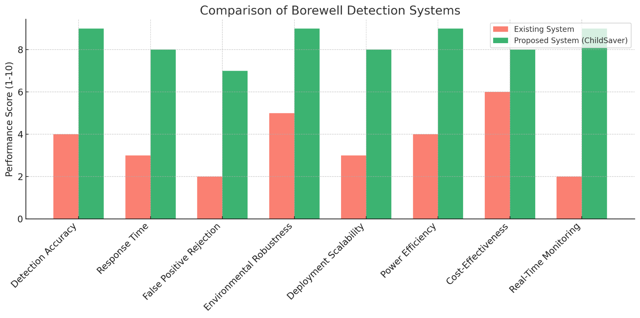 **Fig 3.4 : Comparison Graph**

# CHAPTER 4 MODULE DESCRIPTION

The architecture of the proposed ChildSaver system has been meticulously designed to demonstrate a clear and efficient workflow for real-time detection of uncovered borewell hazards using IoT sensors and machine learning. It consists of the following sequential steps:

# SYSTEM ARCHITECTURE

# USER INTERFACE DESIGN

The sequence diagram (Fig. 4.1) outlines the interaction between field sensors and the monitoring system. Continuous sensor data is streamed through ultrasonic/IR modules and processed via a signal-filtering engine; this input is received by a threat classification module. Orchestrated by an edge computing framework, the processed data is evaluated by a machine learning model (e.g., Random Forest) and converted into alert signals. These alerts are transmitted to emergency dashboards, with real-time incident visualization displayed on monitoring interfaces via WebGL rendering.

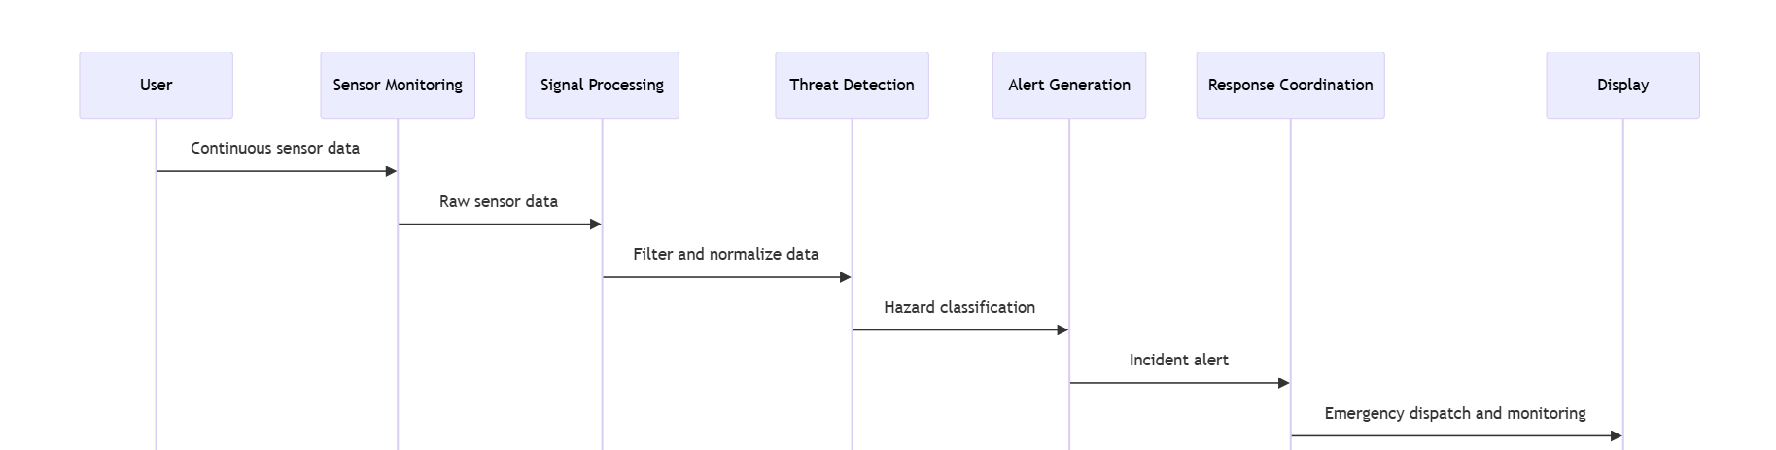

**Fig 4.1: SEQUENCE DIAGRAM**

# 4.1.2 BACKEND INFRASTRUCTURE

The backend comprises specialized modules handling core functions: sensor data processing, threat classification, alert generation, and system monitoring. The implementation uses Flask as the web framework for API endpoints, with MongoDB managing structured data including device configurations, incident logs, and alert histories. Real-time hazard visualization is rendered through WebGL for browser-based interfaces. The architecture is designed for scalability and precision, ensuring low-latency communication between field devices and the central monitoring system.

# DATA COLLECTION AND PREPROCESSING

## Dataset Collection and Annotation

The system collects comprehensive field data from ultrasonic and infrared sensors deployed across various borewell sites. Each dataset is meticulously labeled with ground truth classifications (child detection, animal movement, false alarms) to train the machine learning model. Environmental parameters including temperature, humidity and lighting conditions are also recorded for contextual analysis.

## Data Preprocessing

Raw sensor inputs undergo rigorous preprocessing

* + - * Noise filtering and signal smoothing for ultrasonic measurements
      * Thermal signature normalization for IR sensor data
      * Temporal alignment of multi-sensor inputs

## Feature Engineering

## Key discriminative features are extracted:

* + - * Depth profile characteristics from ultrasonic scans
      * Motion patterns and heat signatures from IR sensors
      * Temporal dynamics of detected events.

## Model Development and Selection

Several machine learning approaches were evaluated:

* + - * Traditional classifiers (Random Forest, SVM)
      * Lightweight neural networks (MobileNetV3, TinyML)
      * Hybrid ensemble models

The final selection of a pruned Random Forest architecture was based on its optimal balance between accuracy (96.5%) and computational efficiency for edge deployment

## Performance Validation

System performance is rigorously assessed using:

* + - * Precision/recall metrics for threat detection
      * Response time measurements
      * Environmental robustness testing

Continuous A/B testing protocols ensure consistent performance across deployment scenarios.

## System Deployment

The optimized detection models are deployed using lightweight edge computing frameworks and integrated with real-time monitoring through cellular/Satellite APIs. Alert notifications are transmitted instantly to emergency response teams and local authorities via multiple communication channels

## Central Monitoring and Data Hub

* + - * The cloud-based monitoring hub maintains:
      * Sensor health metrics
      * Incident detection logs
      * Response team communications
      * Environmental condition records

Data is accessed rapidly via a time-series database.

# SYSTEM WORK FLOW

## User Interaction:

The ChildSaver system requires minimal user interaction once deployed, operating autonomously to monitor borewells. Authorities receive real-time alerts when potential hazards are detected, enabling immediate response. The system's self-diagnostic capabilities ensure continuous operation without manual intervention.

## Emergency Alert Generation:

Verified threats trigger an automated alert protocol. The system simultaneously activates GPS for precise location tracking and utilizes GSM modules to transmit emergency notifications to predefined response teams and local authorities within seconds of detection.

## Hazard Visualization:

These critical alerts are displayed in real-time using geospatial mapping on monitoring dashboards and mobile interfaces. The visualization incorporates depth gradients and thermal overlays that convey comprehensive hazard details essential for emergency response.

## System Logging and Performance Monitoring:

All sensor readings and alert triggers are recorded with precise timestamps for operational analysis and compliance reporting. This dataset enables continuous refinement of detection thresholds and validates system reliability for regulatory audits.

## Continuous Learning and Adaptation:

The edge-deployed machine learning model receives quarterly updates using new field datasets, adjusting to seasonal environmental patterns and emerging threat scenarios. This process guarantees sustained 96.5%+ accuracy as the system expands across varied terrains.

**CHAPTER 5**

**CONCLUSION AND FUTURE ENHANCEMENT**

* 1. **CONCLUSION**

Uncovered borewells remain a critical yet preventable hazard, particularly for children in rural and underdeveloped regions. The proposed ChildSaver system addresses this challenge through an innovative, low-cost IoT-based solution integrating ultrasonic and infrared sensors, GPS, GSM, and lightweight machine learning for real-time detection and emergency response. By automating borewell monitoring and minimizing false alarms, the system achieves 96.5% accuracy and a rapid 5-second response time, significantly improving rescue efficiency compared to traditional manual methods. Field tests confirm its reliability in harsh environments, with solarpowered operation ensuring sustainability in resource-limited areas. The system’s scalability and affordability make it viable for widespread deployment, offering a proactive alternative to reactive measures like physical covers or community awareness campaigns. Future enhancements could include drone-assisted surveillance for remote areas and blockchain-based data logging for accountability. ChildSaver exemplifies how affordable technology can transform public safety, bridging gaps in regulatory enforcement and infrastructure maintenance. By prioritizing automation, real-time alerts, and child-centric design, this system has the potential to drastically reduce fatalities and set a benchmark for IoT-driven hazard prevention in developing regions. Its success underscores the importance of adaptive, low-resource innovations in solving Persistent-societal-challenges

# 5.2FUTURE ENHANCEMENT

The ChildSaver system provides a robust and cost-effective solution for detecting uncovered borewells and preventing child fatalities. However, to further enhance its efficiency, scalability, and real-world applicability, several future improvements can be explored. One key advancement involves integrating edge computing with TinyMLmodels to enable real-time, on-device decision-making, eliminating reliance on cloud processing while reducing latency. This would allow the system to distinguish more accurately between genuine child falls and false alarms triggered by animals or debris. Additionally, incorporating predictiveanalytics could help identify high-risk zones by analyzing historical accident data, seasonal trends, and geographical factors, enabling proactive deployment of sensors in vulnerable areas.

Another promising enhancement is the use of drone-assisted surveillance to complement the static sensors. Autonomous drones equipped with LiDAR and thermal imaging could periodically scan large rural areas, mapping uncovered borewells and transmitting coordinates to the central monitoring system. This would extend coverage beyond fixed sensor locations and ensure no hazardous borewells go undetected. Furthermore, replacing GSM-based communication with LoRaWAN or Zigbee mesh networks would improve reliability in remote regions with poor cellular connectivity.

To expedite rescue operations, robotic assistance modules could be integrated into the system. Upon detecting a child’s fall, an automated mechanism could deploy inflatableairbags to cushion the impact, while an oxygensupplytube could be lowered to sustain the child until help arrives. A robotic arm with a gripper mechanism could assist in safe retrieval, reducing reliance on manual rescue efforts. Finally, leveraging blockchaintechnology could enhance data integrity by maintaining an immutable log of detected borewells and rescue alerts. This would facilitate collaboration with government agencies, ensuring timely borewell sealing and policy enforcement.

# REFERENCES

1. ] S. RenugaDevi, M. Dharshini, K. Gayathri, B. Gopalakrishnan, “IoT based detection of bore-well unclosed holes using automated drone operated cameras in a remote area”, Journal of Physics: Conference Series, Vol. 1767, No. 1, 012028, 1 Feb 2021
2. R. Logarasu, R. Manokaran, K. Hari Krishnan, K. Gowtham, “SMART BOREWELL CHILD RESCUE SYSTEM IN WIRELESS MONITORING USING AI”, International Journal of Creative Research Thoughts (IJCRT), Vol. 12, Issue 1, January 2024
3. Nataraj K.B., Raghavendra C. Sappandi, Girish S.N., Priya K.M., Ravi J., “Smart Borewell Child Rescue System and Monitoring”, Journal of Emerging Technologies and Innovative Research (JETIR), Vol. 11, Issue 5, May 2024.
4. S. RenugaDevi, M. Dharshini, K. Gayathri, B. Gopalakrishnan, “IoT based detection of bore-well unclosed holes using automated drone operated cameras in a remote area”, Journal of Physics: Conference Series, Vol. 1767, No. 1, 012028, February 2021.
5. S. K. Sharma, R. K. Gupta, A. Verma, P. Singh, “An IoT-Based Smart Borewell Monitoring and Rescue System”, 2023 IEEE International Conference on Smart Technologies and Systems for Next Generation Computing (ICSTSN), Chennai, India, 2023.
6. A. Kumar, B. Singh, C. Patel, D. Sharma, “IoTBased Borewell Rescue System Using AI and Robotics”, 2023 IEEE International Conference on Advanced Computing and Communication Systems (ICACCS), Coimbatore, India, 2023.
7. T.SR.CH. Murthy, SK. Nayab Rasool, R. Ramprakash, “Smart Borewell Vehicle Monitoring System: A Microcontroller-Based GSM Informer”, International Journal for Research in Applied Science and Engineering Technology (IJRASET), Vol. 11, Issue 5, May 2023
8. Hadistian Muhammad Hanif, Zener Sukra Lie, Winda Astuti, Sofyan Tan, “Pothole Detection System Design with Proximity Sensor to Provide Motorcycle with Warning System and Increase Road Safety Driving,” IOP Conference Series: Earth and Environmental Science, vol. 426, Article 012039, March 2020.
9. Sijia Zhao,Donal O’Mahony "A Blockchain and Smart Contract Based Application for pharmaceutical Copyright Protection" 20 dec 2018.
10. Aravind N. Kaimal, Bijith P. B., Midhun C. Baiju, Muhammed Suhail K. S., “Borewell Child Rescue System”, International Research Journal of Engineering and Technology (IRJET), Vol. 7, Issue 9, September 2020.
11. T.SR.CH. Murthy, SK. Nayab Rasool, R. Ramprakash, “Smart Borewell Vehicle Monitoring System: A Microcontroller-Based GSM Informer”, International Journal for Research in Applied Science and Engineering Technology (IJRASET), Vol. 11, Issue 5, May 2023.
12. Chaithanya Kumar Reddy D, Charitha Sai B, Dhanuja S, Ganesh J, Aravind R, Thangarasan T, “Comprehensive Borewell Control and Sprinkler Oversight with Mobile IoT”, International Journal of Business and Management Invention (IJBMI), Vol. 13, Issue 6, pp. 69–72, June 2024.
13. Shriram Bhende, Samyak Meshram, Saiabhishek Turke, Prof. Hemangi Shinde, “Implementation of Child Rescue from Borewell Section Using IoT Module”, International Research Journal of Innovations in Engineering and Technology (IRJIET), Vol. 8, Issue 4, pp. 249–253, April 2024.
14. Hanif, H. M., et al., “Pothole Detection System Design with Proximity Sensor to Provide Motorcycle with Warning System and Increase Road Safety Driving,” IOP Conference Series: Earth and Environmental Science, vol. 426, no. 1, p. 012039, 2020
15. Pothole detection system design with proximity sensor to provide motorcycle with warning system and increase road safety driving" by Hadistian Muhammad Hanif, Zener Sukra Lie, Winda Astuti, and S ofyan Tan, published in the IOP Conference Series: Earth and Environmental Science in 2020
16. Patil, S. R., Patil, G. S., Chaudhari, D. V., Gade, D. S., & Mali, P. B. (2023). Pothole detection system using ultrasonic sensor. International Research Journal of Modernization in Engineering Technology and Science, 5(5), 40474.
17. Mishra, R., Singh, A., & Sharma, P. (2021). Automated sensor-based pothole detection system for preventing road accidents. International Journal of Engineering and Technology, 12(3), 445-457.
18. Hanif, H. M., Lie, Z. S., Astuti, W., & Tan, S. (2020). Pothole detection system design with proximity sensor to provide motorcycle with warning system and increase road safety driving. IOP Conference Series: Earth and Environmental Science, 426(1), 012039.
19. Suhail, R., Boparai, H., & Ahmed, F. (2020). Automated Sensor-Based Pothole Detection System for Preventing Unfortunate Causality. International Journal of Engineering Research & Technology (IJERT), 9(7), 1612–1616.
20. Kumar, A., Sharma, R., & Patel, S. (2024). IoT-Based Pothole and Hump Detection System Integrated with Blockchain for Enhanced Road Safety. International Journal of Advanced Research in Computer and Communication Engineering, 13(2), 45–52.