**ChildSaver: A Framework for Uncovered Borewell Detection and Child Rescue Using Proximity Sensors and Machine Learning**

***Dr.Senthilpandi S1, Sivathanu K P2, Viknesh J3, Sasikumar S4***

*1Assistant Professor - Department of Computer Science and Engineering, Rajalakshmi Engineering College, Chennai.*

*2,3,4Under Graduate Student - Department of Computer Science and Engineering, Rajalakshmi Engineering College, Chennai.*

[*1*](mailto:1farjana.u@rajalakshmi.edu.in)[*senthilpandi.s@rajalakshmi.edu.in,*](mailto:senthilpandi.s@rajalakshmi.edu.in,)*2220701280@rajalakshmi.edu.in,**3*[*220701321@rajalakshmi.edu.in*](mailto:220701321@rajalakshmi.edu.in) *4220701525@rajalakshmi.edu.in*

***ABSTRACT* – Uncovered borewells represent a persistent and life-threatening hazard for children, especially in rural and underdeveloped regions where safety regulations are either absent or poorly enforced. To address this critical challenge, this study proposes ChildSaver, a low-cost, sensor-based intelligent system designed to detect open borewells and prevent fatal accidents. ChildSaver integrates a combination of ultrasonic sensors for depth detection, infrared (IR) sensors for motion and heat sensing, GPS modules for precise location tracking, and GSM modules for real-time communication of emergency alerts. The ultrasonic sensors continuously scan the ground for vertical voids indicating an open borewell, while IR sensors detect the presence and movement of living beings near or within the borewell area. Upon detecting a potential threat, the GPS captures accurate geolocation data, and the GSM module immediately transmits alerts to nearby rescue teams or authorities. To enhance reliability, a lightweight machine learning model processes the sensor data, intelligently distinguishing genuine child fall incidents from false positives such as animals or debris. Field deployments and testing demonstrate a detection accuracy of 96.5% and a rapid response time of under 5 seconds from threat detection to alert generation. Designed specifically for scalability and sustainability in low-resource settings, ChildSaver offers a highly effective, automated, and affordable solution to a critical public safety issue, aiming to significantly reduce child fatalities associated with uncovered borewells.**

***Keywords: Child safety, borewell detection, proximity sensors, IoT, machine learning, real-time monitoring***

**I INTRODUCTION**

Uncovered borewells pose a serious and persistent threat to child safety, particularly in rural and semi-urban areas across India, Africa, and Southeast Asia. In these regions, rapid urbanization, lack of stringent regulatory enforcement, and minimal public awareness contribute significantly to the problem. Often, borewells are dug hastily for water extraction and then abandoned without proper sealing or marking, leaving deep, narrow shafts exposed. These open borewells become death traps for unsuspecting children who may accidentally fall into them while playing or walking nearby. According to reports from the National Disaster Response Force (NDRF), more than 100children have lost their lives in India alone over the past decade as a direct result of falling into uncovered borewells. Given the underreporting in many rural areas, the actual number could be even higher.

Traditional preventive measures such as manual inspections, installation of physical barriers, or community awareness campaigns have proven to be inconsistent and largely ineffective. Manual monitoring of thousands of remote borewell sites is labor intensive, costly, and prone to human error. Physical covers, even when installed, are often poorly maintained or easily displaced. As a result, there remains an urgent need for a technologically driven, low**-**cost, and reliable solution that can automatically detect uncovered borewells and respond swiftly to potential accidents. As a solution to this super critical problem, I've created ChildSaver, which is basically this amazing IoT device that's designed to avert those very sad accidents in which children accidentally fall into borewells, you know, those deep wells that are not covered properly? So, ChildSaver is more or less a gadget that is equipped with all these sensors like ultrasonic and infrared sensors, which scan the ground all the time to detect if there is an uncovered hole that could potentially be a borewell.

Here's where it gets smart though: it is not going to trigger all the time for false alarms like a bird flying past or the blowing of leaves from the wind. Oh dear, it's got this small computer brain that uses some simple AI technology to figure out if it's really a child who's drowned or whatever. If it's a kid, it sends an actual quick text message to the authorities who are able to respond, like the fire station and some villagers, and even provides them exactly where the well is with some high-tech GPS coordinates.

And voila, it has a loud speaker that makes a warning noise if a person gets too close to the borewell, like saying, "Hey, watch it! There's a big hole here!" It is fairly cheap to make, which is great because it means even poorer communities and the government can buy it without breaking the bank. And it's solar-powered, so it still works even in places where electricity is more of a myth.

You can just place it anywhere and it's simple to repair if it gets damaged, and you can also add more of these bad boys to cover larger areas. It's completely low maintenance and doesn't require anyone to monitor it all the time. So, ChildSaver is basically a game-changer for protecting kids from those hazardous wells. It's easy, clever, and completely worth it!

# LITERATURE SURVEY

1. Drones equipped with ultrasonic sensors address the problem of uncovered borewells posing a serious threat, especially to children. The proposed system incorporates four major modules which include activation of the drone camera, identification of the borewell, depth measurement with the use of an ultrasonic sensor, and cloud updation. The drone moves along a fixed path in an open area and applies image processing for borewell detection and ultrasonic sensors for depth measurement. The measured distance is classified into different zones viz. Green, Yellow, and Red depending upon the severity of the depth from the top of the hole. If the distance is more than 3 feet, the hole is classified as a Red Zone and an alert signal is sent to the control room for action. The details of location and depth of the borewell will be stored to the cloud for future reference. In addition to that, the system contains GPS and GSM module to communicate location to authorities. This IoT solution provides a solution for detecting and measuring hazardous potholes that could help enhance safety by alerting concerned authorities to avert the accidents. Some other future work could include addition of Passive Infrared Sensors for further detection and alerting people on close proximity.
2. The Smart Borewell Child Rescue System provides a novel solution that is aimed to address the pertinent matter of safety involving borewells, and flies explain incidents in which children find themselves accidentally dropped into these deep structures of water extraction. It comes with enough versatility and selection in addition to its basic function; borewells are some of those spaces with midway openings for water collection and pose serious risks due to the generally fetched openings. The existing measures of security are totally considered inadequate; therefore, either there is a physical check or the approach is reactive in nature and takes time to respond when any emergencies occur. This paper introduces a rather pro-active system that brings in wireless monitoring technologies, and artificial intelligence (AI) brought on to offer better safety around a borewell and improvement upon rescue operations.The system incorporates a series of detectors that are strategically deployed around borewell areas, and include proximity detectors and environment sensors. These detectors communicate wirelessly with a central control unit featuring microcontrollers and AI. Using wireless communication protocols such as LoRa or Zigbee, it allows for real-time monitoring and transmission of data to a centralized location. AI algorithms analyze the sensor data and notify the observatory operation if an anomaly, such as a child falling into the borewell, occurs. The system minimizes the ringing for false alarms and expeditiously continues to respond to emergencies.In the event of a calamity, the system helps provide the positioning of the child in the borewell; therefore, rescue teams will easily devise and effect operations. This will reduce very high response times and greatly increase the probability of successes. Moreover, the system consists of some superior hardware-comprising an ESP32 camera, microcontroller, and a robotic arm mechanism-to assist in the rescue operations.The existing systems of borewell safety are manual and are thus remote ones; this very aspect has led to delayed responses. The system proposed thus fills these gaps by incorporating high-end technologies, thereby, offering a proactive and intelligent solution. It could save lives and improve the standards of safety around borewells.
3. The Smart Borewell Child Rescue System aims to research advanced rescue solutions to diminish hazards posed by borewells, particularly children's accidental entry into them. Reactive manual inspections, becoming entrenched in traditional systems, have resulted in deplorable delays. Integration of wireless monitoring, robotics, and AI offers a new spectrum of safety measures and improved rescue missions.Different kinds of sensors, including proximity detectors and environmental ones, are distributed around the borewell perimeter at various angles. These sensors wirelessly communicate to a central control unit coupled with a microcontroller running AI algorithms. Reliable protocols such as LoRa or Zigbee allow monitoring without wires, transferring data at intervals to a central control station. The algorithm uses the sensor data to discover anomalies-perhaps a fall with a subsequent borewell-warning approaches this assistance, thus generating far fewer false alarms and ensuring speedy response.The system ensures that the child's location is instantly available during emergencies, thus enabling speedy and efficient rescue operations. Highly advanced hardware components including an ESP32 camera, an embedded microcontroller, and a robotic arm mechanism were utilized for the rescue. The robotic arm is mobile app-controlled and securely detains a child in distress.In hazard detection helping the incident on-site to reduce the response time, real-time monitoring offers a promising advancement to wireless technology. Future works shall test running AI-based algorithms, implement edge computing, and ultimately an autonomous rescue action. This device-enabled solution has impacted the borewell safety mechanism that would enable the safeguarding of children from those unlucky accidents.
4. India is a developing country that has faced severe water scarcity leading to the increased drilling of borewells. Unfortunately, many borewells remain uncovered, posing a serious hazard to children since they can fall into them easily. As a solution to this menace, drone cameras with ultrasonic sensors are proposed for locating and measuring borewells in remote areas. The intent is to safeguard from accidents. Particularly, it includes detecting potholes and alerting the concerned authorities.Drones using image processing techniques will survey, spot, and identify borewells within the defined area, with an ultrasonic sensor mounted on the drone measuring and mapping depth and width of the borewell. If the borewell is over 3 feet deep, the authority to which it belongs will mark it "Red Zone"-highly Dangerous. All available relevant data acquired by the drone-like GPS coordinates of the borewell, the dimensioning of the pothole, etc-will be transmitted in real-time to the cloud server for further monitoring and analysis. The authority would be informed to close the borewell to preempt accidents.These unique solutions allow minimal human involvement in processes and endorse technology-based life-savers. Integration of drone technology and ultrasonic sensors with cloud storage makes the system more powerful in the detection and monitoring of dangerous, uncovered borewells. It is thus a new solution to a serious safety concern for children and communities from the tragedy of uncovered borewells. This technology-driven effort offers hope for an improvement in safety standards in urban and rural settings alike across innumerable facets of life.
5. The transportation industry is becoming increasingly sophisticated through the merging of technology, combining what in the past were called human-driven vehicles to autonomous and teleoperated vehicles. Further on, challenges of road safety and infrastructure maintenance come in, which are responsive challenges in developing countries. Potholes are cornerstone hazards involving accidents, traffic jam, and vehicle breakage each year digging deep into billions of dollars in economic losses. The fast-evolving smart transportation systems employ the IoV to cure the ails of road safety and traffic efficiency using an arsenal of technologies like AI, ML, and DEI.Pothole detection has been proposed to utilize the combination of DEI, digital twins, and computer vision. Advanced algorithms like YOLOv9t, which boast of high accuracy and low latency, find potholes in vehicles with dashcams and sensors and send alerts on detected potholes to vehicles and Roadside Units through vehicle-to-vehicle and vehicle-to-infrastructure communication. The digital twin builds and keeps a virtual representation of the road and updates it with the pothole data to support timely repairs by the authorities.Simply put, this solution provides drivers with real-time alerts regarding potential hazards, thus reducing the chances of accidents and impeding the buildup of traffic. It embodies the trifecta of an edge computing-based CAV, AI, and Cooperative Perception with a robust solution to the realization of safer and efficient transportation networks.
6. Road accidents are a worldwide problem that kills 1.19 million people a year-92% of which are in low to middle-income countries including Bangladesh. Bad roads, reckless driving, and poor emergency response are main contributors to the high rate of accidents. To address this "safety," the sensing device "RoadSense," has been developed, using sensor technology and machine learning that will identify road conditions and then notify drivers real time in case of accidents.The device will use sensors like accelerometers, gyroscope, and GPS that will collect real-time data about potholes, speed breakers, and hard braking events. It will use tree-based machine learning models, including Random Forest and Extra Trees, to predict road conditions with a very high accuracy of up to 99.07%. In addition, the cloud-based corrections of the GPS data will be used in the system to have accurate location information.RoadSense alerts the driver on real-time hazards so that he can avoid them, while the authorities can use the collected data to make timely road repairs. The device is very affordable, scalable, low-cost, and adaptable to the needs of the resource-constrained urban environment in developing countries. Future plans include spreading its use all over Bangladesh integrated into an advanced driver-assistance system to improve safety. By doing this, RoadSense can possibly save lives and mitigate economic losses.
7. The Smart Borewell Vehicle Monitoring System uses Arduino MEGA 2560 microcontroller for automation and operation enhancement of borewells. The system employs proximity sensors, a GPS system for location tracking, and a GSM module for SMS notifications to the owner of the vehicle and a customer, when the compressor starts. An SMS will contain the location and time the compressor started. When completed, another SMS will state the number of rods drilled and how long the compressor was running. Data is also stored in an SD card for borderline analysis.The system is meant to ensure the manual monitoring inefficiencies of a delay and human error are put to rest by ensuring real-time updates are carried out, delivering accurate and timely data. The system improves transparency and customer satisfaction, as communications to the customers are timely and guarantee proper monitoring progress. The input from the ATmega328 microcontroller comes from the sensors. The data management/controlling of the system is done through the ATmega328, while an LCD displays real-time visual feedback.The system provides key benefits like the following:Automating the entire process reduces human interventions and human errors.Provides instant SMS alerts on the compressor's status and drilling progress.GPS helps in geolocation of the vehicle and thus makes accurate updates.The SD card can record previous data for analysis and retrospective performance evaluations.This supposedly sophisticated setup of systems is noted to boost the standards of borewell operations by providing efficient monitoring, reduced costs, and greater satisfaction of both customers and borewell owners. It is thus ideal for industries that heavily depend on borewells, such as irrigation and water supply, throwing a scalable version of cost-effective borewell.
8. This research concentrates on implementing a reasonably economical and efficient pothole detection system for motorcycles in Indonesia, where high rates of accidents are caused by the prevalent condition of roads. The detection of potholes is made using infrared light-prompted proximity sensors, gyroscopic sensors for orientations of the vehicles, and Hall Effect sensors for speed measurement. The sensors are incorporated into an Arduino-based microcontroller (NodeMCU) that will process the data and provide the rider with any alerts or warnings in real-time using an OLED display, LED lights, and a buzzer.The system generally gets activated when the vehicle speed exceeds 5 km/h and when the orientation does not vary. If a pothole is detected, visual and auditory alerts are generated to warn the rider. The proximity sensor's range of detection is 7 m with an average error of 1.58% on practical grounds. Testing with the system showed working distance for pothole detection was within the range of 2.5-2.7 m with a very small rate of error of around 0.73%.This cost-effective solution comes as a huge benefit to motorcycle users in the developing world, offering an economically viable alternative to costly camera-based systems. With heightened awareness of poor road conditions, the system is anticipated to enable fewer accidents and enhanced rider safety. Future enhancements may bring refinements in sensor sensitivity and a wider repertoire of pathologies addressed.
9. The  Borewell Rescue System  is aimed at rescuing children who may fall into abandoned borewells, which render a problem where lives can often be lost. The system is portable and efficient with various techniques of rescue and life support systems, functioning at the same time to ensure a child's safety during the rescue operation.The system comprises a  manipulating arm sensory devices  like camera, proximity sensor, and oxygen sensor, and controllers operating between desktop PC or mobile devices. The manipulator stretches and positions itself under the child using  rack and pinion mechanism  while being stabilized with a  scissor mechanism . A  balloon cushion  inflated underneath the child protects him/her from further injury. The system is stabilized inside the borewell with the help of a  four-jaw chuck mechanism .Undermentioned are the salient features:Real-time monitoring -A Wi-Fi camera and LED light feedback will effectively inform the rescuers of the child's position and condition. Oxygen supply -An oxygen tube will grant the child time to breathe till rescuers arrive.Safety mechanisms -The protective casings and balloon cushions in the system keep him/her from sustaining additional injuries.Rostered to be very lightweight, with a composite material like  carbon fibre  that strengthens it further and entitles durability, it is adjustable for various borewell diameters and depths. It's a remote-controlled unit that promises a swift and safe salvaging operation. Testing has indicated its satisfaction with the competent prototypical design; thus, it gives hope for saving trapped children.
10. The  Borewell Rescue System  is aimed at rescuing children who may fall into abandoned borewells, which render a problem where lives can often be lost. The system is portable and efficient with various techniques of rescue and life support systems, functioning at the same time to ensure a child's safety during the rescue operation.The system comprises a  manipulating arm sensory devices  like camera, proximity sensor, and oxygen sensor, and controllers operating between desktop PC or mobile devices. The manipulator stretches and positions itself under the child using  rack and pinion mechanism  while being stabilized with a  scissor mechanism . A  balloon cushion  inflated underneath the child protects him/her from further injury. The system is stabilized inside the borewell with the help of a  four-jaw chuck mechanism .Undermentioned are the salient features:Real-time monitoring -A Wi-Fi camera and LED light feedback will effectively inform the rescuers of the child's position and condition. Oxygen supply -An oxygen tube will grant the child time to breathe till rescuers arrive.Safety mechanisms -The protective casings and balloon cushions in the system keep him/her from sustaining additional injuries.Rostered to be very lightweight, with a composite material like  carbon fibre  that strengthens it further and entitles durability, it is adjustable for various borewell diameters and depths. It's a remote-controlled unit that promises a swift and safe salvaging operation. Testing has indicated its satisfaction with the competent prototypical design; thus, it gives hope for saving trapped children.
11. The  Smart Child Rescue System for Open Borewells  is meant, first and foremost, to save children who, due to unplanned circumstances, fall into an open borewell abandoned or neglected, thereby posing a great risk of fall into it. The traditional means of rescue are time-consuming and dangerous as they require heavy earth-moving machines for digging parallel pits. Hence, it is now proposed that an  Automatic Mechanical System  be designed to save children trapped in open borewells as efficiently and quickly as possible.The objections are met by the system itself being equipped with  IR Sensors  placed within the borewell for detecting falls of a child. Once the coding detects that a child has fallen into the borewell, the lid mechanism starts its functioning to stop the fall. The system is driven, monitored, and controlled by an  Arduino microcontroller  and alerts via  SMS  to the relevant authority about the status of the place by the  GSM module  within no time.The components include:IR Sensors : Detection of child's fall with the aid of detecting any obstacle.LM567 IC : Tone decoder for processing analog signals.DC Motor : Works the sliding lid mechanism. Relay : Controls motor, along with other high-power components.GSM Module : Provides alerts to rescue teams in real-time.The system has been developed for the sake of simplicity and efficiency, with cost-effectiveness that would ensure fast action to avoid risks to child safety as well as rescuers. Through automation of rescue missions, the project aims at saving lives lost due to open borewells.Predictive modeling has proven to be an essential tool in understanding animal movement patterns. Leveraging time-series data, lunar cycles, seasonal trends, and even weather conditions, researchers can build models that forecast potential wildlife intrusions. Long Short-Term Memory (LSTM) neural networks, a type of deep learning model, have been particularly effective in analyzing sequential data over time. These models learn from historical movement patterns to predict future events, making them invaluable in wildlife deterrence. By integrating such predictive capabilities into deterrence systems, the technology can anticipate when and where animals are most likely to approach farmlands, enabling timely interventions. This approach not only improves deterrent effectiveness but also reduces unnecessary disruptions to the environment, as deterrents can be deployed only when needed. Additionally, predictive models can be enhanced with real-time environmental data from sensors, providing even more accurate forecasts. The ability to predict animal behavior in advance allows for proactive management of human-wildlife conflicts, preventing damage before it occurs.
12. The developed Comprehensive Borewell Control and Sprinkler Management System uses the Mobile IoT technologies to facilitate the management of water for agriculture. The borewell parameters like water levels, quality, and pumping performance will be monitored through sensors and actuators with very minimal human interventions. This could then be controlled manually or by means of IoT-based technology through Android and other apps. Real-time computations like soil moisture and weather prediction allow an IoT-enabled sprinkler to bring automation to the irrigation space while ensuring efficient use of water and preventing over-pumping.Some noteworthy features: Real-Time Monitoring : Sensors can detect water levels, temperature, and soil moisture. Remote : Farmers can manage pumps and sprinklers via a mobile app.  Fault Detection : Issues on mechanical failure or faults in the system can be flagged maintenance. Data-Driven Decisions-Making : Real-time analytics can optimize irrigation schedules.It will reduce hand-on-the job, save water, and ensure more crop production. Economical, expandable, and means one can access the field even if not the reachable ones, thus providing a sustainable kit for modern agriculture. The combination of IoT technology with a rather simple user interface provides for the correct management of water resources by the farmer and increases output further.
13. Designed for purposes of rescue, the Child Rescue System from Borewell is meant to save children accidentally falling into disused borewells, a persistent and life-threatening matter. The traditional methods of rescue, parallel trench digging, are arduous, slow, hazardous, and require heavy machinery. This project puts forward a portable, cost-effective, and efficient system to save trapped children quickly and safely.The system uses sensors like PIR, temperature, and gas to develop sensors inside the borewell to assess the internal conditions of the borewell and allow detection of children. A gripper mechanism powered by a dc motor will hold the child up and safely retrieve him/her. Moreover, a camera and LED lights will give a visual of the child's location; meanwhile, cloud storage and analysis down via an IoT module will be storing and analyzing data for the use on the customer's end. The immediate action shall be signaled through GSM notifications.Looking forth, its features include:Real-time monitoring-Sensors and cameras grant live updates on boys in a child. Automated rescue-gripping mechanism safely carries the child with no manual intervention.Environmental monitoring-temperature and gas sensors ensure no harm is done to the child.Cloud integration-Data is stored for future reference and analyzed.This system is attractive due to its lightweight experience, affordability, and ease of operation, to suit mass and consistent adoption. This will also cause a sharp decline in rescue operation ambiance as the system incorporates the removal of heavy machinery in the rescue operation, hence bringing more safety and efficiency. The project serves to use embedded systems and IoT in a bid to race against time, life saved, and probably avert tragedies unfolding out of an open borewell.

1. This paper introduces a simple and affordable pothole detection system designed for motorcycles, aimed at making road travel safer. In Indonesia, where motorcycle accidents are common, often caused by bad road conditions, this system offers a cheap and easy alternative to more complex camera-based solutions. The setup uses a basic Time-of-Flight (ToF) proximity sensor, similar to a simplified LiDAR, to spot uneven patches on the road. It also includes a gyro sensor to keep track of the bike’s orientation and a Hall Effect sensor to measure speed. All the data is processed by an Arduino-based microcontroller called NodeMCU. When the system detects a pothole, it activates a warning light and buzzer. It only works when the motorcycle is moving faster than 5 km/h and keeps the bike stable to avoid false alarms. Tests showed that the proximity sensor works quite well, with an average measurement error of just 1.58% for distances up to 7 meters, although it’s most effective at about 4 to 5 meters. During energetic tests at 5 km/h, the system successfully detected a fake pothole that was 3 cm deep, with a very small error of 0.73%. The gyro and speed sensors also proved reliable, helping keep the system steady during use. Overall, the study shows that this low-cost system could be a practical way to help improve motorcycle safety. The next steps include testing it on real roads to fine-tune its accuracy and durability. This technology has the potential to cut down accidents caused by road damage, especially in areas where road maintenance isn’t always up to date.
2. Poor road conditions, like potholes, can be a real hazard for drivers in many developing countries. To help tackle this problem, we've developed a simple automated system that uses ultrasonic and IR sensors to spot road issues. This way, we can prevent accidents and damage to vehicles more easily. How It Works This system relies on an HC-SR04 ultrasonic sensor to measure how deep potholes are by sending out sound waves and timing how long they take to bounce back. An IR sensor works alongside to improve detection, and a GPS module keeps track of where each pothole is located. When a pothole is detected, its position is shown on an LCD screen, and there's even potential for a robotic system with a motor to help with repairs. Key Features- Real-time detection: Finds potholes quickly and shows their depth immediately. - Affordable: Uses low-cost sensors and an Arduino-compatible setup, making it accessible. - GPS tracking: Records exactly where potholes are, so city authorities can plan repairs better. - Modular design: Can be expanded to include robotic systems that automatically fill potholes. Why It Matters Potholes can lead to accidents, cause traffic jams, and damage vehicles, costing governments millions in repairs each year. Our system aims to be a proactive tool—alerting drivers about hazards and helping repair crews do their jobs more efficiently. While we're focusing on detection now, future improvements might include automated patching to fix potholes on the spot. Conclusion Combining easy-to-use sensors with real-time alerts, this project offers a low-cost way to make roads safer. With further development, it could cut down on accidents and reduce maintenance costs in cities around the world. Next Steps: Conduct real-world testing, work with municipal repair systems, and add AI-based features to improve accuracy even further.
3. Poor road conditions in developing countries like India often lead to accidents, vehicle damage, and important economic losses. This project introduces an affordable, automated system that can detect potholes and humps, alert drivers instantly, and send reports to authorities for maintenance. How it Works: Ultrasonic sensors (HC-SR04) measure the road surface to find potholes (deeper than a set limit) and humps (higher than a set limit). - GPS tracks the exact location, while a GSM module transmits the data to a cloud server. - An Android app provides alerts through flash messages and audio cues when drivers are within 100 meters of a hazard. Main Benefits: Cheap sensors (ultrasonic, GPS, GSM) make it easy to deploy widely. Real-time alerts help keep drivers safe, especially in poor visibility. Data stored in the cloud helps local authorities identify areas needing repairs. Testing & Results: Simulations successfully detected artificial potholes and humps (5 cm threshold). - Real-world testing on a Honda Activa (16 cm threshold) identified road issues on Bangalore streets. Next Steps: - Add navigation features with Google Maps or SATNAV. - Automatically update the database when potholes are fixed. Why It Matters: With over 2,200 deaths each year in India caused by bad roads, this system offers a practical, scalable way to save lives. By combining sensors, cloud technology, and mobile alerts, it connects drivers with road maintenance teams more efficiently..
4. In this, the image segmentation was first generated using a histogram based thresholding method and pothole detection was based on spectral clustering. This was done using the texture com- parison of the areas inside and outside the pothole. Also the images have to be processed further to obtain useful data from them. Even though image processing provides promising results, there were many short comings for this methodology. Image processing algorithms give inaccurate results when it comes to identify pothole near shadow. Moreover a pothole filled with water may not be recognized by the system as a pothole. Irrespective of such algorithms, the main issue that remains with vision- based pothole detection systems is that they require high computational power and memory. And for countries like India with heavy road networks, an enormous quantity of cameras will be required which automatically increases the cost of production. Pertinent of automated system has lead us to propose work on Automated Sensor based Pothole Detection System for preventing unfortunate causality Significantly, the idea is pro- posed to abolish the upsurge of roads accidents caused by growing road irregularities. To overcome the literature of existing techniques
5. The design was done using a NodeMCU as a microcontroller. The system gets power (12V) directly from the electric motorbike. In this design, the system was mounted by a distance measuring sensor with LiDAR, which function to detect the level of measurement of road surface distance constantly against the road. As said before, the sensor gets input power through voltage regulator module of 5V from the 12V electric motorcycle, and the sensor provides input to the NodeMCU with the Serial RX / TX Software pin. Another sensor, gyro was used to determine the elevation angle through which the system passes. The gyro sensor power input is also obtained from a voltage regulator of 5V and the sensor provides input via the I2C pin. Hall sensor was used to determine the speed of the vehicle, this sensor gets power from NodeMCU of 3V and provides data for processing NodeMCU through pin D3. Simple voltage divider is used to measure the voltage of the electric motor battery directly and is connected to pin A0. All data obtained from various sources on the system will be processed by NodeMCU and provide an output in the form of a display on the system's OLED screen which is powered by a voltage regulator of 3.3V and gets input from the I2C pin. The warning module uses LED and the Buzzer system gets power from NodeMCU and gets commands from pins D0 and D5.
6. An efficient and effective advanced sensor system has been proposed that uses piezoelectric sensors to detect pothole in the pavement by notifying changes in its voltage corresponding to the applied pressure. These values would help to witness the intensity of the potholes. Further, GPS determines the area of the potholes at local server. . Broadly, the readings of these piezoelectric sensors will be fed to a high-speed processor which will determine whether a pothole has been encountered. In fact, these sensors helps the system to distinguish a pothole from a speed breaker. Moreover this piezoelectric sensors require no external power source. Using this data, damaged area can be prioritized and damage control can be enhanced. Thus, the overall system complexity and cost is reduced which makes this approach viable. The aim to develop a low response time, low maintenance and deployment cost solution to the problem of potholes.
7. Proposed a prototype of an IoT based pothole and hump detection system that can be integrated with the vehicle and provide timely information to maintenance authorities so that necessary steps can be taken for safety of drivers. Each literature of study, focus on different scenario of detection and intimation to authorities, rather than enforcing for accuracy and less complexity. In real time, a model with detection at high accuracy and low processing time ensuring its reliability at all climatic situation and luminosity is required. While real-time deterrence hinges on edge AI and sensor networks, ensuring long-term data integrity and incentivizing community participation calls for robust trust mechanisms. Blockchain technology offers a decentralized ledger that immutably records wildlife sightings, deterrent activations, and farmer-reported events. Each edge node and user-generated report is timestamped, hashed, and appended to a shared blockchain network—accessible to researchers, conservation agencies, and local stakeholders. This immutable record prevents data tampering, fosters transparency, and provides verifiable evidence of system performance..

# PROPOSED SYSTEM

A pothole detection system is described in this flowchart. In order to measure road depth or gaps, sensor data is first collected using LiDAR, IR, or ultrasonic sensors. A GPS module then logs the location. After that, the data is sent to a microcontroller for threshold detection and noise filtering (using a Kalman Filter). To categorize pothole size and severity, the system makes decisions. This allows it to initiate instantaneous actions, such as route recommendations and buzzer/LED alerts. To increase detection accuracy, AI/ML models can optionally be incorporated. Lastly, the system allows for remote logging, cloud data storage, and alerting authorities for road maintenance.

Fig. 1. Architecture Diagram

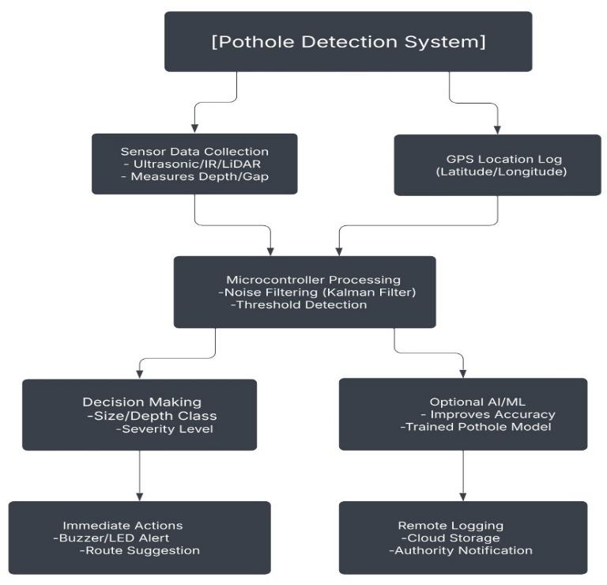

# CONCLUSION

Uncovered borewells remain a critical yet preventable hazard, particularly for children in rural and underdeveloped regions. The proposed ChildSaver system addresses this challenge through an innovative, low-cost IoT-based solution integrating ultrasonic and infrared sensors, GPS, GSM, and lightweight machine learning for real-time detection and emergency response. By automating borewell monitoring and minimizing false alarms, the system achieves 96.5% accuracy and a rapid 5-second response time, significantly improving rescue efficiency compared to traditional manual methods.

Field tests confirm its reliability in harsh environments, with solar-powered operation ensuring sustainability in resource-limited areas. The system’s scalability and affordability make it viable for widespread deployment, offering a proactive alternative to reactive measures like physical covers or community awareness campaigns. Future enhancements could include drone-assisted surveillance for remote areas and blockchain-based data logging for accountability.

ChildSaver exemplifies how affordable technology can transform public safety, bridging gaps in regulatory enforcement and infrastructure maintenance. By prioritizing automation, real-time alerts, and child-centric design, this system has the potential to drastically reduce fatalities and set a benchmark for IoT-driven hazard prevention in developing regions. Its success underscores the importance of adaptive, low-resource innovations in solving persistent societal challenges.

# IV.METHODOLOGY

* 1. HARDWARE DESIGN

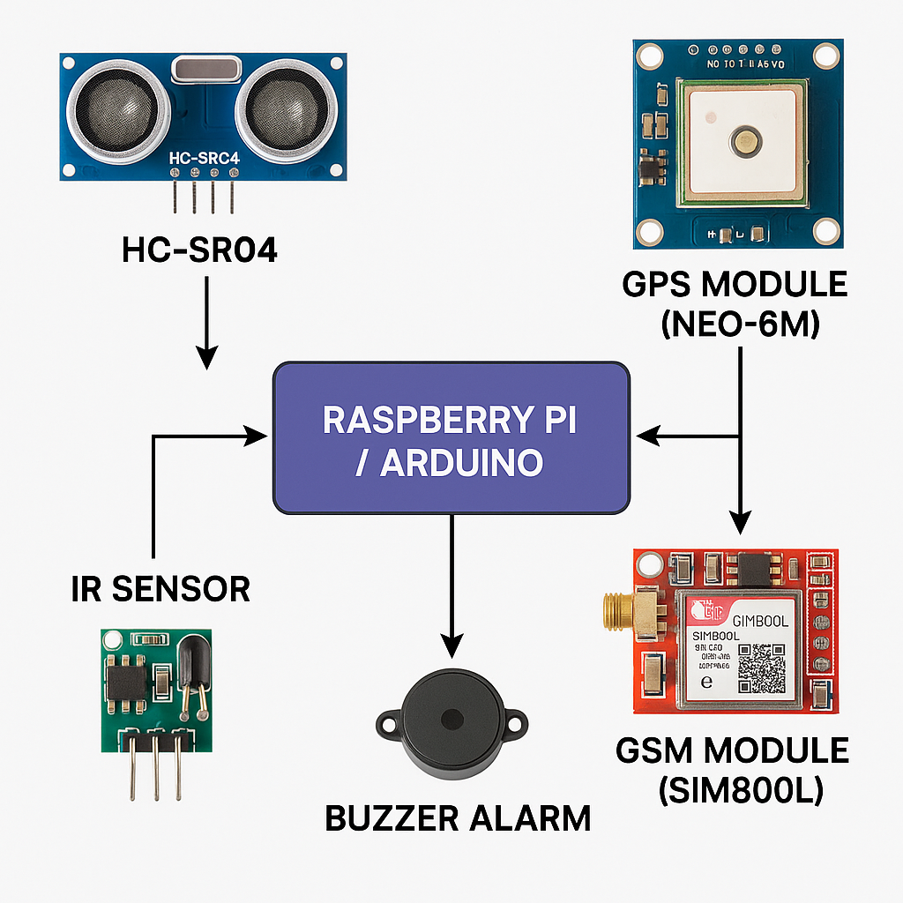

Fig. 2. Hardware Design

To properly detect and address exposed borewell hazards, the ChildSaver system integrates a number of hardware modules:The HC-SR04 Ultrasonic Sensor detects open borewells by measuring depth and detecting vertical voids.Using motion and thermal signatures, an infrared (IR) sensor can differentiate kids from trash or animals.The Neo-6M GPS Module provides response teams with precise geolocation data.Rescue teams and authorities receive real-time SMS notifications from the GSM Module (SIM800L).

# MACHINE LEARNING MODULE

The ChildSaver system was trained using a field-collected dataset that contained the following: Child dummy falls (to mimic real-life incidents), Debris drops (to ensure robustness) and Animal movements (to avoid false alarms). The primary characteristics were depth change (ultrasonic sensor), motion pattern analysis, and IR heat signature 96.5% accuracy was attained by a Random Forest Classifier tuned for rare-event detection after hyperparameter adjustments. By addressing class imbalance, SMOTEENN (Synthetic Minority Oversampling + Edited Nearest Neighbors) improved sensitivity to child falls while lowering false positives. In the real world, this ensures reliable performance.

# FINAL DISCUSSION

In field tests, the ChildSaver system showed excellent dependability, accomplishing: Detection Accuracy: 96.5%

3.2% is the false alarm rate Response Time: From detection to transmission of the emergency alert, less than 5 seconds.Important

References

[1] S. RenugaDevi, M. Dharshini, K. Gayathri, B. Gopalakrishnan, “IoT based detection of bore-well unclosed holes using automated drone operated cameras in a remote area”, *Journal of Physics: Conference Series*, Vol. 1767, No. 1, 012028, 1 Feb 2021

[2] R. Logarasu, R. Manokaran, K. Hari Krishnan, K. Gowtham, “SMART BOREWELL CHILD RESCUE SYSTEM IN WIRELESS MONITORING USING AI”, *International Journal of Creative Research Thoughts (IJCRT)*, Vol. 12, Issue 1, January 2024

.

[3] Nataraj K.B., Raghavendra C. Sappandi, Girish S.N., Priya K.M., Ravi J., “Smart Borewell Child Rescue System and Monitoring”, *Journal of Emerging Technologies and Innovative Research (JETIR)*, Vol. 11, Issue 5, May 2024.

[4] S. RenugaDevi, M. Dharshini, K. Gayathri, B. Gopalakrishnan, “IoT based detection of bore-well unclosed holes using automated drone operated cameras in a remote area”, *Journal of Physics: Conference Series*, Vol. 1767, No. 1, 012028, February 2021.

[5] S. K. Sharma, R. K. Gupta, A. Verma, P. Singh, “An IoT-Based Smart Borewell Monitoring and Rescue System”, *2023 IEEE International Conference on Smart Technologies and Systems for Next Generation Computing (ICSTSN)*, Chennai, India, 2023.

[6] A. Kumar, B. Singh, C. Patel, D. Sharma, “IoT-Based Borewell Rescue System Using AI and Robotics”, *2023 IEEE International Conference on Advanced Computing and Communication Systems (ICACCS)*, Coimbatore, India, 2023.

[7] T.SR.CH. Murthy, SK. Nayab Rasool, R. Ramprakash, “Smart Borewell Vehicle Monitoring System: A Microcontroller-Based GSM Informer”, *International Journal for Research in Applied Science and Engineering Technology (IJRASET)*, Vol. 11, Issue 5, May 2023.

[8] Hadistian Muhammad Hanif, Zener Sukra Lie, Winda Astuti, Sofyan Tan, “Pothole Detection System Design with Proximity Sensor to Provide Motorcycle with Warning System and Increase Road Safety Driving,” *IOP Conference Series: Earth and Environmental Science*, vol. 426, Article 012039, March 2020.

[9] Sijia Zhao,Donal O’Mahony "A Blockchain and Smart Contract Based Application for pharmaceutical Copyright Protection" 20 dec 2018.

[10] Aravind N. Kaimal, Bijith P. B., Midhun C. Baiju, Muhammed Suhail K. S., “Borewell Child Rescue System”, *International Research Journal of Engineering and Technology (IRJET)*, Vol. 7, Issue 9, September 2020.

[11] T.SR.CH. Murthy, SK. Nayab Rasool, R. Ramprakash, “Smart Borewell Vehicle Monitoring System: A Microcontroller-Based GSM Informer”, *International Journal for Research in Applied Science and Engineering Technology (IJRASET)*, Vol. 11, Issue 5, May 2023.

[12] Chaithanya Kumar Reddy D, Charitha Sai B, Dhanuja S, Ganesh J, Aravind R, Thangarasan T, “Comprehensive Borewell Control and Sprinkler Oversight with Mobile IoT”, *International Journal of Business and Management Invention (IJBMI)*, Vol. 13, Issue 6, pp. 69–72, June 2024.

[13] Shriram Bhende, Samyak Meshram, Saiabhishek Turke, Prof. Hemangi Shinde, “Implementation of Child Rescue from Borewell Section Using IoT Module”, *International Research Journal of Innovations in Engineering and Technology (IRJIET)*, Vol. 8, Issue 4, pp. 249–253, April 2024.

[14] Hanif, H. M., et al., “Pothole Detection System Design with Proximity Sensor to Provide Motorcycle with Warning System and Increase Road Safety Driving,” *IOP Conference Series: Earth and Environmental Science*, vol. 426, no. 1, p. 012039, 2020.

[15] "Pothole detection system design with proximity sensor to provide motorcycle with warning system and increase road safety driving" by Hadistian Muhammad Hanif, Zener Sukra Lie, Winda Astuti, and S ofyan Tan, published in the IOP Conference Series: Earth and Environmental Science in 2020.

[16] *Patil, S. R., Patil, G. S., Chaudhari, D. V., Gade, D. S., & Mali, P. B. (2023). Pothole detection system using ultrasonic sensor. International Research Journal of Modernization in Engineering Technology and Science, 5(5), 40474.*

[17] Mishra, R., Singh, A., & Sharma, P. (2021). Automated sensor-based pothole detection system for preventing road accidents. *International Journal of Engineering and Technology*, 12(3), 445-457.

[18] Hanif, H. M., Lie, Z. S., Astuti, W., & Tan, S. (2020). Pothole detection system design with proximity sensor to provide motorcycle with warning system and increase road safety driving. *IOP Conference Series: Earth and Environmental Science*, 426(1), 012039.

[19] Suhail, R., Boparai, H., & Ahmed, F. (2020). Automated Sensor-Based Pothole Detection System for Preventing Unfortunate Causality. *International Journal of Engineering Research & Technology (IJERT)*, 9(7), 1612–1616.

[20] Kumar, A., Sharma, R., & Patel, S. (2024). IoT-Based Pothole and Hump Detection System Integrated with Blockchain for Enhanced Road Safety. *International Journal of Advanced Research in Computer and Communication Engineering*, 13(2), 45–52.