Name : Anjali

Superset ID :6365319

Week 3

**LAB 1: Understanding ORM with a Retail Inventory System**

**CODE**

Program.cs

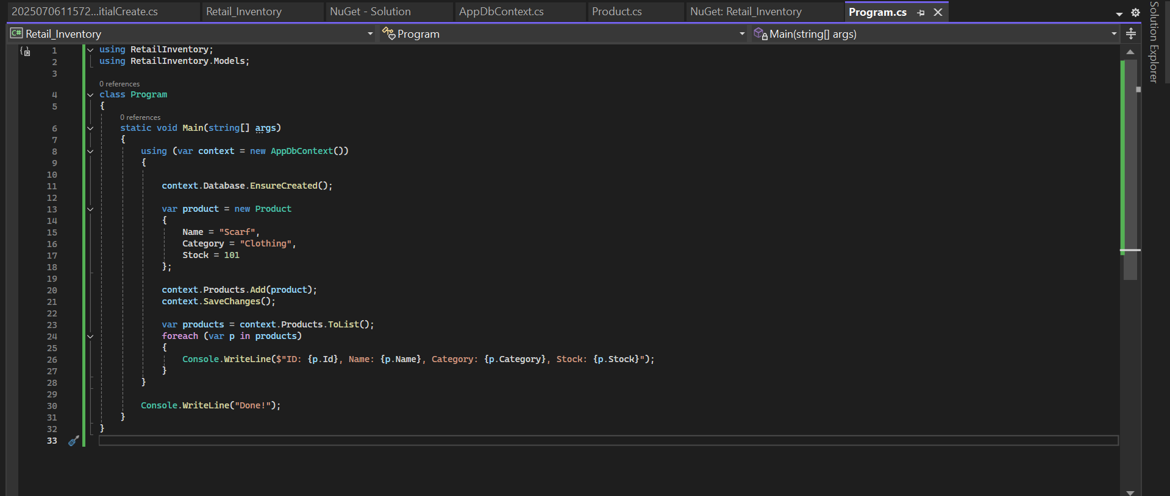

Product.cs

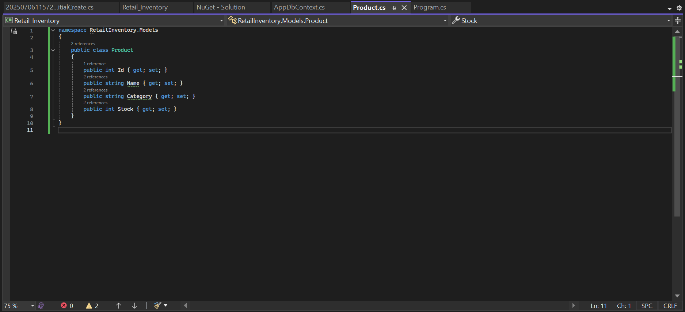

AppDbContext.cs

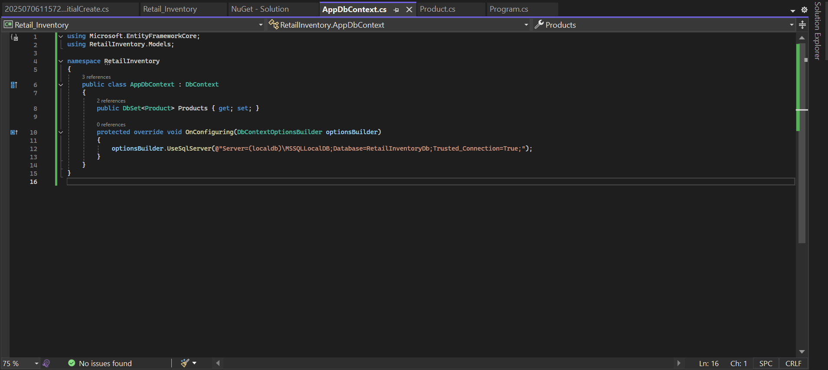

**OUTPUT**

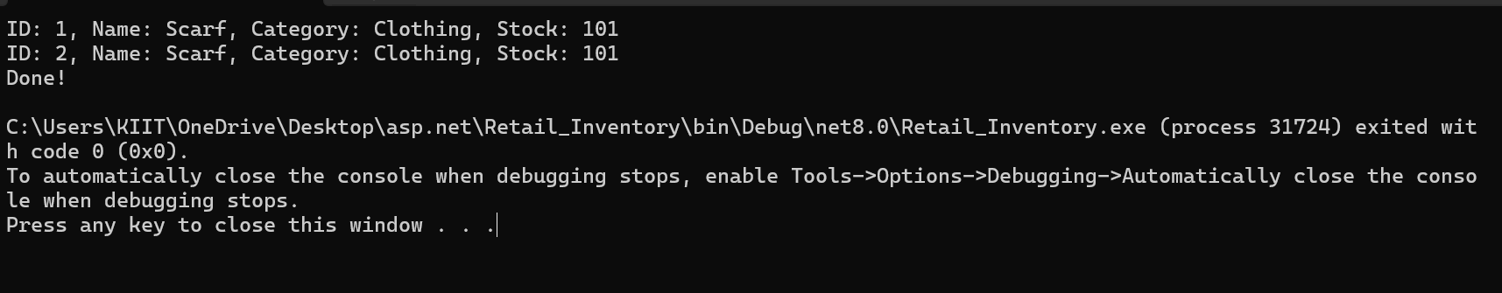

**Lab 2:**

**Setting Up the Database Context for a Retail Store**

**CODE**

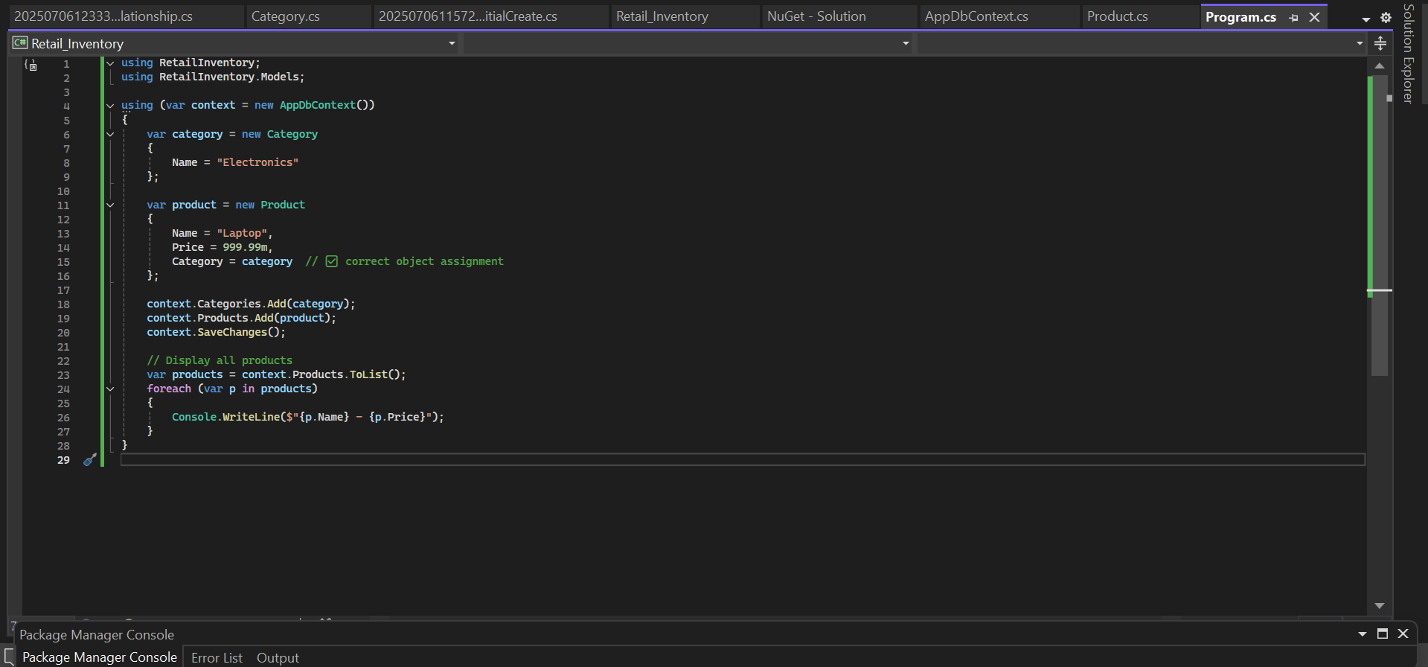

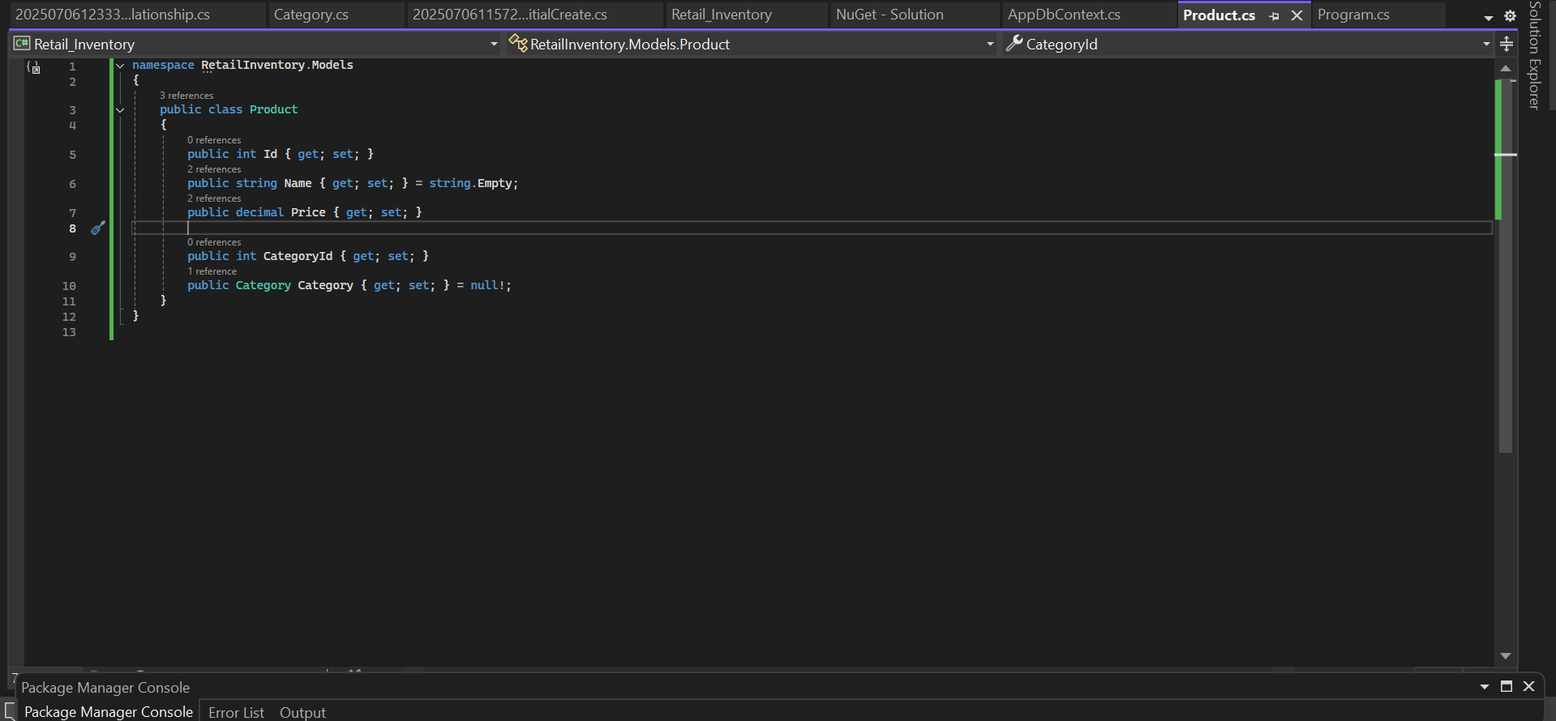

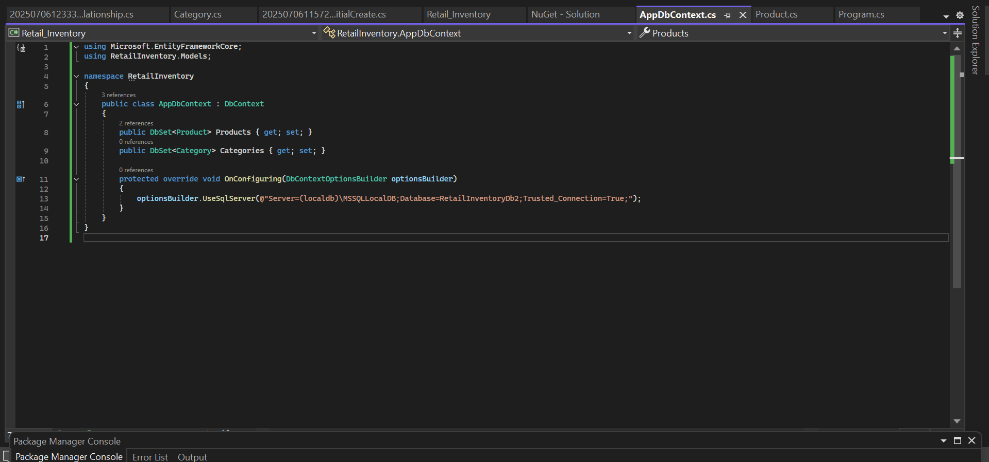

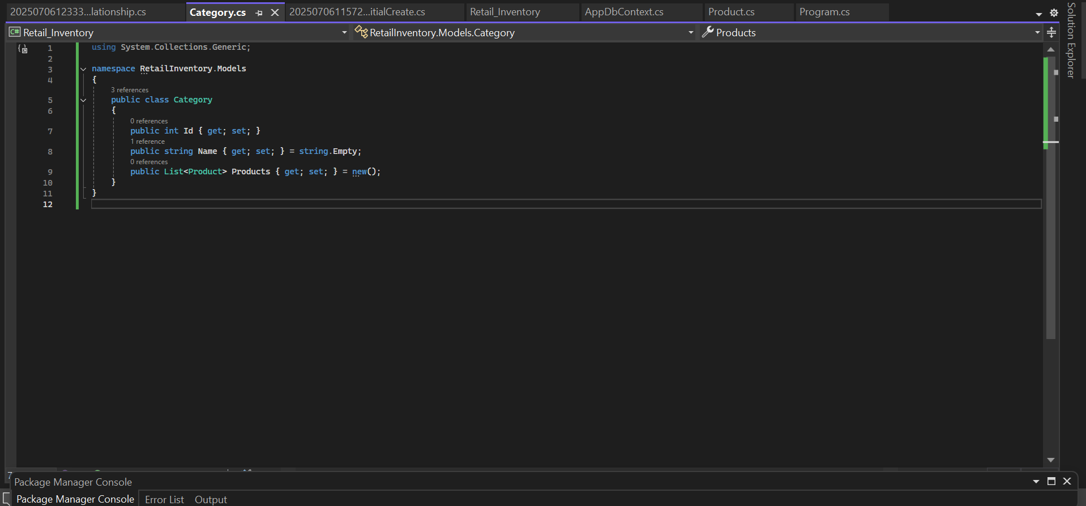

**OUTPUT**

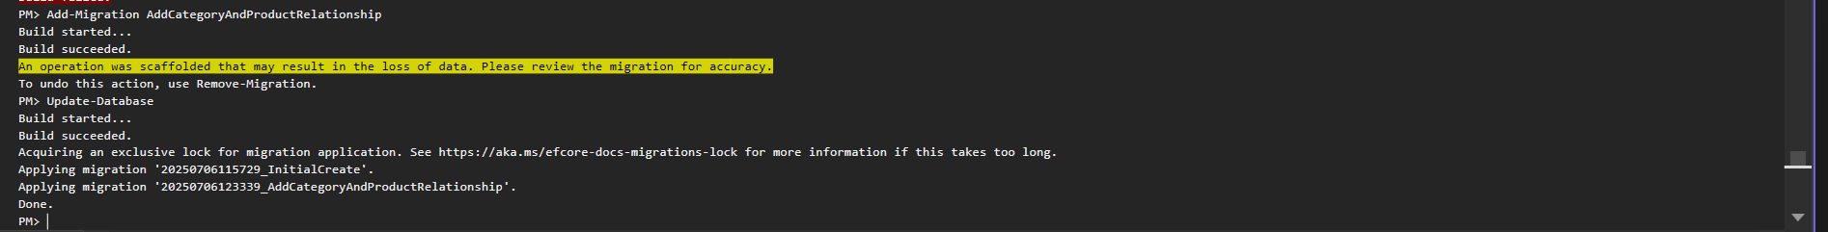

**Lab 3: Using EF Core CLI to Create and Apply Migrations**

**CODE**

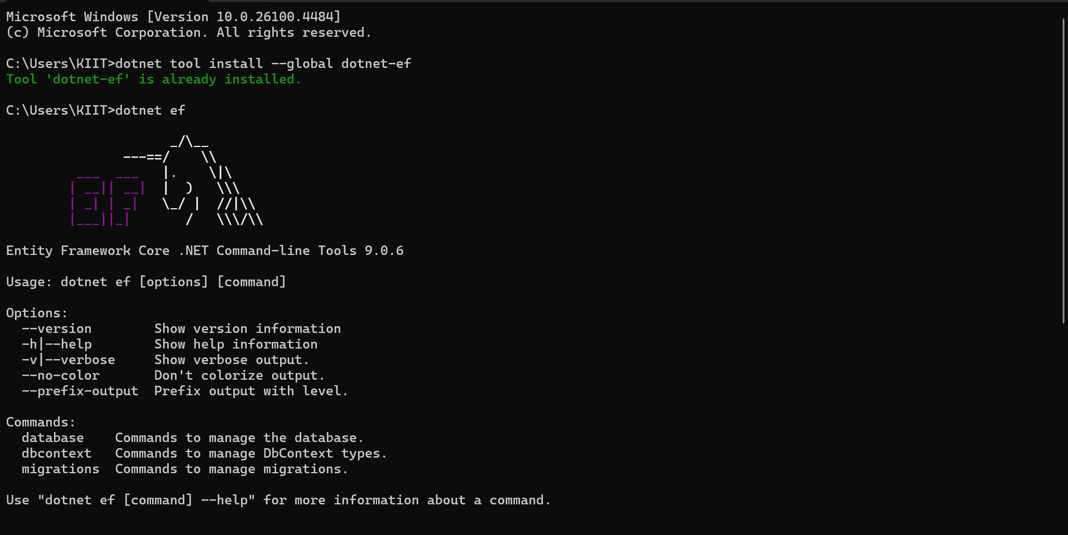

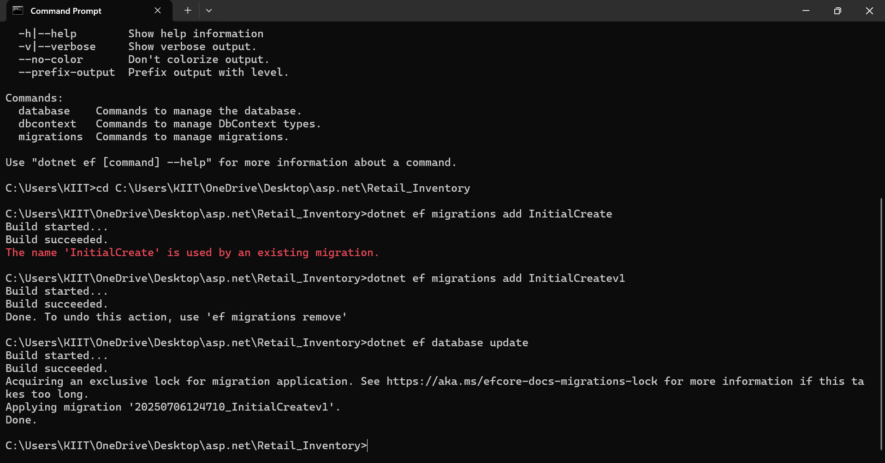

**OUTPUT**

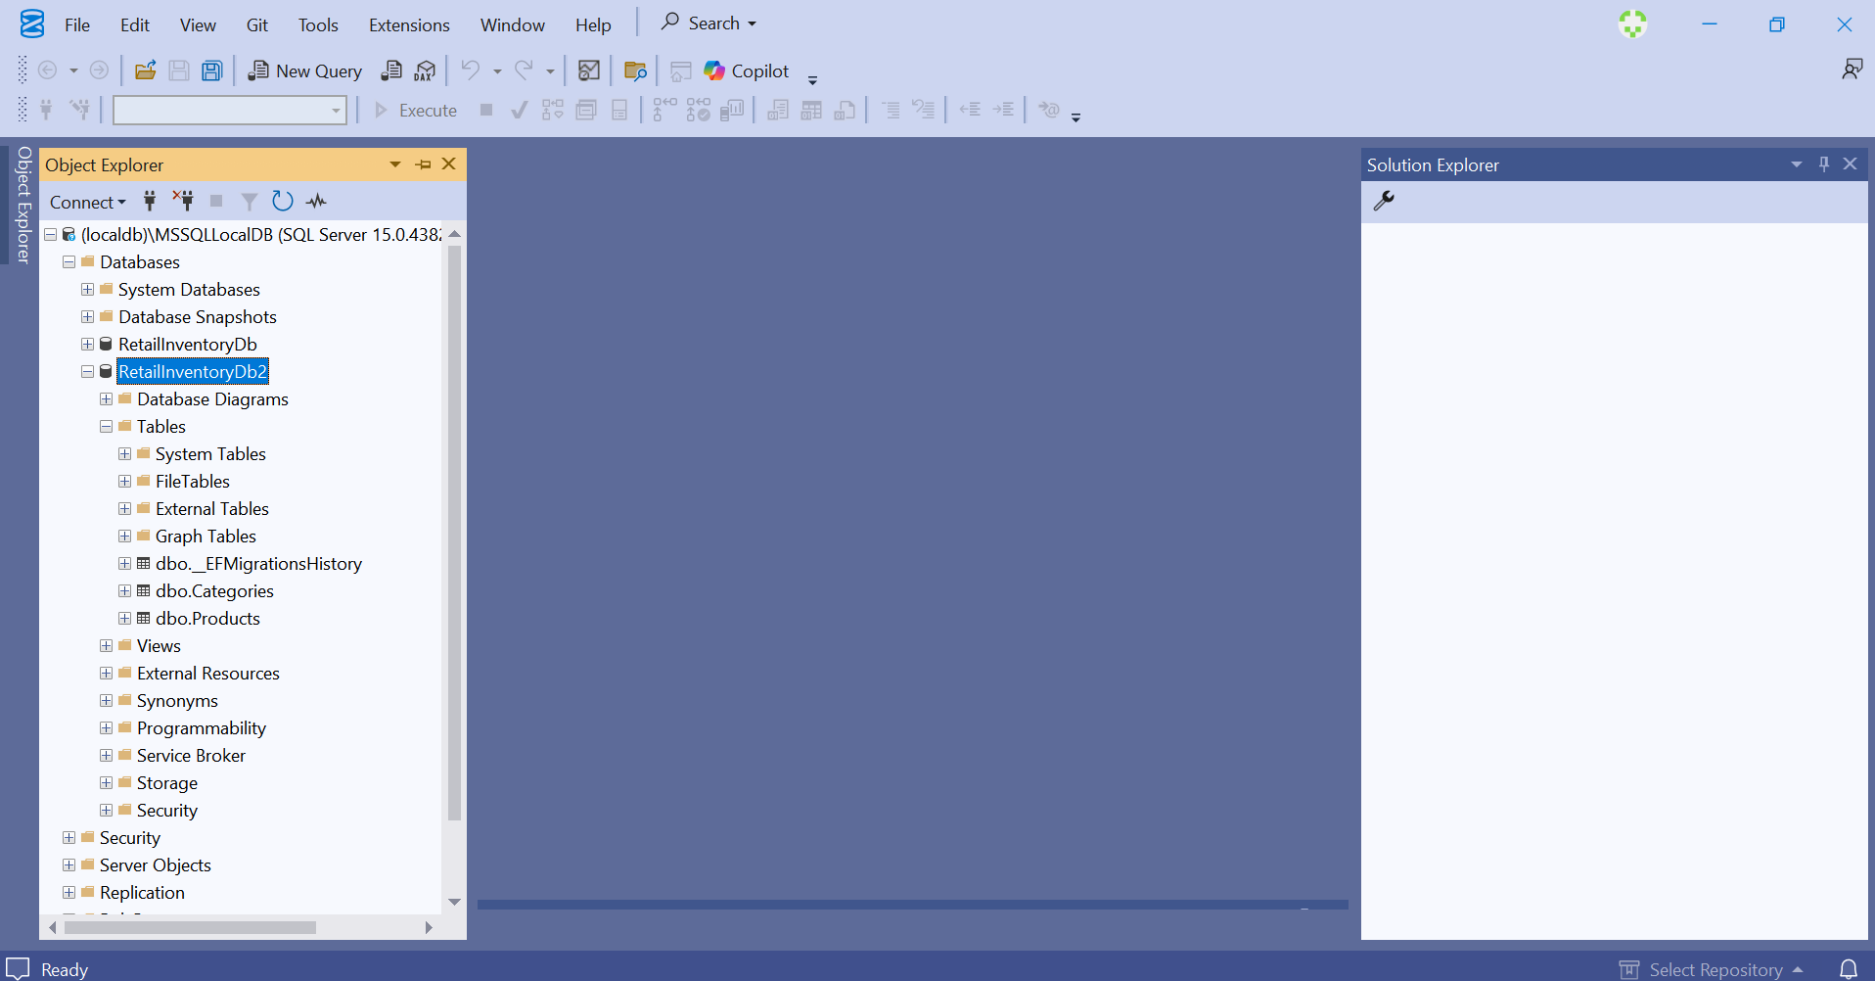

**Lab 4: Inserting Initial Data into the Database**

**CODE**

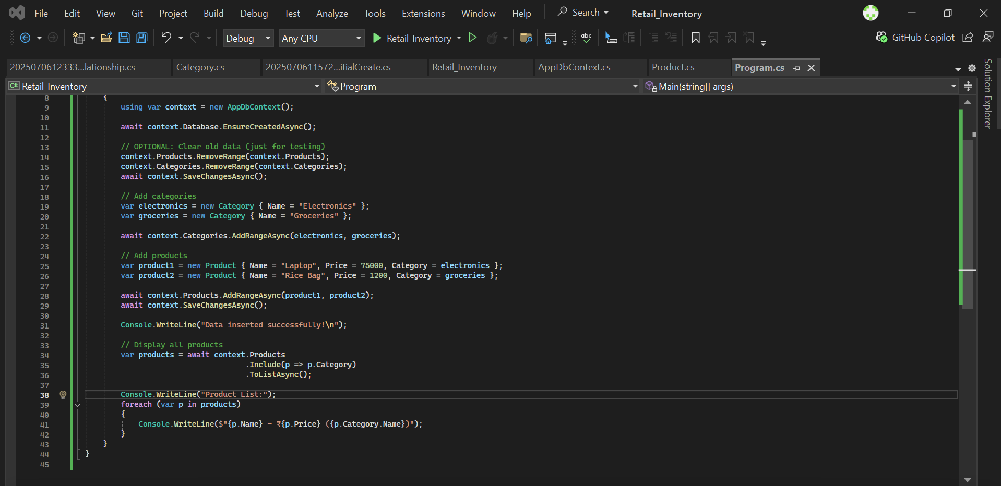

**OUTPUT**

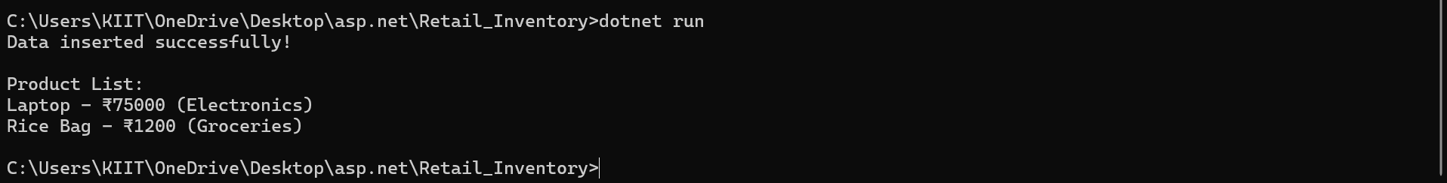

**Lab 5: Retrieving Data from the Database**

**CODE**

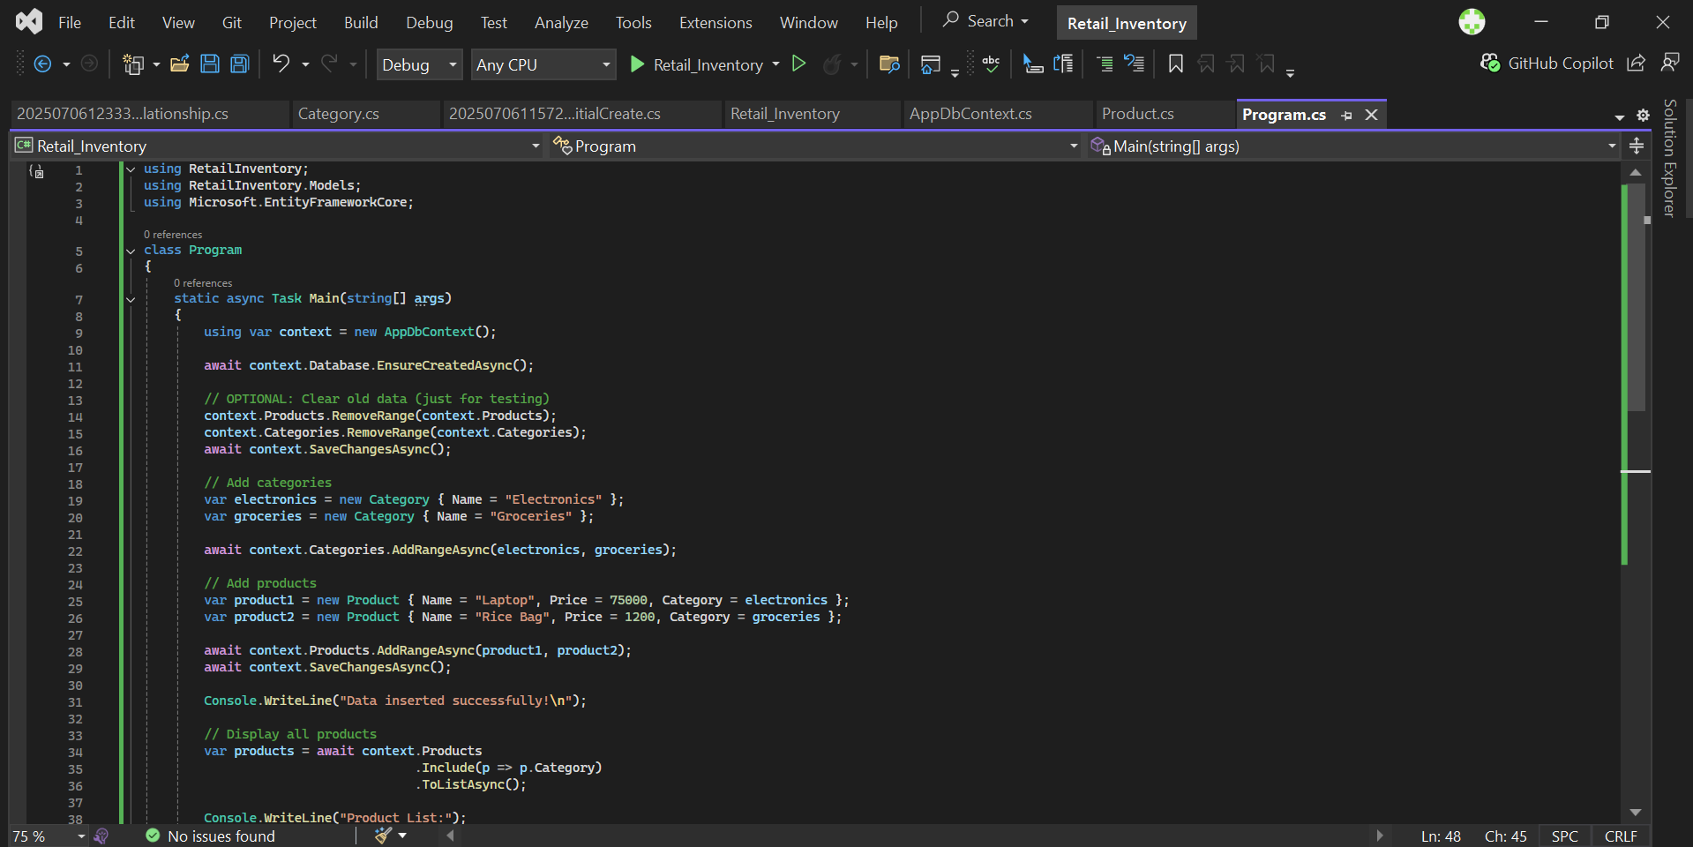

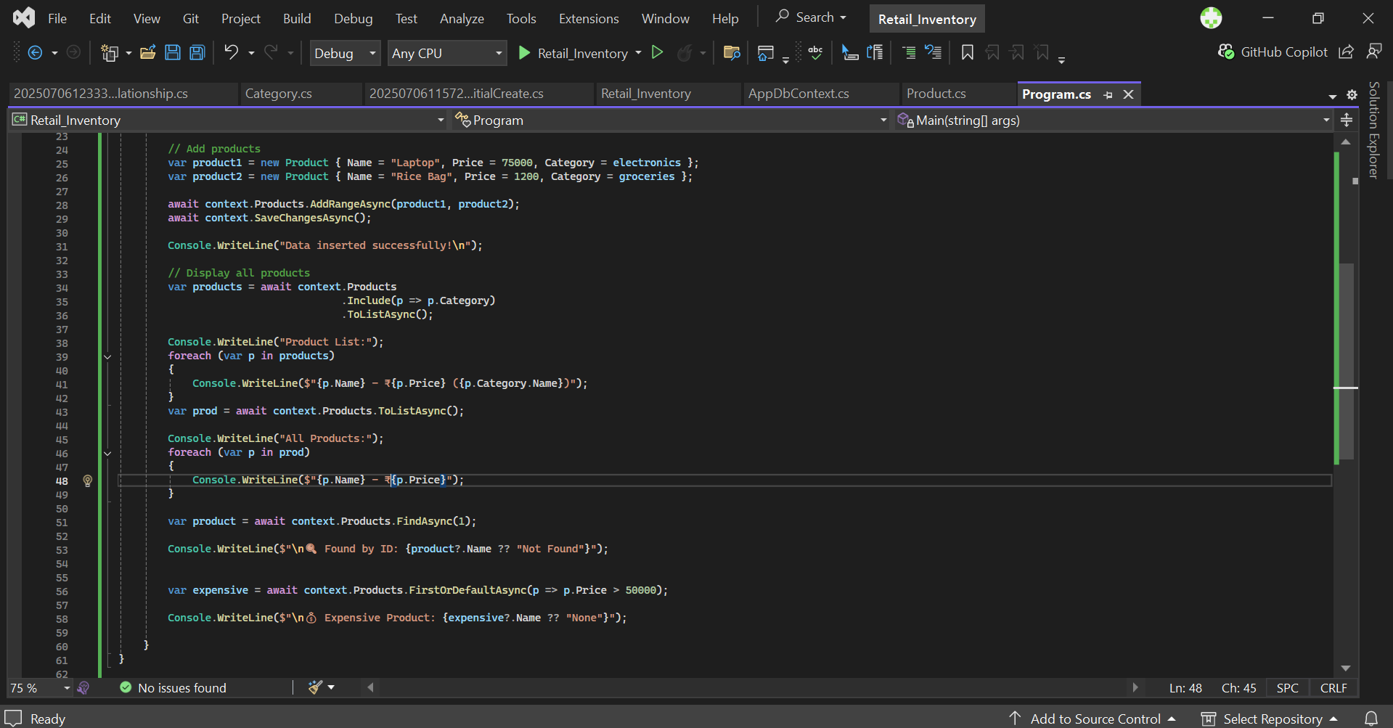

**OUTPUT**

