**Practical 2**

|  |
| --- |
| **Aim:**  **Given a string, return a string made of the first 2 chars (if present), however include first char only if it is 'o' and include the second only if it is 'z', so "ozymandias" yields "oz".**  **startOz("ozymandias") → "oz"**  **startOz("bzoo") → "z"**  **startOz("oxx") → "o"** |

**Code:**

import java.util.*\**;

public class mprac2 {

//lazy functions

public static *void* prints(*String* *str*) {

System.out.println(str);

}

public static *void* printId() {

prints("\nID:18DCS129 \nNAME:MADHAV ");

}

public static *void* main(*String*[] *args*) {

*Scanner* scan = **new** Scanner(System.in);

prints("Enter a string : ");

*String* str = scan.nextLine();

scan.close();

if (str.charAt(0) == 'o' && str.charAt(1) == 'z')

prints("oz");

else if (str.charAt(0) == 'o')

prints("o");

else if (str.charAt(1) == 'z')

prints("z");

printId();

}

}

**Output:**

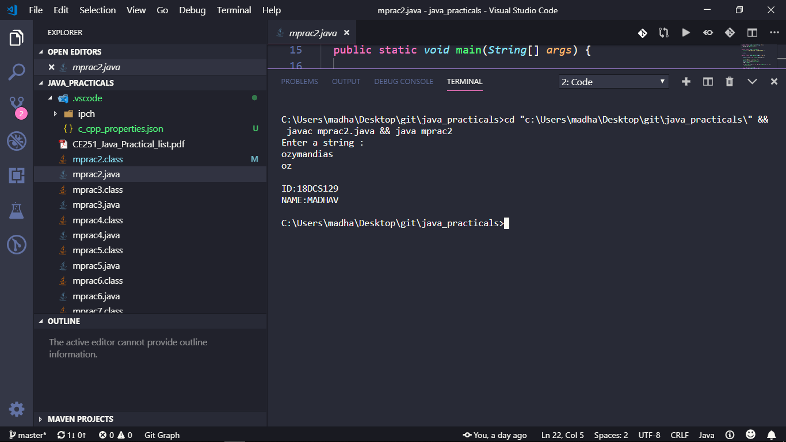

**Practical 3**

**Aim:**

|  |
| --- |
| **Given two non-negative int values, return true if they have the same last digit, such as with 27 and 57. Note that the % "mod" operator computes remainders, so 17 % 10 is 7.**  **lastDigit(7, 17) → true**  **lastDigit(6, 17) → false**  **lastDigit(3, 113) → true** |

**Code:**

import java.util.*\**;

public class mprac3 {

// function to check if the lastDigit are same or not

public static *boolean* lastDigit(*int* *a*, *int* *b*) {

b %= 10;

a %= 10;

return (a == b);

// returns true if a==b;

}

//lazy functions

public static *void* prints(*String* *str*) {

System.out.println(str);

}

public static *void* printn(*int* *num*) {

System.out.println(num);

}

public static *void* printId() {

prints("\nID:18DCS129 \nNAME:MADHAV ");

}

public static *void* main(*String*[] *args*) {

*Scanner* scan = **new** Scanner(System.in);

prints("Enter two numbers to check if their last digits are same or not :");

// taking inputs from user

*int* a = scan.nextInt();

*int* b = scan.nextInt();

scan.close();

if (lastDigit(a, b))// if function returns true

prints("true");

else

prints("false");

printId();

}

}

**Output:**

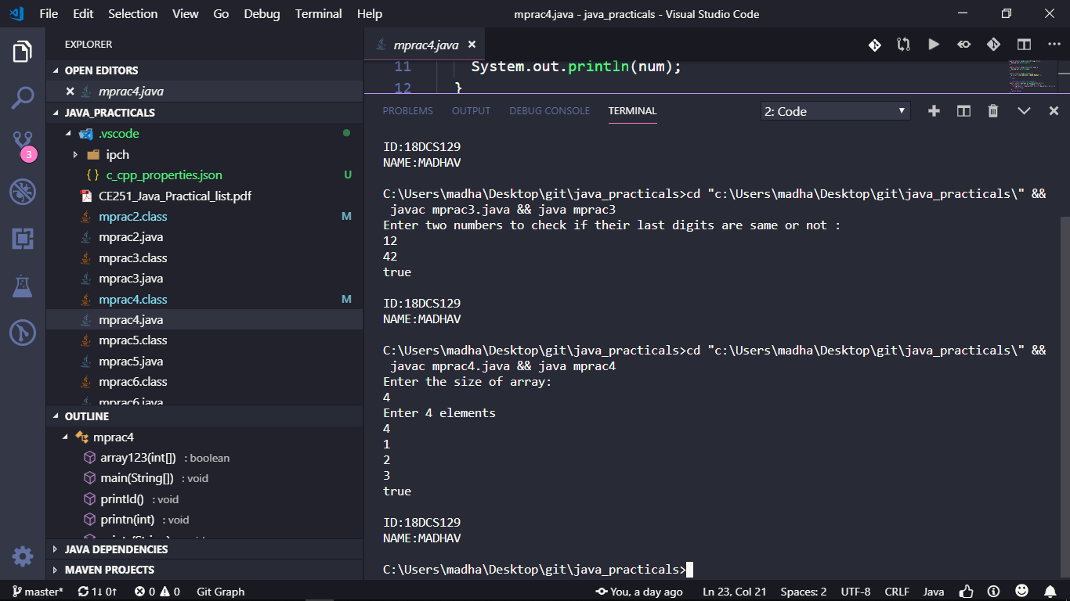

**PRACTICAL 4**

**Aim:**

|  |
| --- |
| **Given an array of ints, return true if the sequence of numbers 1, 2, 3 appears in the array somewhere.**  **array123([1, 1, 2, 3, 1]) → true**  **array123([1, 1, 2, 4, 1]) → false**  **array123([1, 1, 2, 1, 2, 3]) → true** |

**Code:**

import java.util.*\**;

public class mprac4 {

//lazy functions

public static *void* prints(*String* *str*) {

System.out.println(str);

}

public static *void* printn(*int* *num*) {

System.out.println(num);

}

public static *void* printId() {

prints("\nID:18DCS129 \nNAME:MADHAV ");

}

// function to check the sequence

public static *boolean* array123(*int*[] *arr*) {

for (*int* i = 0; i < arr.length; ++i) {

if (arr[i] == 1 && arr[i + 1] == 2 && arr[i + 2] == 3)

return true;

}

return false;

}

public static *void* main(*String*[] *args*) {

*Scanner* scan = **new** Scanner(System.in);

prints("Enter the size of array:");

*int* n = scan.nextInt();

prints("Enter " + n + " elements");

// dynamic initialization of array

*int*[] arr = **new** *int*[n];

// Scanning n elements

for (*int* i = 0; i < n; ++i)

arr[i] = scan.nextInt();

scan.close();

// prints true if sequence found

if (array123(arr))

prints("true");

else

prints("false");

printId();

}

}

**Output:**



**Practical 5**

**Aim:**

|  |
| --- |
| **Given 2 strings, a and b, return the number of the positions where they contain the same length 2 substring. So "xxcaazz" and "xxbaaz" yields 3, since the "xx", "aa", and "az" substrings appear in the same place in both strings.**  **stringMatch("xxcaazz", "xxbaaz") → 3**  **stringMatch("abc", "abc") → 2**  **stringMatch("abc", "axc") → 0** |

**Code:**

import java.util.*\**;

public class mprac5 {

//lazy functions

public static *void* prints(*String* *str*) {

System.out.println(str);

}

public static *void* printn(*int* *num*) {

System.out.println(num);

}

public static *void* printId() {

prints("\nID:18DCS129 \nNAME:MADHAV ");

}

public static *int* minLength(*String* *s1*, *String* *s2*) {

if (s1.length() < s2.length())

return s1.length();

else

return s2.length();

}

public static *int* stringMatch(*String* *str1*, *String* *str2*) {

*int* count = 0;

for (*int* i = 0; i < minLength(str1, str2) - 1; i++) {

if (str1.charAt(i) == str2.charAt(i) && str1.charAt(i + 1) == str2.charAt(i + 1))

count++;

}

return count;

}

public static *void* main(*String*[] *args*) {

*Scanner* scan = **new** Scanner(System.in);

prints("Enter two strings : ");

*String* str1 = scan.nextLine();

*String* str2 = scan.nextLine();

scan.close();

prints("no. of occourences of substrings are :");

printn(stringMatch(str1, str2));

printId();

}

}

**Output:**

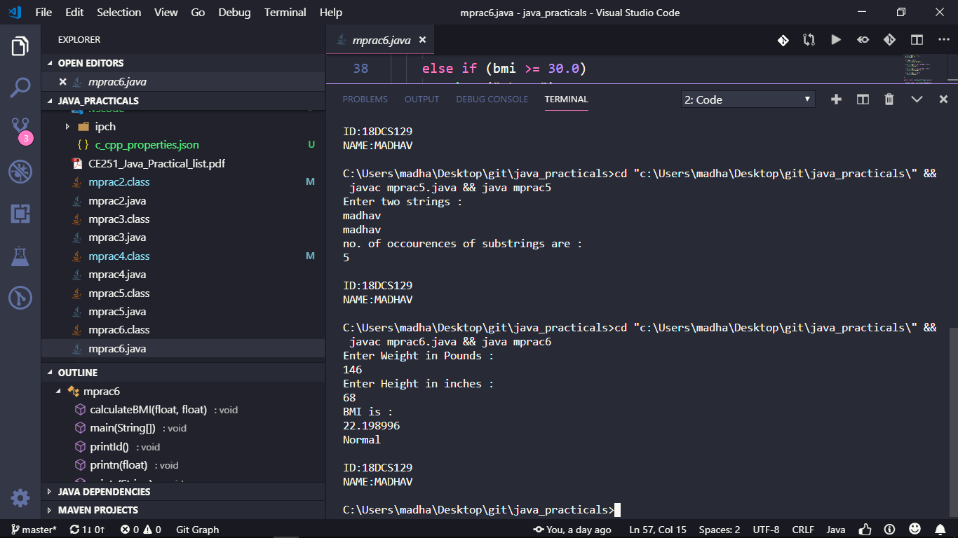

**Practical 6**

**Aim:**

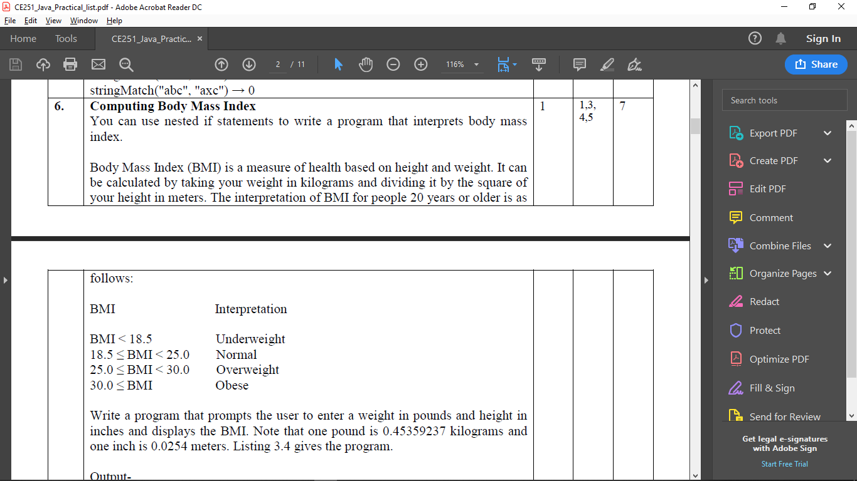

**Code:**

import java.util.*\**;

public class mprac6 {

public static *void* prints(*String* *str*) {

System.out.println(str);

}

public static *void* printn(*float* *num*) {

System.out.println(num);

}

public static *void* printId() {

prints("\nID:18DCS129 \nNAME:MADHAV ");

}

public static *void* calculateBMI(*float* *wt*, *float* *ht*) {

// converting into KGs

wt *= 0.45359237;

// converting into meters

ht *= 0.0254;

*float* bmi = wt / (ht * ht);

prints("BMI is : ");

printn(bmi);

if (bmi < 18.5)

prints("Underweight");

else if (bmi >= 18.5 && bmi < 25.0)

prints("Normal");

else if (bmi >= 25.0 && bmi < 30.0)

prints("Overweight");

else if (bmi >= 30.0)

prints("Obese");

}

public static *void* main(*String*[] *args*) {

*Scanner* scan = **new** Scanner(System.in);

prints("Enter Weight in Pounds : ");

*float* weight = scan.nextFloat();

prints("Enter Height in inches : ");

*float* height = scan.nextFloat();

scan.close();

calculateBMI(weight, height);

printId();

}

}

**Output:**

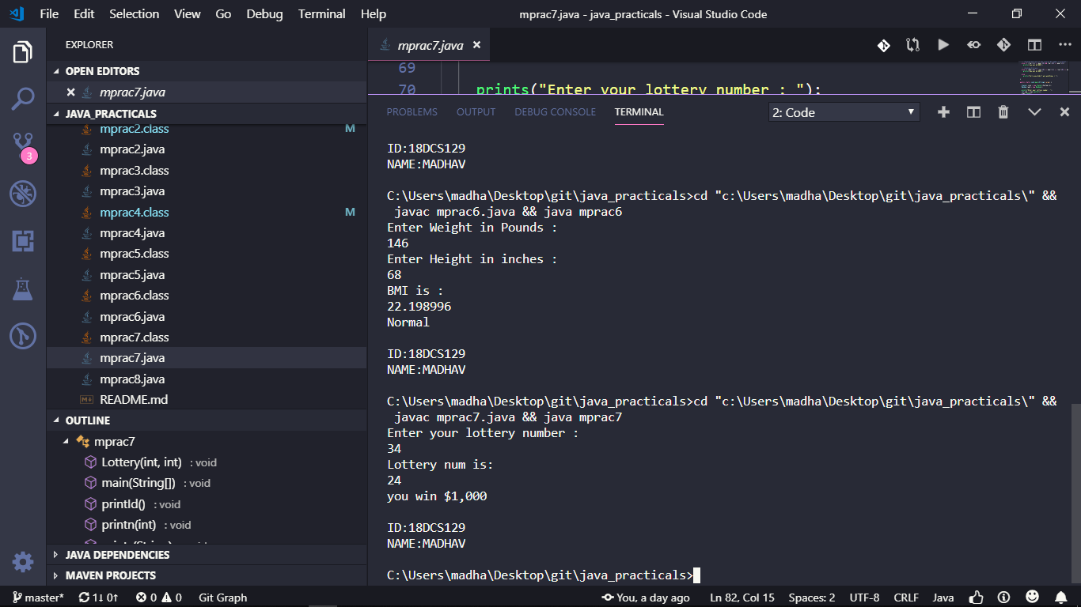

**Practical 7**

**Aim:**

**Lottery**

**The lottery program involves generating random numbers, comparing digits, and using Boolean operators.**

**Suppose you want to develop a program to play lottery. The program randomly generates a lottery of a two-digit number, prompts the user to enter a two-digit number, and determines whether the user wins according to the following rules:**

**1. If the user input matches the lottery number in the exact order, the award is $10,000.**

**2. If all digits in the user input match all digits in the lottery number, the award is $3,000.**

**3. If one digit in the user input matches a digit in the lottery number, the award is $1,000.**

**Note that the digits of a two-digit number may be 0. If a number is less than 10, we assume the number is preceded by a 0 to form a two-digit number. For example, number 8 is treated as 08 and number 0 is treated as 00 in the program. Listing 3.8 gives the complete program.**

**Code:**

import java.util.*\**;

public class mprac7 {

public static *void* prints(*String* *str*) {

System.out.println(str);

}

public static *void* printn(*int* *num*) {

System.out.println(num);

}

public static *void* printId() {

prints("\nID:18DCS129 \nNAME:MADHAV ");

}

// only valid for 2 digit numbers

public static *void* Lottery(*int* *rn*, *int* *myNum*) {

// converting the lottery number into array of two int

*int* rnarr[] = **new** *int*[2];

// capturing 1st digit

rnarr[0] = rn / 10;

// capturing 2nd digit

rnarr[1] = rn % 10;

// converting the my number into array of two int

*int* myarr[] = **new** *int*[2];

myarr[0] = myNum / 10;

myarr[1] = myNum % 10;

prints("Lottery num is:");

printn(rn);

if (rn == myNum)

prints("you win $10,000");

// checking 2nd case if the reverse 0f number is present.

else if (rnarr[1] == myarr[0] && rnarr[0] == myarr[1])

prints("you win $3,000");

// checking 3rd case

else if (myarr[0] == rnarr[0] || myarr[1] == rnarr[0] || myarr[0] == rnarr[1] || myarr[1] == rnarr[1])

prints("you win $1,000");

else

prints("Sorry you didn't win anything :( ");

}

public static *void* main(*String*[] *args*) {

*Scanner* scan = **new** Scanner(System.in);

*Random* rand = **new** Random();

prints("Enter your lottery number : ");

*int* num = scan.nextInt();

scan.close();

// generating inclusive random number

*int* rn = rand.nextInt(num + 1);

if (num < 100)

Lottery(rn, num);

else

prints("invalid number(please enter a two digit number)");

printId();

}

}

**Output:**

