

ASSIGNMENT 1 OF PYTHON

SUBMITTED TO: MR.VARUN MALIK

SUBMITTED BY:

ISHIKA

2210997103 BCA 4B

Questions:

Practical 1 – Simple Introductory Python Programs

1.1 WAP to Calculate Area and Perimeter of a Rectangle

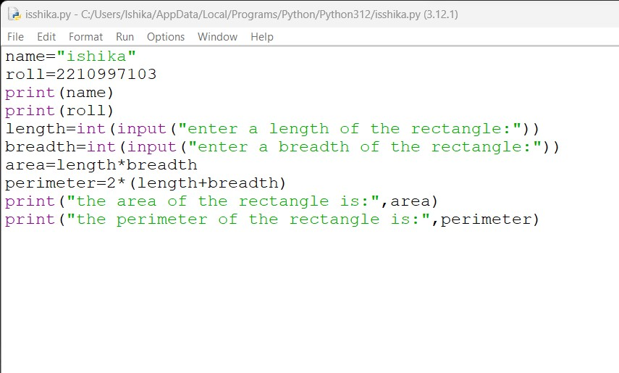

output:

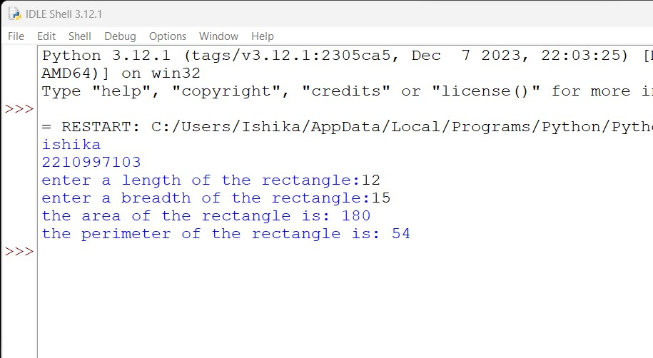

1.2 WAP to calculate Average marks of 3 subjects:

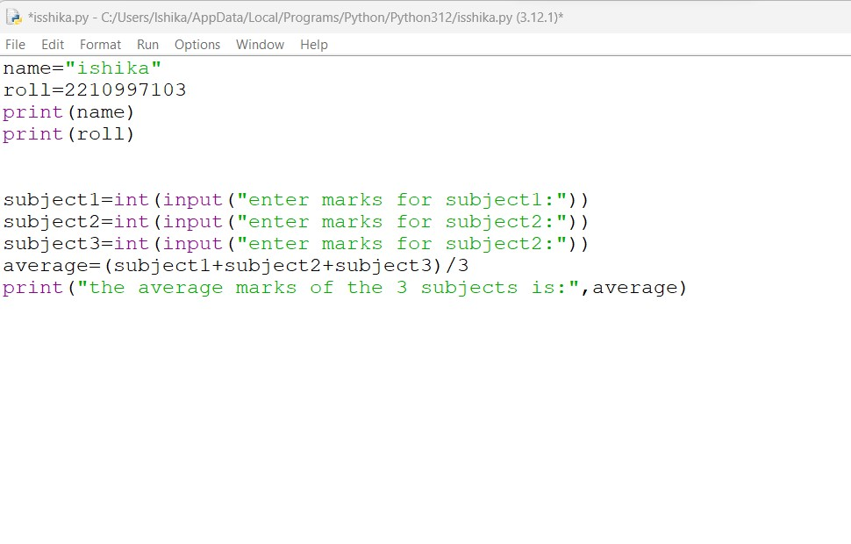

output:

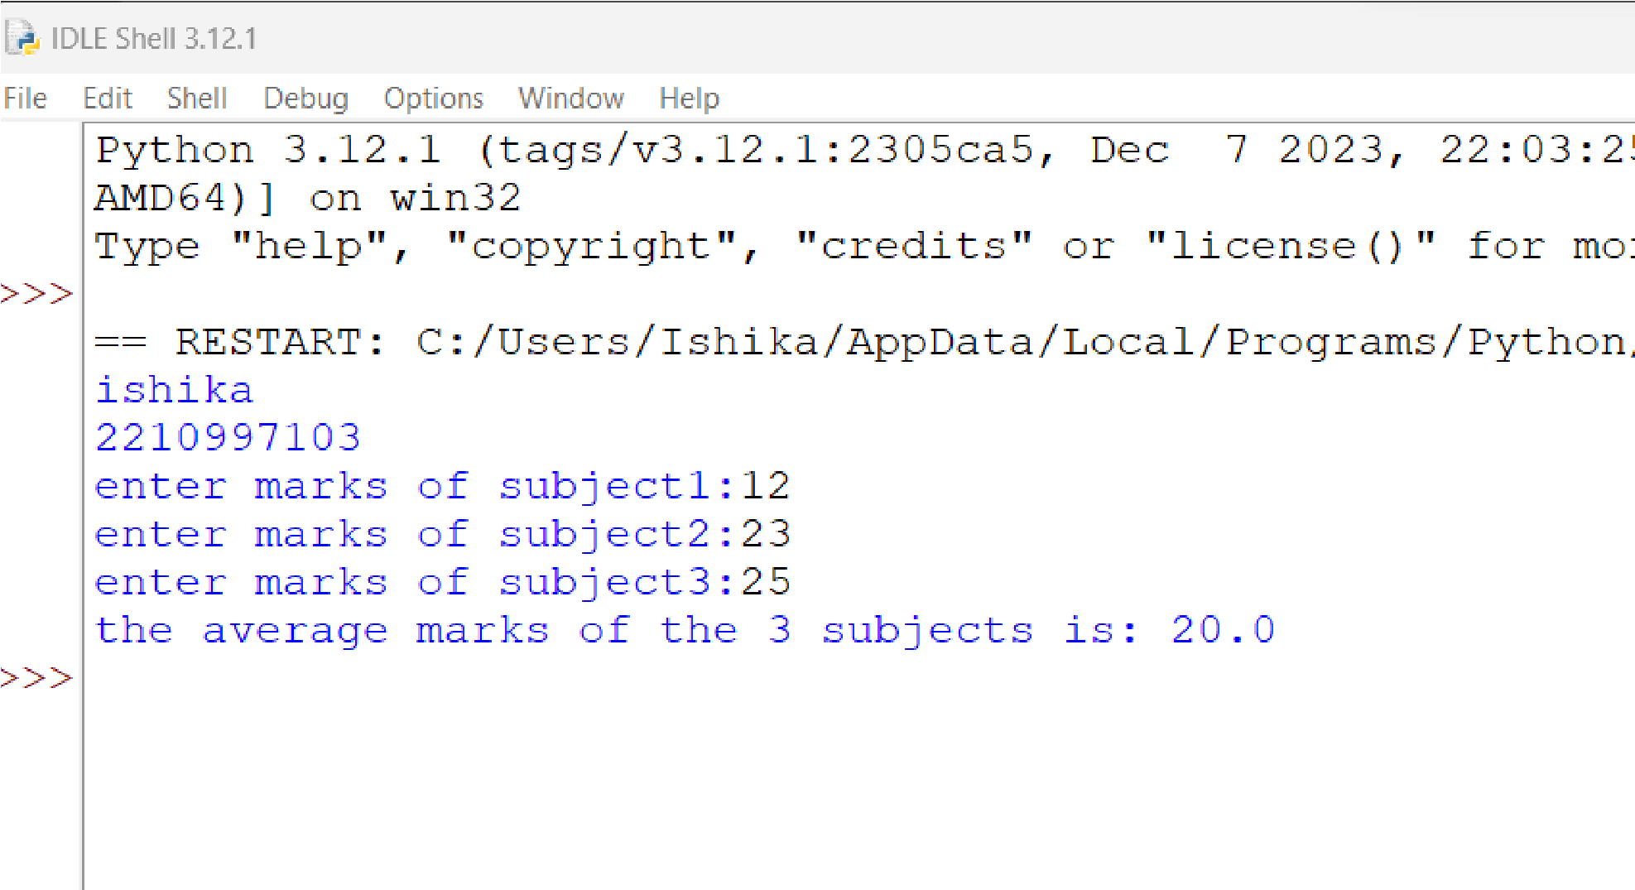

1.3 WAP to compute compound Interest:

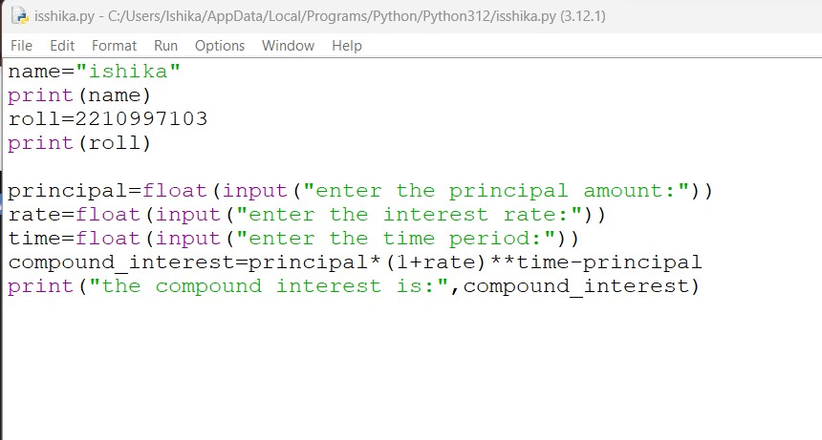

output:

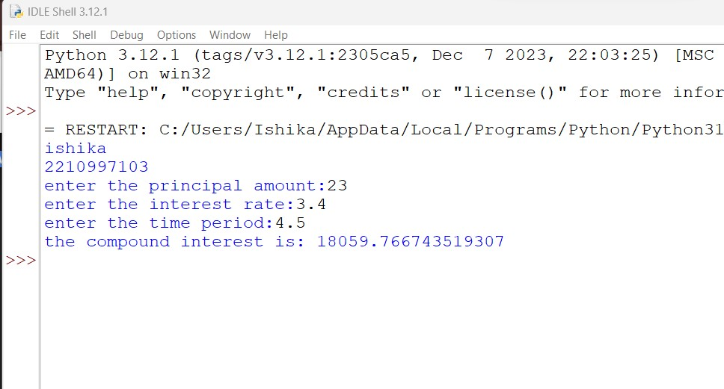

Practical 2 – Working with Strings – basic String Operations

2.1 WAP to demonstrate Slicing Operations in Strings:

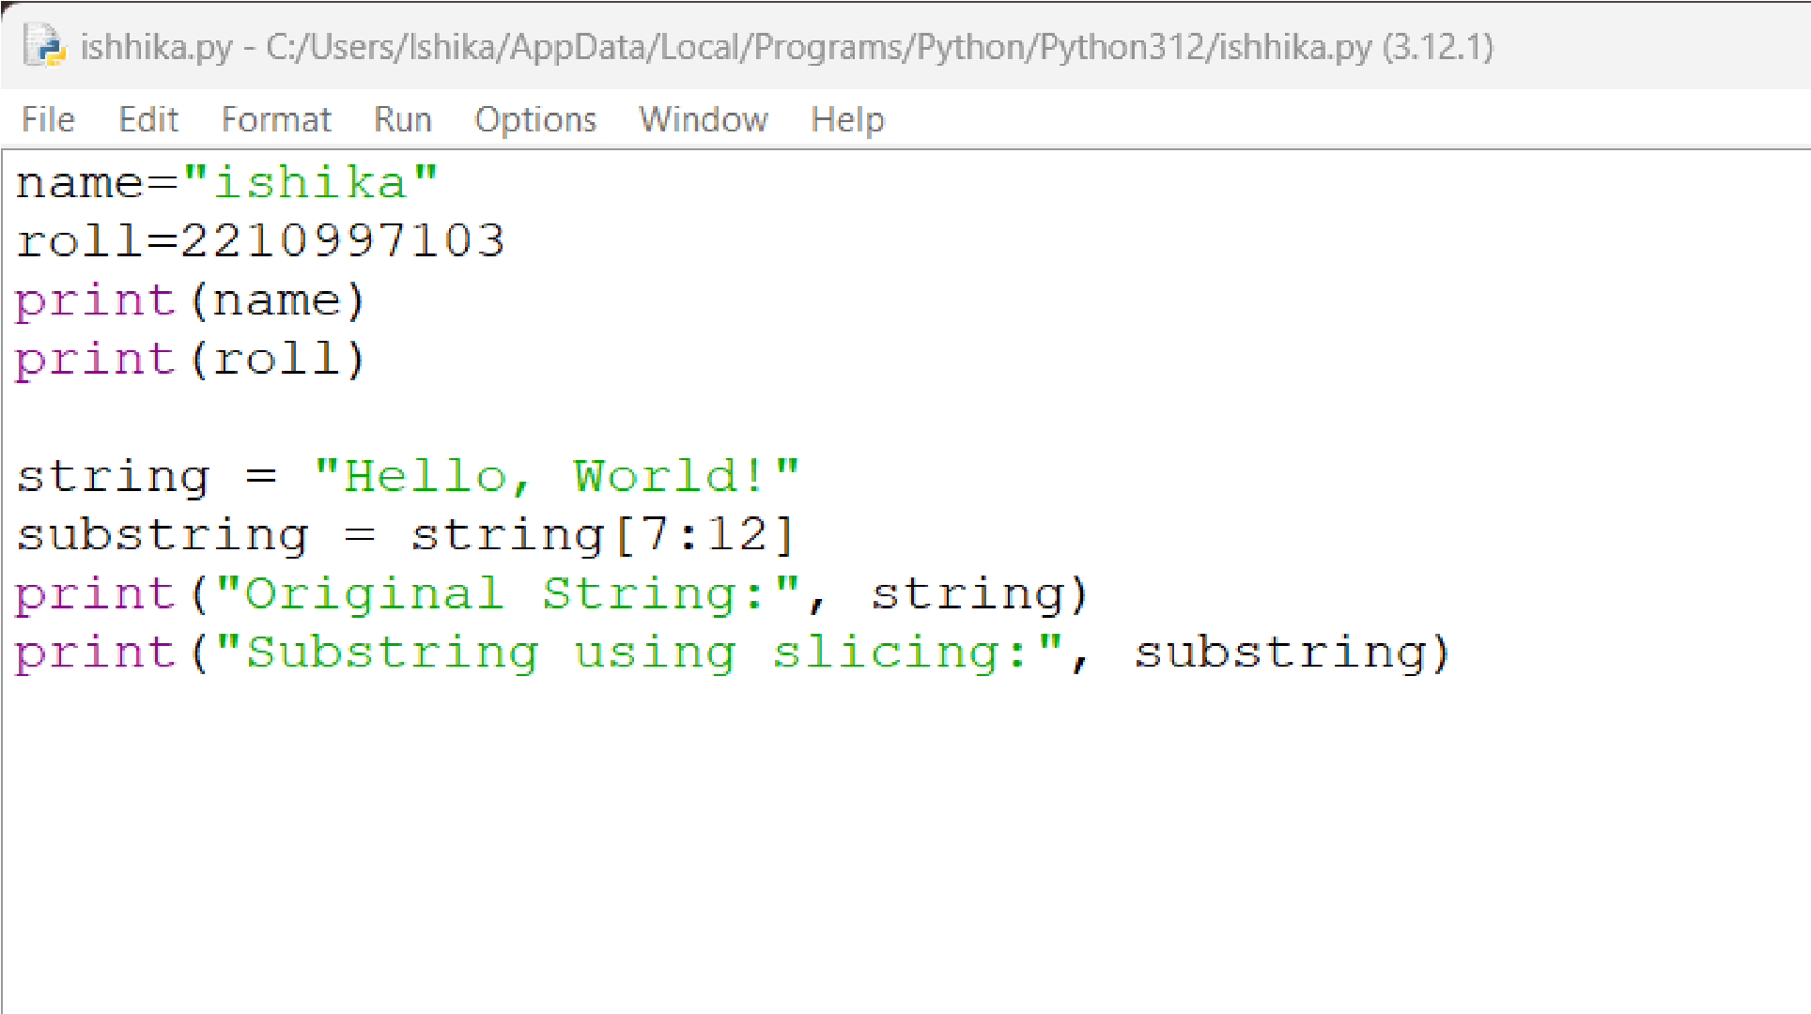

output:

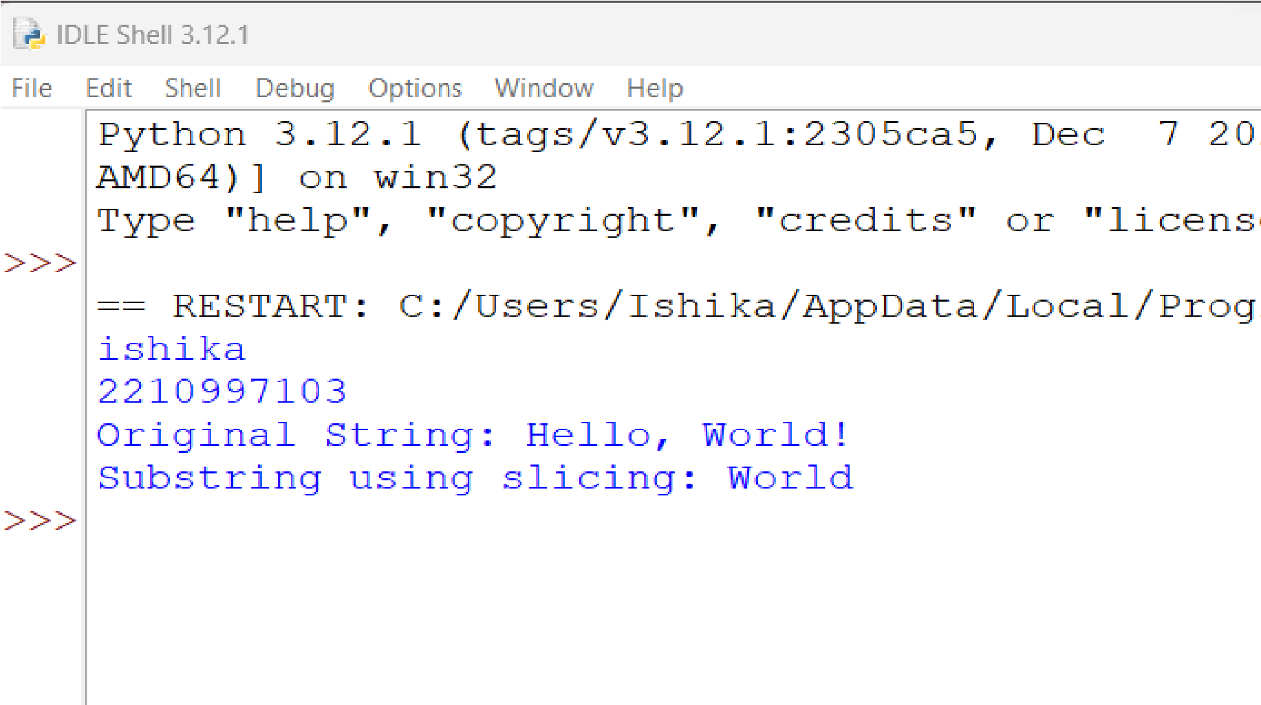

2.2 WAP to demonstrate built-in functions in string

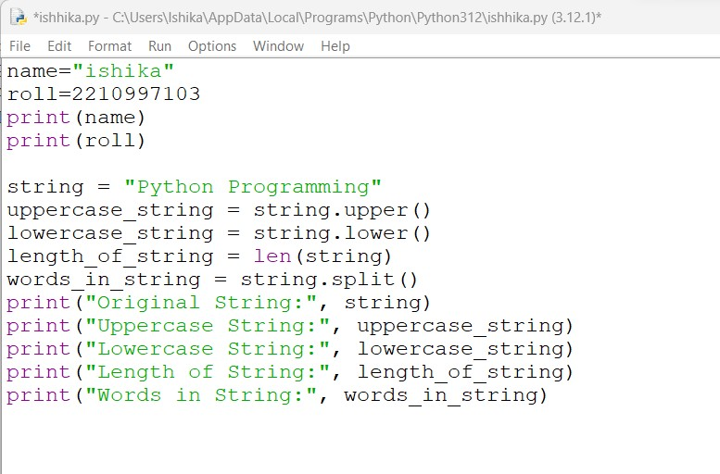

output:

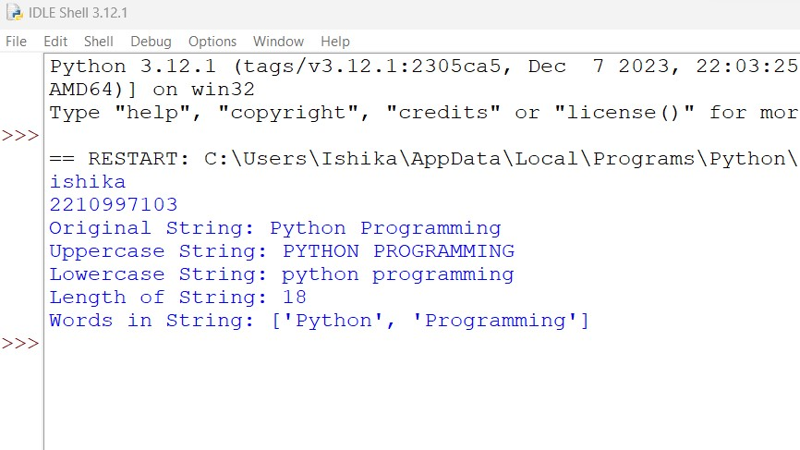

Practical 3 – Conditionals in Python – Decision Control

3.1 WAP to check if one number is divisible by the other or not:

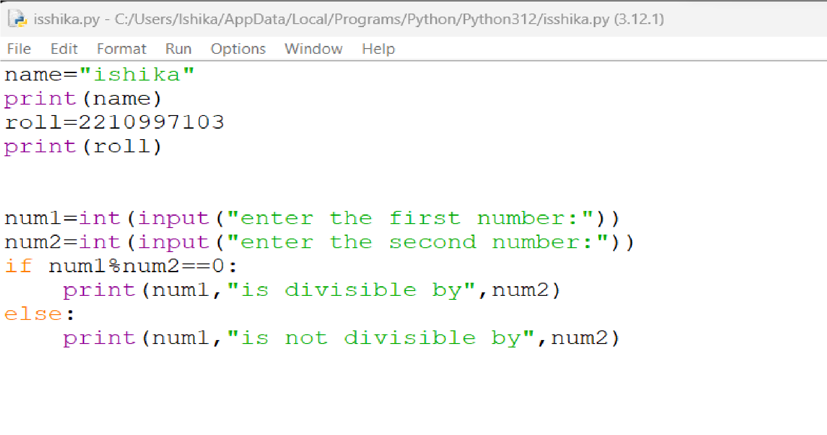

output:

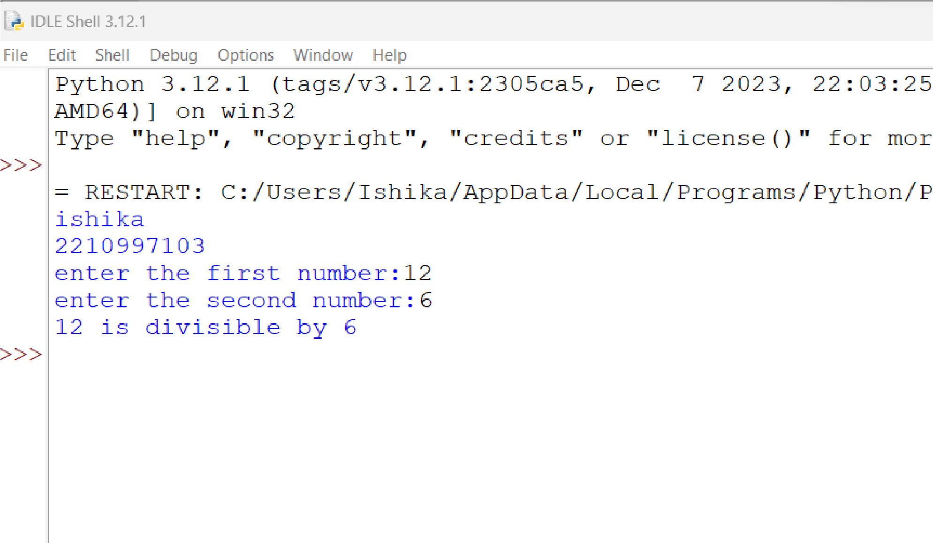

3.2 WAP to check if a number is positive, negative, or zero:

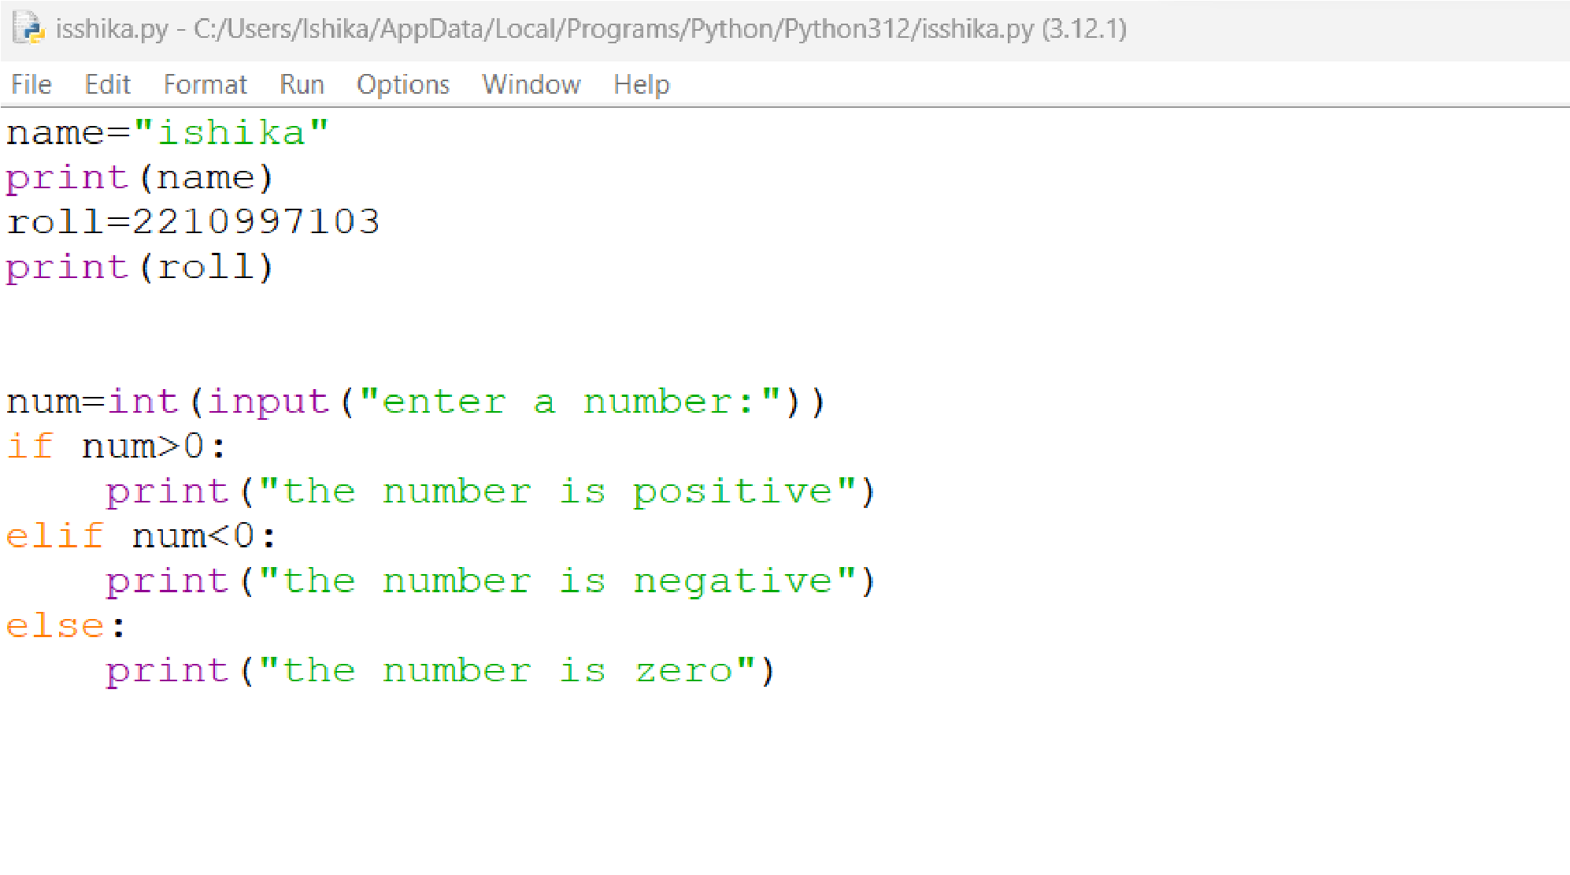

output:

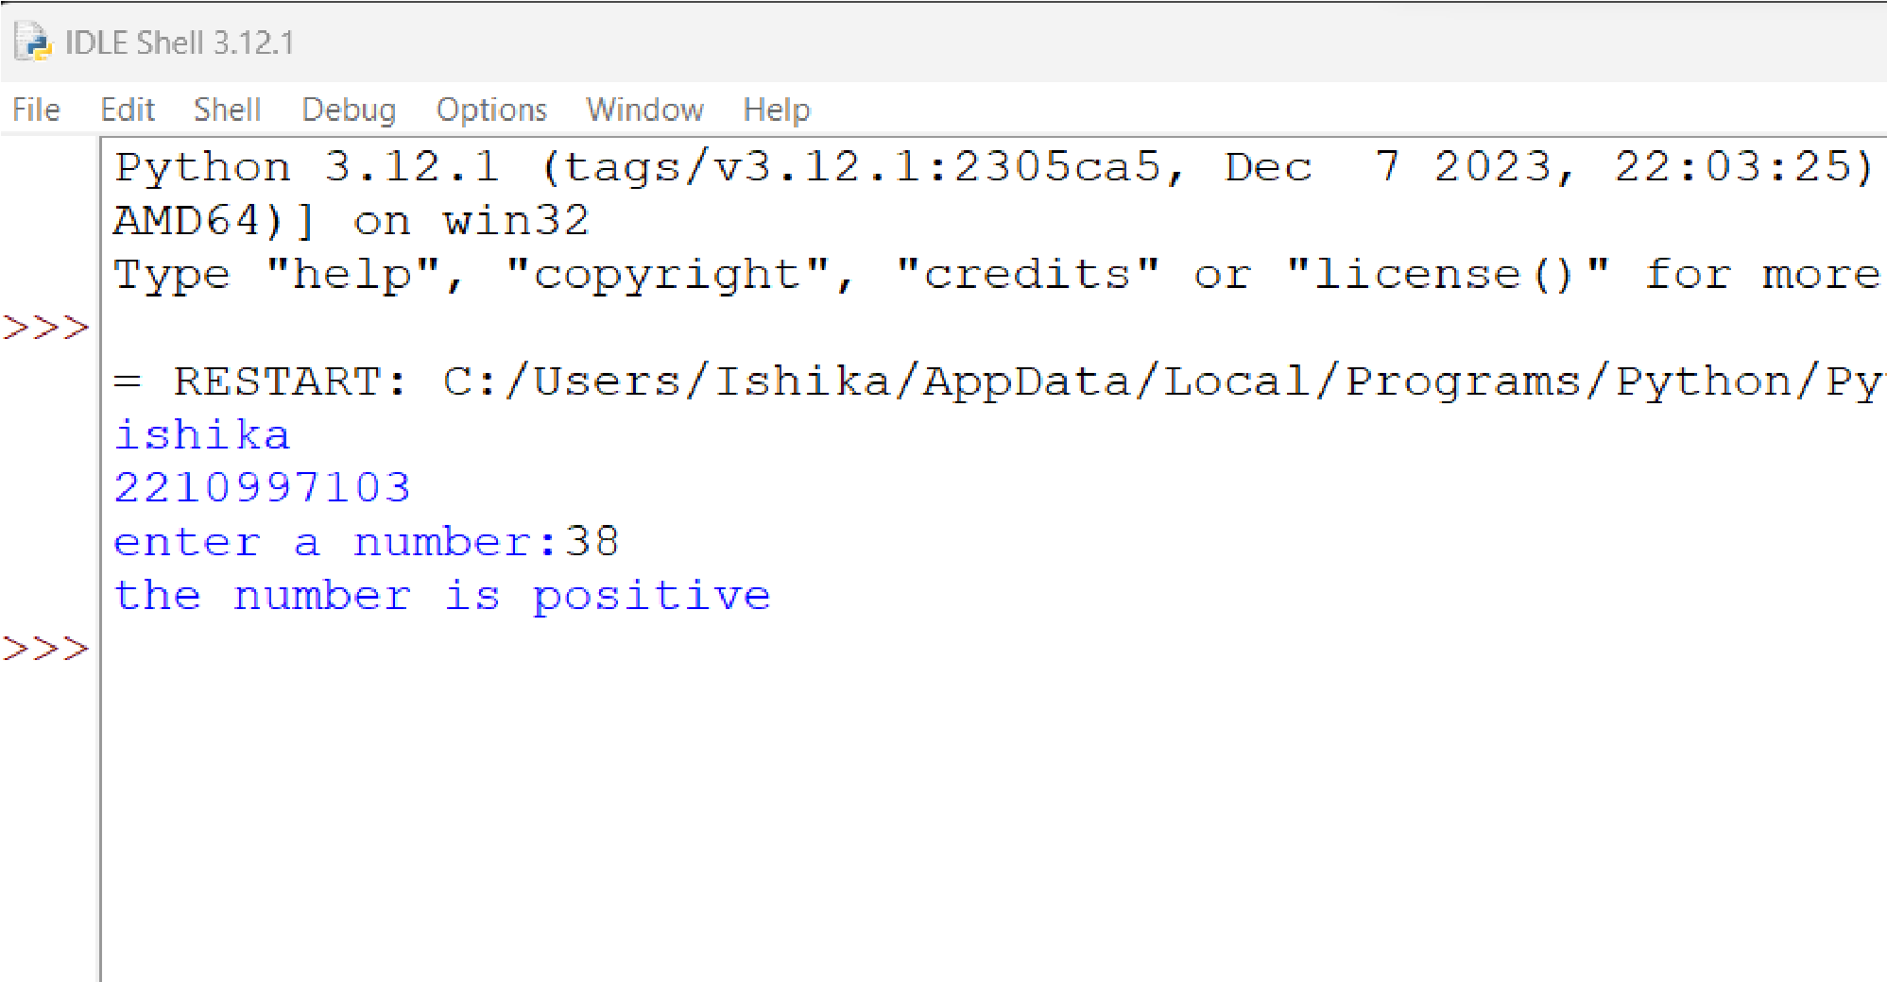

3.3 WAP to check if a given year is Leap or not:

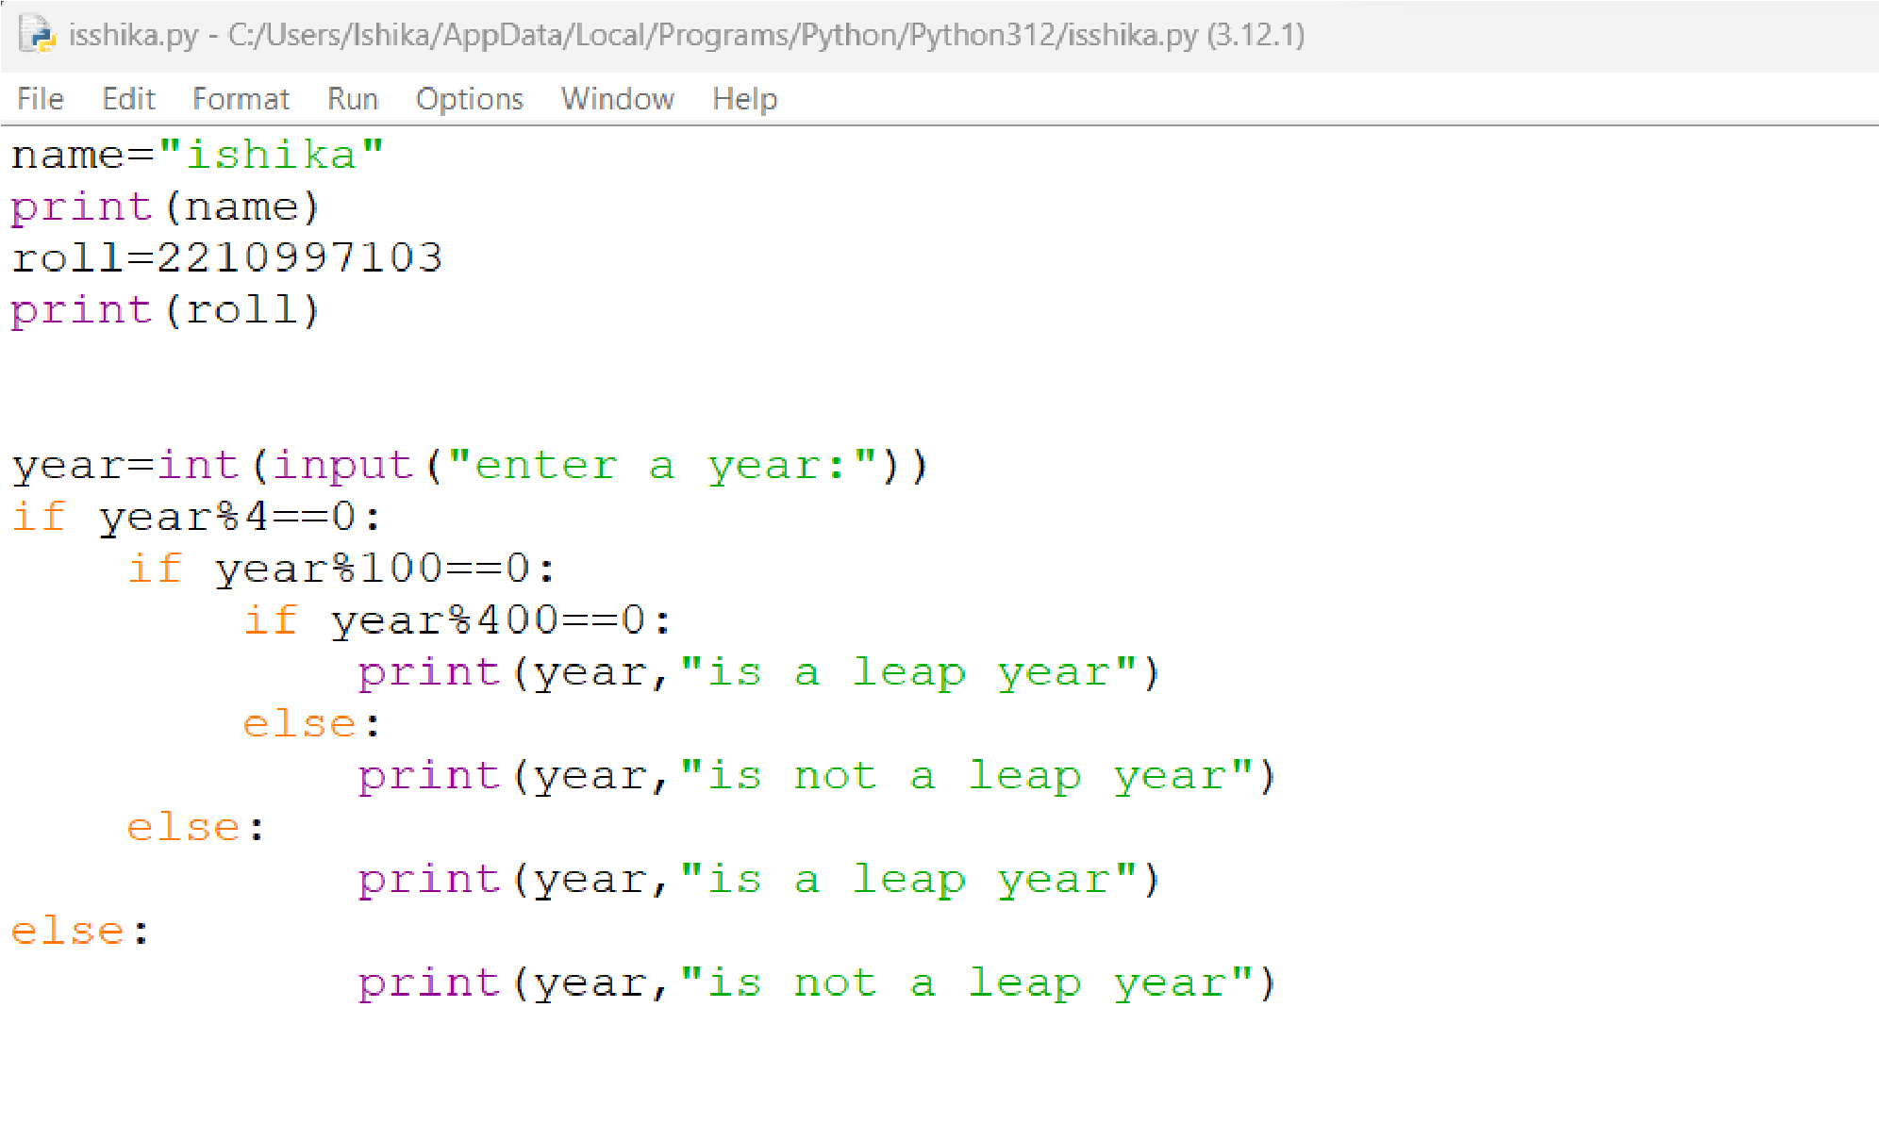

output:

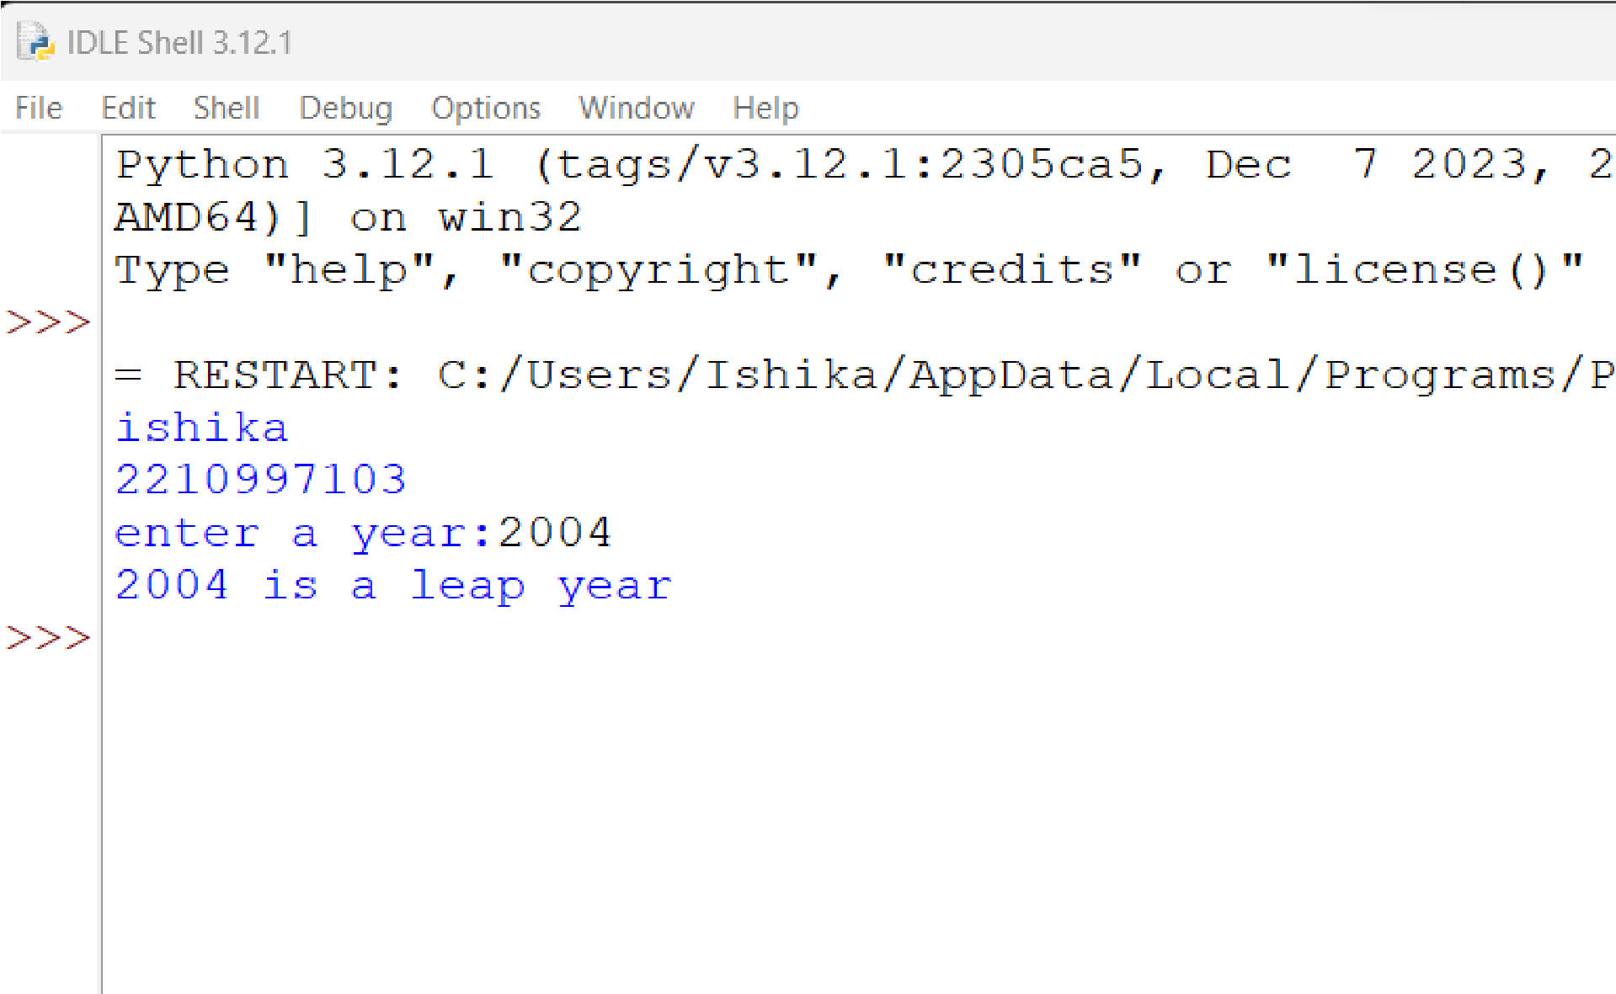

3.4 WAP to accept basic salary for the employee. Calculate DA and HRA based on the conditions.

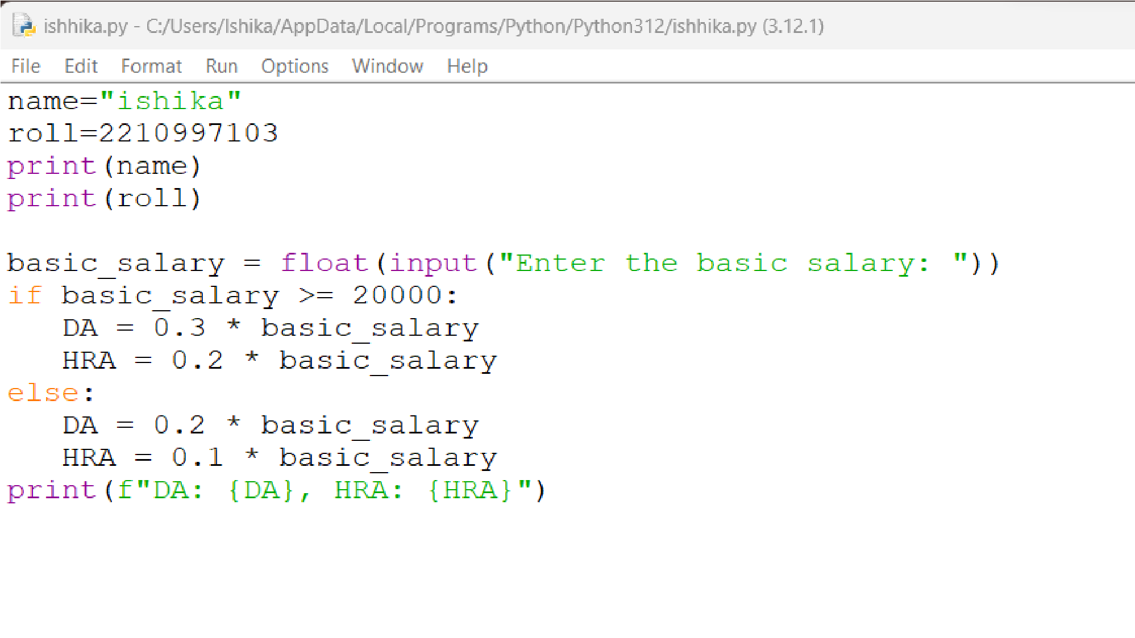

output:

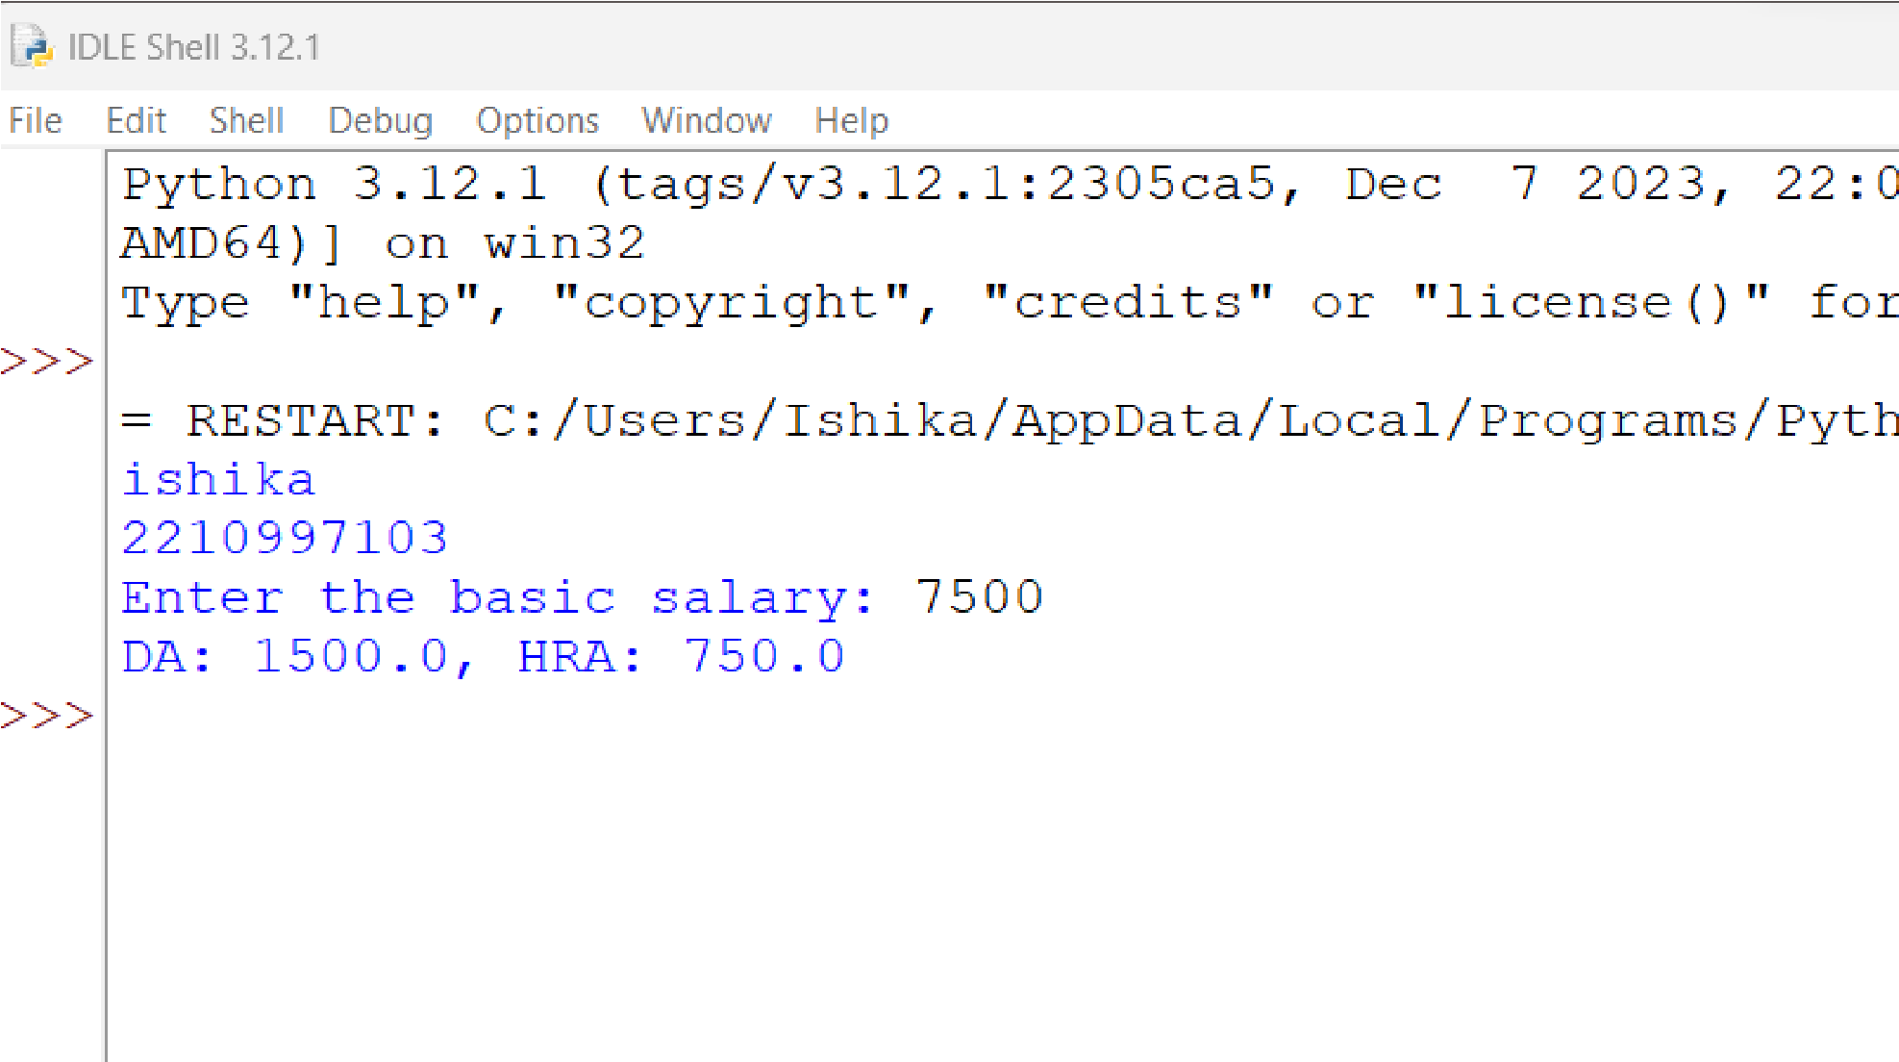

3.5 WAP to accept sales amount for the salesman and calculate commission based on sales amount:

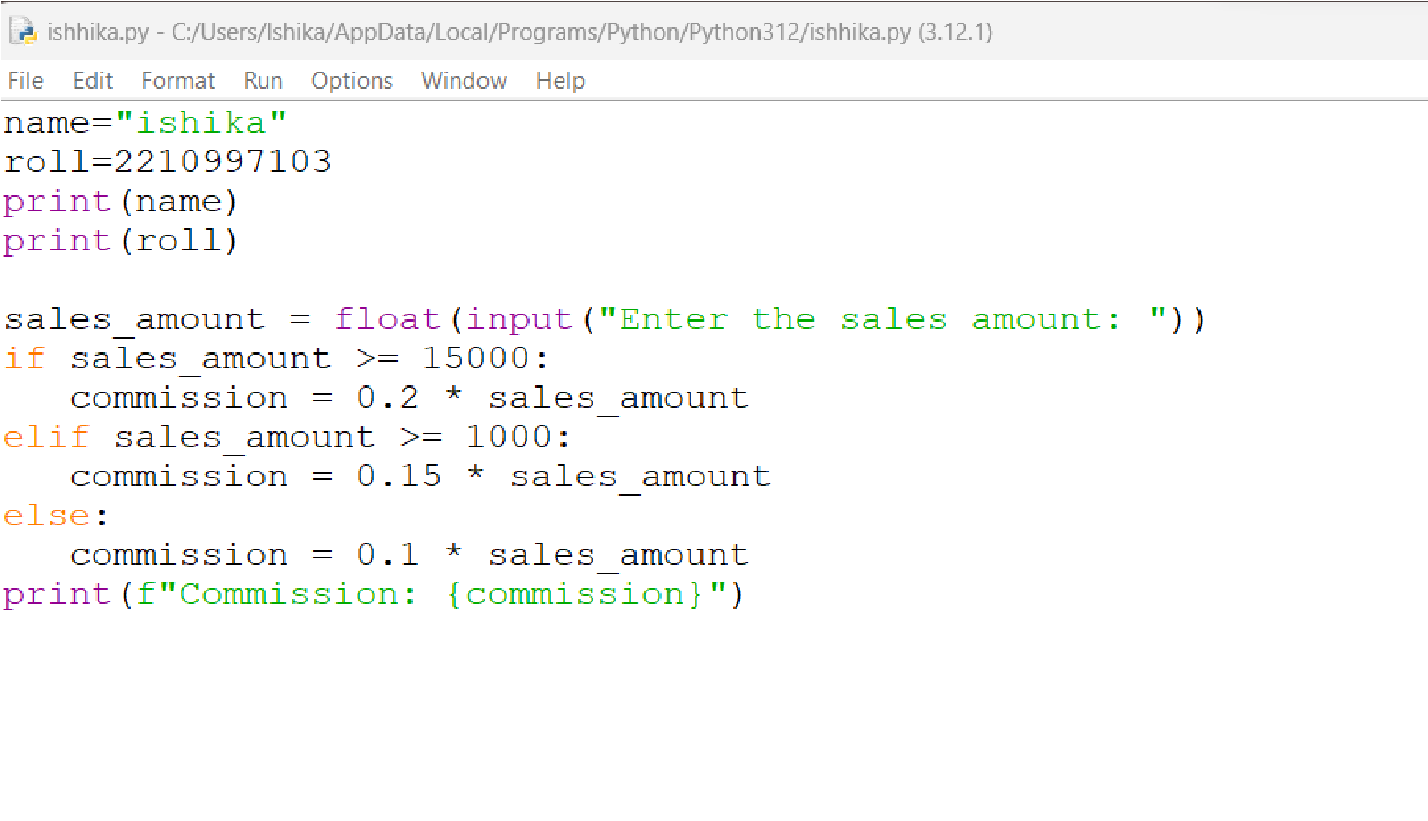

output:

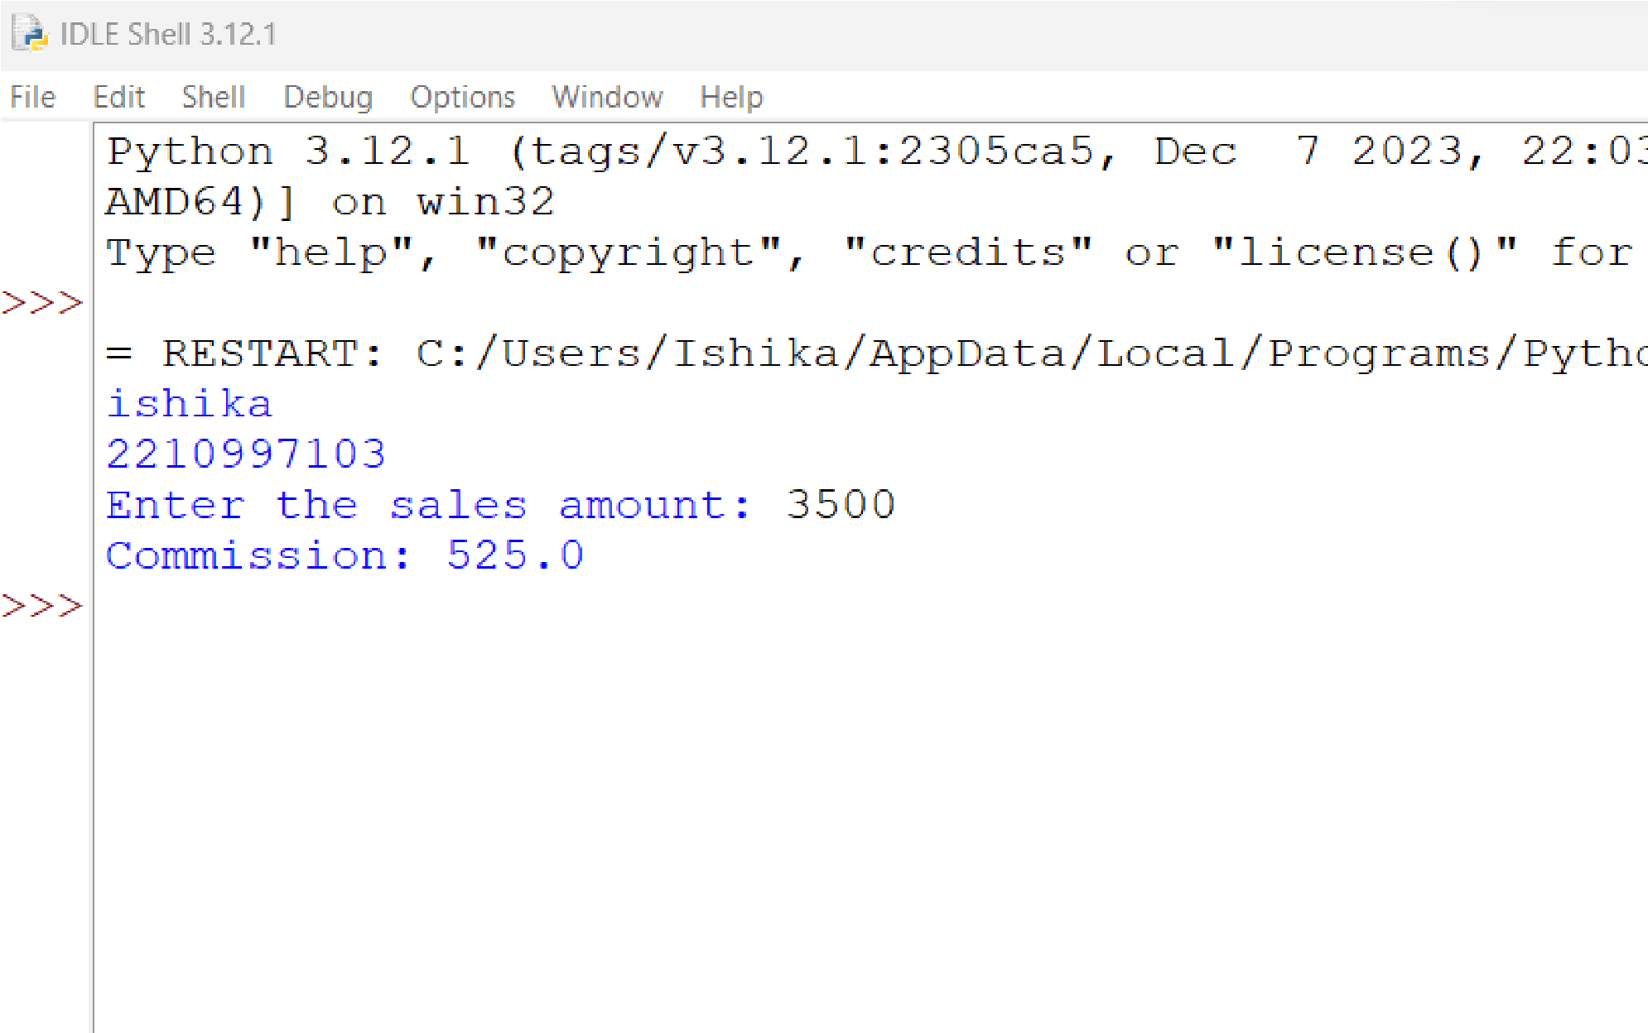

Practical 4 – While and For loops – Repetition Control Statements

4.1 WAP to show the working of a while loop with text:

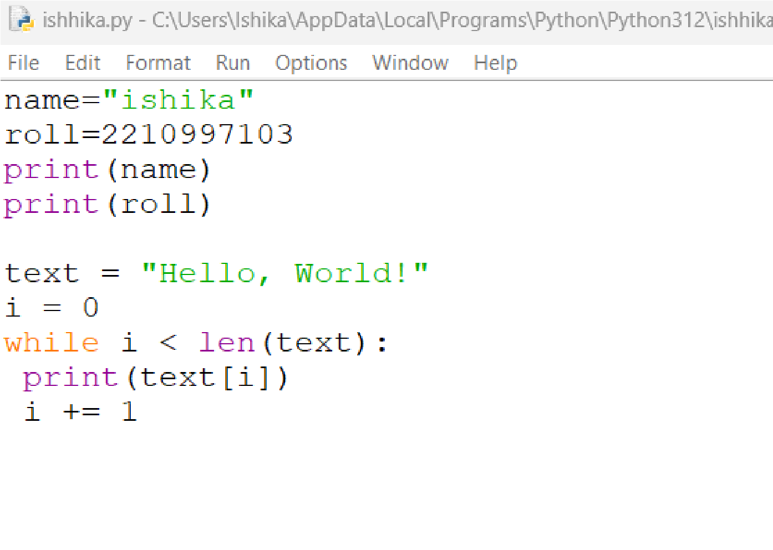

output:

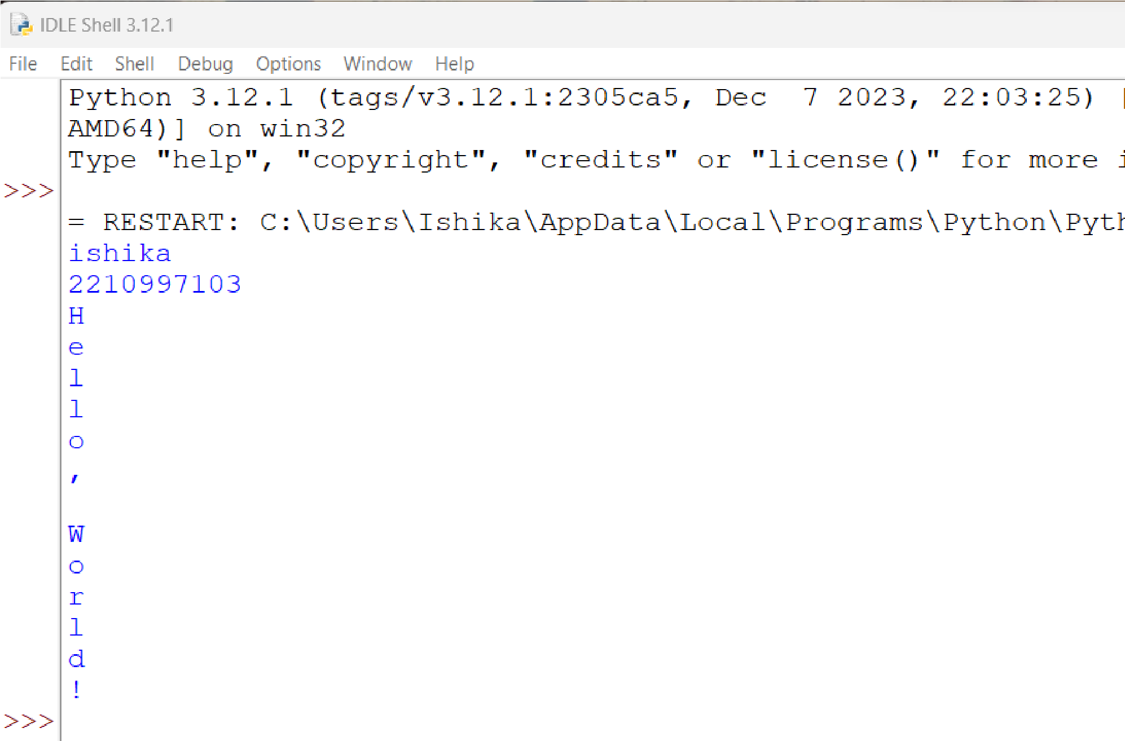

4.2 WAP to show the working of a while loop with numbers:

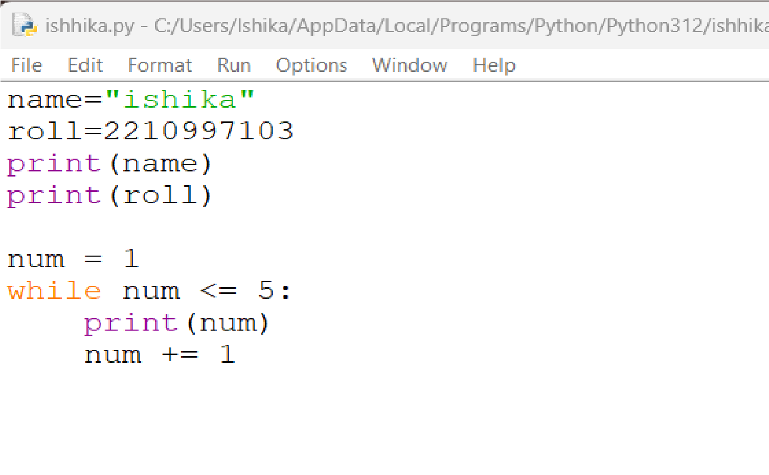

output:

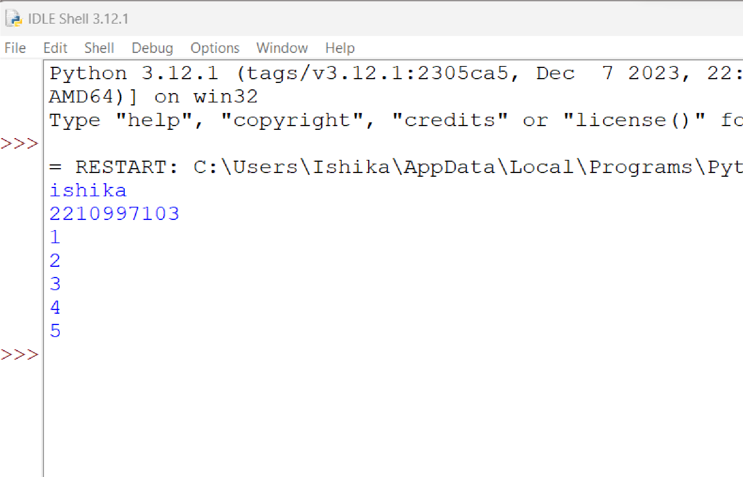

4.3 WAP to show the working of break and continue statements:

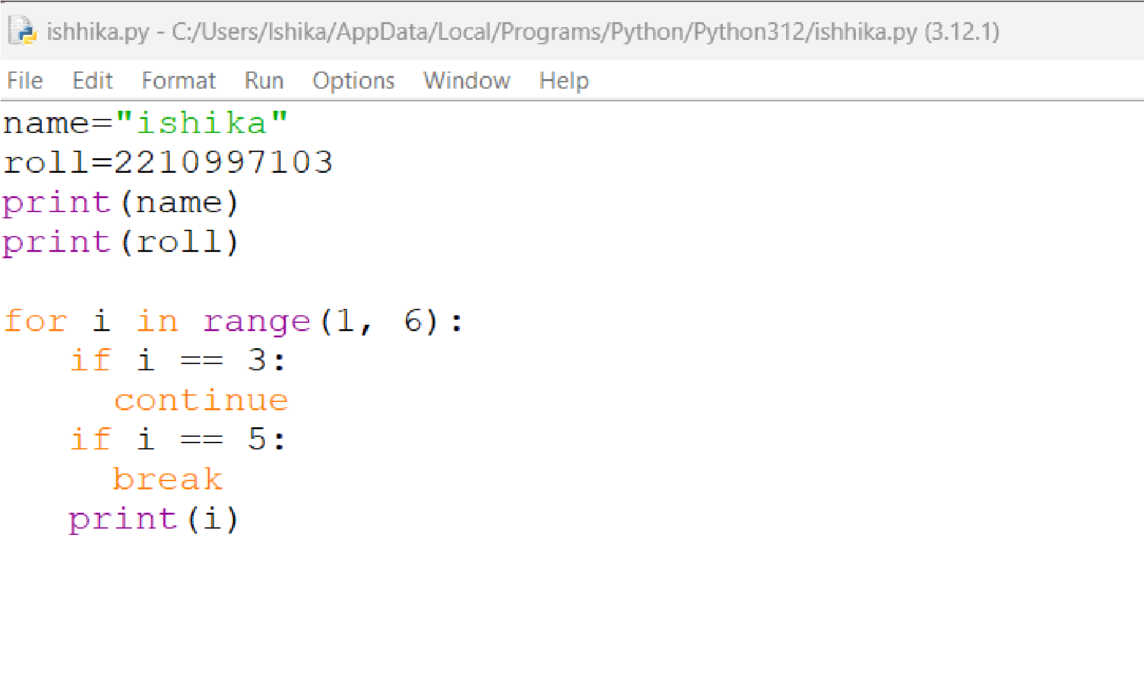

output:

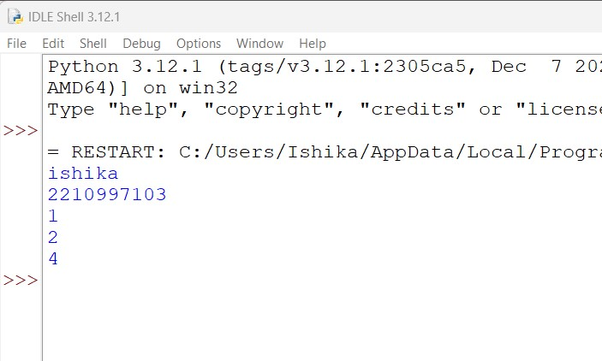

4.4write a program demonstrate the use of the else statement with while and break:

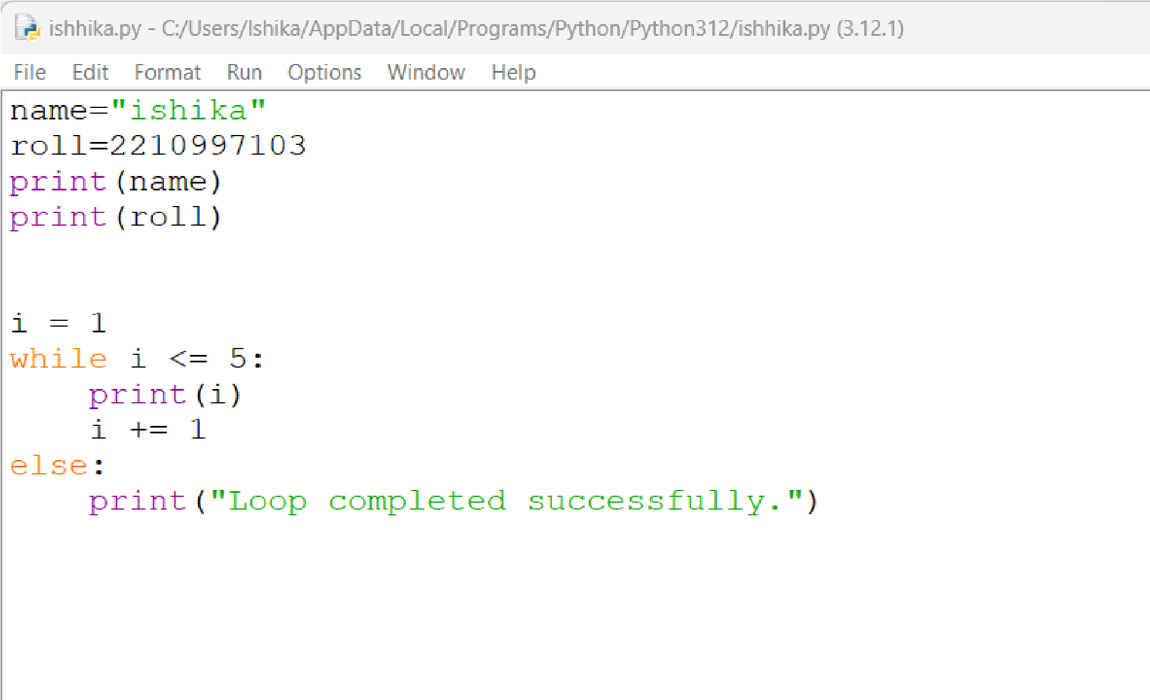

output:

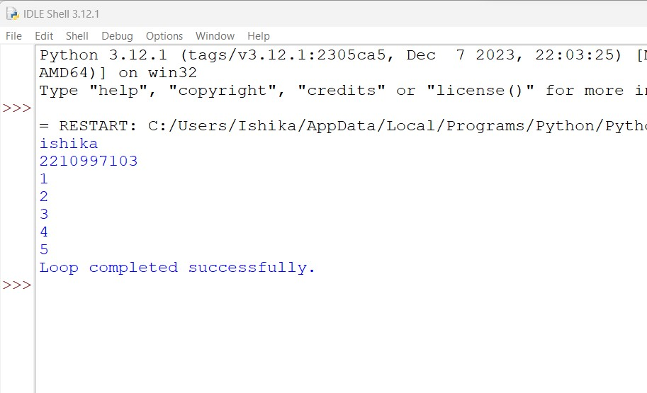

4.5 WAP to compute the sum of the series 4 + 8 + 12 + ... + 40:

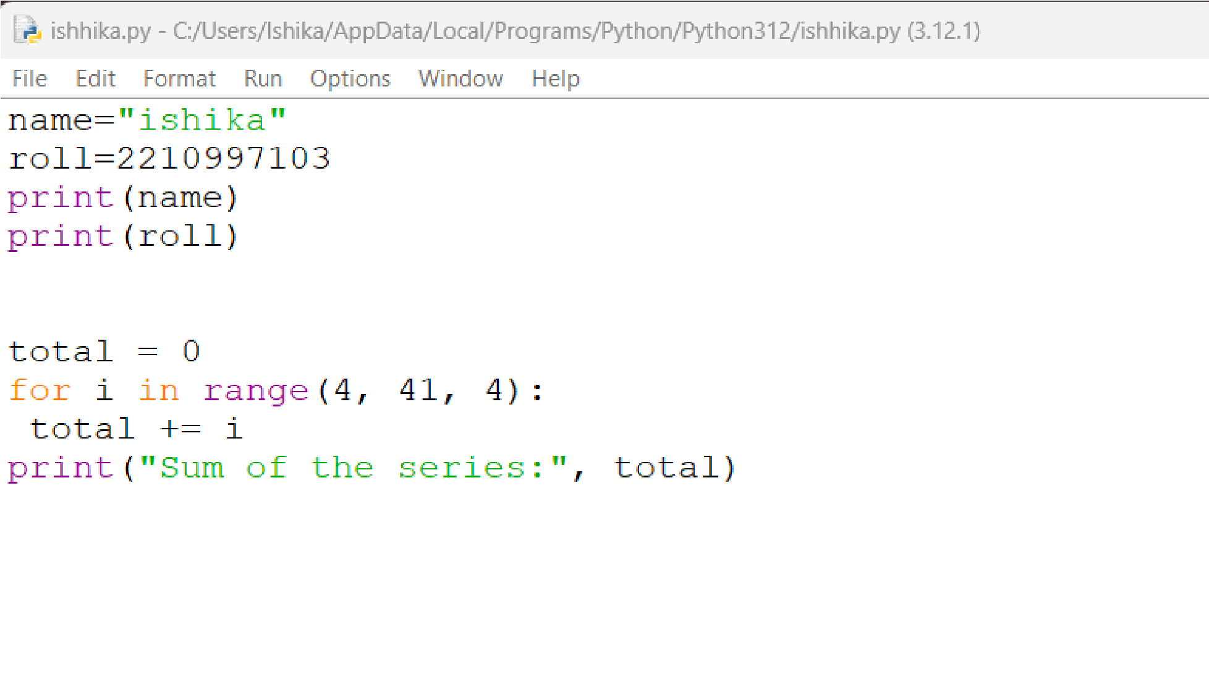

output:

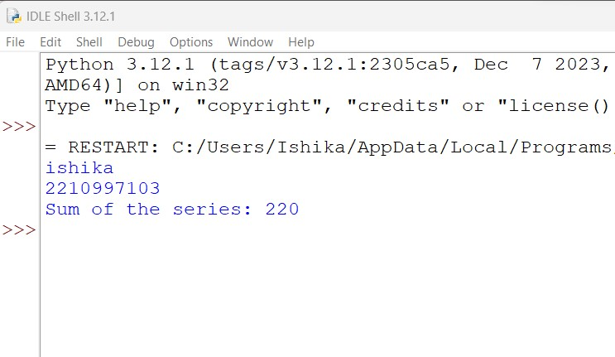

4.6 Program to display the Fibonacci sequences up to the nth term where n is

provided by the user:

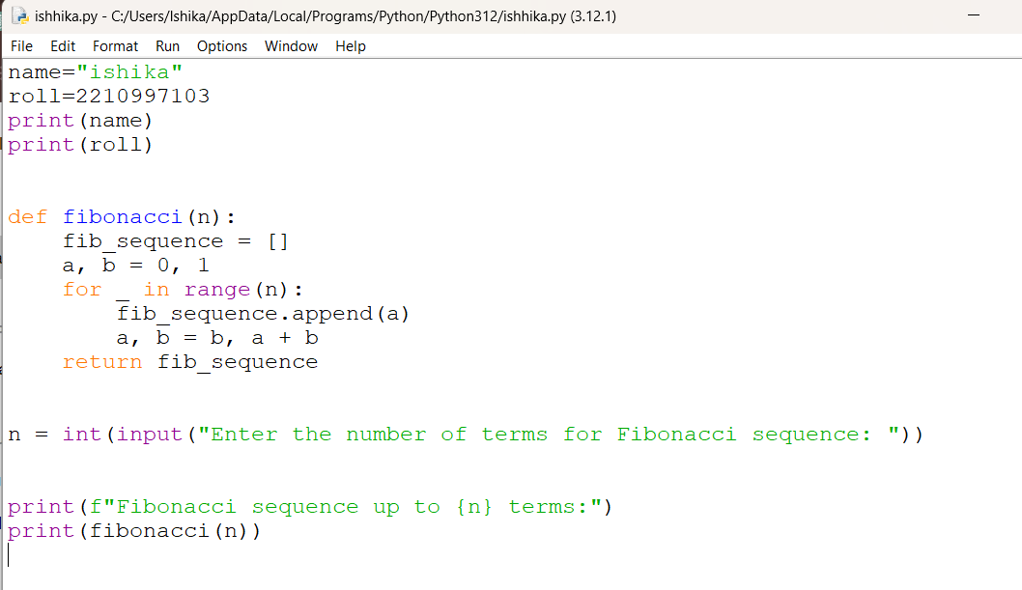

Output:

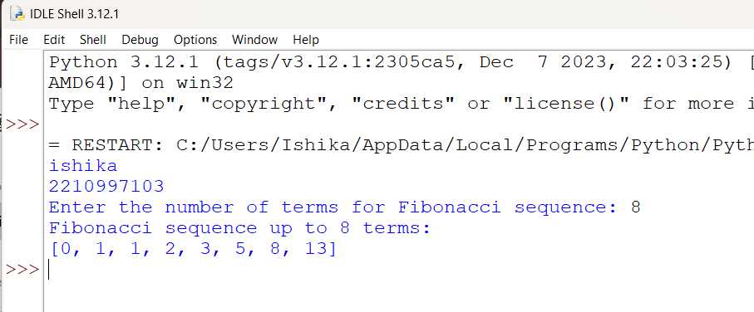

4.7 WAP that prints the multiplication table of a number using a for loop:

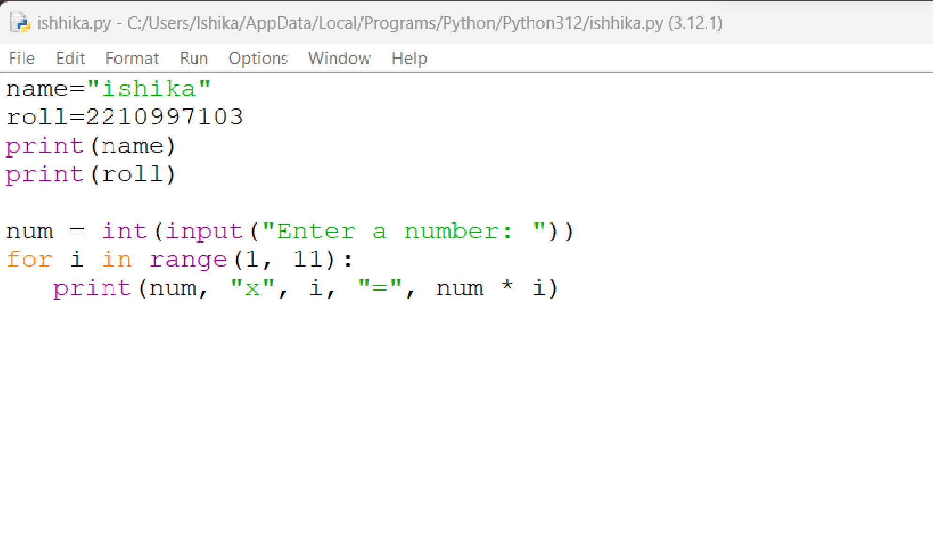

output:

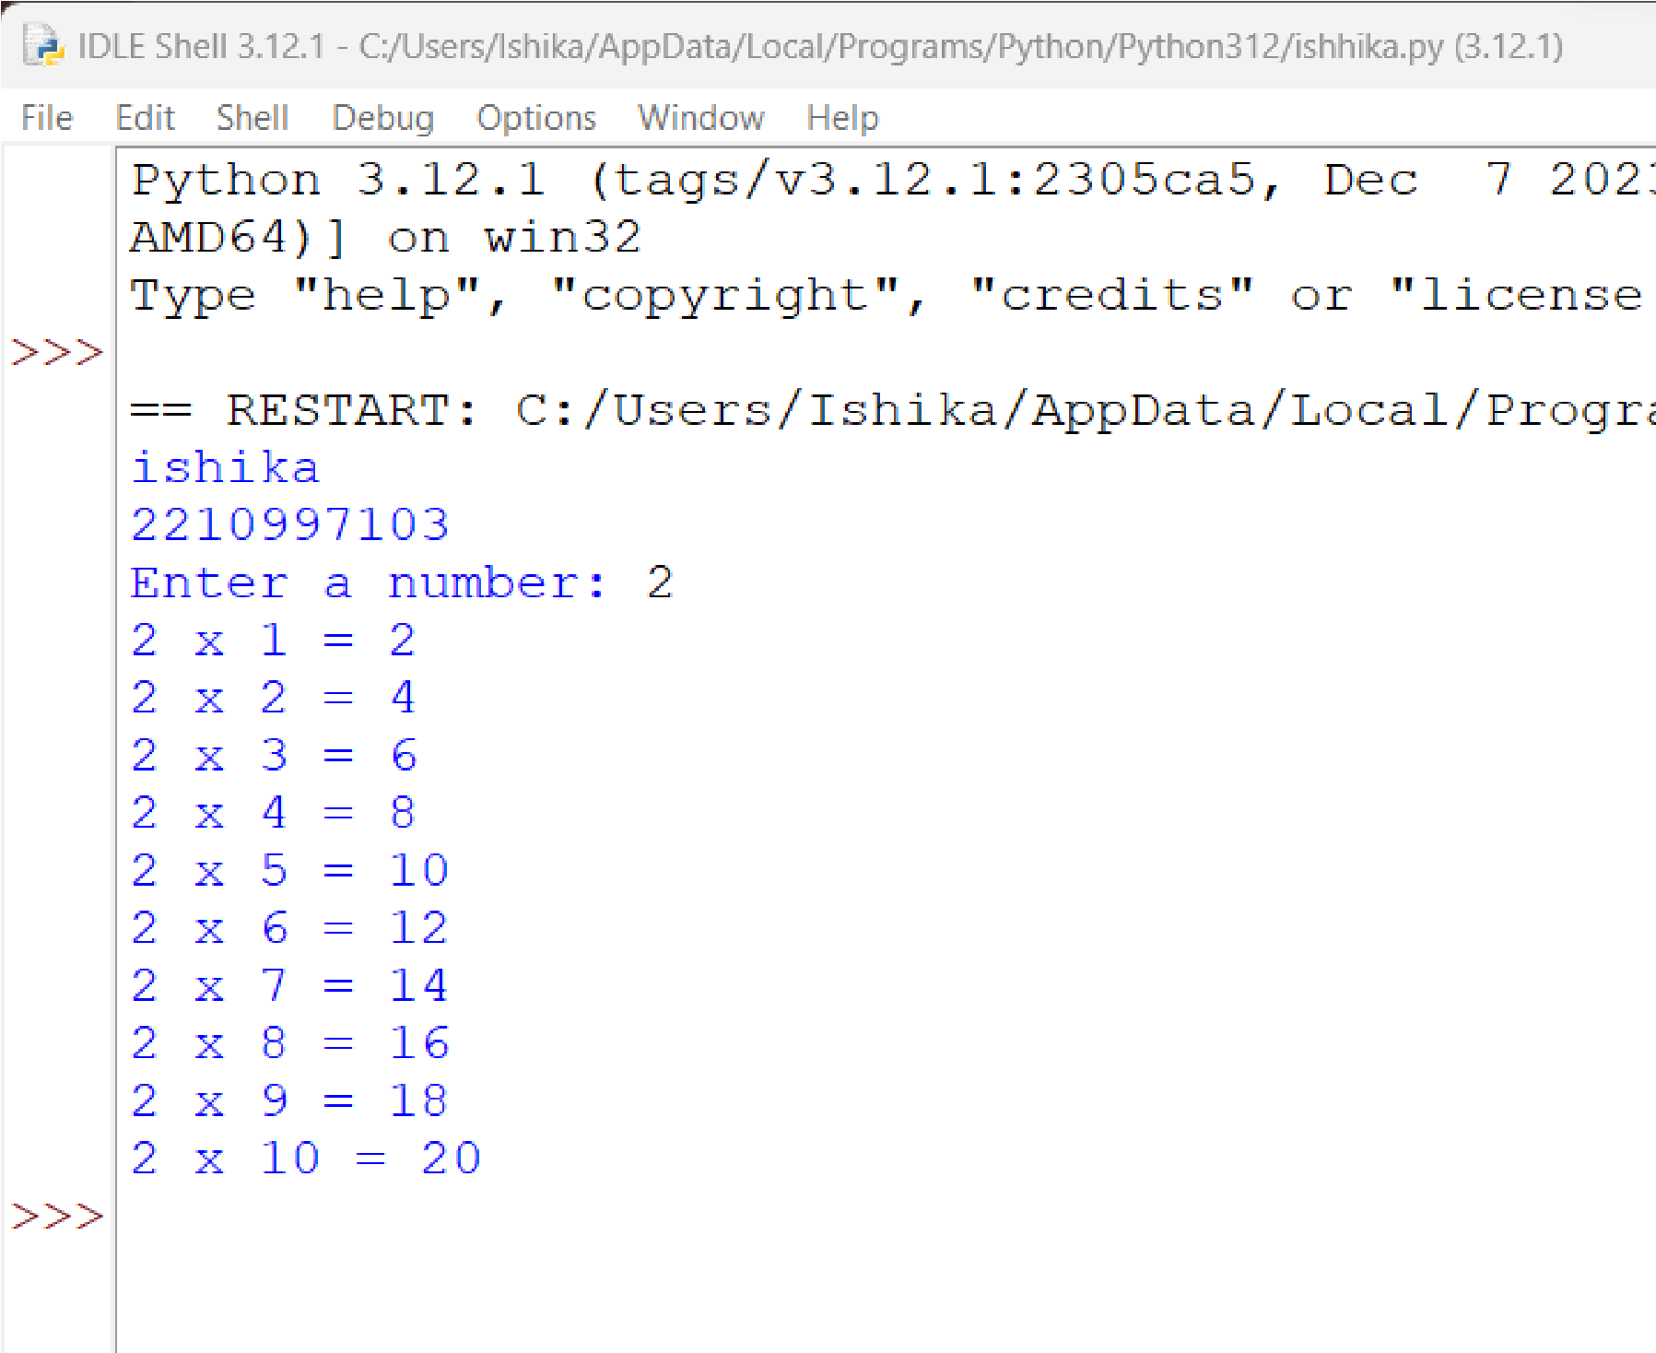

4.8 WAP to print a Triangle Pattern:

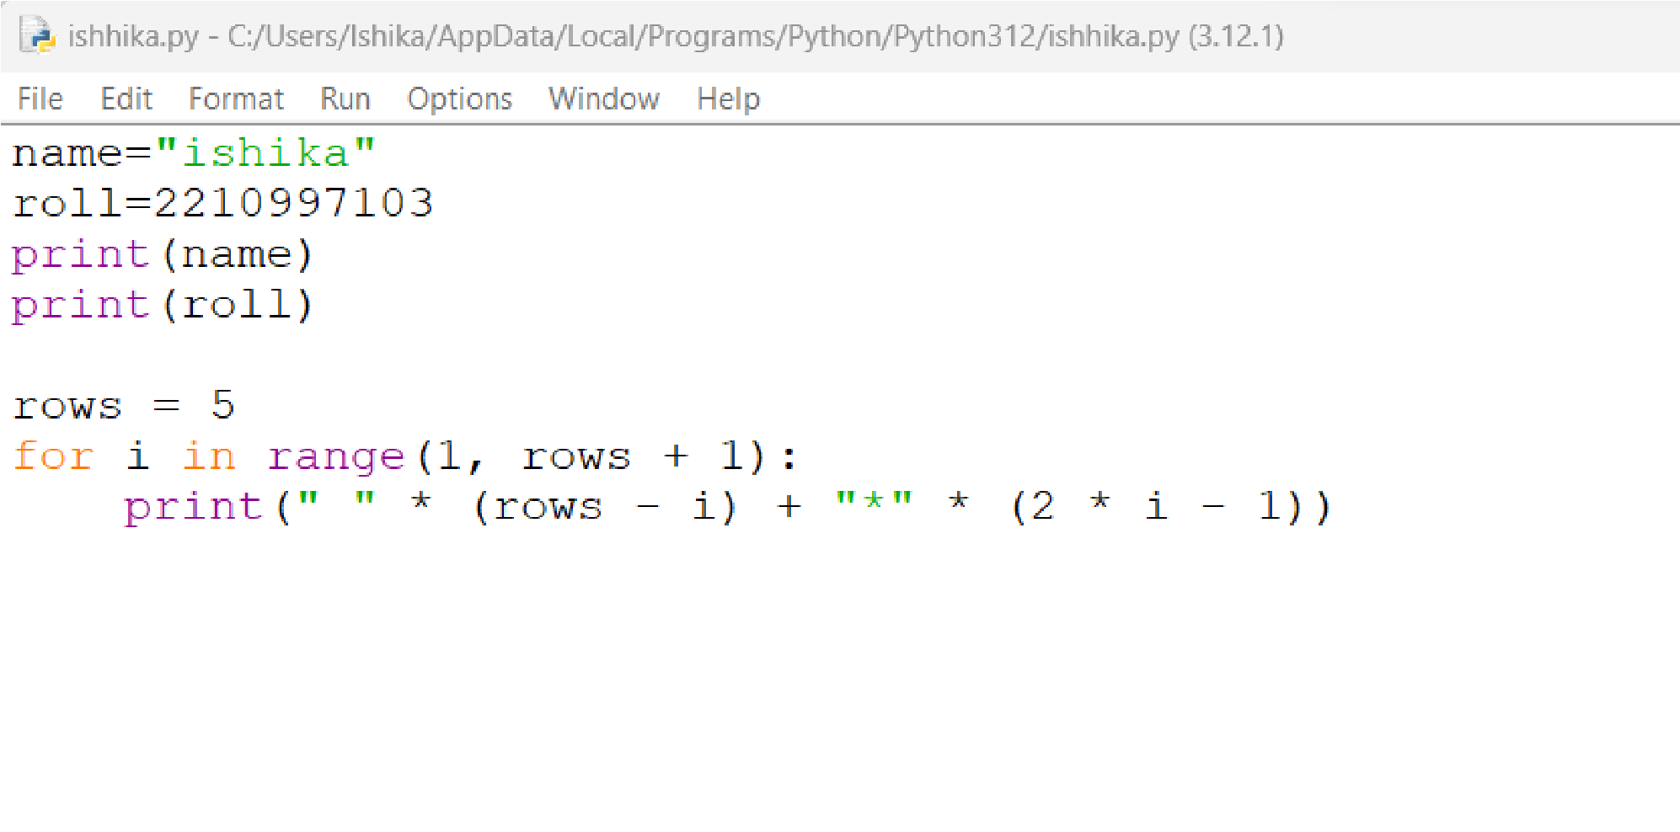

output:

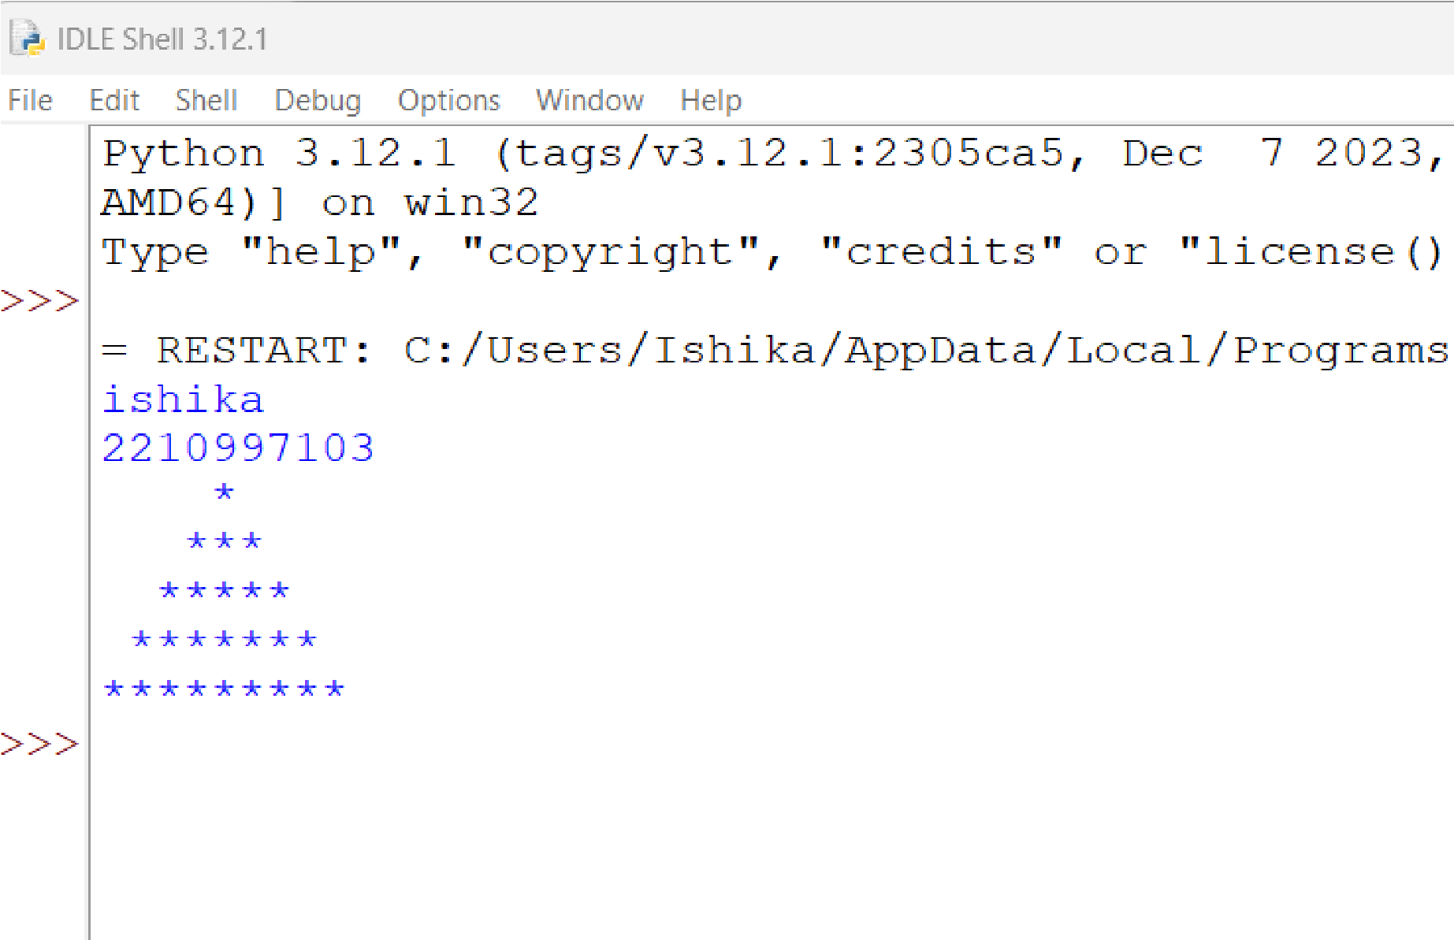

4.9WAP to compute the sum of the series 3 + 6 + 9 +... + 30:

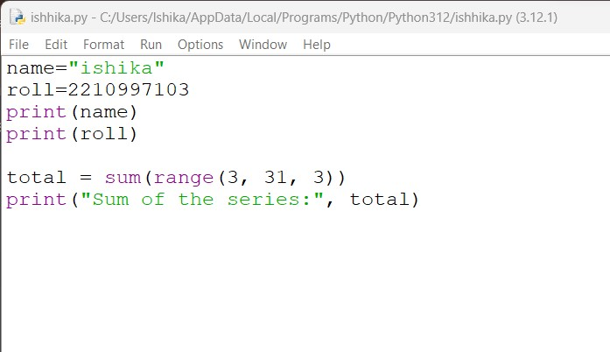

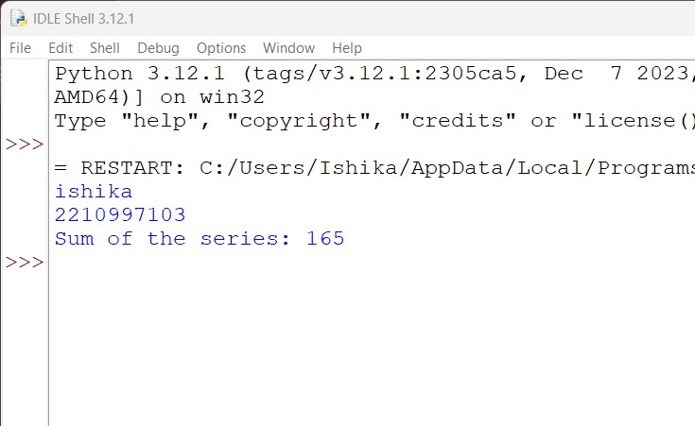

4.10 Program to print the product of the series m = 15 \* 13 \* 11 \* 9 \* 7:

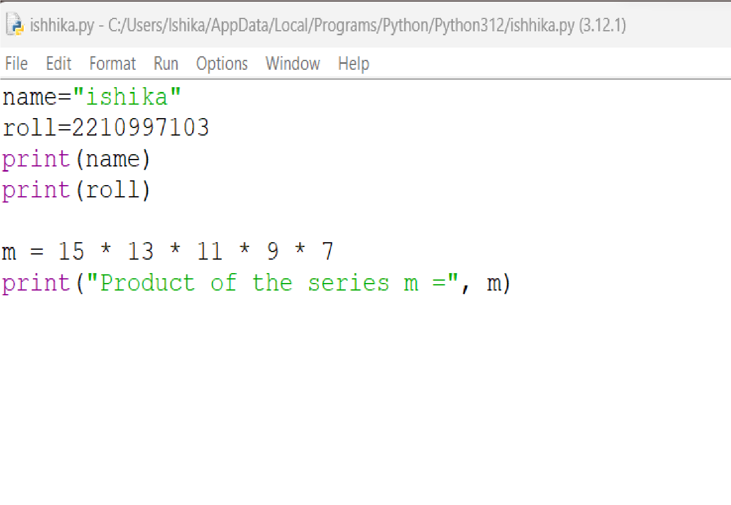

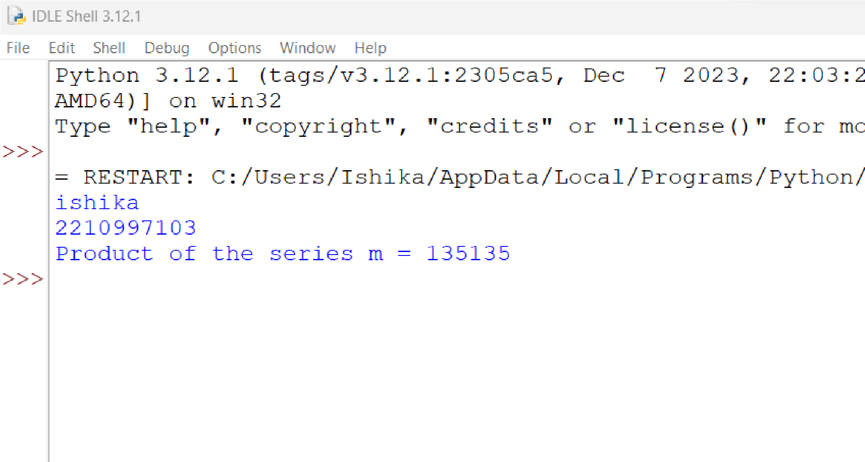

4.11 Program to compute the factorial of a number:

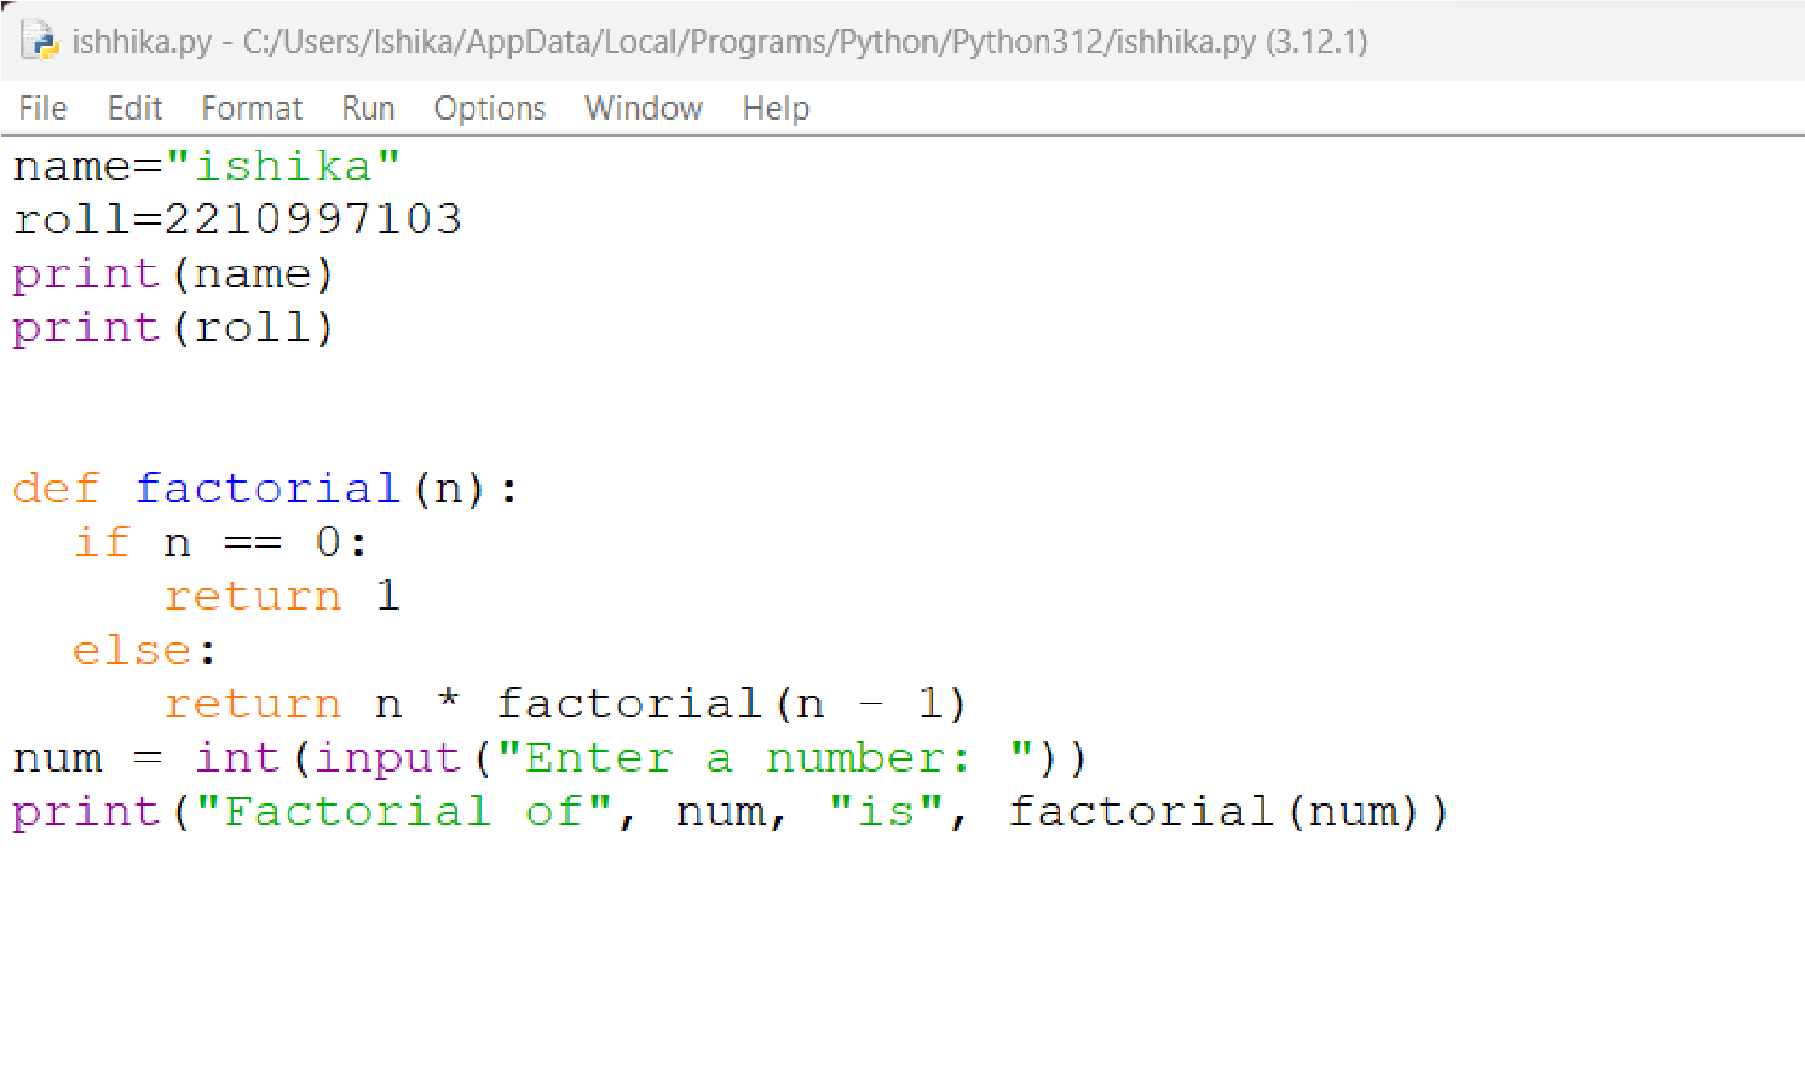

output:

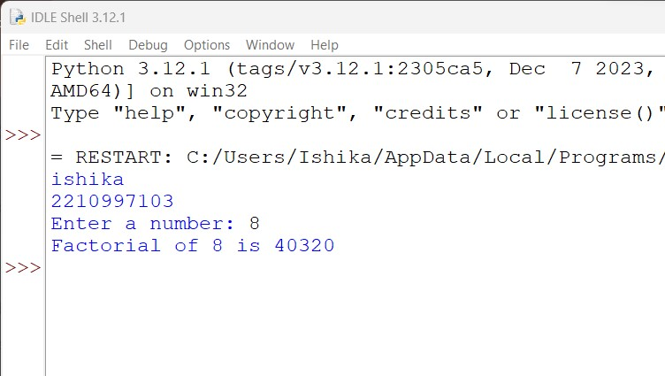

4.12 Program to display the cube of the first 10 even numbers:

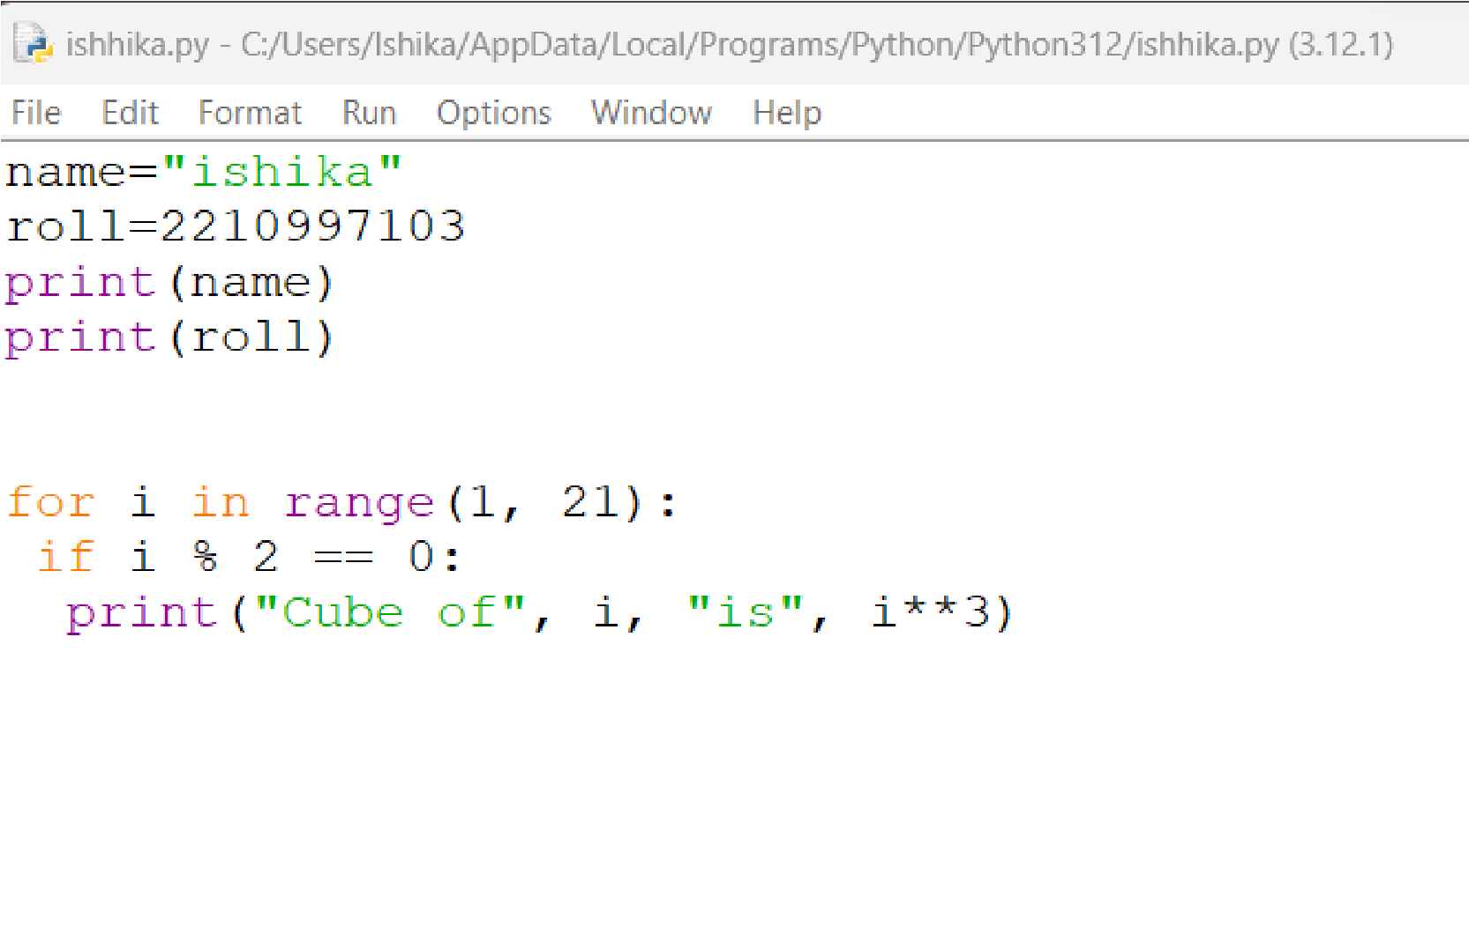

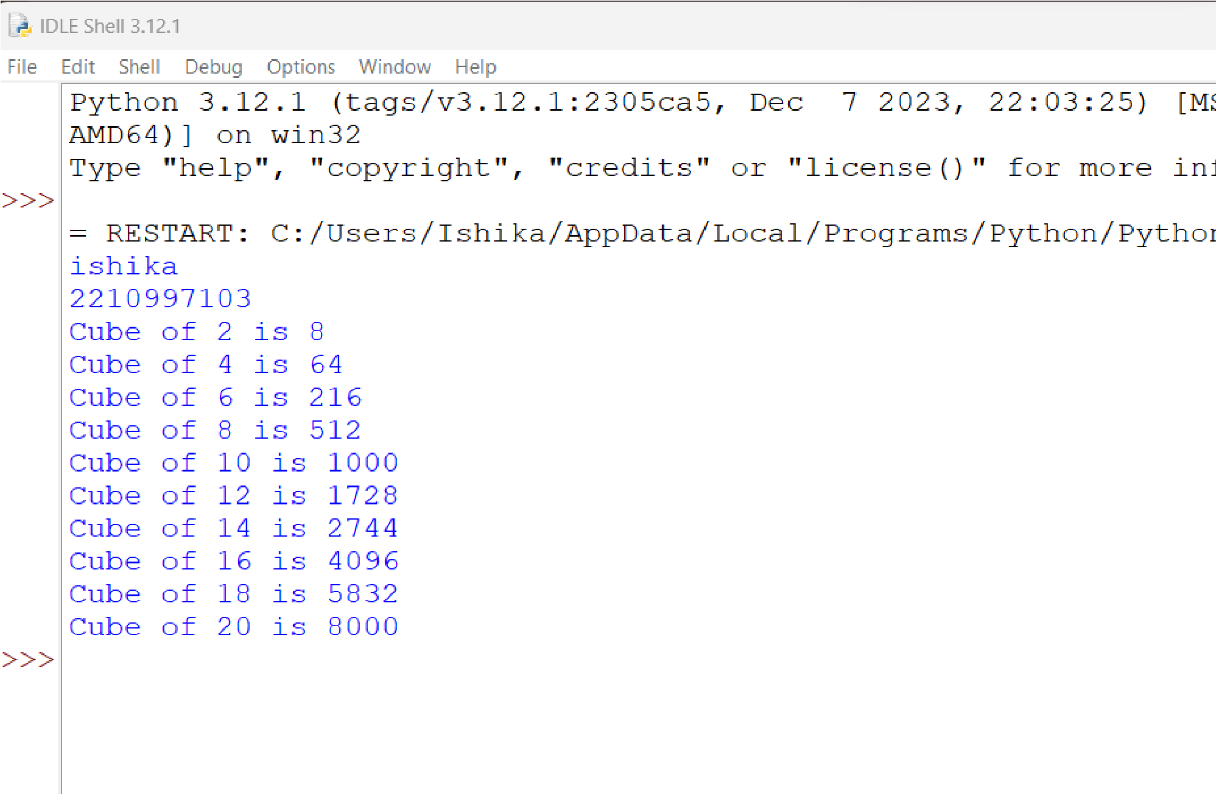

4.13 Program to compute the sum of the first n natural numbers:

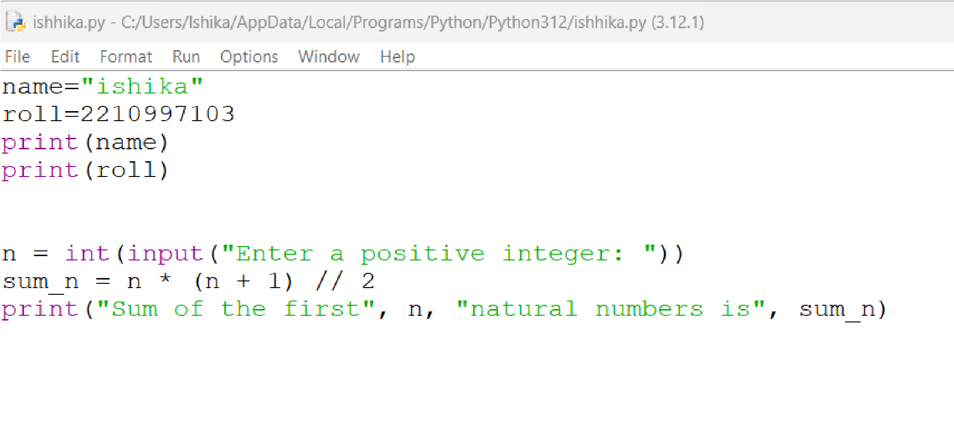

output:

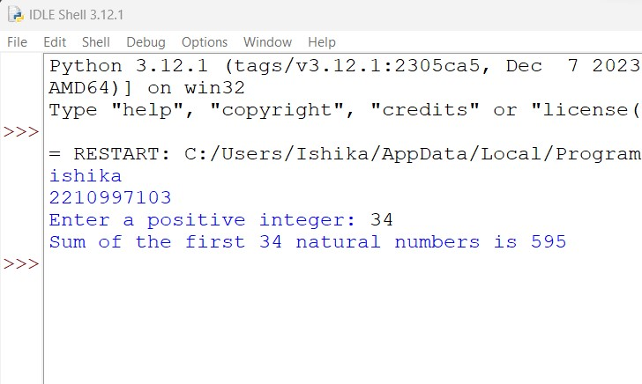4.14

4.14 Program to display numbers from 1 to 10 in reverse order:

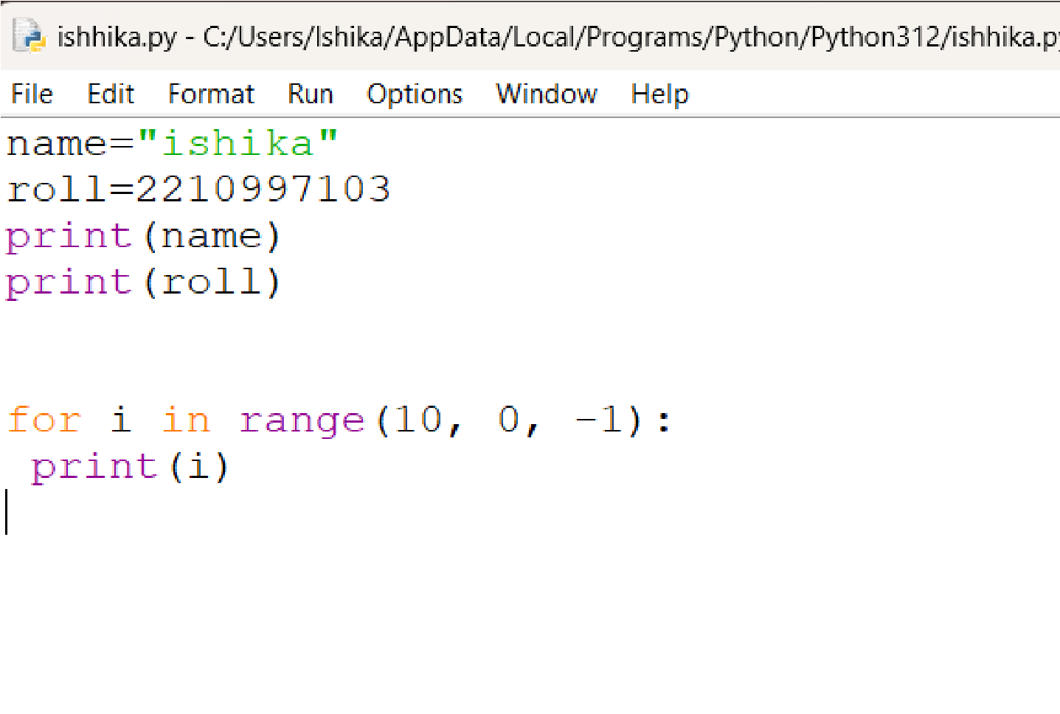

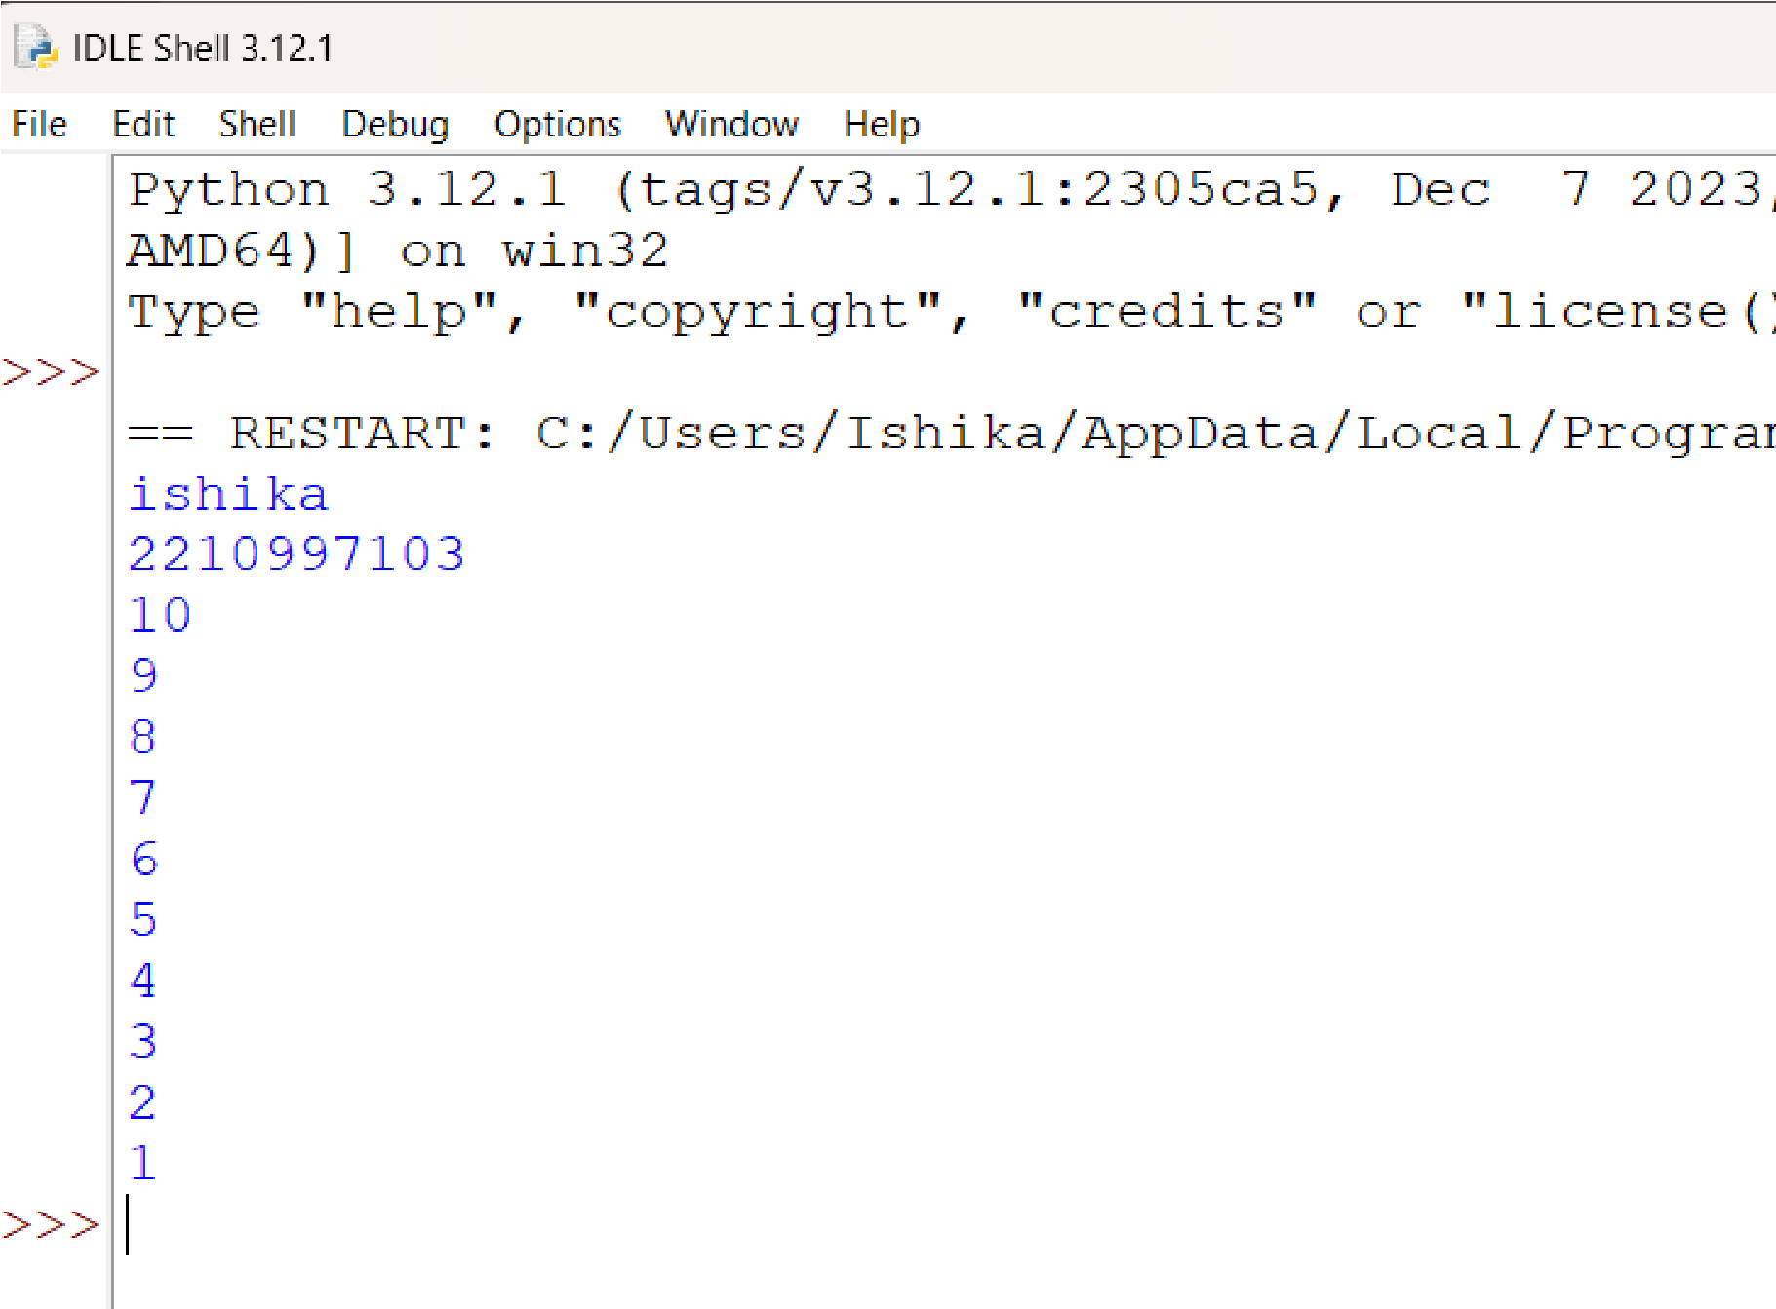

4.15 Program to create a list of a specific size, arrange all the elements in ascending order, and display the list before and after sorting:

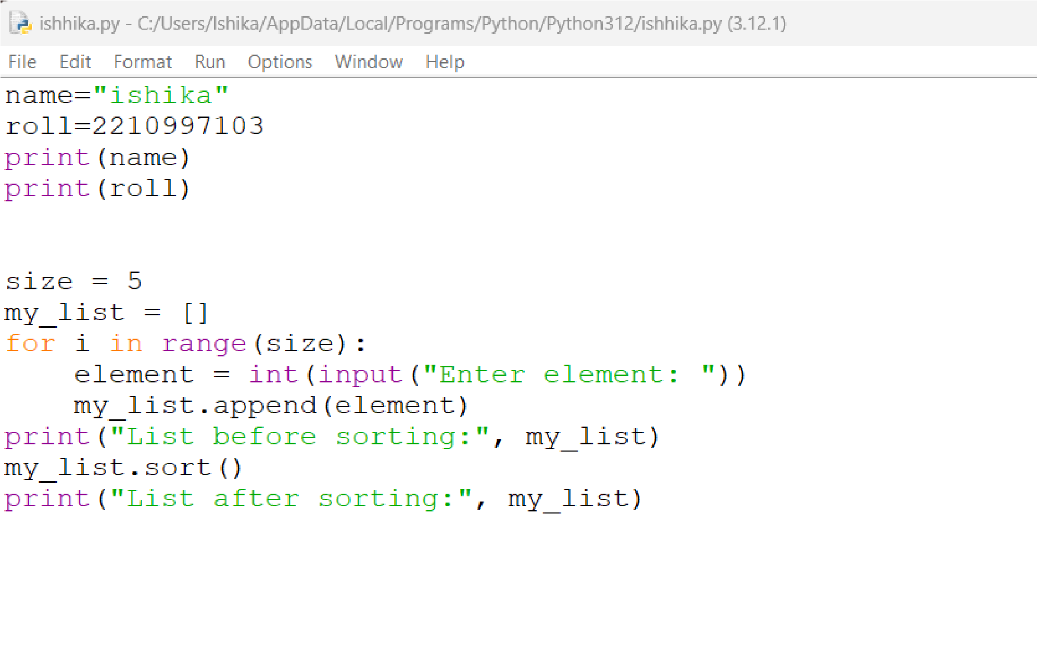

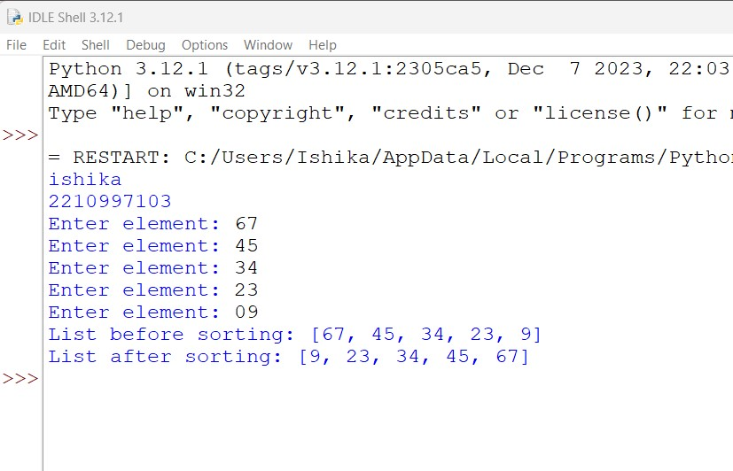

Practical 5 Working with Lists in Python

5.1 Program to show the creation and working of lists:

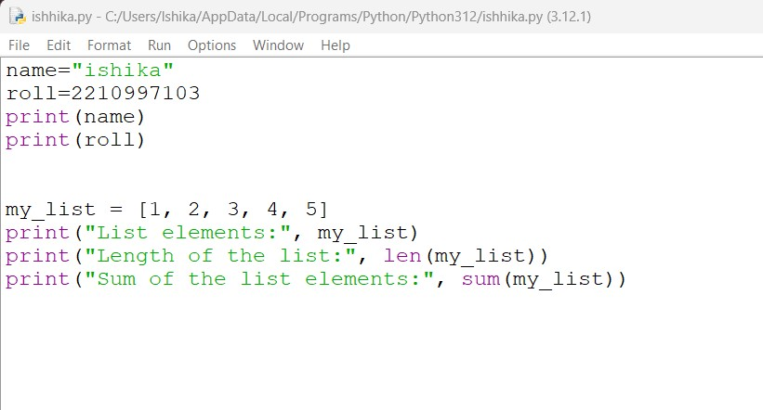

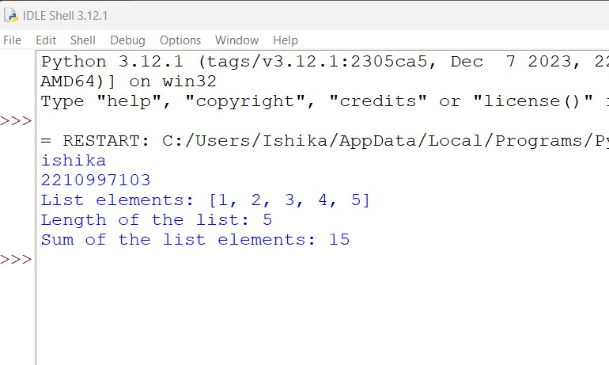

5.2 Program to print elements of a list ['q', 'w', 'e', 'r', 't', 'y'] in separate lines along with element's both indexes (Positive and Negative):

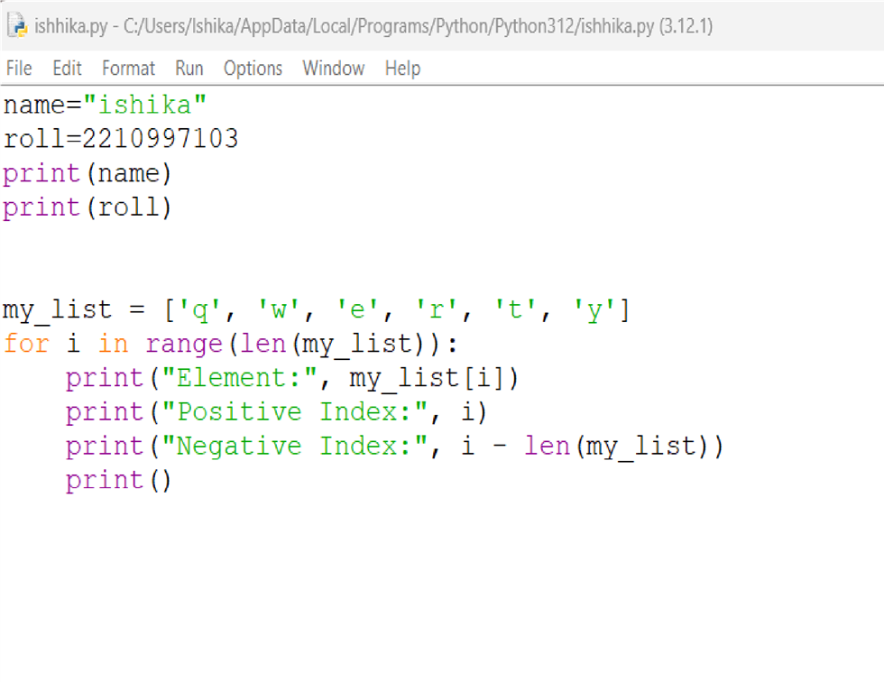

Output:

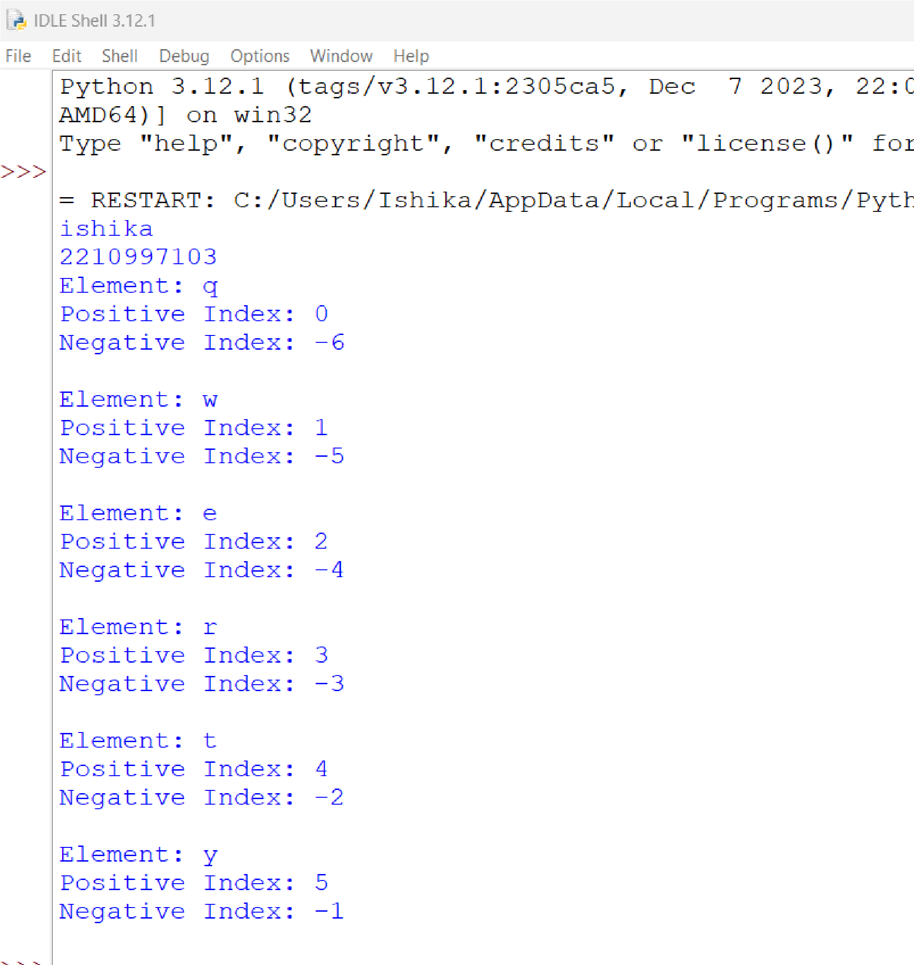

5.3 Program to demonstrate the working of methods used with lists:

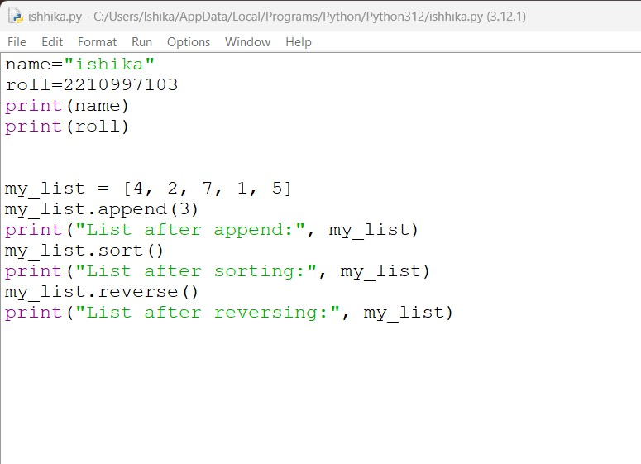

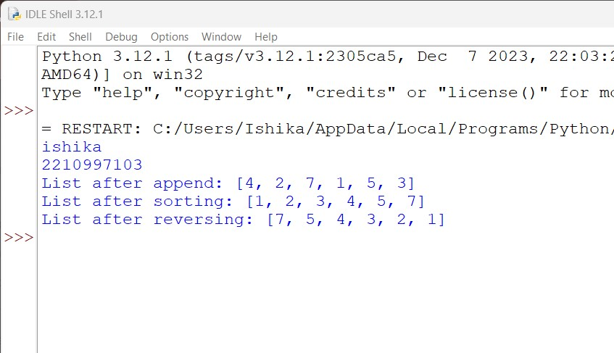

5.4 Program to create a 3x3 Matrix and how to extract individual elements of the matrix:

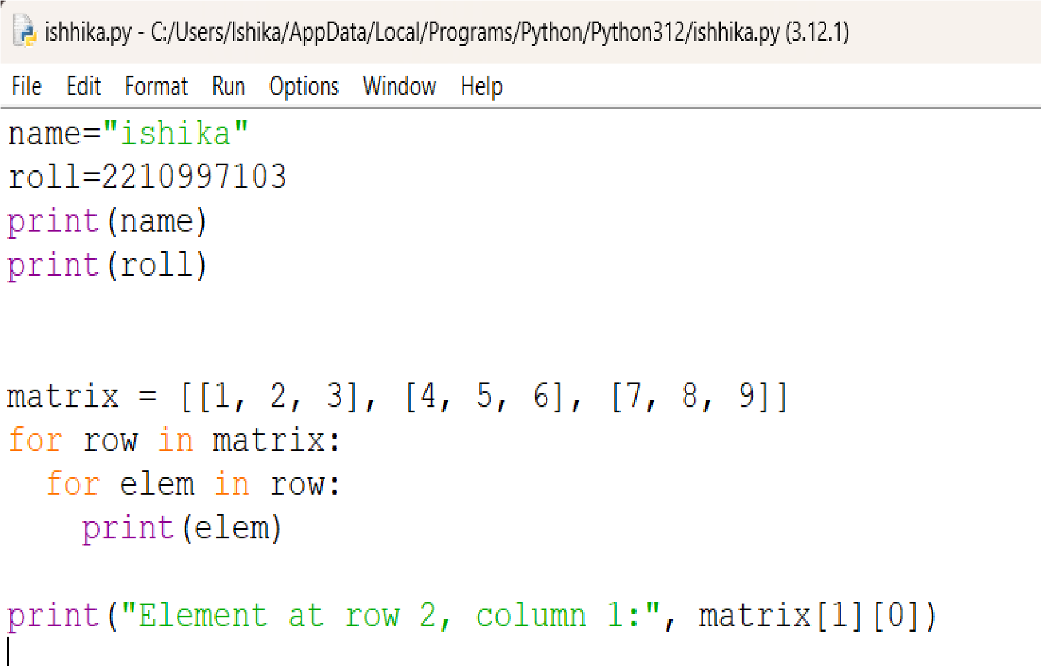

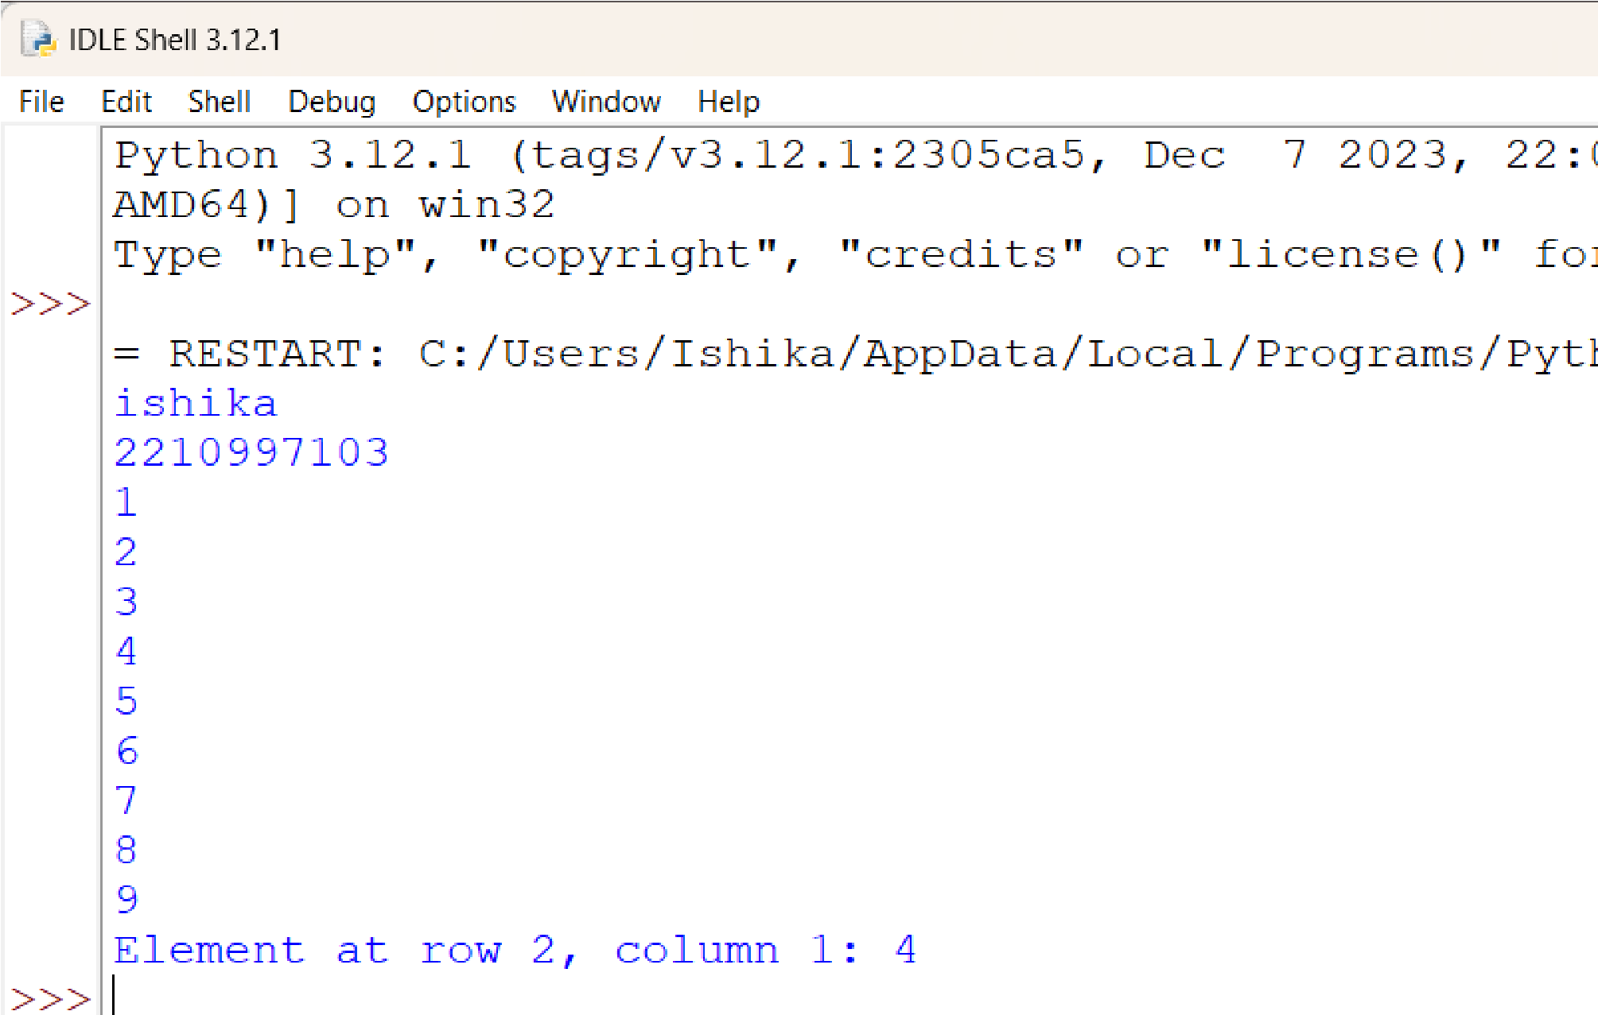

5.5 Program to demonstrate built-in functions in Lists:

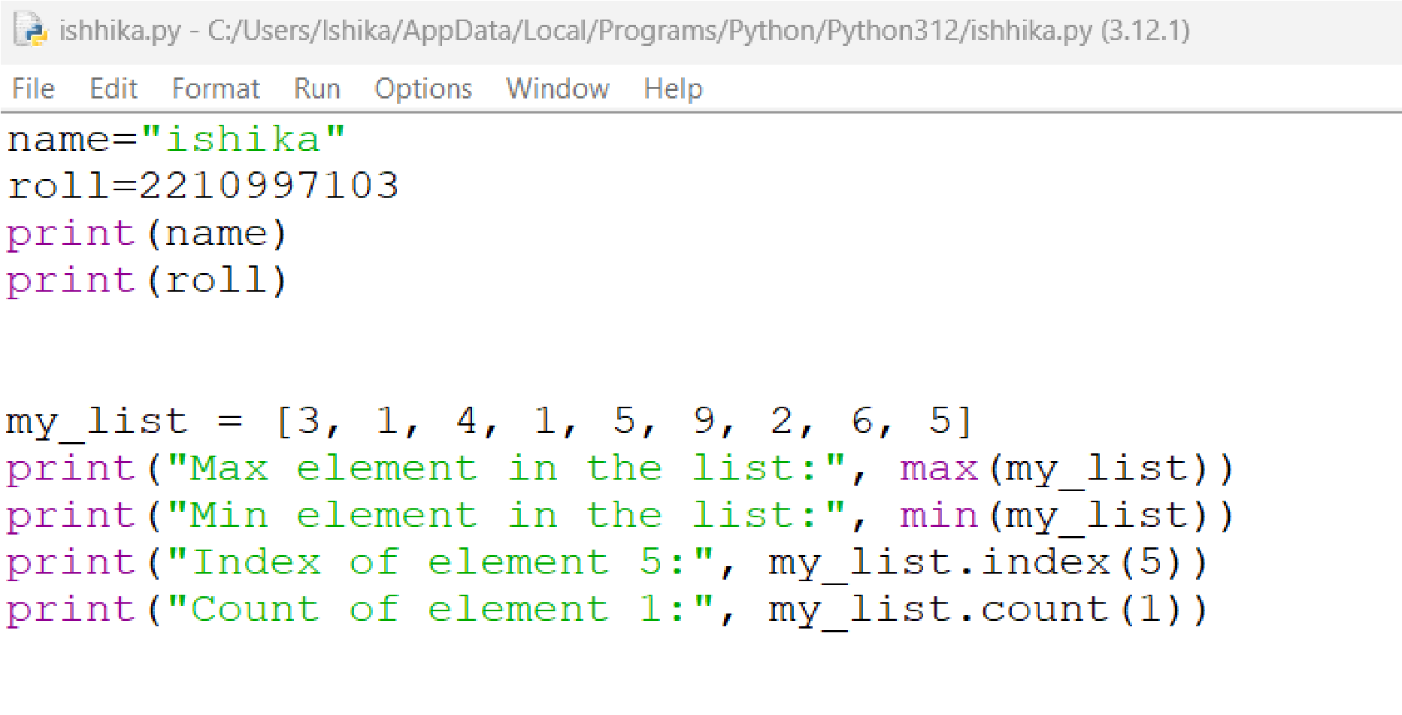

Output:

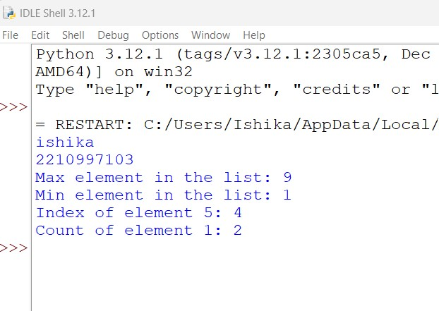

5.6 Program to calculate the mean, variance, and standard deviation of a given list of numbers in Python:

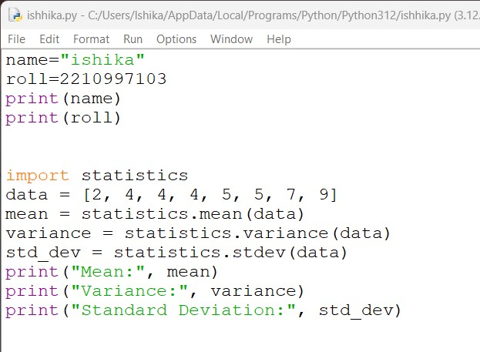

Output:

