BAO CAO THUYET MINH GIAI PHAP DU THI

BLUBLA SPEAKUP
Ung dung Chatbot da tro ly AI ho tro ren luyen phan xa
giao tiep tieng Anh danh cho hoc sinh THCS

Linh vuc: Phan mem tin hoc va chuyen doi so
Dia chi truy cap: blublaspeakup.io.vn

MUC LUC
1. Ten giai phap du thi
2. Muc dich cua giai phap
3. Mo ta giai phap
4. Tinh moi, tinh sang tao
5. Noi dung thuc hien
6. Huong dan su dung, van hanh mo hinh, san pham
7. Kha nang ap dung vao thuc tien
8. Gia tri mang lai cua giai phap
9. Ket luan va kien nghi
Phu luc tai lieu minh hoa

1. TEN GIAI PHAP DU THI
Ten chinh thuc: BLUBLA SPEAKUP - Ung dung Chatbot da tro ly AI ho tro ren luyen phan xa giao tiep tieng Anh danh cho hoc sinh THCS.
Linh vuc dang ky du thi: Phan mem tin hoc va chuyen doi so.

2. MUC DICH CUA GIAI PHAP
Hien nay, nhieu hoc sinh gap kho khan khi ren luyen ky nang giao tiep tieng Anh. Rao can lon nhat chinh la tam ly so sai, so bi che cuoi ve phat am hay ngu phap, khien cac ban hoc sinh tro nen e de va ngai mo loi. Ben canh do, si so lop hoc thuong rat dong, giao vien kho co du thoi gian de huong dan thuc hanh cho tung ca nhan trong tiet hoc ngan. Hon nua, chi phi tai cac trung tam ngoai ngu hien nay con kha cao. Dieu nay vo tinh tao ra khoang cach trong viec tiep can giao duc chat luong.
Tu nhung phan tich thuc trang noi tren, nhom tac gia xay dung ung dung Blubla SpeakUp nham huong toi cac muc tieu chien luoc sau:
1. Giam ap luc tam ly: Blubla SpeakUp tao ra mot khong gian giao tiep rieng tu voi AI. Tai day, nguoi hoc co the thoai mai thuc hanh ma khong lo so bi danh gia hay cham diem.
2. Ren luyen phan xa moi luc: Voi kha nang tuong tac giong noi 24/7, ung dung mo phong cac tinh huong thuc te de nguoi hoc luyen tap thuong xuyen.
3. Tiep can cong nghe de dang: Nhom tac gia tan dung suc manh cua cac dich vu AI mien phi de tao ra mot cong cu luyen nghe - noi de tiep can cho hoc sinh co dieu kien kho khan.

3. MO TA GIAI PHAP

3.1. Ban chat cua giai phap
Xuat phat tu thuc trang hoc sinh THCS thuong co rao can tam ly 'so sai, ngai giao tiep' khi thuc hanh ngoai ngu, nhom tac gia da nghien cuu va phat trien nen tang BLUBLA SPEAKUP. Day la mot ung dung nen web (Web App) duoc tich hop cong nghe Tri tue nhan tao Da tro ly. Ban chat cua giai phap la tao ra mot moi truong dam thoai Anh ngu gia lap an toan, cho phep nguoi hoc tuong tac truc tiep voi cac 'nhan vat ao ban xu' qua ca giong noi va van ban, tu do thuc day phan xa ngon ngu tu nhien.

3.2. Cau truc va co che hoat dong ky thuat
Giai phap duoc nhom tac gia ke thua va phat trien tu ma nguon mo py-xiaozhi (ngon ngu lap trinh Python). Thong qua phuong phap lap trinh co su ho tro cua AI (Vibe Coding), nhom tac gia da tai cau truc toan dien, nang cap he thong tu mot phan mem yeu cau cai dat cuc bo tren may tinh thanh mot Web App linh hoat, co the dung truc tiep tren trinh duyet o nhieu loai thiet bi (may tinh, dien thoai, may tinh bang) thong qua dia chi chinh thuc blublaspeakup.io.vn.
Diem dot pha ve mat kien truc phan mem la viec thiet ke 02 luong AI hoat dong song song, toi uu hoa hoan toan tu cac tai nguyen AI mien phi:
- Luong dam thoai (Stream A): Su dung API tu may chu Tenclass (Xiaozhi.me). Luong nay dam nhiem vai tro 'nhap vai' nhan vat, xu ly ngon ngu tu nhien, lang nghe giong noi cua hoc sinh va phan hoi bang am thanh ket hop cung hop thoai tin nhan hien thi truc tiep.
- Luong tro ly su pham (Stream B): Tich hop API Groq Cloud voi cac mo hinh ngon ngu lon hieu nang cao (nhu LLaMA-3). Luong nay chay ngam doc lap, dong vai tro nhu mot bo vi xu ly giam sat, lien tuc phan tich boi canh hoi thoai de thuc hien nhiem vu dich thuat va trich xuat cau goi y giao tiep, nhac bai cho hoc sinh theo thoi gian thuc.

3.3. Cac tinh nang cot loi
Da dang hoa nhan vat dam thoai (Persona Ecosystem): He thong tich hop he sinh thai nhieu AI mang tinh cach va chuc danh khac nhau (Co giao Anna day phong van, Le tan Sophia khach san, Nhan vien san bay David, Tro ly mua sam Emily...). Co che nay dat nguoi hoc vao cac mo hinh giao tiep theo tinh huong bam sat thuc tien.
Co che nhac bai thong minh (Smart Hint System): Trong suot qua trinh giao tiep, he thong (thong qua Luong B) se lien tuc nam bat toan bo ngu canh cua cac luot hoi thoai truoc do. Dua tren nguon du lieu nay, AI se tu dong tong hop va de xuat san cac mau cau tra loi kha thi, dong thoi cung cap cong cu dich thuat hai chieu.
Tro choi hoa dua tren viec thuc day su tu tin: Di nguoc lai voi phuong phap cham diem truyen thong, thuat toan cua BLUBLA SPEAKUP uu tien cong diem dua tren su dan di va tan suat chu dong giao tiep (so luong tin nhan thoai trao doi).

3.4. Khac phuc nhuoc diem cua cac giai phap da biet
Bang tong hop cac diem cai tien cua BLUBLA SPEAKUP so voi cac giai phap hien co:
Tieu chi | Ma nguon goc (py-xiaozhi) | Phan mem hoc tieng Anh khac | BLUBLA SPEAKUP
Nen tang van hanh | Cai dat phuc tap tren may tinh | Ung dung dien thoai / Web dong kin | Web App tien loi, da nen tang
Kien truc AI | 01 luong AI don nhiem | Kich ban (Script) hoi thoai tinh | 02 luong AI song song
Moi truong dam thoai | 01 nhan vat tro ly duy nhat | Hoi thoai rap khuon | He sinh thai Persona da dang
Triet ly danh gia | Khong tich hop danh gia | Sua loi khat khe, tao ap luc | Cham diem su tu tin
Chi phi su dung | Mien phi (phan cung cao) | Phi ban quyen dat | Hoan toan mien phi

4. TINH MOI, TINH SANG TAO

4.1. Tinh moi ve mat cong nghe
Ung dung 'Vibe Coding' de vuot qua gioi han ky thuat: La hoc sinh THCS, nhom tac gia da ap dung phuong phap 'Vibe Coding' - tap trung vao tu duy giai quyet van de, dinh hinh ro y tuong va chuc nang, sau do su dung AI nhu mot tro ly dac luc de doc hieu, tinh chinh va ket noi ma nguon mo.
Co che hai luong AI hoat dong song song: Diem sang tao la phan chia cong viec cho hai AI hoat dong dong thoi. Luong AI thu nhat (Tenclass) chuyen dong vai nhan vat de dam thoai va phat am. Luong AI thu hai (Groq Cloud) am tham chay phia sau lam nhiem vu phan tich ngu canh, dich thuat va goi y cau.
Cau hinh tu dong ket noi tu xa qua Device Pool: Diem sang tao dot pha o backend la viec xay dung he quan tri Be thiet bi ao (Device Pool). He thong da loai bo hoan toan rao can ky thuat cua phien ban goc bang cach tu dong hoa quy trinh thue va dong bo ket noi ao tu xa.

4.2. Tinh sang tao trong trai nghiem hoc tap
Doi moi cach cham diem de xoa bo noi so: BLUBLA SPEAKUP sang tao ra co che thi dua tap trung vinh danh su tu tin. He thong uu tien cong diem cho su dan di, toc do duy tri hoi thoai va tan suat chu dong giao tiep.
Tinh nang nhac bai tu dong: Bang viec tan dung luong AI thu hai de lien tuc theo doi noi dung cuoc tro chuyen, he thong luon tu dong tong hop va chuan bi san cac mau cau tra loi goi y cung cong cu dich nghia hai chieu.
Thuc hanh giao tiep qua nhap vai: He thong mang den mot loat cac 'nhan vat ao' voi nghe nghiep ro rang (nhan vien san bay, tiep tan khach san, thu ngan...).

5. NOI DUNG THUC HIEN

5.1. Qua trinh phat trien va cach thuc xay dung ung dung
Giai doan 1 - Khao sat thuc trang va dinh hinh giai phap: Nhom tac gia da tien hanh khao sat tren quy mo 400 hoc sinh tai truong de tim hieu kho khan trong viec hoc tieng Anh. Ket qua cho thay ky nang nghe, noi va phan xa dam thoai la rao can lon nhat.
Giai doan 2 - Lap trinh ung dung va xu ly su co ky thuat voi su ho tro cua AI: De chuyen doi ma nguon cuc bo thanh ung dung Web va tich hop he thong 02 luong AI, nhom tac gia da lap trinh duoi su ho tro cua AI thong qua moi truong Antigravity.
Giai doan 3 - Tinh chinh va hoan thien giao dien: Khi kien truc phan mem da on dinh, nhom tac gia tap trung viet cac cau lenh he thong de tao tinh cach cho cac nhan vat dam thoai va xay dung thuat toan cho he thong thi dua.

5.2. Thoi gian va ket qua thu nghiem thuc te
San pham duoc dua vao thu nghiem thuc te voi 14 hoc sinh trong thoi gian lien tuc 01 tuan. Nhom tac gia thuc hien danh gia nang luc va tam ly thong qua 02 bai khao sat truoc va sau khi su dung. Qua mot tuan thu nghiem, co khoang 40% hoc sinh duy tri viec tuong tac deu dan voi ung dung va hoan thanh tron ven lo trinh.

6. HUONG DAN SU DUNG, VAN HANH MO HINH, SAN PHAM

6.1. Quy trinh su dung va hoc tap danh cho Hoc sinh
Buoc 1: Truy cap ung dung tai dia chi chinh thuc: blublaspeakup.io.vn tren trinh duyet web.
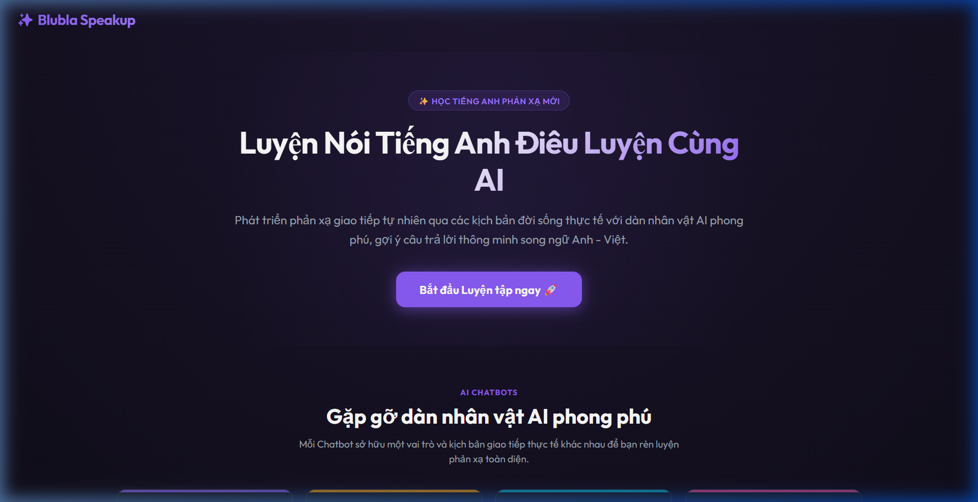
Hinh 6.1: Trang chu ung dung BLUBLA SPEAKUP tai blublaspeakup.io.vn
Trang chu gioi thieu dan nhan vat AI phong phu voi cac vai tro va kich ban giao tiep thuc te khac nhau:
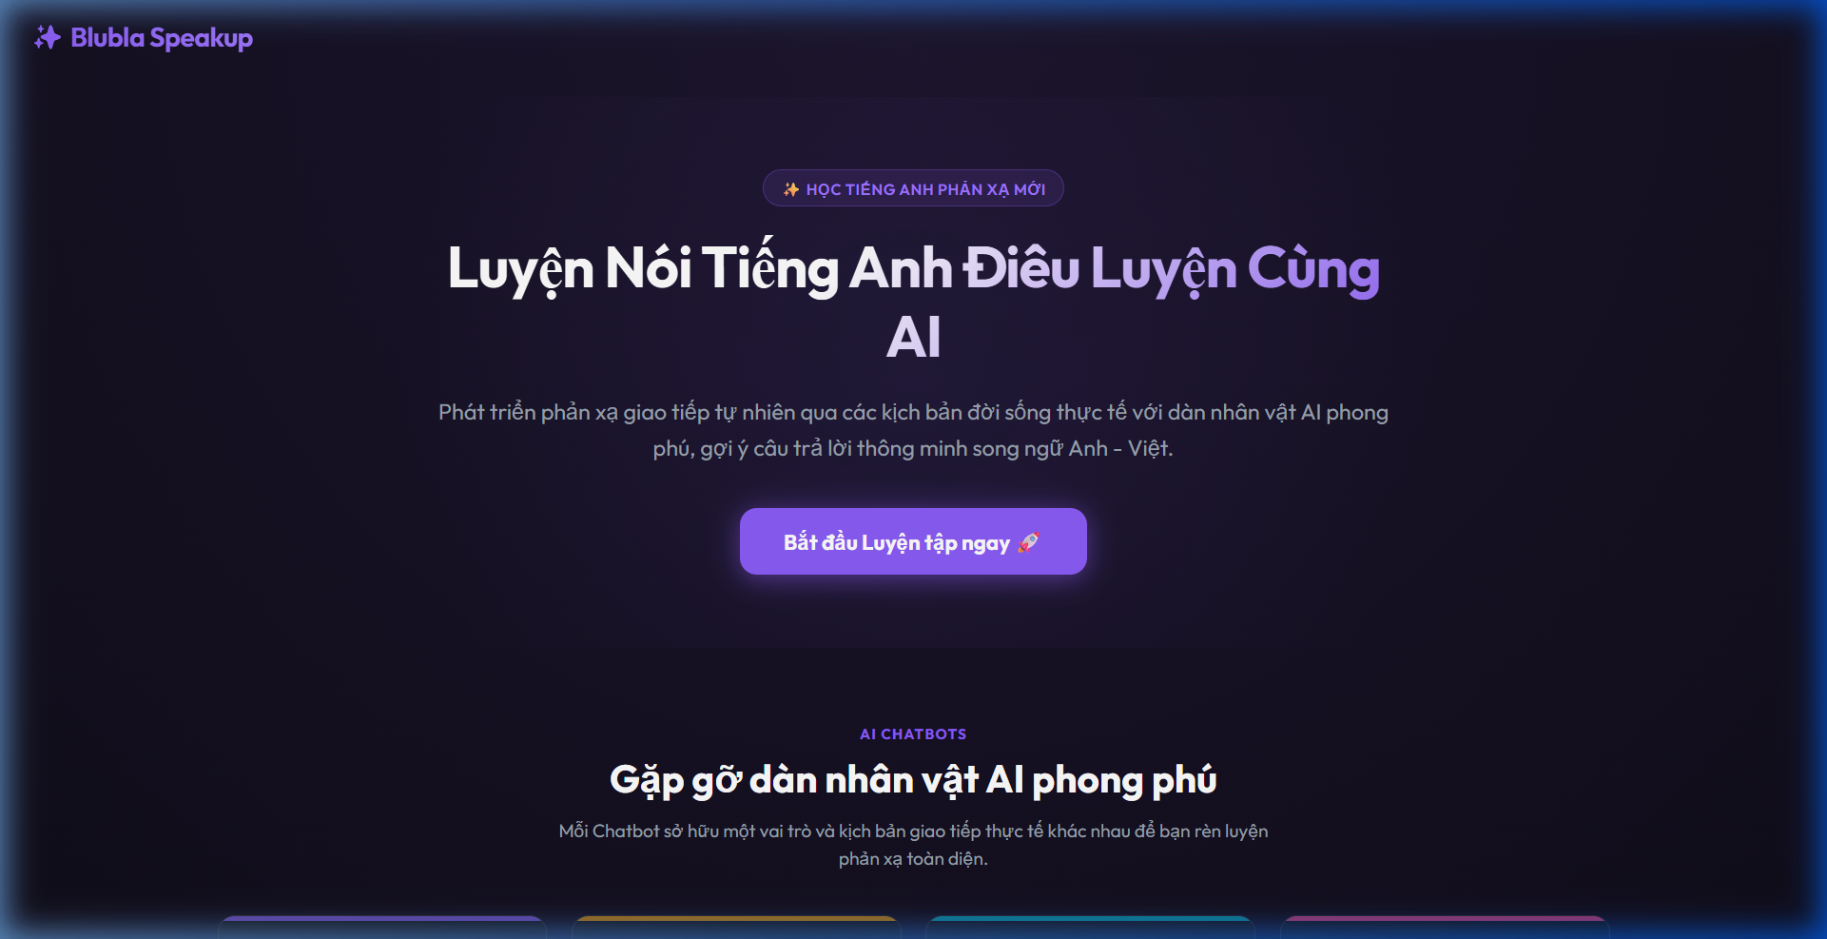
Hinh 6.2: Khu vuc gioi thieu cac nhan vat AI Chatbot
Buoc 2: Dang nhap he thong bang tai khoan ca nhan duoc giao vien cap.
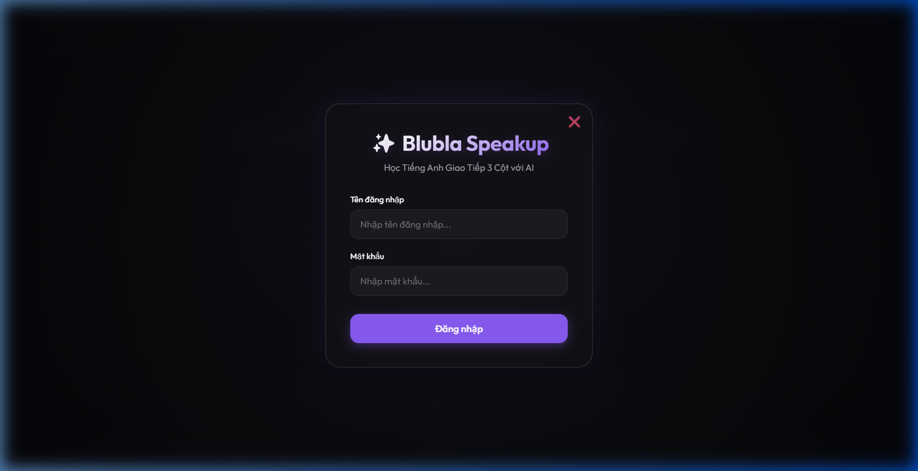
Hinh 6.3: Giao dien dang nhap he thong
Buoc 3: Tai giao dien chinh, chon nhan vat AI phu hop voi muc tieu luyen tap. Su dung tinh nang thu am truc tiep (Voice) de dam thoai voi AI.
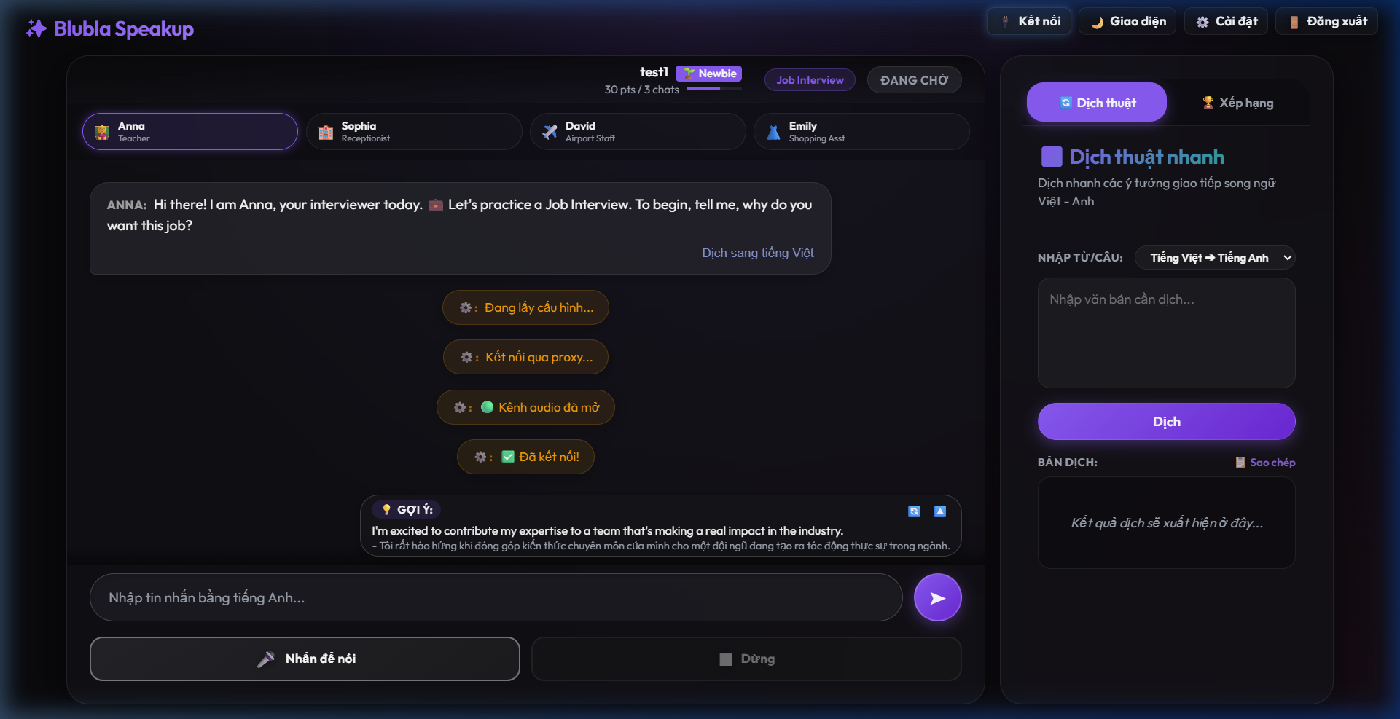
Hinh 6.4: Giao dien chinh cua hoc sinh - Khung dam thoai 3 cot
Buoc 4: Theo doi tien trinh hoc tap, tich luy diem so su tu tin va bang xep hang thi dua.
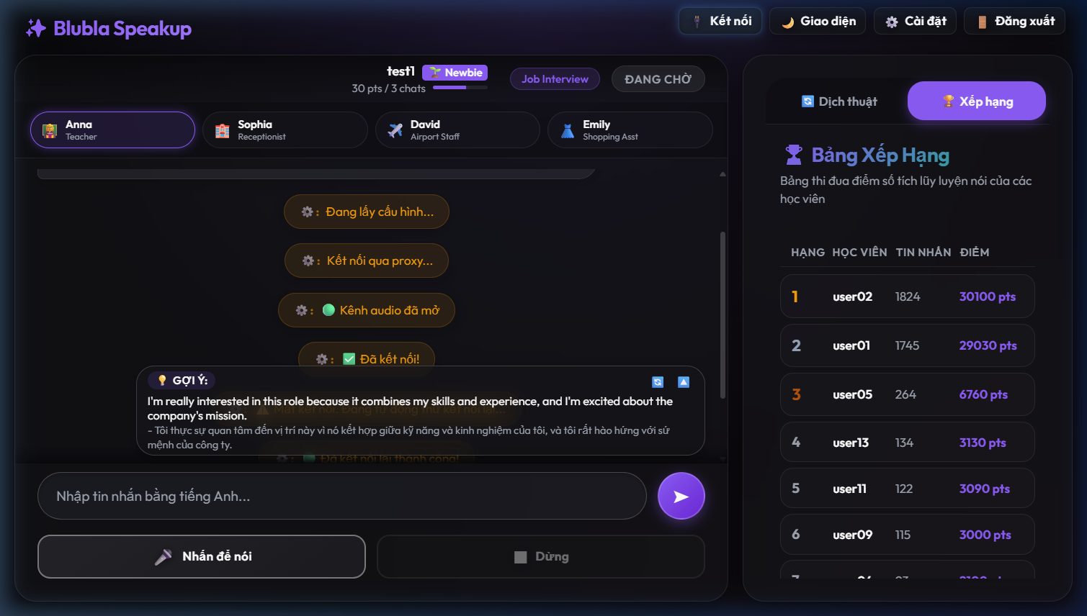
Hinh 6.5: Bang xep hang thi dua (Leaderboard)

6.2. Quy trinh van hanh va kiem tra danh cho Giao vien / Ban Giam Khao
Duong dan trai nghiem: https://blublaspeakup.io.vn
Tai khoan quan tri (Admin): admin / Mat khau: admin123
Sau khi dang nhap tai khoan quan tri, nhap vao bieu tuong Admin o thanh cong cu phia tren ben phai man hinh de truy cap Bang quan tri tap trung:
Tab Quan ly tai khoan:
Xem danh sach, tao don le hoac tao hang loat tai khoan hoc sinh nhanh chong bang Prefix, doi mat khau chung, xoa tai khoan, hoac xuat tep CSV du lieu diem.
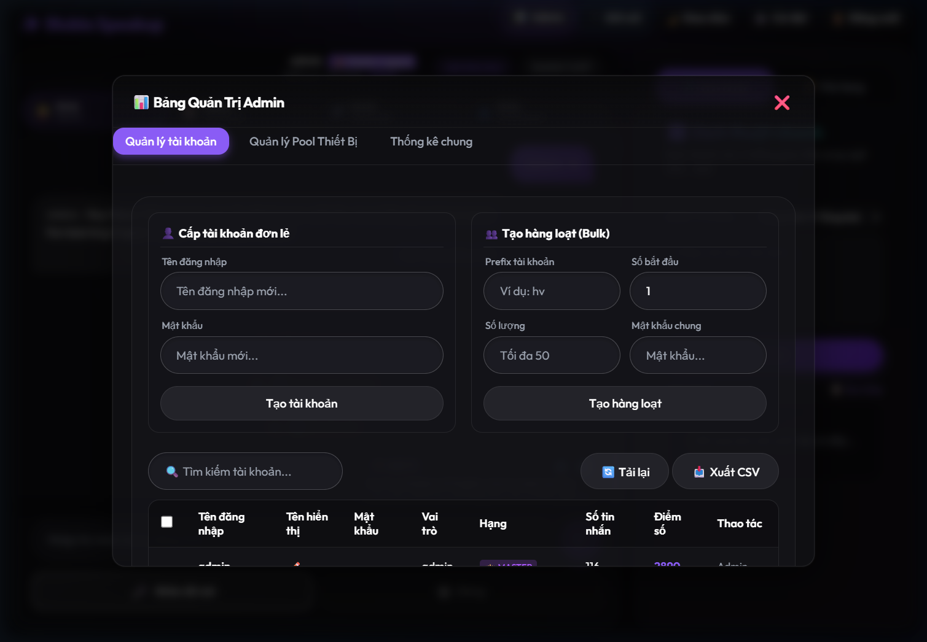
Hinh 6.6: Bang quan tri - Tab Quan ly Tai khoan
Tab Quan ly Pool thiet bi:
Quan ly danh sach ket noi thiet bi ao dam thoai, theo doi chi so ban/ranh theo thoi gian thuc va kich hoat them tai nguyen ket noi.
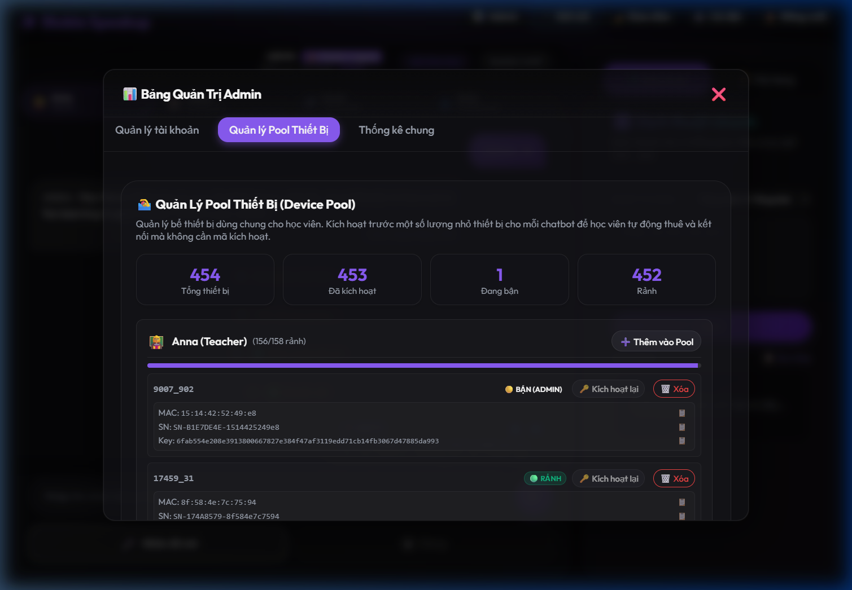
Hinh 6.7: Bang quan tri - Tab Quan ly Pool ket noi thiet bi ao
Tab Thong ke chung:
Giam sat tong diem toan lop, xem bieu do phan bo thu hang va danh sach hoc vien tieu bieu.
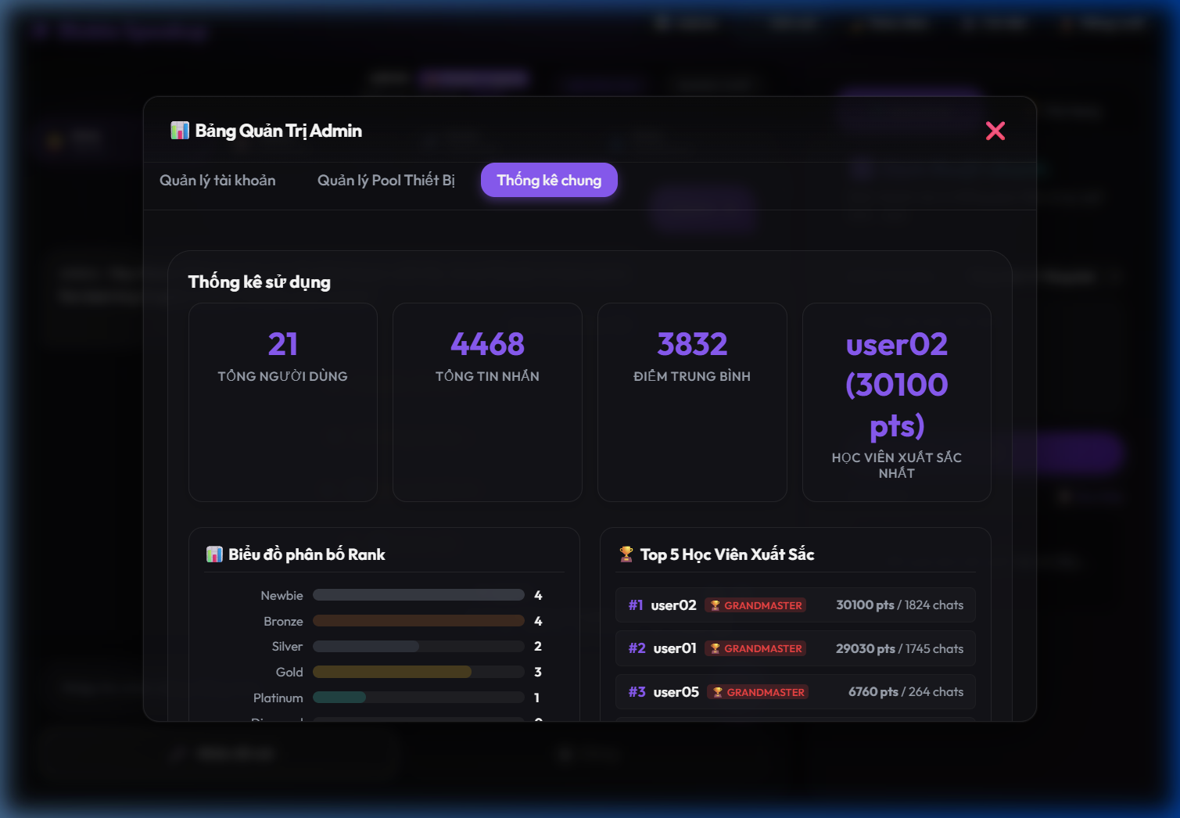
Hinh 6.8: Bang quan tri - Tab Thong ke chung

6.3. Co che tu dong hoa lien ket thiet bi ao thay the phan cung vat ly
Nhan thay viec yeu cau moi hoc sinh phai trang bi mot thiet bi phan cung ESP32 vat ly la khong kha thi va gay rao can lap dat, nhom tac gia da phan mem hoa thiet bi vat ly thanh thiet bi ao (Virtual Device) chay truc tiep tren trinh duyet cua nguoi dung:
Gia lap luong am thanh Opus: Trinh duyet Web tu dong lam nhiem vu thu nhan am thanh tu micro, nen truc tiep sang codec nen Opus (16kHz) va day nhi phan qua WebSocket, gia lap hoan hao phan cung vat ly.
Co che cap phat tu dong (Device Pool API): Thay vi bat buoc hoc sinh phai dang nhap vao xiaozhi.me de nhap ma kich hoat thiet bi thu cong, backend Node.js cua Blubla SpeakUp tu dong ket noi va quan ly be ket noi. Khi hoc sinh bam chon chatbot, API /api/pool/lease se tu dong tim kiem mot thiet bi ao dang ranh trong tep pools.json, cap nhat thong tin cho thue va gui cau hinh (MAC, SN, HMAC Key) ve cho trinh duyet thiet lap bat tay.
Cong Proxy Cloudflare Worker: Khac phuc nhuoc diem trinh duyet khong cho chen Header HTTP tuy chinh (Device-Id, Client-Id) vao WebSocket handshake. Trinh duyet se ket noi WebSocket den Cloudflare Worker Proxy de chen cac Header bao mat can thiet truoc khi ket noi truc tiep den may chu dam thoai Tenclass.

6.4. So do kien truc he thong va luong du lieu
So do kien truc tong the he thong BLUBLA SPEAKUP:
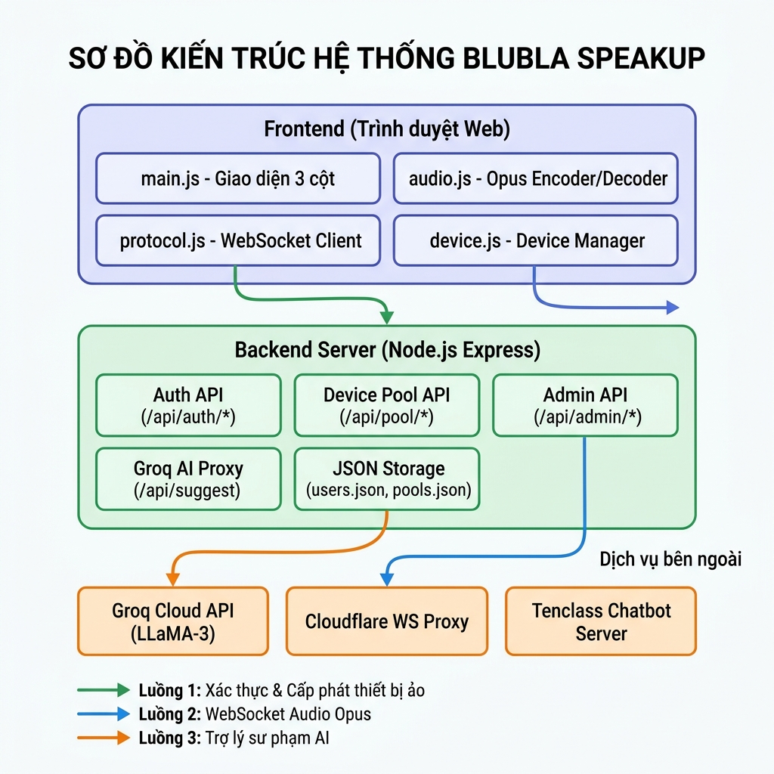
Hinh 6.9: So do kien truc tong the he thong BLUBLA SPEAKUP
He thong BLUBLA SPEAKUP van hanh thong qua su ket hop cua 03 luong du lieu chay song song, doc lap:
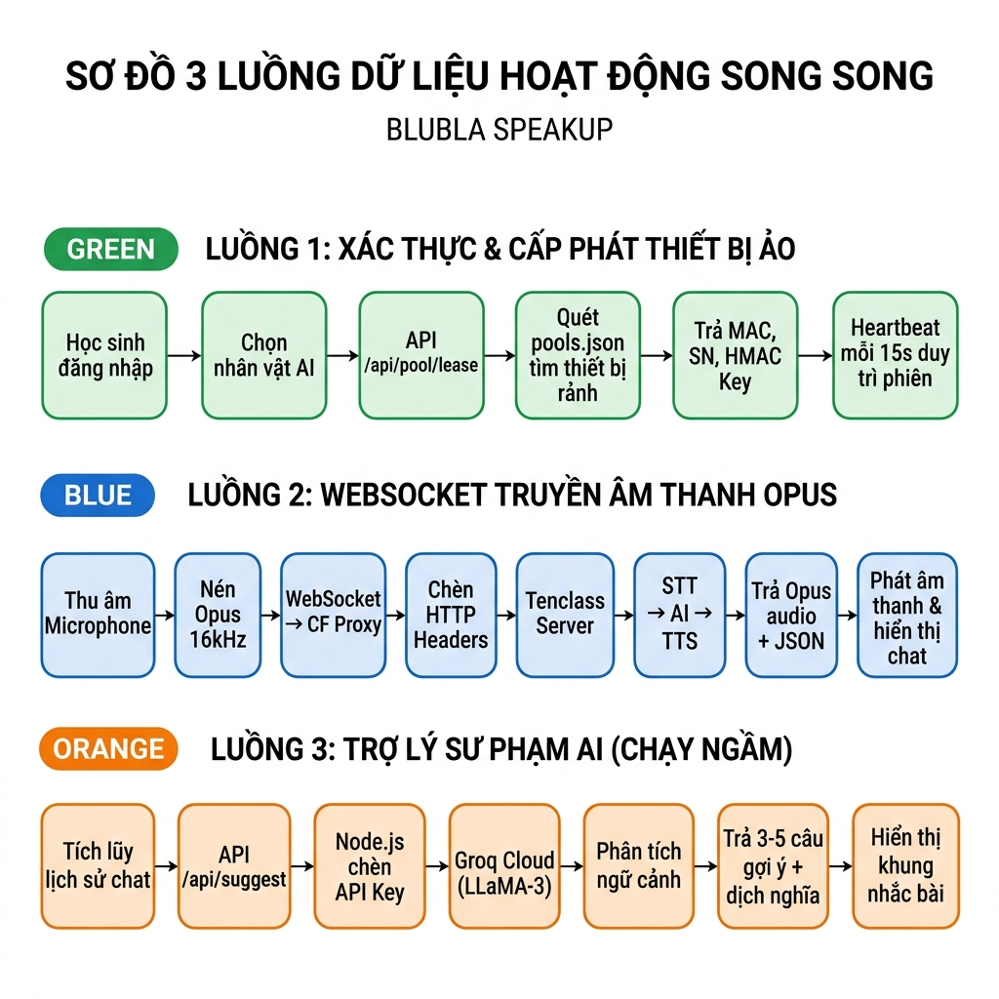
Hinh 6.10: So do 3 luong du lieu hoat dong song song cua he thong
Luong 1 - Xac thuc va Cap phat Thiet bi ao tu dong (Auth & Device Leasing Flow):
Khi hoc sinh dang nhap va chon mot chatbot, Web App gui yeu cau thue thiet bi ao len API /api/pool/lease. Server Node.js quet danh sach thiet bi ao da duoc kich hoat truoc trong be thiet bi ao (pools.json), tim kiem thiet bi ranh, ghi nhan thiet bi da duoc thue boi hoc sinh do va tra thong tin cau hinh (MAC, Serial Number, HMAC Key) ve cho trinh duyet. Trinh duyet bat dau dam thoai va gui nhip tim (heartbeat) duy tri phien thue moi 15-20 giay.
Luong 2 - WebSocket truyen am thanh Opus (WebSocket Audio Flow):
Trinh duyet khoi tao ket noi WebSocket den Cloudflare Worker Proxy, truyen cac tham so cau hinh thiet bi ao da thue. Cloudflare Worker Proxy thuc hien bat tay voi may chu Tenclass, tu dong chuyen doi cac tham so thanh cac HTTP Header bat buoc. Khi hoc sinh bam giu nut noi, Web Audio API thu am thanh tu micro, audio.js thuc hien ma hoa Opus thoi gian thuc va truyen cac goi tin nhi phan qua ket noi WebSocket. May chu Tenclass nhan luong am thanh, xu ly Voice-to-Text, tao cau tra loi dam thoai bang AI, chuyen van ban tra loi thanh giong noi tu nhien roi truyen luong am thanh Opus va thong diep JSON tuong ung tro lai.
Luong 3 - Tro ly su pham phan tich ngam (Pedagogical Groq Cloud Stream):
Khi co bat ky tin nhan thoai moi nao duoc hien thi o cot giua dam thoai, Web App ghi nhan lai toan bo lich su cac luot hoi thoai truoc do. Web App gui ngam mang lich su tro chuyen nay len API /api/suggest cua backend Node.js. Server Node.js chen API Key Groq bao mat cung System Prompt dinh huong su pham. Groq API xu ly bang mo hinh ngon ngu lon (LLaMA-3) cuc nhanh va tra ket qua dang JSON chua cac cau goi y ve cho Web App. Giao dien nguoi dung lap tuc hien thi cac cau goi y len Khung nhac bai cua hoc sinh.

7. KHA NANG AP DUNG VAO THUC TIEN

7.1. Truoc khi ap dung (Pre-test)
Ket qua khao sat dau vao doi voi 14 hoc sinh cho thay phan lon cac ban deu gap kho khan lon trong viec nghe - noi. Tro ngai chinh la tam ly e ngai, so phat am sai, so vi pham ngu phap va hoan toan thieu mot moi truong an toan de thuc hanh dam thoai hang ngay.

7.2. Trong va Sau khi ap dung (Post-test)
Ung dung ghi nhan muc do tuong tac thuc te kha kha quan. Trong so 14 hoc sinh tham gia, co khoang 40% (tuong duong 5-6 ban) da hinh thanh va duy tri thoi quen truy cap, dam thoai deu dan voi AI trong suot tuan. Du lieu khao sat dau ra cho thay su cai thien ro ret, dac biet o nhom hoc sinh duy tri su dung thuong xuyen.
Bieu do truc quan the hien su cai thien ro ret cac chi so tam ly va thuc hanh truoc va sau khi su dung giai phap:
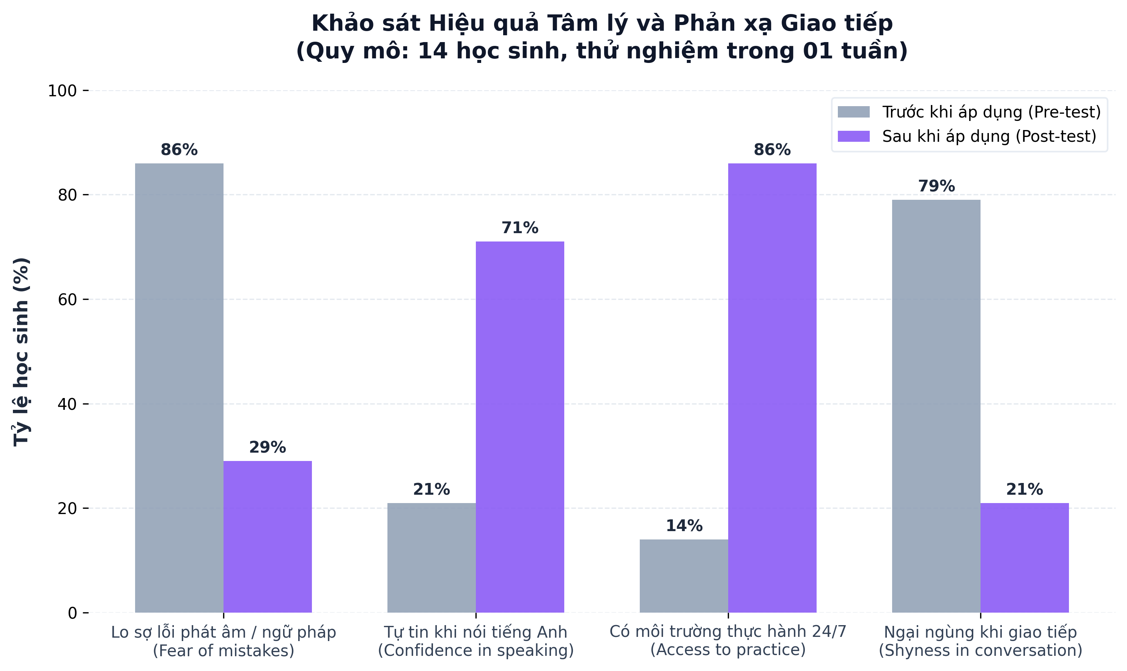
Hinh 7.1: Bieu do so sanh Pre-test va Post-test (14 hoc sinh, 01 tuan)
Bang tong hop chi tiet muc do thay doi nang luc va tam ly:
Chi so khao sat | Truoc khi ap dung | Sau khi ap dung | Xu huong thay doi
Lo so loi phat am / ngu phap | 86% | 29% | Giam 57%
Cam thay ngai ngung khi noi | 79% | 21% | Giam 58%
Co moi truong thuc hanh 24/7 | 14% | 86% | Tang 72%
Tu tin khi noi tieng Anh giao tiep | 21% | 71% | Tang 50%

7.3. Minh hoa Bang xep hang Thi dua (Leaderboard)
Hoc sinh tich cuc tham gia luyen noi se duoc cong diem thi dua tu dong. Bang xep hang vinh danh cac ban co so luong tin nhan dam thoai nhieu nhat:
Thu hang | Ten hien thi | Ten tai khoan | So tin nhan | Diem so | Cap do
Hang 1 | Nguyen Minh Triet | test1 | 45 | 450 | Platinum
Hang 2 | Tran Thao Vy | test2 | 32 | 320 | Gold
Hang 3 | Le Tuan Anh | test3 | 25 | 250 | Gold
4 | Admin User | admin | 1 | 10 | Newbie

8. GIA TRI MANG LAI CUA GIAI PHAP

8.1. Gia tri ve Kinh te
Viec ket hop kheo leo ma nguon mo cung cac nen tang API cung cap mo hinh ngon ngu lon mien phi (Tenclass va Groq Cloud) giup kien tao mot ung dung hoc tap tieng Anh voi chi phi van hanh gan nhu bang khong. Hoc sinh chi can mot thiet bi co ket noi internet co ban la da co the tiep can moi truong hoc tap chat luong cao.

8.2. Gia tri ve Ky thuat
Giai phap minh chung cho kha nang hoat dong on dinh cua he sinh thai tich hop hai luong AI chay song song. Su thanh cong cua du an thong qua phuong phap Vibe Coding la minh chung cho viec hoc sinh hoan toan co the su dung AI nhu mot tro ly lap trinh dac luc de vuot qua gioi han ky thuat ban than.

8.3. Gia tri ve Xa hoi va Giao duc
Voi co che thi dua dua tren thuc day su tu tin thay vi bat loi, ung dung mang lai gia tri to lon ve mat tinh than, giup hoc sinh THCS coi bo tam ly 'so sai, ngai noi'. Giai phap tao ra mot moi truong dam thoai da tinh huong sat voi thuc te, mang lai co hoi luyen tap cung 'nguoi ban xu ao' cho tat ca hoc sinh, dac biet huu ich voi nhung ban chua co dieu kien tai chinh de theo hoc tai cac trung tam ngoai ngu.

9. KET LUAN VA KIEN NGHI

9.1. Ket luan
Qua qua trinh nghien cuu, xay dung va thu nghiem, giai phap BLUBLA SPEAKUP da dat duoc nhung muc tieu cot loi ban dau de ra: San pham buoc dau giai quyet duoc kho khan lon nhat cua hoc sinh khi hoc ngoai ngu la rao can tam ly 'so noi, so sai'. Bang cach cung cap mot moi truong dam thoai ao an toan, ket hop giua co che goi y va phuong phap thi dua dua tren su tu tin, ung dung da thuc su mang lai nhung chuyen bien tich cuc, giup nguoi hoc dan di hon trong thuc te.

9.2. Kien nghi va Huong phat trien
Bo sung cac chu de 'bat trend' tuoi hoc tro: Lap trinh them cac AI dong vai nhung nguoi ban co cung so thich voi lua tuoi THCS: AI thich ban luan ve tro choi dien tu (e-sports), AI dong vai than tuong am nhac, hay AI lam 'nguoi ban dong hanh' cung chia se ap luc on thi chuyen cap.
Phat trien tinh nang giao luu, thi dau: Ung dung co the phat trien them cac phong chat nhom, noi 2 hoac 3 ban hoc sinh cung tham gia giai quyet mot tinh huong giao tiep do AI dua ra.
Hinh anh hoa cac phong hoi thoai theo ngu canh: Thiet ke them cac hinh nen minh hoa truc quan bam sat chu de (vi du: hinh nen quay le tan khach san, hinh nen phong hoc, hinh nen cua hang...).

PHU LUC TAI LIEU MINH HOA
1. So do cau truc he thong va luong du lieu (Data Flow)
Duoi day la so do kien truc hoat dong song song cua hai luong AI va su tuong tac giua Web App, Cloudflare Proxy, Thiet bi ao va cac API dich vu:

Phu luc 1: So do cau truc he thong va luong du lieu

Phu luc 2: So do 3 luong du lieu hoat dong song song
2. Cam ket tuan thu ban quyen ma nguon mo
Nhom tac gia cam ket tuan thu cac quy dinh ve ma nguon mo va ban quyen cua thu vien goc (py-xiaozhi) theo Dieu 6, Khoan 5, Diem d cua The le cuoc thi:
- Ma nguon goc ke thua: py-xiaozhi (Phat hanh duoi Giay phep MIT).
- Dong gop cai tien cua nhom tac gia: Tai cau truc thanh Web App hoat dong da nen tang, thiet ke luong xu ly AI thu hai song song qua Groq API de chay tinh nang phan tich su pham/nhac bai, tich hop he thong cham diem su tu tin va bang xep hang, xay dung Device Pool de cho thue/quan ly thiet bi ao tu dong tu xa.

