page1image2942528

**Software Design Document**

page1image2942528

Wbay

**Version 1.0 approved**

**Prepared by:**

Sajed Najib Tantush 2211844916

Ibrahim Abdelwahab Elsharif 2211844042

Mohammed Adel Elkilani 2211845885

Mohamed Jallul Aljorni 2211845917

Hayder Ahmed Eljenfawi 2211844655

**University Of Tripoli**

**27/12/2024**

**Revision History**

|  |  |  |  |
| --- | --- | --- | --- |
| **Date** | **Version** | **Description** | **Author** |
|  |  |  |  |
|  |  |  |  |
|  |  |  |  |

Table of Contents

1. INTRODUCTION…………………………………………………4

1.1 Purpose……………………………………………………………………..4

2. DATABASE DESIGN……………………………………………..4

2.1 Entity Relationship Diagram……………………………………………...5

2.2 Data dictionary……………………………………………………………..6

2.2.1 The users_cred Entity………………………………………………………6

2.2.2 The customers Entity……………………………………………………….6

2.2.3 The vendors Entity………………………………………………………….6

2.2.4 The products Entity…………………………………………………………7

2.2.5 The orders Entity……………………………………………………………7

2.2.6 The cart Entity………………………………………………………………7

2.2.7 The rating Entity…………………………………………………………….8

3. USER INTERFACE DESIGN…………………………………….8

3.1 SignIn & SignUp to the web-application…………………………..8

3.2 Admin Interface Page………………………………………………..10

3.3 Vendor Interface Page…………………………………………….13

3.4 Customer Interface Page………………………………………….16

# INTRODUCTION

## Purpose

The Software Design Description (SDD) document describes all of the essential components of the system to satisfy the requirements given by the client. This report is used especially during implementation of the system.

# DATABASE DESIGN

## Entity Relationship Diagram

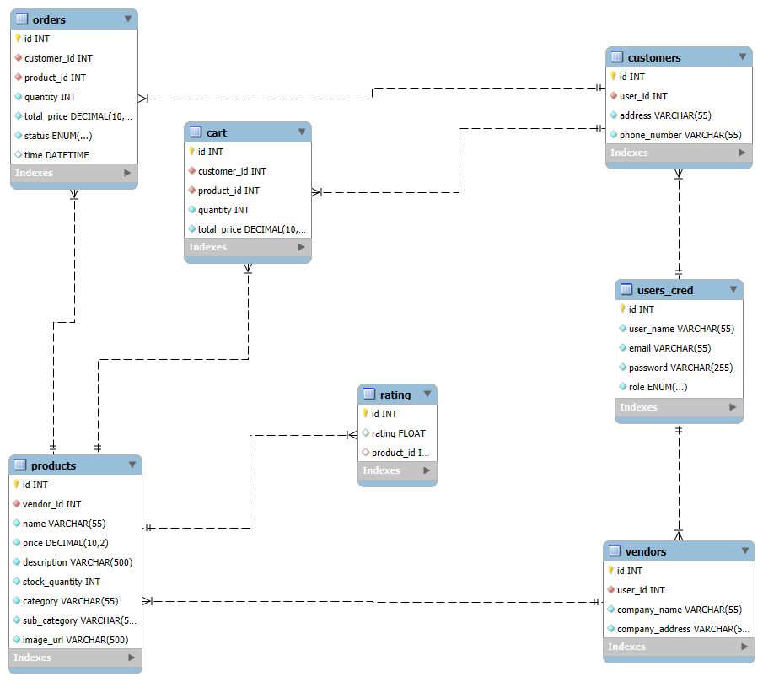

Figure 1. E/R Diagram

## Data dictionary

### 2.2.1 The users_cred Entity

|  |  |  |  |  |
| --- | --- | --- | --- | --- |
| Field name | type | length | primary | foreign |
| id | INT | 4 bytes | √ |  |
| user_name | VARCHAR(55) | 50 bytes |  |  |
| email | VARCHAR(55) | 50 bytes |  |  |
| password | VARCHAR(255) | 255 bytes |  |  |
| role | ENUM(‘customer’, ‘vendor’, ‘admin’) | 1 bytes |  |  |

### 2.2.2 The customers Entity

|  |  |  |  |  |
| --- | --- | --- | --- | --- |
| Field name | type | length | primary | foreign |
| id | INT | 4 bytes | √ |  |
| user_id | INT | 4 bytes |  | √ |
| address | VARCHAR(255) | 255 bytes |  |  |
| phone_number | VARCHAR(255) | 255 bytes |  |  |

### 2.2.3 The vendors Entity

|  |  |  |  |  |
| --- | --- | --- | --- | --- |
| Field name | type | length | primary | foreign |
| id | INT | 4 bytes | √ |  |
| user_id | INT | 4 bytes |  | √ |
| company_name | VARCHAR(55) | 55 bytes |  |  |
| company_address | VARCHAR(55) | 55 bytes |  |  |

### 2.2.4 The products Entity

|  |  |  |  |  |
| --- | --- | --- | --- | --- |
| Field name | type | length | primary | foreign |
| id | INT | 4 bytes | √ |  |
| vendor_id | INT | 4 bytes |  | √ |
| name | VARCHAR(55) | 55 bytes |  |  |
| price | DECIMAL(10,2) | 5 bytes |  |  |
| description | VARCHAR(500) | 500 bytes |  |  |
| stock_quantity | INT | 4 bytes |  |  |
| category | VARCHAR(55) | 55 bytes |  |  |
| sub_category | VARCHAR(55) | 55 bytes |  |  |
| image_url | VARCHAR(500) | 500 bytes |  |  |

### 2.2.5 The orders Entity

|  |  |  |  |  |
| --- | --- | --- | --- | --- |
| Field name | type | length | primary | foreign |
| id | INT | 4 bytes | √ |  |
| customer_id | INT | 4 bytes |  | √ |
| product_id | INT | 4 bytes |  | √ |
| quantity | INT | 4 bytes |  |  |
| total_price | DECIMAL(10,2) | 5 bytes |  |  |
| status | ENUM(‘pending’,’on the way’,’deliverd’,’cancelled’) | 1 bytes |  |  |
| time | DATETIME | 5 bytes |  |  |

### 2.2.6 The cart Entity

|  |  |  |  |  |
| --- | --- | --- | --- | --- |
| Field name | type | length | primary | foreign |
| id | INT | 4 bytes | √ |  |
| customer_id | INT | 4 bytes |  | √ |
| product_id | INT | 4 bytes |  | √ |
| quantity | INT | 4 bytes |  |  |
| total_price | DECIMAL(10,2) | 5 bytes |  |  |

### 2.2.7 The rating Entity

|  |  |  |  |  |
| --- | --- | --- | --- | --- |
| Field name | type | length | primary | foreign |
| id | INT | 4 bytes | √ |  |
| rating | FLOAT | 4 bytes |  |  |
| product_id | INT | 4 bytes |  | √ |

## 3 USER INTERFACE DESIGN

In this section, each user interface is explained along with some screenshots.

## 3.1 SignIn & SignUp to the web-application

This page will be the first page that the user will encounter when they want to access the web-application it is made up of 2 components the Sign in part to the left **Figure 2** and the Sign up part in the right **Figure 3**

* **Sign in**

The sign in component asks for the username and password of the user the data will be processed and checked whether or not the user actually exists in the DB if the user will be redirected to their supposed home page depending on their role.

* **Sign up**

The sign up component asks for username, email and password for both users and depending on the user type (vendor or customer) it will either ask for their address and phone number if they want to create a customer account **Figure 3** or the company name and company address if they want to create a vendor account **Figure 4**

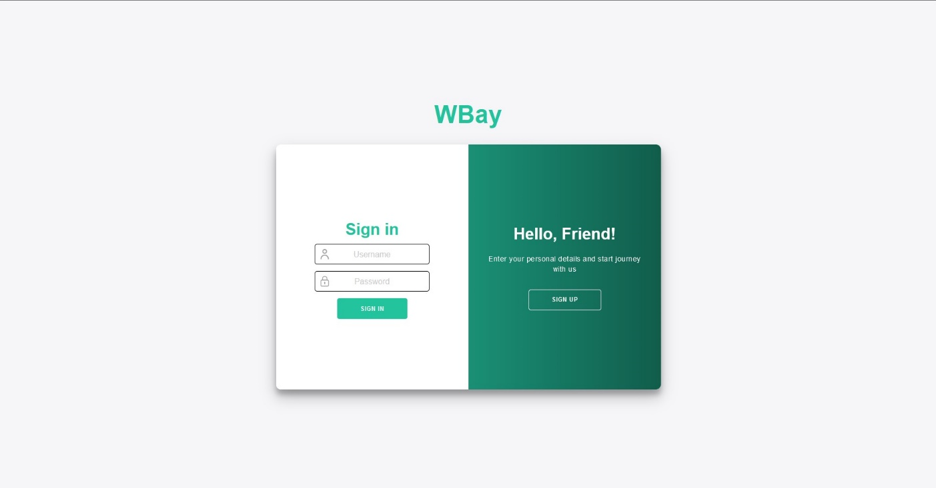

Figure 2 Sign In

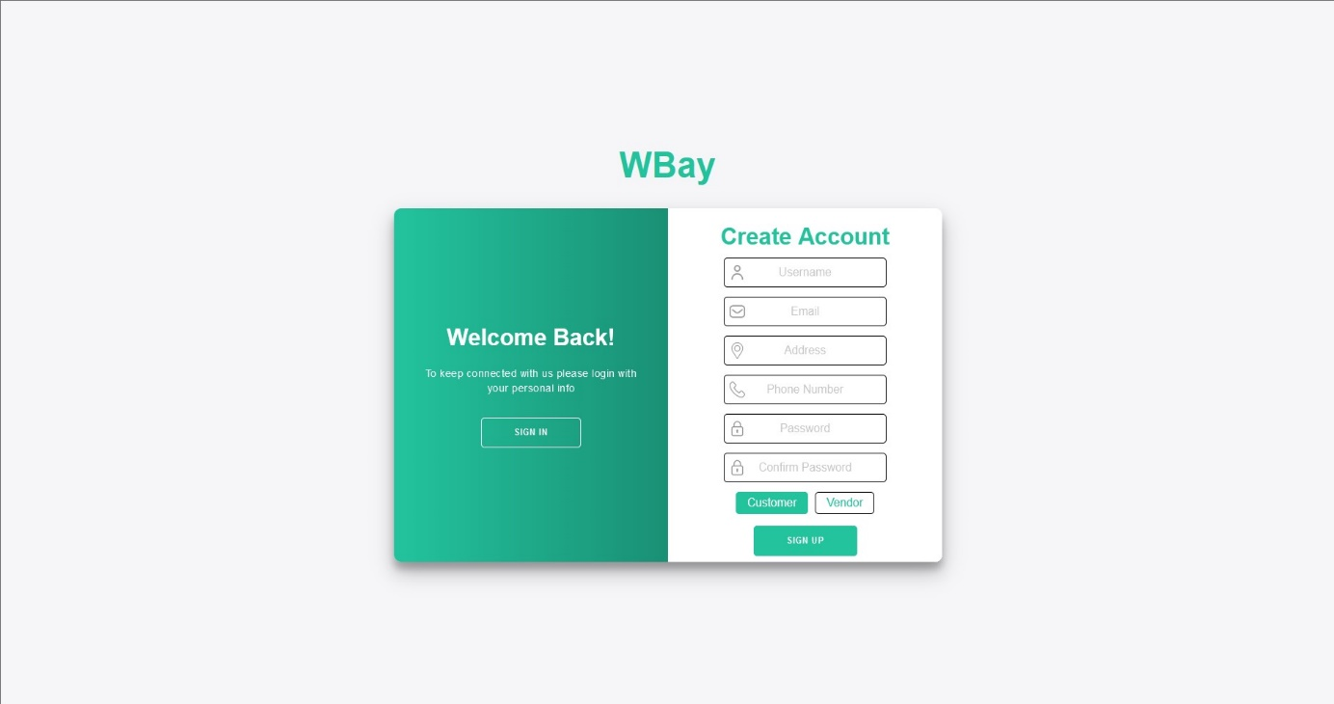

Figure 3 Sign Up Customer

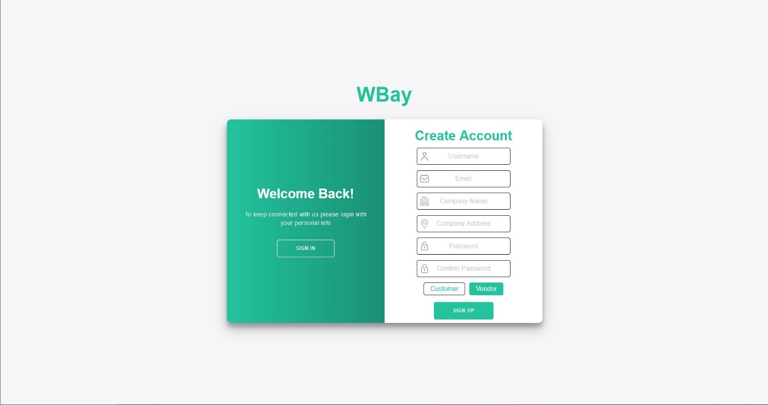

Figure 4 Sign Up Vendor

## 3.2 Admin Interface Page

This page **Figure 5** will only be viewed by the user-class admin it has a nav bar to navigate through different sections such as the User Management Page **Figure 6** and the Manage Products Page **Figure 7** and profile which will only show their profile info and the ability to edit it **Figure 9.**

The main admin page will show the latest added products in the web-Application (around 20 products) which will be pulled by the Search & Product Listing System Feature with the product id

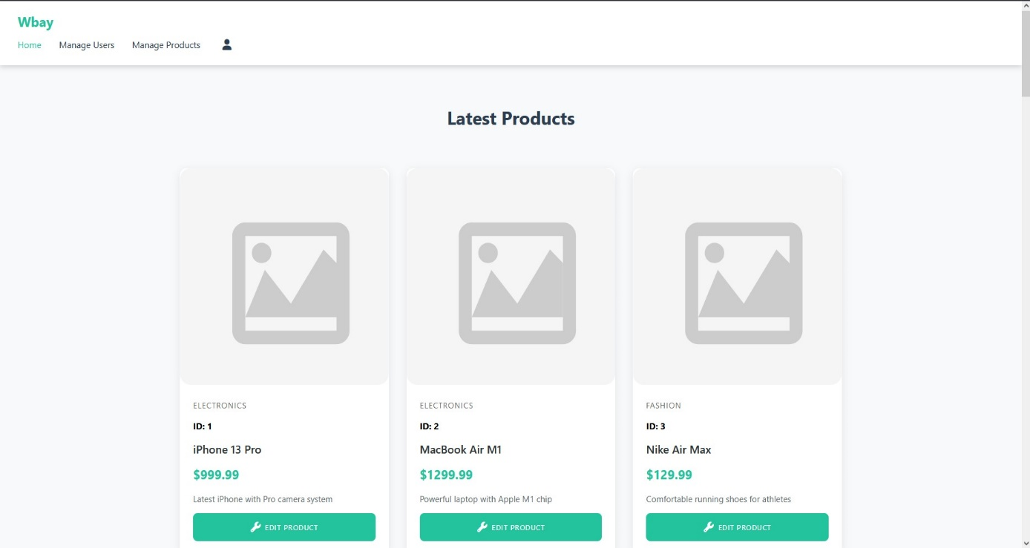

Figure 5. Admin Home

The user management page will display all current users and the ability to terminate their account

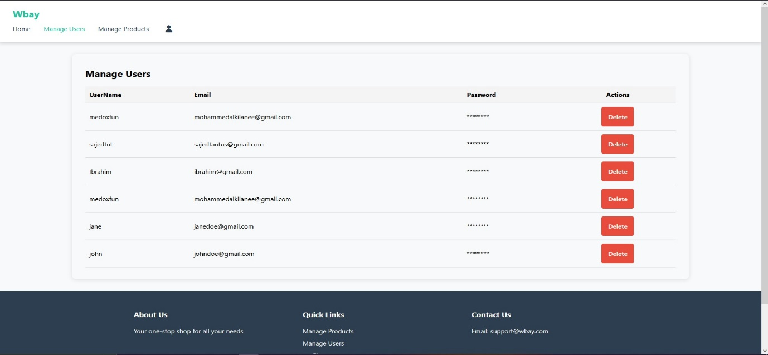

Figure 6 User Management Page

This is the manage products page which will list all available products in the DB and the ability to delete or Edit **Figure 8**

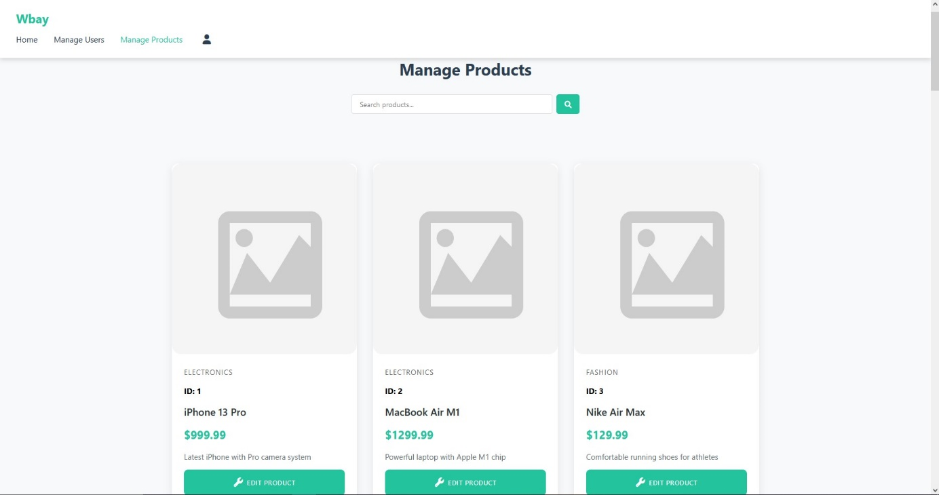

Figure 7 Manage Products Page

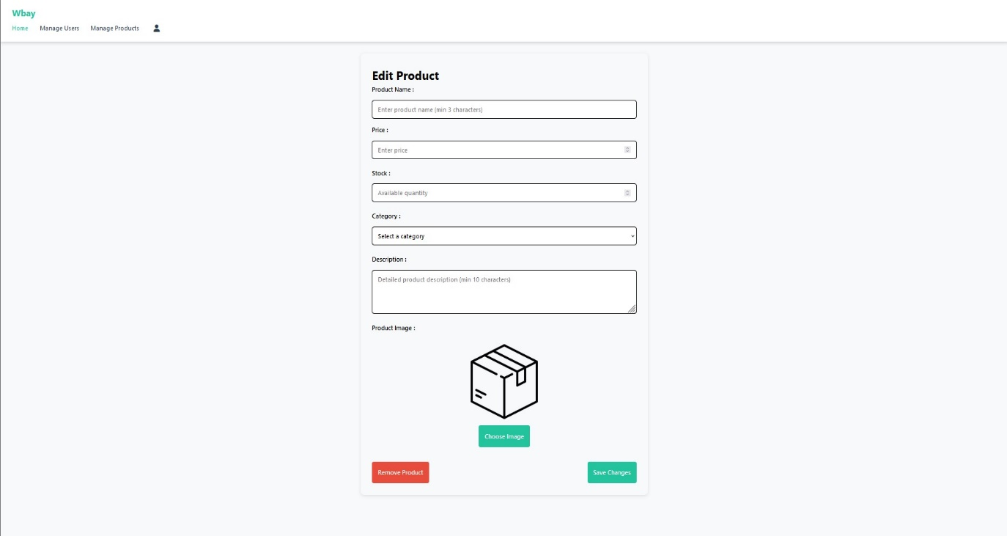

Figure 8 Edit Product Page

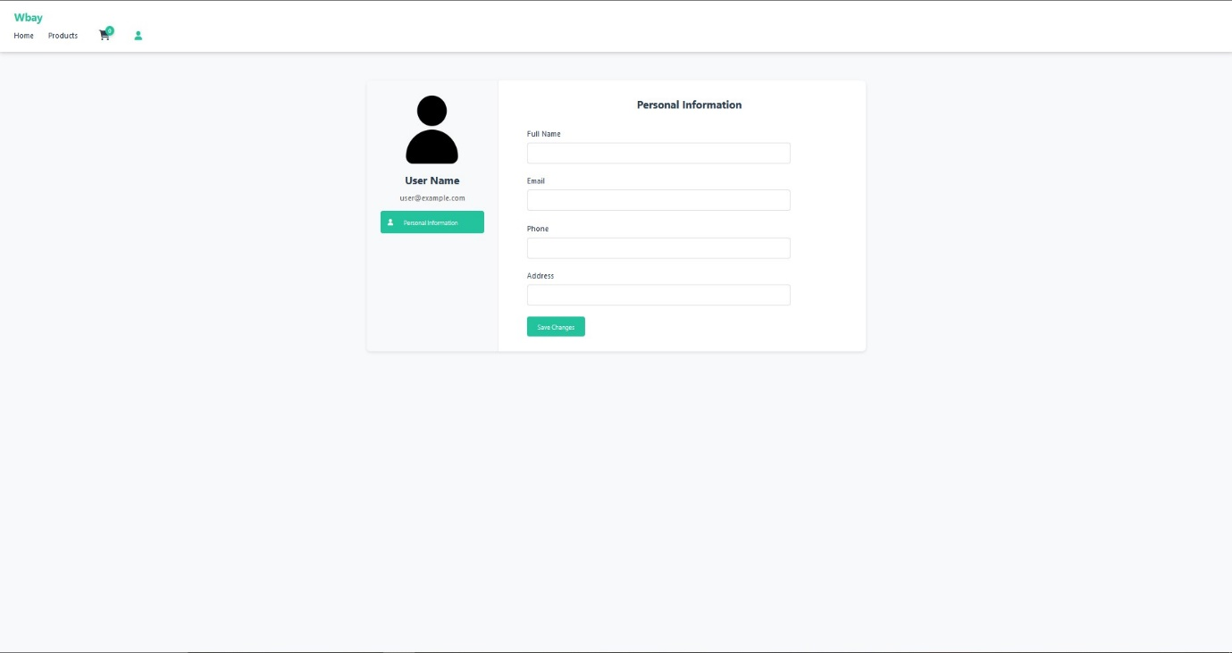

**Figure 9 Admin Profile Page**

## 3.3 Vendor Interface Page

This page **Figure 10** can only be accessed by the vendor user-class it shows the user some of the products they have listed (around 20) it also has a navbar that allows the user to access the Add Product Page **Figure 11** which gives them the ability to list a new product, a Your Products Page **Figure 12** which shows the user all of their listed productsand the ability to edit said product **Figure 13,** and also clicking on any of the listed product’s card which shows them the Product Details Page to see all details and check their product rating **Figure 14** and finally the vendor Profile page **Figure 15** which shows the vendor details and the ability to change it, it also show**s** the pending order that are awaiting confirmation**.**

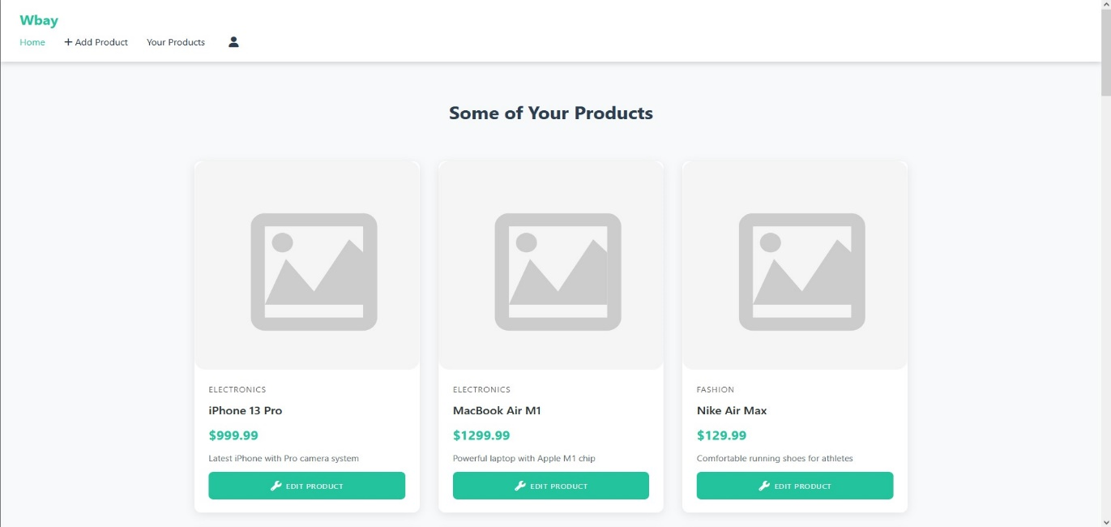

Figure 10 Vendor Home Page

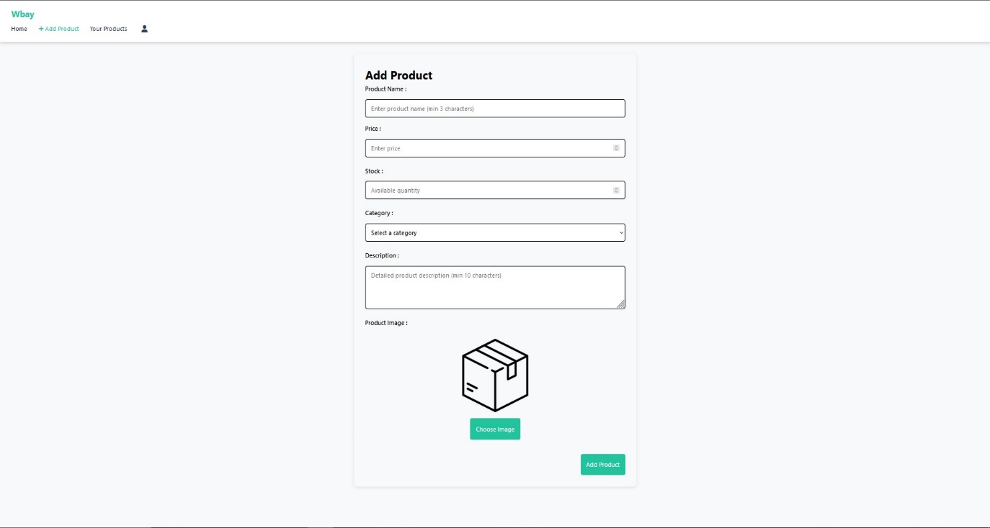

Figure 11 Add Product Page

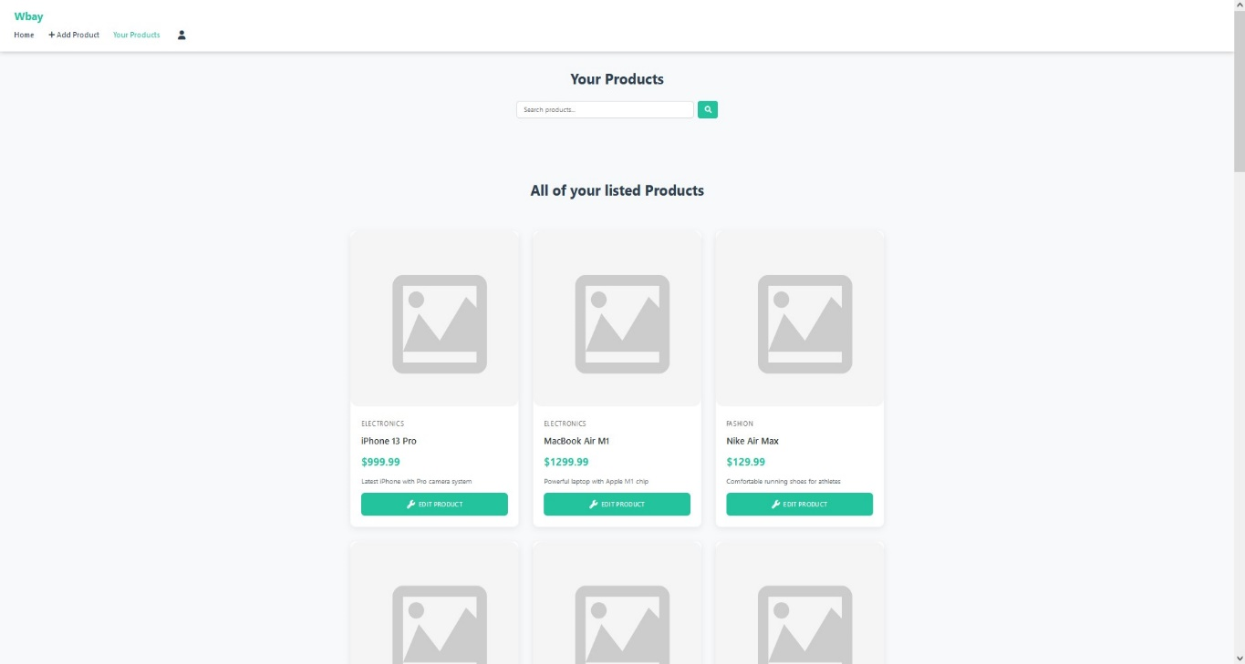

Figure 12 Your Product Page

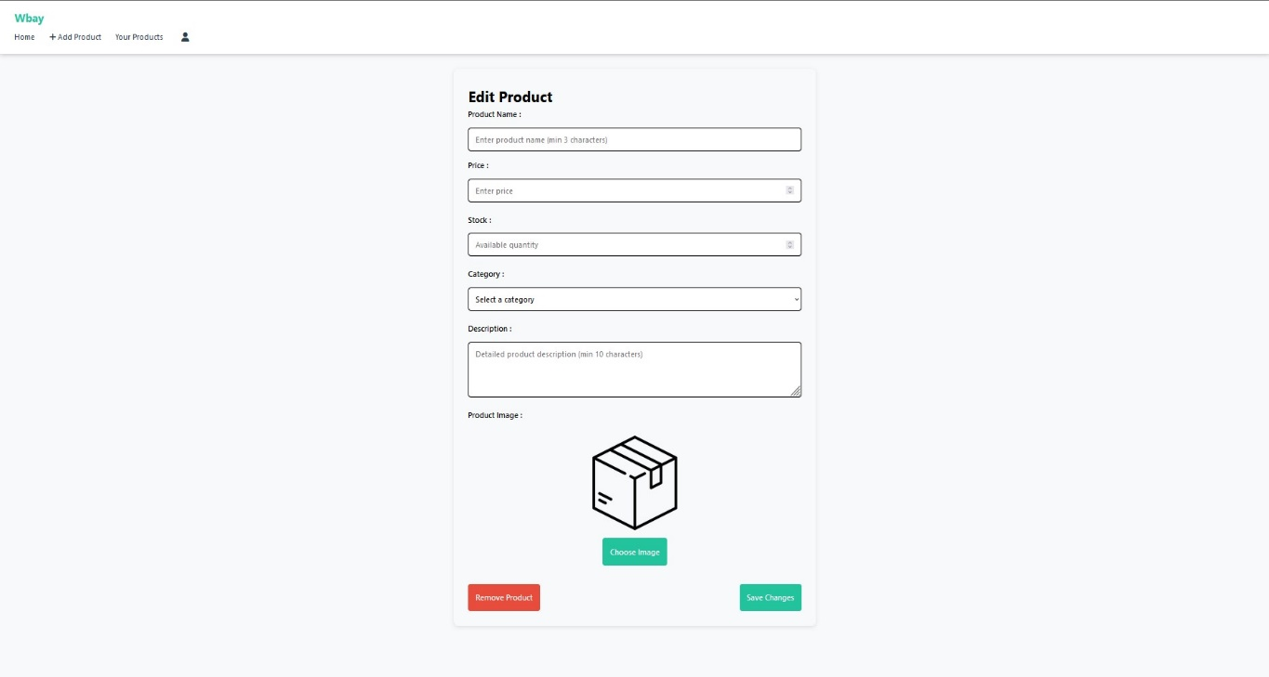

Figure 13 Edit Product Page

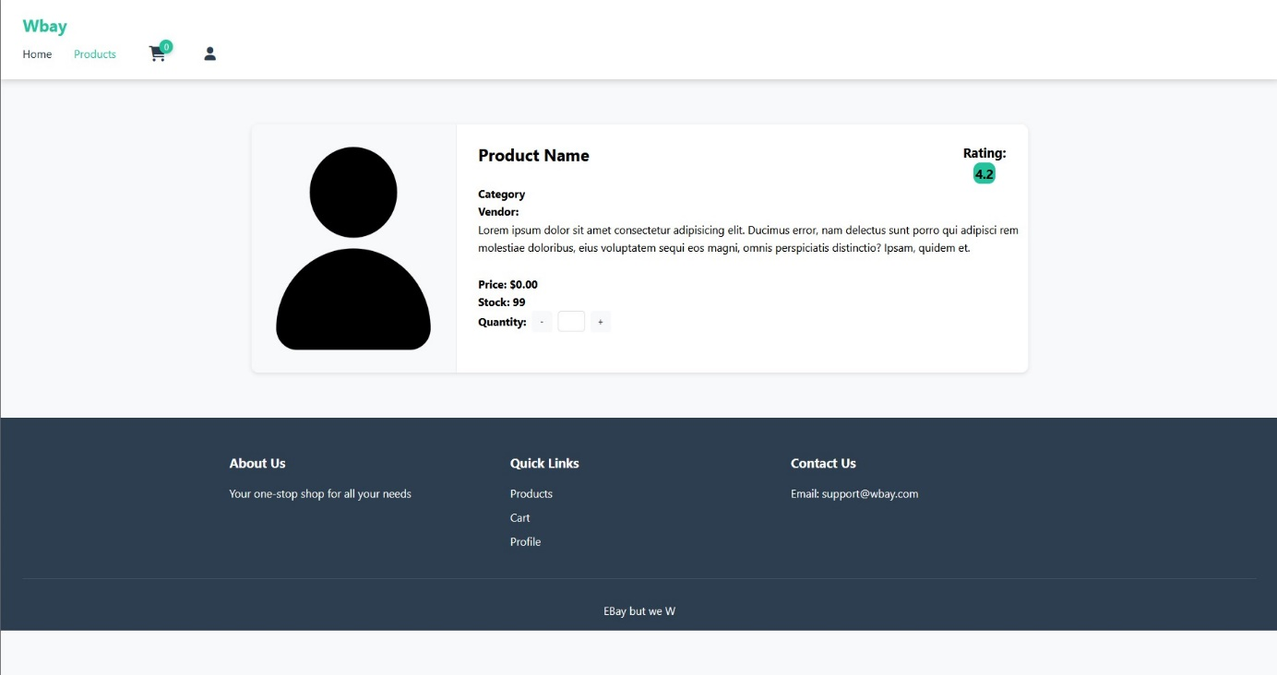

Figure 14 Product Detail

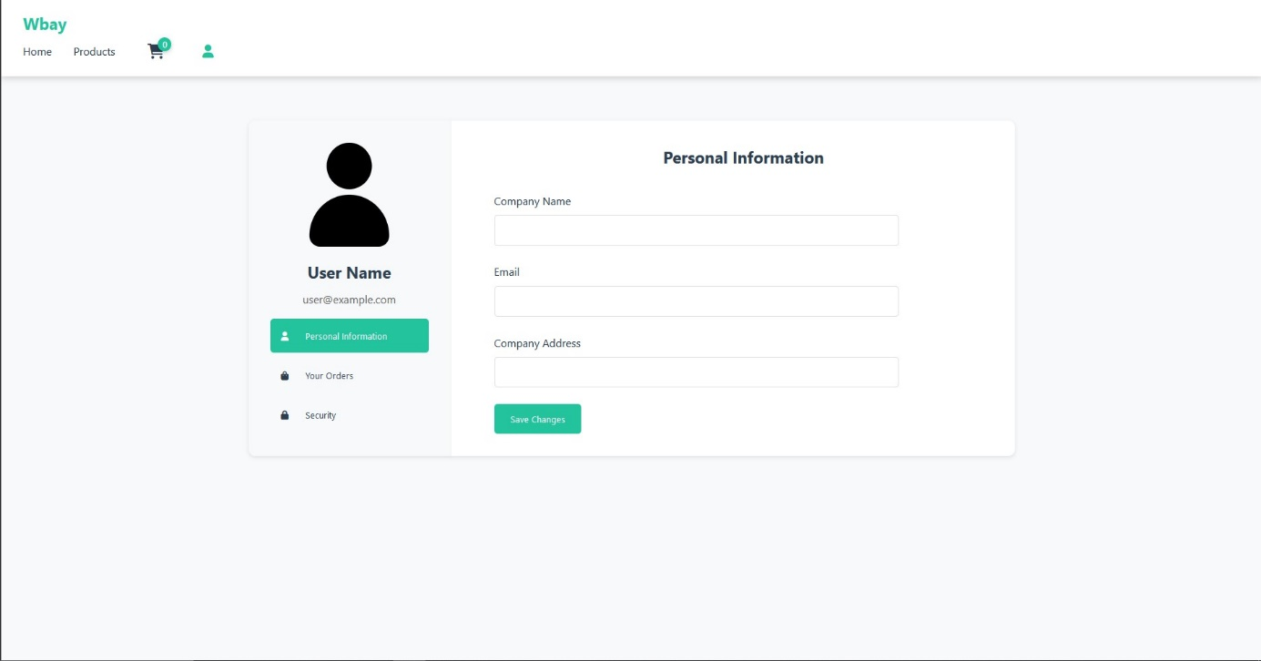

**Figure 15 Vendor Profile Page**

## 3.4 Customer Interface Page

This screen will only be accessed by the user-class Customer the home Page **Figure 16** shows a list of products (around 20) and also a navbar with the Products Page **Figure 17** which shows all available products in the DB and the ability to search and filter it, all products in the home page and Products page can be instantly added to the cart **Figure 18** the user also has the ability to click on the product which opens the Product Detail Page **Figure 19** which gives them the ability to view the product its rating and add their own rating to it, finally the profile page **Figure 20** this page will allow the user to view their profile details and edit them it also has a order history section which displays all current and previous orders that the user has placed with their status

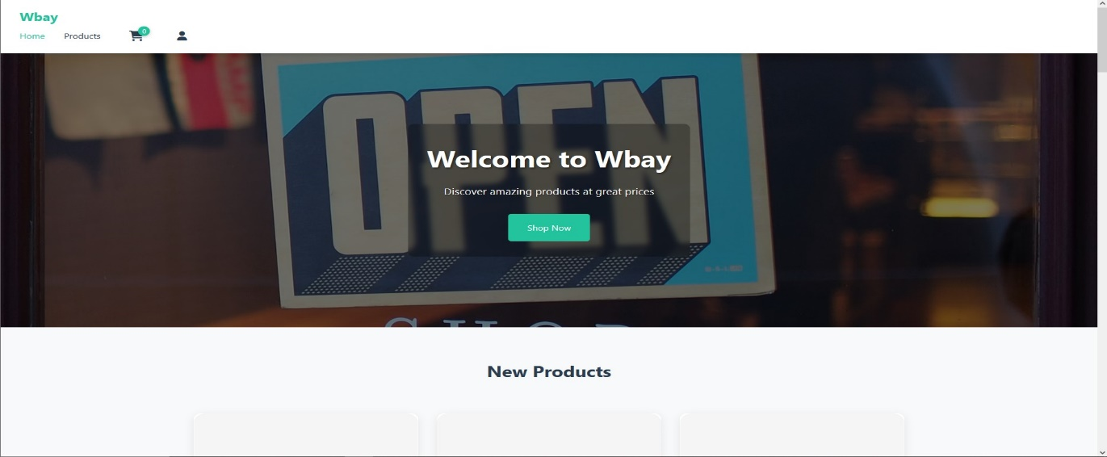

Figure 16 Customer Home Page

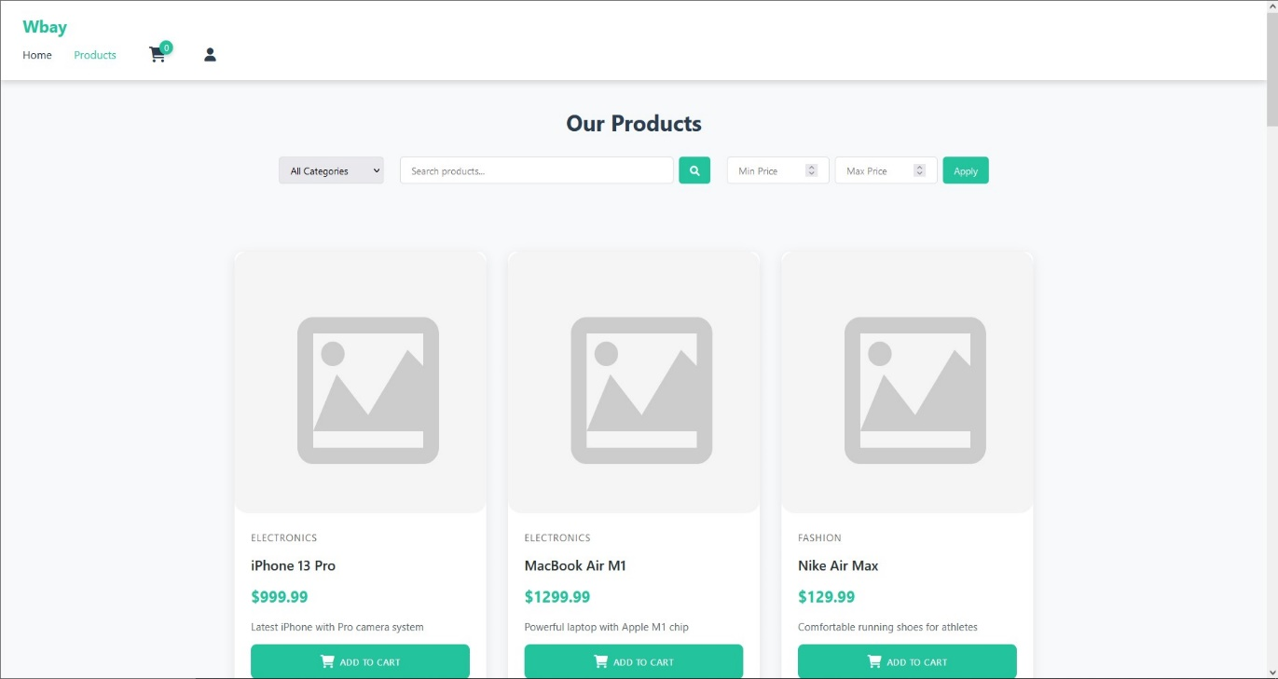

Figure 17 Customer Product Page

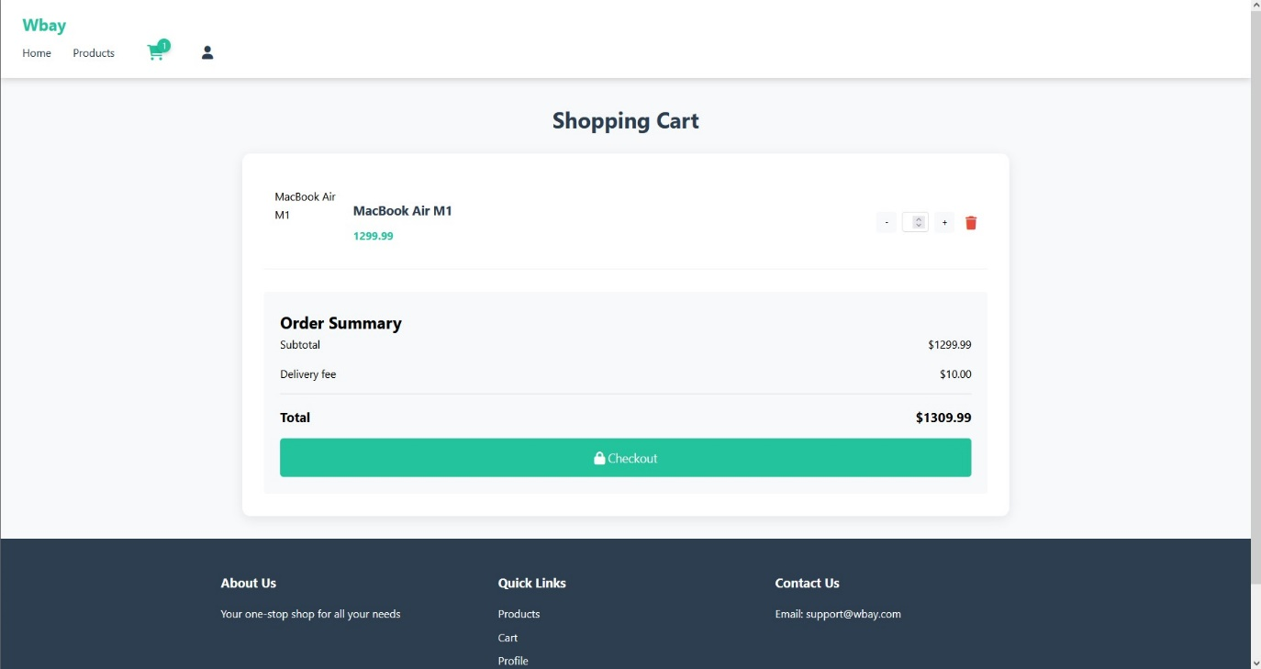

Figure 18 Cart Full Page

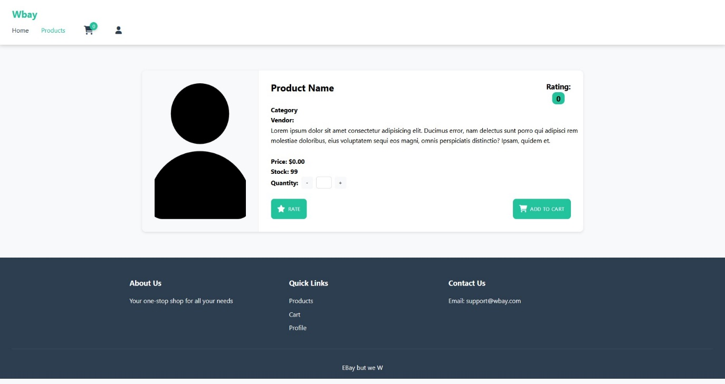

Figure 19 Product Detail Page

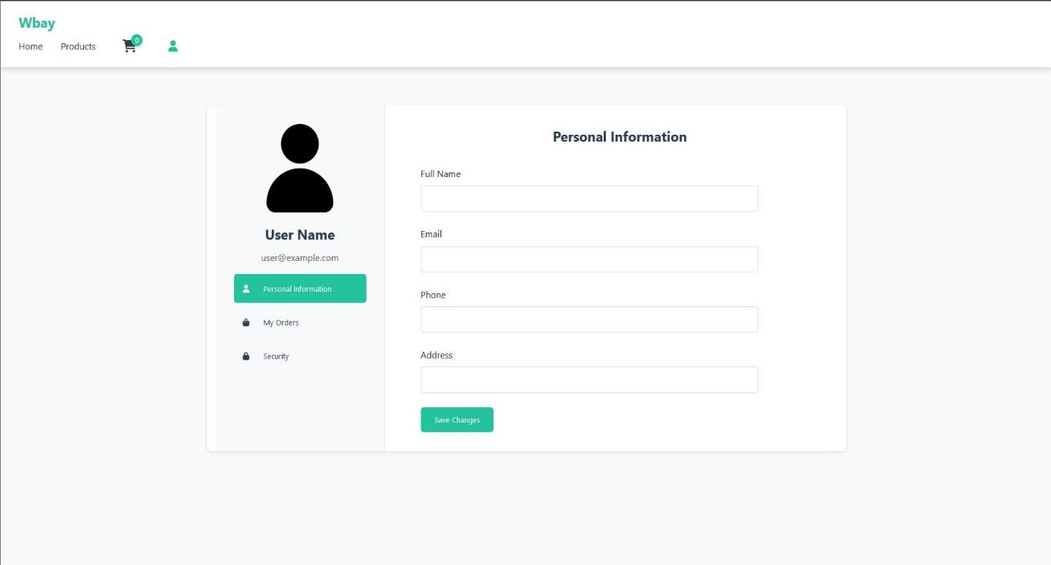

Figure 20 Customer Profile Page