Software Design Document

Wbay

Version 1.0 approved
Prepared by:
Sajed Najib Tantush 2211844916
Ibrahim Abdelwahab Elsharif 2211844042
Mohammed Adel Elkilani 2211845885
Mohamed Jallul Aljorni 2211845917
Hayder Ahmed Eljenfawi 2211844655
University Of Tripoli
27/12/2024
Revision History

Date | Version | Description | Author

Table of Contents

1. INTRODUCTION 4
1.1 Purpose (الغرض من الوثيقة) 3
2. DATABASE DESIGN 4
2.1 Entity Relationship Diagram 5
2.2 Data dictionary 6
2.2.1 The users_cred Entity 6
2.2.2 The customers Entity 6
2.2.3 The vendors Entity 6
2.2.4 The products Entity 7
2.2.5 The orders Entity 7
2.2.6 The cart Entity 7
2.2.7 The rating Entity 7
3. USER INTERFACE DESIGN 8
3.1 SignIn & SignUp to the web-application 8
3.2 Admin Interface Page 10
3.3 Vendor Interface Page 12
3.4 Customer Interface Page 15

INTRODUCTION

Purpose
The Software Design Description (SDD) document describes all of the essential components of the system to satisfy the requirements given by the client. This report is used especially during implementation of the system.

DATABASE DESIGN (اجباري)

Entity Relationship Diagram مثال
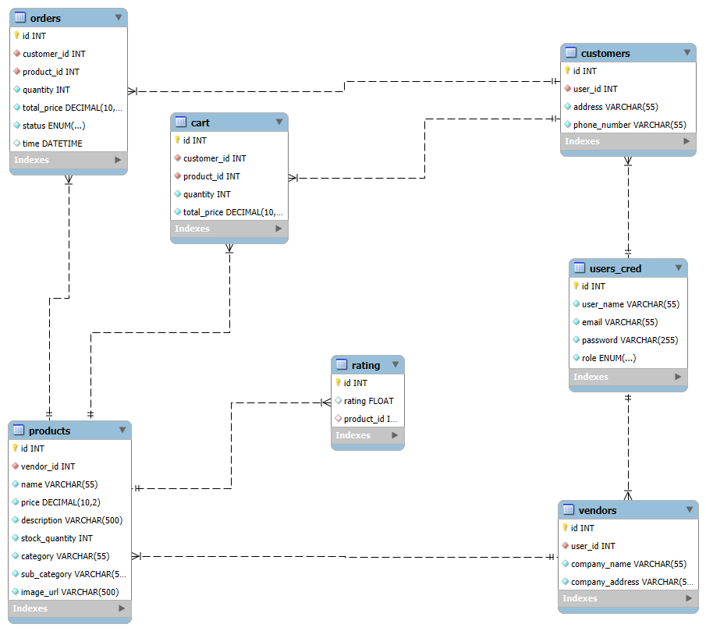
Figure 1. E/R Diagram

Data dictionary

The users_cred Entity
Field name | type | length | primary | foreign
id | INT | 4 bytes | √
user_name | VARCHAR(55) | 50 bytes
email | VARCHAR(55) | 50 bytes
password | VARCHAR(255) | 255 bytes
role | ENUM(‘customer’, ‘vendor’, ‘admin’) | 1 bytes

The customers Entity
Field name | type | length | primary | foreign
id | INT | 4 bytes | √
user_id | INT | 4 bytes |  | √
address | VARCHAR(255) | 255 bytes
phone_number | VARCHAR(255) | 255 bytes

The vendors Entity
Field name | type | length | primary | foreign
id | INT | 4 bytes | √
user_id | INT | 4 bytes |  | √
company_name | VARCHAR(55) | 55 bytes
company_address | VARCHAR(55) | 55 bytes

2.2.4 The products Entity
Field name | type | length | primary | foreign
id | INT | 4 bytes | √
vendor_id | INT | 4 bytes |  | √
name | VARCHAR(55) | 55 bytes
price | DECIMAL(10,2) | 5 bytes
description | VARCHAR(500) | 500 bytes
stock_quantity | INT | 4 bytes
category | VARCHAR(55) | 55 bytes
sub_category | VARCHAR(55) | 55 bytes
image_url | VARCHAR(500) | 500 bytes

2.2.5 The orders Entity
Field name | type | length | primary | foreign
id | INT | 4 bytes | √
customer_id | INT | 4 bytes |  | √
product_id | INT | 4 bytes |  | √
quantity | INT | 4 bytes
total_price | DECIMAL(10,2) | 5 bytes
status | ENUM(‘pending’,’on the way’,’deliverd’,’cancelled’) | 1 bytes
time | DATETIME | 5 bytes
2.2.6 The cart Entity
Field name | type | length | primary | foreign
id | INT | 4 bytes | √
customer_id | INT | 4 bytes |  | √
product_id | INT | 4 bytes |  | √
quantity | INT | 4 bytes
total_price | DECIMAL(10,2) | 5 bytes
2.2.7 The rating Entity
Field name | type | length | primary | foreign
id | INT | 4 bytes | √
rating | FLOAT | 4 bytes
product_id | INT | 4 bytes |  | √

3 USER INTERFACE DESIGN

In this section, each user interface is explained along with some screenshots.

3.1 SignIn & SignUp to the web-application
This page will be the first page that the user will encounter when they want to access the web-application it is made up of 2 components the Sign in part to the left Figure 2 and the Sign up part in the right Figure 3
- Sign in
The sign in component asks for the username and password of the user the data will be processed and checked whether or not the user actually exists in the DB if the user will be redirected to their supposed home page depending on their role.
- Sign up
The sign up component asks for username, email and password for both users and depending on the user type (vendor or customer) it will either ask for their address and phone number if they want to create a customer account Figure 3 or the company name and company address if they want to create a vendor account Figure 4

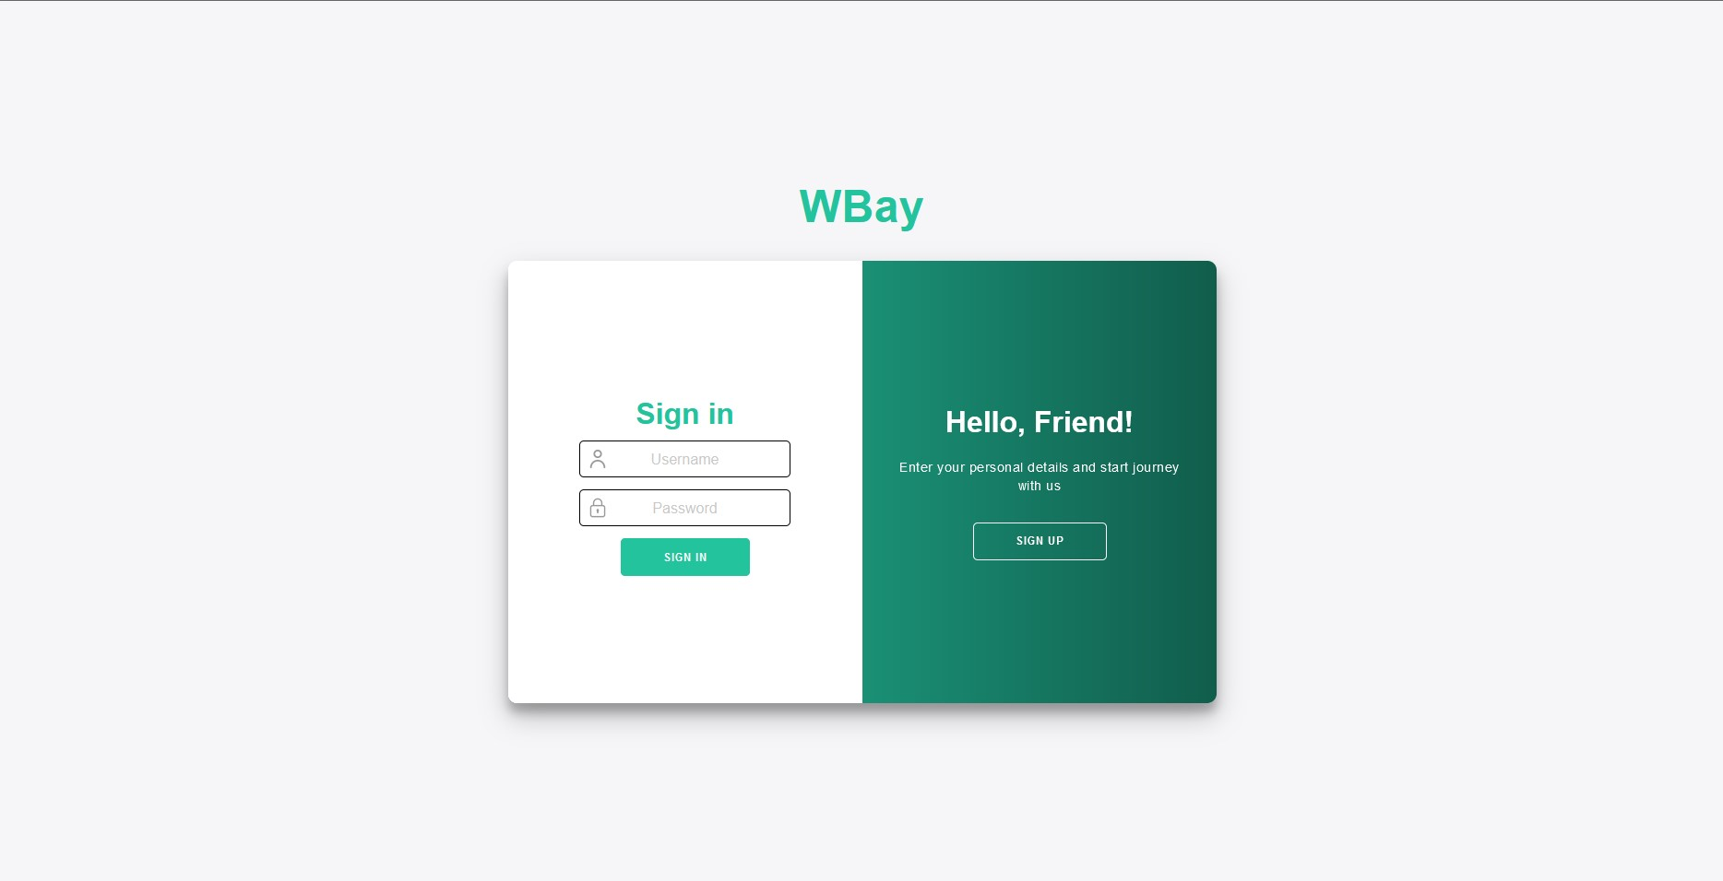
Figure 2 Sign In

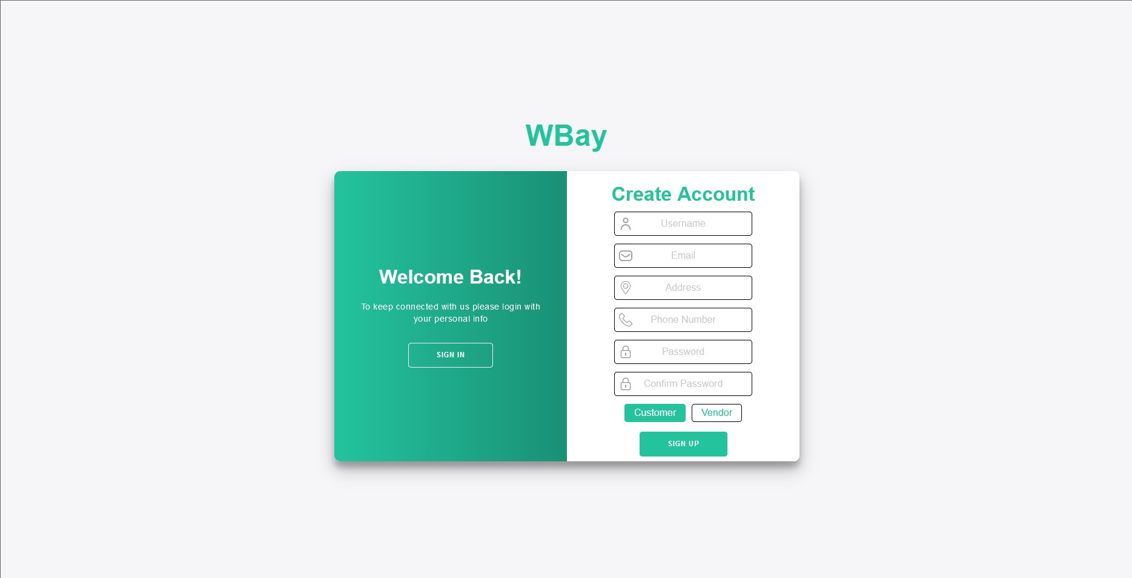
Figure 3 Sign Up Customer

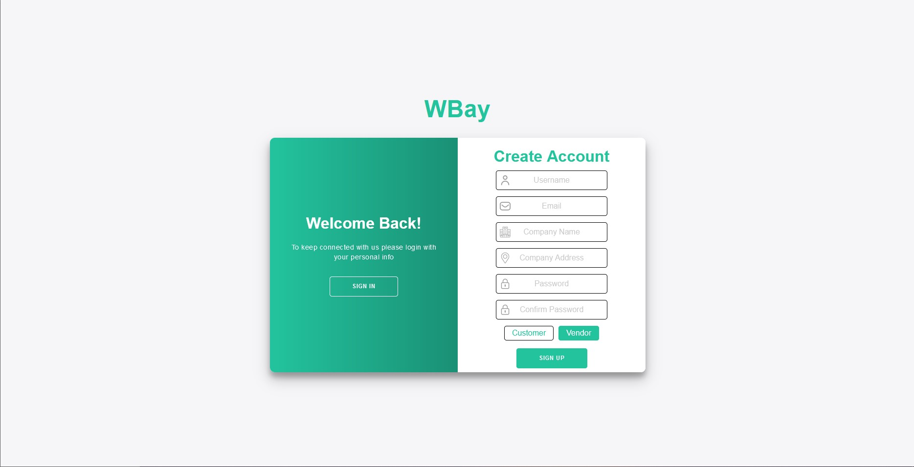
Figure 4 Sign Up Vendor

3.2 Admin Interface Page
This page Figure 5 will only be viewed by the user-class admin it has a nav bar to navigate through different sections such as the User Management Page Figure 6 and the Manage Products Page Figure 7 and profile which will only show their profile info and the ability to edit it Figure 9.
The main admin page will show the latest added products in the web-Application (around 20 products) which will be pulled by the Search & Product Listing System Feature with the product id

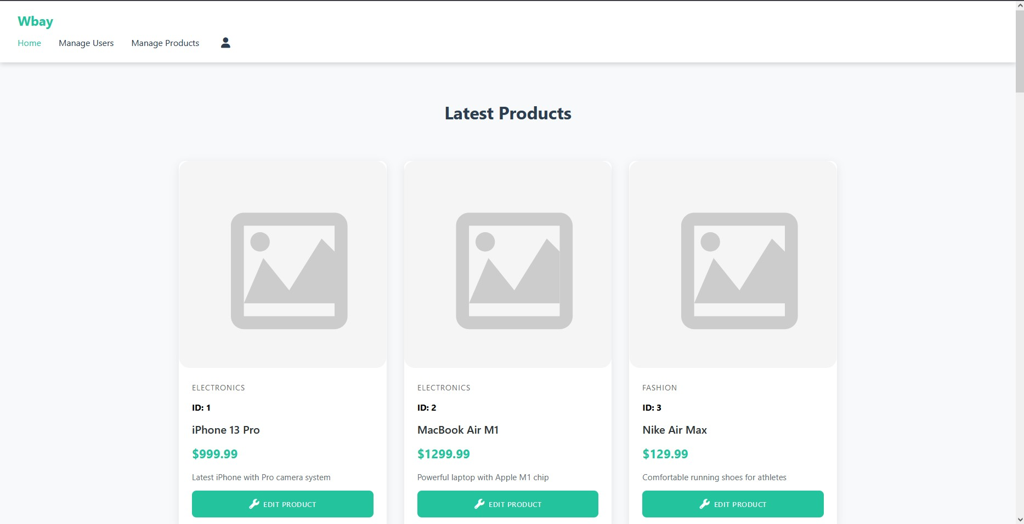
Figure 5. Admin Home
The user management page will display all current users and the ability to terminate their account
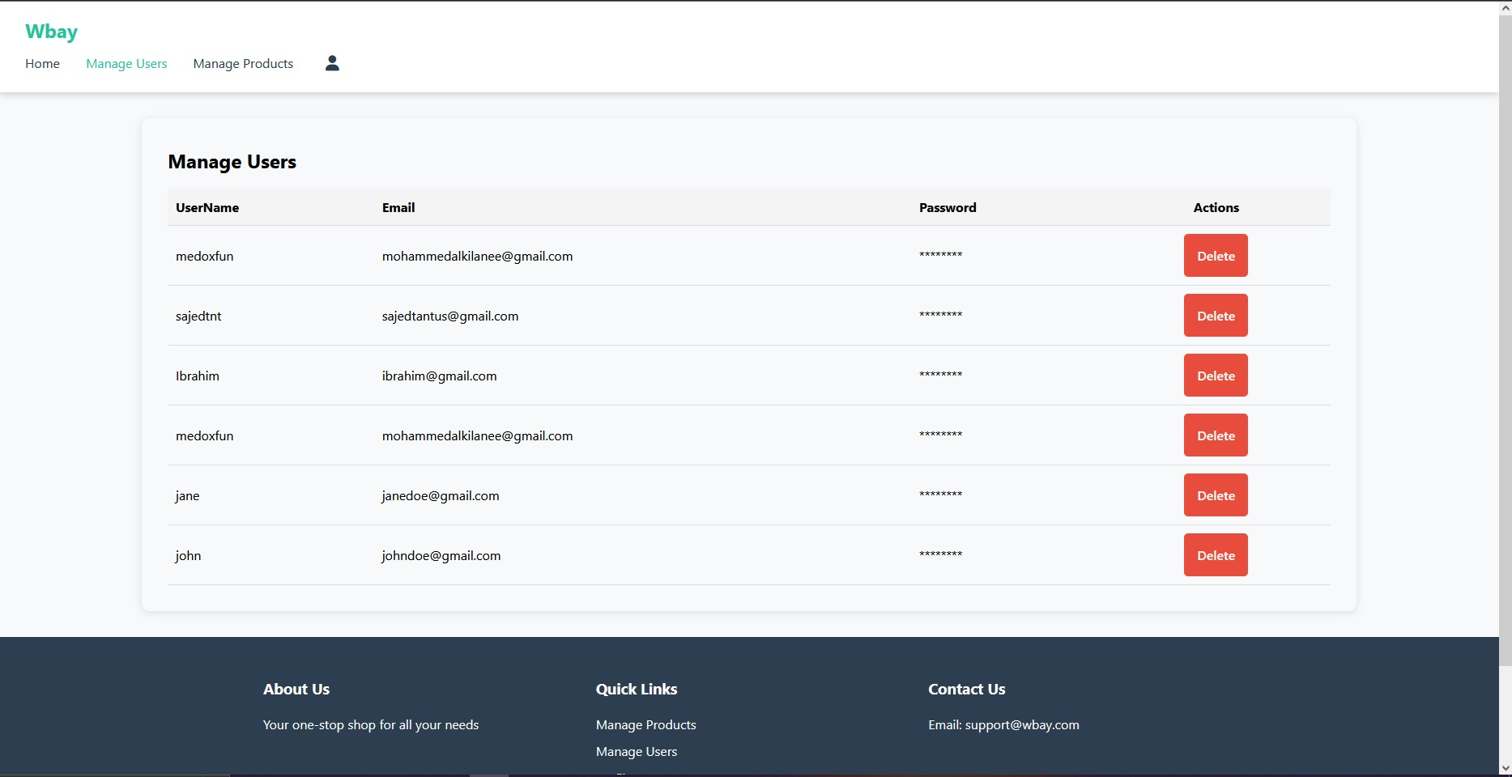
Figure 6 User Management Page

This is the manage products page which will list all available products in the DB and the ability to delete or Edit Figure 8
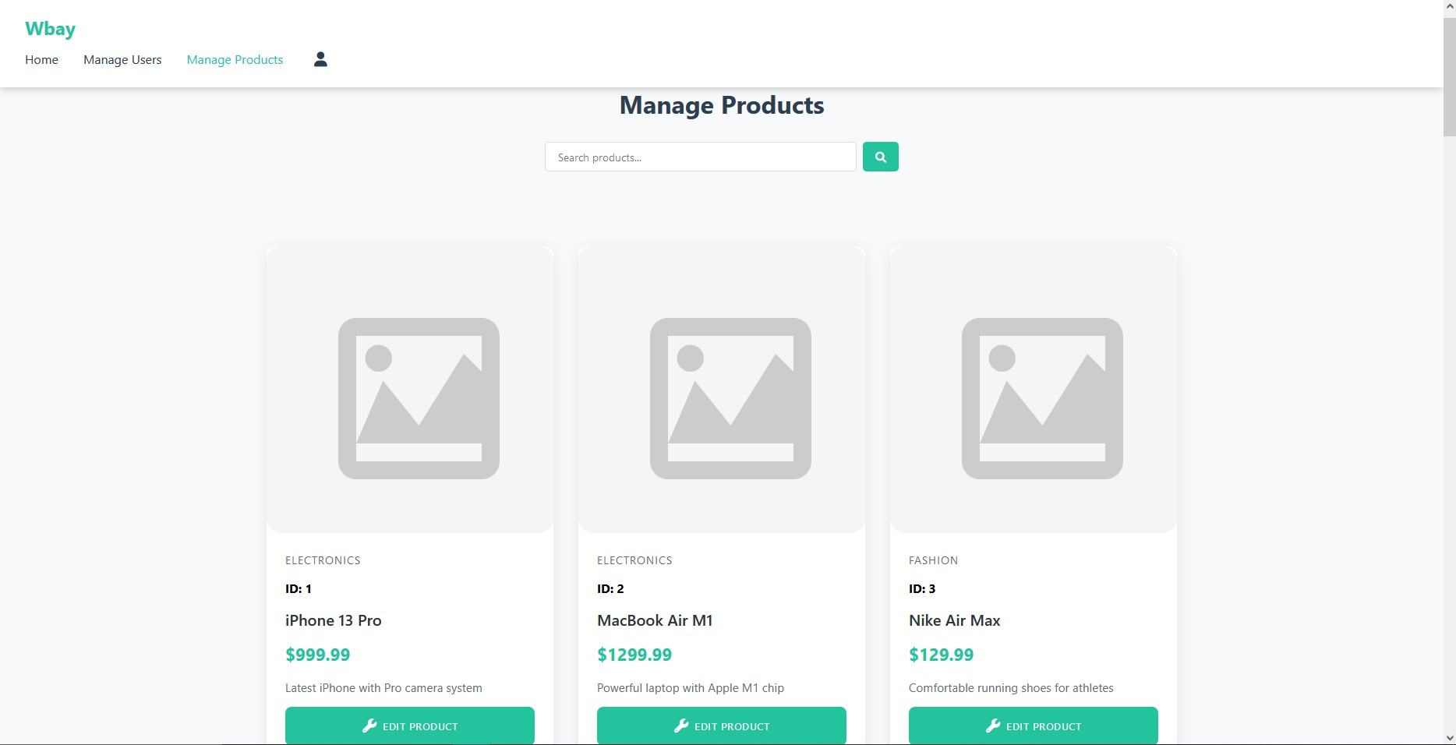
Figure 7 Manage Products Page
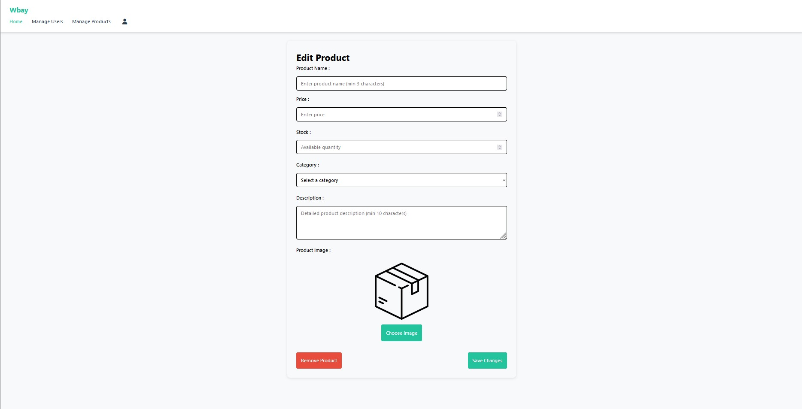
Figure 8 Edit Product Page
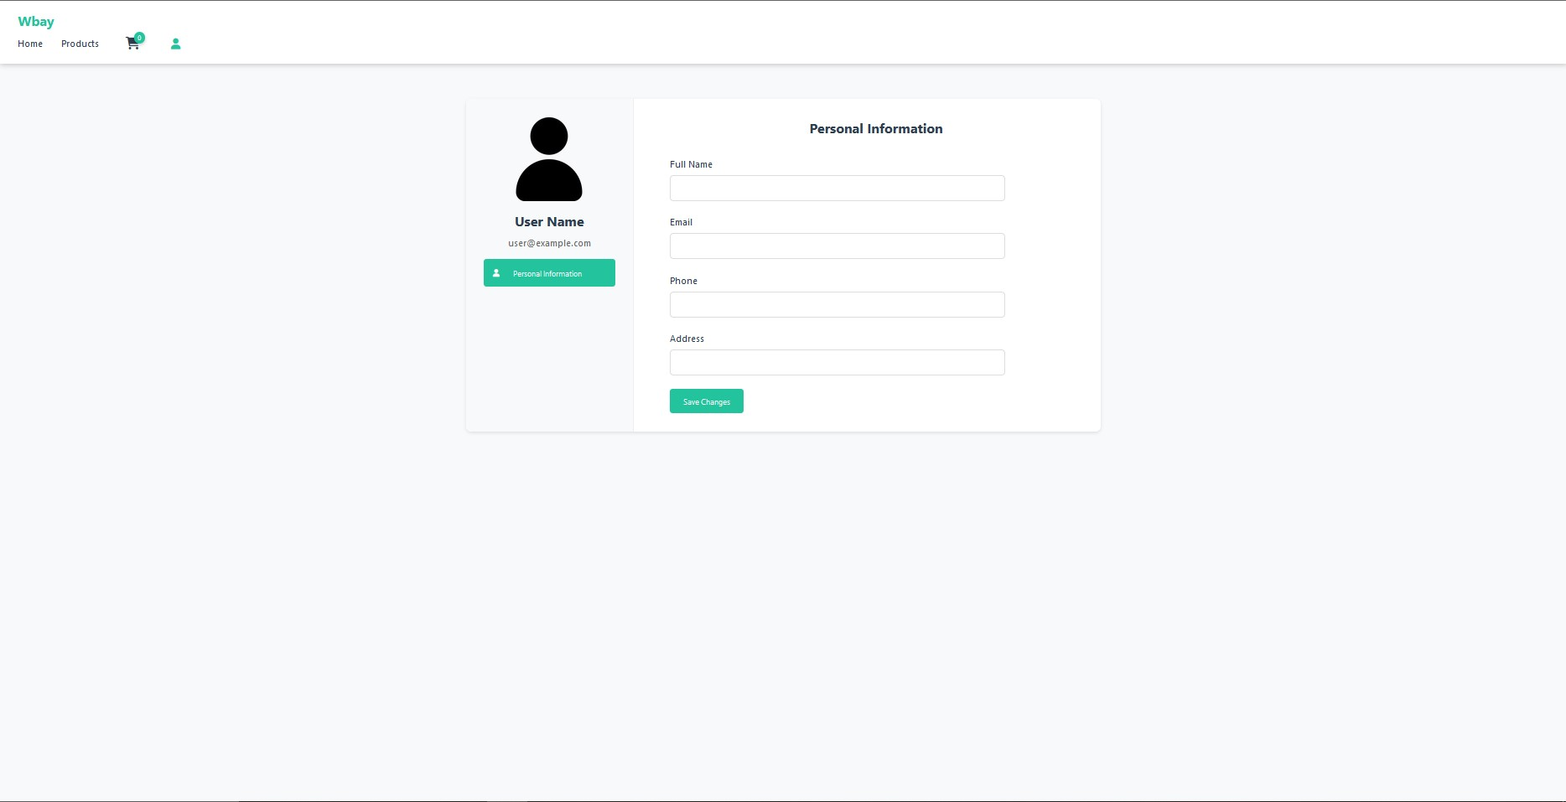
Figure 9 Admin Profile Page

3.3 Vendor Interface Page
This page Figure 10 can only be accessed by the vendor user-class it shows the user some of the products they have listed (around 20) it also has a navbar that allows the user to access the Add Product Page Figure 11 which gives them the ability to list a new product, a Your Products Page Figure 12 which shows the user all of their listed products and the ability to edit said product Figure 13, and also clicking on any of the listed product’s card which shows them the Product Details Page to see all details and check their product rating Figure 14 and finally the vendor Profile page Figure 15 which shows the vendor details and the ability to change it, it also shows the pending order that are awaiting confirmation.
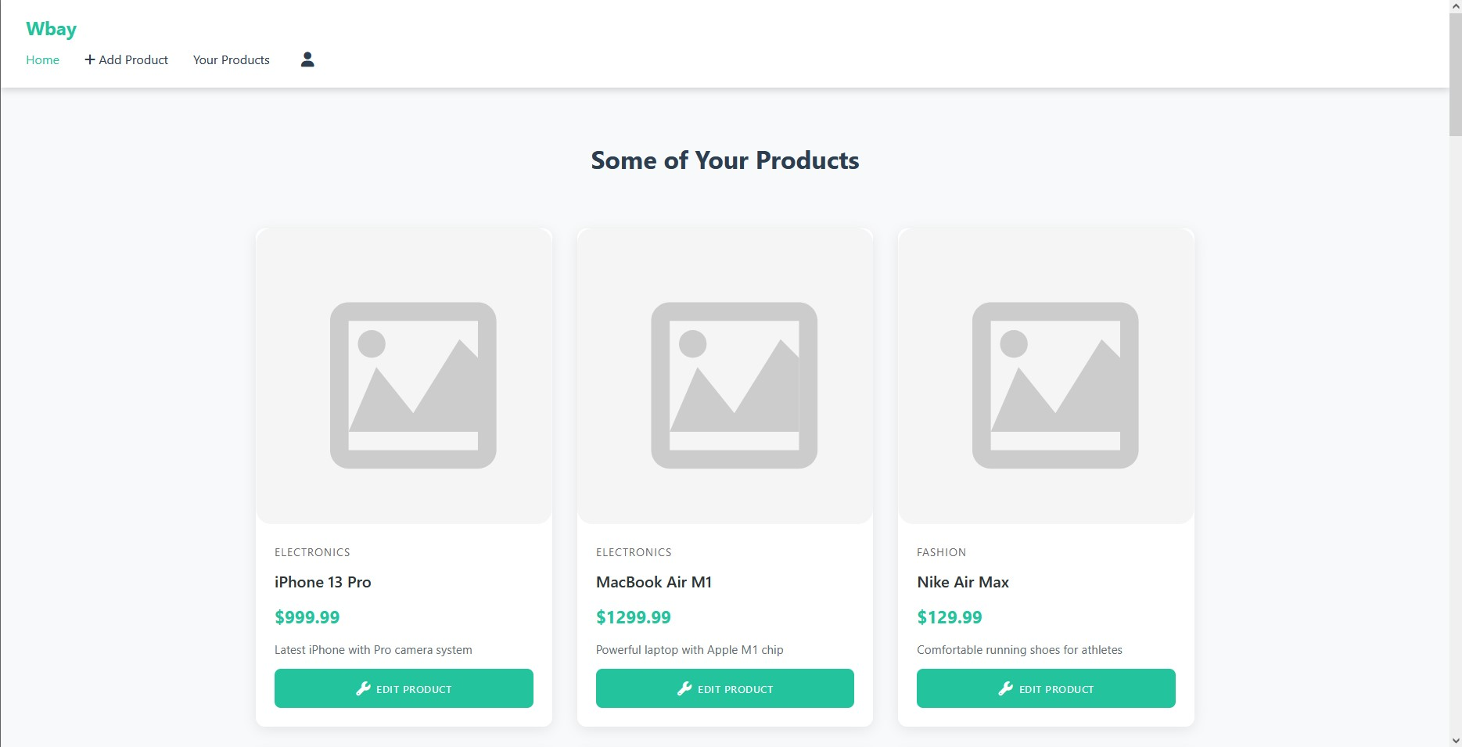
Figure 10 Vendor Home Page
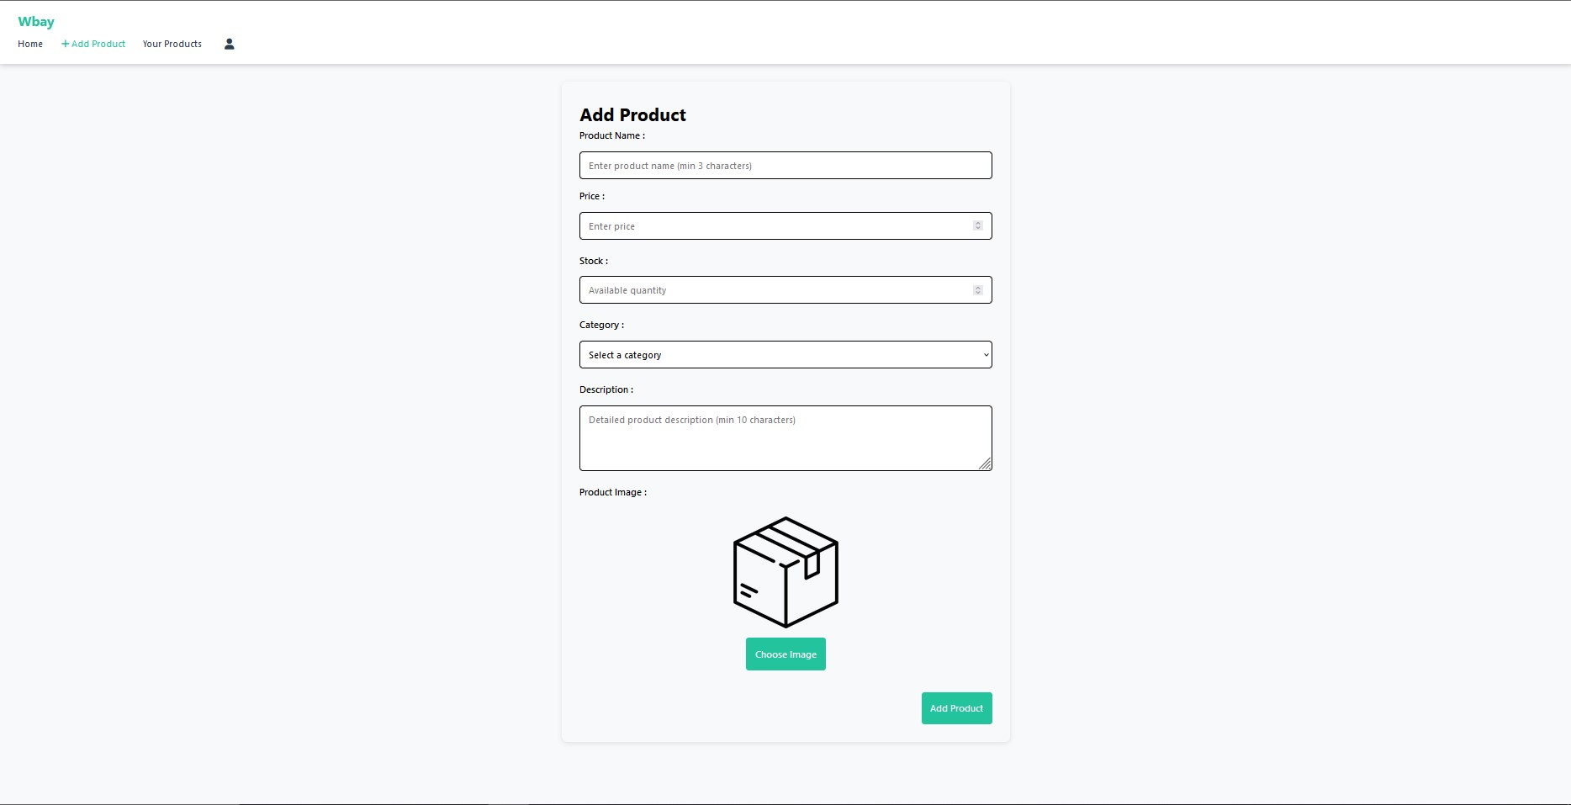
Figure 11 Add Product Page
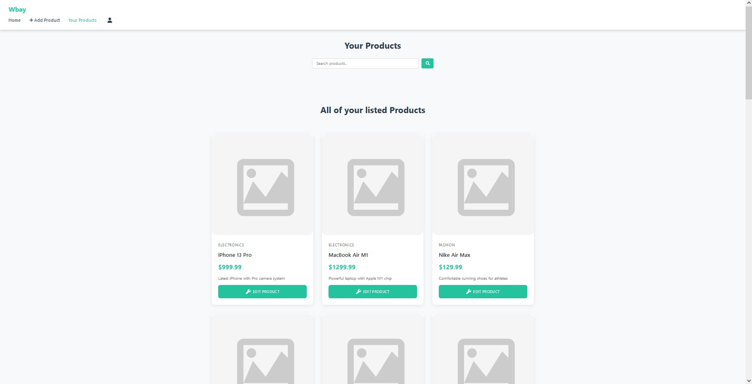
Figure 12 Your Product Page
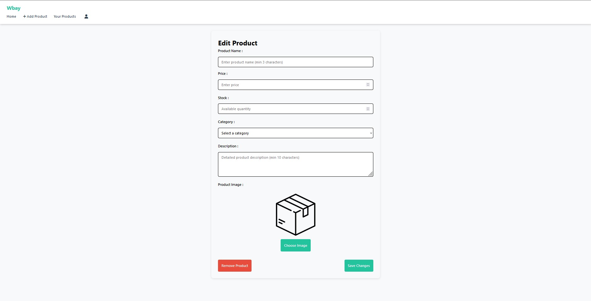
Figure 13 Edit Product Page
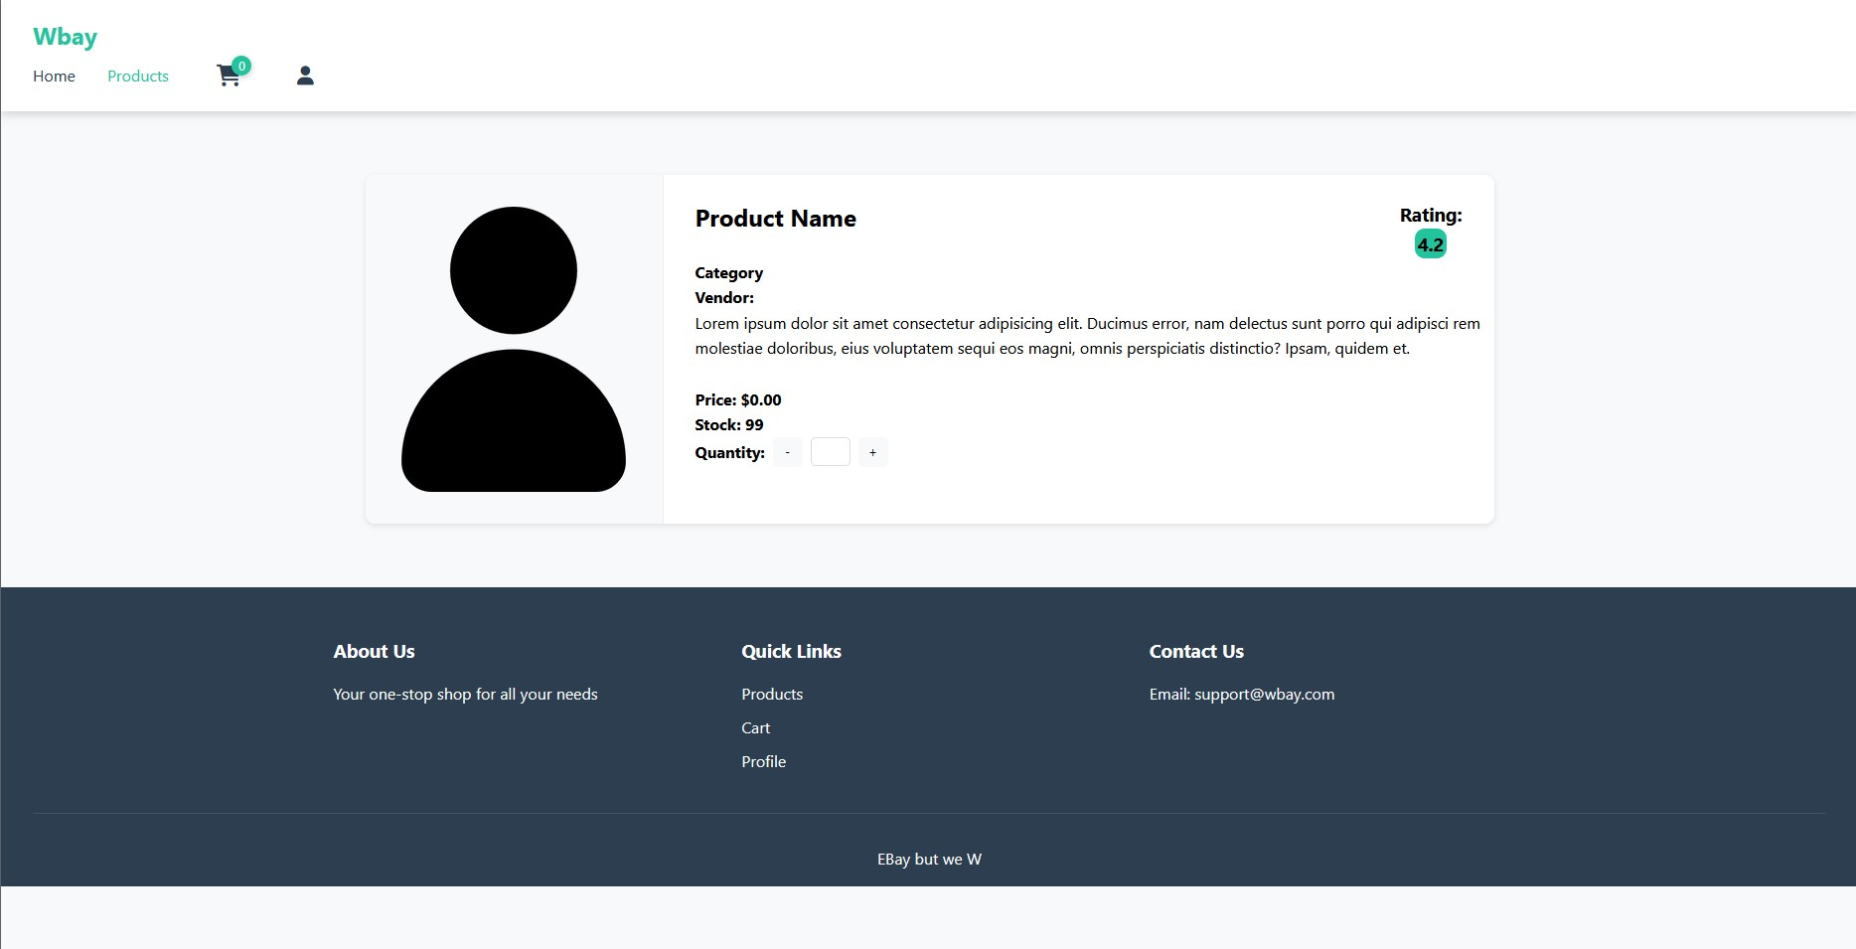
Figure 14 Product Detail
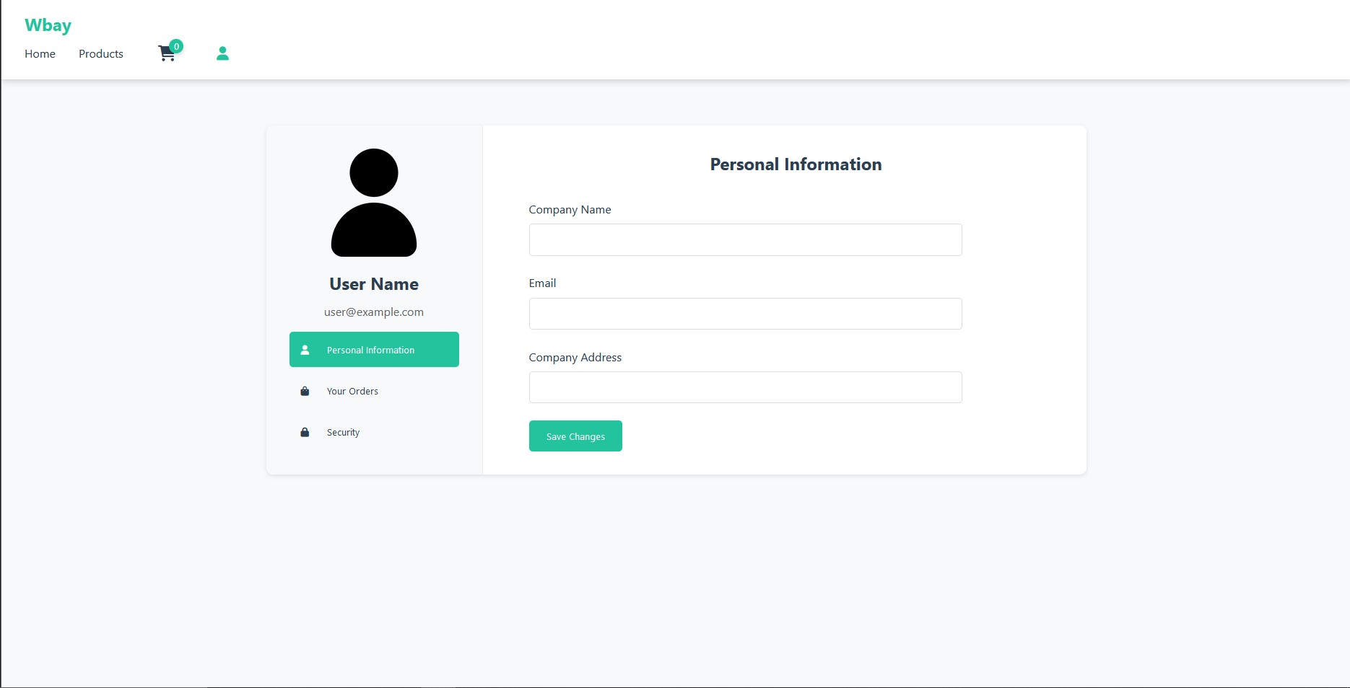
Figure 15 Vendor Profile Page

3.4 Customer Interface Page
This screen will only be accessed by the user-class Customer the home Page Figure 16 shows a list of products (around 20) and also a navbar with the Products Page Figure 17 which shows all available products in the DB and the ability to search and filter it, all products in the home page and Products page can be instantly added to the cart Figure 18 the user also has the ability to click on the product which opens the Product Detail Page Figure 19 which gives them the ability to view the product its rating and add their own rating to it, finally the profile page Figure 20 this page will allow the user to view their profile details and edit them it also has a order history section which displays all current and previous orders that the user has placed with their status

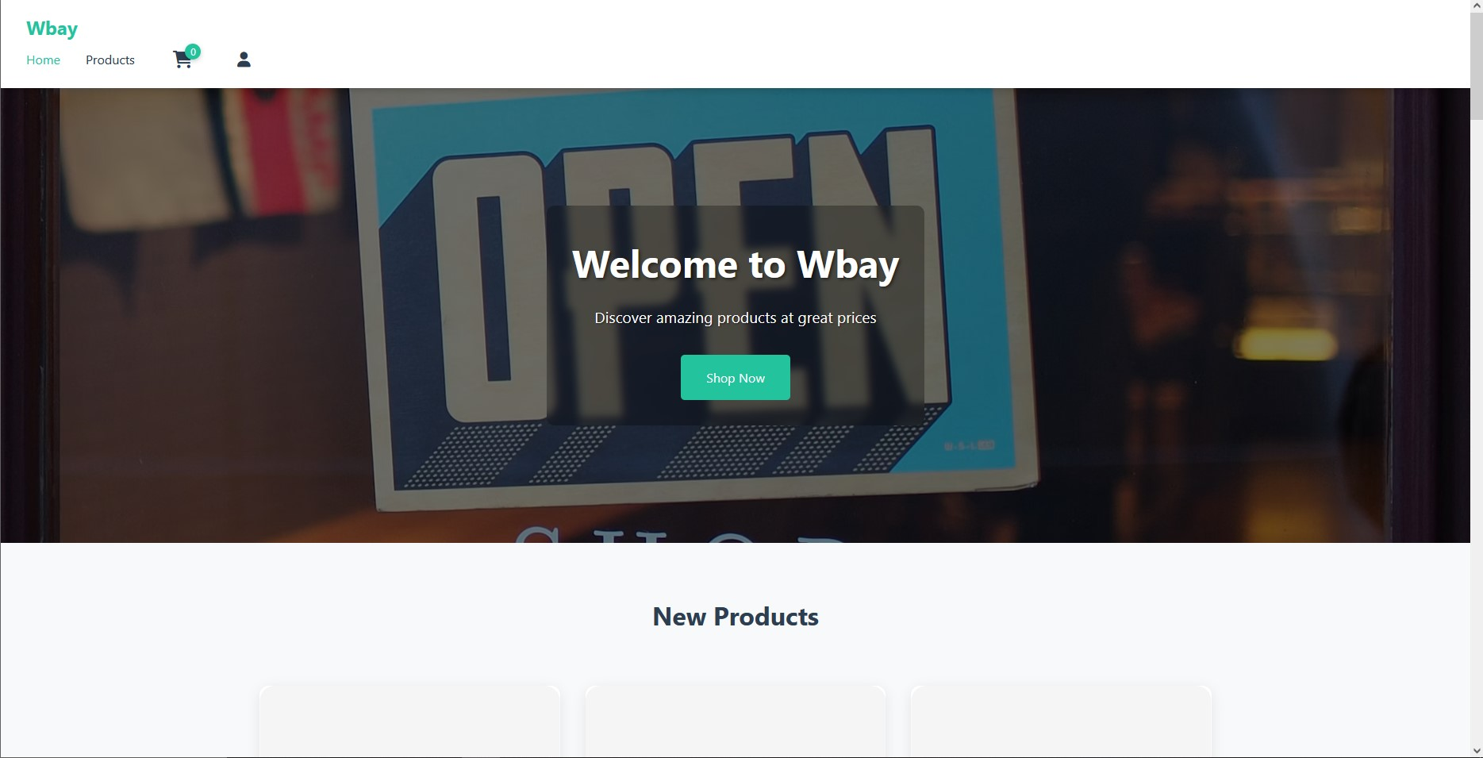
Figure 16 Customer Home Page
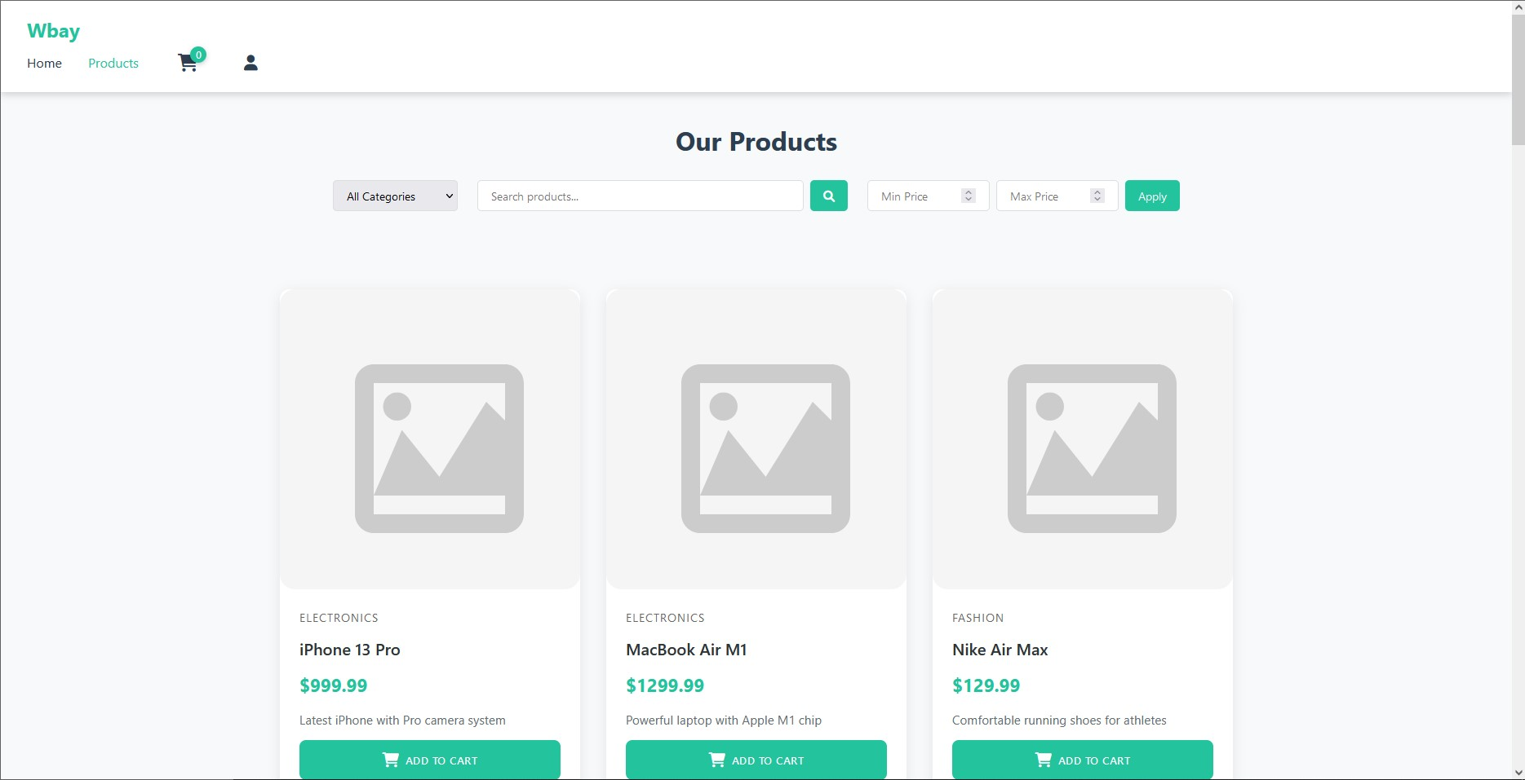
Figure 17 Customer Product Page
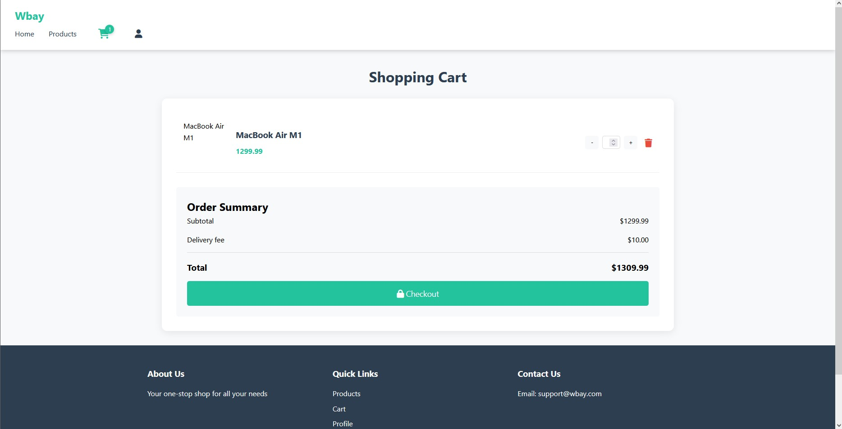
Figure 18 Cart Full Page
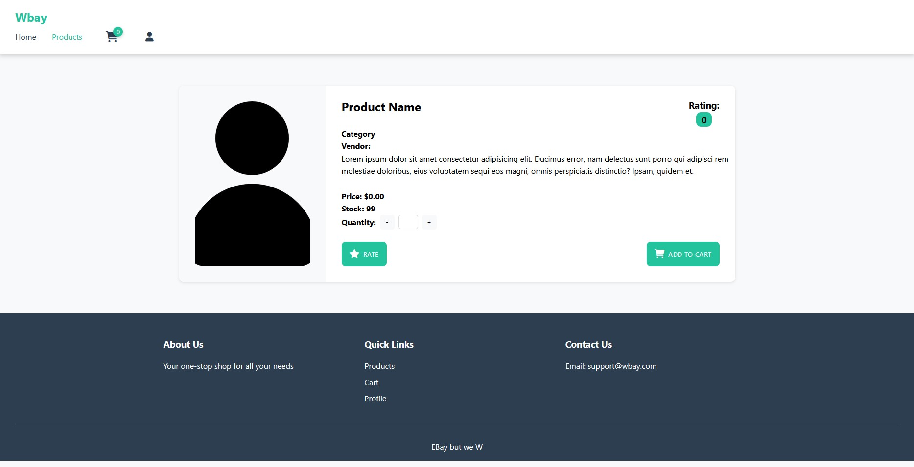
Figure 19 Product Detail Page
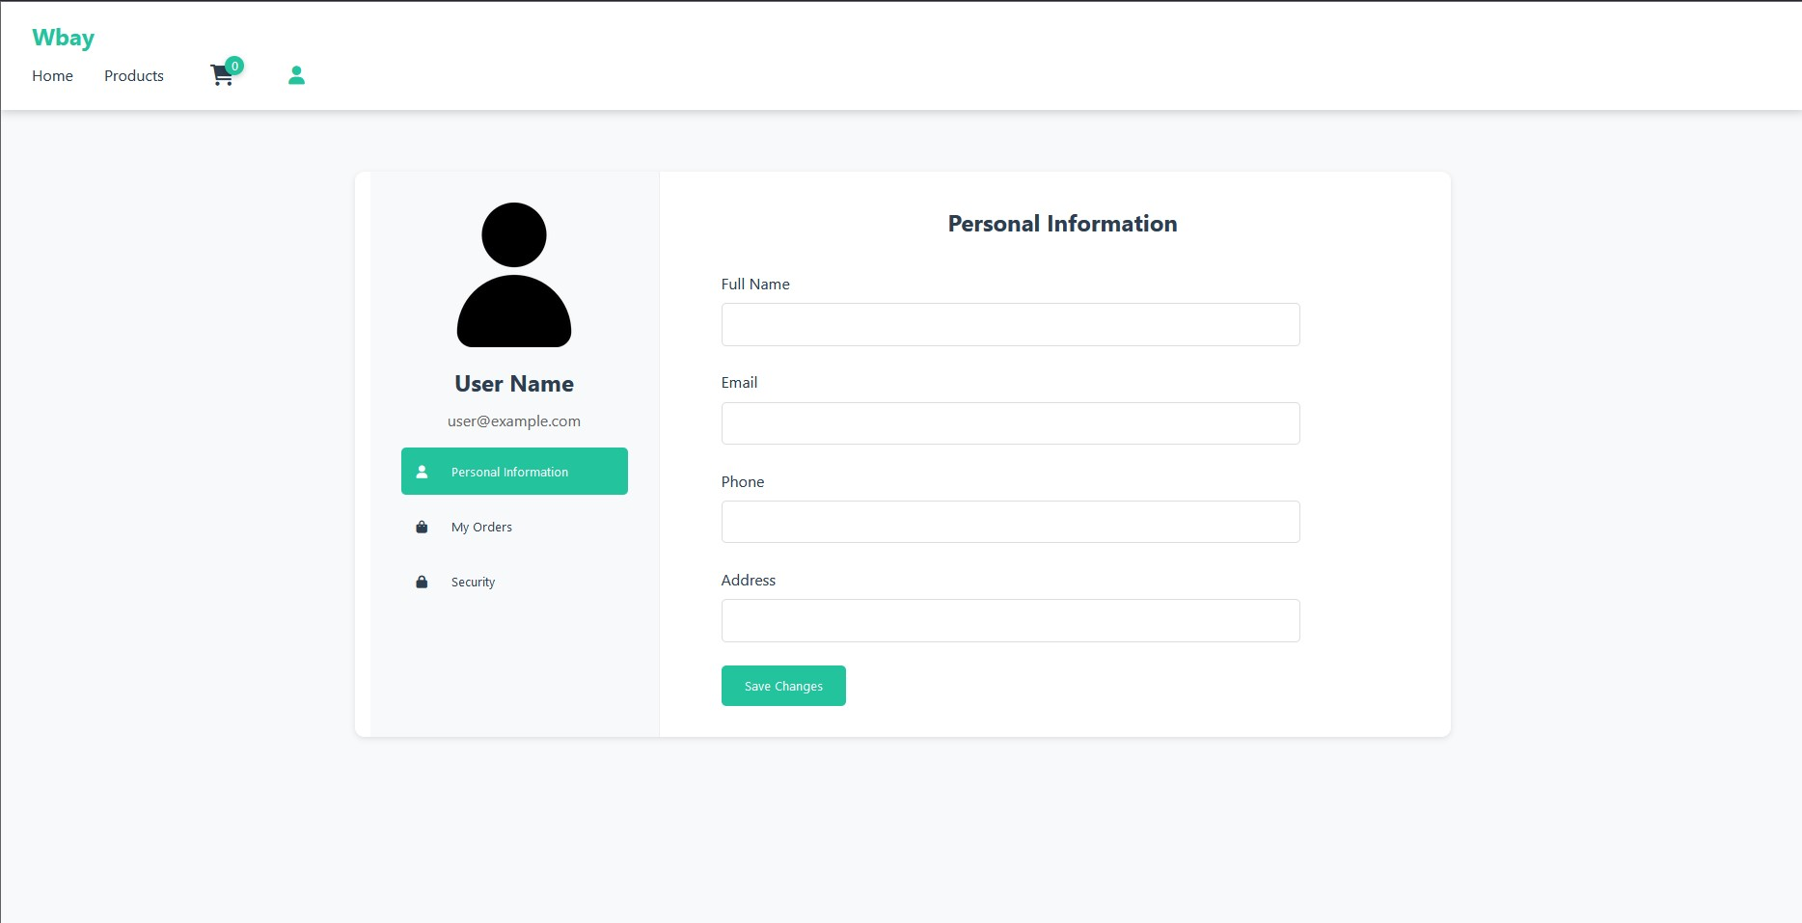
Figure 20 Customer Profile Page

