**EINSTEIN INSIGHTS : A QA AND SUMMARIZATION TOOL USING TRANSFORMERS**

**PROJECT OVERVIEW :**

This project uses NLP models to create an interactive tool that answers fact-based questions about Albert Einstein and summarizes his achievements. It integrates DistilBERT for question-answering and BART for summarization, both powered by Hugging Face Transformers. The user-friendly interface, built with Gradio, allows users to interact seamlessly by asking questions or generating concise summaries

**OBJECTIVE :**

To develop an interactive tool that leverages state-of-the-art NLP models for answering fact-based questions and summarizing text about Albert Einstein, providing users with an educational platform that enhances accessibility and understanding of complex information through an intuitive interface.

**TECHNOLOGIES USED :**

* **Gradio:** For building the interactive web interface.
* **Transformers (Hugging Face):**
  + DistilBERT: For question answering.
  + BART: For text summarization.
* **Python:** The programming language used for development.
* **Google Colab:** For running and sharing the project easily.
* **CSS:** For customizing the UI elements.

**DATASET :**

The project utilizes a custom context about Albert Einstein, which includes information on his life, achievements, and contributions to physics. This context serves as the foundational data for both the question-answering and summarization tasks. While there is no external dataset used, the context is crafted to provide comprehensive coverage of key facts and insights about Einstein.

**MODEL OVERVIEW :**

* **DistilBERT (Question Answering):**
  + A distilled version of BERT for fast and efficient answer retrieval.
  + Trained on the SQuAD dataset to provide precise answers based on context.
* **BART (Summarization):**
  + A sequence-to-sequence model that generates coherent summaries.
  + Combines BERT and GPT features, pre-trained for effective text summarization.

These models enable users to ask questions and receive informative summaries about Albert Einstein.

**PROGRAM :**

!pip install gradio

import gradio as gr

from transformers import pipeline

# Initialize the QA and Summarization pipelines

qa_pipeline = pipeline("question-answering", model="distilbert-base-uncased-distilled-squad")

summarization_pipeline = pipeline("summarization", model="facebook/bart-large-cnn")

# Sample context about Einstein

context = """

Albert Einstein was a theoretical physicist who developed the theory of relativity, one of the two pillars of modern physics.

His work is also known for its influence on the philosophy of science. He is best known to the general public for his mass–energy

equivalence formula E = mc², which has been dubbed "the world's most famous equation." He received the 1921 Nobel Prize in Physics

for his services to theoretical physics and his discovery of the photoelectric effect, a pivotal step in quantum theory. ...

"""

# Function for factoid QA

def answer_factoid_question(question):

    result = qa_pipeline(question=question, context=context)

    return result['answer']

# Function for summarization

def summarize_text():

    summary = summarization_pipeline(context, max_length=50, min_length=25, do_sample=False)

    return summary[0]['summary_text']

# Gradio interface with colorful buttons and elements

with gr.Blocks(css=".btn-green {background-color: #4CAF50; color: white;} .btn-orange {background-color: #FF5733; color: white;}") as app:

    gr.Markdown("<h1 style='color: purple; text-align: center;'>🌟 Einstein QA & Summarization Tool 🌟</h1>")

    gr.Markdown("<h2 style='color: teal; text-align: center;'>Ask questions about Albert Einstein or summarize his achievements!</h2>")

    with gr.Row():

        question = gr.Textbox(label="🔍 Ask a question:", placeholder="E.g., What is Einstein famous for?", lines=1)

        answer = gr.Textbox(label="📝 Answer:", interactive=False)

    with gr.Row():

        submit_btn = gr.Button("❓ Get Answer", elem_classes="btn-green")

        summarize_btn = gr.Button("📝 Summarize Context", elem_classes="btn-orange")

    summary = gr.Textbox(label="🗒 Summary:", interactive=False)

    # Set button functionality

    question.submit(fn=answer_factoid_question, inputs=question, outputs=answer)

    submit_btn.click(fn=answer_factoid_question, inputs=question, outputs=answer)

    summarize_btn.click(fn=summarize_text, outputs=summary)

app.launch()

**OUTPUT :**

**OUTPUT:**

**Summarizing :**

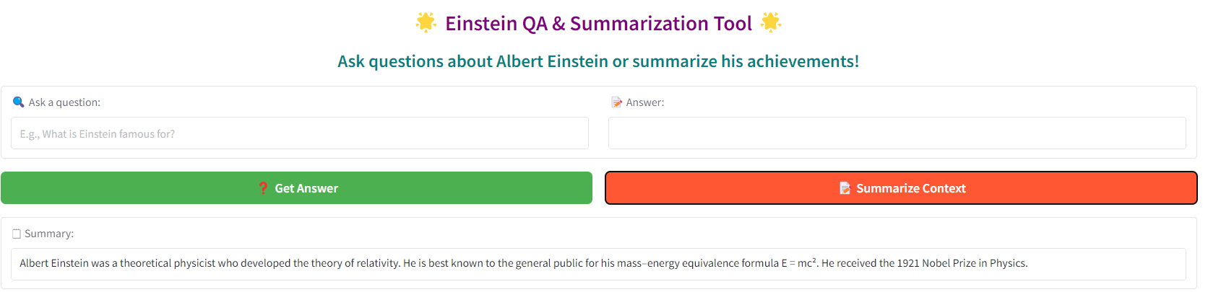

**Get Answer :**

