Practical Worksheet 6

Version: 1.0 Date: 12/04/2018 Author: David Glance

## Learning Objectives

1. Create a web app using Django
2. Implement nginx and a load balancer
3. Add a relational database using RDS

## Technologies Covered

Ubuntu

AWS

AWS ELB

RDS

Python/Boto scripts

**Note**: Do this from your VirtualBox VM – if you do it from any other platform (Windows, Mac – you will need to resolve any potential issues yourself)

## Background

The aim of this lab is to write a program that will:

[1] Understand the basis for a web architecture that incorporates scalability and security using ELB

[2] Familiarise yourself with the basics of programming using Django

## EC2 instance

## [Step 1] Create an EC2 instance

[1] Create an EC2 micro instance using Ubuntu

[2] Create a directory with a path /opt/wwc/mysites and cd into that. Set up a virtual environment as you did in the first lab:

python3 -m venv virtualenv --without-pip

apt install python3-pip

pip3 install django

django-admin startproject lab

cd lab

django-admin startapp polls

Stop and look at the files that have been created – the project files are to do with the running of the application. We will deal with the files as we go through.

## [Step 2] Install and configure nginx

[1] install nginx

it is easier now if you change the bash to operate as sudo

sudo bash

apt install nginx

edit /etc/nginx/sites-enabled/default and replace the contents of the file with

server {

listen 80 default_server;

listen [::]:80 default_server;

location / {

proxy_set_header X-Forwarded-Host $host;

proxy_set_header X-Real-IP $remote_addr;

proxy_pass http://127.0.0.1:8000;

}

}

Once you have done this you can restart nginx

service nginx restart

in your app directory: /opt/wwc/mysites/lab you can run

python3 manage.py runserver 8000

If you go to a browser now and use the ip address of your ec2 instance, you should see:

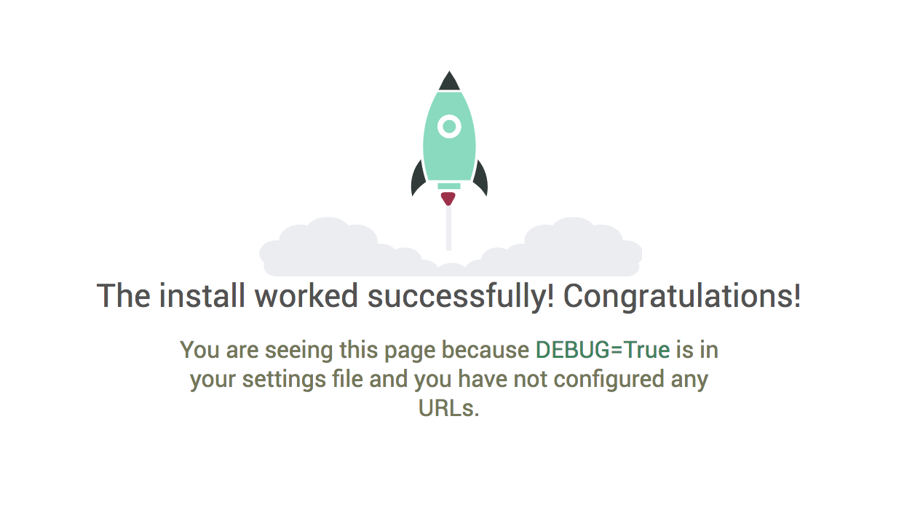

## [Step 3] Changing the code

[1] Following the steps outlined in the lecture, edit the following files

edit polls/views.py

from django.http import HttpResponse

def index(request):

    return HttpResponse("Hello, world.”)

edit polls/urls.py

from django.urls import path

from . import views

urlpatterns = [

    path('', views.index, name='index’),

]

edit lab/urls.py

from django.urls import include, path

from django.contrib import admin

urlpatterns = [

    path(‘polls/’, include(‘polls.urls’)),

    path(‘admin/’, admin.site.urls),

]

now run

python3 manage.py runserver 8000

and check that you get Hello, world. when you type the url http://<ip address>/polls/

**NOTE** remember to put the /polls/ on the end

## [Step 4] Adding the load balancer

[1] Create an application load balancer – note that you will have to use two subnets for this – we are not going to load balance between the subnets so you can choose any other one in addition to the subnet with your instance in it.

[2] Choose the security group – it must allow HTTP

[3] For the target group, in the health check, specify /polls/ for the path

[4] Add your instance as a registered target

Once you have created the ELB, you should see the health check fetch the /polls/ page every 30 seconds

You can now access the site using the url http://<load balancer dns name>/polls/

## [Step 5] Web interface for CloudStorage application

In views.py, add boto3 code to scan the DynamoDB table you created for your CloudStorage command line application. Display the results in the calling page.

In Django, you can use templates to properly format a web page using supplied variables – you can do that to make the table look nice. To use a template, you need to create a templates directory under polls and then add to the TEMPLATES section of lab/settings.py

TEMPLATES = [

{

'BACKEND': 'django.template.backends.django.DjangoTemplates',

'DIRS': [

'polls/templates/'

],

In the templates directory, add a file files.html with the following contents:

<html>

<head>

<title>Files</title>

</head>

<body>

<h1>Files </h1>

<ul>

{% for item in items %}

<li>{{ item.fileName }}</li>

{% endfor %}

</ul>

</body>

</html>

Finally in views.py, you can pass variables from your DynamoDB call and render the template in the following way:

from django.shortcuts import render

from django.template import loader

from django.http import HttpResponse

import boto3

import json

from boto3.dynamodb.conditions import Key, Attr

from botocore.exceptions import ClientError

def index(request):

template = loader.get_template('files.html')

dynamodb = boto3.resource('dynamodb', region_name='ap-southeast-2',

aws_access_key_id='Your Access Key',

aws_secret_access_key=’Your Secret’)

table = dynamodb.Table("UserFiles")

items = []

try:

response = table.scan()

except ClientError as e:

print(e.response['Error']['Message'])

else:

context = {'items': response['Items'] }

return HttpResponse(template.render(context, request))

You can add variables to the template and more formatting to display the information correctly.

## Submission and Quiz

Submit the views.py file with the boto3 DynamoDB code added – respond to the quiz

## Respond to the Quiz

[1] Which of the following statements is true:

[A] nginx converts the http request received from the internet into a special web service call that manage.py understands

[B] The http request bypasses nginx and calls runserver directly

[C] nginx acts as a proxy and forwards the http request to manage.py

[D] nginx runs the python code in response to an http request for a django program

[2] An ELB load balancer determines if a target is healthy and unhealthy respectively after x and y attempts where x and y are:

[A] 5 and 2

[B] 5 and 10

[C] 2 and 5

[D] 5 and 5