**SIT315 Concurrent and Distributed Programming**

**Seminar 1 Real-time Systems**

Team Member: Chanputhi Tith, Aryan Sharma, Jishnu Chauhan, and Steven Makris.

**Activity 1 – Von Neumann vs Harvard Architecture**

1. List at least four main differences between Von Neumann and Harvard architecture.

|  |  |
| --- | --- |
| Von Neumann | Harvard |
| program instructions and stores data in both the physical and logical memory. | stores them in separate physical memory spaces |
| uses 1 Data bus for both instruction fetches and data transfers | uses separates data buses for them. |
| instructions are accessed and processed in the order in which they are stored in memory. | has separate instruction memory which allows for parallel fetching. |
| CPU can not access instructions and read/write at the same time | can access instructions and read/write at the same time. |

1. Discuss advantages and disadvantages of Harvard architecture.

* The key advantages to the Harvard architecture are the following: Simultaneous Access, and Improved performances.
  + Simultaneous Access: The separate memory access for data and instructions allows the Harvard architecture to process parallel and simultaneous access to both memory spaces therefore increased and more efficient data access.
  + Improved Performance: Since the Harvard provides simultaneous Access, the performance of the Harvard architecture is increased.
* The key disadvantage of the Harvard architecture is the following: Complex, Limited flexibility and Increased memory requirements.
  + Complex: The design of the Harvard is more complicated as the sperate use for the memory spaces for the instructions and the data introduces the more complex system.
  + Flexibility: Harvard architecture has limited flexibility this is because when modifying instructions; the instructions and data are stored in separate memory spaces. This leads the architecture to implement programming more difficult or impossible to implement.
  + Increased Memory Requirement: Harvard architecture requires more memory than Von Neumann architecture.
* <https://www.geeksforgeeks.org/harvard-architecture/>
* <https://teachcomputerscience.com/harvard-architecture/>
* <https://study.com/learn/lesson/von-neumann-vs-harvard-architectures-differences-uses-examples.html>

# Activity 2- Arduino board architecture

Below is the architecture of the Arduino board(ATmega328p).

|  |  |
| --- | --- |
|  |  |
|  |  |

1. Based on the diagram, what architecture is used in the Arduino board? Justify your answer.

Because of its components' effective instruction flow and data access, it leverages Harvard architecture. It is possible to access data and instructions at the same time thanks to the division of programme memory and data memory.

1. Identify different types of memory in the Arduino architecture, discuss their usage, and sort them based on speed.  
    - SRAM:  
    It stores temporary data such as variables, program stacks and data structures.  
      
   - Flash Program Memory:  
    The firmware or programme code on the microcontroller is saved in flash memory. The amount of flash memory needed to hold the programme code depends on its size. Even unneeded code from libraries in programmes is still present in flash memory.   
   - EEPROM:  
   It stores small amounts of data that needs to be retained even when power is removed. Typically for Configuration Settings, data loggings and PC serial numbers  
   - Program counter:  
   determines the memory location of the upcoming instruction, allowing for branching, jumping, calling other subroutines, interruptions, and control over the flow of the programme.  
   - Instruction Register:  
   holds the current instruction for decoding and execution in a CPU.  
     
   - General purpose registers:  
   Are versatile memory locations in the CPU used for storing data during program execution.

order based on speed (fastest to slowest):

- Registers: proximity to the CPU, volatite  
 - SRAM: used for storing and retrieving data,volatite  
 - Flash Program Memory: used for program storage and execution, non-volatite  
 - EEPROM: used for non-volatile data storage

**Activity 2 – Arduino Board Architecture**

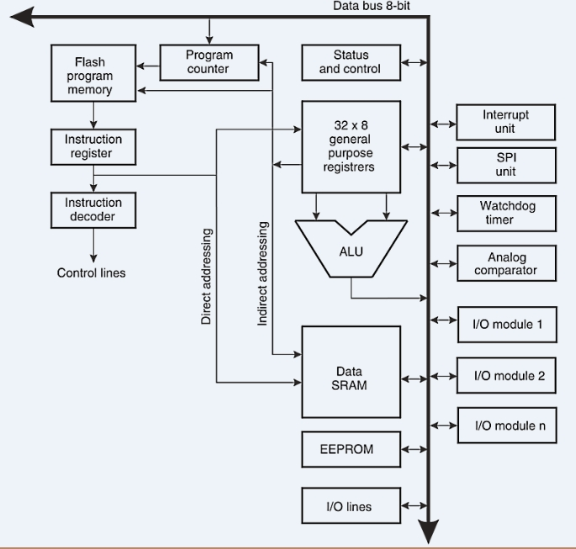

1. Based on the diagram, what architecture is used in the Arduino board? Justify your answer.

* The Arduino board uses the Harvard Architecture, this is because Arduino has separate program memory and data memory. Which is as show in the image above Flash Memory and SRAM are separated.

1. Identify different types of memory in the Arduino architecture, discuss their usage, and sort them based on speed.

* SRAM: SRAM is used to store the data and it is the fastest as it is S(Static)RAM. The SRAM has direct access therefore it does not need to process the Read and Write.
* Flash Memory: Flash Memory is used to store the program code but it requires additional time for reading and writing data in blocks.
* EEPROM: Slowest access speed among the three because of the write and erase cycle which limits the speed of the EEPROM.