**BACKEND WORK ON FEEDBACK OF THE MUSIC WEBSITE**

**STEP 1:**

In MYSQL workbench

Create a table on MYSQL workbench based on the front-end requirements.

**STEP 2:**

In visual studio code

Create “node.js” files in **music-js-sql** folder and check whether the code is running properly or not, if errors take place resolve the issue.

**STEP 3:**

In postman

Check whether data is inserting into the database or not.

**STEP 4:**

Open the corresponding, database html file i.e,music.html

By using “ajax” and API URL, in order to connect to the database.

**STEP 5:**

Finally open the music.html page in web-browser

Insert the data in feedback form and click on submit button

On opening MYSQL workbench,we can see that data is successfully inserted into the database tab

**!!STEP 1!!**

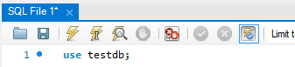

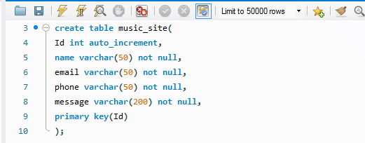

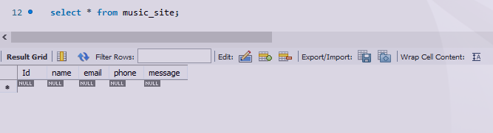

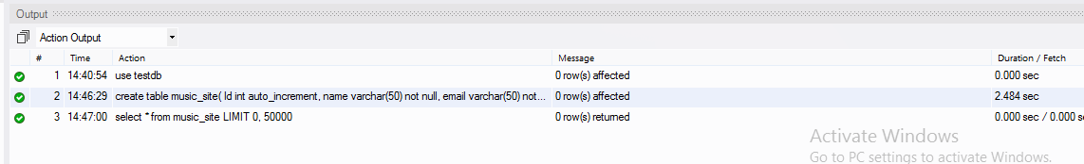

Now we have to create node.js files after installing node js in visual studio code:

**npm install**  command is used to install node js on visual studio code

**!!STEP 2!!**

Files in node.js:

In **music.js.sql folder**:

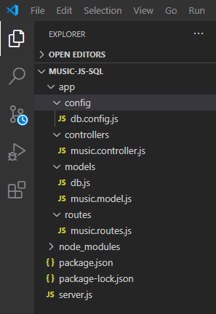

**server.js**

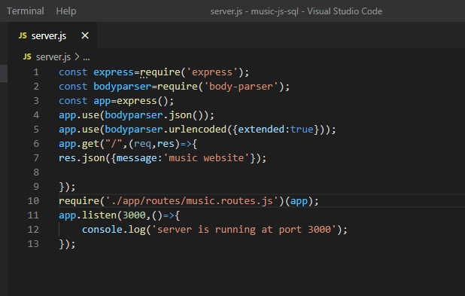

In app folder:

config->

**db.config.js**

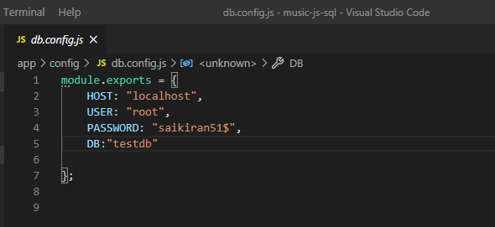

controllers->

**music.controller.js**

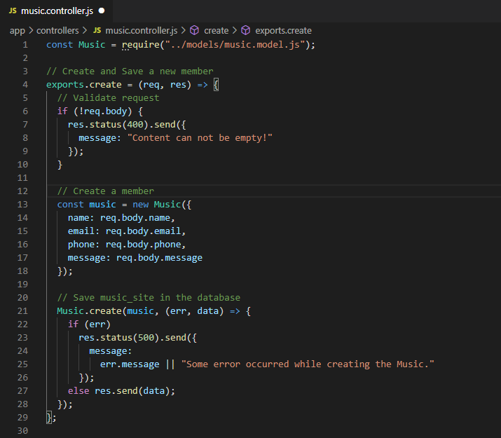

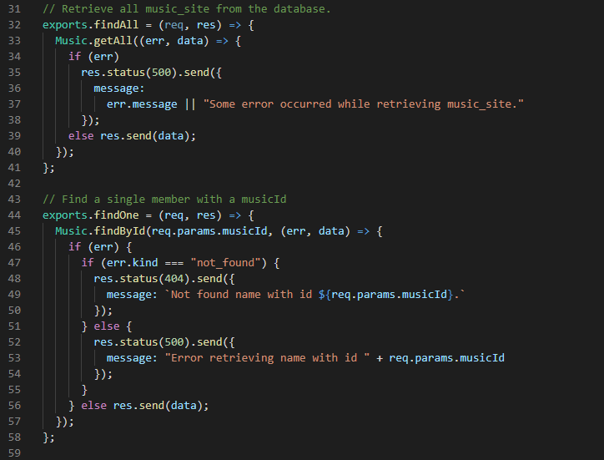

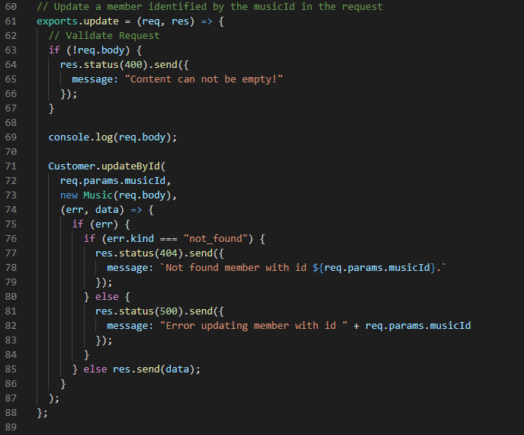

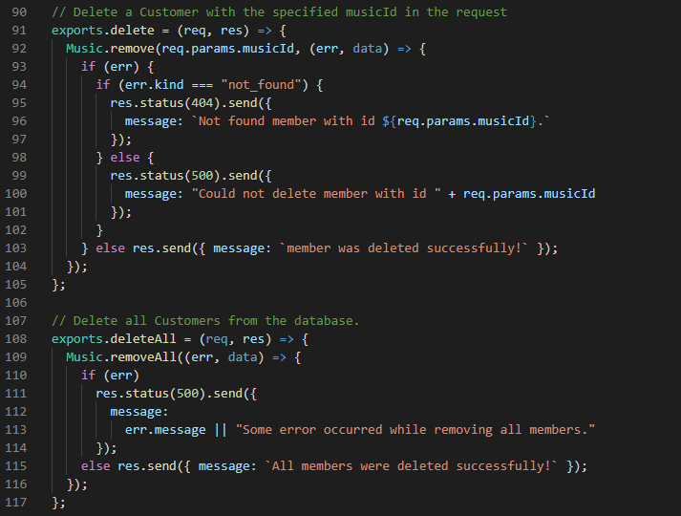

models->

**db.js**

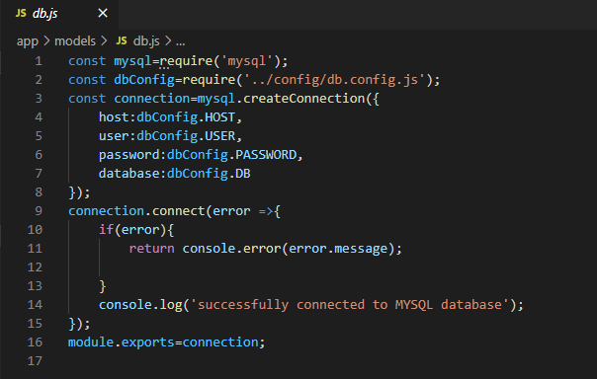

**music.model.js**

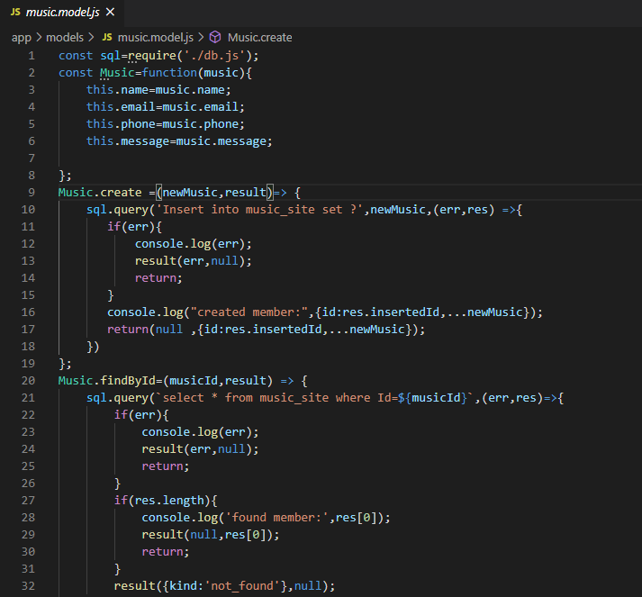

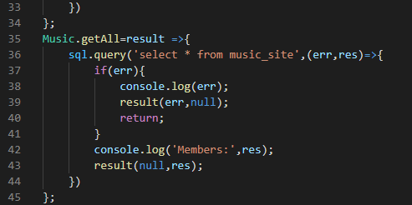

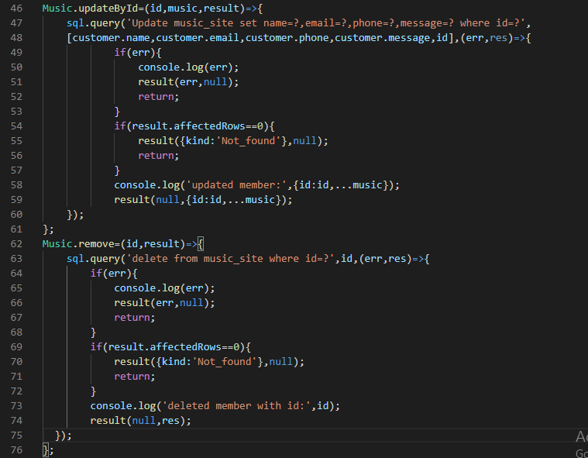

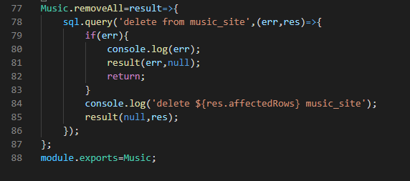

routes->

**Music.routes.js**

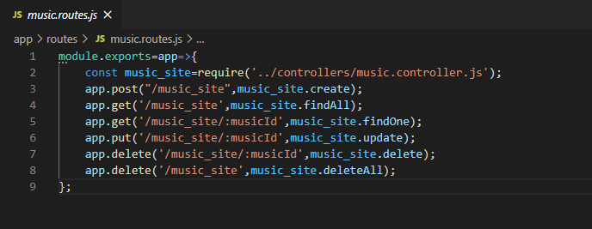

**Open new terminal and check weather the code is running properly or not:**

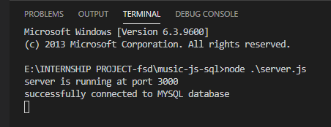

**!!STEP 3!!**

**In postman:**

after creating post request:

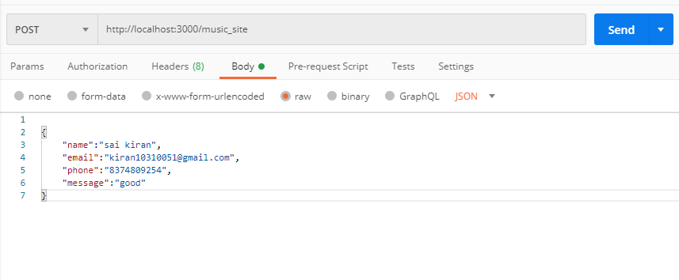

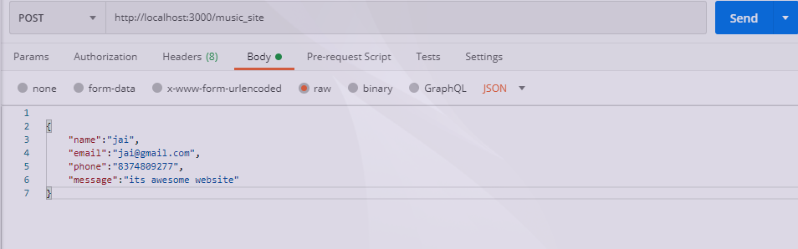

In visual studio code:

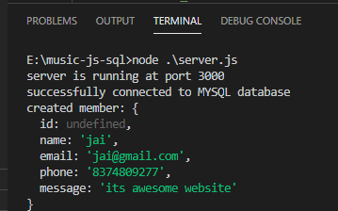

Sql database after updation:

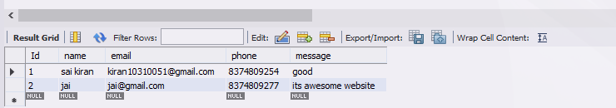

**!!STEP 4!!**

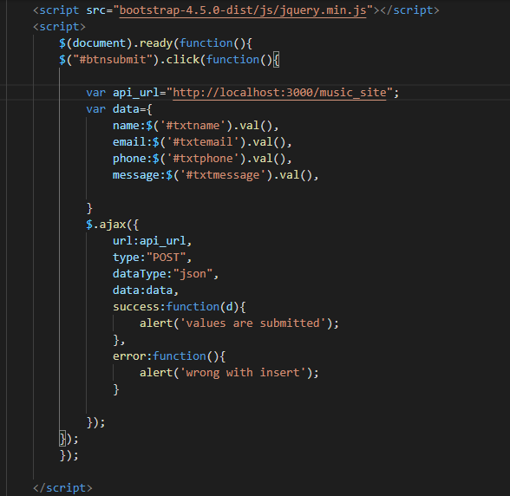

**!!STEP 5!!**

Now inserting values to “testdb” database, to SQL

Open **music.htm**l file

Now sending message to the server side:

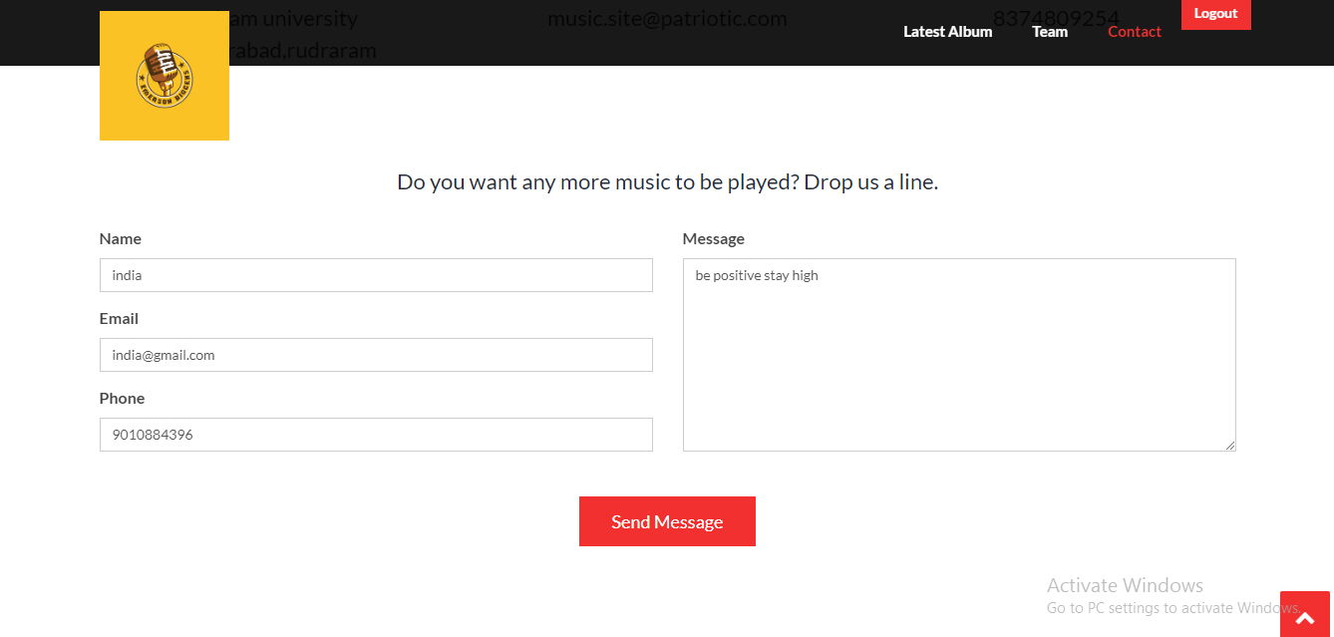

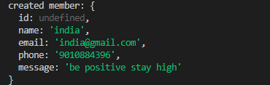

We can see a message that a member is successfully created in “visual studio code”

Now checking weather that values are inserted in MYSQL database or not:

Open MYSQL workbench:

Database present before:

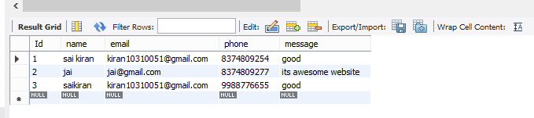

Now checking values are inserted or not:



now , the updated database is:

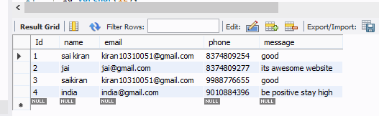

Now, the values are successfully inserted into the database from front- end application.