**FACULTY OF INF****ORMATICS & DESIGN**

**DIPLOMA in INFORMATION &**

**COMMUNICATIONS TECHNOLOGY**

**PROJECT 3 Individual ASSIGNMENT**

|  |  |
| --- | --- |
| **COURSE CODE:** | **PRT362S** |
| SUPERVISOR | **MR W OLIVIER** |
| GROUP | **WO1** |
| Name and Surname | Masibuve Sikhulume |
| Student Number | **221807144** |

This is my first drawing for our wireframes

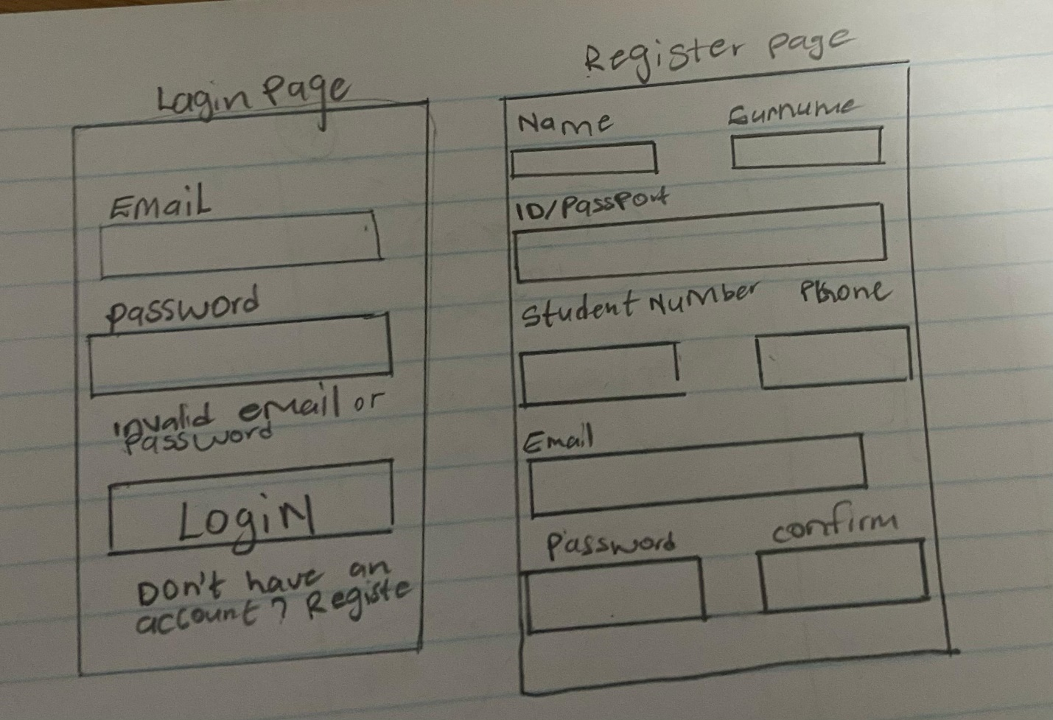

Then I drew three wireframes on each page then we discussed which page we going to use for our frontend

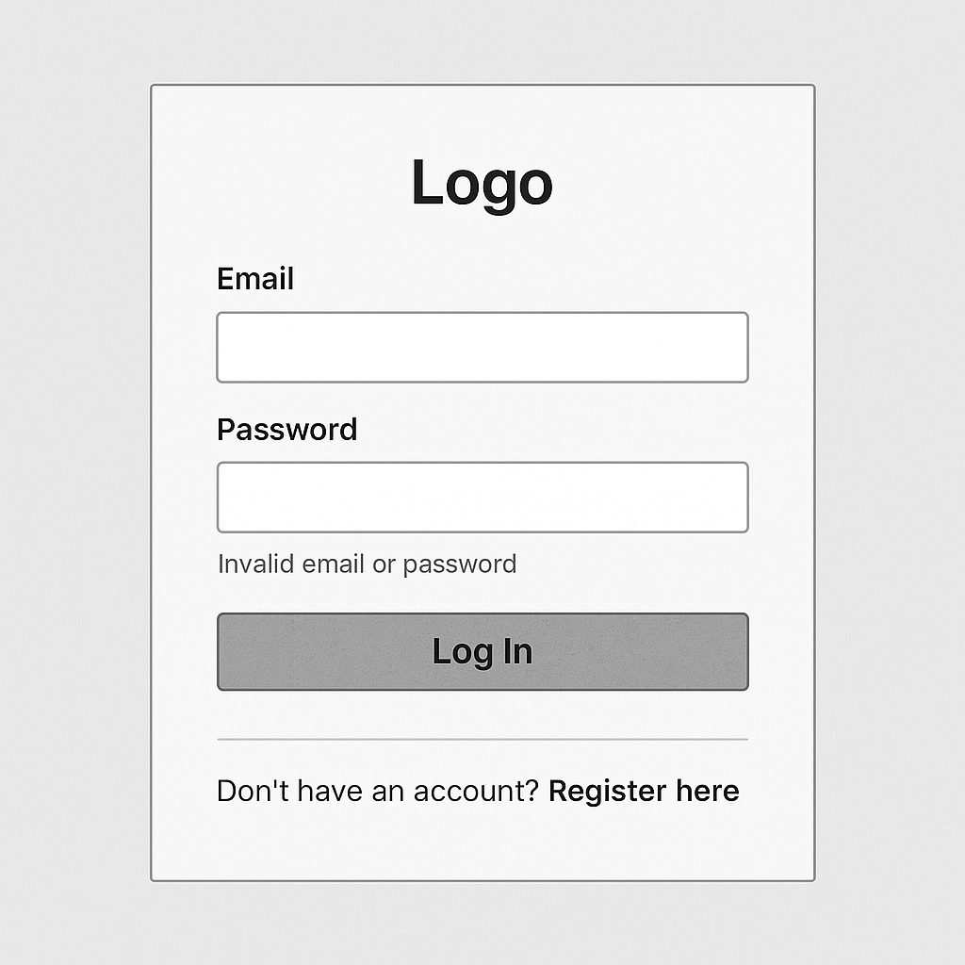

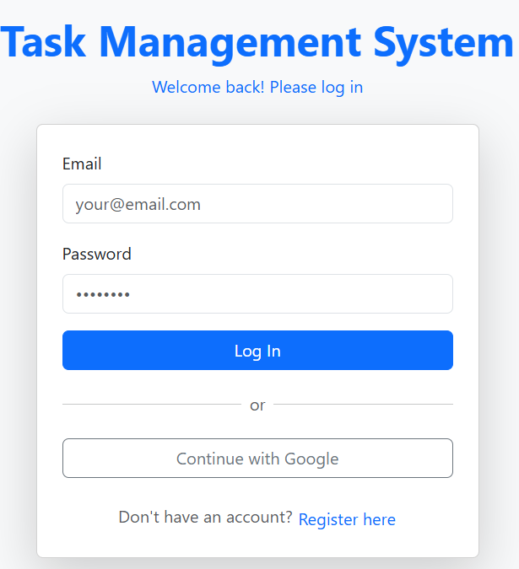

Then here it where the User will register for personal information

