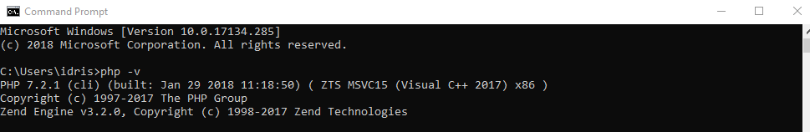

https://i.gyazo.com/d3b613bff9b15118756c0ea1973d166a.png

https://github.com/22193/BAP_Bewijzen_21