JEEVAN RAKSHA PHARMACY
MySQL Mini Project
Prepared by: M V Hari Chandana
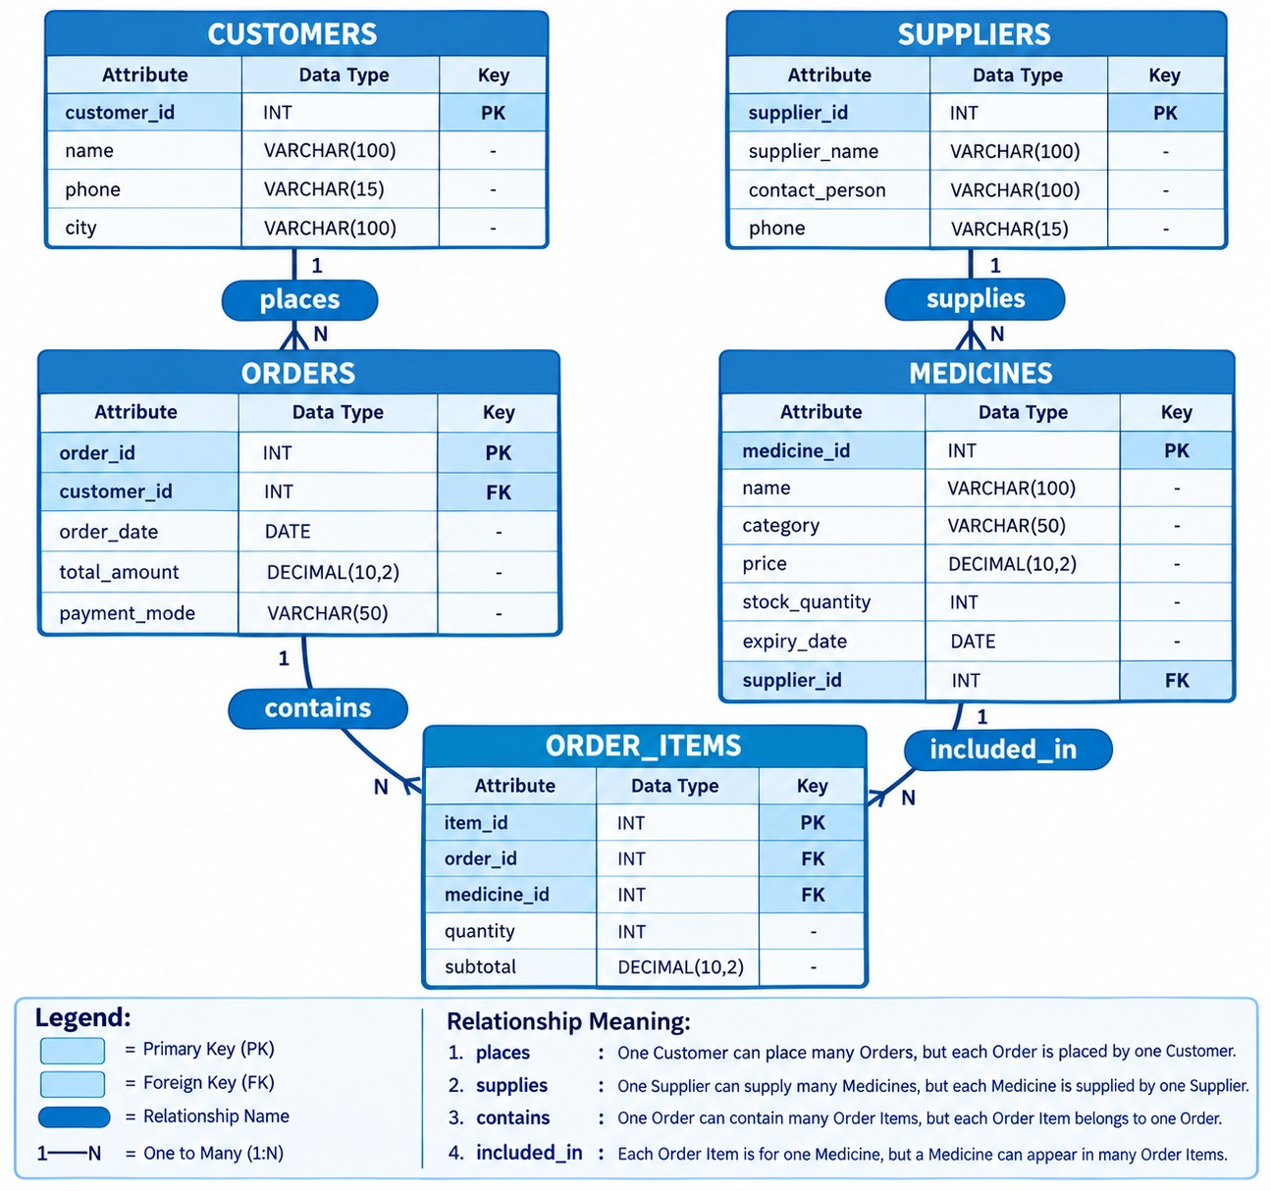

1. Case Study Overview
Jeevan Raksha Pharmacy is a pharmacy-management database project that stores customer details, supplier information, medicine inventory, orders and order-item details.
2.Tables and Relationships
Customers → Orders → Order_Items → Medicines → Supplie
One customer can place many orders. One supplier can supply many medicines. One order can contain many order items. One medicine can appear in many order items.
3. Database and Table Creation
CREATE DATABASE jeevan_raksha_pharmacy;
USE jeevan_raksha_pharmacy;
CREATE TABLE Customers (
customer_id INT PRIMARY KEY AUTO_INCREMENT,
customer_name VARCHAR(100) NOT NULL,
phone VARCHAR(10) NOT NULL,
city VARCHAR(50) NOT NULL,
created_at TIMESTAMP DEFAULT CURRENT_TIMESTAMP
);
CREATE TABLE Suppliers (
supplier_id INT PRIMARY KEY AUTO_INCREMENT,
supplier_name VARCHAR(150) NOT NULL UNIQUE,
phone VARCHAR(10),
city VARCHAR(50)
);
CREATE TABLE Medicines (
medicine_id INT PRIMARY KEY AUTO_INCREMENT,
medicine_name VARCHAR(150) NOT NULL,
medicine_type VARCHAR(50) NOT NULL,
price DECIMAL(10,2) NOT NULL,
stock_quantity INT NOT NULL,
expiry_date DATE NOT NULL,
supplier_id INT NOT NULL,
FOREIGN KEY (supplier_id) REFERENCES Suppliers(supplier_id)
);
CREATE TABLE Orders (
order_id INT PRIMARY KEY AUTO_INCREMENT,
customer_id INT NOT NULL,
order_date DATETIME DEFAULT CURRENT_TIMESTAMP,
total_amount DECIMAL(10,2) NOT NULL,
payment_mode VARCHAR(20) NOT NULL,
FOREIGN KEY (customer_id) REFERENCES Customers(customer_id),
CHECK (payment_mode IN ('UPI', 'Cash', 'Card'))
);
CREATE TABLE Order_Items (
order_item_id INT PRIMARY KEY AUTO_INCREMENT,
order_id INT NOT NULL,
medicine_id INT NOT NULL,
quantity INT NOT NULL,
unit_price DECIMAL(10,2) NOT NULL,
FOREIGN KEY (order_id) REFERENCES Orders(order_id),
FOREIGN KEY (medicine_id) REFERENCES Medicines(medicine_id),
CHECK (quantity > 0),
CHECK (unit_price >= 0)
);
SHOW TABLES;
4. Insert Sample Data
INSERT INTO Customers (customer_name, phone, city) VALUES
('Rohan Desai', '9876543218', 'Mumbai'),
('Kavita Rao', '9876543219', 'Pune'),
('Suresh Nair', '9876543220', 'Kerala'),
('Anjali Shah', '9876543221', 'Ahmedabad'),
('Manish Gupta', '9876543222', 'Delhi'),
('Deepika Reddy', '9876543223', 'Hyderabad'),
('Karan Malhotra', '9876543224', 'Chandigarh'),
('Meera Iyer', '9876543225', 'Chennai'),
('Nitin Pawar', '9876543226', 'Pune'),
('Swati Mishra', '9876543227', 'Lucknow');
INSERT INTO Suppliers (supplier_name, phone, city) VALUES
('Sunrise Pharma Distributors', '9000000005', 'Mumbai'),
('Wellness Medico', '9000000006', 'Pune'),
('CarePlus Distributors', '9000000007', 'Nashik'),
('Aarogya Pharma', '9000000008', 'Nagpur'),
('Global Med Supplies', '9000000009', 'Delhi'),
('Shree Medical Distributors', '9000000010', 'Bangalore'),
('MediTrust Pharma', '9000000011', 'Hyderabad'),
('Reliable Healthcare', '9000000012', 'Chennai'),
('Prime Life Distributors', '9000000013', 'Ahmedabad'),
('Unity Pharma Suppliers', '9000000014', 'Kolkata');
INSERT INTO Medicines
(medicine_name, medicine_type, price, stock_quantity, expiry_date, supplier_id) VALUES
('Dolo 650', 'Tablet', 35.00, 100, '2027-10-15', 5),
('Cetirizine 10mg', 'Tablet', 40.00, 80, '2028-02-20', 6),
('Azithromycin 250mg', 'Tablet', 75.00, 40, '2027-09-10', 7),
('Benadryl Syrup', 'Syrup', 110.00, 60, '2027-12-25', 8),
('Rabies Vaccine', 'Injection', 550.00, 25, '2027-05-30', 9),
('Omeprazole 20mg', 'Tablet', 65.00, 45, '2028-01-18', 10),
('Calamine Lotion', 'Lotion', 90.00, 70, '2027-11-22', 11),
('ORS Powder', 'Powder', 25.00, 200, '2028-03-15', 12),
('Diclofenac Gel', 'Gel', 130.00, 35, '2027-08-28', 13),
('Cough Relief Syrup', 'Syrup', 145.00, 20, '2027-06-12', 14);
INSERT INTO Orders
(customer_id, order_date, total_amount, payment_mode) VALUES
(1, '2026-09-11 10:30:00', 650.00, 'UPI'),
(2, '2026-09-12 11:00:00', 350.00, 'Cash'),
(3, '2026-09-13 12:15:00', 1250.00, 'Card'),
(4, '2026-09-14 14:30:00', 780.00, 'UPI'),
(5, '2026-09-15 15:45:00', 450.00, 'Cash'),
(6, '2026-09-16 16:00:00', 1800.00, 'Card'),
(7, '2026-09-17 10:15:00', 550.00, 'UPI'),
(8, '2026-09-18 13:00:00', 290.00, 'Cash'),
(9, '2026-09-19 14:45:00', 1100.00, 'Card'),
(10, '2026-09-20 17:30:00', 900.00, 'UPI');
5. Table Structures

Customers
Attribute | Data Type | Key / Constraint
customer_id | INT | PK, AUTO_INCREMENT
customer_name | VARCHAR(100) | NOT NULL
phone | VARCHAR(10) | NOT NULL
city | VARCHAR(50) | NOT NULL
created_at | TIMESTAMP | DEFAULT CURRENT_TIMESTAMP

Suppliers
Attribute | Data Type | Key / Constraint
supplier_id | INT | PK, AUTO_INCREMENT
supplier_name | VARCHAR(150) | NOT NULL, UNIQUE
phone | VARCHAR(10) | NULL
city | VARCHAR(50) | NULL

Medicines
Attribute | Data Type | Key / Constraint
medicine_id | INT | PK, AUTO_INCREMENT
medicine_name | VARCHAR(150) | NOT NULL
medicine_type | VARCHAR(50) | NOT NULL
price | DECIMAL(10,2) | NOT NULL
stock_quantity | INT | NOT NULL
expiry_date | DATE | NOT NULL
supplier_id | INT | FK → Suppliers

Orders
Attribute | Data Type | Key / Constraint
order_id | INT | PK, AUTO_INCREMENT
customer_id | INT | FK → Customers
order_date | DATETIME | DEFAULT CURRENT_TIMESTAMP
total_amount | DECIMAL(10,2) | NOT NULL
payment_mode | VARCHAR(20) | UPI/Cash/Card

Order_Items
Attribute | Data Type | Key / Constraint
order_item_id | INT | PK, AUTO_INCREMENT
order_id | INT | FK → Orders
medicine_id | INT | FK → Medicines
quantity | INT | CHECK > 0
unit_price | DECIMAL(10,2) | CHECK >= 0

6. Level 1 – Simple Queries

1. Customer List
Retrieve the customer name and city of all customers.
SELECT customer_name, city
FROM Customers;

2. Stock Check
Find medicine names where the medicine type is Syrup or Injection.
SELECT medicine_name
FROM Medicines
WHERE medicine_type IN ('Syrup', 'Injection');

3. High Value Bills
List all orders where total_amount is greater than ₹500.
SELECT *
FROM Orders
WHERE total_amount > 500;

4. Mumbai Residents
Find phone numbers of customers living in Mumbai.
SELECT phone
FROM Customers
WHERE city = 'Mumbai';
7. Level 2 – Intermediate Queries

5. Supplier Count
Count medicines supplied by Apollo Distributors.
SELECT COUNT(*) AS medicine_count
FROM Medicines m
JOIN Suppliers s ON m.supplier_id = s.supplier_id
WHERE s.supplier_name = 'Apollo Distributors';

6. Order Details
List customer name, order date and total amount for every order.
SELECT c.customer_name, o.order_date, o.total_amount
FROM Orders o
JOIN Customers c ON o.customer_id = c.customer_id
ORDER BY o.order_date;

7. Revenue by Mode
Calculate total revenue for each payment mode.
SELECT payment_mode, SUM(total_amount) AS total_revenue
FROM Orders
GROUP BY payment_mode;

8. Level 3 – Complex Queries

8. Best Selling Medicine
Find the medicine sold in the highest total quantity.
SELECT m.medicine_name, SUM(oi.quantity) AS total_quantity_sold
FROM Order_Items oi
JOIN Medicines m ON oi.medicine_id = m.medicine_id
GROUP BY m.medicine_id, m.medicine_name
ORDER BY total_quantity_sold DESC
LIMIT 1;

9. Customer Lifetime Value
List customers who spent more than ₹1,000 across all orders.
SELECT c.customer_name, SUM(o.total_amount) AS total_spent
FROM Customers c
JOIN Orders o ON c.customer_id = o.customer_id
GROUP BY c.customer_id, c.customer_name
HAVING SUM(o.total_amount) > 1000
ORDER BY total_spent DESC;

10. Inventory Audit
List medicines with less than 50 units and their supplier names.
SELECT m.medicine_name, m.stock_quantity, s.supplier_name
FROM Medicines m
JOIN Suppliers s ON m.supplier_id = s.supplier_id
WHERE m.stock_quantity < 50
ORDER BY m.stock_quantity ASC;

9. Expected Summary from the Supplied Orders
Metric | Expected Value
Total pharmacy revenue | ₹8,120.00
Number of orders | 10
Average order amount | ₹812.00
UPI revenue | ₹2,880.00
Cash revenue | ₹1,090.00
Card revenue | ₹4,150.00
Customers spending over ₹1,000 | Deepika Reddy, Suresh Nair, Nitin Pawar
These values are calculated from the ten Orders INSERT records supplied.

10. Additional SQL Practice Queries

11. Display All Medicines
SELECT * FROM Medicines;

12. Medicines by Price
SELECT medicine_name, medicine_type, price FROM Medicines ORDER BY price DESC;

13. Most Expensive Medicine
SELECT medicine_name, price FROM Medicines WHERE price = (SELECT MAX(price) FROM Medicines);

14. Cheapest Medicine
SELECT medicine_name, price FROM Medicines WHERE price = (SELECT MIN(price) FROM Medicines);

15. Count Customers by City
SELECT city, COUNT(*) AS customer_count FROM Customers GROUP BY city;

16. Medicines Expiring Before 2028
SELECT medicine_name, expiry_date FROM Medicines WHERE expiry_date < '2028-01-01';

17. Total Pharmacy Revenue
SELECT SUM(total_amount) AS total_revenue FROM Orders;

18. Number of Orders
SELECT COUNT(*) AS total_orders FROM Orders;

19. Average Order Amount
SELECT ROUND(AVG(total_amount), 2) AS average_order_amount FROM Orders;

20. Highest Spending Customer
SELECT c.customer_name, SUM(o.total_amount) AS total_spent FROM Customers c JOIN Orders o ON c.customer_id = o.customer_id GROUP BY c.customer_id, c.customer_name ORDER BY total_spent DESC LIMIT 1;

11. Execution Order
1. Create the database and select it using USE.
2. Create Customers and Suppliers.
3. Create Medicines, Orders and Order_Items.
4. Insert customers and suppliers.
5. Correct the supplier-ID mismatch.
6. Insert medicines and orders.
7. Insert Order_Items records if required.
8. Execute all queries.

12. Project Summary
This project demonstrates primary keys, foreign keys, constraints, INSERT statements, SELECT, WHERE, IN, JOIN, COUNT, SUM, AVG, GROUP BY, HAVING, ORDER BY, subqueries and LIMIT in a pharmacy-management scenario.

