2.0. Introduction
2.0.1 Why should I take this module?
🔹 Purpose: Configure switches & end devices for security & performance.
🔹 Why? Default settings exist, but customization is needed for your network.
🔹 Key Learning Points:
- Accessing Cisco IOS devices
- Basic configuration commands
- Configuring & verifying Cisco IOS devices
- Assigning IP addresses to end devices
🔹 Foundation: Essential first step before advanced network administration.
2.0.2 What will I learn to do in this module?
Module Title: Basic Switch and End Device Configuration
Module Objective: Implement initial settings including passwords, IP addressing, and default gateway parameters on a network switch and end devices.
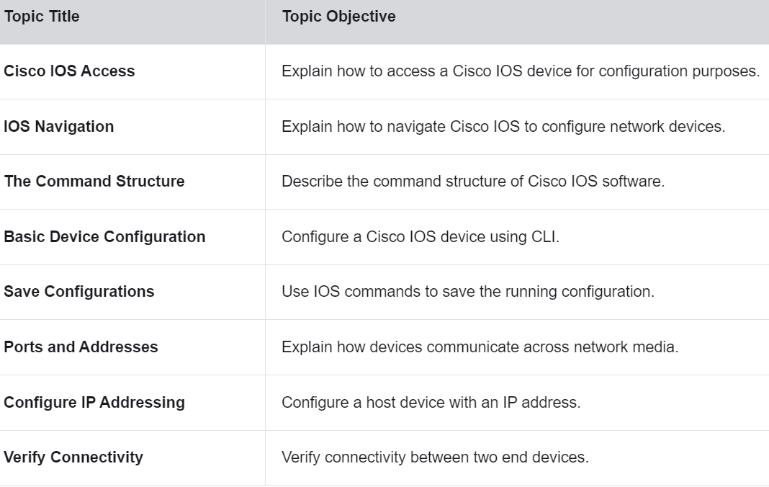
2.1. Cisco IOS Access
2.1.1 Operating Systems
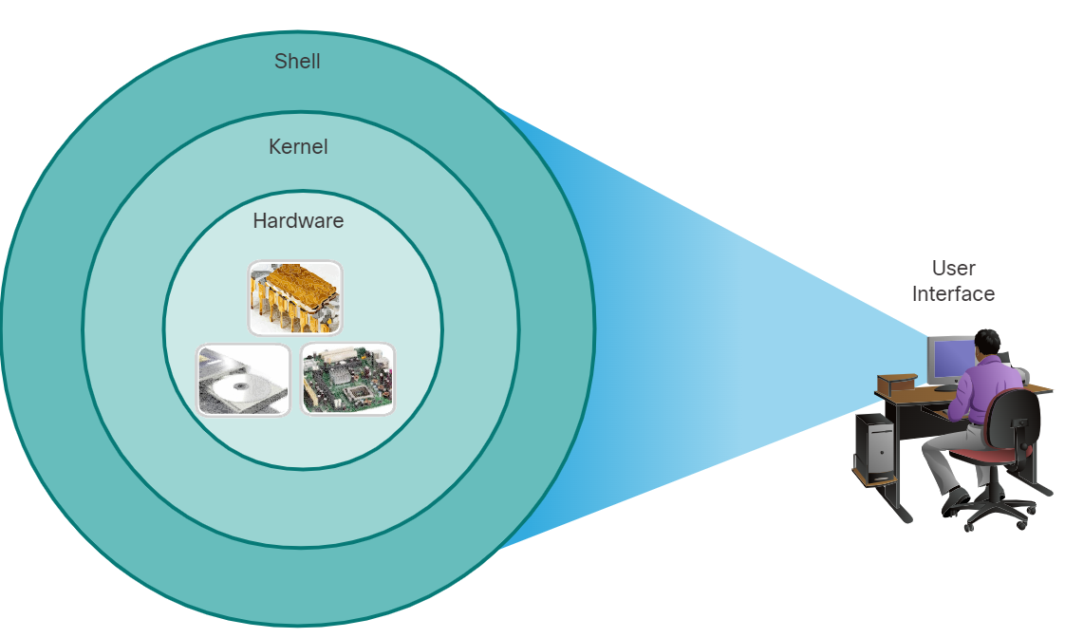
🔹 OS Components:
- Kernel: Directly interacts with hardware, manages resources.
- Shell: Interface for user interactions via CLI or GUI.
- Hardware: Physical components of the system.
🔹 User Interaction:
- CLI (Command-Line Interface): Text-based, low overhead, requires command knowledge.
- GUI (Graphical User Interface): Visual, user-friendly, but uses more system resources.
🔹 Example CLI Commands:
analyst@secOps ~]$ ls
- Lists files and directories.
🚀 Understanding OS structure is crucial for network and device management!
2.1.2 GUI
🔹 GUI (Graphical User Interface):
- User-friendly, uses icons, menus, and windows.
- Requires less technical knowledge.
- Can crash or lack advanced features.
🔹 CLI (Command-Line Interface):
- Used for network devices due to stability & efficiency.
- Requires command knowledge but offers full control.
🔹 Cisco Network Operating Systems:
- Cisco IOS: Used on Cisco routers & switches.
- Variants: IOS XE, IOS XR, NX-OS.
- Different devices use different IOS versions.
🔹 Home Routers:
- Use firmware as an OS.
- Typically configured via web-based GUI.
🚀 CLI mastery is essential for network management!
2.1.3 Purpose of an OS
🔹 PC Operating System (GUI-Based):
- Uses a mouse for selections & running programs.
- Allows text input & text-based commands.
- Displays output on a monitor.
🔹 Network OS (CLI-Based, e.g., Cisco IOS):
- Uses a keyboard to run CLI-based network programs.
- Requires text-based command entry.
- Displays output on a monitor.
🔹 Cisco IOS:
- Different devices use different IOS versions & feature sets.
- Default IOS can be upgraded for more features.
- Example: Cisco Catalyst 2960 Switch IOS versions.
🚀 Understanding IOS versions is key for network configuration & upgrades!
2.1.4 Access Methods

