**College Management System**

**Project Scope:**

**Description**: The College Management System is a comprehensive web-based application built on the Django framework, designed to efficiently manage various administrative tasks and enhance communication within a college or educational institution. The system provides user login functionalities for administrators, students, and HR personnel, each with specific roles and access privileges. It offers a user-friendly interface and essential features.

**Functionalities:**

**Admin Portal:**

1. The admin has exclusive access to the system and can log in with unique credentials.
2. Admins can update and manage the details of teachers and students, including personal information, contact details, and academic records.
3. They can view the profiles of teachers and students and edit the relevant information as needed.
4. The admin can manage essential documents like Transfer Certificates (TC) and other certificates provided by students. These files are accessible only to the admin.

**Teacher and Student Management:**

1. Admins can add, remove, or modify teacher and student accounts within the system.
2. They can assign courses to teachers and allocate students to respective classes.
3. Admins can view the details of individual teachers and students, including academic performance and attendance records.

**Student Portal:**

1. Students can log in using their credentials and access their personal profiles.
2. They can view their timetables, academic calendars, and important announcements.
3. Students have the ability to rate their allocated teachers based on their teaching experience.
4. They can upload documents such as TC and other certificates to the database for administrative purposes.

**HR Portal:**

1. HR personnel can log in and monitor the ratings provided by students for teachers.
2. They can view the average ratings of each teacher, providing insight into their performance.
3. The system generates a pie chart using the Canvas JS library to visually represent the aggregated ratings.

**Additional Features:**

1. Secure login and authentication system to protect sensitive information.
2. Responsive design and user-friendly interface for easy access from any device.
3. Search functionality to quickly find teachers, students, courses, or specific information within the system.

**SOFTWARE REQUIREMENTS:**

* Operating System: Windows
* Framework: Django
* Language: Python,

Frontend Framework: HTML, CSS, J avaScript,

Database: SQL LITE

* IDE: Pycharm

**Design and methodology:**

The College Management System is developed using an iterative model, which follows a cyclic process of development and refinement. The project progresses through a series of iterations, each focusing on specific functionalities and improvements. The iterative model allows for flexibility and adaptability, enabling continuous feedback.

The iterative model also promotes incremental development, where features and functionalities are added progressively. This allows for early delivery of essential features, quick identification of issues, and continuous improvement based on user feedback.

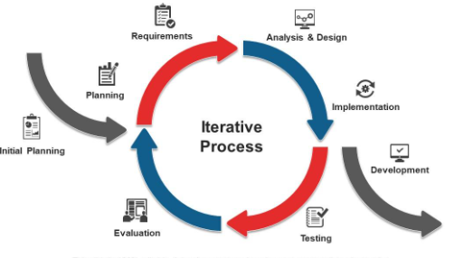

**Testing and validation:**

Unit testing:

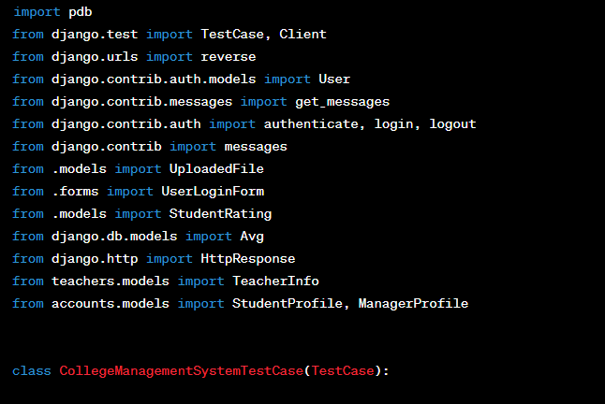

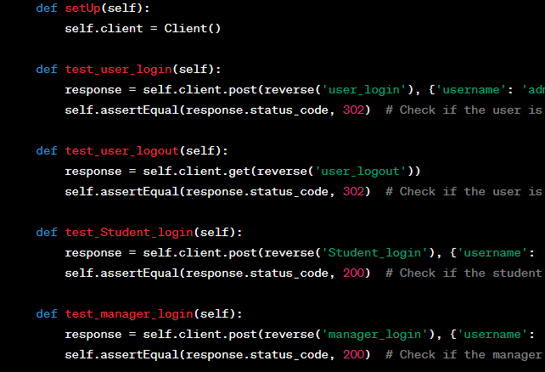

Output:

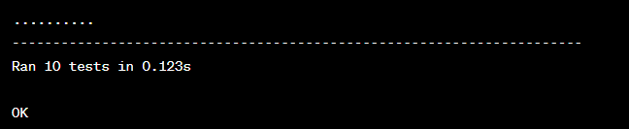

**User-Interface (UI):**

Admin login:

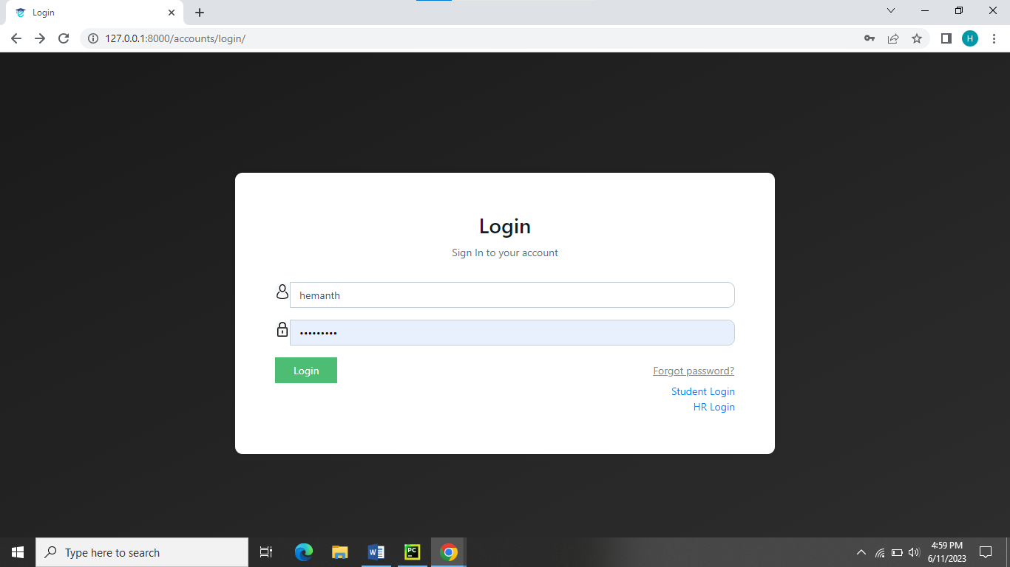

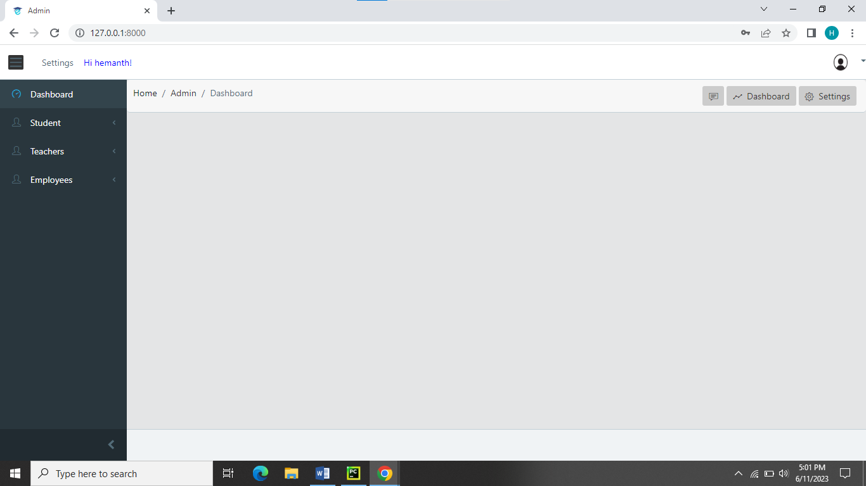Admin dashboard:

Additional Features:

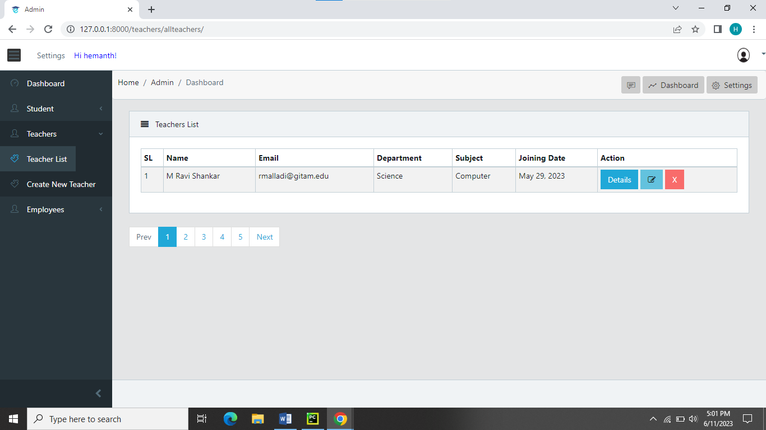

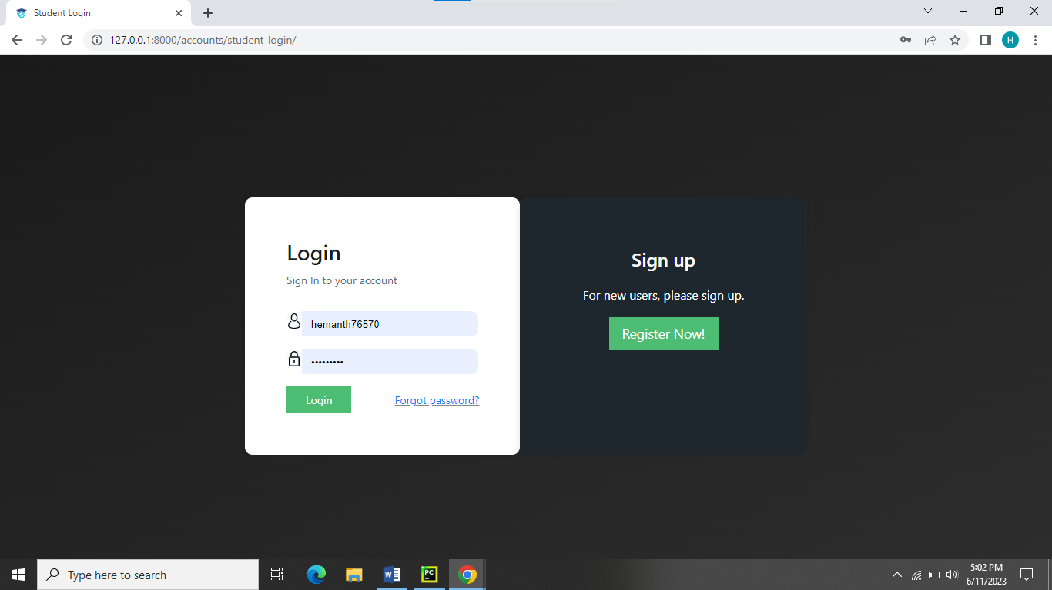Student Login:

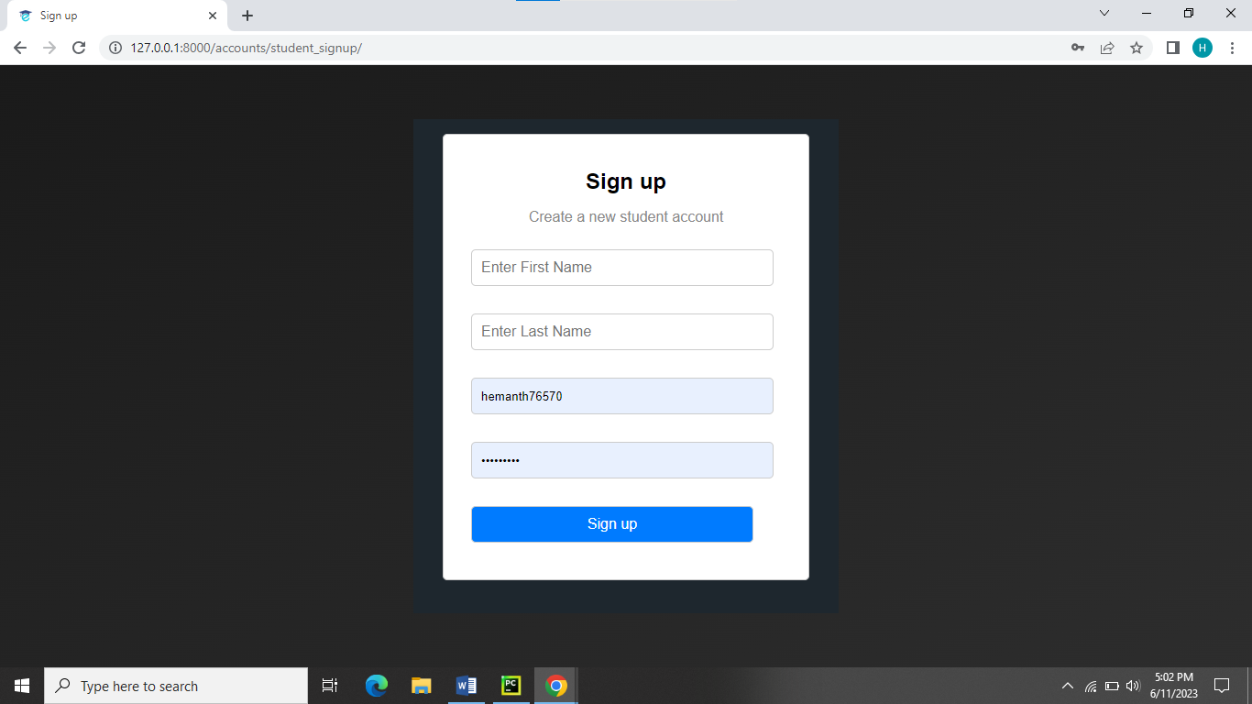New registrations:

Student dashboard:

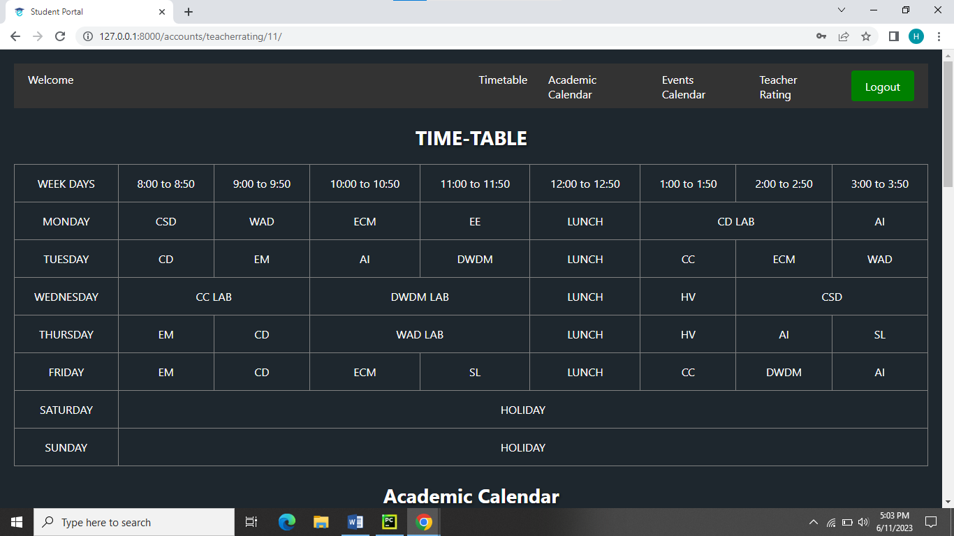

Student- rating page:

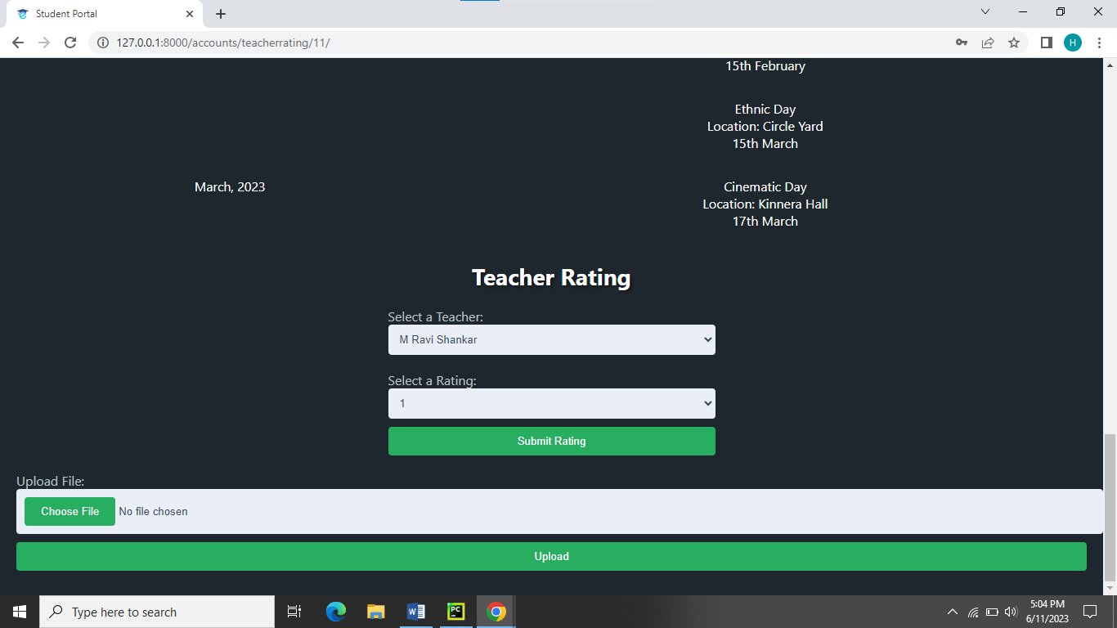

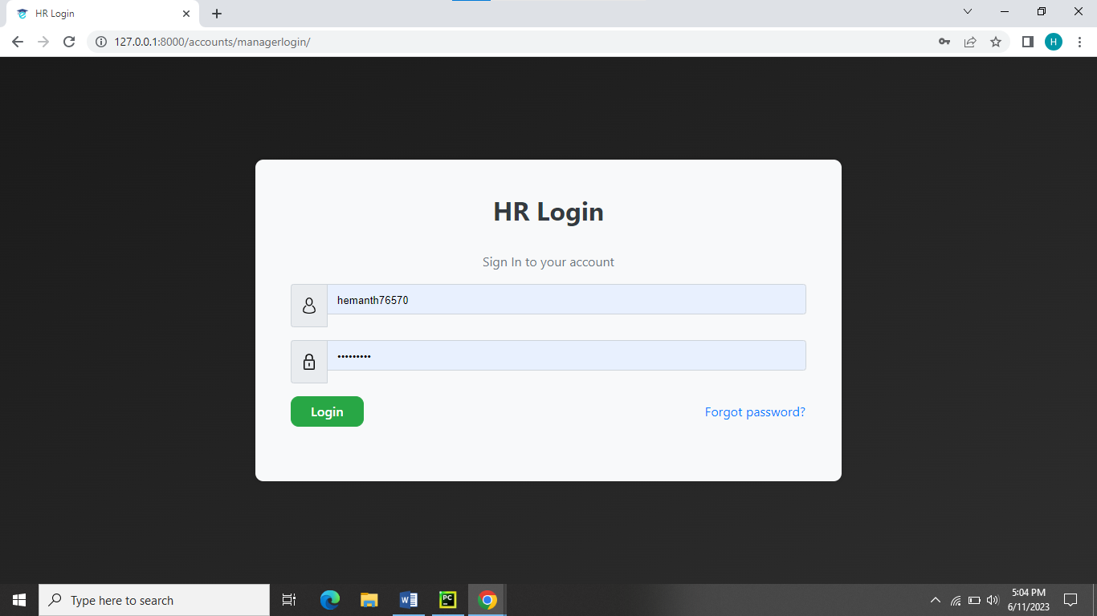HR Login:

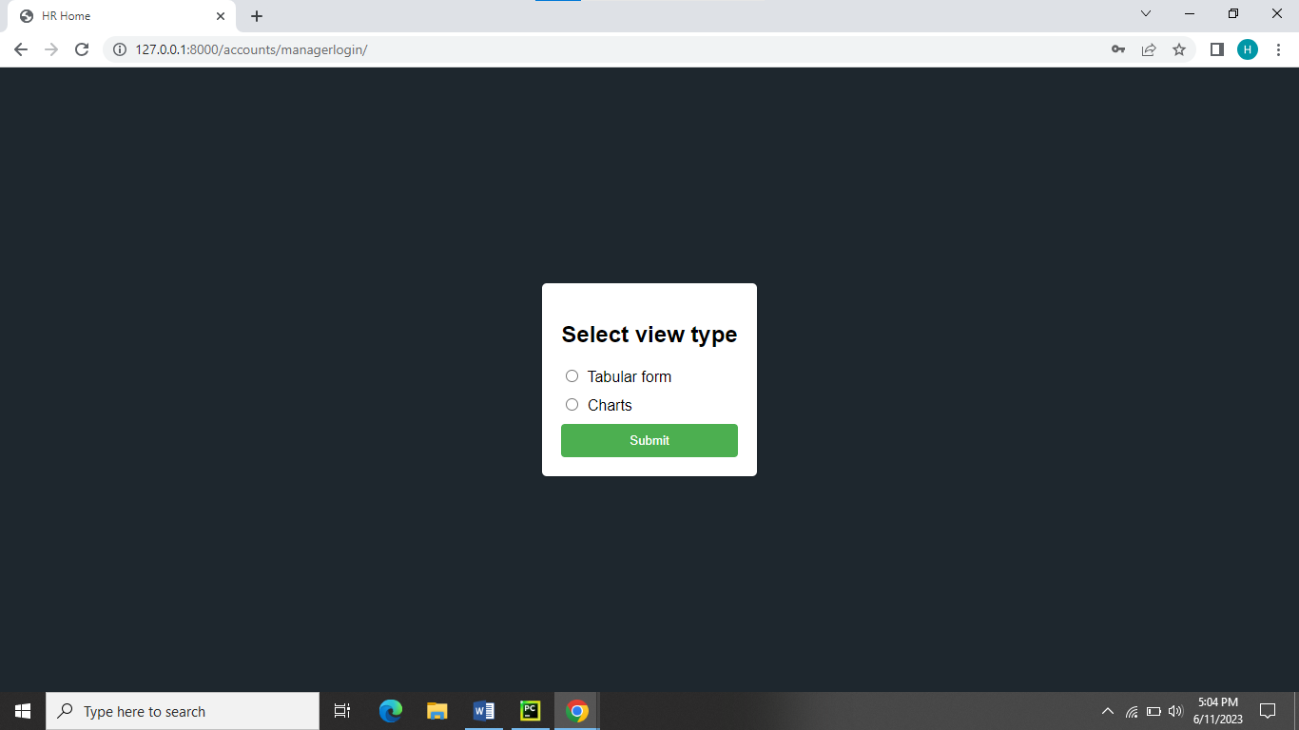HR dashboard:

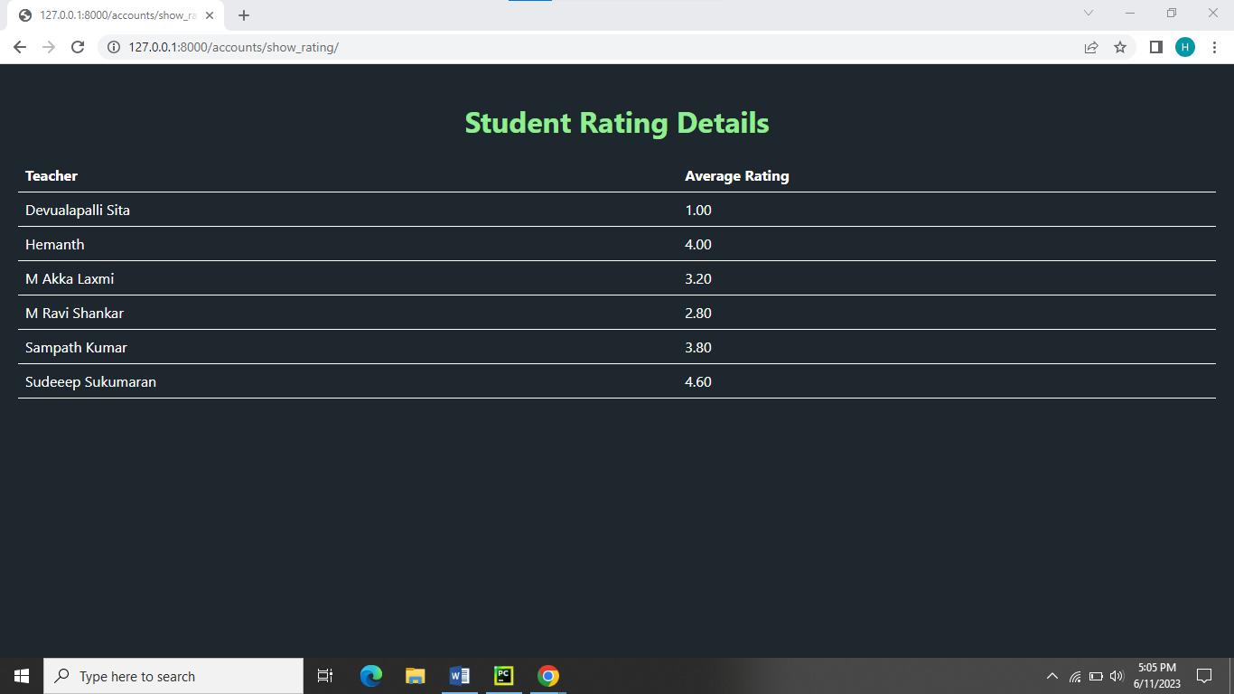Tabular Form:

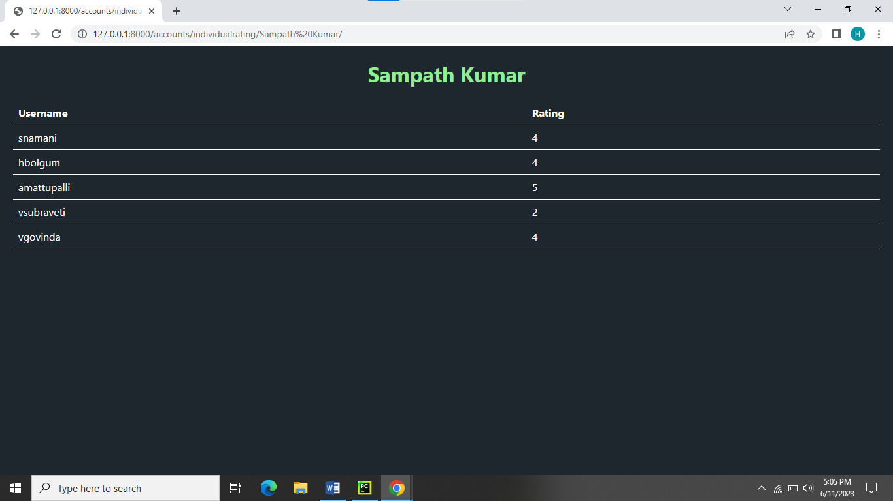

Pie chart:

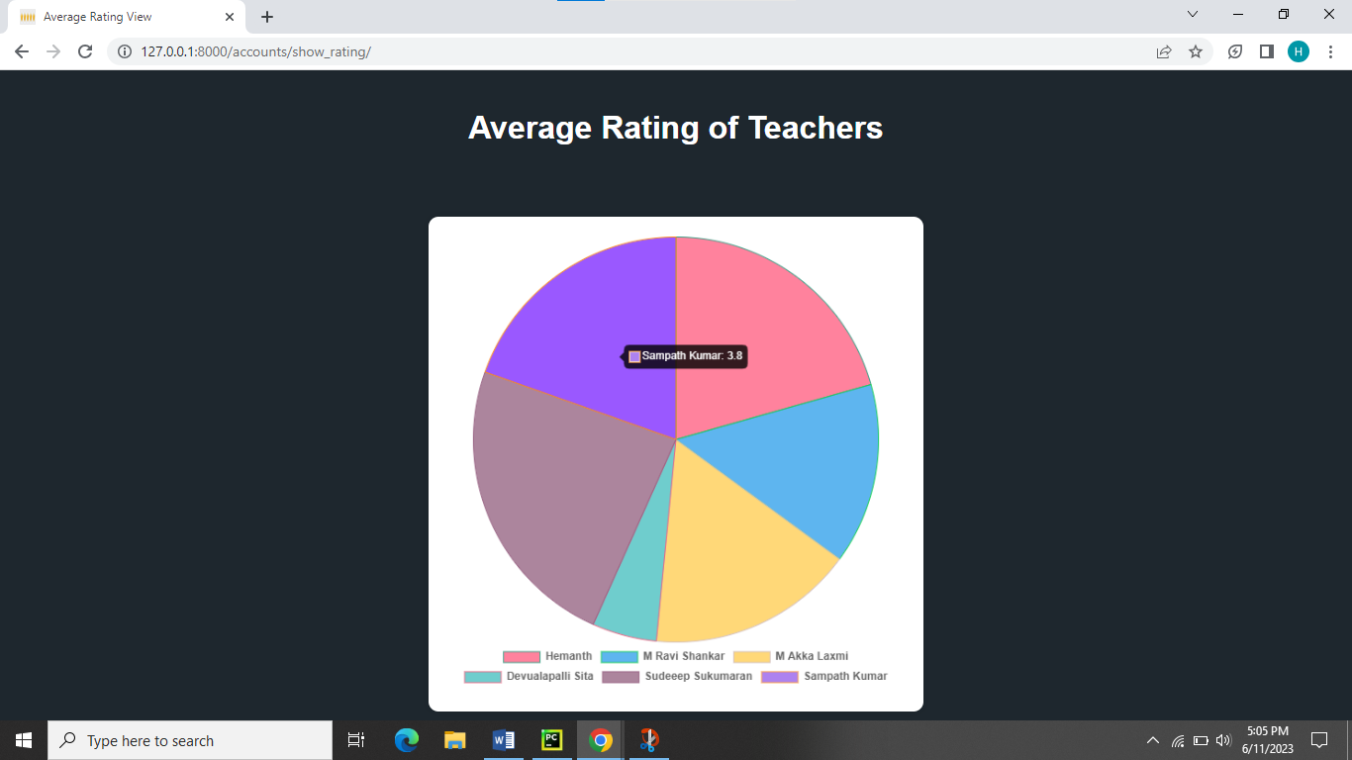

Admin Database: Sql Lite

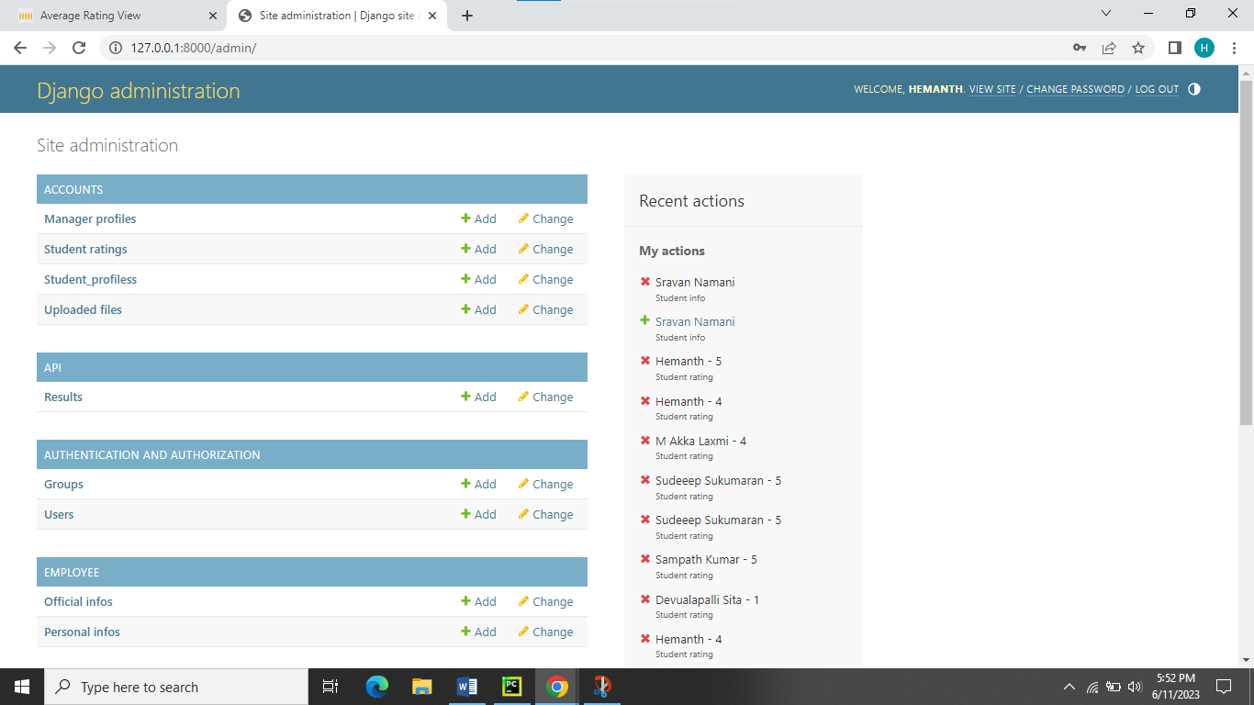

**Conclusion and Future Scope:**

In conclusion, the College Management System project has successfully created a user-friendly software solution to academic processes in the college. By using an iterative approach, the project continuously improved based on feedback and collaboration.

The system allows administrators, teachers, and students to easily manage their tasks. It includes features like user login, student timetables, academic calendars, teacher ratings, and HR monitoring. The secure Django framework ensures data safety and scalability.

For future development, the system can be expanded to include attendance tracking, exams management, and result generation. Integration with other systems like a Learning Management System or library management system can further enhance college operations.

Moreover, the system can be extended to support online admissions, fee payment, and alumni management, simplifying the entire student journey.

Overall, the College Management System lays a strong foundation for efficient college administration and management. With future improvements, it will continue to meet the evolving needs of the college, providing a seamless and productive experience for all users.