**College Management System**

**A Summer Internship Report submitted in partial fulfillment of the requirements for award of degree**

of

## **BACHELOR OF TECHNOLOGY**

In

## **COMPUTER SCIENCE AND ENGINEERING**

Submitted By

**Bolgum Hemanth Goud 222010301016**

**Under the guidance of**

**Dr.K.Dhana Sree Devi**

**Associate Professor**



**Department of CSE**

**GITAM School of Technology**

**GITAM Deemed to be University**

**Hyderabad - 502329**

**GANDHI INSTITUTE OF TECHNOLOGY AND MANAGEMENT**

**(GITAM)**

**(Declared as Deemed-to-be-University u/s 3 of UGC Act 1956)**

**HYDERABAD CAMPUS**



**DECLARATION**

I hereby declare that the summer internship report entitled **“COLLEGE MANAGEMENT SYSTEM”** is an original work done in the Department of Computer Science and Engineering, GITAM School of Technology, GITAM (Deemed to be University) submitted in partial fulfillment of the requirements for the award of the degree of “Bachelor of Technology” in Computer Science and Engineering. The work had not been submitted to any other college or university for the award of any degree or diploma.

Place-HYDERABAD **BOLGUM HEMANTH GOUD**

Date-06-09-2023 **222010301016**

**DEPARTMENT OF COMPUTER SCIENCE AND ENGINEERING GITAM SCHOOL OF TECHNOLOGY**

**GITAM**

**(DEEMED TO BE UNIVERSITY) HYDERABAD CAMPUS**



This is to certify that the Internship report entitled **“COLLEGE MANAGEMENT SYSTEM ”** is a bonafide record of work carried out by **BOLGUM HEMANTH GOUD (222010301016)** submitted in partial fulfillment of the requirement for the award of the degree of Bachelors of Technology in Computer Science and Engineering

**Dr. K.Dhana Sree Devi Dr. K. S. Sudeep**

Associate Professor Professor & HOD

CSE

**CERTIFICATE OF COMPLETION**

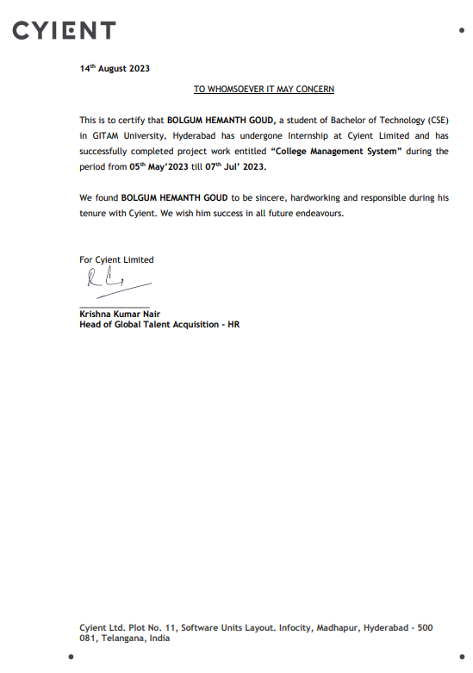

**Abstract**

This report serves as a comprehensive reflection on my two-month internship experience, encompassing an exploration of the lessons learned through my endeavors, work responsibilities undertaken, and the significant value of the internship program at **CYIENT** Limited. Throughout this period, I have acquired valuable insights as a new developer in the realm of web application development, gained proficiency in handling new frameworks, and cultivated essential skills for thriving in a professional office environment. As an intern, my primary focus was to engage with and contribute to web application projects. In the following sections, I shall delineate the specific domains of my work, expounding upon my achievements and the knowledge garnered during my tenure at **CYIENT** Limited.

**Table of Contents**

BACHELOR OF TECHNOLOGY 1

COMPUTER SCIENCE AND ENGINEERING 1

**1. Acknowledgement 7**

**2. Introduction 8**

**3. Executive Summary 9**

3.1 College Management System(CMS) 10

**4. Report Exposition 11**

**5. Pros And Cons of CMS 12**

**6. Different Platforms 16**

**7. System analysis 17**

7.1 Scope and methodology 17

7.2 Problem statement 19

7.3 Existing Problem 19

7.4 Proposed System 20

**8. System Design 21**

8.1.1 Use Case Diagram 21

8.1.2 Class Diagram 22

8.2 Overview of Technologies 23

8.2.1 Languages 23

8.2.2 Framework 26

8.2.3 IDE 27

**9. Implementation 28**

9.1 Code: 28

9.2. Web Page Snippets (UI) 33

**10. Testing And Validation 37**

10.1 Unit Testing 37

**11. References 39**

**12. Future Scope 40**

**Conclusion 41**

# 1. **Acknowledgement**

My project would not have been successful without the help of several people. We would like to thank the personalities who were part of our project in numerous ways, those who gave us outstanding support from the birth of the project.

We are extremely thankful to our honorable Pro-Vice Chancellor, **Dr. D. Shambasiva rao** for providing necessary infrastructure and resources for the accomplishment of our project.

We are highly indebted to **Prof. N. Seetharamaiah**, Principal, School of Technology, for his support during the tenure of the project.

We are very much obliged to our beloved **Prof. Dr. K.S.Sudeep**, Head of the Department of Computer Science & Engineering for providing the opportunity to undertake this project and encouragement in completion of this project.

We hereby wish to express our deep gratitude to **Dr. K.Dhana Sree Devi Associate Professor**, Department of Computer Science and Engineering, School of Technology for the esteemed guidance, moral support and invaluable advice provided by her for the success of the project.

We are also thankful to all the staff members of the Computer Science and Engineering department who have cooperated in making our project a success. We would like to thank all our parents and friends who extended their help, encouragement and moral support either directly or indirectly in our project work.

# **2. Introduction**

The College Management System is a web application based on Django Framework that incorporates three different login types: admin login, student login, and HR login. The admin login allows administrators to access and manage student and employee details.

Additionally, admins possess the authority to create new admin user accounts. Students can log in using their username and password in the student login section. If a student is new to the application, they can sign up and subsequently log in. Once logged in, students can view their timetable, academic calendar, and events calendar. They also have the option to provide feedback on their teachers, which is stored in the backend database.

Furthermore, students can upload files such as assignments within the web application. HR department members can log in using their specific credentials in the HR login section.

Upon logging in, they are directed to the home page, where they can choose the type of view for average teacher ratings. The application offers both tabular form and pie chart views. In the tabular form view, clicking on a teacher name reveals all the students and their respective ratings for that teacher. In the pie chart view, a comparison of the average ratings of teachers can be observed.

# **3. Executive Summary**

The College Management System project aims to streamline and enhance the overall management of a college by incorporating key features such as student ratings, student and HR login functionality, an academic calendar, and a timetable. This system is designed to improve the efficiency and effectiveness of various administrative tasks, foster student engagement.

The inclusion of student ratings within the College Management System enables students to provide feedback on various aspects of their educational experience, including courses. This valuable input can assist in identifying areas of improvement and recognizing exceptional performance, contributing to the overall quality enhancement of the college. Moreover, the HR login feature allows authorized individuals to access and analyze the ratings, providing valuable insights for faculty development and decision-making.

The project also incorporates an academic calendar and timetable module, which serves as a comprehensive resource for students. The academic calendar outlines important dates such as registration periods, examination schedules, and holidays, ensuring that all Students are well-informed and can plan their activities accordingly. The timetable module facilitates the efficient scheduling and allocation of classes, labs, and other academic events, minimizing conflicts and optimizing resource utilization.

## **3.1** **College Management System(CMS)**

Welcome to the College Management System, an innovative solution designed to enhance the efficiency and effectiveness of academic operations. This comprehensive system offers various features, including a Teacher Rating module, Academic Calendar access, and Timetable management.

With the Teacher Rating module, students can provide valuable feedback on their learning experience, enabling continuous improvement and fostering a collaborative environment between teachers and students.

Access to the Academic Calendar ensures that students and faculty stay informed about important dates, such as exams, holidays, and special events, promoting effective planning and organization.

The Timetable management feature simplifies the scheduling process, allowing students to easily access their class schedules, ensuring a smooth and well-coordinated learning experience.

Events Calendar into your college management system can greatly enhance organization and communication within the institution. The Events Calendar feature provides a centralized platform to manage and display various events happening in the college, such as academic seminars, workshops, cultural events, sports competitions, and administrative meetings

# **4. Report Exposition**

The College Management System is an advanced platform designed to optimize and streamline various aspects of academic operations. This report highlights the key features of the system, focusing on the Teacher Rating module, Academic and Event calendar access, and Timetable management.

The Teacher Rating module enables students to provide valuable feedback on their learning experience. This feature promotes a constructive and collaborative environment, allowing teachers to receive ratings from pupils and make necessary improvements. By incorporating student perspectives, the module aims to enhance teaching effectiveness and ensure continuous improvement in the quality of education.

In addition to the Teacher Rating module, the College Management System also incorporates an Academic and Event Calendar feature. This feature provides a centralized platform for students, faculty, and staff to access and manage academic schedules, important dates, and upcoming events. The Academic Calendar aspect ensures that everyone is well-informed about class schedules, examination periods, and holidays, facilitating effective time management and planning. The Event Calendar aspect, on the other hand, enables users to stay updated on various college events, such as seminars, workshops, cultural festivals, and sports tournaments. This feature promotes engagement, participation, and a sense of community among students, fostering a vibrant and enriching college experience.

# **5. Pros And Cons of CMS**

| PROS | CONS |
| --- | --- |
| Enhanced Teacher-Student Collaboration | Technical Challenges |
| Streamlined Timetable Management | Initial Setup and Training |
| Improved Efficiency | Data Security and Privacy |
| Data-Driven Decision-Making | Resistance to Change |
| Optimal Resource Utilization | Scalability and Future Expansion |

**PROS**

* **Enhanced Teacher-Student Collaboration:** The College Management System project enhances teacher-student collaboration through effective communication and interaction. Features like student ratings and login functionality enable valuable rating, while the academic calendar and timetable module ensure seamless scheduling. By fostering collaboration, the project supports students' academic growth and success.
* **Streamlined Timetable Management**:The College Management System project includes streamlined timetable management, optimizing the scheduling and allocation of classes, labs, and academic events. This feature minimizes conflicts, improves resource utilization, and provides a user-friendly interface for students and faculty. Automation reduces errors and administrative burden, ensuring a well-structured and organized learning environment.
* **Improved Efficiency:**The College Management System project greatly enhances efficiency by centralizing student ratings, enabling quick access for analysis and decision-making. Additionally, the integration of academic,event calendars and timetable modules optimizes scheduling and resource allocation. This improved efficiency streamlines administrative tasks, saving time and resources for the college.
* **Data-Driven Decision-Making**: With the incorporation of student ratings and feedback, the College Management System project enables data-driven decision-making. Faculty and administrators can gain valuable insights into the quality of courses, instructors, and facilities based on student ratings. This information helps identify areas of improvement, recognize exceptional performance, and make informed decisions regarding curriculum enhancements, faculty development, and resource allocation
* **Optimal Resource Utilization**: The inclusion of an academic calendar and timetable module optimizes resource utilization within the college. The system helps identify scheduling conflicts, allocate classrooms, labs, and other resources efficiently, and ensure a balanced distribution of workload for faculty members. This results in better utilization of resources, reduced conflicts, and improved overall operational efficiency.

**CONS**

* **Technical Challenges**: The College Management System project encountered technical challenges in integrating different modules, ensuring data security, scalability, and user-friendliness. Overcoming compatibility issues, implementing robust security measures, handling a large user base, and designing a user-friendly interface were key challenges. Despite these hurdles, the project team successfully delivered an efficient, secure, scalable, and user-friendly system.
* **Initial Setup and Training:** A challenge faced during the initial setup of the College Management System project was the need for comprehensive training, as it required faculty and staff to adapt to new technology. While this process may be time-consuming and disruptive, it is essential for successful system adoption and long-term benefits.
* **Data Security and Privacy:** Data security and privacy are crucial aspects of the College Management System project. Strong encryption, access controls, and regular audits will be implemented to protect student ratings and personal information. Balancing data security with user convenience is essential.
* **Resistance to Change:** Introducing a new College Management System may face resistance from faculty, staff, and students accustomed to traditional manual processes. Some individuals may be reluctant to embrace technological changes, leading to a slower adoption rate. Resistance to change can hinder the successful implementation of the system and require additional efforts to ensure buy-in, provide training, and address concerns.
* **Scalability and Future Expansion:** As the college grows and evolves, scalability and future expansion of the College Management System project may pose challenges. The system should be designed with scalability in mind to accommodate increasing data volumes, additional modules, and future technological advancements. Failure to plan for scalability may result in performance issues, data management complexities, and limitations in adapting to changing needs.

# **6. Different Platforms**

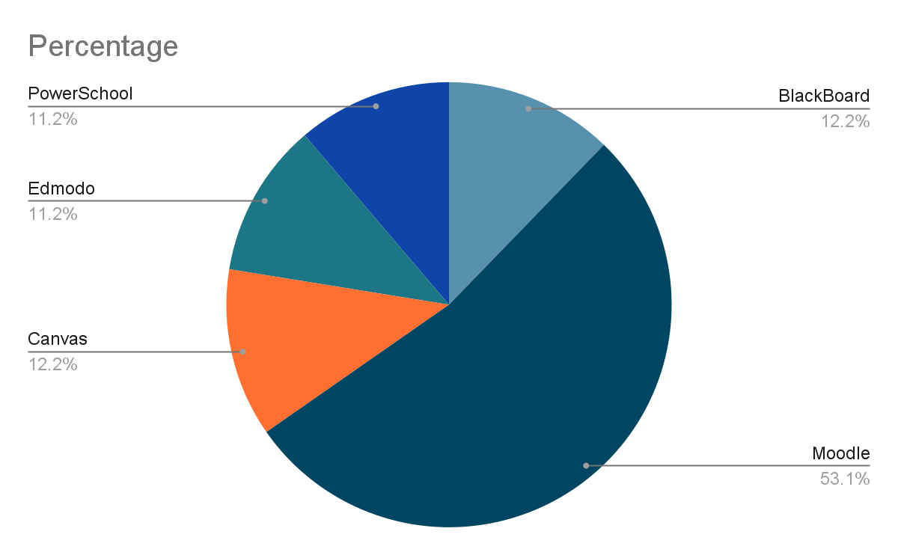

**Other Platforms**

* Google Classrooms
* D2L BrightSpace
* Sakai
* Schoox
* NEO Lms
* Schoology

# **7. System analysis**

## **7.1** **Scope and methodology**

The scope of the College Management System web application based on the Django framework includes the following functionalities and features:

* **Login System**
  + **Admin Login**: Administrators can access and manage student and employee details. They have the authority to create new admin user accounts.
  + **Student Login:** Students can log in using their username and password. New students can sign up and subsequently log in.
  + **HR Login**: HR department members can log in using their specific credentials.
* **Admin Functionality**
  + **Manage Student and Employee Details:** Administrators can access and manage the information of students and employees stored in the backend database.
  + **Create Admin User Accounts:** Administrators can create new admin user accounts for additional administrative access.
* **Student Functionality**
  + **View Timetable:** Students can view their timetable, which provides information about their classes and schedules
  + **Academic Calendar:** Students can access the academic calendar to stay updated on important events, holidays, and academic deadlines.
  + **Events Calendar:** Students can view the events calendar to know about upcoming events and activities.
  + **Provide Teacher Feedback:** Students can provide feedback on their teachers, which will be stored in the backend database.
  + **Upload Documents:** Students can upload files, such as Grade cards, Address proofs, Bonafide certificates, etc within the web application.
* **HR Functionality**
  + HR can analyze the average teacher ratings for PerformanceEvaluation, Professional Development, Feedback And Training.
  + **Average Teacher Ratings:** HR department members can choose the type of view for average teacher ratings.
  + **Tabular Form View:** HR members can view a tabular form that displays teachers and reveals all the students ratings for each teacher upon clicking their name.
  + **Pie Chart View:** HR members can compare the average ratings of teachers through a pie chart.

The project aims to provide an efficient and user-friendly system for college management offering administrators the tools to manage student and employee information effectively. It also empowers students by providing access to their academic-related information, allowing them to provide feedback and upload documents conveniently.

Additionally, HR department members can gain insights into teacher ratings through different visualization options,promoting effective decision-making.

## **7.2 Problem statement**

The College Management System project addresses the challenges and limitations associated with the current manual and fragmented processes involved in managing a college. The absence of a centralized system hampers efficient administration, impedes effective communication, and limits data-driven decision-making. Additionally, the lack of a standardized platform for student ratings and feedback collection undermines efforts to improve educational quality and identify areas of improvement. The absence of an integrated academic,events calendar and timetable further exacerbates scheduling conflicts and resource allocation inefficiencies. To overcome these obstacles, there is a pressing need for a comprehensive College Management System that streamlines administrative tasks, fosters student engagement, and ensures efficient utilization of resources.

## **7.3 Existing Problem**

One problem in recent college management systems is the lack of seamless integration between different platforms. Colleges and universities often use multiple software applications to manage various aspects of their operations, but these systems operate in silos, resulting in data inconsistencies and administrative burdens. When information is updated in one system, it may not reflect in others, leading to errors and manual data entry. This inefficiency hampers productivity and negatively impacts students' experiences.

To address this, colleges should prioritize system integration. By implementing robust data exchange mechanisms, standardized formats, and APIs, they can enable seamless communication and synchronization between platforms. Real-time data sharing improves efficiency, reduces administrative workload, and enhances the overall user experience for students, faculty, and staff

## **7.4 Proposed System**

The proposed College Management System aims to address the existing challenges and enhance the overall management of the college through the utilization of modern technologies. The system will be developed using HTML, Django, and Python, providing a robust and scalable solution. It will incorporate key modules such as student ratings, student and HR login functionality, an academic,event calendars and a timetable. This integrated system will streamline administrative processes and optimize resource utilization, ultimately improving the overall efficiency and effectiveness of the college management.

# **8. System Design**

## **8.1.1 Use Case Diagram**

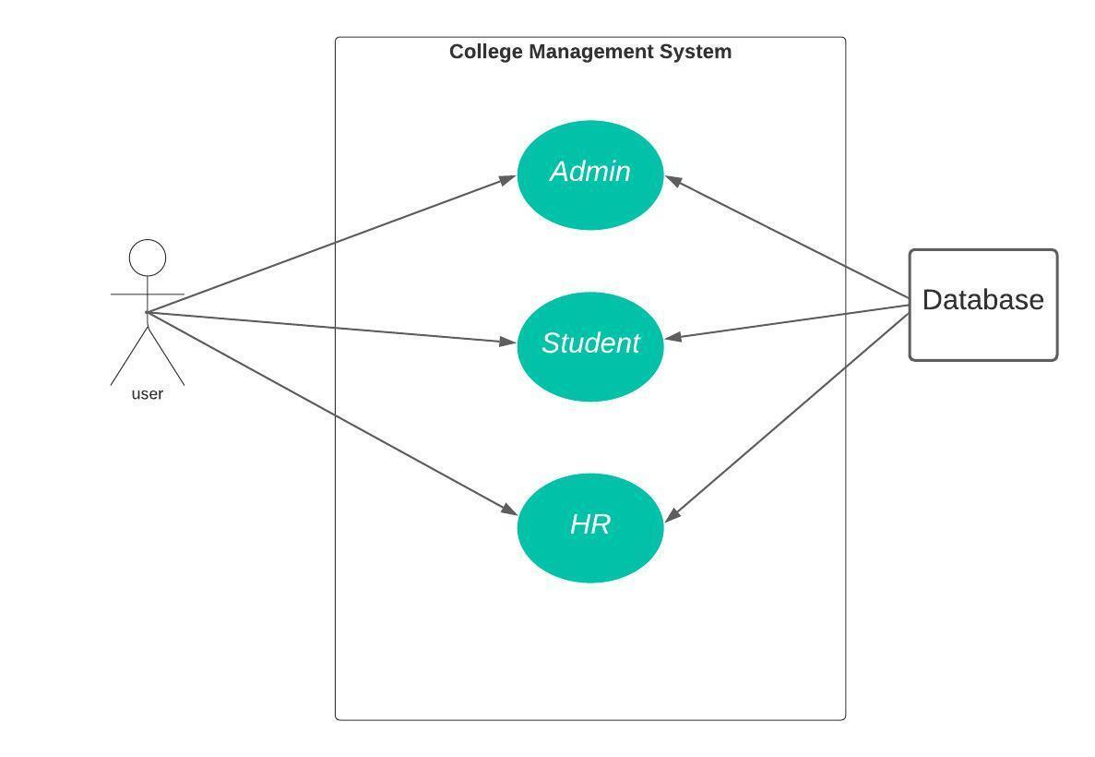

## **8.1.2 Class Diagram**

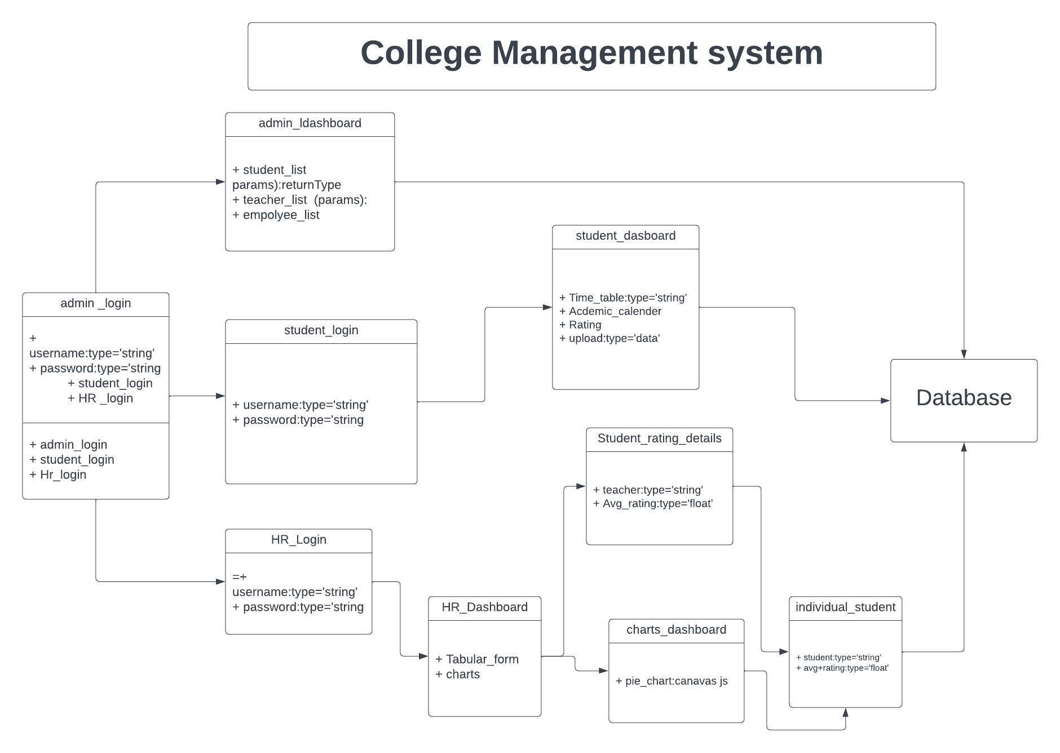

## **8.2 Overview of Technologies**

### **8.2.1 Languages**

**Python:** Python is used extensively in the College Management System project for its backend development, data processing, and integration tasks. With Python's powerful and versatile capabilities, it serves as the programming language of choice for implementing the system's functionalities and logic. Python, along with the Django framework, allows for efficient database management, handling of user authentication and authorization, and seamless integration of different modules. It enables the development team to write clean and maintainable code, ensuring scalability and flexibility as the project evolves. Additionally, Python's rich ecosystem of libraries and frameworks supports various tasks, such as data analysis for student ratings, generating dynamic web pages, and managing APIs for third-party integrations.

**HTML:** HTML is a fundamental technology used in the College Management System project for creating the structure and layout of web pages. It is utilized to define the elements and their organization within the user interface of the system. HTML tags and attributes are employed to format text, insert images, create forms for user input, and establish hyperlinks to navigate between different pages. Additionally, HTML is instrumental in ensuring the accessibility and compatibility of the system across various web browsers and devices. Overall, HTML plays a crucial role in providing the visual representation and interactive functionality of the College Management System, enhancing the user experience and facilitating seamless navigation and interaction within the system.

**CSS:** CSS (Cascading Style Sheets) is utilized in the College Management System project to enhance the visual presentation and layout of the web pages. It is used to define the styling and formatting aspects of the system's user interface, including fonts, colors, backgrounds, spacing, and positioning of elements. CSS allows for consistent styling across multiple pages, ensuring a cohesive and professional appearance. It enables the customization of various components such as buttons, forms, tables, and navigation menus, enhancing the overall user experience and visual appeal of the system. By separating the presentation layer from the content layer, CSS simplifies maintenance and allows for easy updates and modifications to the system's design.

**Bootstrap:** Bootstrap is utilized in the College Management System project to ensure responsive and visually appealing user interfaces. By leveraging Bootstrap's framework, the project's web pages are developed with pre-built CSS styles and components that facilitate consistent and professional-looking designs. Bootstrap's grid system enables the responsive layout of elements across different devices and screen sizes, ensuring an optimal user experience. Additionally, the extensive collection of ready-to-use components, such as navigation bars, forms, buttons, and modals, simplifies the development process and enhances the overall aesthetics of the system. The utilization of Bootstrap in the project helps to create a user-friendly and visually appealing interface that adapts seamlessly to various devices, enhancing usability and accessibility for all users.

**SQLite3:** SQLite3 is used in the College Management System project as the database management system. It serves as a reliable and lightweight solution for storing and managing data related to student ratings, academic calendars, timetables, and other essential information. By leveraging SQLite3, the system can efficiently organize and retrieve data, ensuring seamless access and retrieval for users.

The integration of SQLite3 offers several benefits for the project. Firstly, it provides a self-contained, serverless architecture, eliminating the need for complex database setup and administration. This simplifies the deployment process and reduces maintenance overhead. Secondly, SQLite3 supports ACID (Atomicity, Consistency, Isolation, Durability) properties, ensuring data integrity and reliability. This ensures that data modifications occur in a consistent and secure manner, minimizing the risk of data corruption. Overall, SQLite3 serves as a robust and efficient database solution for the College Management System project, enabling smooth data management and retrieval operations..

**JavaScript:**JavaScript plays a significant role in enhancing the functionality and interactivity of the College Management System project. It is used to create dynamic and responsive web pages, providing a seamless user experience. For instance, JavaScript can be utilized to validate form inputs, ensuring that users provide accurate and appropriate information when submitting feedback or registering for events. It enables real-time validation, such as checking for required fields, email formats, or password strength, thus improving data accuracy and reducing errors.

Furthermore, JavaScript is instrumental in implementing interactive features within the system. It allows for the creation of event handlers that respond to user actions, such as clicking buttons or selecting options.

These event handlers can trigger actions like displaying pop-up messages, updating information on the page dynamically, or loading content without requiring a full page refresh. JavaScript also facilitates asynchronous communication with the server, enabling features like auto-suggest search, dynamic filtering of data, or real-time updates of event details. Overall, JavaScript enhances the user interface of the College Management System, making it more intuitive, interactive, and user-friendly.

### **8.2.2 Framework**

**Django:** The Django framework is utilized in the College Management System project to develop a robust and scalable web application. Django provides a comprehensive set of tools and functionalities that simplify the process of building complex applications. It offers a Model-View-Controller (MVC) architectural pattern, allowing for efficient data management, user interface design, and application logic. Django's built-in features, such as authentication, form handling, and database integration, greatly expedite the development process. Additionally, Django's templating system facilitates the creation of dynamic web pages, enabling seamless integration of various modules, including the Teacher Rating module, Academic and Event Calendar, and Timetable management. Overall, Django empowers developers to build a secure, scalable, and user-friendly College Management System.

### **8.2.3 IDE**

**Pycharm:**

PyCharm IDE is utilized in the College Management System project as the integrated development environment for coding, testing, and debugging purposes. PyCharm provides a user-friendly interface and a wide range of features tailored specifically for Python development. It offers advanced code analysis, intelligent code completion, and debugging capabilities, enabling developers to write efficient and error-free code. With its integrated version control system and support for various frameworks, including Django, PyCharm facilitates seamless collaboration and simplifies the development process, making it an ideal choice for building and maintaining the College Management System.

# **9. Implementation**

## **9.1 Code:**

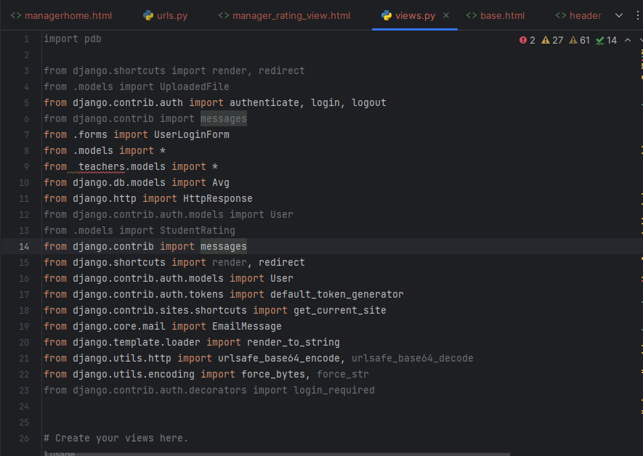

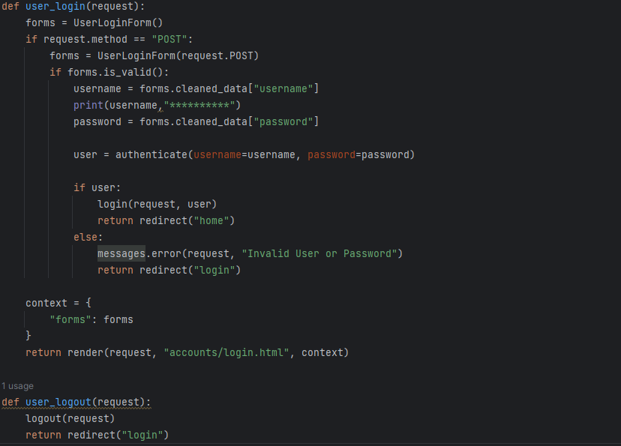

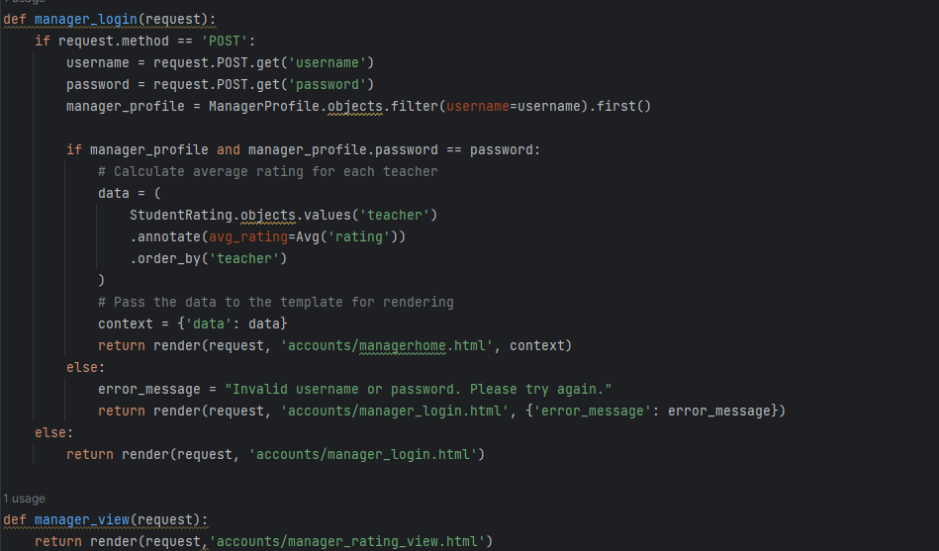

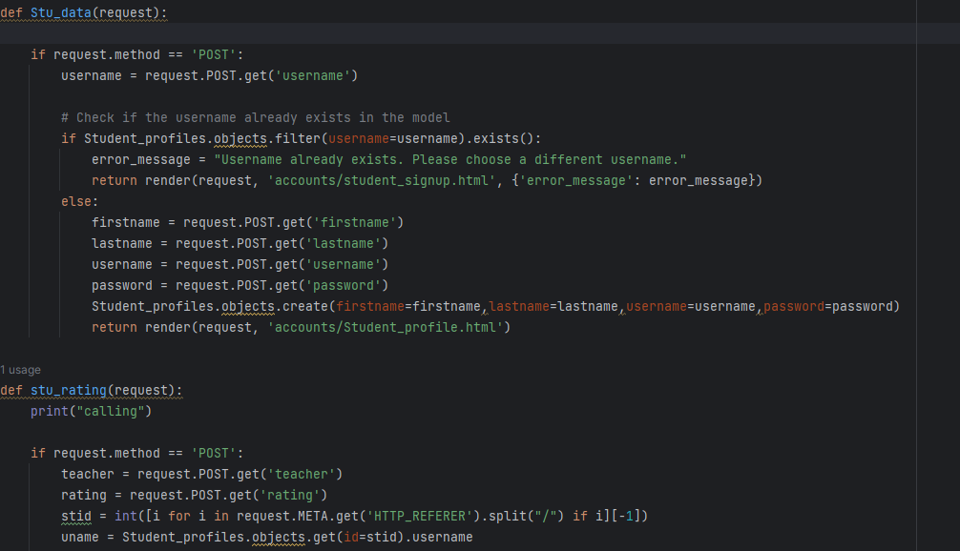

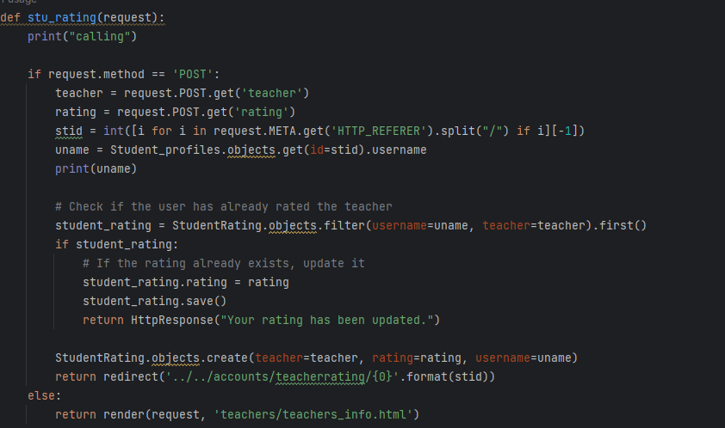

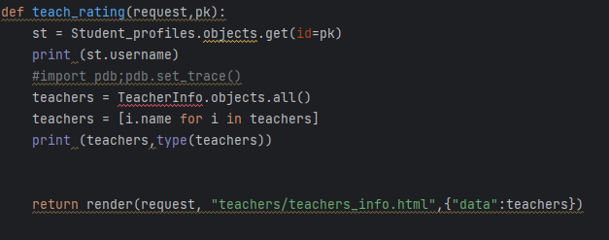

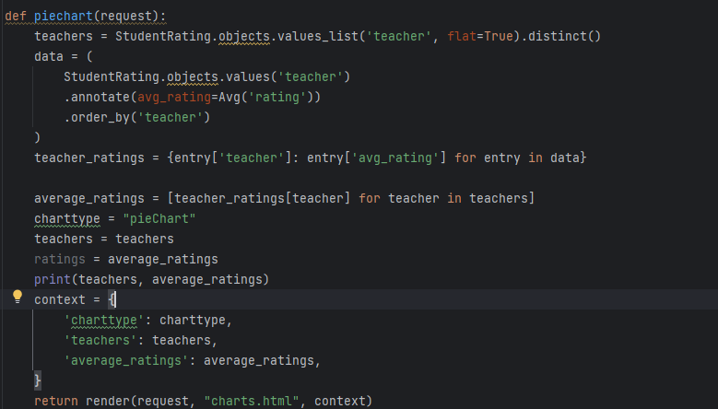

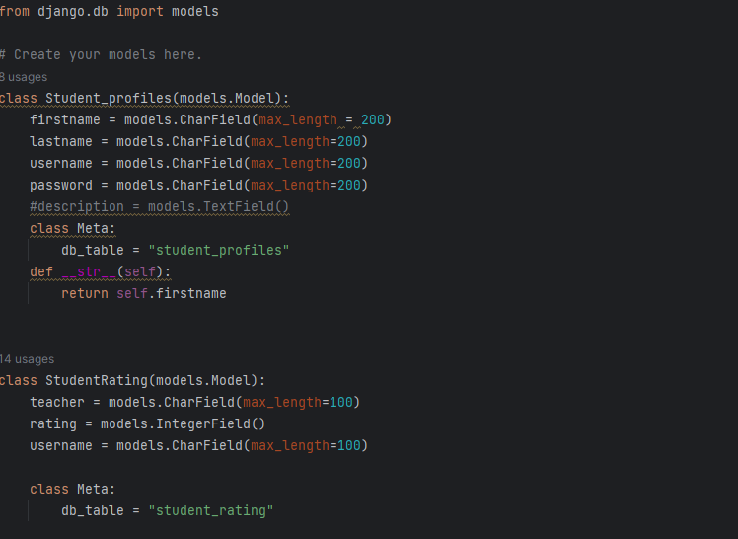

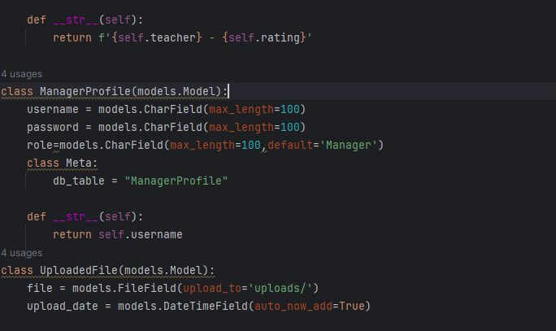

## **9.2. Web Page Snippets (UI)**

**Admin Login:**

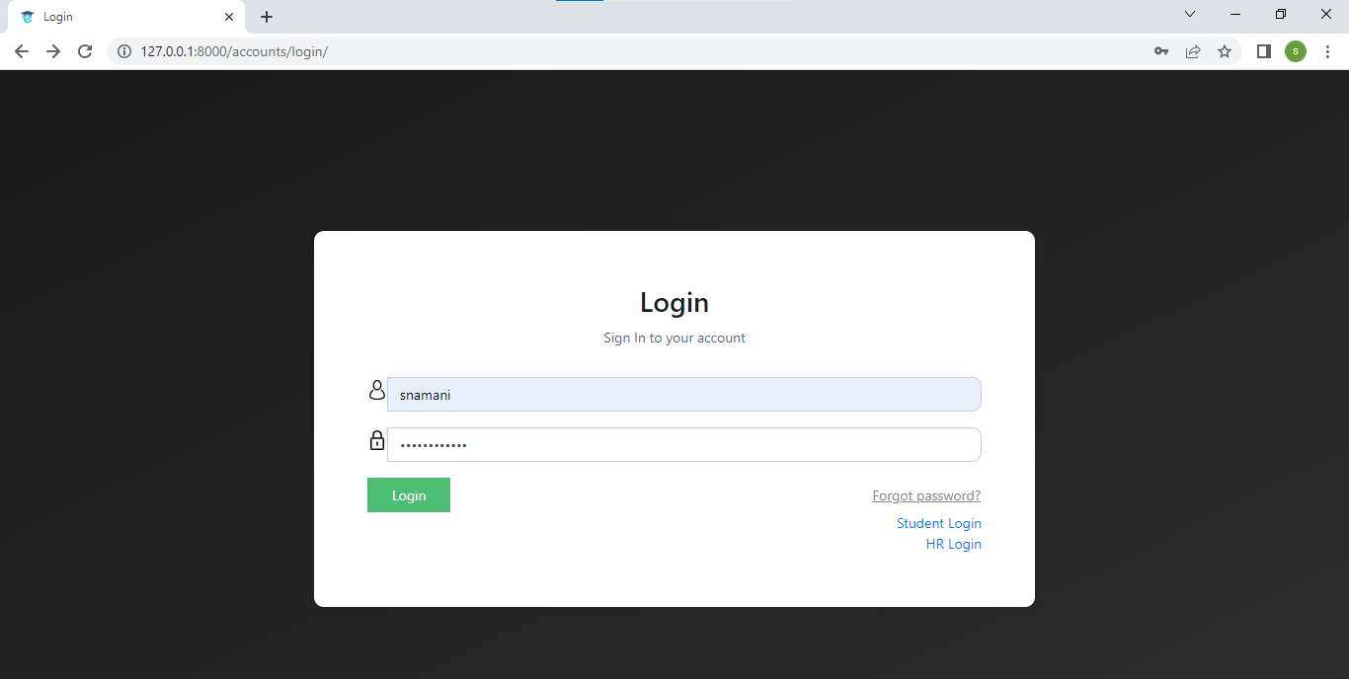

**Additional Features:**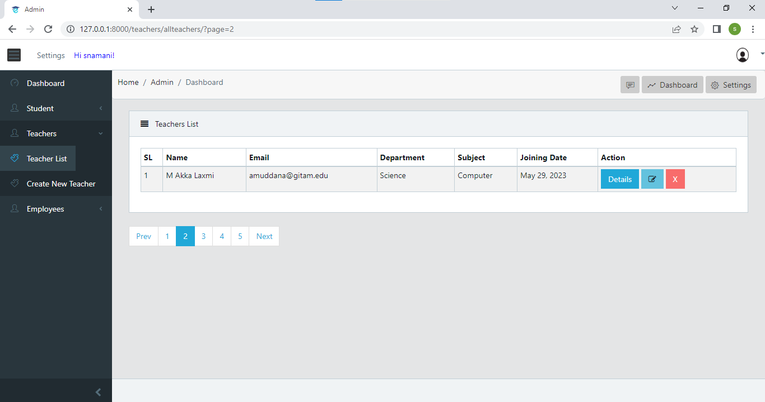

**Student Login:**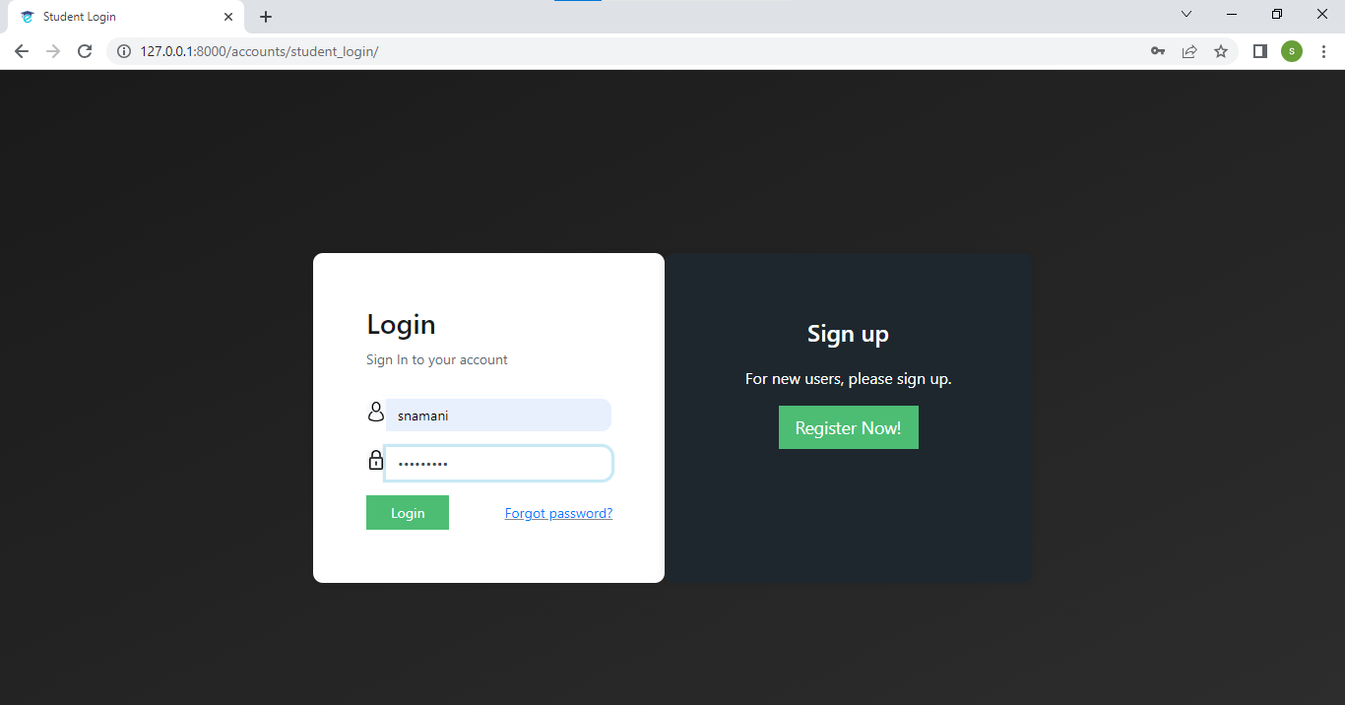

**New Registrations:**

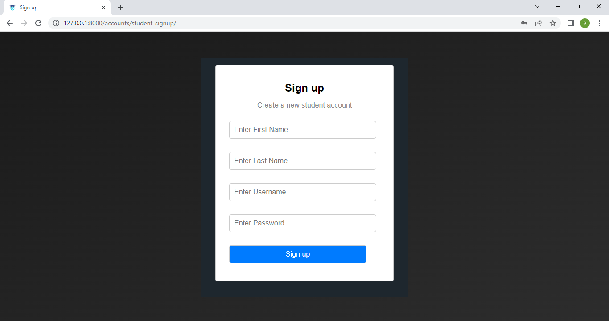

**bv**

**Student Dashboard:**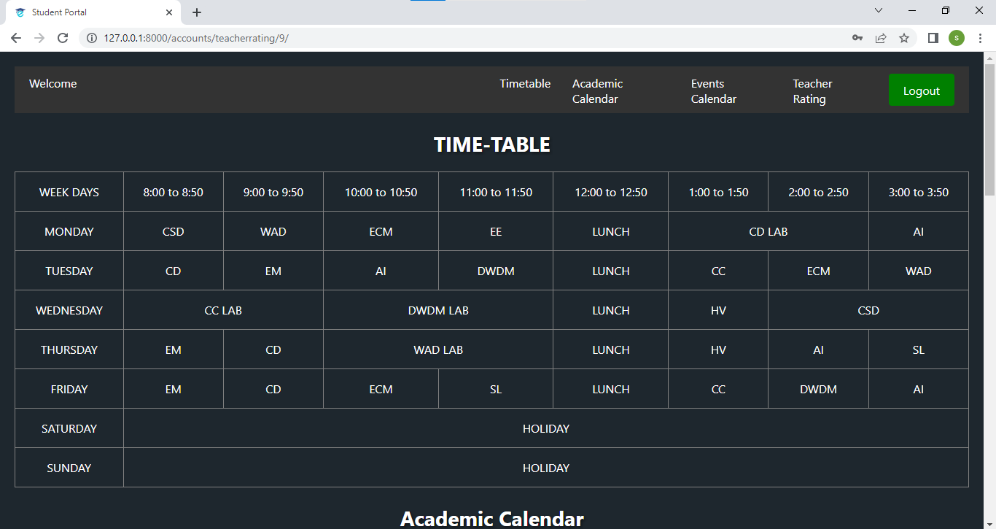

**HR Login:**

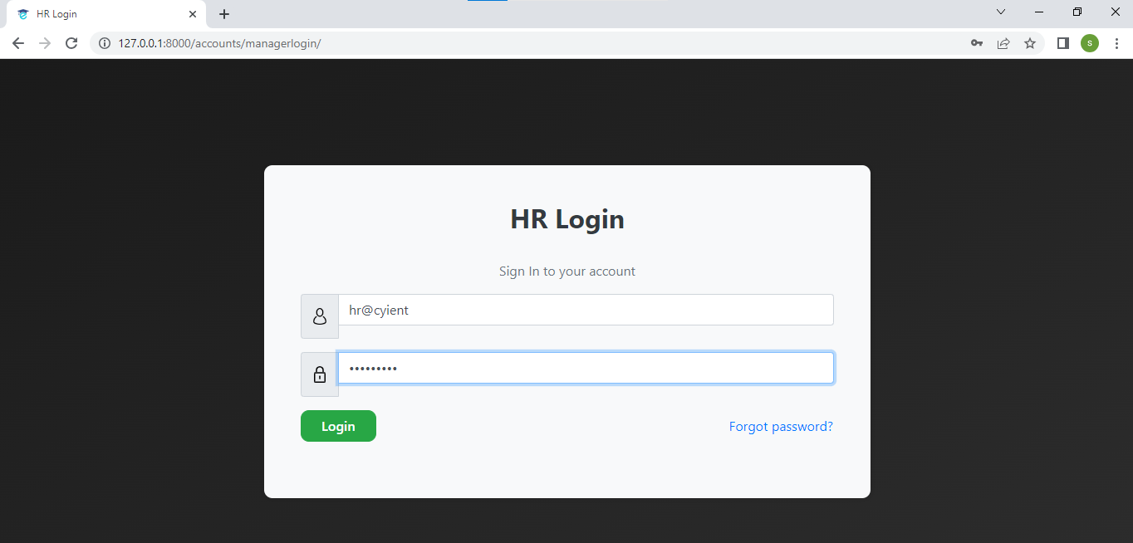

**HR Dashboard:**

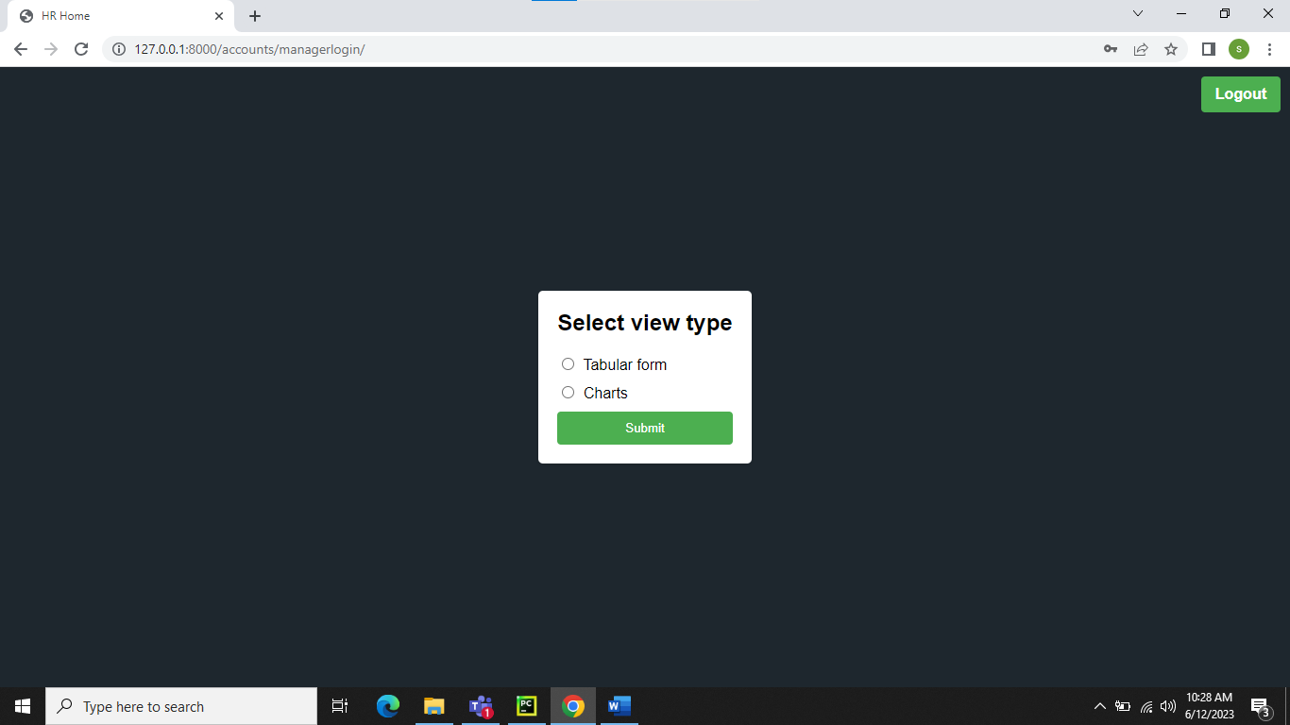

**Admin Database: SQLite**

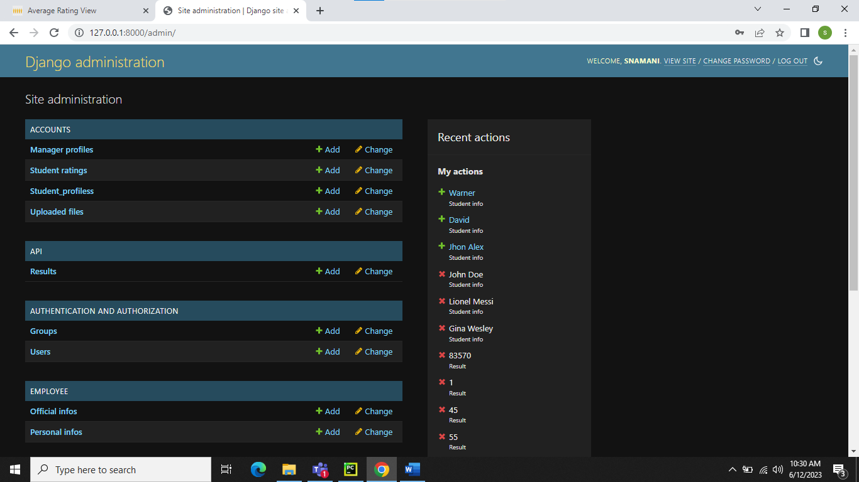

* **GITHUB LINK:** [GIT Repository Link](https://github.com/SravanNamani/College_Management_System.git)

# **10. Testing And Validation**

## **10.1 Unit Testing**

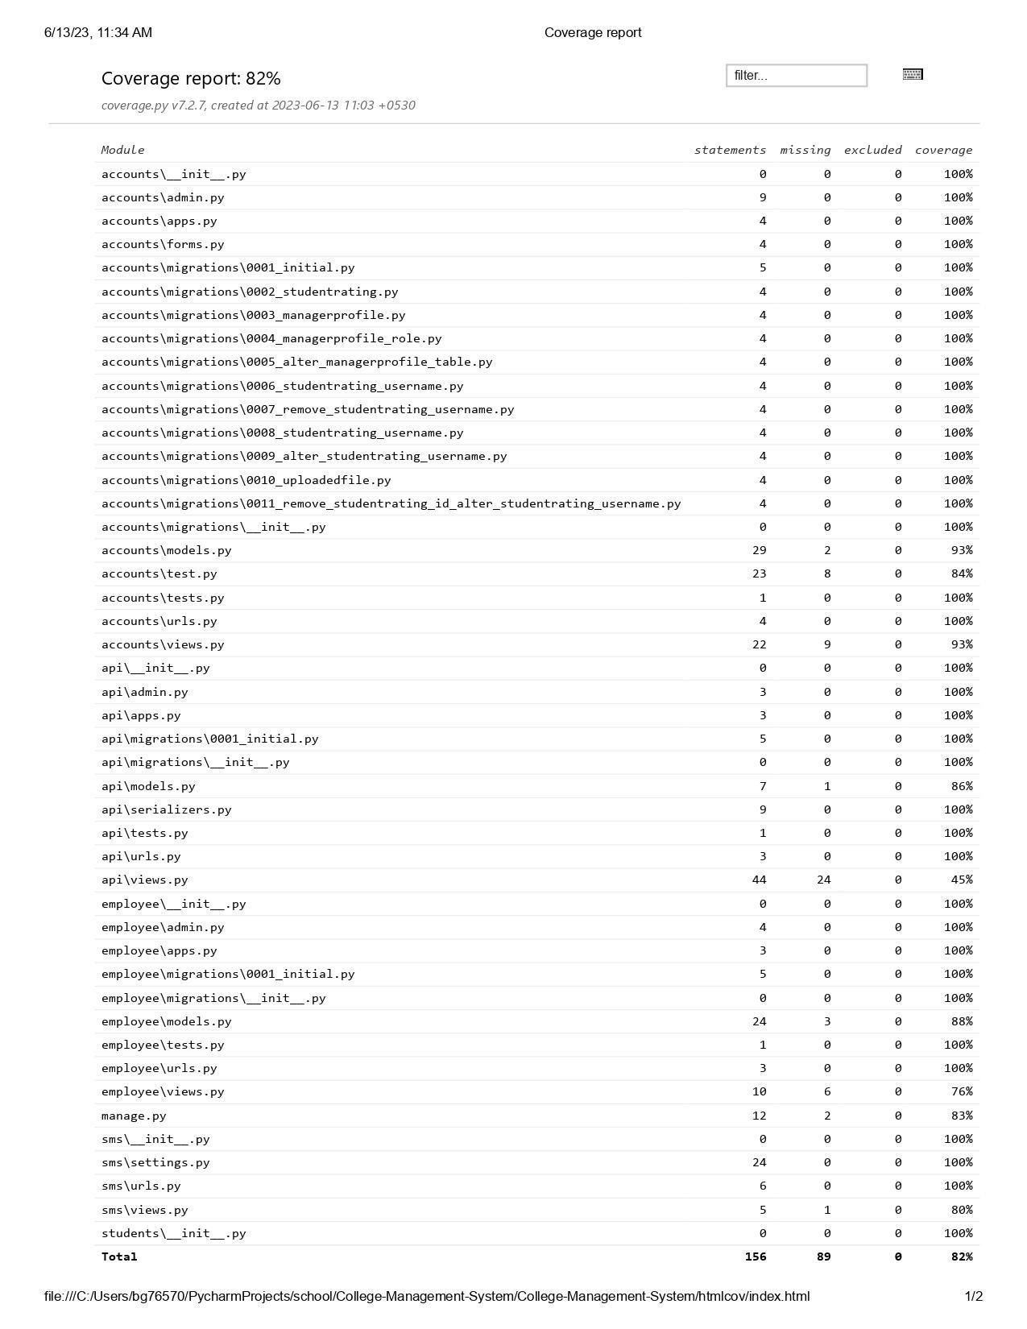

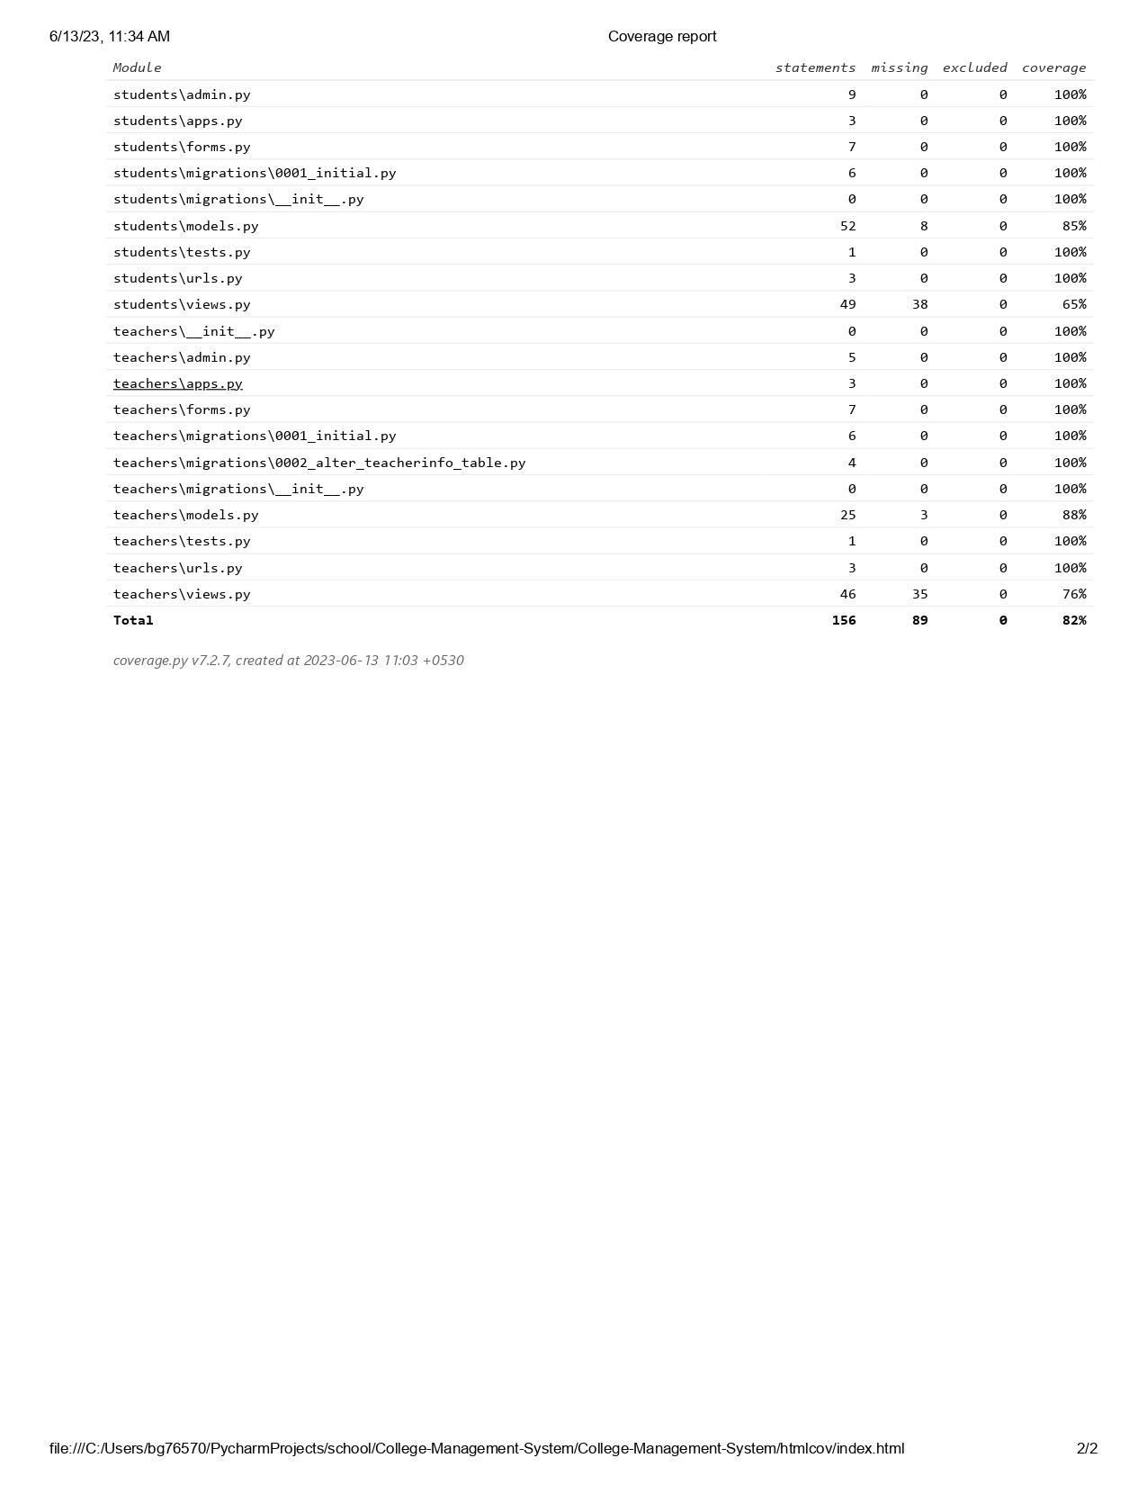

# **11. References**

**Django Documentation.** [Django documentation | Django documentation | Django (djangoproject.com)](https://docs.djangoproject.com/en/4.2/)

**Python Software Foundation**. [Welcome to Python.org](https://www.python.org/)

**PyCharm Documentation**. <https://www.jetbrains.com/pycharm/documentation/>

**Bootstrap Documentation.** [Bootstrap · The most popular HTML, CSS, and JS library in the world. (getbootstrap.com)](https://getbootstrap.com/)

**HTML Documentation.** [HTML: HyperText Markup Language | MDN (mozilla.org)](https://developer.mozilla.org/en-US/docs/Web/HTML)

# **12. Future Scope**

The College Management System project lays a strong foundation for further enhancements and advancements in the management of college operations. The system can be expanded to include additional modules and features such as online admission management, library management, financial management, and alumni engagement. Integration with emerging technologies like machine learning and artificial intelligence can enable predictive analytics for proactive decision-making and personalized student support. Furthermore, the system can be extended to facilitate seamless integration with external stakeholders such as parents and employers, fostering stronger collaboration and engagement. Continuous improvement, scalability, and adaptability should be key considerations for future development, ensuring that the College Management System remains a cutting-edge solution in the evolving landscape of higher education administration.

Additionally, the College Management System project offers opportunities for further advancements in data analysis and reporting. By incorporating data visualization tools and business intelligence capabilities, the system can provide comprehensive insights into various aspects of college operations. This includes analyzing student performance, identifying trends, and generating reports for academic departments, administrators, and accreditation bodies. These insights can drive evidence-based decision-making, facilitate strategic planning, and support quality assurance initiatives.

# **13. Conclusion**

The College Management System project presents a comprehensive and efficient solution for managing various administrative tasks within a college. By incorporating student ratings, student and HR logins, an academic calendar, and a timetable, the system streamlines processes, enhances communication, and optimizes resource allocation. The use of HTML, Django, and Python ensures a robust and scalable platform for seamless integration and future growth. The successful implementation of this project will result in improved efficiency, enhanced student experience, and data-driven decision-making, ultimately elevating the overall quality of the college.

Furthermore, the College Management System project promotes transparency and accountability by providing administrators, students, and HR personnel with access to relevant information and functionalities. Through the system, administrators can effectively manage resources, track student progress, and make informed decisions based on data-driven insights. Students benefit from a centralized platform that offers personalized information, facilitates communication with teachers and peers, and empowers them to actively engage in their academic journey. With its comprehensive features and user-friendly interface, the College Management System project is poised to revolutionize administrative processes, foster academic excellence, and contribute to the overall growth and success of the college.