Date of publication xxxx 00, 0000, date of current version xxxx 00, 0000.
Digital Object Identifier 10.1109/ACCESS.2023.1120000
Convolutional Neural Network for Diabetic
Retinopathy Detection Using the Messidor-2 Dataset
MUROVHI L. PHATHUSTHEDZO¹, (Member, IEEE)

¹University Of Johannesburg, Department: Academy of Computer Science and Software Engineering ) Corresponding author: MUROVHI PHATHUTSHEDZO ( e-mail: phathulivi@gmail.com ).
ABSTRACT DiabeticRetinopathyremainsoneoftheleadingglobalcausesofpreventablevisualimpairment and blindness. Early, accurate screening is essential, as timely clinical intervention can drastically mitigate the risk of severe vision loss. This paper presents a deep learning approach for binary Diabetic Retinopathy detection — classifying retinal fundus images as No DR or DR — using the Messidor-2 dataset. A transfer learning architecture combining an EfficientNetV2S backbone (pre-trained on ImageNet) with a custom tenlayer convolutional neural network (CNN) classification head is proposed. Preprocessing employs selective green-channel CLAHE contrast enhancement, median denoising, and unsharp masking to maximise lesion visibility. Training proceeds in two phases: Phase 1 freezes the first 100 backbone layers to train only the 10 layer Convolutional Neural Network head, and Phase 2 progressively unfreezes the backbone in three stages with a decaying learning rate to prevent catastrophic forgetting of ImageNet representations.
INDEX TERMS Convolutional Neural Networks, Deep Learning, Diabetic Retinopathy, Messidor-2 Dataset, Contrast Limited Adaptive Histogram Equalization, Medical Image Analysis, Transfer Learning, EfficientNet2VS, Binary Classification, Retinal Fundus Imaging, Image Enhancement.
I. INTRODUCTION  Convolutional Neural Networks have become an important deep learning architecture for image classification and computer vision applications. Their ability to automatically learn hierarchical feature representations directly from raw image data has significantly improved performance across a wide range of tasks, including object recognition, medical image analysis, and autonomous systems [2]. The success of CNNs can be attributed to their unique architecture, which combines convolutionallayers,activationfunctions,poolingoperations, and fully connected layers. These components work together to extract increasingly abstract representations from input images. Early layers typically learn low-level features such as edges and textures, while deeper layers capture high-level semantic information that is useful for classification [5]. In medical imaging, CNNs have demonstrated exceptional capability in detecting and classifying diseases from radiological scans, histopathological images, and retinal fundus photographs [3]. Retinal image analysis is particularly well suited to CNN-based approaches because pathological signs often appear as subtle visual patterns that may be difficult to quantify using conventional image processing techniques. By automatically learning relevant visual features, CNNs can | support faster and more consistent disease screening [3]. This study investigates the application of a Convolutional Neural Network for diabetic retinopathy classification using retinal fundus images from the Messidor-2 dataset. The proposed approach incorporates image preprocessing techniques to enhance image quality before training a 10 layer CNN model. The objective is to evaluate how effectively CNNs can learn disease-related retinal features and accurately classify diabetic retinopathy.  II. THEORETICAL BACKGROUND  - CONVOLUTIONAL NEURAL NETWORKS  Convolutional Neural Networks are a specialized class of artificial neural networks designed to process image data efficiently. CNNs exploit the spatial relationships between neighboring pixels through local receptive fields and shared weights, reducing the number of trainable parameters compared to traditional fully connected networks [2].  - CONVOLUTION  This serves as the core building block of a CNN. It extracts local features by applying learnable filters across an input
VOLUME 11, 2023 | 1


image. Each filter detects specific visual characteristics such as edges, corners, textures, or complex object structures.
S(i,j) = ^{XX}I(i + m,j + n)K(m,n) (1)
m n
I is the input image, K is the convolution kernel, and S is the resulting feature map.
C. ACTIVATION FUNCTION
After convolution, activation functions introduce nonlinearity into the network. ReLU is commonly used:

f (x) = max(0,x) (2)
It improves computational efficiency and helps mitigate the vanishing gradient problem encountered in deep neural networks [6].
D. POOLING LAYERS
Pooling layers reduce the spatial dimensions of feature maps while preserving essential information. This dimensionality reduction decreases computational complexity and helps prevent overfitting. Max pooling is used:

P(i,j) = max X(m,n) (3)
(m,n)∈R
R represents the pooling window and X is the input feature map.
- FLATTENING AND FULLY CONNECTED LAYERS
Following feature extraction, the multidimensional feature maps are converted into a one-dimensional vector through a flattening operation. This vector is then passed to fully connected layers responsible for classification. The output of a fully connected neuron is:
n
y = ^{X}w_{i}x_{i} + b (4)
i=1
w_{i} are weights, x_{i} are inputs, b is bias.
- SOFTMAX CLASSIFICATION
The final layer of a CNN often employs the Softmax activation function to produce class probabilities:
ezi

P(y_{i}) = P_{N} e_{z}j (5)
j=1
z_{i} is the score for class i, N is the total number of classes.

III. PROBLEM STATEMENT AND AIMS
- PROBLEM STATEMENT
Investigate the use of a Convolutional Neural Network for automated diabetic retinopathy detection or grading from retinal fundus images in the Messidor-2 dataset.
Author et al.: Preparation of Papers for IEEE TRANSACTIONS and JOURNALS
- AIMS
The model should learn discriminative retinal patterns directly from color fundus photographs and map each image to predefined diagnostic categories, such as diabetic retinopathy present versus absent, or a small number of severity grades depending on the selected labeling scheme.

IV. METHODOLOGY
- DATA LOADING AND PREPARATION
The pipeline is built for binary classification using the Messidor-2 dataset, categorizing images as ‘‘No DR’’ (Grade 0) or ‘‘DR’’ (Grades 1–4). The path of the images is resolved by automatically matching the filenames from the CSV grade file with the images.
- PREPROCESSING
- Selective Green-Channel Enhancement: the green color channel is enhanced, as hemoglobin strongly absorbs green light, making vessels appear dark while lipid exudates appear bright [4].
- All images are initially resized to 384×384 pixels.
- CLAHE is applied exclusively to the green channel using a clip limit of 2.5 and an 8×8 tile grid.
- A 3×3 median blur is applied to the green channel to preserve edges while removing noise.
- An unsharp mask is implemented using a Gaussian blur (σ = 2) with weights of 1.5 for the original and −0.5 for the blurred image, to sharpen vessels and lesion edges.
- The enhanced green channel is merged back with the original red and blue channels to maintain the original ImageNet color statistics.
C. MODEL ARCHITECTURE AND TRAINING PIPELINE
Themodel utilizesatf.data pipelineto applyuniformdata augmentation. The classifier uses an EfficientNetV2S backbone combined with a custom 10-layer CNN classification head, trained in two phases:
- Phase 1: Initial training is conducted with the first 100 backbone layers frozen.
- Phase 2: The network undergoes progressive unfreezing across three distinct stages to fine-tune the model.
D. EVALUATION STRATEGY
Metrics: Accuracy, Precision, Recall, F1-score, Balanced Accuracy.
Visualizations: Confusion matrix, Sample predictions.

2 VOLUME 11, 2023
Author et al.: Preparation of Papers for IEEE TRANSACTIONS and JOURNALS
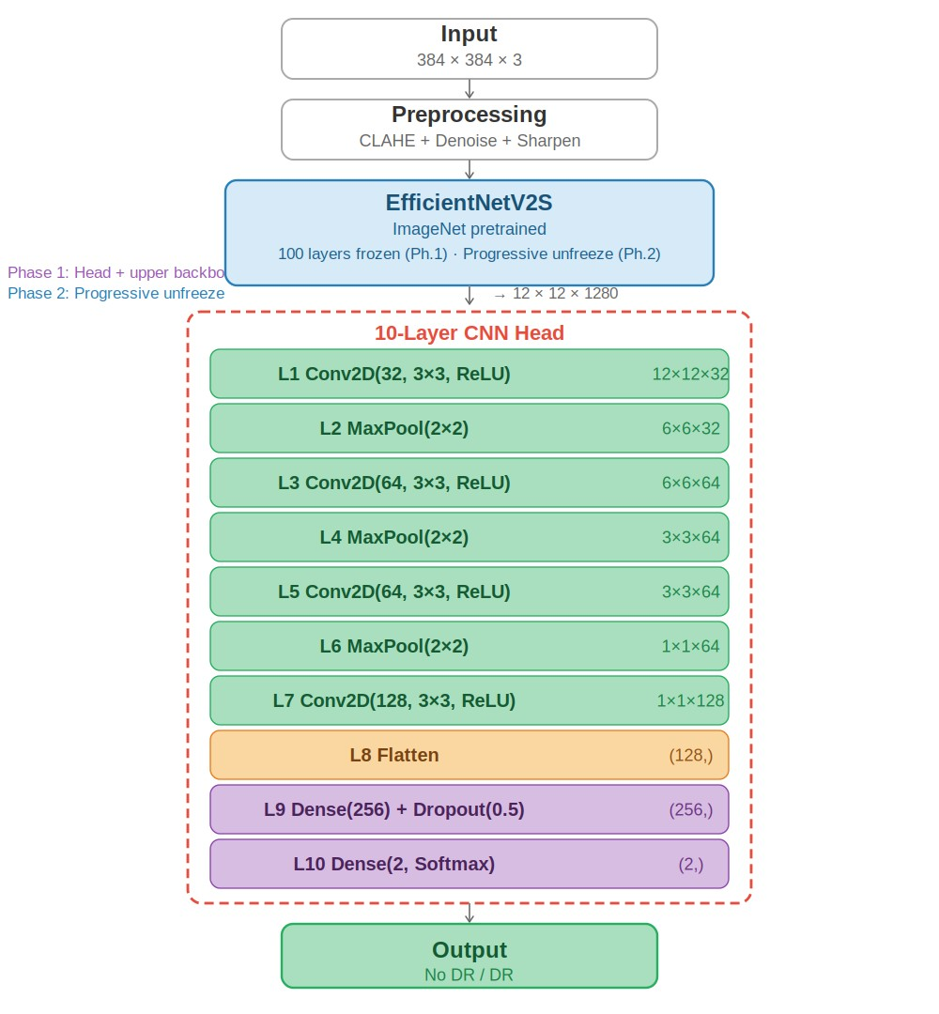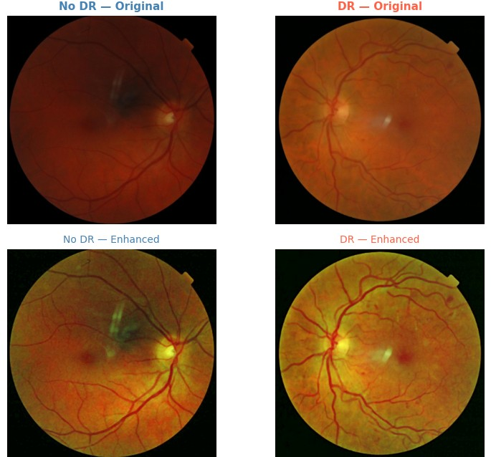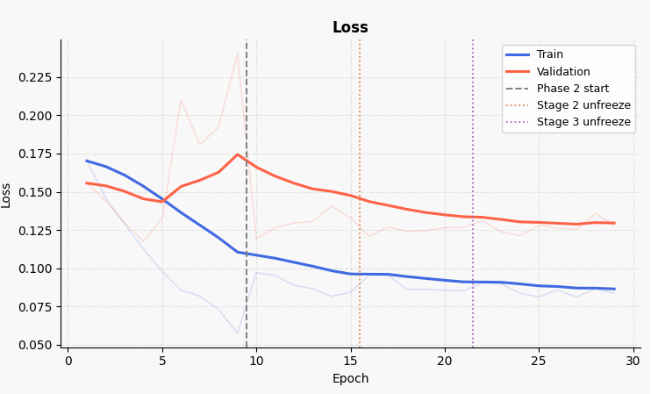
FIGURE 1.
Model Architecture and Pipeline.
V. RESULTS
A. IMAGE ENHANCEMENT
visualizingbloodvessels,hemorrhages,andmicroaneurysms
withoutinterference[1].TheapplicationofCLAHEeffec-
tivelyneutralizeslightingvariations,andthedenoisingfilter
smoothsoutlocalizednoisewithoutcompromisingthestruc-
turalintegrityoftheretina.
B. TRAIN/VALIDATION/TEST SPLIT
Split
Count
Train
1220
Validation
262
Test
262
TABLE 1.
70
%–15%–15% data split.
C. TRAINING EVALUATION
FIGURE 3.
Accuracy over training epochs.
FIGURE 4.
Loss over training epochs.

FIGURE 2. Processing Result.
In the original images, the reddish-orange hue saturates the image and obscures fine vascular details. By isolating the green channel, the enhancement immediately maximizes the contrast between the retinal background and the vascular network. The green channel inherently absorbs the red light reflected by the retina, making it the most effective channel for
- Phase 1: The first 100 layers of EfficientNetV2S are frozen; the CNN head rapidly learns to map pre-trained features to the target classes. Validation loss starts erratic, spiking significantly just before epoch 10, indicating the frozen backbone is acting as a bottleneck.
VOLUME 11, 2023 3
- Phase 2: At epoch 10, progressive unfreezing begins to pay off. Validation loss drops smoothly and tracks parallel to training loss, resolving the bottleneck. Incremental
unfreezing allows weights to be adjusted correctly without destabilizing the network.
- TEST EVALUATION
Metric | Value
Accuracy | 0.8206
Balanced Accuracy | 0.8081
Precision | 0.8163
Recall (Sensitivity) | 0.7339
F1-Score | 0.7729
TABLE 2. Test set evaluation metrics.
Class | Precision | Recall | F1 | Support
No DR (0) | 0.82 | 0.88 | 0.85 | 153
DR (1) | 0.82 | 0.73 | 0.77 | 109
Macro avg | 0.82 | 0.81 | 0.81 | 262
Weighted avg | 0.82 | 0.82 | 0.82 | 262
TABLE 3. Per-class classification report on the held-out test set.
The overall accuracy of 82.06% closely matches the balanced accuracy of 80.81%. This minimal disparity suggests the model genuinely learns features from both classes rather than exploiting the slight class imbalance. Identical precision of 0.82 for both classes means that when the system predicts a specific diagnosis, it is correct approximately 82% of the time. The lower DR recall (0.73) reflects a conservative bias, visible in the F1-score of 0.77.
- CONFUSION MATRIX
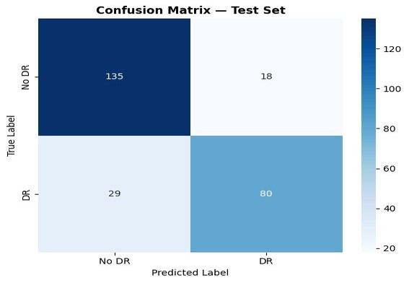
FIGURE 5. Confusion Matrix – Test Set.
The model correctly identifies 135 of 153 healthy cases and 80 of 109 diseased cases, consistent with the reported 82% accuracy.
Author et al.: Preparation of Papers for IEEE TRANSACTIONS and JOURNALS
- SAMPLE PREDICTIONS
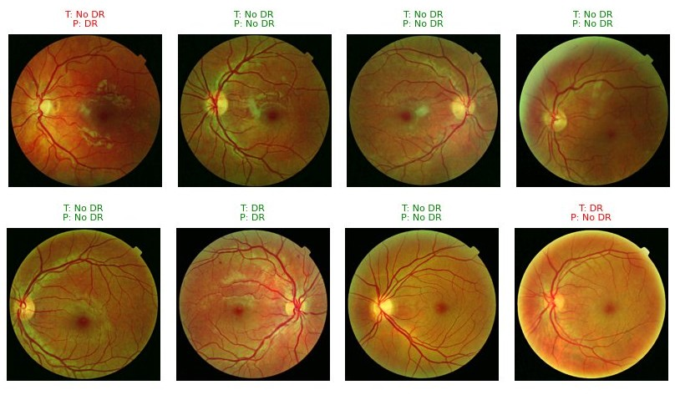
FIGURE 6. Sample Predictions (6 of 8 correct).

VI. CONCLUSION
The findings indicate that the proposed approach successfully learned relevant visual patterns associated with DR. The combination of selective green-channel preprocessing, the EfficientNetV2S backbone, and the 10-layer CNN head helped the model focus on clinically significant retinal structures such as microaneurysms, haemorrhages, and exudates. Class imbalance limited the model’s ability to accurately recognize the minority class. Future research directions include:
- Attention mechanisms such as Convolutional Block Attention Modules (CBAM).
- Expanding and balancing the dataset.
- Applying more advanced augmentation techniques.
- Evaluating modern architectures such as ConvNeXt.

ACKNOWLEDGMENT
Deep appreciation for Prof. Khmaies Ouahada, serving as the primary lecturer, and Mr. Bilal Ahmad, the principal tutor, for their continuous guidance and academic support.

REFERENCES
- Mohammed J Alwazzan, Mohammed A Ismael, and Asmaa N Ahmed. A hybrid algorithm to enhance colour retinal fundus images using a wiener filter and clahe. Journal of Digital Imaging, 34(3):750–759, 2021.
- IanGoodfellow,YoshuaBengio,AaronCourville,andYoshuaBengio. Deep learning, volume 1. MIT press Cambridge, 2016.
- Varun Gulshan, Lily Peng, Marc Coram, Martin C Stumpe, Derek Wu, Arunachalam Narayanaswamy, Subhashini Venugopalan, Kasumi Widner, Tom Madams, Jorge Cuadros, et al. Development and validation of a deep learning algorithm for detection of diabetic retinopathy in retinal fundus photographs. jama, 316(22):2402–2410, 2016.
- Ammar Jawad Kadhim, Hadi Seyedarabi, Reza Afrouzian, and Fadhil Sahib Hasan. Diabetic retinopathy classification using hybrid color-based clahe and blood vessel in deep convolution neural network. IEEE Access, 12:194750–194761, 2024.
- Alex Krizhevsky, Ilya Sutskever, and Geoffrey E Hinton. Imagenet classification with deep convolutional neural networks. Advances in neural information processing systems, 25, 2012.
4 VOLUME 11, 2023
- Vinod Nair and Geoffrey E Hinton. Rectified linear units improve restricted boltzmann machines. In Proceedings of the 27th international conference on machine learning (ICML-10), pages 807–814, 2010.
Author et al.: Preparation of Papers for IEEE TRANSACTIONS and JOURNALS
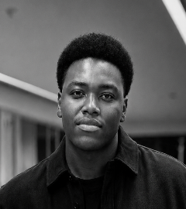Murovhi PL, BSc Computer Science with Artificial Intelligence student at the University of Johannesburg. Hopes to pursue a Master’s degree in Artificial Intelligence.

APPENDIX A SOURCE CODE
import os,cv2,random,warnings,numpy as np,pandas as pd import matplotlib.pyplot as plt,seaborn as sns warnings.filterwarnings(’ignore’); os.environ[’TF_CPP_MIN_LOG_LEVEL’]=’3’ from sklearn.model_selection import train_test_split from sklearn.metrics import (accuracy_score,precision_score,recall_score,
f1_score,confusion_matrix,classification_report,balanced_accuracy_score)
import tensorflow as tf; tf.get_logger().setLevel(’ERROR’) from tensorflow.keras import layers,models from tensorflow.keras.applications import EfficientNetV2S from tensorflow.keras.applications.efficientnet_v2 import preprocess_input from tensorflow.keras.callbacks import EarlyStopping,ModelCheckpoint, ReduceLROnPlateau
SEED=42; random.seed(SEED); np.random.seed(SEED); tf.random.set_seed(SEED)
IMG_SIZE=384; BATCH_SIZE=16; NUM_CLASSES=2; EPOCHS_INITIAL=20; EPOCHS_PER_STAGE =20
LEARNING_RATE=1e-4; FINETUNE_LR=1e-5; GAMMA_FOCAL=2.0; WEIGHT_DECAY=1e-4;
FREEZE_LAYERS=100
IMAGE_FOLDER="/kaggle/input/.../messidor-2/preprocess" CSV_PATH="/kaggle/input/.../messidor_data.csv"
df=pd.read_csv(CSV_PATH)
IMAGE_COL=next(c for c in df.columns if any(k in c.lower() for k in [’image’,’id
’,’file’]))
LABEL_COL=next(c for c in df.columns if any(k in c.lower() for k in [’grade’,’ diagnosis’,’label’]))
df[’label’]=(df[LABEL_COL].astype(int)>0).astype(int) def get_image_path(n): n=str(n).strip() for ext in [’’,’.jpg’,’.jpeg’,’.png’]: p=os.path.join(IMAGE_FOLDER,n+ext) if os.path.exists(p): return p
return None df[’image_path’]=df[IMAGE_COL].apply(get_image_path) df=df[df[’image_path’].notna()].reset_index(drop=True)
def load_and_enhance(image_path):
img=cv2.imread(image_path); img=cv2.cvtColor(img,cv2.COLOR_BGR2RGB) img=cv2.resize(img,(IMG_SIZE,IMG_SIZE)); r,g,b=cv2.split(img) clahe=cv2.createCLAHE(clipLimit=2.5,tileGridSize=(8,8)); g=clahe.apply(g) g=cv2.medianBlur(g,3); blur=cv2.GaussianBlur(g,(0,0),sigmaX=2) g=cv2.addWeighted(g,1.5,blur,-0.5,0); g=np.clip(g,0,255).astype(np.uint8) return cv2.merge([r,g,b]).astype(np.float32)/255.0
def preprocessing(p): return preprocess_input(load_and_enhance(p)*255.0)
all_paths=df[’image_path’].values; all_labels=df[’label’].values train_paths,temp_paths,y_train,y_temp=train_test_split( all_paths,all_labels,test_size=0.30,stratify=all_labels,random_state=SEED) val_paths,test_paths,y_val,y_test=train_test_split(
temp_paths,y_temp,test_size=0.50,stratify=y_temp,random_state=SEED)
_AUG=tf.keras.Sequential([ tf.keras.layers.RandomFlip("horizontal"), tf.keras.layers.RandomRotation(factor=0.056), tf.keras.layers.RandomZoom(height_factor=(-0.08,0.08),width_factor
=(-0.08,0.08)), tf.keras.layers.RandomTranslation(height_factor=0.06,width_factor=0.06, fill_mode="reflect")
],name="spatial_aug") def _load_raw(path):
img=tf.numpy_function(lambda p:load_and_enhance(p.decode("utf-8")),[path],tf.
float32)
img.set_shape((IMG_SIZE,IMG_SIZE,3)); return img
def _apply_preprocess(img):
img=tf.numpy_function(lambda x:preprocess_input(x*255.0),[img],tf.float32) img.set_shape((IMG_SIZE,IMG_SIZE,3)); return img
def make_train_dataset(paths,labels_oh,batch_size): def load_and_aug(path,label):
img=_load_raw(path); img=_AUG(img,training=True) img=tf.image.random_brightness(img,max_delta=0.15) img=tf.image.random_contrast(img,lower=0.82,upper=1.18) img=tf.image.random_saturation(img,lower=0.80,upper=1.20) img=tf.image.random_hue(img,max_delta=0.05) img=tf.clip_by_value(img,0.0,1.0); img=_apply_preprocess(img); return img,
label steps=int(np.ceil(len(paths)/batch_size)) ds=(tf.data.Dataset.from_tensor_slices((paths,labels_oh))
.shuffle(len(paths),seed=SEED,reshuffle_each_iteration=True)
.map(load_and_aug,num_parallel_calls=tf.data.AUTOTUNE)
.batch(batch_size,drop_remainder=False).prefetch(tf.data.AUTOTUNE)) return ds,steps
def make_eval_dataset(paths,labels_oh,batch_size): def load_and_preprocess(path,label):
img=_load_raw(path); img=_apply_preprocess(img); return img,label return(tf.data.Dataset.from_tensor_slices((paths,labels_oh))
.map(load_and_preprocess,num_parallel_calls=tf.data.AUTOTUNE)
.batch(batch_size,drop_remainder=False).prefetch(tf.data.AUTOTUNE))
y_train_oh=tf.keras.utils.to_categorical(y_train,NUM_CLASSES) y_val_oh=tf.keras.utils.to_categorical(y_val,NUM_CLASSES) y_test_oh=tf.keras.utils.to_categorical(y_test,NUM_CLASSES) def categorical_focal_loss(gamma=1.0):
def focal_loss_fn(y_true,y_pred):
eps=tf.keras.backend.epsilon(); y_pred=tf.clip_by_value(y_pred,eps,1.0-eps) ce=-y_true*tf.math.log(y_pred); fl=tf.pow(1.0-y_pred,gamma)*y_true*ce return tf.reduce_mean(tf.reduce_sum(fl,axis=1))
return focal_loss_fn focal_loss_fn=categorical_focal_loss(gamma=GAMMA_FOCAL) train_dataset,steps_per_epoch=make_train_dataset(train_paths,y_train_oh,
BATCH_SIZE) val_dataset=make_eval_dataset(val_paths,y_val_oh,BATCH_SIZE) test_dataset=make_eval_dataset(test_paths,y_test_oh,BATCH_SIZE)
def get_efficientnetv2s_backbone(input_tensor):
backbone=EfficientNetV2S(weights=’imagenet’,include_top=False,input_tensor= input_tensor)
for layer in backbone.layers[:FREEZE_LAYERS]: layer.trainable=False for layer in backbone.layers[FREEZE_LAYERS:]: layer.trainable=True return backbone.output,backbone
def get_cnn_head(x):
x=layers.Conv2D(32,(3,3),activation=’relu’,padding=’same’,name=’Head_Conv1’)(x
) x=layers.MaxPooling2D((2,2),name=’Head_Pool1’)(x) x=layers.Conv2D(64,(3,3),activation=’relu’,padding=’same’,name=’Head_Conv2’)(x
) x=layers.MaxPooling2D((2,2),name=’Head_Pool2’)(x) x=layers.Conv2D(64,(3,3),activation=’relu’,padding=’same’,name=’Head_Conv3’)(x
) x=layers.MaxPooling2D((2,2),name=’Head_Pool3’)(x) x=layers.Conv2D(128,(3,3),activation=’relu’,padding=’same’,name=’Head_Conv4’)(
x)
x=layers.Flatten(name=’Head_Flatten’)(x) x=layers.Dense(256,activation=’relu’,name=’Head_Dense’)(x) x=layers.Dropout(0.5,name=’Head_Dropout’)(x) return layers.Dense(NUM_CLASSES,activation=’softmax’,name=’Output’)(x)
def build_model():
inputs=layers.Input(shape=(IMG_SIZE,IMG_SIZE,3),name=’Input’) feature_maps,backbone=get_efficientnetv2s_backbone(inputs) outputs=get_cnn_head(feature_maps) return models.Model(inputs=inputs,outputs=outputs,name=’
EfficientNetV2S_CNN_Binary’),backbone model,backbone=build_model()
model.compile(optimizer=tf.keras.optimizers.AdamW(learning_rate=LEARNING_RATE, weight_decay=WEIGHT_DECAY), loss=focal_loss_fn,metrics=[’accuracy’]) callbacks_p1=[ReduceLROnPlateau(monitor=’val_loss’,factor=0.5,patience=3,min_lr
=1e-7,verbose=1),
EarlyStopping(monitor=’val_loss’,patience=5,restore_best_weights=True,verbose
=1),
ModelCheckpoint(’best_model_phase1.keras’,monitor=’val_accuracy’, save_best_only=True,verbose=1)] history_p1=model.fit(train_dataset,steps_per_epoch=steps_per_epoch,epochs=
EPOCHS_INITIAL, validation_data=val_dataset,callbacks=callbacks_p1,verbose=1)
FREEZE_REMAINING=[65,35,0]; all_finetune_histories=[] for stage,n_frozen in enumerate(FREEZE_REMAINING,start=1): backbone.trainable=True for layer in backbone.layers[:n_frozen]: layer.trainable=False model.compile(optimizer=tf.keras.optimizers.AdamW(
learning_rate=FINETUNE_LR/stage,weight_decay=WEIGHT_DECAY), loss=focal_loss_fn,metrics=[’accuracy’]) callbacks_stage=[ReduceLROnPlateau(monitor=’val_loss’,factor=0.5,patience=3, min_lr=1e-8,verbose=1),
EarlyStopping(monitor=’val_loss’,patience=5,restore_best_weights=True, verbose=1),
ModelCheckpoint(f’best_model_phase2_stage{stage}.keras’,monitor=’ val_accuracy’,save_best_only=True,verbose=1)] history_stage=model.fit(train_dataset,steps_per_epoch=steps_per_epoch,epochs=
EPOCHS_PER_STAGE, validation_data=val_dataset,callbacks=callbacks_stage,verbose=1)
all_finetune_histories.append(history_stage)
y_pred_probs=model.predict(test_dataset); y_pred=np.argmax(y_pred_probs,axis=1) print(f"Accuracy: {accuracy_score(y_test,y_pred):.4f}") print(f"Balanced Accuracy: {balanced_accuracy_score(y_test,y_pred):.4f}") print(f"Precision: {precision_score(y_test,y_pred,average=’binary’, zero_division=0):.4f}")
print(f"Recall: {recall_score(y_test,y_pred,average=’binary’, zero_division=0):.4f}")
print(f"F1-Score: {f1_score(y_test,y_pred,average=’binary’, zero_division=0):.4f}")
print(classification_report(y_test,y_pred,target_names=[’No DR’,’DR’], zero_division=0))
cm=confusion_matrix(y_test,y_pred) sns.heatmap(cm,annot=True,fmt=’d’,cmap=’Blues’,
xticklabels=[’No DR’,’DR’],yticklabels=[’No DR’,’DR’])
plt.title(’Confusion Matrix’); plt.ylabel(’True Label’) plt.xlabel(’Predicted Label’); plt.tight_layout(); plt.show()
def display_predictions(paths,true_labels,pred_labels,num_images=8):
indices=random.sample(range(len(paths)),num_images) fig,axes=plt.subplots(1,num_images,figsize=(20,3)) for i,idx in enumerate(indices): img=load_and_enhance(paths[idx]) color=’green’ if true_labels[idx]==pred_labels[idx] else ’red’ axes[i].imshow(img); axes[i].axis(’off’)
axes[i].set_title(f"T:{[’No DR’,’DR’][true_labels[idx]]}\nP:{[’No DR’,’DR’][
pred_labels[idx]]}",
color=color,fontsize=8)
plt.tight_layout(); plt.show() display_predictions(test_paths,y_test,y_pred) model.save(’efficientnetv2s_cnn_dr_binary_model.keras’)

VOLUME 11, 2023 5

