CMPE314 – SOFTWARE ENGINEERING

Name : Yaya Diarra
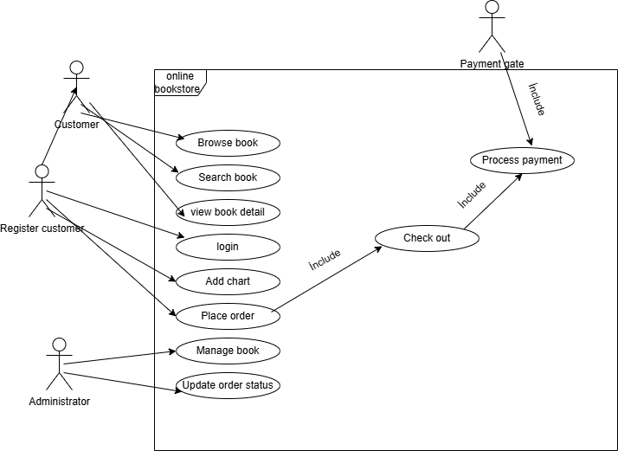
Student No : 22213692

- Use Case Diagrams

Project Description:

