**REQUIREMENTS:**

db2 create table employee(emp-id int, emp-name

varchar(50),designation varchar(30),joindate date,

salary double, address varchar (25), work-location varchar(15), shift varchar(10));

You can create a table in the above mentioned structure. You have to create another program with the corresponding SQL table for the same table and instead of the DB2 query, the SQL query must be executed. Do let me know if you need further information regarding this.

**DESIGN PHASE:**

**ARCHITECTURE:**

**PROGRAMMING ETL**

DB2

**SQL**

**Convert CSV file into SQL table**

Store the data in csv file

Fetch data from the DB2 table

Insert data into SQL

SQL queries

**Flow chart:**

**Loading each line in oracle table**

**Reading data line by line from CSV file**

**Creating directory in local disc using UTL package**

**Exporting the data from DB2 environment to CSV format file**

**Creating table in the DB2 environment**

**DB2**

**Environment**

**[IBM Cloud]**

**Oracle**

**Environment**

**Algorithm:**

**Step1**: Creating a table in DB2 environment.

**Step2**: Inserting the data into DB2 table.

**Step3**: Export the data from DB2 environment to CSV format file.

**Step4**: Open the Oracle database and login as super user.

**Step5**: Create a directory in local disk.

**Step6**: Giving permissions to the normal user to access the directory and UTL file package.

**Step7**: Login as normal user.

**Step8**: Create the table with the same structure as DB2 table.

**Step9**: Create procedure to access the UTL_file package.

**Step10**: Reading the data line by line from CSV file using UTL package.

**Step11**: Loading data into Oracle database.

**Step12**: Test the conversion by retrieving the data from table.

CODING PHASE:

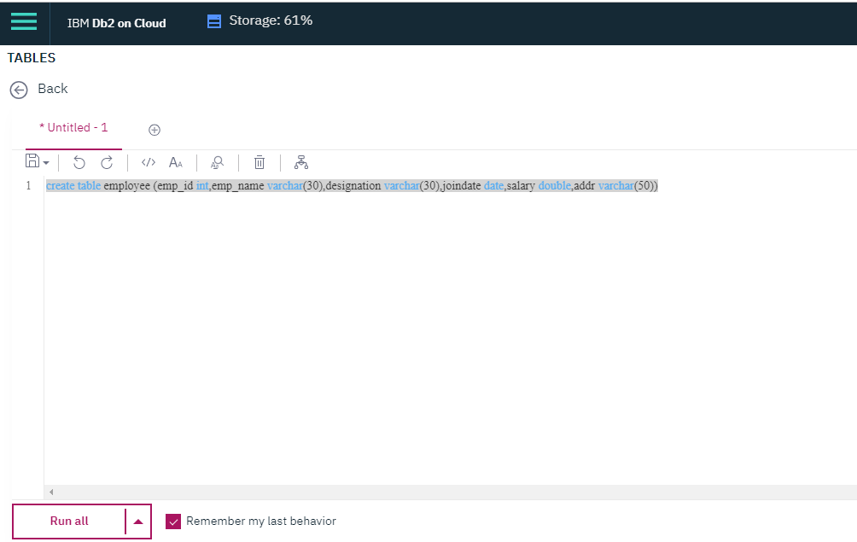

**CREATE TABLE employee**

**(emp_id INT NOT NULL,**

**emp_name VARCHAR(30),**

**designation VARCHAR (30),**

**joindate DATE,**

**salary DOUBLE,**

**addr VARCHAR (50),**

**CONSTRAINT p_e_id PRIMARY KEY (Emp_id))**

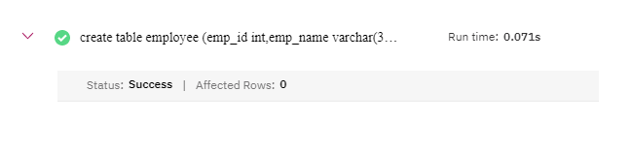

**INSERT INTO employee VALUES (s1.nextval,'Kiyara','Software Engineer','07-07-2017',30000,'V50,Nehru enclave gomti nagar,Lucknow')**

**INSERT INTO employee VALUES (s1.nextval,'Hani','Finance','2011-11-11',40000,'Plot 3, Kharvel Nagar,Delhi')**

**INSERT INTO employee VALUES (s1.nextval,'Yashica','Editing','2015-01-21',45000,'Street 6, Plot no. 200, Srikala Vihar, Guntur')**

**Select * from employee**

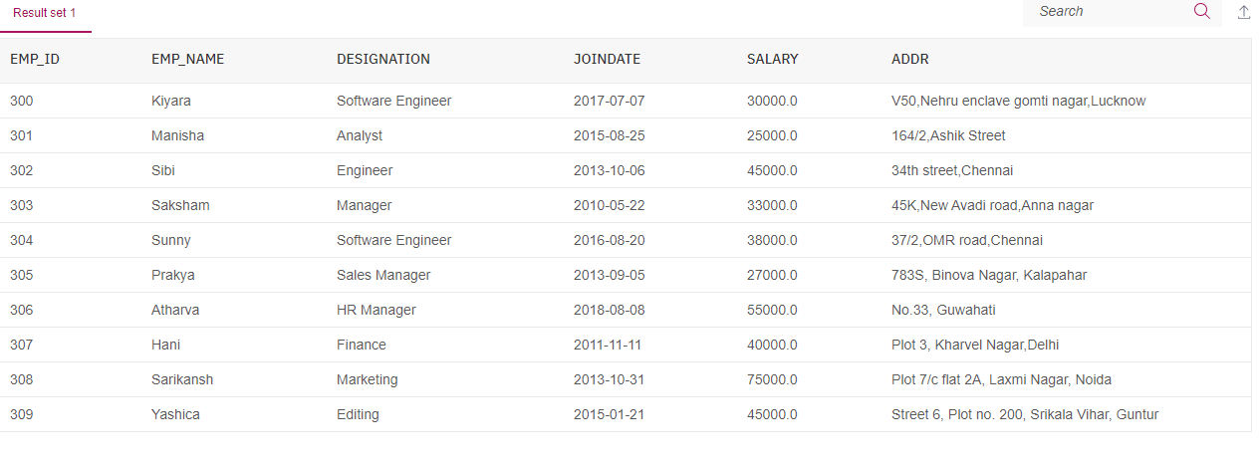

**create or replace procedure import_file is**

**ecount number := 1;**

**e_line varchar2(2000);**

**f utl_file.file_type;**

**e_dir varchar2(250);**

**fname varchar2(50);**

**Comma1 varchar(10);**

**Comma2 varchar(10);**

**Comma3 varchar(10);**

**Comma4 varchar(10);**

**Comma5 varchar(10);**

**e_empid number;**

**e_ename varchar2(30);**

**e_design varchar2(30);**

**e_date varchar2(10);**

**e_sal number;**

**e_add varchar2(50);**

**begin**

**e_dir := 'C:\PLP';**

**fname := 'export.csv';**

**f := utl_file.fopen('IMPORT_DIR',fname,'r');**

**loop**

**begin**

**if (ecount = 1) then**

**utl_file.get_line(f,e_line);**

**utl_file.get_line(f,e_line);**

**ecount := 0;**

**else**

**utl_file.get_line(f,e_line);**

**end if;**

**dbms_output.put_line(e_line);**

**exception**

**when no_data_found then**

**exit;**

**WHEN OTHERS THEN**

**DBMS_output.put_line(sqlerrm);**

**end;**

**Comma1 := INSTR(e_line, '",' ,1 , 1);**

**Comma2 := INSTR(e_line, '",' ,1 , 2);**

**Comma3 := INSTR(e_line, '",' ,1 , 3);**

**Comma4 := INSTR(e_line, '",' ,1 , 4);**

**Comma5 := INSTR(e_line, '",' ,1 , 5);**

**e_empid := SUBSTR(e_line, 2, Comma1-2);**

**DBMS_output.put_line(e_empid);**

**e_ename := SUBSTR(e_line, Comma1+3, Comma2-comma1-3);**

**DBMS_output.put_line(e_ename);**

**e_design := SUBSTR(e_line, Comma2+3, Comma3-comma2-3);**

**DBMS_output.put_line(e_design);**

**e_date := SUBSTR(e_line, Comma3+3, Comma4-comma3-3);**

**DBMS_output.put_line(e_date);**

**e_sal := SUBSTR(e_line, Comma4+3, Comma5-comma4-3);**

**DBMS_output.put_line(e_sal);**

**e_add := RTRIM(SUBSTR(e_line, comma5+3),'"');**

**DBMS_output.put_line(e_add);**

**insert into import_table values (e_empid,e_ename,e_design,to_date(e_date,'yy-mm-dd'),e_sal,e_add);**

**end loop;**

**utl_file.fclose(f);**

**commit;**

**end;**

**/**

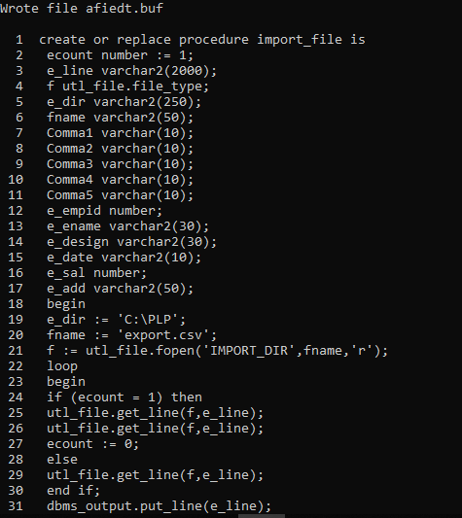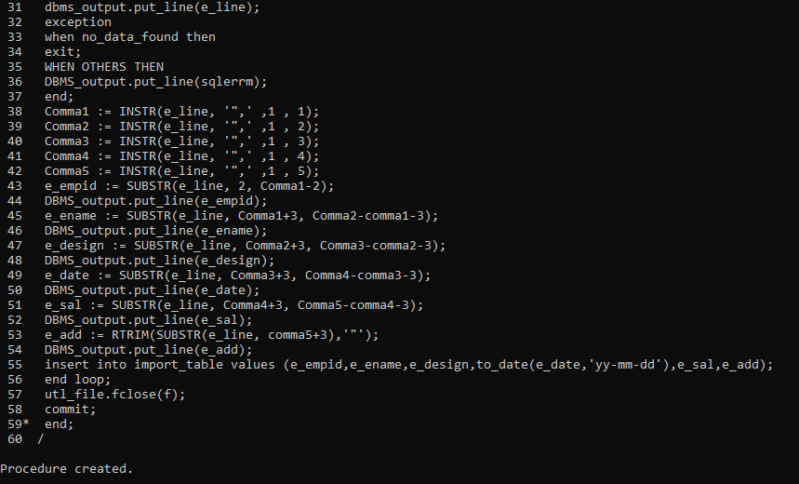

**exec import_file**

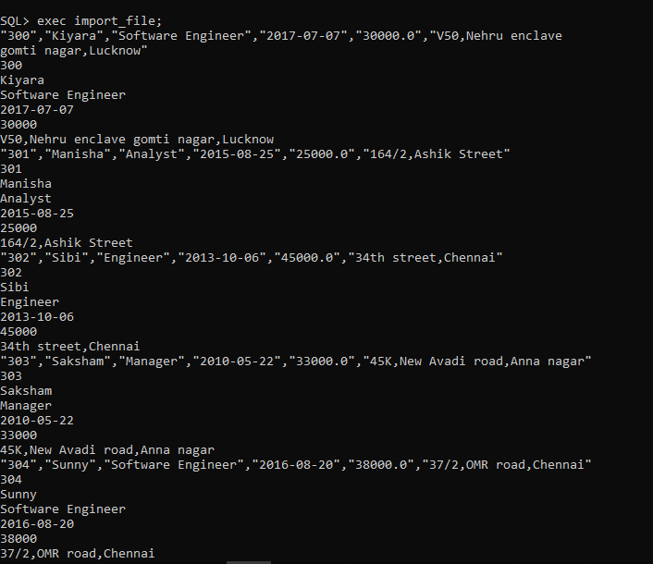

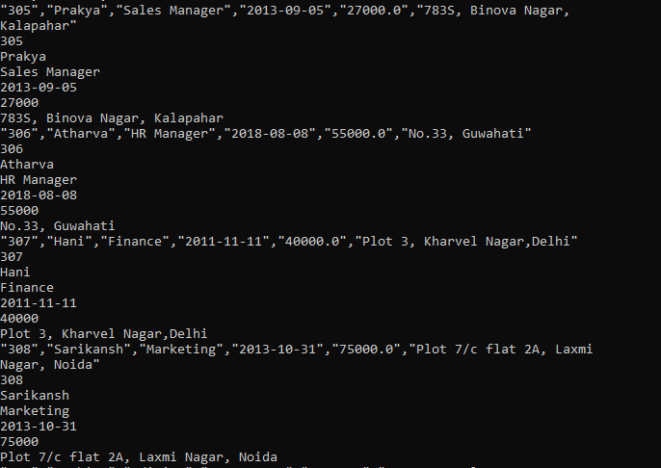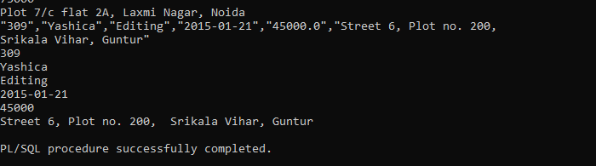

**Select * from import_table;**

