**A**

**Synopsis**

**on**

**Restaurant Website**

**Submitted by**

**Group. No.**

**Atik Ahmed - 21002901400**

**Harshit Kaushik- 2100290140068**

**Mohd Wasim- 2100290140085**



**Submitted to**

**Department of Computer Applications,**

**KIET Group of Institutions,**

**Delhi-NCR, Ghaziabad**

**September’ 2022**

**ABSTRACT**

The purpose of this project is to develop a Fast-food Restaurant management system. It is a system that will assist managers and administrators in managing restaurants effectively and also a system that enabled customer to place their food order online at any time from any place. The reason to develop the system is to Reduce the workload in the present system and reduce time wasted in data processing. It provides a user-friendly web-page for displaying food menu and effective advertising of Paramount cuisine services products to the customers with cheaper cost.

Customers play a vital role in the contemporary food industry when determining the quality of the restaurant and its food. Restaurants give considerable attention to customers’ feedback about their service, since the reputation of the business depends on it. Key factors of evaluating customer satisfaction are, being able to deliver the services effectively to lessen the time of consumption, as well as maintaining a high quality of service. In most cases of selecting a prominent restaurant, customers focus on their choice of favorite food in addition to available seating and space options. Long waiting times and serving the wrong order is a common mistake that happens in every restaurant that eventually leads to customer dissatisfaction. Objectives of this online application “Foody” is to address these deficiencies and provide efficient and accurate services to the customer, by providing unique menus to each customer considering their taste.

The system was designed and implemented using the HTML (Hypertext mark-up language), CSS (Cascading style sheet), PHP (Hypertext Pre-processor) and My SQL database.

**Introduction**

People nowadays hardly want to move from their places for shopping and not even for eating this is because of their hectic schedule. In such circumstances, we have decided to create a system for restaurants. This system is well known as Restaurant Management Services. This will help the restaurant owner in many ways such as ordering goods, inventory control, managing menus, and various customer services.

The cost to attract a new customer is costlier than retaining the old customer. Therefore, there is an argument that for a business, existing customer is worthier than a new customer. In this industry, a customer is likely to return to the restaurant in the future if they received an excellent customer service as well as appetizing food [1]. However, if they had to wait for an unreasonable amount of time or there was a mistake in the order, it’s very unlikely the customer would return.

**Technologies / Software Requirements**

• Server side scripting tool: PHP-5.6.

• Database tools: MYSQL DBMS.

• Compatible operating system: Windows, Mac.

• Front end design tool: Html5, CSS3, Java script

**Hardware Requirements:**

• Hardware recommend by all the software needed.

• RAM: 256MB or more • Hard Drive: 10 GB or more

• Communication hardware to serve client request

**Modules Description**

**Module 1: Login Module** In login module the customer and restaurants login will be taken while they already registered on the application. Every manager/user will have login id and password to login to the application.

**• Module 2: Registration Module** This module is displayed to the visitors if they need to perform some order placements, and new registration for restaurants who wants to do business with us on our online restaurant management application.

**• Module 3:Add/Update/remove Menu** This module is for admin. Admin have rights to insert, update (modify) and delete the data in database as per his/her necessary requirements.

**Reports**

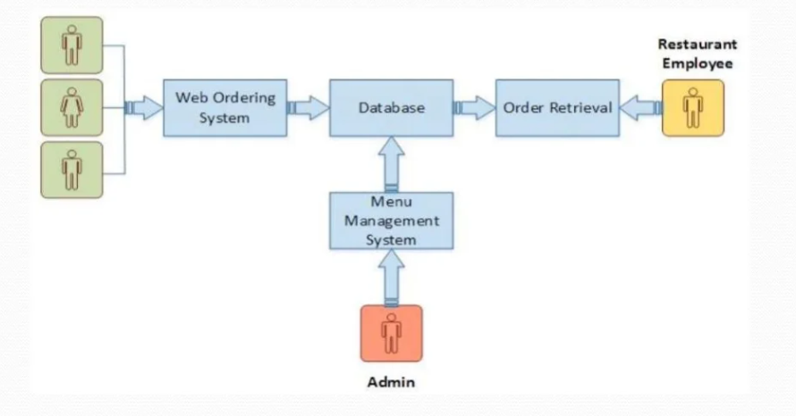

The service goes quicker. Restaurants can build their e-reputation and customer community in live. The restaurant menu has evolved from its humble beginnings on carte chalkboards and imageless print to today’s detailed, colorful displays. With the emergence of digital tablets and user-friendly touch screen technology menus can move to a whole new surface. With this electronic menu, orders can be taken correctly the first time. There is no need to run back and forth to a distant terminal, because the terminal is always with the server. Every order is associated with an individual seat at the table, and orders are built one customer at a time, just like on paper, but with greater accuracy. Items can also easily be shared by the whole table, moved or modified, and noted and the cost can be calculated in real time. The Recommendation algorithm suggests dishes to the patrons based on previous orders. It makes it easier for the customer to build his/her order and also view the most popular dishes. Moreover, various dimension filters can be used according to individual preferences e.g. Price, taste, quantity, etc.

**Output**

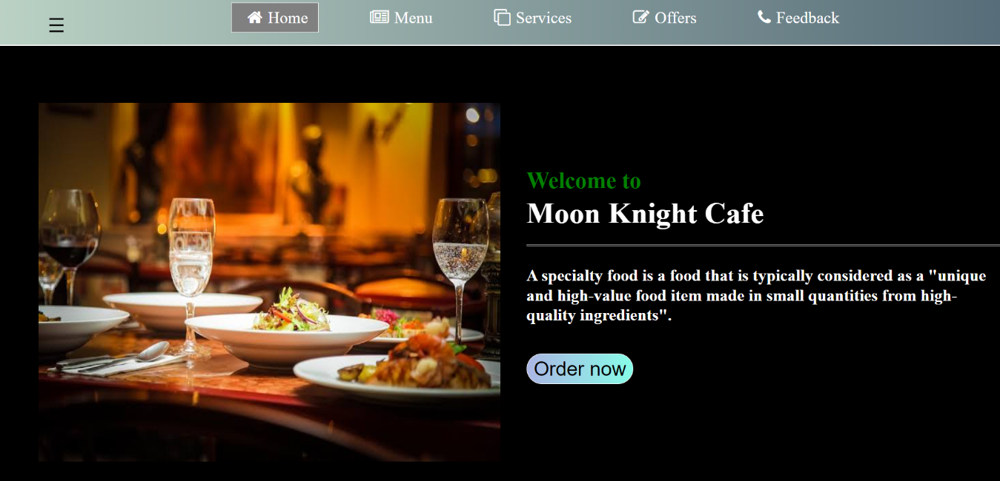

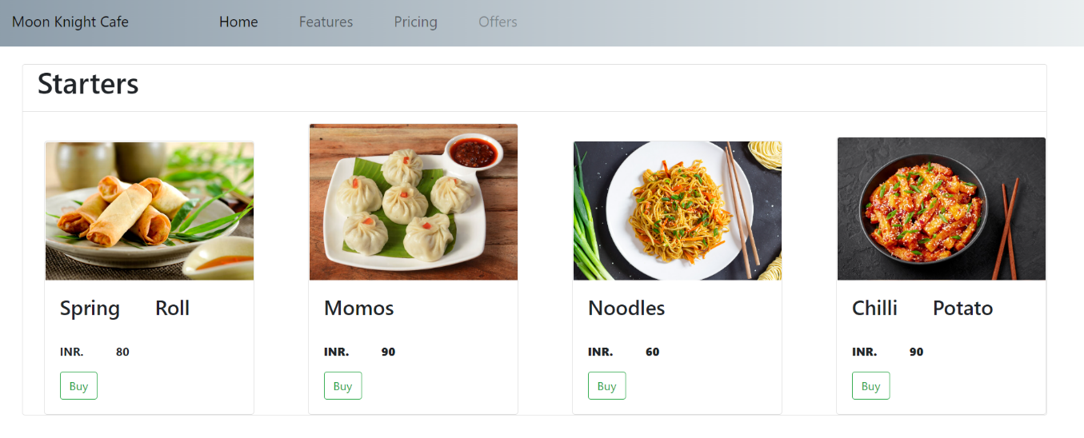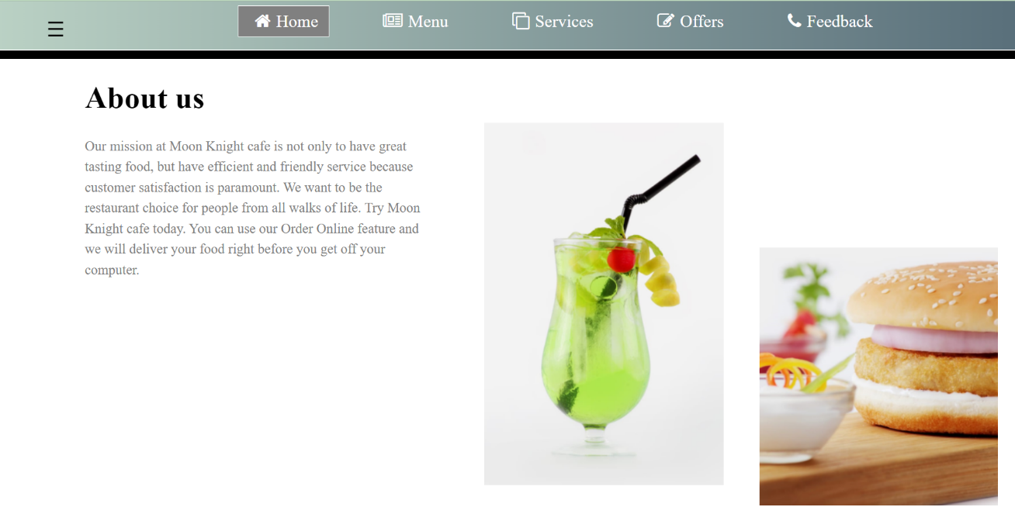

**Conclusion**

This is achieved through an easy to use graphical interface menu options. The users can add any number of items to the cart from any of the available food categorized by simply clicking the Add to Cart button for each item. Once item is added to the cart, user is presented with the detail order to review or continue shopping.