A

SynopsisOnRESUME BUILDER

Submitted By:

Vikas Parmar(2100290140146)

Ayush Sharma(2100290140047)  
Vidhi Sharma(2100290140144

Shivam Kumar(2100290140128)



Submitted to:

Ms. Divya Singhal (Assistant Professor)

DEPARTMENT OF COMPUTER APPLICATIONSKIET GROUP OF INSTITUTIONS, DELHI-NCR,GHAZIABAD

**ABSTRACT**

 A resume is a formal document that a job applicant creates to itemize his or her qualifications for a position.

To stand out among other applicants, you need a resume that markets your strengths and matches for the job

A resume should contain,

* Contact Information.
* Career Objective.
* Skills and Abilities
* Work experience
* Educational qualifications

We can add other information that describes us the most. But the resume that we are going to generate using our tool only contains the above fields.

It is an application that simplifies the task of creating a resume for individuals. The system is flexible to be used and reduces the need of thinking and designing an appropriate resume according to qualifications. The system is developed to provide an easy means for creating a professional looking resume. Individuals just have to fill up a form that specifies questions from all required fields such as personal questions, educational, qualities, interest, skills and so on. The answers provided by the users are stored and the system automatically generates a well structured resume. Users have option to create resume in any format and file.

**Table of Contents**

1. Introduction
2. Technologies / Software Requirements
3. Hardware requirement / Hardware Used
4. Modules Description
5. Reports / Outputs
6. Conclusion
7. Gantt Chart (In terms of weeks)

1. INTRODUCTION

Creating a resume is a bit tedious task for any working professional from any industry. One has to keep it short, simple, and with the latest work experience, and constantly update it over a while.

This project will help you through the process that can be followed to build your resume-builder using ReactJS and NodeJS. Implementing the project will give you the satisfaction of auto-generating it on your own and helping working professionals with the same.

#### Project Stages

This project consists of following stages:

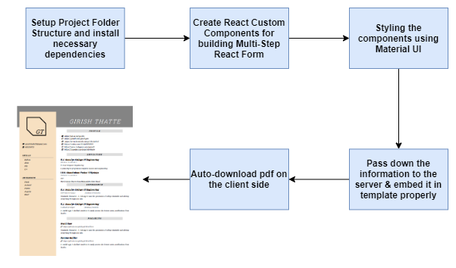

1. TECHNOLOGIES/SOFTWARE REQUIREMENTS

Technologies:-

-HTML, CSS, React js, Bootstrap.

Software:

-Vs code (IDE)

-Chrome (browser)

#### 

3.HARDWARE REQUIREMENT/HARDWARE USED

# **System requirements**

|  |  |  |  |
| --- | --- | --- | --- |
|  | **Windows requirements** | **Mac requirements** | **Linux requirements** |
| **Operating system** | Windows 8 or later | macOS Sierra 10.12 or later | 64-bit Ubuntu 14.04+, Debian 8+, openSUSE 13.3+, or Fedora Linux 24+ |
| **Processor** | Intel Pentium 4 or later | Intel | Intel Pentium 4 or later |
| **Memory** | 2 GB minimum, 4 GB recommended | | |
| **Screen resolution** | 1280x1024 or larger | | |
| **Application window size** | 1024x680 or larger | | |
| **Internet connection** | Required | | |

4.MODULES DESCRIPTION

The First part Of the Resume Deals with the Header Section.

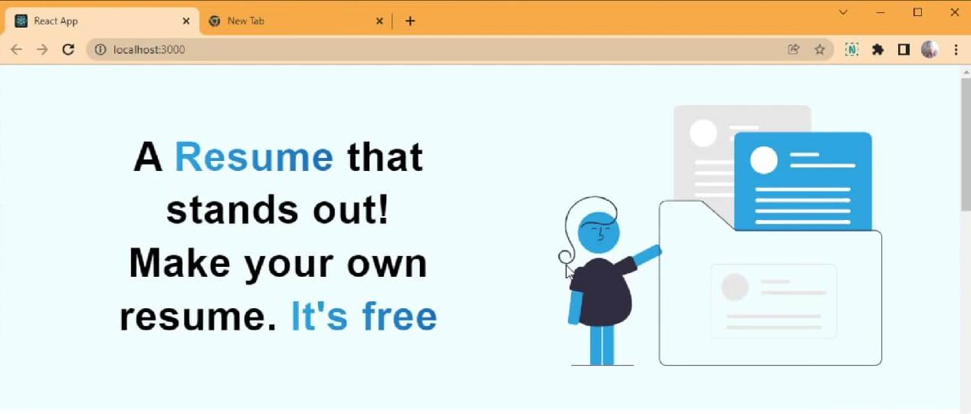

The Second Part deals with the details required to be filled while making a Resume.

The details are like the Name, Contact No., LinkedIn ID Link, GitHub ID Link, Education Details, Work Experience, Achievements, Projects etc.

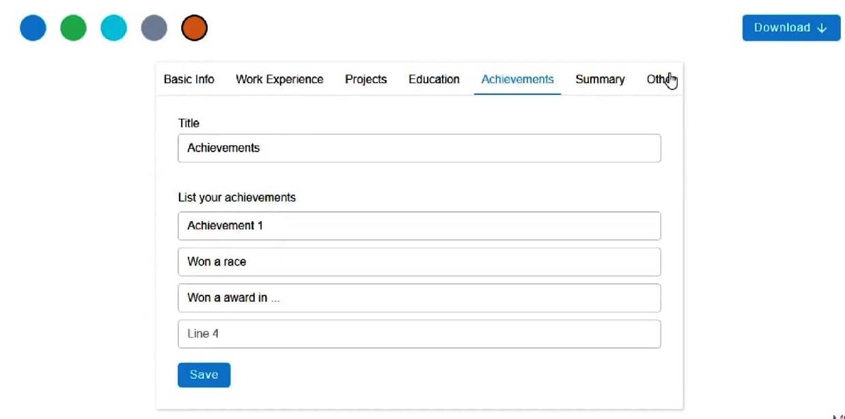

The Third and The Final Part deals with the Final Customized Resume Formed .

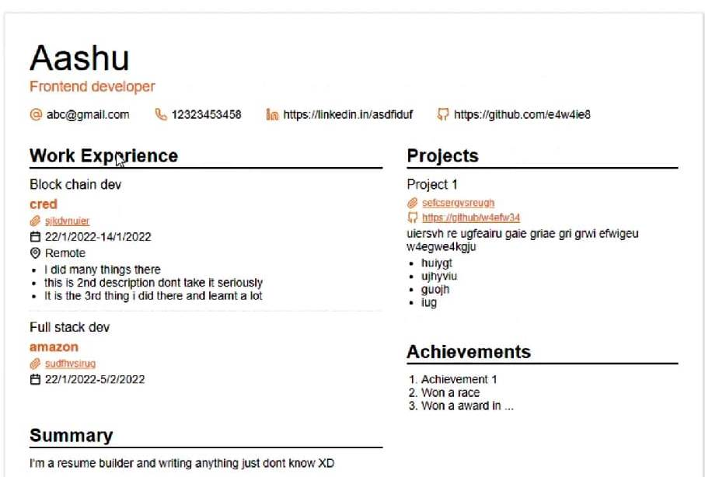

5.REPORTS/OUTPUTS

It generates the Formatted Resume and one can easily download it in the form of a pdf.

6.CONCLUSION

At last, we would like to conclude the Resume Making is a tiresome task and time consuming.

Choosing Specified type of template according to the user’s requirements also takes a lot of time . By using this Web Application a full formatted resume is obtained with its own general template.



7.GANTT CHART

|  |  |  |  |  |
| --- | --- | --- | --- | --- |
|  | | | | |
| PROJECT TASK | SEPTEMBER | | OCTOBER | NOVEMBER |
| 1.Planning and Requirements  2.Design  3.Coding and Implementation  4.Testing and Report |  |  | |