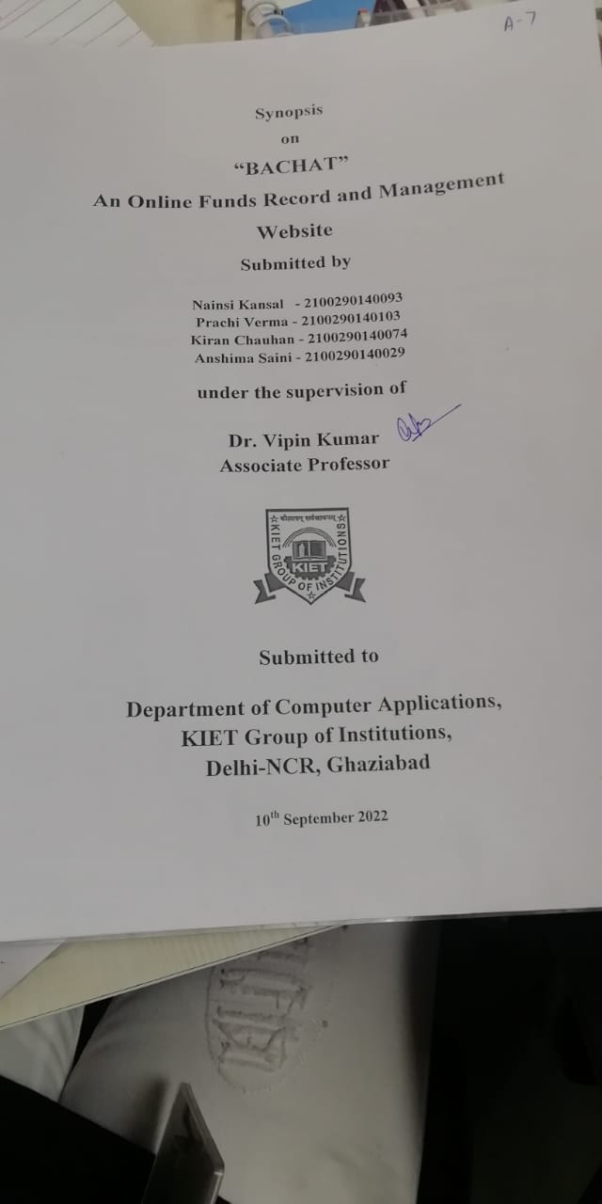

**ABSTRACT**

**Bachat** is a project which aims in developing an online application cum website to provide an Online platform to the user to, maintain weekly, monthly, and yearly expenditures of a person or family based on income. It helps in maintaining records and keeping the track of Payments and other expenses. This project has a variety of features, and logical and rational factors affecting the balance of one’s budget. Users can log in to their own portal separately with a unique ID and password set. The server side is the admin side that can maintain and manage the database and security. This System can be used to maintain a track of income, money spent on a daily basis and analysis all expenses, and notify when the person overspends the money. Overall, this project of ours is being developed to help the people(users) to maintain and analyze the economy and notify them to maintain it.

It is built using React, Spring Boot, Figma, and My SQL

**TABLE OF CONTENTS**

1. Introduction
2. Technologies / Software Requirements
3. Hardware requirement / Hardware Used
4. Modules Description
5. Reports / Outputs
6. Conclusion
7. Gantt Chart

**INTRODUCTION**

Money is the most valuable resource in everyone’s life as it is essential for all the basic requirements in life, from food, water, and house to all the basic to luxury requirements.

People tend to overspend their money and regret not being able to save it for future use or another purpose due to the lack of being able to keep records and analyze them to minimize expenditure.

This website provides various categories to keep a record of expenses and analysis it to notify if the expense exceeds the budget, and helps in savings.

**HARDWARE AND SOFTWARE REQUIREMENTS**

**Operating System**: Microsoft Windows

Front End: React

UI/UX: Figma

**Software Requirements**:

• Windows 10/11 or equivalent

• React

• Spring Boot

• RDBMS (Back end): MySQL

**Hardware Requirements**:

• Processor – Intel i3 5th generation or higher

• RAM – Minimum 4 GB, recommended 8 GB

• Disk space - Minimum 10 GB of free disk space

• Network Connectivity

**MODULES:**

1. Module
2. Sign up for Module
3. Designing Module
4. Verification Module
5. User Information Module
6. Expenditure Information Module
7. Expenditure categories Module
8. Result Analyzing Module
9. Goal Achievement Module

**CONCLUSION:**

In the end, the project helps in savings and maintaining the funds of a family or person.

It helps users like women who manage the family expenses and thrive to save as Indians tend to save. The goal is achieved as all the data is stored easily and analysis is done simultaneously.

**HOW TO SERVE SOCIETY:**

When the economy of people improves the economy of the country improves and it helps in the development of all.

**FUTURE SCOPE:**

The future goal is to make a Mobile application with updated features to make it more user-friendly and easier and more comfortable*.*

**GANTT CHART:**