**ONLINE AUCTION SYSTEM**

**A PROJECT REPORT**

**for**

**Mini Project (KCA353)**

**Group No.GA09**

**Session (2023-24)**

**Submitted by**

**EKANSH ARUN SRIVASTAVA**

**2200290140059**

**AKASH SINGH**

**2200290140019**

**Submitted in partial fulfillment of the**

**Requirements for the Degree of**

**MASTER OF COMPUTER APPLICATION**

**Under the Supervision of**

**Ms. Shalika Arora**

### **Assistant Professor**



**Submitted to**

**Department Of Computer Applications**

**KIET Group of Institutions, Ghaziabad**

**Uttar Pradesh-201206**

**February 2024**

**CERTIFICATE**

Certified that **Akash Singh 220029014008709, Ekansh Arun Srivastava 22002901400** has/ have carried out the project work having “**Online Auction System**” (**Mini Project-KCA353**) for **Master of Computer Application** from Dr. A.P.J. Abdul Kalam Technical University (AKTU**)** (formerly UPTU), Lucknow under my supervision. The project report embodies original work, and studies are carried out by the student himself/herself and the contents of the project report do not form the basis for the award of any other degree to the candidate or to anybody else from this or any other University/Institution.

**Date:**

**Akash Singh (2200290140019)**

**Ekansh Arun Srivastava (2200290140059)**

This is to certify that the above statement made by the candidate is correct to the best of my knowledge.

Date:

**Ms. Shalika Arora Dr. Arun Tripathi**

**Assistant Professor Head**

**Department of Computer Applications Department of Computer Applications**

**KIET Group of Institutions, Ghaziabad KIET Group of Institutions, Ghaziabad**

**EKANSH ARUN SRIVASTAVA**

**AKASH SINGH**

**ONLINE AUCTION SYSTEM**

**ABSTRACT**

The Online Auction System is a modern web platform facilitating seamless auction experiences for users. It acts as a centralized marketplace where individuals can engage in dynamic bidding processes to buy and sell various items. With a user-friendly interface, the system ensures easy navigation for both buyers and sellers, promoting accessibility and engagement.

One of the system's key features is its dynamic bidding mechanism, which injects excitement and competitiveness into the auction process. Through automation, the platform manages essential aspects of auctions, such as item listing and bid tracking, simplifying participation for users. sellers benefit from a dynamic item catalog that allows them to showcase their products effectively, enhancing visibility and attracting potential buyers.

The platform's streamlined approach eliminates unnecessary complexities, providing a hassle-free experience for all participants. the Online Auction System emphasizes simplicity by minimizing such features. Instead, it prioritizes intuitive design and efficient functionality to ensure a smooth user experience.

In summary, the Online Auction System offers a user-centric design, dynamic bidding capabilities, and automated management features. Whether users are interested in rare collectibles or everyday items, the platform provides a convenient solution for conducting online auctions. By focusing on simplicity and effectiveness, it aims to redefine the auction experience and foster increased engagement among participants.

**ACKNOWLEDGEMENTS**

Success in life is never attained single-handedly. My deepest gratitude goes to my project supervisor, Ms. **Shalika Arora** for his/ her guidance, help, and encouragement throughout my project work. Their enlightening ideas, comments, and suggestions.

Words are not enough to express my gratitude to Dr. Arun Kumar Tripathi, Professor and Head, Department of Computer Applications, for his insightful comments and administrative help on various occasions.

Fortunately, I have many understanding friends, who have helped me a lot on many critical conditions.

Finally, my sincere thanks go to my family members and all those who have directly and indirectly provided me with moral support and other kind of help. Without their support, completion of this work would not have been possible in time. They keep my life filled with enjoyment and happiness.

**Akash Singh**

**Ekansh Arun Srivastava**

**TABLE OF CONTENTS**

|  |  |  |  |
| --- | --- | --- | --- |
|  | Certificate | | i |
|  | Abstract | | ii |
|  | Acknowledgments | | iii |
|  | Table of Contents | | iv |
|  | List of Figures | | v |
| 1 | Introduction | | 1-3 |
|  | 1.1 | Overview | 1 |
|  | 1.2 | Project Objectives | 2 |
|  | 1.3 | Project Requirements | 3 |
| 2 | Feasibility Study | | 4-5 |
|  | 2.1 | Technical Feasibility | 4 |
|  | 2.2 | Economical Feasibility | 4 |
|  | | 2.3 | Operational Feasibility | 5 |
| 3 | | | System Analysis and Design | | 6 |
|  | | | 3.1 | System Analysis | 6 |
|  | | | 3.2 | System Design | 6 |
| 4 | | | | Data Flow Diagram | | 7-8 |
|  | | | | 4.1 | Block Diagram | 7 |
|  | | | | 4.2 | Data Flow Diagram | 8 |
| 5 | | | | | System Implementations and Figures | | 9-26 |
|  | | | | | 5.1 | Seller Registration Page | 9 |
|  | | | | | 5.2 | Buyer Dashboard | 20 |
| 6 | | | | | | Data Base | | 27-31 |
|  | | | | | | 6.1 | Register | 27 |
|  | | | | | | 6.2 | Products | 29 |
| 7 | | |  | Conclusion | 32 |
|  | | |  | Bibliography | 33 |

|  |  |  |
| --- | --- | --- |
|  |  |  |
|  |  |  |

**CHAPTER 1**

**INTRODUCTION**

* 1. **OVERVIEW**

In an era characterized by the rapid evolution of technology and the increasing interconnectedness of global markets, traditional methods of commerce are undergoing a profound transformation. The advent of the internet has paved the way for novel and dynamic approaches to buying and selling, with online platforms becoming the nexus of modern trade. One such paradigm shift is witnessed in the realm of auctions, where the convergence of digital innovation and commerce has given rise to a new frontier – the Online Auction System.

The Online Auction System encapsulates the essence of a contemporary marketplace, transcending geographical boundaries and temporal constraints. It offers a virtual arena where individuals and businesses can engage in the exhilarating process of bidding and selling, leveraging the power of connectivity and accessibility. This report delves into the conceptualization, development, and implementation of our Online Auction System, exploring its multifaceted features, innovative functionalities, and the overarching impact it seeks to make in the landscape of e-commerce.

As we navigate through the intricacies of this project, it is imperative to recognize the transformative potential embedded in the fusion of traditional auction dynamics with cutting-edge technological solutions. This report unfolds the layers of our Online Auction System, elucidating the user-centric design, robust security measures, and the seamless integration of features aimed at enhancing the overall user experience. From user registration to bid management, payment transactions to comprehensive analytics, our system aspires to redefine online auctions, fostering a secure, transparent, and engaging marketplace for participants across the digital spectrum.

**1.2 PROJECT OBJECTIVES**

**Development of a User-Centric Platform:**

Design and implement an intuitive and user-friendly interface for both buyers and sellers, prioritizing ease of navigation and accessibility across various devices.

**Efficient User Registration and Authentication:**

Create a streamlined user registration process with secure authentication mechanisms to ensure a seamless onboarding experience while safeguarding user data.

**Comprehensive Product Listing:**

Enable sellers to list items for auction with detailed descriptions, images, and categorization, enhancing the overall visibility and searchability of products.

**Dynamic Auction Management:**

Implement a flexible auction management system that allows sellers to set parameters such as starting bids, reserve prices, and durations, ensuring adaptability to a diverse range of auction scenarios.

**Robust Bidding System:**

Develop a responsive bidding system that supports real-time bidding, increments, proxy bidding, and bid notifications to enhance user engagement and competition.

**Responsive Design Across Devices:**

Ensure a responsive design that adapts to different screen sizes, providing a consistent and user-friendly experience on desktops, tablets, and smartphones.

**1.3 PROJECT REQUIREMENTS**

**1.3.1 Hardware:**

* Processor: Minimum 2.0GHz requires.
* Ram: 2 GB.
* Hard Disk: 100 GB.
* Input device: Standard Keyboard and Mouse.
* Output device: VGA and High, Resolution Monitor.

**1.3.2 Software:**

* Operating System: Windows 7
* Language: PHP, JAVASCRIPT
* Database: phpMyAdmin.
* Tool: Visual Studio, XAMPP.

**CHAPTER 2**

**FEASIBILITY STUDY**

A feasibility study is a critical phase in project planning, serving as a comprehensive analysis to determine the viability of a proposed project. In this context, we will explore the technical, economic, and operational feasibility of implementing a Bidding system.

**2.1 Technical Feasibility:**

There are very few situations in which Biddings cannot be performed due to existing market conditions (e.g., in the case of a monopoly). It is more likely that the combination of different (legitimate) interests of the internally involved parties will lead to a situation in which a Bidding would seem inappropriate. By means of thorough and systematic preparation with all responsible internal parties involved, we help establish a framework in which a Bidding can be carried out, allowing the realization of the underlying savings potential. At the same time, we make sure that the company's main sourcing targets are reached. Many of our clients initially thought that commitment to the outcome of a Bidding would reduce their flexibility. They very soon concluded that systematic preparation only shifts the required flexibility to a position closer to the beginning. If a certain result is not to be supported, we make sure - by systematic preparation and careful Bidding design - that it will never occur.

**2.2 Economic Feasibility:**

Economic Feasibility means the cost of understanding project should less cost than the existing system. Electronic mailing system is economically feasible, because it reduces the expenses in the system

Economic feasibility evaluates the financial viability of a proposed project or initiative. It entails analyzing various factors such as costs, revenue projections, return on investment (ROI), and potential risks. By assessing these elements, stakeholders can determine whether the project is economically sound and worth pursuing. Economic feasibility studies help in making informed decisions, guiding resource allocation, and mitigating financial risks. They provide valuable insights into the project's profitability, sustainability, and long-term impact on the organization's financial health. Ultimately, economic feasibility serves as a crucial determinant in evaluating the feasibility and potential success of a project in the marketplace.

**2.3 Operational Feasibility:**

Operational feasibility for an online auction system involves assessing the infrastructure and resources necessary to support its functionality. This includes evaluating staffing needs for roles like customer support, logistics management, and technical maintenance, as well as providing adequate training for personnel. Additionally, the system's scalability and flexibility are crucial for adapting to fluctuations in user demand, transaction volumes, and technological advancements. Identifying and mitigating operational risks such as system downtime, security breaches, and regulatory compliance issues are paramount to ensuring smooth operations. Ultimately, operational feasibility is determined by user acceptance and minimal disruption post-implementation. A prime example of operationally feasible technology is electronic mail, as it garnered widespread user support without causing significant user-related issues. Thus, an online auction system must exhibit similar operational feasibility to ensure seamless user adoption and functionality.

**CHAPTER 3**

**SYSTEM ANALYSIS AND DESIGN**

**3.1 System Analysis:**

The entire project has been developed keeping in view of the distributed client server computing technology, in mind. The specification has been normalized up to 3NF to eliminate all the anomalies that may arise due to the database transaction that are executed by the general users and the organizational administration. The user interfaces are browser specific to give distributed accessibility for the overall system. The internal database has been selected as SQL Server. The basic constructs of table spaces, clusters and indexes have been exploited to provide higher consistency and reliability for the data storage. The SQL server was a choice as it provides the constructs of high-level reliability and security. The total front end was dominated using the html and Css At all proper levels high care was taken to check that the system manages the data consistency with proper business rules or validations. The database connectivity was planned to use the latest “SQL Connection” technology provided by Microsoft Corporation. The authentication and authorization were crosschecked at all the relevant stages.

**3.2 System Design:**

People tend to frequent seized property Biddings because goods can be purchased at a low price relative to market value. This is good for the buyer, but not for the debtor whose budget and credit record are dependent on this money. A limited audience who will not pay the full value of the items up for bidding attends the Biddings. The body appointed to seize and Bidding property operates it. When debtors must liquidate their assets, they must first open an account with the Collection Authority. The Collection Authority is housed inside the sheriff’s office or the organization responsible for public Biddings of seized property and assets. It is a combination of customer service counters and an inventory/shipping warehouse. Seized goods and items brought in by a debtor are inventoried at the Collection Authority where daily shipments are made for the items sold. Once the item is sold, the buyer makes the payment to the Collection Authority, which then transfers the balance owed to the creditor, minus shipping costs and a percentage charged by the Collection Authority. All items going through site, either seized or brought in by the debtor, use the Item Profiler to create a standard description page to post items on the on-line Bidding site. The page layout includes digital images representing the orthographic views of the item plus a text section detailing its make, model, year, history, etc. with an additional line worded by the debtor.

**CHAPTER 4**

**BLOCK DIAGRAM**

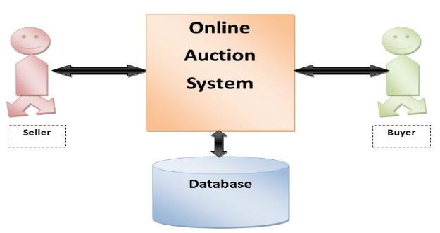

**Fig- 1: Online Auction System Block Diagram**

* **Buyer and Seller:** components represent the users interacting with the system.
* **Online Auction Platform:** is the central hub facilitating communication between buyers and sellers.
* **User Database:** stores user information such as registration details, contact information, etc.
* **Item Database:** stores information about the items being auctioned, including descriptions, images, starting bids, etc.
* **Process Box:** (not explicitly labeled) represents the various processes and functionalities within the auction platform, including registration, listing items, bidding, etc.

**CHAPTER 5**

**DATA FLOW DIAGRAM**

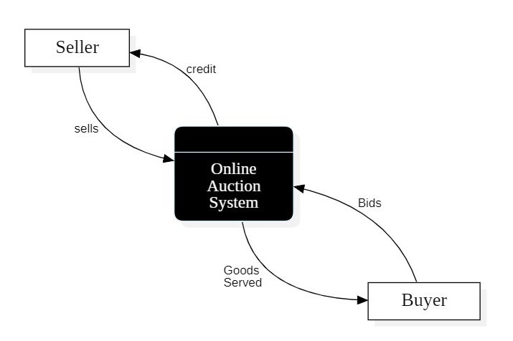

**Fig- 2: Data Flow Diagram**

The context-level Data Flow Diagram (DFD) for the online auction system features a central process denoting the system itself, with external entities represented by "Seller" and "Buyer." Sellers interact with the system to list items for auction, while buyers engage in bidding and purchasing activities. This high-level overview outlines the primary interactions between the system and its external entities, omitting internal processes and data flows for simplicity.

CHAPTER 6

SYSTEM IMPLEMENTATION AND FIGURES

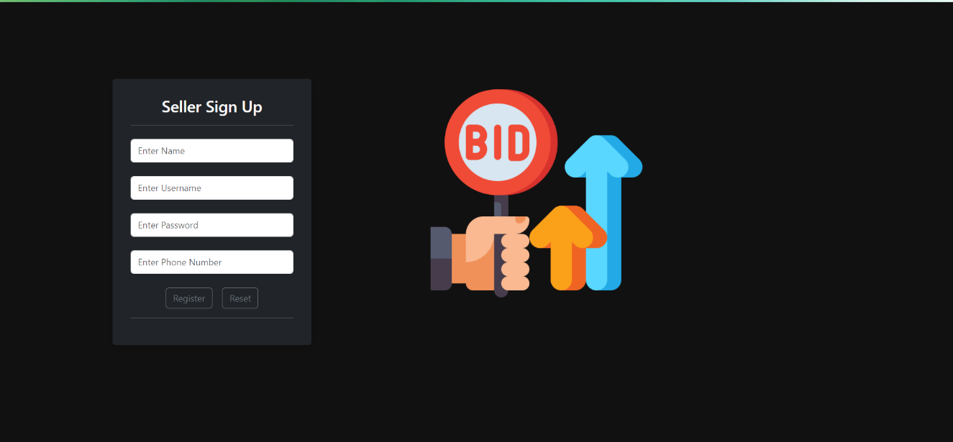

**Fig- 3: New Seller Registration Page**

For an auction system's seller registration page, you would typically design a form that collects essential information from the user. Here's a description of the fields you mentioned:

1. **Name:**

Type: Text input

Label: Enter Your Full Name

Description: User should input their complete name.

2. **Username:**

Type: Text input

Label: Choose a Username

Description: Unique identifier for the user's account.

3. **Password:**

Type: Password input

Label: Create a Password

Description: Secure password to protect the account. Consider including guidelines for a strong password.

4. **Phone Number:**

Type: Text input

Label: Enter Your Phone Number

Description: User's contact number. You may include a format example for clarity.

5. **Reset Button:**

Type: Button

Label: Reset Form

Description: Click to clear all entered information and start over.

**Additional considerations:**

* Validation: Implement validation checks for each field (e.g., ensuring the phone number is in the correct format, password strength requirements).
* Submit Button: A button labeled "Login" to submit the form.
* Error Handling: Display clear error messages if the user enters information incorrectly.
* Remember to design the registration page with a user-friendly interface to enhance the overall user experience.



**Fig- 4: Seller Login Page**

Here's a description of a login page where users can select their user type (buyer or seller) and enter their username and password:

**1.** **User Type:**

Type: Dropdown menu

Label: Select User Type

Options:

* Buyer
* Seller

The user will choose their role from the provided options.

**2.** **Username:**

Type: Text input

Label: Enter Your Username

Description: Users will input their unique identifier associated with their account.

**3.** **Password:**

Type: Password input

Label: Enter Your Password

Description: Users will enter the password associated with their account. The password should be hidden for security.

**4.** **Login Button:**

Type: Button

Label: Login or Sign In

Description: Clicking this button will attempt to log the user into the system.

**5.** **Error Messages**:

Display clear error messages if the login credentials are incorrect, or if there are any

other issues during the login process

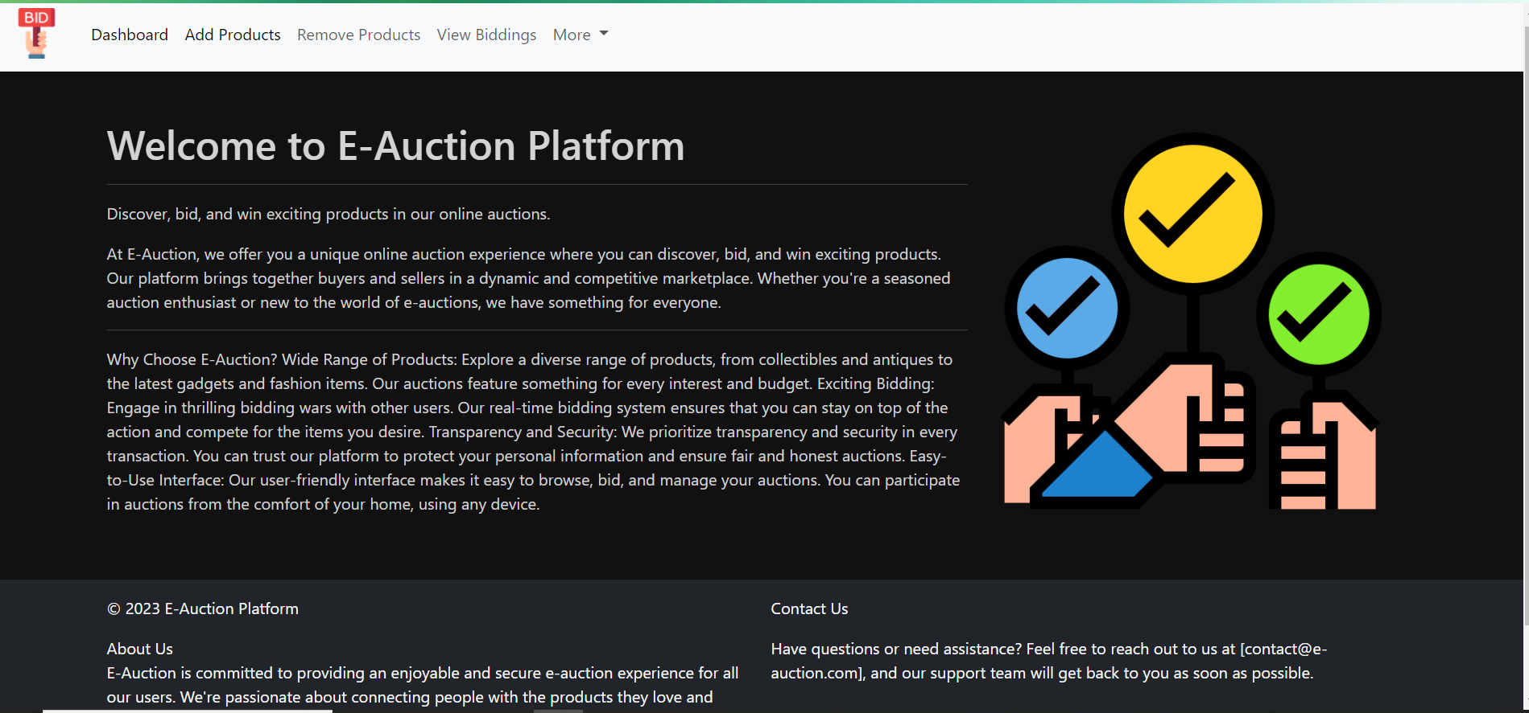

**Fig- 5: Seller Dashboard**

The home page of an auction system serves as the main entry point for users and typically provides an overview of the platform's offerings, features, and navigation options. Here's a description of key elements you might find on the home page of an auction system:

Great! With the given navigation menu options, your auction system's navigation bar could look something like this:

**1. Add Product:**

This option allows sellers to add new products to the auction platform. Clicking on "Add Product" would likely lead sellers to a form where they can provide details about the product they want to auction.

**2. Remove Product:**

Sellers might use this option to remove a product from the auction platform. Clicking on "Remove Product" could lead to a list of the seller's products with an option to delete or remove selected items.

**3. View Biddings:**

This option is likely for both buyers and sellers. It allows users to view the current and past bidding activities. Clicking on "View Biddings" could lead to a page displaying a list of ongoing and completed auctions, along with bid details.

**4. More:**

The "More" dropdown or menu typically contains options related to user profiles and account management:

**Profile:** This link would lead to the user's profile page, where they can update personal information, view their activity, etc.

**Sign Out:** Clicking on "Sign Out" would log the user out of their current session.

**FAQ:** This could link to a page containing frequently asked questions to assist users with common queries.

**Here's a simple representation:**

---------------------------------------

| Add Product | Remove Product | View Biddings | More (Profile, Sign Out, FAQ) |

---------------------------------------

Ensure that each option in the navigation menu leads users to the relevant section with a clear and user-friendly interface. This layout makes it easy for both sellers and buyers to navigate through the key functionalities of the auction system.

**1. Header:**

The top section often contains the platform's logo, navigation menu, and user account- related options.

Links to essential pages like Home, Auctions, etc.

**2. Footer:**

The bottom section of the home page typically includes links to important pages, About-us and contact information.

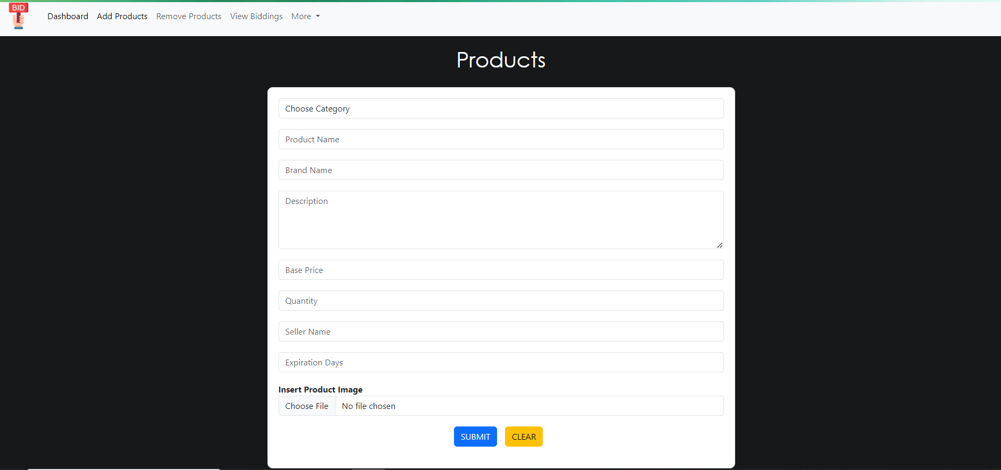

**Fig- 6: Add Products**

Below is a description of the "Add Product" page with the specified fields:

**1. Choose Category:**

Type: Dropdown menu

Options: Electronics, Clothing, Shoes, Watches, Books, Toys, Furniture

Description: Sellers select the category that best fits their product.

**2. Product Name:**

Type: Text input

Label: Enter Product Name

Description: Sellers enter the name of the product they are adding.

**3. Brand Name:**

Type: Text input

Label: Enter Brand Name

Description: Sellers input the brand name associated with the product.

**4. Description:**

Type: Text area

Label: Product Description

Description: Sellers provide a detailed description of the product, including its features and condition.

**5. Base Price:**

Type: Number input

Label: Enter Base Price

Description: Sellers specify the starting price for the auction.

**6. Quantity:**

Type: Number input

Label: Enter Quantity

Description: Sellers input the quantity of the product available for auction.

**7. Seller Name:**

Type: Text input

Label: Seller Name (auto-filled or pre-populated if the user is logged in)

Description: Displays the name of the seller. If the user is logged in, this field may be auto- filled.

**8. Expiration Days:**

Type: Number input

Label: Enter Expiration Days

Description: Sellers specify the number of days the auction will be active before expiration.

**9. Choose File:**

Type: File input

Label: Upload Product Image

Description: Sellers upload an image of the product. This could be a photo that showcases the item.

**10. Submit Button:**

Type: Button

Label: Submit

Description: Clicking this button will submit the product details for auction.

**11. Clear Button:**

Type: Button

Label: Clear

Description: Clicking this button will clear all entered information, allowing sellers to start over.

This form provides a structured layout for sellers to input the necessary details when adding a product for auction. The "Submit" button allows them to save the product, and the "Clear" button enables them to reset the form if needed.

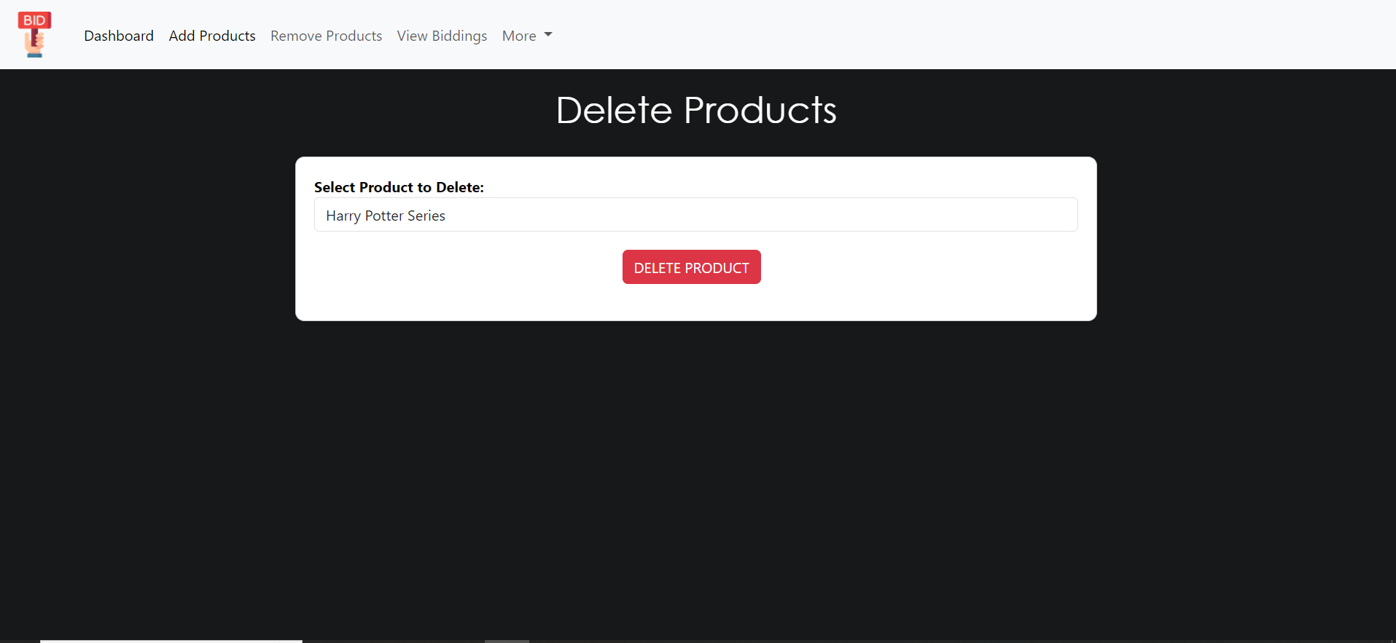

**Fig- 7: Remove Products**

Below is a description of the "Delete Products" page with the specified field:

**1. Select Product to Delete:**

Type: Checkbox or dropdown menu

Options: List of products that the user can select for deletion

Description: Sellers can choose one or more products from the list to delete. If using checkboxes, multiple selections can be made.

**2. Delete Button:**

Type: Button

Label: Delete Selected Products

Description: Clicking this button will initiate the deletion process for the selected products.

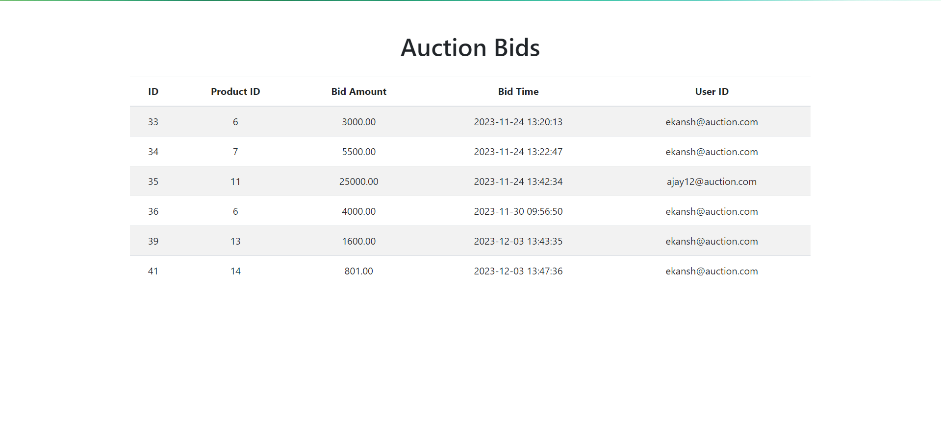

**Fig- 8: View Biddings**

**1. Database Schema:**

The database schema for the Auction Bids project includes the following tables and their corresponding columns:

**2. Table Name: Auction Bids**

Columns: ID, Product ID, Bid Amount, Bid Time, User ID

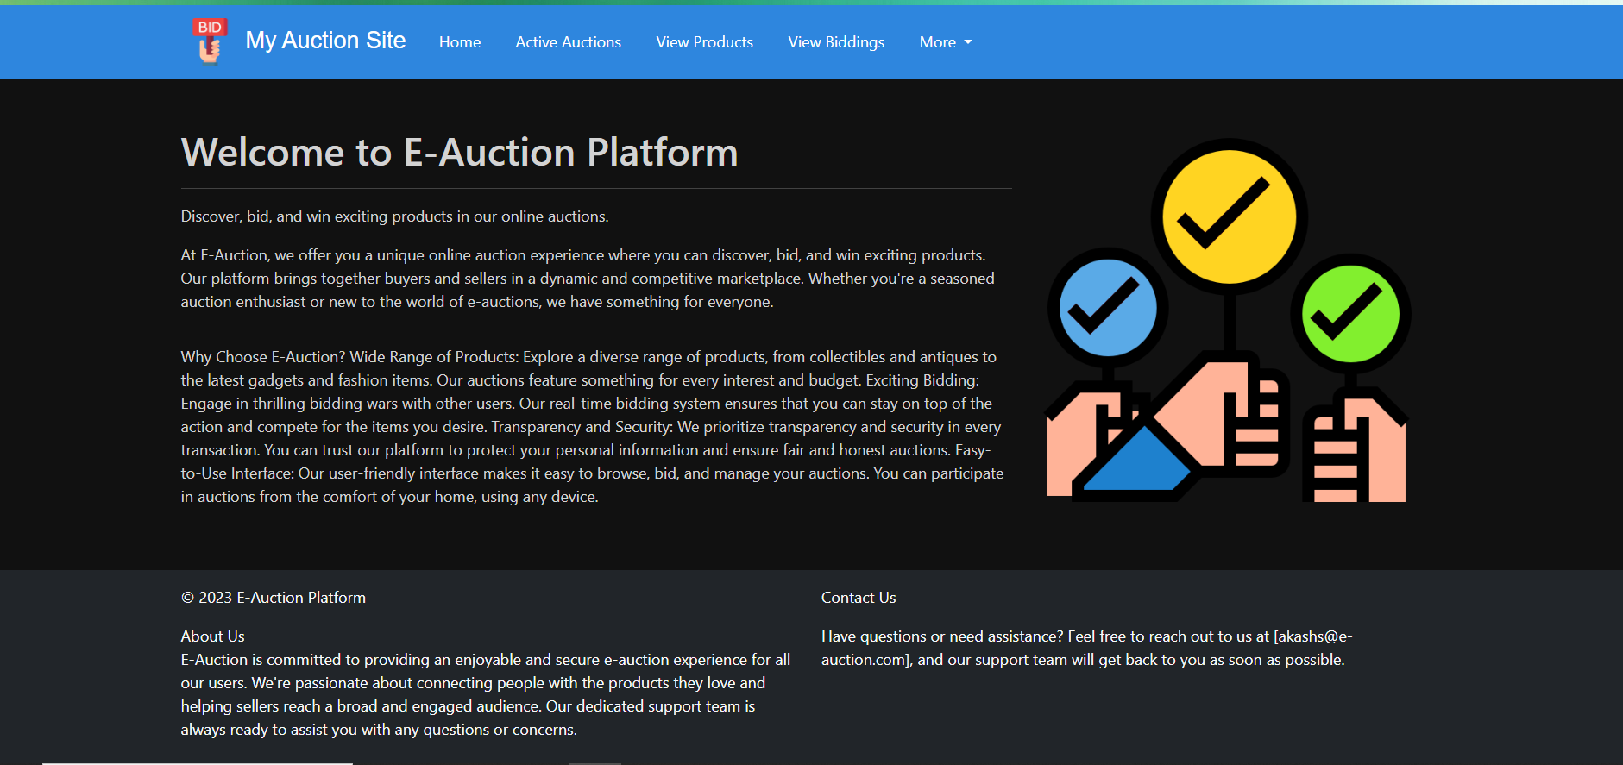

**Fig- 8: Buyer Dashboard**

**1. Active Auction:**

Navigates the buyer to a page where they can see a list of currently active auctions.

**2. View Products:**

Takes the buyer to a page where they can explore and view details of available products.

**3. View Biddings:**

Directs the buyer to a page displaying information about their bidding history or ongoing bids.

**4. More (Profile, Sign Out, FAQ):**

A dropdown or menu containing additional options:

**Profile:** Takes the buyer to their profile page where they can manage personal information.

**Sign Out:** Logs the buyer out of the current session.

**FAQ:** Links to a page containing frequently asked questions to assist buyers with common queries.

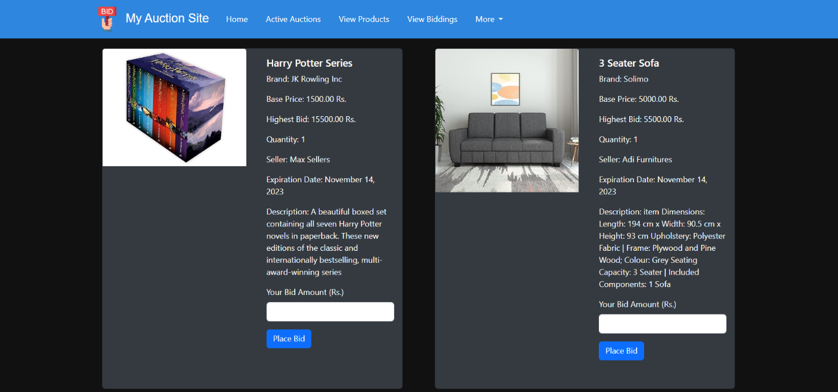

**Fig- 9: View Products**

Here's a description of the "View Product" page with the specified fields, along with the input box for placing bids:

**1. Product Image:**

Display: An image representing the product.

Description: Provides a visual representation of the product.

**2. Product Name:**

Display: Text

Description: Indicates the name or title of the product.

**3. Brand Name:**

Display: Text

Description: Specifies the brand or manufacturer of the product.

**4. Base Price:**

Display: Numeric value (e.g., $100)

Description: Shows the initial or base price set for the product.

**5. Highest Bid:**

Display: Numeric value (e.g., $150)

Description: Indicates the current highest bid for the product.

**6. Quantity:**

Display: Numeric value

Description: Specifies the quantity of the product available for auction.

**7. Seller Name:**

Display: Text

Description: Indicates the name of the seller or vendor.

**8. Expiration Date:**

Display: Date and time

Description: Specifies the date and time when the auction for the product will expire.

**9. Description:**

Display: Text or rich text

Description: Provides a detailed description of the product, including its features and condition.

**10. Bid Amount Input Box:**

Type: Numeric input

Label: Enter Bid Amount

Description: Allows the user to input their bid amount for the product.

**11. Place Bid Button:**

Type: Button

Label: Place Bid

Description: Initiates the bidding process when clicked.

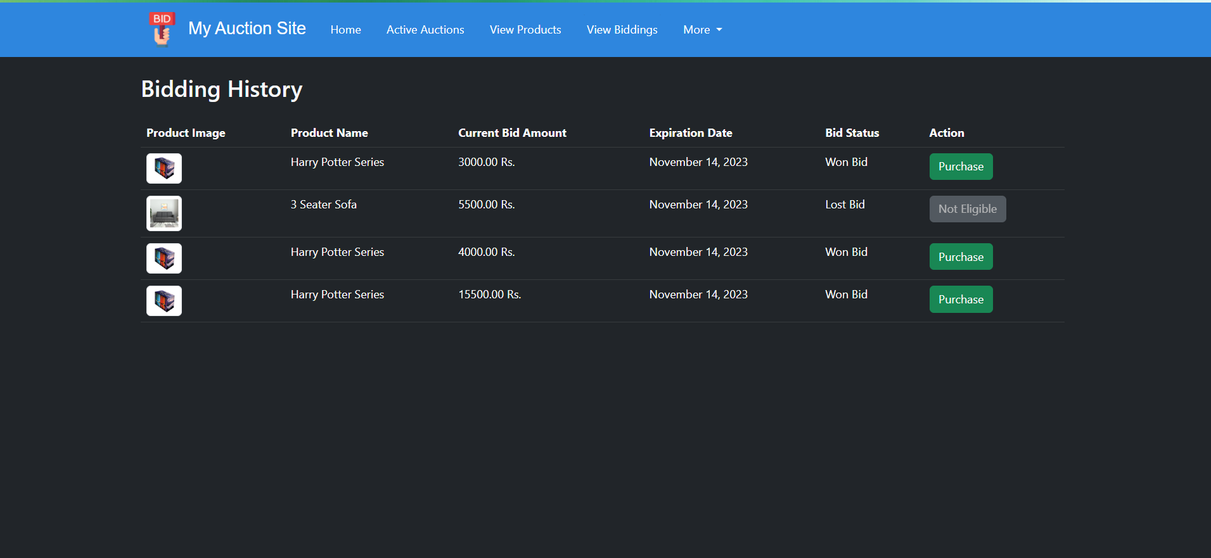

**Fig- 10: Bidding History**

Here's a description of the "Bidding History" page with the specified fields:

**1. Product Image:**

Display: An image representing the product that was bid on.

Description: Provides a visual reference for the product.

**2. Product Name:**

Display: Text

Description: Indicates the name or title of the product that was part of the bidding history.

**3. Current Bid Amount:**

Display: Numeric value (e.g., $150)

Description: Shows the amount of the current highest bid for the product.

**4. Expiration Date:**

Display: Date

Description: Specifies the date when the bidding for the product expired.

**5. Bid Status:**

Display: Text (e.g., "Won," "Outbid," "Active")

Description: Describes the status of the bid, indicating whether the user won the bid, was outbid, or if the bidding is still active.

**6. Action:**

Display: Action button(s)

Description: Provides options for actions related to the bidding history. This could include buttons such as "View Details"

In this example, the table includes columns for product image, product name, current bid amount, expiration date, bid status, and an action button. The "Action" button can be customized based on the specific actions you want users to perform related to their bidding history. Adjust the styling and functionality as needed for your application.

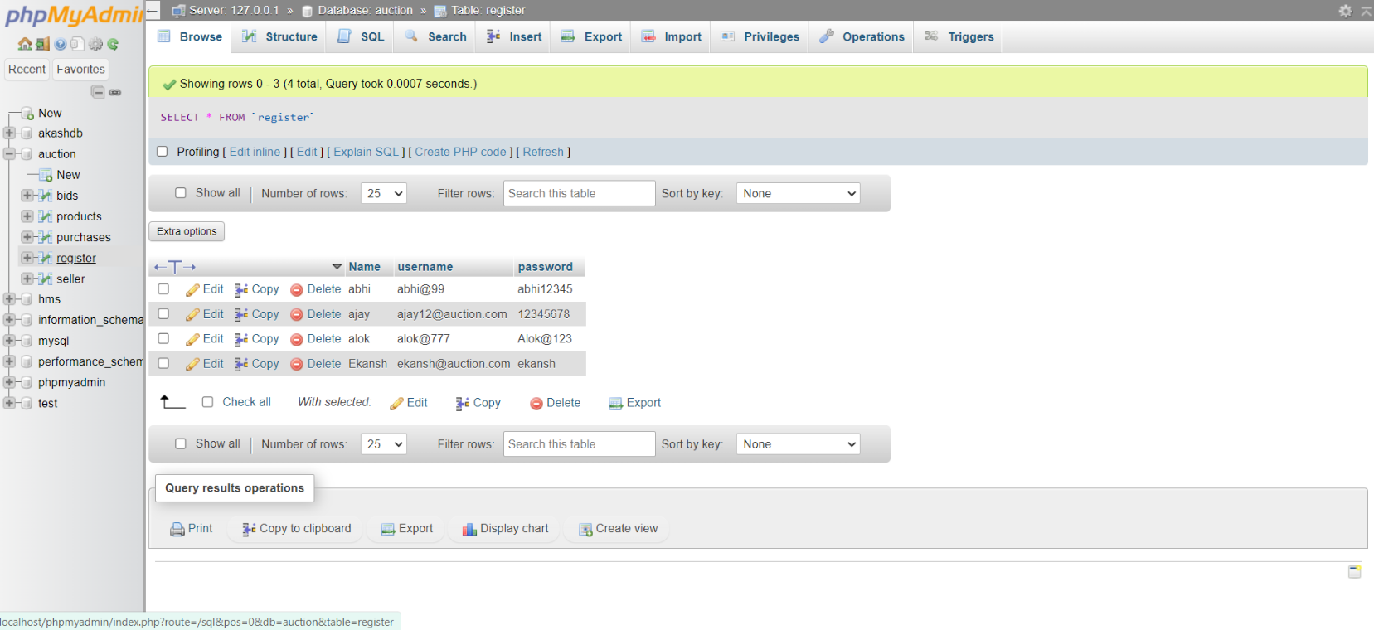

**Fig -11: Register Table**

The "register" table in your database likely serves as a repository for user registration information. It presumably stores essential data such as usernames, corresponding passwords, and possibly associated names or other relevant details. This table plays a crucial role in authentication processes, allowing users to securely access your system or platform. Properly managing and securing this data is paramount to safeguarding user accounts and maintaining trust in your application or service.

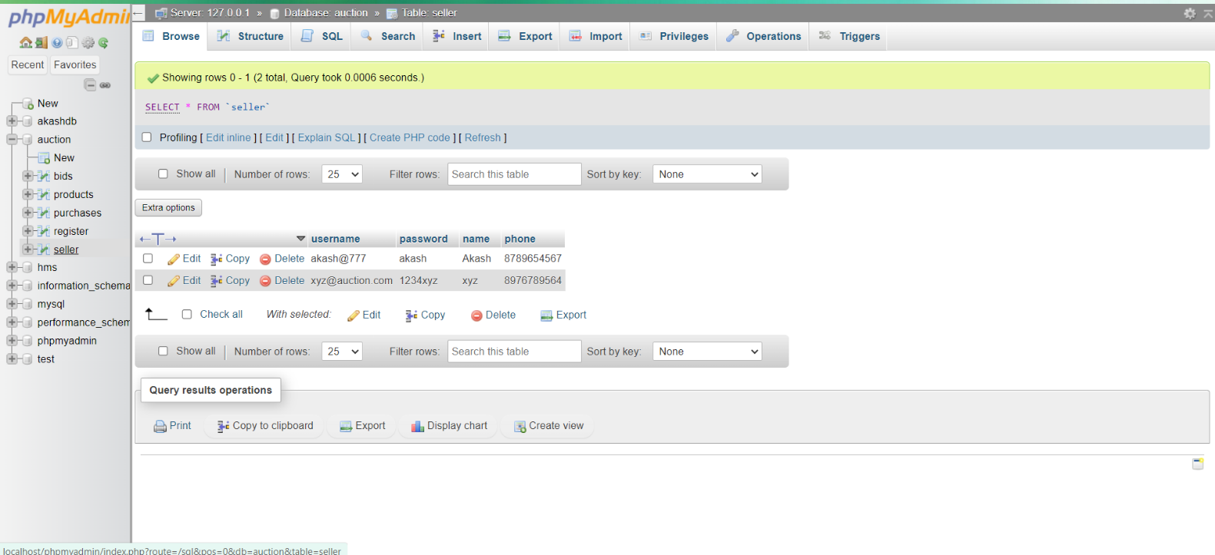

**Fig -12**: **Seller Table**

The "seller" table serves as a repository for seller registration information within your database. It typically stores essential data such as usernames, corresponding passwords, seller names, and phone numbers. This table is integral to managing seller accounts and facilitating their interaction with your platform or system. Properly securing and managing this data is crucial for ensuring the integrity and security of your platform while providing a seamless experience for sellers.

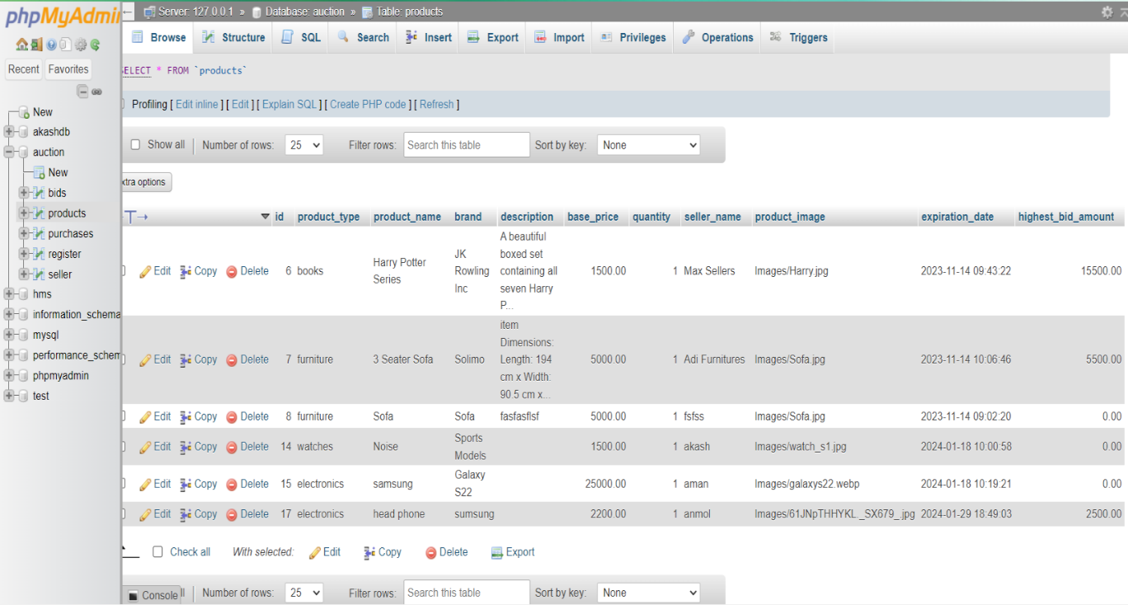

**Fig -13: Products Table**

The "Products" table is designed to comprehensively store information about various products available within your system. Here's a breakdown of the fields it contains:

1. id: A unique identifier for each product, typically auto-incremented.

2. product_type: Categorization of the product, such as electronics, clothing, or groceries.

3. product_name: The name or title of the product.

4. brand: The brand or manufacturer of the product.

5. description: A detailed description or overview of the product.

6. base_price: The initial or base price of the product.

7. quantity: The available quantity or stock of the product.

8. seller_name: The name or identifier of the seller associated with the product.

9. product_image: A reference or link to the image representing the product.

10. expiration_date: this field stores the date when the product expires or becomes invalid.

11. highest_bid_amount: this field tracks the highest bid amount.

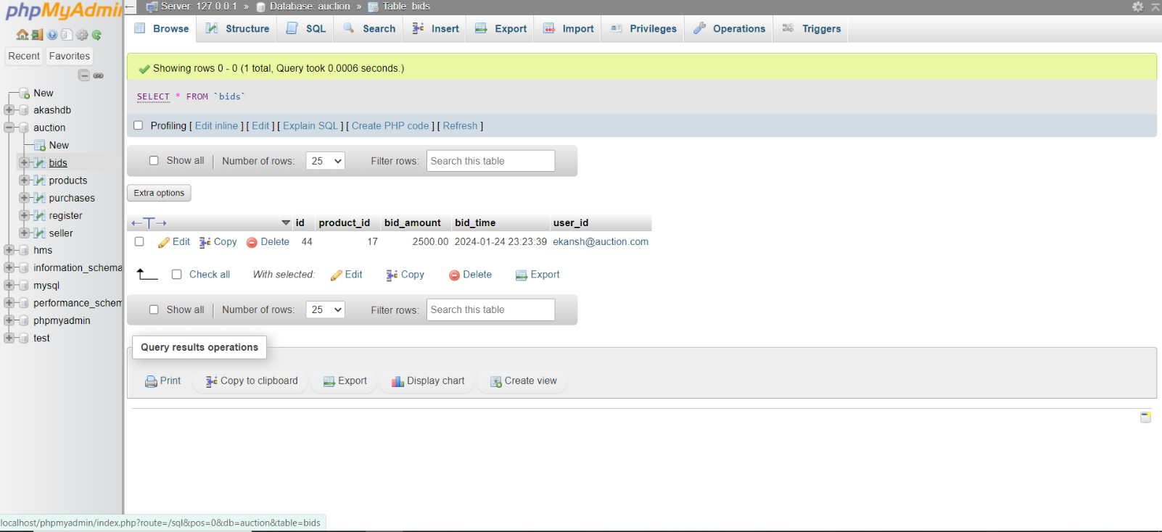

**Fig -14: Bids Table**

The "bids" table is designed to track bidding activity for products within your system. Here's a breakdown of the fields it contains:

1. id: A unique identifier for each bid, typically auto-incremented.

2. product_id: A reference to the product for which the bid is placed.

3. bid_amount: The amount bid by the user for the product.

4. bid_time: The timestamp indicating when the bid was placed.

5. username: The username or identifier of the user who placed the bid.

This table allows you to monitor and manage bidding activities for each product, including the amount bid, the time of bidding, and the user who placed the bid. It enables features such as tracking bid history, determining the highest bidder, and managing bidding rules within your system. Properly organizing and maintaining this data is crucial for effective bidding functionality and ensuring a fair and transparent bidding process.

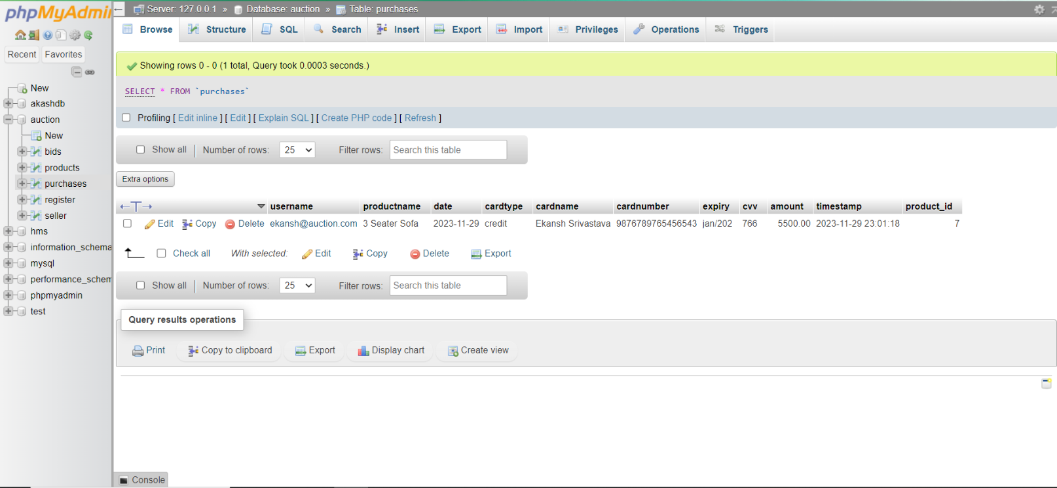

**Fig -15: Purchases Table**

The "purchases" table is responsible for storing information related to user purchases within your system. Here's a breakdown of the fields it contains:

1. username: The username or identifier of the user who made the purchase.

2. productname: The name of the product purchased.

3. date: The date when the purchase was made.

4. cardtype: The type of payment card used for the purchase.

5. cardname: The name on the payment card.

6. cardnumber: The card number used for the purchase (masked or encrypted for security).

7. expiry: The expiration date of the payment card.

8. ccv: The CCV (Card Verification Value) or CVV (Card Verification Code)

9. amount: The amount paid for the purchase.

10. timestamp: when the purchase transaction was recorded.

11. product_id: A reference to the product purchased.

CHAPTER 14

CONCLUSION

In conclusion, the development of the online auction system marks a significant stride towards modernizing traditional auction processes. Through meticulous design and implementation, the system offers a seamless platform for buyers and sellers to engage in dynamic bidding interactions from the comfort of their homes.

The system's robust features, including user authentication, item listing, bidding mechanisms, ensure transparency, fairness, throughout the auction process. Moreover, its intuitive user interface enhances user experience, making it accessible to a wide range of participants, from casual buyers to seasoned auction enthusiasts.

Looking ahead, continual refinement and adaptation will be essential to meet evolving user needs and technological advancements. Integrating machine learning algorithms for personalized recommendations, enhancing mobile compatibility for on-the-go bidding, and implementing blockchain technology for immutable transaction records are just a few potential avenues for further enhancement.

Ultimately, the online auction system represents not only a technological innovation but also a catalyst for transforming the way auctions are conducted, fostering efficiency, accessibility, and trust in the digital marketplace. As it continues to evolve, it holds the promise of revolutionizing the auction industry and redefining the concept of online commerce.

**BILIOGRAPHY**

**1.** GitHub. "GitHub - Version Control and Collaboration Platform." https://github.com/.

1. W3Schools. "W3Schools - Web Development Tutorials." https://www.w3schools.com/.

**3.** Wikipedia. "Wikipedia - The Free Encyclopedia." https://www.wikipedia.org/.

**4.** Stack Overflow. "Stack Overflow - Question and Answer Community for Programmers." https://stackoverflow.com/.