**SYNOPSIS**

**Report on**

Art Gallery

**by**

Bittu Jaiswal 2200290140048

**Session:2023-2024 (III Semester)**

Under the supervision of

**Dr. Vipin Kumar**

### KIET Group of Institutions, Delhi-NCR, Ghaziabad



### Department Of Computer Applications

**KIET GROUP OF INSTITUTIONS, DELHI-NCR GHAZIABAD-201206**

(2023-2024)

**ABSTRACT**

ArtGallery is a web-based application designed to fetches image data from Api about the searched thing and displays all the images in beautiful layout. This system employs a robust technology stack, primarily utilizing React and Node.js

**Key Features:**

**User Authentication and Authorization**

The system offers secure login and registration functionalities for end-users, ensuring data privacy and access control.

**API Integration:**

Connect React application to an external API that provides information about artworks. This API could be custom-built or a third-party service like a public art database.

**Responsive Design:**

The application is designed with a responsive layout, ensuring seamless functionality across various devices, including desktops, tablets, and mobile phones.

**User-Friendly Interface:**

The intuitive user interface, implemented using React, provides an aesthetically pleasing and easy-to-navigate experience for both administrators and users.

**TABLE OF CONTENT**

|  |  |  |
| --- | --- | --- |
| Sr.No. | CONTENT | Page No |
| 01. | Introduction | 04 |
| 02. | Literature Review | 05 |
| 03. | Project Objective | 06 |
| 04. | Product Methodology | 07 |
| 05. | Project Outcome | 08 |
| 06. | Proposed Time Duration | 09 |
| 07. | References | 10 |

**INTRODUCTION**

ArtGallery is a web-based application designed to fetches image data from Api about the searched thing and displays all the images in beautiful layout. This system employs a robust technology stack, primarily utilizing React and Node.js

The core feature of the application is the stunning presentation of artworks. Users can explore a vast array of artistic creations, each accompanied by high-resolution images, detailed descriptions, and the artist's information.

To enhance the user experience, the application provides robust search and filtering capabilities. Users can search for specific artworks, artists, or styles, and filter results based on criteria such as medium, date, and popularity.

For art enthusiasts and collectors, the platform offers the option to create user profiles. Registered users can save their favorite artworks, create personalized collections, and engage with the art community through comments and ratings.

**LITERATURE REVIEW**

Art Gallery have evolved as essential tools for optimizing and modernizing Search of Images in various institutions and organizations. This literature review explores existing Product and applications related to Art Gallery specifically those leveraging React and Node.js technologies.

**Technology Stack Overview:**

The utilization of React and Node.js in Art Gallery development is a widely adopted approach. Node.js, as a server-side scripting language, enables dynamic content generation and interaction with databases. React is used to enhancing the visual appeal and user experience.

**User Interface and Experience:**

Art Gallery applications employing React are known for their user-friendly interfaces. These technologies allow for the creation of visually appealing and intuitive interfaces, contributing to an enhanced user experience.

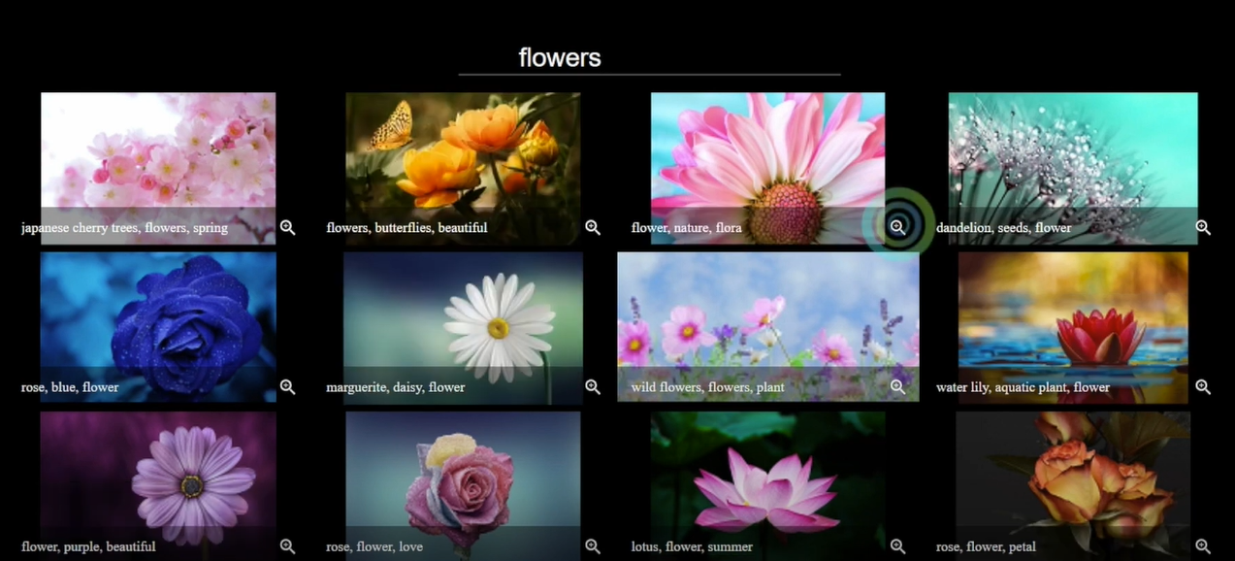

**Database Integration:**

Node.js serves as a powerful bridge between the front-end and back-end database. This integration enables seamless data retrieval and manipulation, facilitating functionalities like signin , signup.

**Responsive Design and Accessibility:**

This ensures that Art Gallery applications are accessible and functional across a wide range of devices, including desktops, tablets, and mobile phones.

**PROJECT OBJECTIVE**

* Create an accessible and engaging online space for art lovers and enthusiasts to explore and appreciate art from diverse cultures and time periods.
* The system offers secure login and registration functionalities for end-users, ensuring data privacy and access control.

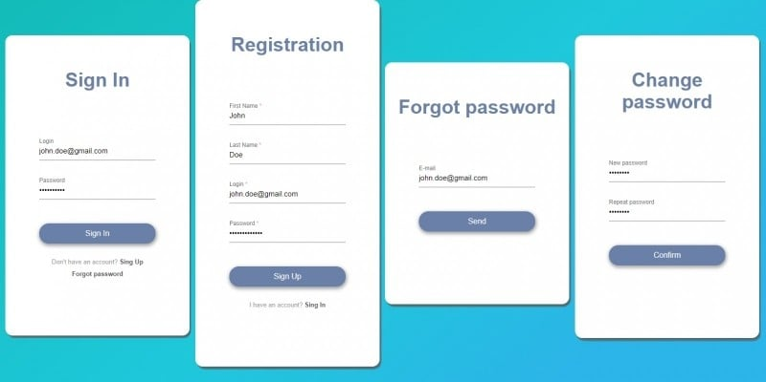

* Deliver a seamless and visually pleasing user experience across various devices.
* Enable users to leave comments and ratings on artworks, fostering engagement and discussion.

**Product Methodology**

* Develop a prototype Art Gallery using React and Node.js incorporating key features identified in the literature review and stakeholder feedback.
* Conduct usability testing sessions with representative users to evaluate the effectiveness and user-friendliness of the prototype. Gather feedback on interface design, navigation, and overall user experience.
* Perform functional testing to ensure that all components of the Art Gallery, including Image search, Sign in, Sign up.
* Evaluate the security measures of the Art Gallery prototype, including data encryption, authentication mechanisms, and protection against common security vulnerabilities.
* Assess the performance of the Art Gallery under varying load conditions to ensure it can handle the expected user traffic without degradation in response times.

**PRODUCT OUTCOME**

**Performance and Optimization:**

Optimized the performance of Art Gallery to ensure fast loading times, efficient rendering, and minimal data usage. This could involve techniques like lazy loading images and code splitting.

**Artwork Display:**

The main functionality of art gallery project would be to display artwork. Fetched data from an API (possibly containing information about different artworks, artists, descriptions, and images) and rendered this data on website. React components would have been used to display this information in an organized and aesthetically pleasing manner.

**Robust Authentication and Authorization**:

The Art Gallery incorporated strong authentication and authorization mechanisms, safeguarding user information and regulating access levels for both users

**PROPOSED TIME DURATION**

The time duration for implementing a ArtGallery based on React and Node.js technology stack can vary depending on various factors including the scope and complexity of the project, the specific features required, and the availability of resources. Here is a general breakdown of the time duration for different stages of the implementation:

**Planning and Requirement Analysis** (1 weeks):

* This phase involves defining the project scope, identifying requirements, and creating a detailed project plan.

**Design and Prototyping** (1 weeks):

* During this phase, the system's architecture, database structure, and user interface are designed. A prototype of the ArtGallery may be developed for initial testing and feedback.

**Development** (4-6 weeks):

* This is the phase where the actual coding and development of the ArtGallery takes place. React and Node.js and other technologies are used to build the system according to the defined requirements.

**Testing and Quality Assurance** (1-2 weeks):

* Rigorous testing is conducted to identify and fix bugs, ensure the system's functionality, security, and performance meet the specified criteria.

**REFERENCES**

Designing and implementation phase: -

1. Software engineering: a practitioner’s approach by roger s pressman.
2. System analysis and design by Elias m. Ewad.
3. DBMS: Bipin C Desai

Coding phase: **-**

1. React in Action by Mark Tielens Thomas
2. CodeHelp Youtube Channel

Referenced Sites:

* [www.w3school. com](http://www.w3school.microsoft.com)
* www. nodejs.org