|  |  |  |  |  |  |  |  |  |  |  |  |  |  |  |  |  |
| --- | --- | --- | --- | --- | --- | --- | --- | --- | --- | --- | --- | --- | --- | --- | --- | --- |
|  | X1 | X2 | X3 | X4 | X5 | X6 | X7 | X8 | X9 | X10 | | X11 | X12 | X13 | X14 | X15 |
| X1 | 0 | 3 | 1 | 4 | 3 | 0 | 0 | 0 | 0 | | 0 | 0 | 0 | 0 | 0 | 0 |
| X2 | 3 | 0 | 0 | 1 | 2 | 0 | 0 | 0 | 1 | | 0 | 0 | 0 | 0 | 0 | 0 |
| X3 | 1 | 0 | 0 | 0 | 0 | 2 | 2 | 2 | 0 | | 0 | 0 | 0 | 0 | 0 | 0 |
| X4 | 4 | 1 | 0 | 0 | 0 | 0 | 0 | 0 | 0 | | 0 | 0 | 2 | 0 | 0 | 1 |
| X5 | 3 | 2 | 0 | 0 | 0 | 0 | 0 | 0 | 2 | | 0 | 0 | 0 | 0 | 0 | 1 |
| X6 | 0 | 0 | 2 | 0 | 0 | 0 | 1 | 0 | 0 | | 2 | 0 | 0 | 0 | 1 | 0 |
| X7 | 0 | 0 | 2 | 0 | 0 | 1 | 0 | 1 | 1 | | 3 | 0 | 0 | 2 | 0 | 0 |
| X8 | 0 | 0 | 2 | 0 | 0 | 0 | 1 | 0 | 0 | | 4 | 0 | 0 | 0 | 0 | 0 |
| X9 | 0 | 1 | 0 | 0 | 2 | 0 | 1 | 0 | 0 | | 1 | 0 | 0 | 0 | 0 | 0 |
| X10 | 0 | 0 | 0 | 0 | 0 | 2 | 3 | 4 | 1 | | 0 | 0 | 0 | 0 | 0 | 0 |
| X11 | 0 | 0 | 0 | 0 | 0 | 0 | 0 | 0 | 0 | | 0 | 0 | 2 | 0 | 0 | 3 |
| X12 | 0 | 0 | 0 | 2 | 0 | 0 | 0 | 0 | 0 | | 0 | 2 | 0 | 0 | 1 | 3 |
| X13 | 0 | 0 | 0 | 0 | 0 | 0 | 2 | 0 | 0 | | 0 | 0 | 0 | 0 | 0 | 1 |
| X14 | 0 | 0 | 0 | 0 | 0 | 1 | 0 | 0 | 0 | | 0 | 0 | 1 | 0 | 0 | 3 |
| X15 | 0 | 0 | 0 | 1 | 1 | 0 | 0 | 0 | 0 | | 0 | 3 | 3 | 1 | 3 | 0 |

|  |  |
| --- | --- |
|  | P |
| X1 | 11 |
| X2 | 7 |
| X3 | 7 |
| X4 | 8 |
| X5 | 8 |
| X6 | 6 |
| X7 | 10 |
| X8 | 7 |
| X9 | 5 |
| X10 | 10 |
| X11 | 5 |
| X12 | 7 |
| X13 | 3 |
| X14 | 5 |
| X15 | 12 |

|  |  |  |  |  |  |  |  |  |  |  |  |  |  |  |  |  |
| --- | --- | --- | --- | --- | --- | --- | --- | --- | --- | --- | --- | --- | --- | --- | --- | --- |
| Номер подграфа | Выбранные вершины | 1 | 2 | 3 | 4 | 5 | 6 | 7 | 8 | 9 | 10 | 11 | 12 | 13 | 14 | 15 |
| 1 | 15  15, 11  15,11,12  15,11,12,14  15,11,12,14,4 | 0 | 0 | 0 | 1  3  3 | 1 | 0  1 | 0 | 0 | 0 | 0 | 3  -  -  - | 3  5  -  - | 1 | 3  4  - | -  -  -  - |
| 2 | 1 1,2 1,2,5 1,2,5,9 1,2,5,9,3 | - | 3 - | 1 | - | 3 5 - | 0 | 0 | 0 | 0 1 3 - | 0   1 | - | - | 0 | - | - |
| 3 | 6,7,8,10,13 | - | - | - | - | - |  |  |  | - |  | - | - |  | - | - |

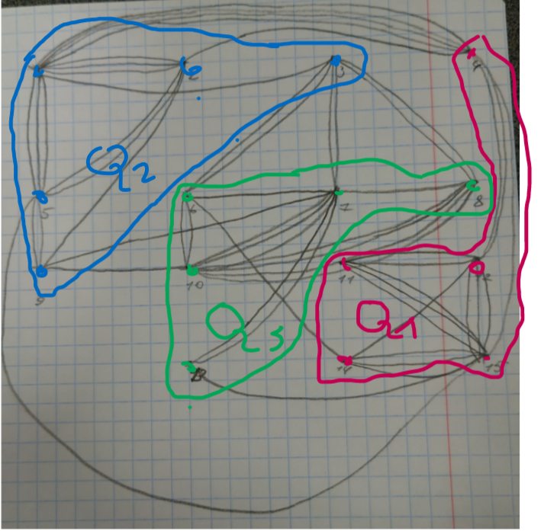

Qобщ = 16   
Q1 = 8  
Q2 = 14  
Q3 = 10

|  |  |  |  |  |  |  |  |  |  |  |  |  |  |  |  |  |
| --- | --- | --- | --- | --- | --- | --- | --- | --- | --- | --- | --- | --- | --- | --- | --- | --- |
| Номер подграфа | Выбранные вершины | 1 | 2 | 3 | 4 | 5 | 6 | 7 | 8 | 9 | 10 | 11 | 12 | 13 | 14 | 15 |
| 1 | 15 15,11 | -11 | -7 | -7 | -6 | -6 | -6 | -9 | -7 | -5 | -10 | 1 - | -2 | -1 | 1 | - |
| 2 |  |  |  |  |  |  |  |  |  |  |  |  |  |  |  |  |
| 3 |  |  |  |  |  |  |  |  |  |  |  |  |  |  |  |  |