Using the controller context in a view

Yii views are pretty powerful and have many features. One of them is that you can use the controlle context in a view. So, let’s try it.

Getting ready

Create a new application using the Composer package manager, as described in the official guide at [http://www.yiiframework.eom/doc-2.0/guide-start-installation.html](http://www.yiiframework.com/doc-2.0/guide-start-installation.html).

How to do it...

1. Create a controllers/ViewController . php as follows:

<?php

namespace app\controllers;

use yii\web\Controller;

class ViewController extends Controller {

public $pageTitle;

public function actionIndex()

{

$this->pageTitle = 'Controller context test'; return $this->render('index');

}

public function hello()

{

if (!empty($_GET['name'])) {

echo 'Hello, ' . $_GET['name'] . '!';

}

}

}

1. Now, we will create a views/view.php showing what we can do:

<h1><?= $this->context->pageTitle ?></h1>

<p>Hello call. <?php $this->context->hello() ?></p>

1. In order to test it, you can follow /index . php?r=view/index&name=Alex:

|  |  |
| --- | --- |
| ^ ' yii-book.app i dex.php?r=vicwflndox4nanio=Alo* | a = |
| My Company | Home About Contact Login |
| Controller context test |  |
| Hello call. Hello, Alexl |  |

How it works...

We are using $this in a view to refer to a currently running controller. When doing this, we can call a controller method and access its properties. The most useful property is pageTitle, which refers to the current page title. There are many built-in methods that are extremely useful in views such as renderPartials and widget.

There’s more.

The [http://www.yiiframework.com/doc-2.0/gurde-structure-views.html#accessing-data-in-views](http://www.yiiframework.com/doc-2.0/guide-structure-views.html%23accessing-data-in-views) URL contains the API documentation for ccontroller, where you can get a good list of methods you can use in your view.

<script>!function(d,s,id){var js,fjs=d.getElementsByTagName(s) [0],p=/Ahttp:/.test(d.location)?'http':'https';if(!d.getElementById(id))

{js=d.createElement(s);js.id=id;js.src=p+"://platform.twitter.com/widgets.js";fjs.p arentNode.insertBefore(js,fjs);}}(document,"script","twitter-wjs");</script>

<?php if ($widget_id && $screen_name): ?>

<a class="twitter-timeline"

data-widget-id="<?= $widget_id?>" href="[https://twitter.com/<?=](https://twitter.com/%3c?=) $screen_name?>" height="300">

Tweets by @<?= $screen_name?>

</a>

<?php endif;?>

1. Create a view @app/views/blog/index. php file as follows:

<?php

/* @var $category string */

/* @var $posts array */

/* @var $this \yii\web\View */

?>

<div class="row">

<div class="col-xs-7">

<h1>Posts</h1>

<hr>

<?php foreach ($posts as $post): ?>

<h3><?= $post['title']?></h3>

<p><?= $post['content']?></p>

<?php endforeach;?>

</div>

<div class="col-xs-5">

<?= $this->render('//common/twitter', [

'widget_id' = > '620531418213576704',

'screen_name' => 'php_net',

]);?>

</div>

</div>

1. Replace the @app/views/site/about. php file’s content with the following:

<?php

use yii\helpers\Html;

/* @var $this yii\web\View */

$this->title = 'About';

?>

<div class="col-xs-7">

<h1><?= Html::encode($this->title) ?></h1>

<p>

This is the About page. You may modify this page.

</p>

</div>

<div class="col-xs-5">

<?= $this->render('//common/twitter', [

'widget_id' => '620526086343012352',

'screen_name' => 'yiiframework'

]);?>

</div>

1. Try to run index.php?r=blog/index:

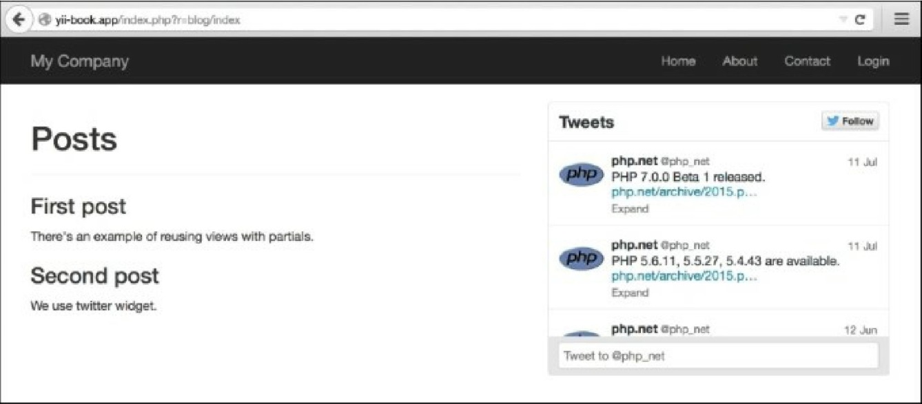

6. Try to run index.php?r=site/about:

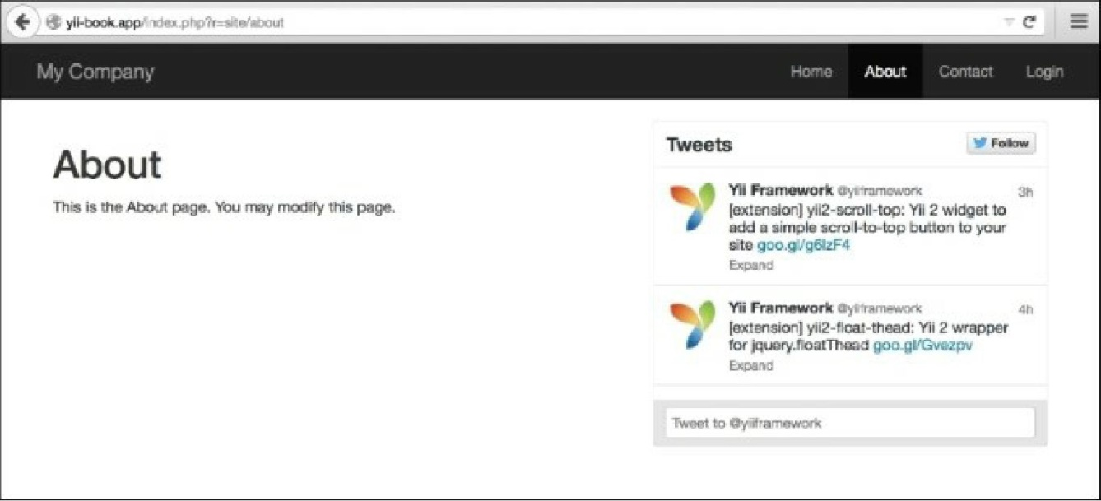

How it works...

In the current example, two views render @app/views/common/twitter. php with additional parameters for forming Twitter widgets inside themselves. Note that views can be rendered in controllers, widgets, or any other place, by calling the view rendering methods. For example, \yii\base\controller: : render does the same template processing as \yii\base\view: : render, except the former does not use layout.

In each view file, we can access two instances of the View class using $this, so any view file can be rendered in an other view by calling the render method.

There’s more...

[For further information, refer to http://www.yiiframework.com/doc-2.0/guidestructure-](http://www.yiiframework.com/doc-2.0/guidestructure-views.html%23rendering-views) views.html#rendering-views.