Tabular input

In this section, we will show you how to use a model to save and validate related models. Sometimes you  
will need to handle multiple models of the same kind in a single form.

For instance, we have contests and prizes for contests. Any contest might contain an unlimited number of  
prizes. So, we need the ability to create a contest with prizes, validate them, display all errors, and save the  
primary model (contest model) and all related models (prize models) to the database.

Getting ready

1. Create a new application by using the Composer package manager, as described in the official  
   guide at [http://www. yiiframework. c om/doc-2.0/guide -start-installation .html](http://www.yiiframework.com/doc-2.0/guide-start-installation.html)**.**
2. Create migrations for contest and prize tables with the following commands:

./yii migrate/create create_table_contest_and_prize_table

Update just created migration's methods up() and down() by following code

public function up()

{

$tableOptions = null;

if ($this->db->driverName === 'mysql') {

$tableOptions = 'CHARACTER SET utf8 COLLATE utf8_general_ci ENGINE=InnoDB';

}

$this->createTable('{{%contest}}', [

'id' => Schema::TYPE_PK,

'name' => Schema::TYPE_STRING . ' NOT NULL',

], $tableOptions);

$this->createTable('{{%prize}}', [

'id' => Schema::TYPE_PK,

'name' => Schema::TYPE_STRING,

'amount' => Schema::TYPE_INTEGER,

], $tableOptions);

$this->createTable('{{%contest_prize_assn}}', [

'contest_id' => Schema::TYPE_INTEGER,

'prize_id' => Schema::TYPE_INTEGER,

], $tableOptions);

$this-addForeignKey('fk_contest_prize_assn_contest_id',  
'{{%contest_prize_assn}}', 'contest_id', {{%contest}}', 'id');

$this->addForeignKey('fk_contest_prize_assn_prize_id',

'{{%contest_prize_assn}}', 'prize_id', '{{%prize}}', 'id');

}

public function down()

{

$this-dropForeignKey('fk_contest_prize_assn_contest_id',

'{{%contest_prize_assn}}');

$this->dropForeignKey('fk_contest_prize_assn_prize_id',

'{{%contest_prize_assn}}');

$this->dropTable('{{%contest_prize_assn}}');

$this->dropTable('{{%prize}}');

$this->dropTable('{{%contest}}');

}

1. Then, install migration with the following command:

./yii migrate/up

1. With Gii, generate contest, prize, and ContestPrizeAssn models.

How to do it...

1. Let’s create @app/controllers/ContestController. php with the following code:  
   <?php

namespace app\controllers;  
use app\models\Contest;  
use app\models\ContestPrizeAssn;  
use app\models\Prize;  
use Yii;

use yii\base\Model;

use yii\helpers\VarDumper;

use yii\web\Controller;

class ContestController extends Controller  
{

public function actionCreate()

{

$contestName = 'Happy New Year';

$firstPrize = new Prize();

$firstPrize->name = 'Iphone 6s';

$firstPrize->amount = 4;

$secondPrize = new Prize();

$secondPrize->name = 'Sony Playstation 4';

$secondPrize->amount = 2;

$contest = new Contest();

$contest->name = $contestName;

$prizes = [$firstPrize, $secondPrize];

if ($contest->validate() && Model::validateMultiple($prizes)) {  
$contest->save(false);  
foreach ($prizes as $prize) {

$prize->save(false);

$contestPrizeAssn = new ContestPrizeAssn();  
$contestPrizeAssn->prize_id = $prize->id;  
$contestPrizeAssn->contest_id = $contest>id;  
$contestPrizeAssn->save(false);

}

return $this->renderContent(

'All prizes have been successfully saved!'

);

} else {

return $this->renderContent(

VarDumper::dumpAsString($contest->getErrors())

);

}

}

public function actionUpdate()

{

$prizes = Prize::find()->all();

if (Model::loadMultiple($prizes, Yii::$app->request->post()) &&  
Model::validateMultiple($prizes)) {

foreach ($prizes as $prize) {

$prize->save(false);

}

return $this->renderContent(

'All prizes have been successfully saved!'

);

}

return $this->render('update', ['prizes' => $prizes]);

}

}

1. Create @app/views/contest/update.php and place the following code inside it:

<?php

use yii\helpers\Html;  
use yii\widgets\ActiveForm;

$form = ActiveForm::begin();  
foreach ($prizes as $i => $prize) {

echo $form->field($prize, "[$i]amount")->label($prize->name);

}

echo Html::submitButton('submit' , ['class' => 'btn btn-success']);

ActiveForm::end();

How it works...

The following information shows how to implement tabular input with Yii.

In the contest/update action, we will be able to display all prizes with their amounts and edit them all at  
once. We’ve used two special Yii methods:

* Model: : loadMultiple (): This method populates a set of models with data from the end user
* Model: : validateMultiple(): This methods takes a set of models and validates them all at once

Because we’ve validated our models before with validateMultiple(), we’re passing false as a  
parameter to save() to avoid running validation twice.

First, visit /index. php?r=contest/create page. After visiting, you will see the page that will validate and  
create ' Happy New Year' with two prizes, and will pass the prizes to the current contest model. You  
should note that we will only save the contest model and prizes to the database if they are valid:

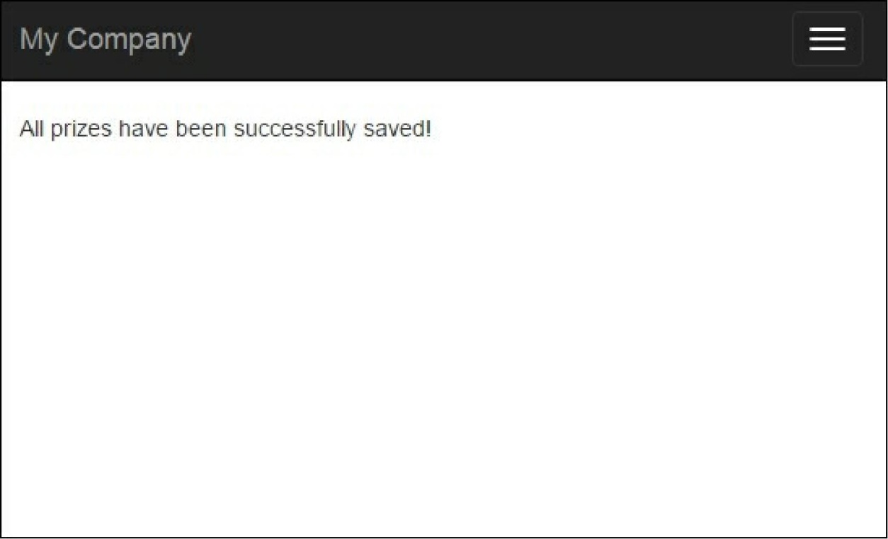

It is provided by following condition:

if ($contest->validate() && Model::validateMultiple($prizes)) { ...}  
Go to the /index. php?r=contest/update page and you will see this form:

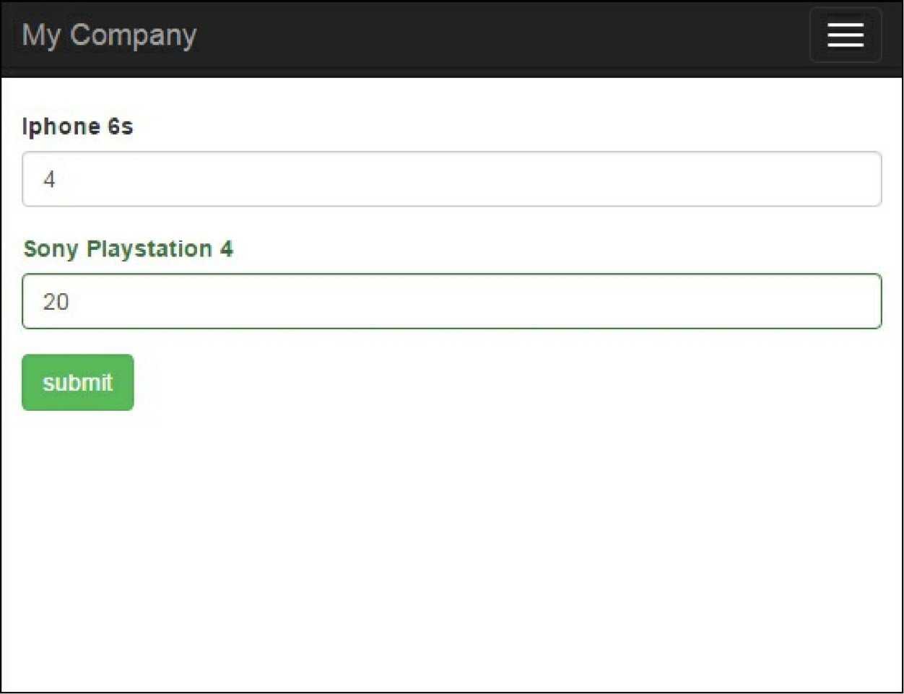

In the @app/views/contest/update. php for each prize, we render a name and an input with an amount.  
We must add an index to each input name so that Model: : loadMultiple() may identify which model to  
fill with which values.

In conclusion, this approach is used for collecting tabular input data when you process all your attributes  
from a view form and populate parent and related models from the form.

See also

For further information, refer to the following URL:

[http://www.yiiframework.com/doc-2.0/guide-input-tabular-input.html#co]lecting-tabular-input](http://www.yiiframework.com/doc-2.0/guide-input-tabular-input.html%23collecting-tabular-input)