Conditional validation

There are cases when it is necessary to enable or disable specific validation rules in the model. Yii2  
provides a mechanism to do that.

Getting ready

Create a new application by using the Composer package manager, as described in the official guide at  
[http://www.yiiframework.com/doc-2.0/gurde-startinstallation.html](http://www.yiiframework.com/doc-2.0/guide-startinstallation.html)**.**

How to do it...

1. Create a form file, @app/models/DeliveryForm.php, as follows:

<?php

namespace app\models;  
use app\components\WordsValidator;  
use yii\base\Model;  
class DeliveryForm extends Model  
{

const TYPE_PICKUP = 1;  
const TYPE_COURIER = 2;  
public $type;  
public $address;  
public function rules()

{

return [

['type', 'required'],

['type', 'in', 'range'=>[self::TYPE_PICKUP, self::TYPE_COURIER]],  
['address', 'required', 'when' => function ($model) {  
return $model->type == self::TYPE_COURIER;

}, 'whenClient' => "function (attribute, value) {

return $('#deliveryform-type').val() == '".self::TYPE_COURIER."';

}"]

];

}

public function typeList()

{

return [

self::TYPE_PICKUP => 'Pickup',

self::TYPE_COURIER => 'Courier delivery',

];

}

}

1. Create a controller file, @app/controllers/ValidationController . php, as follows:

<?php

namespace app\controllers;  
use Yii;

use yii\web\Controller;  
use app\models\DeliveryForm;

class ValidationController extends Controller  
{

public function actionIndex()

{

$model = new DeliveryForm();

if ($model->load(Yii::$app->request->post()) && $model->validate()) {

Yii::$app->session->setFlash('success',

'The form was successfully processed!'

);

}

return $this->render('index', array(

'model' => $model,

));

}

}

1. Create a view file, @app/views/validation/index. php, as follows:

<?php

use yii\bootstrap\ActiveForm;  
use yii\helpers\Html;

?>

<h1>Delivery form</h1>

<?php if (Yii::$app->session->hasFlash('success')): ?>

<div class="alert alert-success"><?= Yii::$app->session->getFlash('success'); ?  
></div>

<?php endif; ?>

<?php $form = ActiveForm::begin(); ?>

<?= $form->field($model, 'type')->dropDownList($model->typeList(), [

'prompt'=>'Select delivery type']

) ?>

<?= $form->field($model, 'address') ?>

<div class="form-group">

<?= Html::submitButton('Submit', ['class' => 'btn btn-primary']) ?>

</div>

<?php ActiveForm::end(); ?>

1. Run the validation controller by opening the index. php?r=validation URL, and choose the  
   courier delivery value for type input; then you’ll get the following:

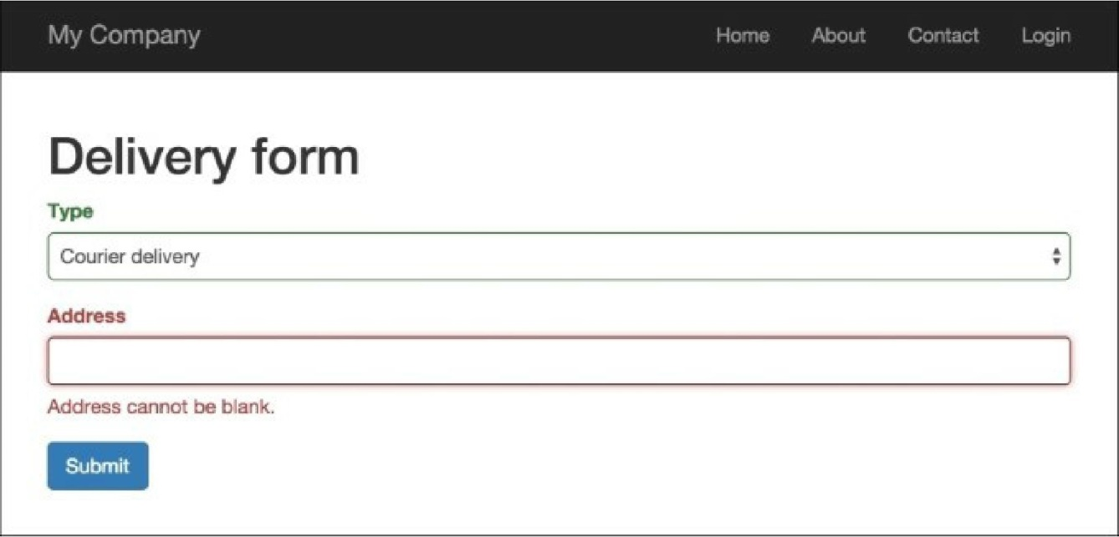

How it works...

The DeliveryForm address attribute is required when the type attribute is set to  
DeliveryForm: :type_courier; otherwise, we choose the Courier delivery option in type select.

Also, to support client-side conditional validation, we configure the whenClient property, which takes a  
string representing a JavaScript function whose return value determines whether to apply the rule or not.

See also

[For further information, refer to http://www.yiiframework.com/doc-2.0/guideinput-](http://www.yiiframework.com/doc-2.0/guideinput-validation.html%23conditional-validation)**validation.html#conditional-validation**