AJAX validation

Some validations can only be done on the server-side, because only the server has the necessary  
information. For example, to validate that a company name or user e-mail is unique, we have to check the  
corresponding tables on the server side. In this case, you should use built-in AJAX validation. Yii2 supports  
AJAX form validation, which essentially sends the form values to the server, validates them, and sends  
back the validation errors, all without leaving the page. It does this every time you tab out of a (changed)  
field.

Getting ready

Create a new application by using the Composer package manager, as described in the official guide at  
[http://www.y]i'framework.com/doc-2.0/guide-startinstallation.html](http://www.yiiframework.com/doc-2.0/guide-startinstallation.html)**.**

How to do it...

1. In the basic app template, we have a simple contact form. You can see this page at http: //yii-  
   book. app/index. php?r=site/contact. Open and modify the related view form,  
   @app/views/site/contact. php. To enable AJAX validation for the whole form, set up the  
   enableAjaxValidation option as true in the form config:

$form = ActiveForm::begin([

'id' => 'contact-form',

'enableAjaxValidation' => true,

]);

1. Also, you should add handling for the AJAX validation on the server-side. This code snippet just  
   checks whether the current request is AJAX and if it’s a post request. If it is, we will receive  
   errors in JSON format:

if (Yii::$app->request->isAjax && $model->load(Yii::$app->request->post())) {  
Yii::$app->response->format = Response::FORMAT_JSON;  
return ActiveForm::validate($model);

}

1. Let’s modify our actionContact() in the siteController with the following code:

public function actionContact()

{

$model = new ContactForm();

if (Yii::$app->request->isAjax && $model->load(Yii::$app->request->post())) {  
Yii::$app->response->format = Response::FORMAT_JSON;  
return ActiveForm::validate($model);

}

if ($model->load(Yii::$app->request->post()) && $model->contact(Yii::$app-  
>params['adminEmail'])) {

Yii::$app->session->setFlash('contactFormSubmitted');  
return $this->refresh();

} else {

return $this->render('contact', [

'model' => $model,

]);

}

}

How it works...

The previous code will check whether the current request is AJAX. If it is, it will respond to this request  
by running the validation and returning the errors in JSON format.

You can check the response from the server in the debug panel in the browser. Try to submit an empty  
form and you will see the response.

For example, in the Google Chrome browser, press **F12** and select the **Network** tab in the development  
toolbar. You will see the JSON array with errors and messages:

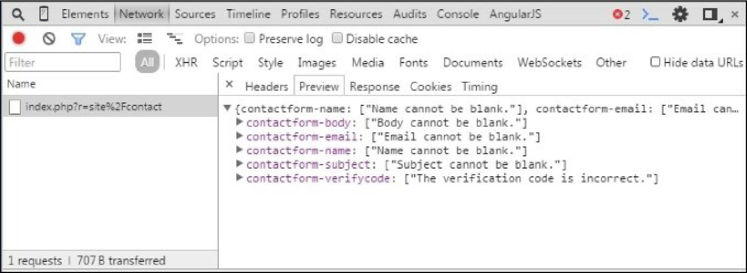

See also

[http://www.yiiframework.com/doc-2.0/guide-input-validation.html#ajaxvalidation](http://www.yiiframework.com/doc-2.0/guide-input-validation.html%23ajaxvalidation)