Using RBAC

Role-Based Access Control (RBAC) provides simple yet powerful centralized access control. It is the  
most powerful access control method available in Yii. It is described in the guide, but since it is rather  
complex and powerful, it is not as easy to understand without getting under the hood a little.

In this recipe, we will take the roles hierarchy from the definitive guide, import it, and explain what is  
happening internally.

Getting ready

1. Create a new application by using the Composer package manager, as described in the official  
   guide at [http://www. yiiframework. c om/doc-2.0/guide -start-installation .html](http://www.yiiframework.com/doc-2.0/guide-start-installation.html).
2. Create a MySQL database and configure it.
3. Configure the authManager component in your config/main . php and config/console . php as  
   follows:

return [

// ...

'components' => [

'authManager' => [

'class' => 'yii\rbac\DbManager',

],

// ...

],

];

1. Run the migration:

yii migrate --migrationPath=@yii/rbac/migrations

How to do it...

Carry out the following steps:

1. Create the access rule rbac/AuthorRule. php:

<?php

namespace app\rbac;  
use yii\rbac\Rule;

/**

* Class AuthorRule.
* @package app\rbac  
  */

class AuthorRule extends Rule  
{

public $name = 'isAuthor';

/**

* @param int|string $user
* @param \yii\rbac\Item $item
* @param array $params

*

* @return bool  
*/

public function execute($user, $item, $params)

{

return isset($params['post']) ? $params['post']->createdBy == $user : false;

}

}

2. Create a console command, command/RbacController. php, to init the RBAC rules command:

<?php

namespace app\commands;

use app\models\User;  
use Yii;

use yii\console\Controller;

/**

* Class RbacController.
* @package app\commands  
  */

class RbacController extends Controller  
{

public function actionInit()

{

$auth = Yii::$app->authManager;

$createPost = $auth->createPermission('createPost');

$createPost->description = 'Create a post';

$updatePost = $auth->createPermission('updatePost');

$updatePost->description = 'Update a post';

$updatePost = $auth->createPermission('updatePost');

$updatePost->description = 'Update a post';

$deletePost = $auth->createPermission('deletePost');

$deletePost->description = 'Delete a post';

$readPost = $auth->createPermission('readPost');

$readPost->description = 'Read a post';

$authorRule = new \app\rbac\AuthorRule();

// add permissions  
$auth->add($createPost);

$auth->add($updatePost);

$auth->add($deletePost);

$auth->add($readPost);

$auth->add($authorRule);

// add the "updateOwnPost" permission and associate the rule with it.  
$updateOwnPost = $auth->createPermission('updateOwnPost');  
$updateOwnPost->description = 'Update own post';

$updateOwnPost->ruleName = $authorRule->name;

$auth->add($updateOwnPost);

$auth->addChild($updateOwnPost, $updatePost);

// create Author role

$author = $auth->createRole('author');

$auth->add($author);

$auth->addChild($author, $createPost);  
$auth->addChild($author, $updateOwnPost);

$auth->addChild($author, $readPost);

// create Admin role

$admin = $auth->createRole('admin');

$auth->add($admin);

$auth->addChild($admin, $updatePost);  
$auth->addChild($admin, $deletePost);  
$auth->addChild($admin, $author);

// assign roles

$auth->assign($admin, User::findByUsername('admin')->id);  
$auth->assign($author, User: : findByUsername('demo')->id);

echo "Done!\n";

}

}

1. That’s it. Run it in the console:

yii rbac/init

1. Create controllers/RbacController.php as follows:

<?php

namespace app\controllers;

use app\models\User;  
use stdClass;  
use Yii;

use yii\filters\AccessControl;  
use yii\helpers\Html;  
use yii\web\Controller;

/**

* Class RbacController.

*/

class RbacController extends Controller  
{

public function behaviors()

{

return [

'access' => [

'class' => AccessControl::className(),

'rules' => [

[

'allow' => true,

'actions' => ['delete'],

'roles' => ['deletePost'],

],

[

'allow' => true,

'actions' => ['test'],

],

],

],

];

}

public function actionDelete()

{

return $this->renderContent(

Html::tag('h1', 'Post deleted.')

);

}

/ **

* @param $description
* @param $rule
* @param array $params

*

* @return string  
*/

protected function renderAccess($description, $rule, $params = [])

{

$access = Yii::$app->user->can($rule, $params);  
return $description.': '.($access ? 'yes' : 'no');

}

public function actionTest()

{

$post = new stdClass();

$post->createdBy = User::findByUsername('demo')->id;

return $this->renderContent(

Html::tag('h1', 'Current permissions').

Html: :ul([

$this->renderAccess('Use can create post', 'createPost'),  
$this->renderAccess('Use can read post', 'readPost'),  
$this->renderAccess('Use can update post', 'updatePost'),  
$this->renderAccess('Use can own update post', 'updateOwnPost', [  
'post' => $post,

]),

$this->renderAccess('Use can delete post', 'deletePost'),

])

);

}

}

5. Now run rbac/test once to check access to all the created permissions of the RBAC hierarchy:

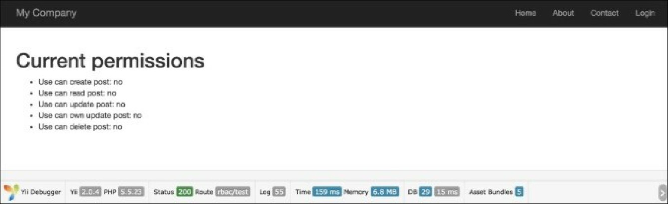

6. Then, try to log in as demo (the password is demo) and run rbac/test again:

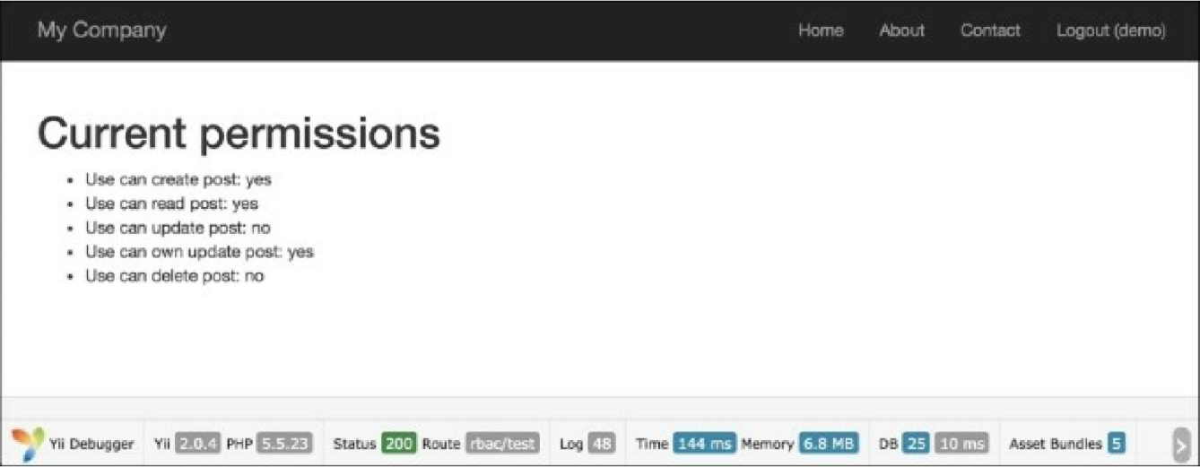

7. Then, try to log in as admin (the password is admin) and run rbac/test again:

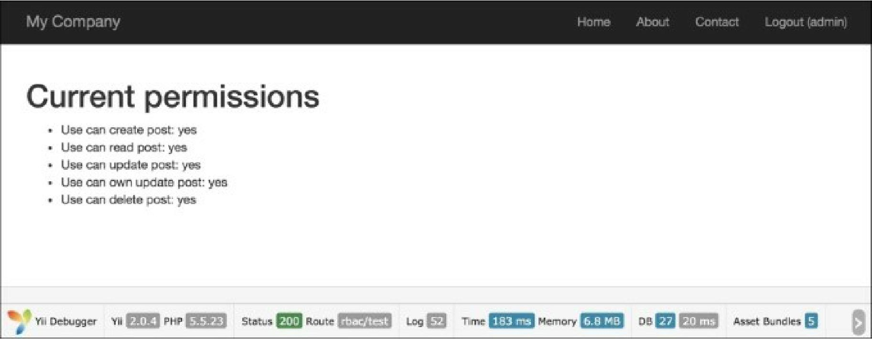

8. Log in as demo user and run rbac/delete:

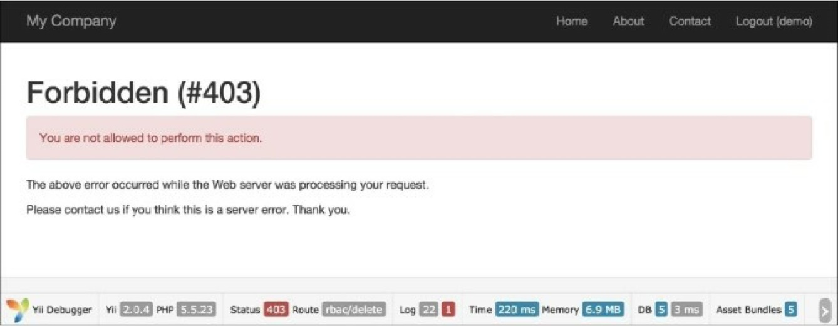

9.

Log in as admin and run rbac/delete:

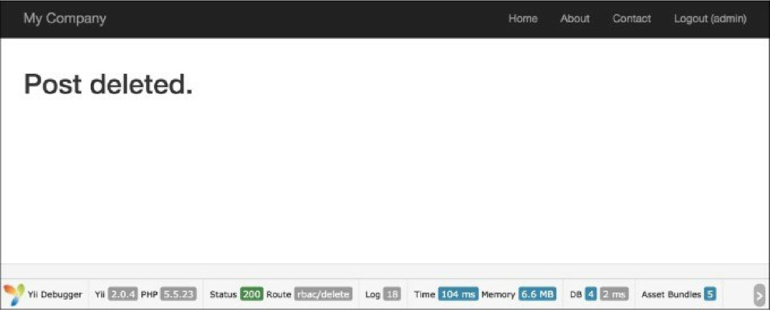

How it works...

Yii implements a general hierarchical RBAC following the nist rbac model. It provides RBAC  
functionality through the authManagerapplication component.

The RBAC hierarchy is a directed acyclic graph, that is, a set of nodes and their directed connections or  
edges. There are three types of node available: roles, permissions, and rules.

A role represents a collection of permissions (for example creating posts and updating posts). A role may  
be assigned to one or multiple users. To check if a user has a specified permission, we may check whether

the user is assigned with a role that contains that permission.

Both roles and permissions can be organized in a hierarchy. In particular, a role may consist of other roles  
or permissions, and a permission may consist of other permissions. Yii implements a partial-order  
hierarchy, which includes the more special tree hierarchy. While a role can contain a permission, it is not  
true vice versa.

For testing permissions, we have created two actions. The first action, test, contains checkers for created  
permissions and roles. The second action is delete, which is limited through the access filter. The rule for  
the access filter contains the following code:

[

'allow' => true,

'actions' => ['delete'],

'roles' => ['deletePost'],

],

This means that we are allowing all users who have the deletePost permission to run the deletePost  
action. Yii starts checking with the deletePost permission. Besides the fact that the access rule element  
is named as roles, you can specify an RBAC hierarchy node be it a role, rule, or permission. Checking  
for updatePost is complex:

Yii::$app->user->can('updatePost', ['post' => $post]);

We use a second parameter to pass a post (in our case, we have simulated it with stdclass). If a user is  
logged in as demo, then to get access we need to go from updatePost to author. If you’re lucky, you only  
have to go through updatePost, updateOwnPost, and author.

As updateOwnPost has a rule defined, it will be run with a parameter passed to checkAccess. If the result  
is true, then access will be granted. As Yii does not know what the shortest way is, it tries to check all  
possibilities until it is successful, or no alternatives are left.

There’s more...

There are some useful tricks that will help you to use RBAC efficiently, which are discussed in the  
following subsections.

Keeping hierarchy simple and efficient

Follow these recommendations where possible to maximize the performance and reduce hierarchy  
complexity:

* Avoid attaching multiple roles to a single user
* Don’t connect nodes of the same type; so, for example, avoid connecting one task to another

Naming RBAC nodes

A complex hierarchy becomes difficult to understand without using some kind of naming convention. One  
possible convention that helps to limit confusion is as follows:

[group_][own_]entity_action

Where own is used when the rule determines an ability to modify an element only if the current user is the  
owner of the element and the group is just a namespace. The entity is the name of the entity we are  
working with and action is the action that we are performing.

For example, if we need to create a rule that determines whether the user can delete a blog post, we will  
name it blog_post_delete. If the rule determines whether a user can edit his or her own blog comment,  
the name will be blog_own_comment_edit.

See also

In order to learn more about SQL injections and working with databases through Yii, refer to the following:

* <http://csrc.nist.gov/rbac/sandhu-ferraiolo-kuhn-00.pdf>
* [http://en.wikipedia.org/wiki/Role-based access control](http://en.wikipedia.org/wiki/Role-based_access_control)
* [http://en.wikipedia.org/wiki/Directed acyclic graph](http://en.wikipedia.org/wiki/Directed_acyclic_graph)
* [http://www.yiiframework.com/doc-2.0/guide-security-authorization.html#role-based-access-control-](http://www.yiiframework.com/doc-2.0/guide-security-authorization.html%23role-based-access-control-rbac)  
  rbac
* The Using controller filters recipe