Gii code generator

This extension provides a web-based code generator called Gii for Yii 2 applications. You can use Gii to  
quickly generate models, forms, modules, CRUD, and many more.

Подготовка

1. Создайте новое приложение с помощью диспетчера пакетов Composer, как описано в официальном руководстве по адресу  
   <http://www.yiiframework.com/doc-2.0/guide-start-installation.html>.   
   По русски <http://yiiframework.domain-na.me/doc/guide/2.0/ru/start-installation>.
2. Create a new migration with the shell command:

php yii migrate/create create_customer_table

1. Put the following code into the up() and down () methods:

use yii\db\Schema;  
use yii\db\Migration;

class m160201_154207_create_customer_table extends Migration  
{

public function up()

{

$tableOptions = null;

if ($this->db->driverName === 'mysql') {

$tableOptions =

'CHARACTER SET utf8 COLLATE utf8_unicode_ci ENGINE=InnoDB';

}

$this->createTable('{{%customer}}', [

'id' => Schema::TYPE_PK,

'name' => Schema::TYPE_STRING . ' NOT NULL',

'email' => Schema::TYPE_STRING . ' NOT NULL',

'address' => Schema::TYPE_STRING,

], $tableOptions);

}

public function down()

{

$this->dropTable('{{%customer}}');

}

}

1. Apply the migration:

php yii migrate/up

How to do it...

In your projects, you can use this extension in two ways:

* Working with GUI
* Working with CLI

Working with GUI

1. Check that your web configuration file contains the following code:

if (YII_ENV_DEV) {

$config['bootstrap'][] = 'gii';

$config['modules']['gii'] = [

'class' => 'yii\gii\Module',

];

}

1. Your web/index. php file will define the development environment:

defined('YII_ENV') or define('YII_ENV', 'dev');

The previous configuration states that when in a development environment, the application should  
include a module named gii, which is of the class yii\gii\Module.

By default, the module allows access from the IP address, 127.0.0.1. If you work from another  
location, add your address in the allowedIPs property:

$config['modules']['gii'] = [

'class' => 'yii\gii\Module',

allowedIPs = ['127.0.0.1', '::1', '192.168.0.*'],

];

1. Go to the gii route of your application: <http://localhost/index>. php?r=gii.

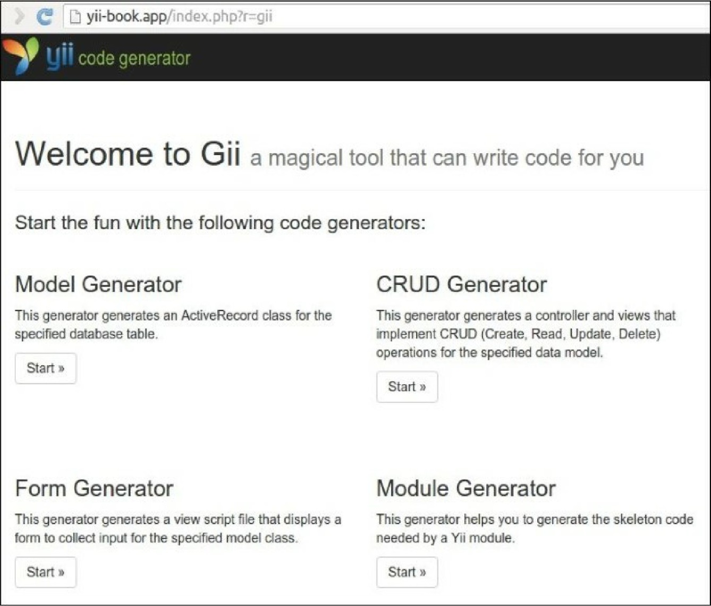

4. Click on the Model Generator button and type your table name and model name in the form:

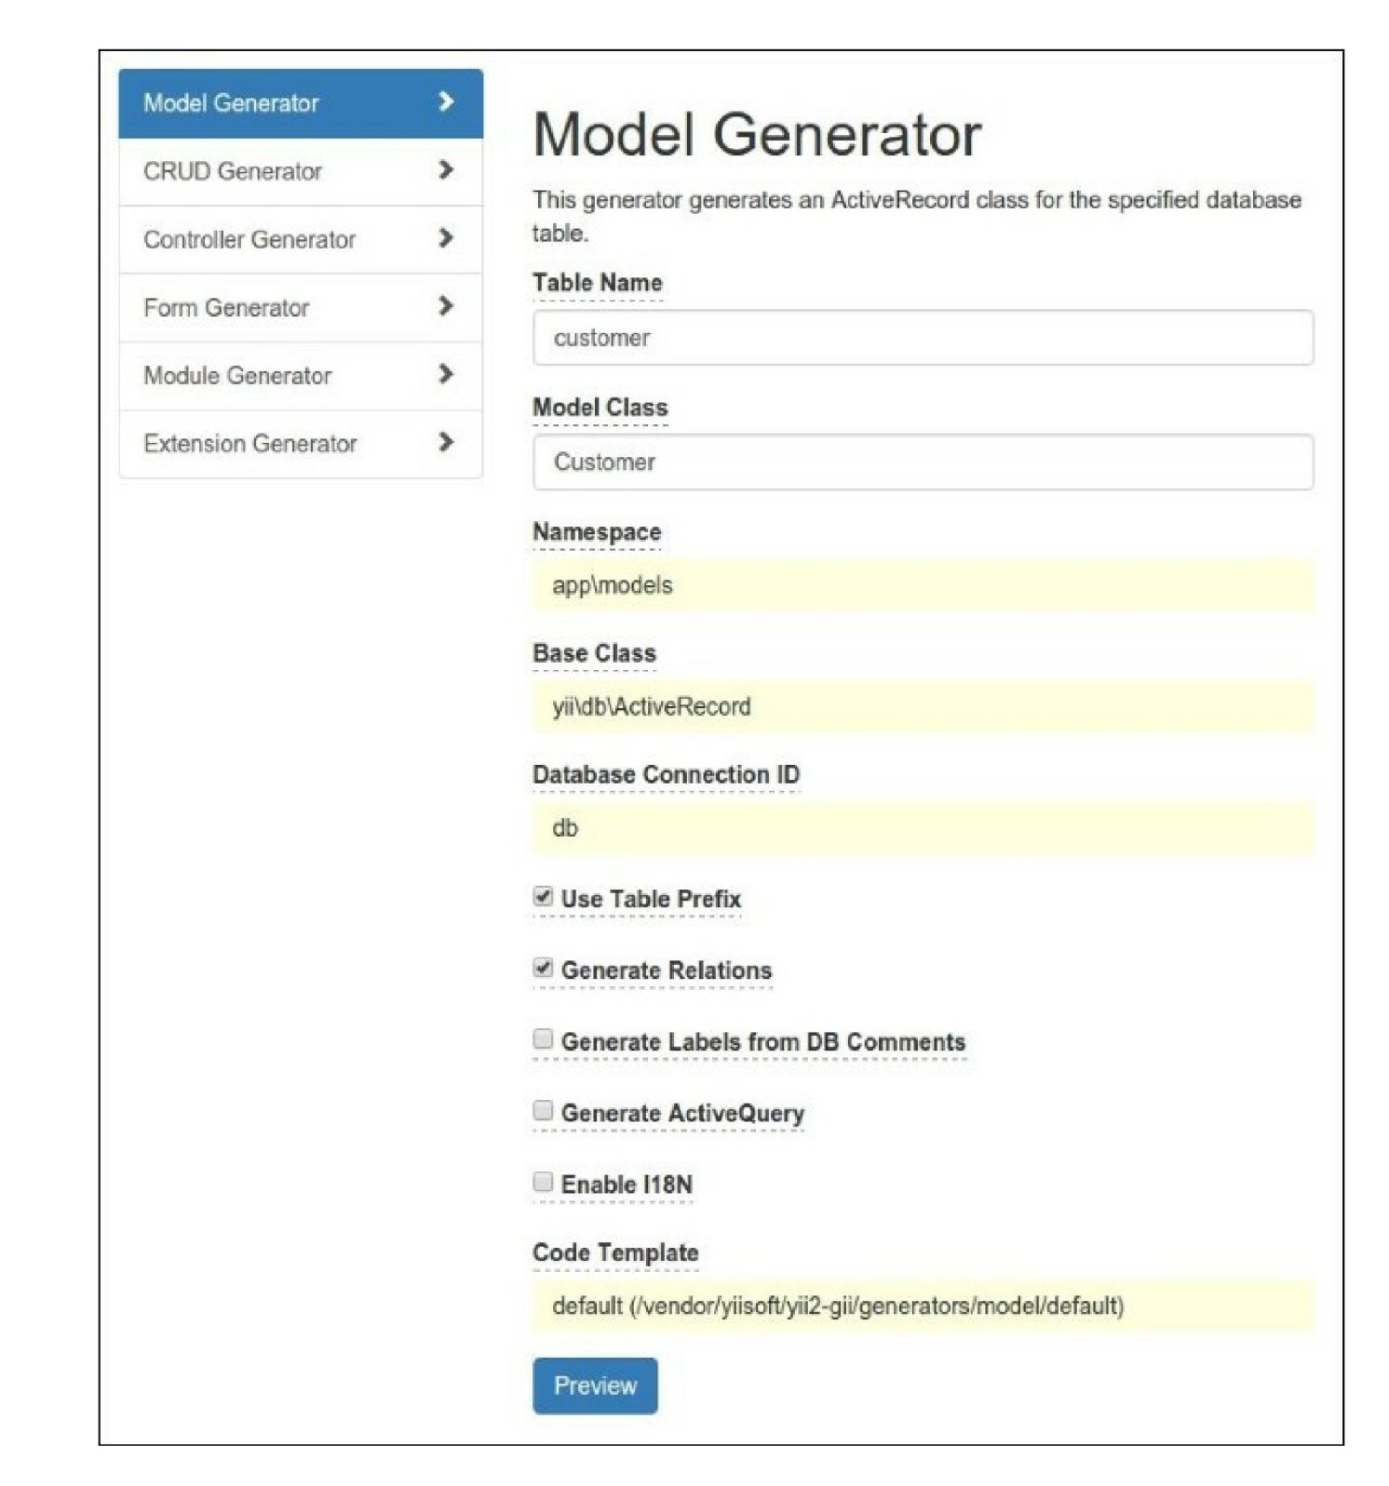5. Click the Preview button. You must view the featured files list:

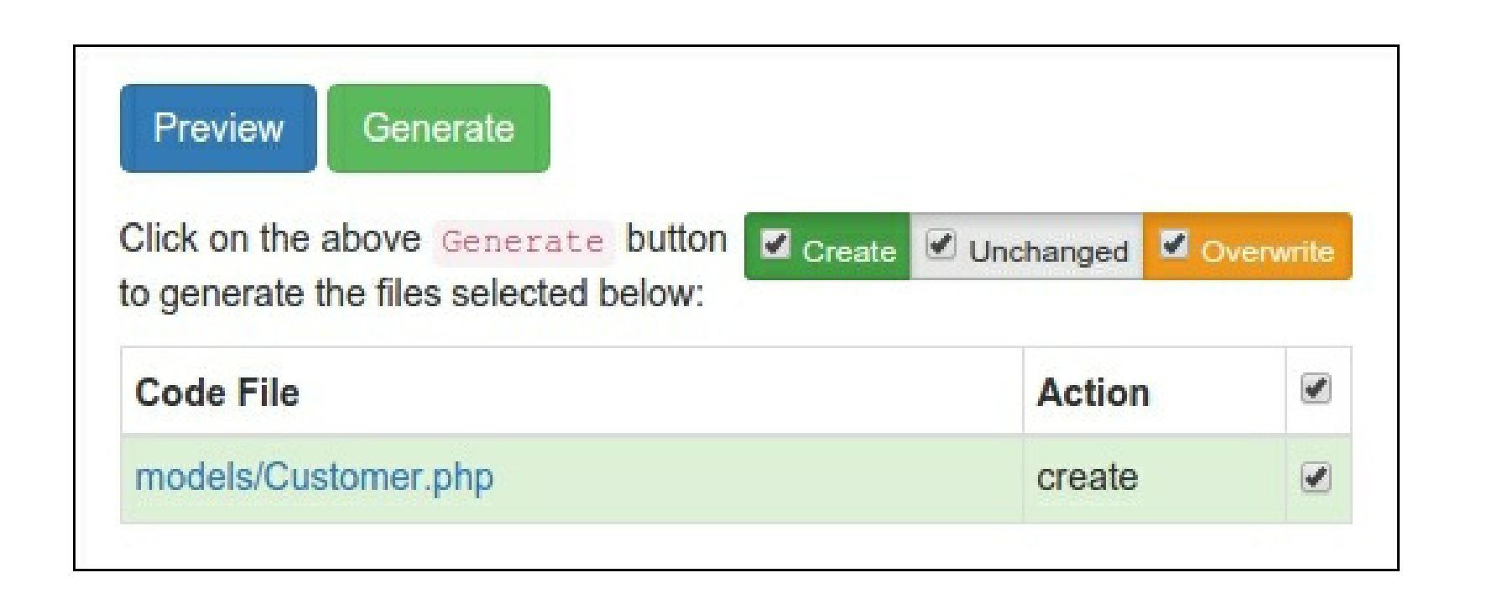

6. If you want to regenerate existing files, Gii will mark those in yellow:

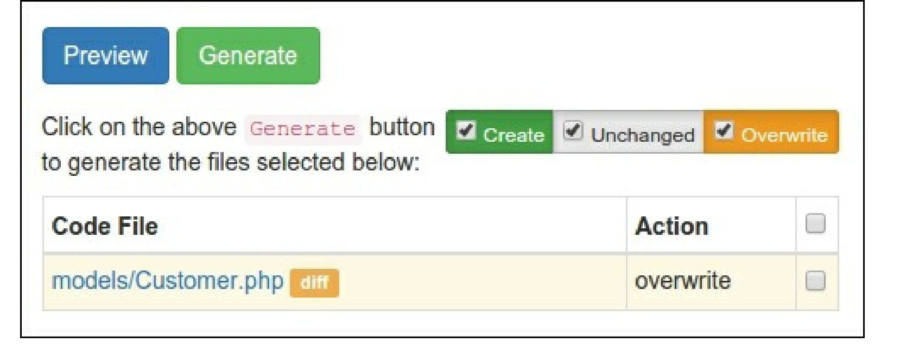

1. In this case, you can view the difference between existing and new files and overwrite the target if  
   needed.
2. After all that, click the Generate button:

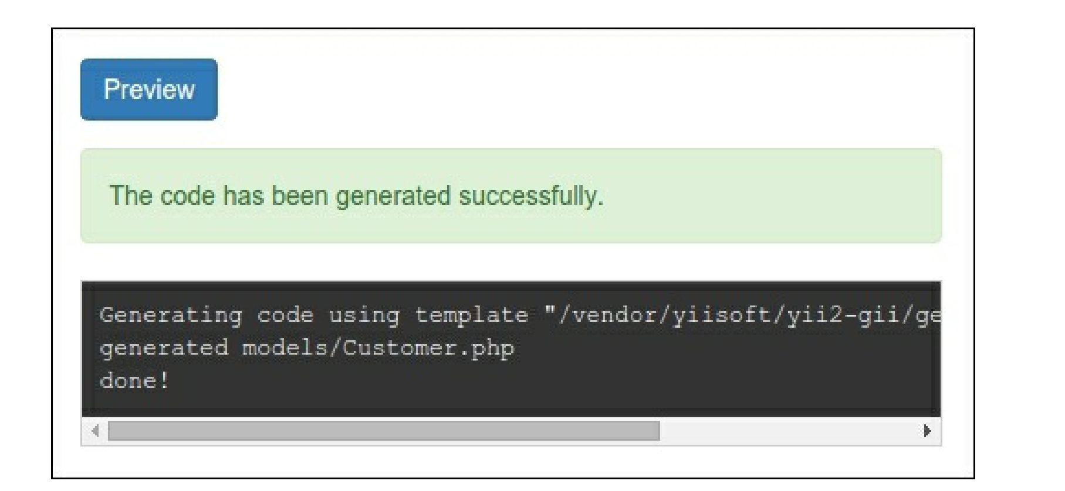

9. Check that the new class, \app\models\customer, exists.

10. CRUD is an abbreviation for the four common tasks using data on most websites: Create, Read,  
Update, and Delete. To create CRUD using Gii, select the CRUD Generator section. Specify  
your model class and type the other fields:

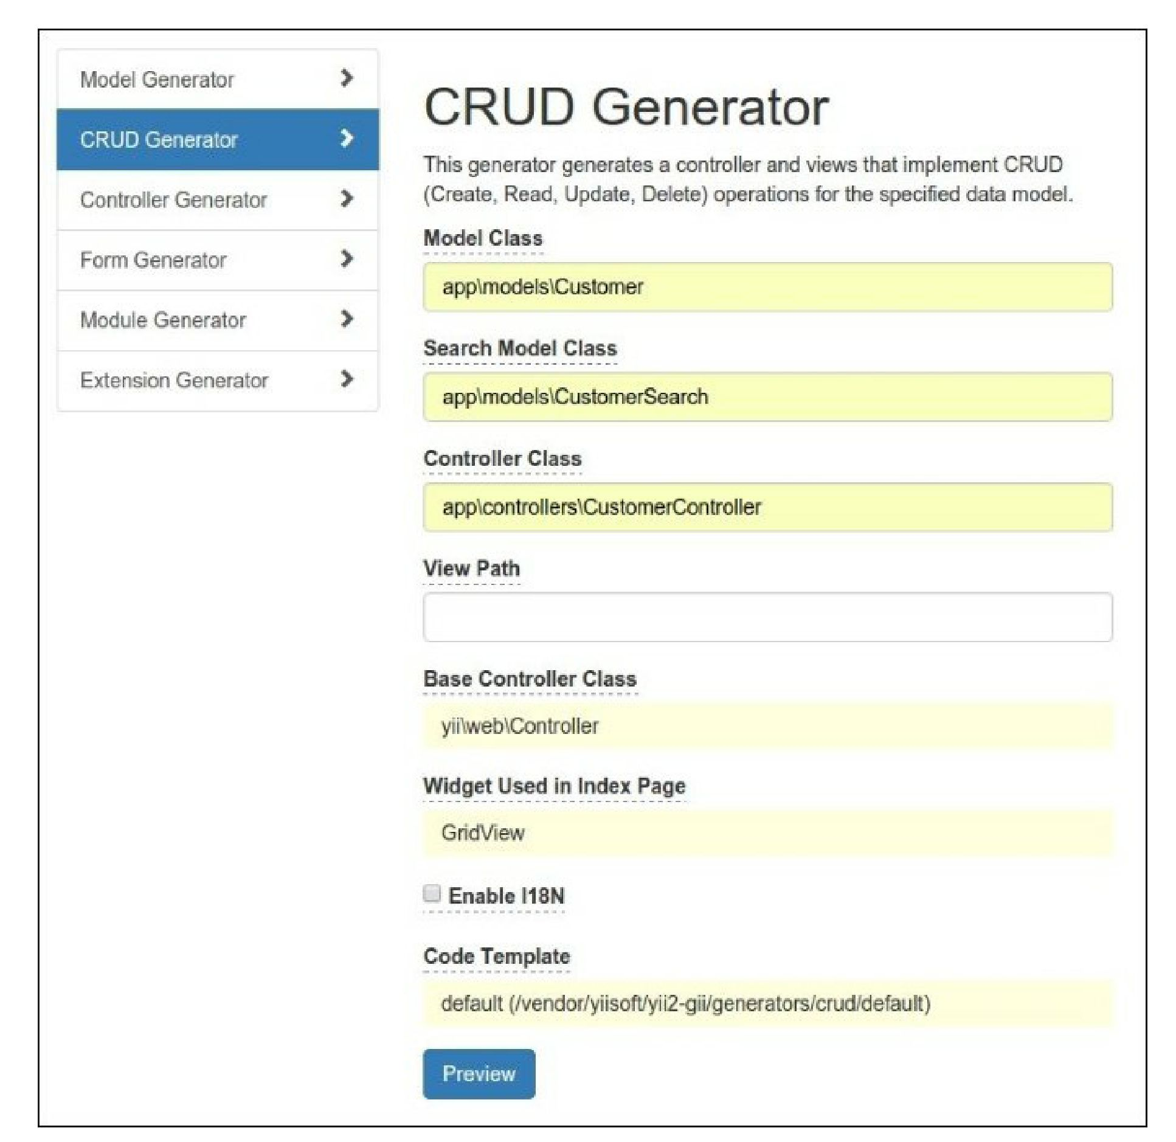

11. Generate the new items:

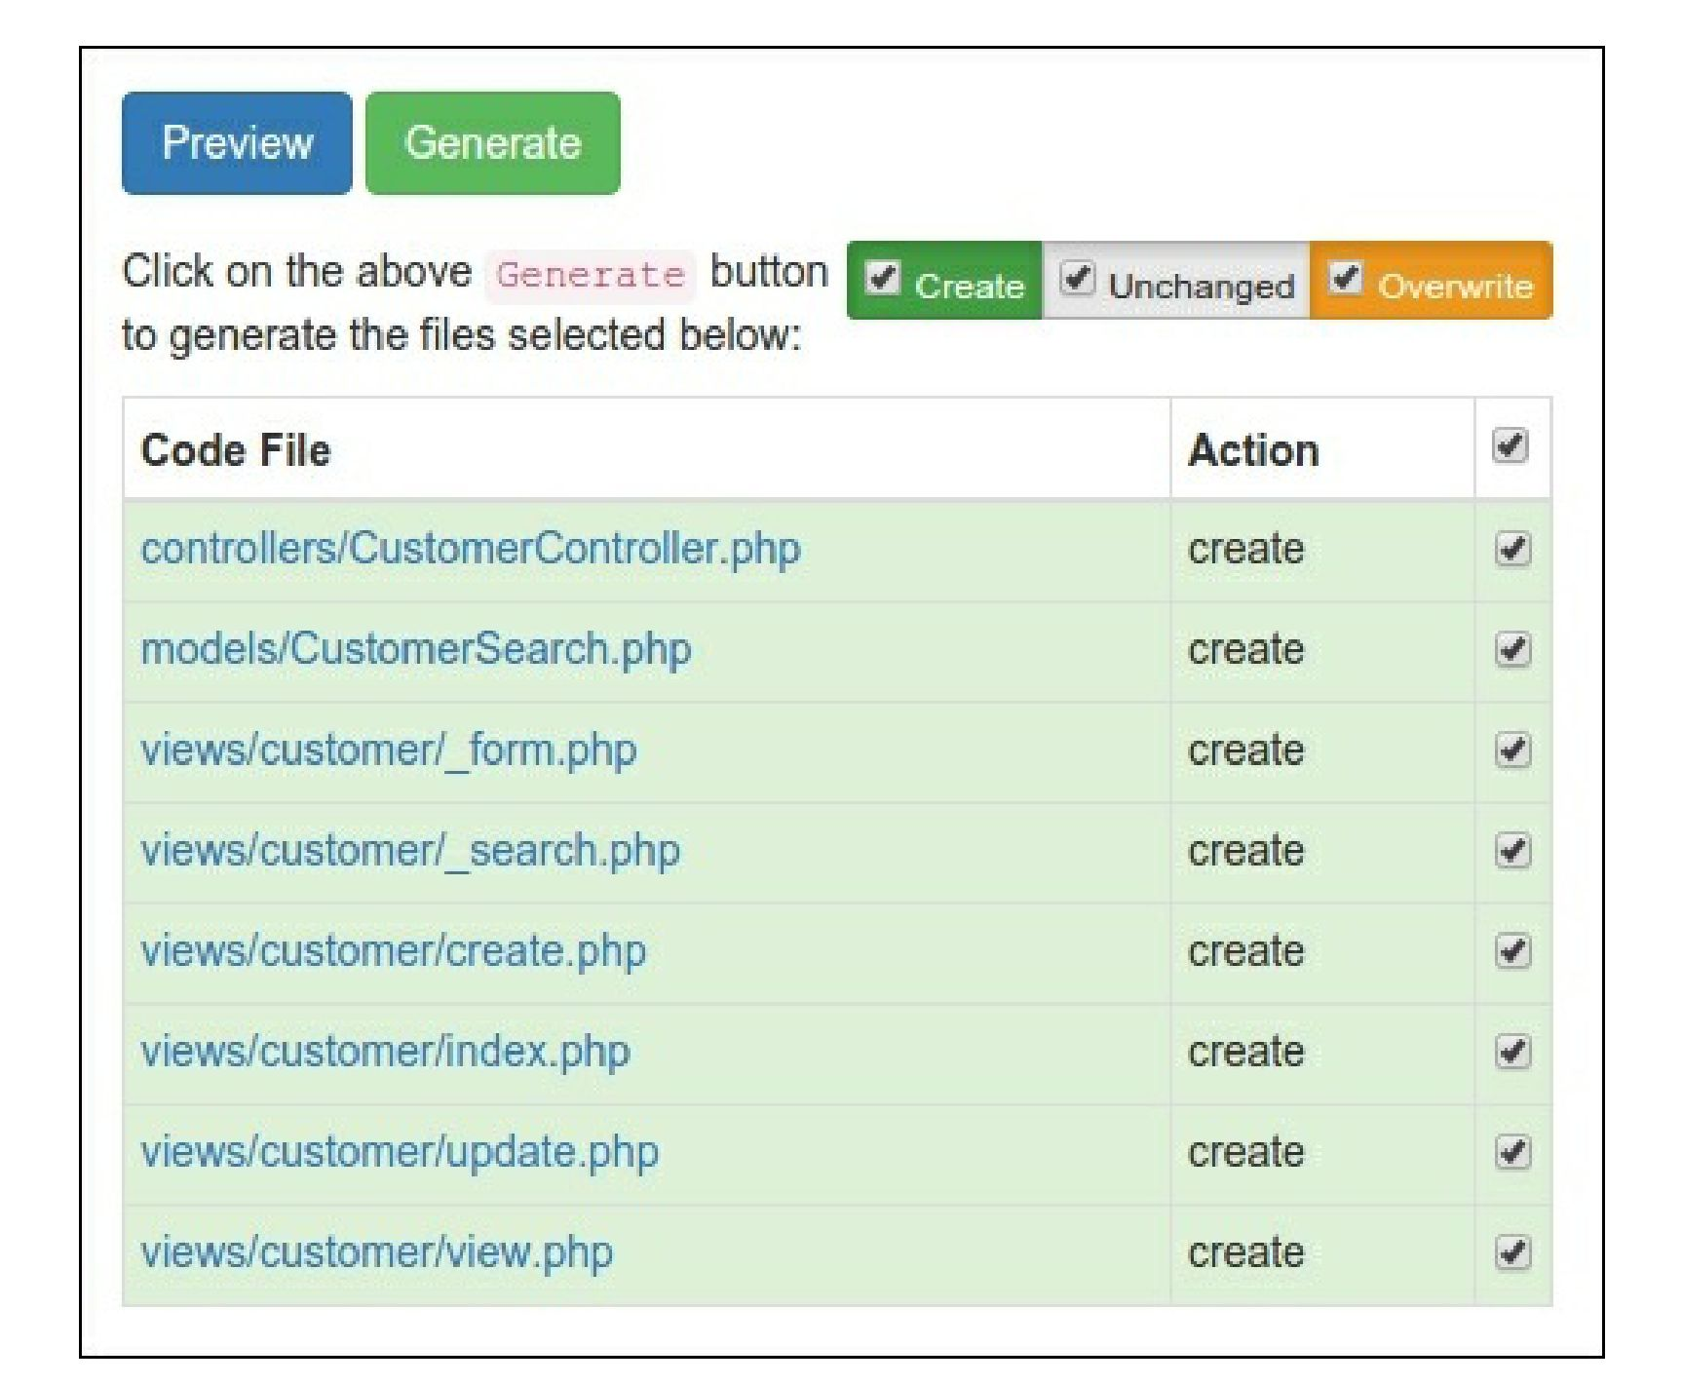12. After that, try to open the new controller:

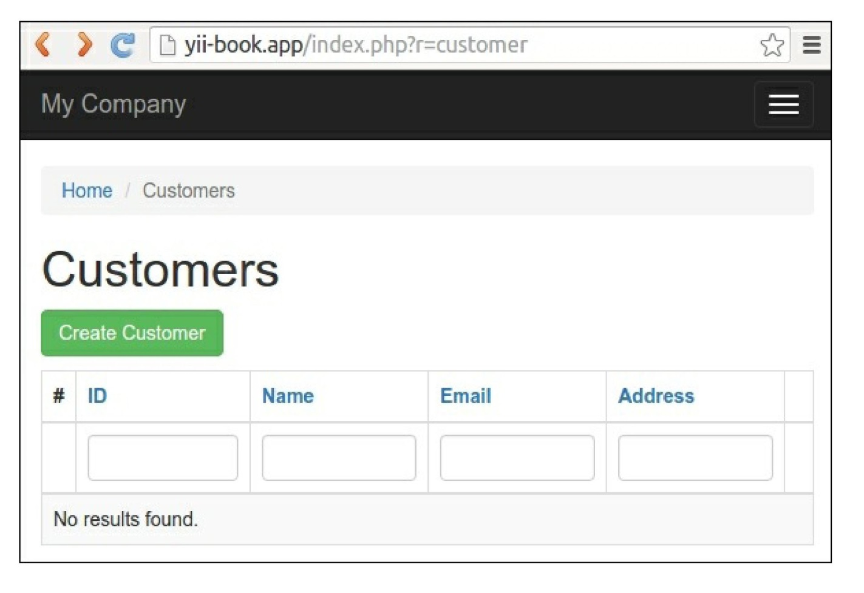

You will see a data grid showing the customers in the database table. Try to create a new item. You may  
sort the grid or filter it by entering filter conditions in the column headers.

Working with CLI

Gii also provides a console controller for code generation.

1. Check that your console configuration contains the Gii module settings:

return [

// ...

'modules' => [

'gii' => 'yii\gii\Module',

],

// ...

];

1. Run any shell command for help:

php yii help gii  
php yii help gii/model

1. Type the following command to start the model generation process:

php yii gii/model --tableName=customer --modelClass=Customer --useTablePrefix=1

1. Check that the new class, \app\models\customer, exists.
2. Generate CRUD for your model:

php yii gii/crud --modelClass=app\\models\\Customer \

- -searchModelClass=app\\models\\CustomerSearch \

--controllerClass=app\\controllers\\CustomerController

How it works...

Gii allows you to generate some standard code elements instead of manually typing. It provides web-based  
and console interfaces to work with every generator.

See also

* For more information about the extension’s usage, see:

o [http://www.yiiframework.com/doc-2.0/gurde-start-gii.html](http://www.yiiframework.com/doc-2.0/guide-start-gii.html)  
° [http://www.viiframework.com/doc-2.0/ext-gii-indpx.hrml](http://www.yiiframework.com/doc-2.0/ext-gii-index.html)  
o [httpsy/giYhub.comyiisoft/yEZ-gii/tree/master/docs/guide](https://github.com/yiisoft/yii2-gii/tree/master/docs/guide)

* For MongoDB integration refer to the Creating a widget recipe in Chapter 8, Extending Yii