Creating a widget

A widget is a reusable part of a view that not only renders some data but also does it according to some  
logic. It can even get data from models and use its own views, so it is like a reduced reusable version of a  
module.

Let’s create a widget that will draw a pie chart using Google APIs.

Getting ready

Create a new yii2-app-basic application using the composer as described in the official guide at  
[http://www.y]i'framework.com/doc-2.0/guide-start-installation.html](http://www.yiiframework.com/doc-2.0/guide-start-installation.html).

How to do it...

1. Create the widgets directory and add the Chartwidget class:

<?php

namespace app\widgets;

use yii\base\Widget;

class Chartwidget extends Widget  
{

public $title;  
public $width = 300;  
public $height = 200;  
public $data = [];  
public $labels = [];

public function run()

{

$path = '<http://chart.apis.google.com/chart'>;

$query = http_build_query([

'chtt' => $this->title,

' cht' => 'pc',

'chs' => $this->width . 'x' . $this->height,

'chd' => 't:' . implode(',', $this->data),

' chds ' => 'a',

'chl' => implode('|', $this->labels),

' chxt' => 'y',

'chxl' => '0:|0|' . max($this->data)

]);

$url = $path . '?' . $query;

return $this->render('chart', [

'url' => $url,

]);

}

}

1. Create the widgets/views/chart. php view:

<?php

use yii\helpers\Html;

/* @var $this yii\web\View */

/* @var $url string */

?>

<div class="chart">

<?= Html::img($url) ?>

</div>

1. Now create a Chartcontroller controller:

<?php

namespace app\controllers;

use yii\base\Controller;

class Chartcontroller extends Controller  
{

public function actionIndex()

{

return $this->render('index');

}

}

1. Add the views/chart/index.php view:

<?php

use app\widgets\ChartWidget;  
use yii\helpers\Html;

/* @var $this yii\web\View */

$this->title = 'Chart';

$this->params['breadcrumbs'][] = $this->title;

?>

<div class="site-about">

<h1><?= Html::encode($this->title) ?></h1>

<?= ChartWidget::widget([

'title' => 'My Chart Diagram',

'data' => [

100 - 32,

32,

],

'labels' => [

'Big',

'Small',

],

]) ?>

</div>

1. Now try to run the index action of the controller. You should see a pie chart like the following:

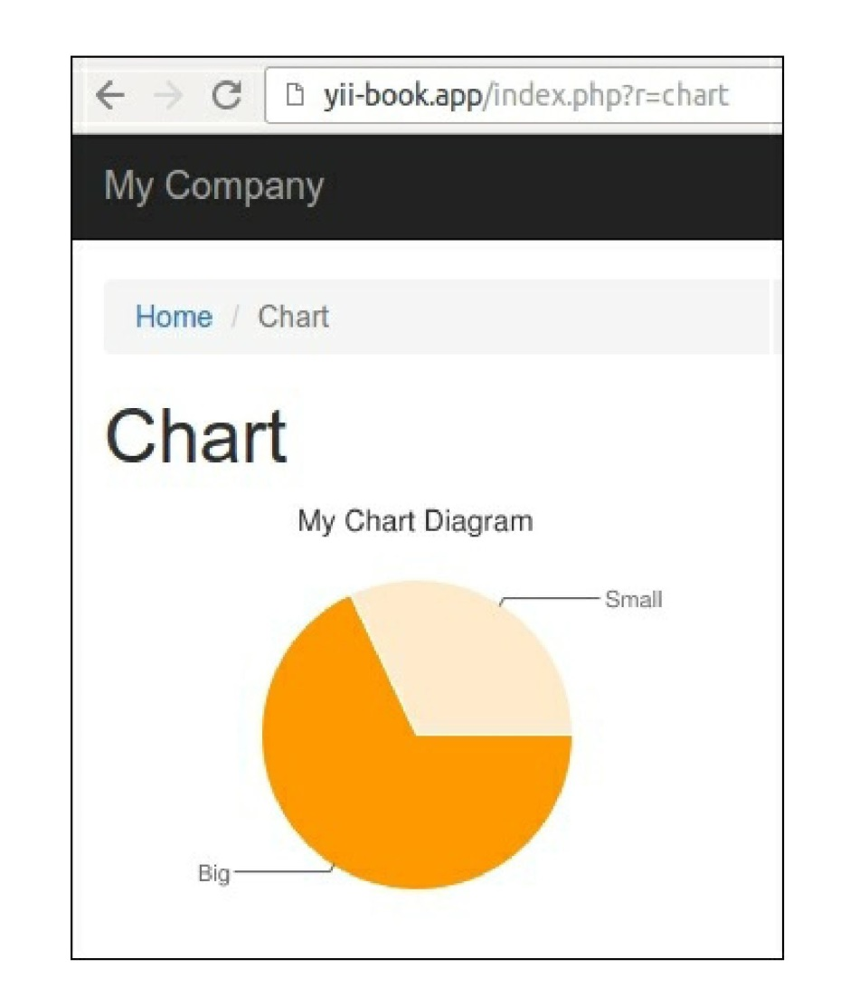

6. You can show any chart with different sizes and data sets.

How it works...

As in every other type of extension, we are creating some public properties we can configure when calling  
a widget using its widget method. In this case, we are configuring the title, data set, and data labels.

The main method of a widget is run(). In our widget, we are generating a URL and rendering the widget  
view, which uses the Google charting API for printing the <img> tag.

See also

* [To learn more about widgets, refer to http://www.viiframework.com/doc-2.0/guide-structure-](http://www.yiiframework.com/doc-2.0/guide-structure-widgets.html)  
  widgets.html
* The Making extensions distribution-ready recipe in this chapter