Using cache dependencies and chains

Yii supports many cache backends, but what really makes the Yii cache flexible is the dependency and  
dependency chaining support. There are situations when you cannot simply cache data for an hour  
because the information cached can be changed at any time.

In this recipe, we will see how to cache a whole page and still always get fresh data when it is updated.  
The page will be of the dashboard-type and will show the five latest articles added and a total calculated  
for an account.

Note

Note that an operation cannot be edited as it is added, but an article can be.

Подготовка

Создайте новое yii2-app-basic приложение с помощью диспетчера пакетов Composer, как описано в официальном руководстве по адресу  
<http://www.yiiframework.com/doc-2.0/guide-start-installation.html>.   
По русски <http://yiiframework.domain-na.me/doc/guide/2.0/ru/start-installation>

1. Activate the caching component in config/web. php as follows:

return [

// ...

'components' => [

cache => ['class' => 'yii\caching\FileCache,

],

],

];

1. Set up a fresh database and configure it into config/db. php.
2. Run the following migration:

<?php

use yii\db\Schema;  
use yii\db\Migration;

class m160308_093233_create_example_tables extends Migration  
{

public function up()

{

$tableOptions = null;

if ($this->db->driverName === 'mysql') {

$tableOptions = 'CHARACTER SET utf8 COLLATE utf8_general_ci  
ENGINE=InnoDB';

}

$this->createTable('{{%account}}', [

'id' => Schema::TYPE_PK,

'amount' => Schema::TYPE_DECIMAL . '(10,2) NOT NULL',

], $tableOptions);

$this->createTable('{{%article}}', [

'id' => Schema::TYPE_PK,

'title' => Schema::TYPE_STRING . ' NOT NULL',

'text' => Schema::TYPE_TEXT . ' NOT NULL',

], $tableOptions);

}

public function down()

{

$this->dropTable('{{%article}}');

$this->dropTable('{{%account}}');

}

}

1. Generate models for the account and article tables using Yii.
2. Create protected/controllers/DashboardController . php as follows:

<?php

namespace app\controllers;

use app\models\Account;  
use app\models\Article;  
use yii\web\Controller;

class DashboardController extends Controller  
{

public function actionIndex()

{

$total = Account::find()->sum('amount');

$articles = Article::find()->orderBy('id DESC')->limit(5)->all();

return $this->render('index', array(

'total' => $total,

'articles' => $articles,

));

}

public function actionRandomOperation()

{

$rec = new Account();

$rec->amount = rand(-1000, 1000);

$rec->save();

echo 'OK';

}

public function actionRandomArticle()

{

$n = rand(0, 1000);

$article = new Article();

$article->title = "Title #".$n;

$article->text = "Text #".$n;

$article->save();

echo 'OK';

}

}

1. Create views/dashboard/index . php as follows:

<?php

use yii\helpers\Html;

/* @var $this yii\web\View */

/* @var $total int */

/* @var $articles app\models\Article[] */

?>

<h1>Total: <?= $total ?></h1>

<h2>5 latest articles:</h2>

<?php foreach($articles as $article): ?>

<h3><?= Html::encode($article->title) ?></h3>

<div><?= Html::encode($article->text) ?></div>

<?php endforeach ?>

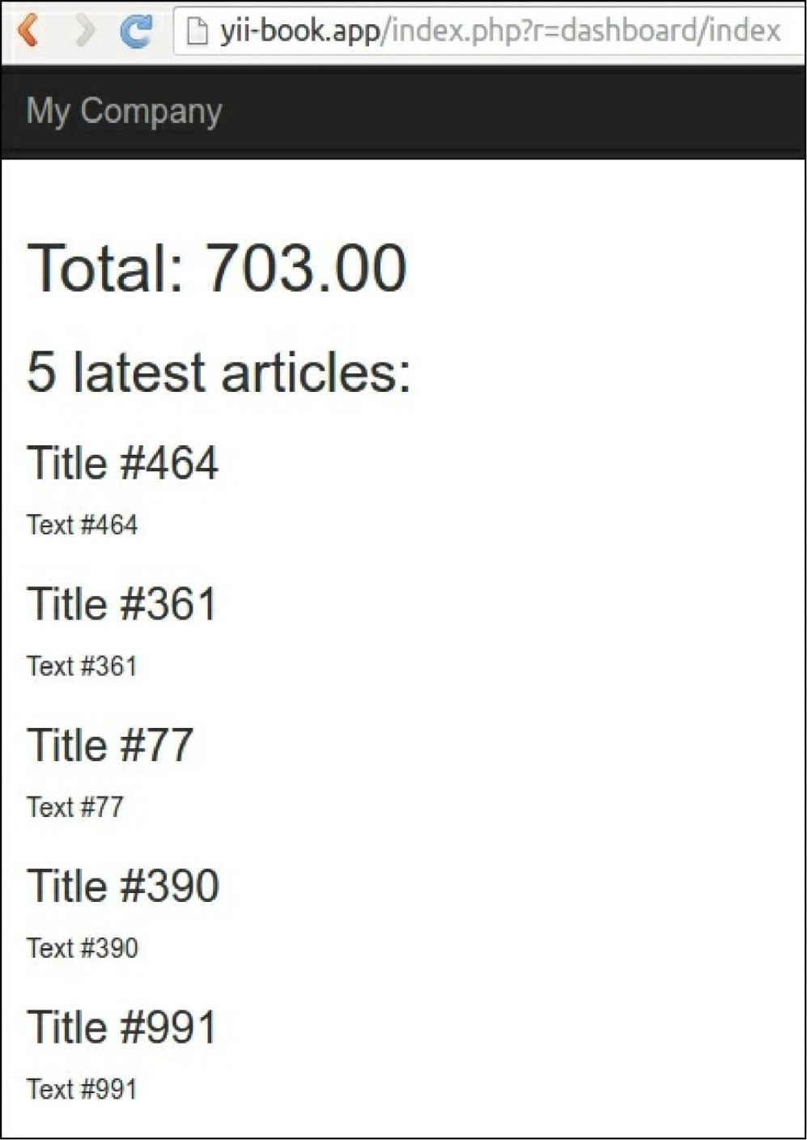7. Run dashboard/random-operation and dashboard/random-article several times. Then, run  
dashboard/index and you should see a screen similar to the one shown in the following screenshot:

8. Click on the number of database queries in the debug panel at the bottom of the page:



See a query list:

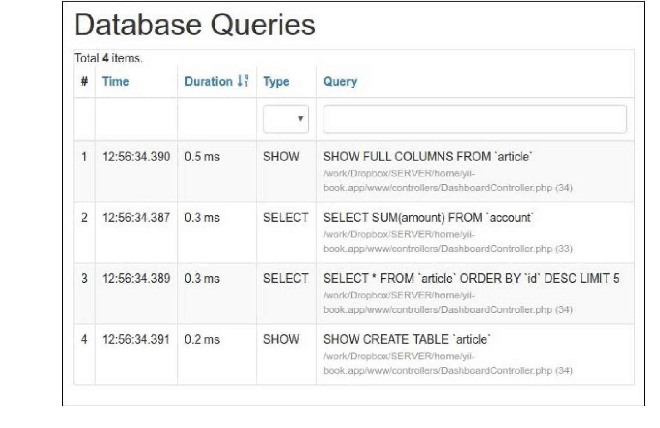

How to do it...

Carry out the following steps:

1. We need to modify the controller code as follows:

<?php

namespace app\controllers;

use app\models\Account;  
use app\models\Article;  
use yii\caching\DbDependency;  
use yii\caching\TagDependency;  
use yii\web\Controller;

class DashboardController extends Controller  
{

public function behaviors()

{

return [

'pageCache' => [

'class' => 'yii\filters\PageCache',

'only' => ['index'],

'duration' => 24 * 3600 * 365, // 1 year  
'dependency' => [

'class' => 'yii\caching\ChainedDependency',

'dependencies' => [

new TagDependency(['tags' =>

['articles']]),

new DbDependency(['sql' => 'SELECT MAX(id) FROM ' .

Account::tableName()])

]

],

],

];

}

public function actionIndex()

{

$total = Account::find()->sum('amount');

$articles = Article::find()->orderBy('id DESC')->limit(5)->all();

return $this->render('index', array(

'total' => $total,

'articles' => $articles,

));

}

public function actionRandomOperation()

{

$rec = new Account();

$rec->amount = rand(-1000, 1000);

$rec->save();

echo 'OK';

}

public function actionRandomArticle()

{

$n = rand(0, 1000);

$article = new Article();

$article->title = "Title #".$n;

$article->text = "Text #".$n;

$article->save();

TagDependency::invalidate(\Yii::$app->cache, 'articles');  
echo 'OK';

}

}

2. That is it. Now, after loading dashboard/index several times, you will get only one simple query in

the latest snapshot, as shown in the following screenshot:

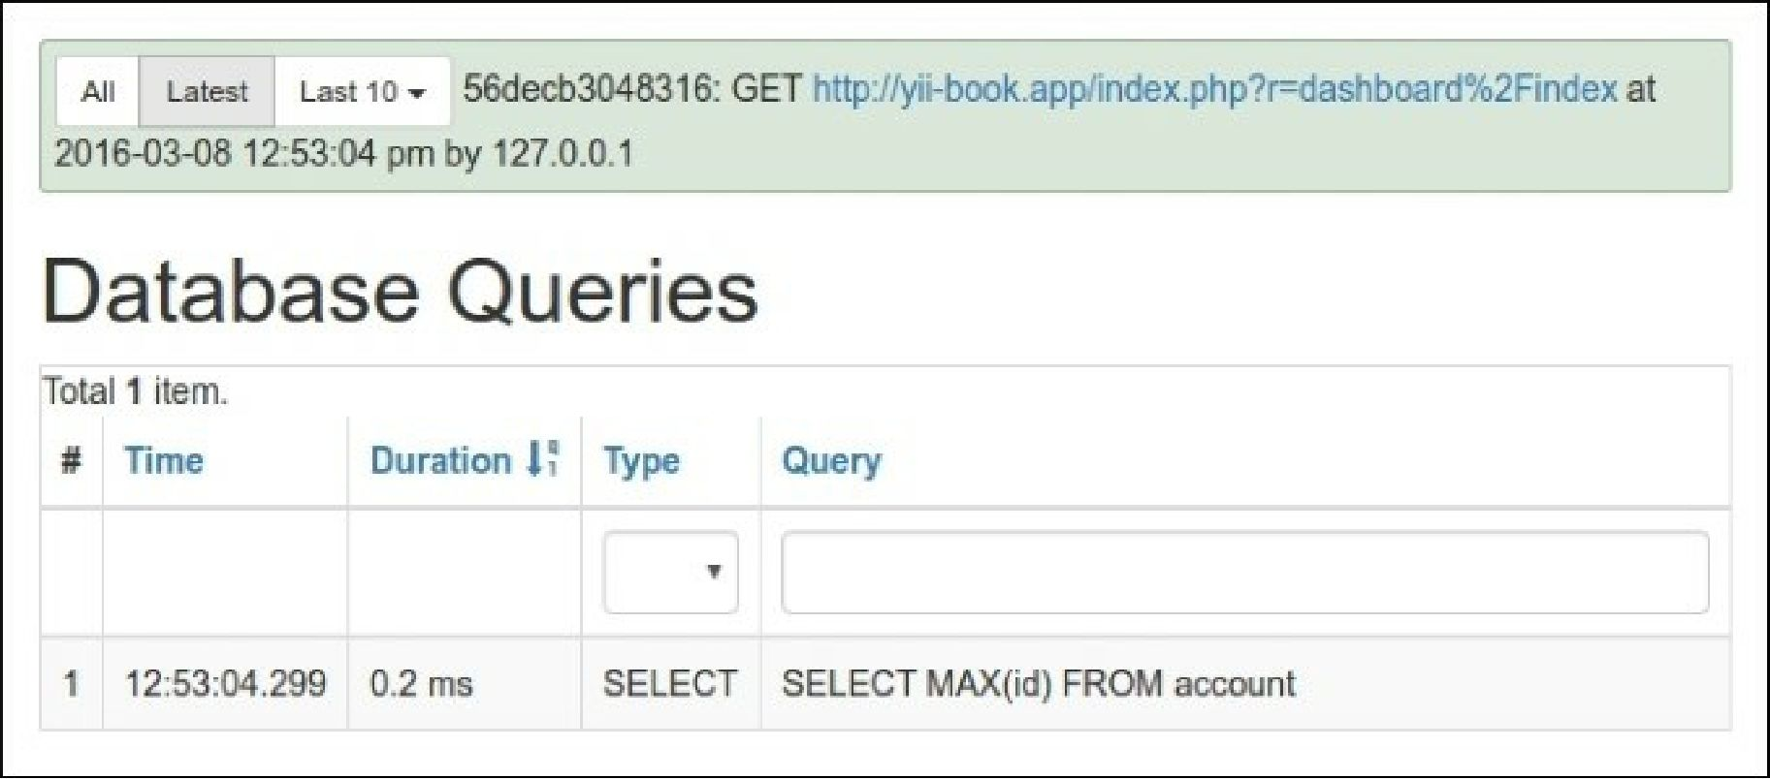

Also, try to run either dashboard/random-operation or dashboard/random-article and refresh  
dashboard/index after that. The data should change as follows: