Running Yii2 on HHVM

HipHop Virtual Machine (HHVM) is a process virtual machine from Facebook based on just-in-time  
(JIT) compilation. HHVM transforms PHP code into intermediate HipHop bytecode (HHBC) and  
dynamically translates PHP code into machine code, which will be optimized and natively executed.

Подготовка

Создайте новое yii2-app-basic приложение с помощью диспетчера пакетов Composer, как описано в официальном руководстве по адресу  
<http://www.yiiframework.com/doc-2.0/guide-start-installation.html>.   
По русски <http://yiiframework.domain-na.me/doc/guide/2.0/ru/start-installation>

How to do it...

Follow these steps to run Yii on HHVM:

1. Install the Apache2 or Nginx web server.
2. Follow the guide for installing HHVM on Linux or Mac available at

<https://docs.hhvm.com/hhvm/installation/introduction>. For example, on Ubuntu you must run the  
following commands:

sudo apt-get install software-properties-common

sudo apt-key adv --recv-keys --keyserver hkp://keyserver.ubuntu.com:80  
0x5a16e7281be7a449

sudo add-apt-repository "deb <http://dl.hhvm.com/ubuntu> $(lsb_release -sc) main"

sudo apt-get update

sudo apt-get install hhvm

After installing, you will see the following tips in your terminal:

********************************************************************

* HHVM is installed.

*

* Running PHP web scripts with HHVM is done by having your
* webserver talk to HHVM over FastCGI. Install nginx or Apache,
* and then:
* $ sudo /usr/share/hhvm/install_fastcgi.sh
* $ sudo /etc/init.d/hhvm restart
* (if using nginx) $ sudo /etc/init.d/nginx restart
* (if using apache) $ sudo /etc/init.d/apache restart

*

* Detailed FastCGI directions are online at:
* <https://github.com/facebook/hhvm/wiki/FastCGI>

*

* If you're using HHVM to run web scripts, you probably want it
* to start at boot:
* $ sudo update-rc.d hhvm defaults

*

* Running command-line scripts with HHVM requires no special setup:
* $ hhvm whatever.php

*

* You can use HHVM for /usr/bin/php even if you have php-cli
* installed:
* $ sudo /usr/bin/update-alternatives \
* --install /usr/bin/php php /usr/bin/hhvm 60

********************************************************************

1. Try to start the built-in server manually for your site:

cd web

hhvm -m server -p 8080

Open the localhost: 8080 host in your browser:

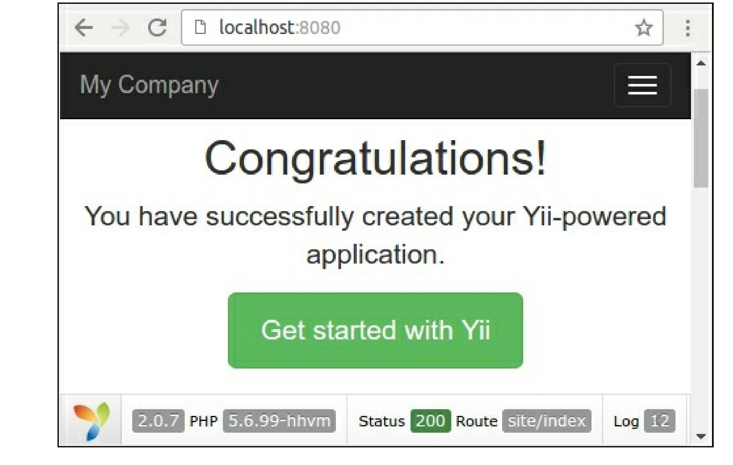

Right now you can use HHVM to develop your project.

4. If you use the Nginx or Apache2 server, then HHVM automatically creates its own configuration  
files in the /etc/nginx and /etc/apache2 directories. In the case of Nginx, it creates the  
/etc/nginx/hhvm. conf template to include configuration file to your projects. For example, let’s  
create a new virtual host called yii-book-hhvm.app:

server {

listen 127.0.0.1:80;  
server_name .yii-book-hhvm.app;  
root /var/www/yii-book-hhvm.app/web;  
charset utf-8;

index index.php index.html index.htm;  
include /etc/nginx/hhvm.conf;

}

Add the hostname into your /etc/hosts:

127.0.0.1 yii-book-hhvm.app

Now restart the Nginx server:

sudo service nginx restart

Finally, open the new host in your browser.

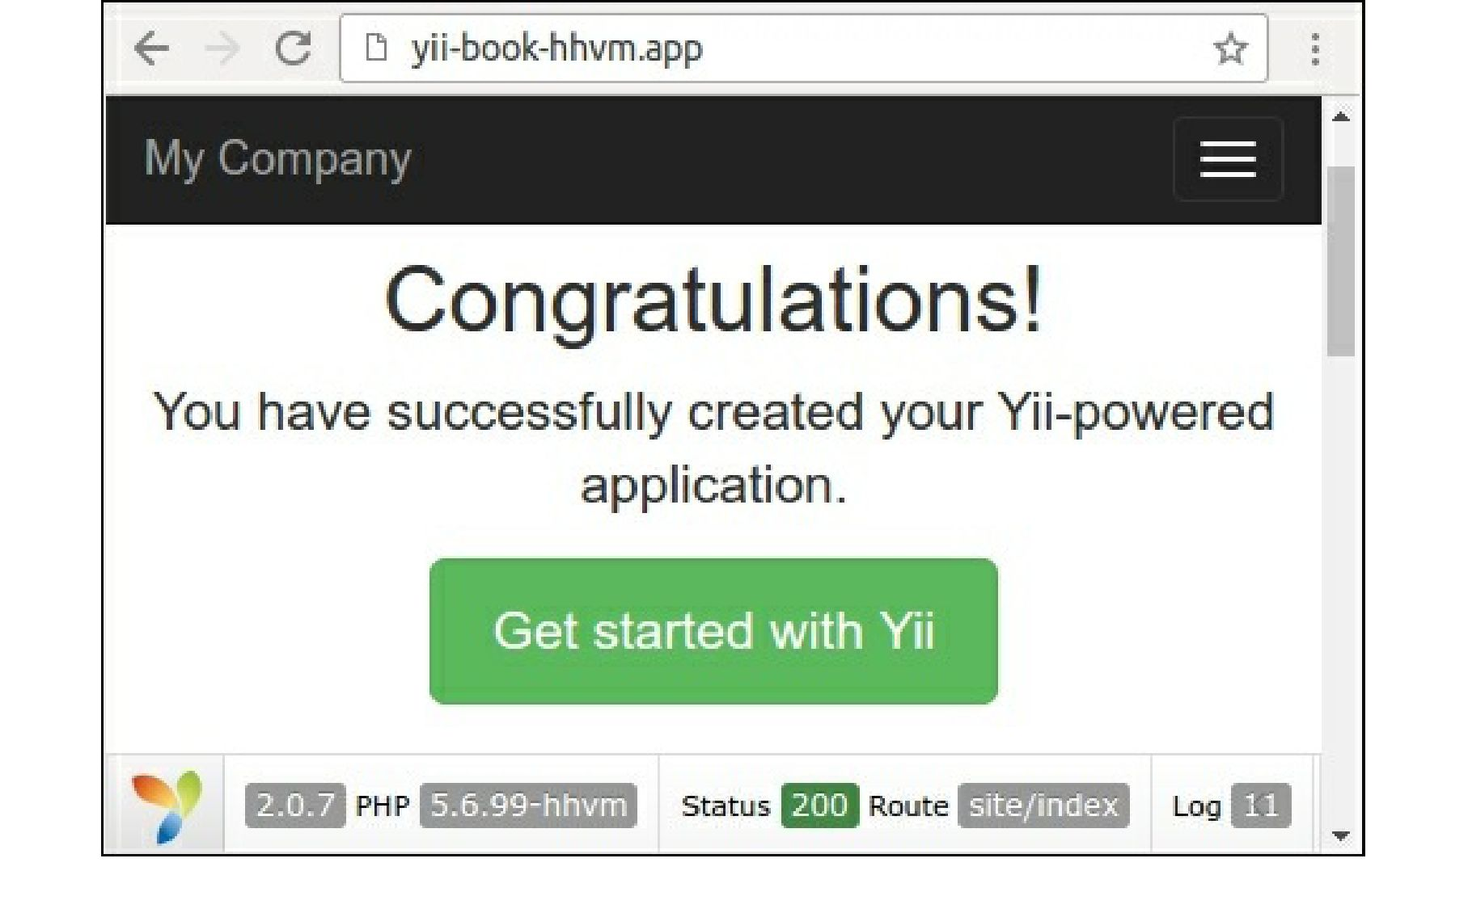

Your server is successfully set up.

How it works...

You can use HHVM as an alternative PHP process in the fastcgi mode. By default, it listens to the 9000  
port. You can change the default port of the fastcgi process in the /etc/hhvm/server. ini file:

hhvm.server.port = 9000

Configure the specific PHP options in the /etc/hhvm/php.ini file.

See also

For more information about installing HHVM, refer to the following URLs:

* <https://docs.hhvm.com/hhvm/installation/linux>
* <https://docs.hhvm.com/hhvm/installation/mac>

In order to learn more information about HHVM usage refer to <https://docs.hhvm.com/hhvm/>.