USER MANUAL
1. Getting Started Instructions
1.1 Target Platform System Requirements
SafeRoute is built using the modern cross-platform Expo SDK platform. To ensure proper runtime execution of native tracking and sensor background micro-tasks, your device must meet the following baseline hardware and operating system metrics:
- Android: Android 8 or higher (Optimized for Android 13/14).
- iOS: iOS 15.0 or higher.
- Hardware Essentials: Onboard Accelerometer, GPS, active Cellular or Wi-Fi connection.
1.2 Permissions
Grant Permissions: Upon initial application boot, the Android OS will ask for access to permissions. You must select the following parameters to ensure structural stability:
- Location Access: Select "While using the app" followed by "Change to always allow" (Crucial for background tracking).
- Sensor Access: Grant immediate permission to access physical motion data.
2. How to Use the Application
2.1 Interface & Dashboard Breakdown
SafeRoute uses a streamlined, distraction-free Tab Navigation Matrix anchored at the bottom of the screen. This layout ensures you can access life-saving tools instantly during a high-stress event.
Live Map Screen: Your operational flight deck. It renders an interactive map window showing your current location alongside a dynamic historical breadcrumb trail powered by an embedded SQLite engine.
Guardians Screen: A secure dashboard containing data-entry forms where you save, update, and manage your primary emergency contacts.
Fall Radar Screen: A live diagnostics panel displaying continuous gravitational force outputs G-force) computed along your device's physical axes.

2.1 Interface & Dashboard Breakdown
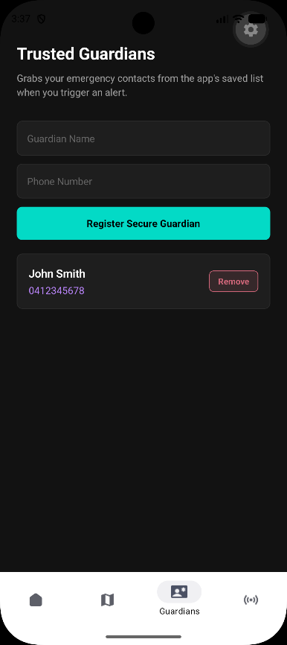

Walkthrough A: Setting Up Your Guardian Contacts
- Tap the Guardians icon on the bottom navigation bar to open your emergency contact ledger.
- Locate the configuration input fields labelled Contact Name and Phone Number.
- Type in your primary emergency responder's info (e.g., Name: Jane Doe, Phone: 0412345678).
- Tap Save Contact. The background validation layers instantly verify the formatting, store the contact securely inside the app's sandboxed data vault, and print a success confirmation.

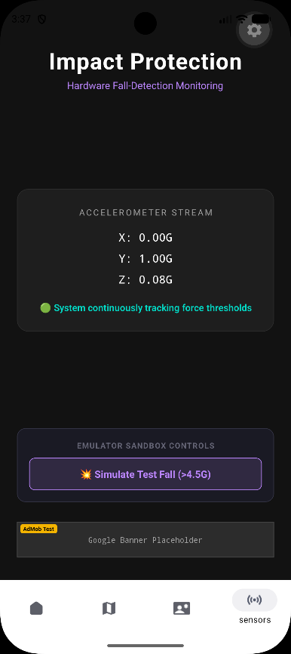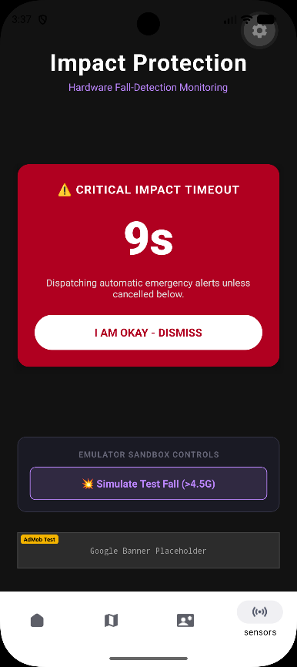

Walkthrough B: Managing the Fall Detection Radar
- Navigate to the Fall Radar tab view to look at your real-time hardware telemetry.
- Observe the vector magnitude gauge. When the phone is at rest or in normal use, it sits at a balanced baseline of approximately $1.0\text{G}$ (Earth's natural gravity).
- The Lifeline Trigger Loop: If you experience an abrupt impact event—such as a vehicular collision, cycling accident, or hard trip and fall—that crosses the safety threshold ($>4.5\text{G}$), SafeRoute will immediately take over the UI and trigger a high-visibility 10-Second Emergency Countdown Window.
- Action Required: If you are uninjured and do not need assistance, simply tap the prominent green "I Am Safe" button before the timer hits zero to cancel the alert. If the countdown expires without user interaction, the system will instantly flag an emergency state and dispatch your precise location coordinates.

3. Common Issues and Troubleshooting Tips
Encountered Symptom | Root Cause Analysis | Corrective Action Plan
The map displays a blank grid or an infinite loading spinner. | The application has been restricted by system location permissions, or the local hardware GPS receiver is struggling to get a line-of-sight satellite lock. | 1. Open device Settings Apps SafeRoute Permissions.  2. Select Location and change it to "Allow all the time."  3. Toggle "Use precise location" to On to engage high-accuracy GPS triangulation.  4. Step outside or away from heavy concrete structures to re-establish satellite tracking.
The app displays a validation error when trying to save an emergency contact. | The app input filters rejected an invalid phone number or an empty name. | 1. Ensure the Contact Name field is filled out and isn’t empty.  2. Check that the Phone Number contains only numeric characters, matching standard mobile lengths with no hidden spaces or punctuation.
The ad banner at the bottom of the screen doesn't show an active ad. | The app is currently running its built-in safety sandbox profile to protect your privacy and shield you from ad-network click fraud. | * No action needed. The app is working exactly as intended. The system displays a placeholder to keep the application stable while ensuring it doesn't drain your cellular data.

