Library Management System – Use Case Descriptions

Introduction
This document describes the main functionalities of the Library Management System based on the provided use case diagram. It explains how different users interact with the system and what actions they can perform.
The system includes three main actors:
- Student
- Librarian
- Admin
Each role has specific permissions and responsibilities within the system.
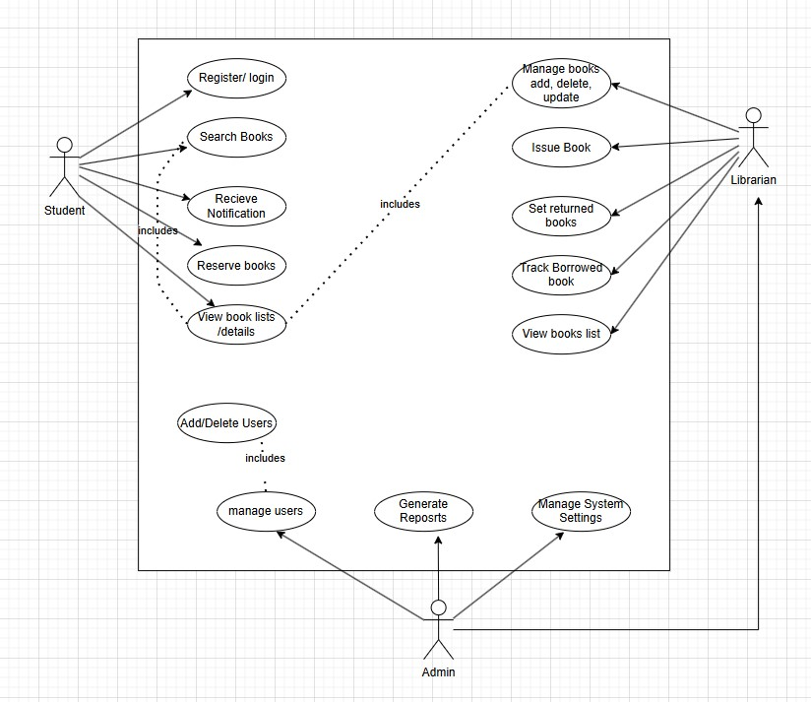

Actor Relationship
Description:
In this system, there is a hierarchical relationship between the Librarian and Admin roles. The Admin is considered a specialized type of Librarian, meaning that the admin has all the permissions of a librarian, in addition to extra administrative privileges such as managing users, system settings, and generating reports.
However, a Librarian does not have administrative privileges and cannot perform admin-specific tasks.

Student Use Cases

Register / Login
Description:
This functionality allows students to create a new account or log into the system. New users must enter their personal information such as name, email, and password.
Existing users can log in to access all available features.

Search Books
Description:
Students can search for books using different criteria such as title, author, or category.
The system returns a list of books that match the search input.

View Book List / Details
Description:
Students can browse all available books and view detailed information about each one, including availability status and description.

Reserve Books
Description:
If a book is not available, students can reserve it.
The system keeps track of reservations and informs the student when the book becomes available.

Receive Notification
Description:
Students receive notifications related to:
- Book availability
- Reservation updates
- Due dates and reminders

Librarian Use Cases

Manage Books (Add, Delete, Update)
Description:
The librarian is responsible for maintaining the book collection.
This includes adding new books, updating existing information, and deleting books when necessary.

Issue Book
Description:
The librarian issues books to students.
The system records the issue date and assigns a return deadline.

Set Returned Books
Description:
When a book is returned, the librarian updates its status in the system.
This makes the book available again for other students.

Track Borrowed Books
Description:
The librarian monitors all borrowed books, including who borrowed them and their due dates. This helps in identifying overdue books.

View Books List
Description:
The librarian can access a complete list of books along with their current status.

Admin Use Cases

Add / Delete Users
Description:
The admin manages user accounts by adding new users or removing existing ones.
This ensures proper access control within the system.

Track Borrowed Books
Description:
The admin can monitor borrowing activities across the system.
This includes checking which books are currently borrowed and by whom.

Set Returned Books
Description:
The admin has the ability to update book return status when needed, similar to the librarian role.

Issue Book
Description:
The admin can also issue books to users in special cases or when administrative intervention is required.

Manage System Settings
Description:
The admin controls system-wide configurations such as rules, policies, and operational settings.

Generate Reports
Description:
The admin can generate reports that include:
- Borrowing statistics
- User activity
- Book usage
These reports help in analyzing system performance and improving management.

Conclusion
The Library Management System provides a clear separation of roles between students, librarians, and admins.
Students interact mainly with book-related services, librarians handle daily library operations, and the admin oversees the system with higher-level control and management capabilities.

