**Topic: Chiplets** Xindong Zhou U53670847

1. Discuss the target users or applications of your topic

**Target users:** Designers and manufacturers of high-performance computing, data centers, and embedded systems

**Application:** Manufacturing modern processors with high scalability at low cost

1. Outcome of ChatGPT or your favorite LLM model about the topic

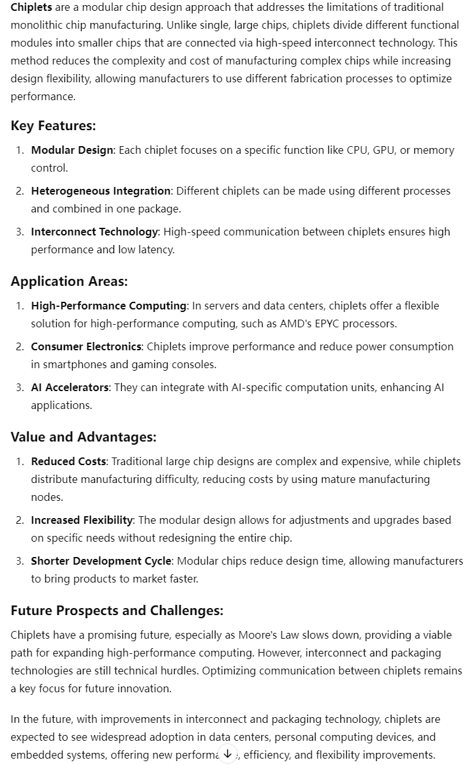

1. Your analysis of the outcome of ChatGPT.  This should be a thorough analysis that includes criticisms, lessons learned, next steps

GPT's answer already includes the main advantages and applications of chiplets, which offer new ways to address the need for computing power growth in the post-Moore's Law era. Like EYPC processors, designers can use different process nodes to combine more dies together and achieve parallel performance improvements at lower edge costs by increasing the number of high-performance cores in a single processor. At the same time, chiplets can be reused to be used in different combinations.

However, GPT's answer doesn't mention chiplets' current shortcomings. According to what I checked online, the packaging technology of chiplets has a big impact on chip features and cost. The first is delay. Among several packaging processes of chiplets, MCM technology is the most mature, but the inter-core delay between different dies is high, and cross-die scheduling is prone to performance degradation, it will lower the experience of customer in many daily application situation, such as gaming or web view. Second, the capacity of COWOS package with the lowest delay is still limited, which is an important factor restricting the capacity of high-end computing chips such as H100, and the high price weakens the low-cost advantage of chiplets to a certain extent. Then there is the life problem. For example, the H100 encapsulates the memory and the computing unit together. But due to the low life of the memory under the high work pressure, the whole board is often scrapped due to memory damage in large data centers, and the maintainability is reduced. In the period of rapid industrial growth, enterprises focus on computational efficiency, and in the future, when large-scale product promotion is required, maintainability should be an aspect that needs to be improved. In addition, more advanced packaging methods may need to be developed to increase the application potential of chiplets technology, and unified development standards, so that chip modules developed by different companies can be better reused.

I think I can study the potential application of chiplets in edge computing next, and learn more about the advantages and limitations of each packaging technology, and explore whether materials with better properties will be used in the development of advanced packaging technology for chiplets in the future.

1. List of scientific papers you will focus on for next week

<https://www.nature.com/articles/s41928-024-01175-3.pdf>

https://arxiv.org/abs/2311.16417