**Computer Organization and Architecture (EET2211)**

**LAB II: Analyze and Evaluate the Branching operation in the 8086 Microprocessor.**

**Siksha ‘O’ Anusandhan (Deemed to be University), Bhubaneswar**

|  |  |  |  |
| --- | --- | --- | --- |
| **Branch: Section:** | | | |
| **S. No.** | **Name** | **Registration No.** | **Signature** |
|  |  |  |  |

**Marks: ______/10**

**Remarks:**

**Teacher’s Signature**

**I. OBJECTIVE:**

1. Find the sum and average of N 16-bit numbers.
2. Count no. of 0’s in an 8-bit number.
3. Move a block of 16-bit data from one location to other.
4. Multiplication of two 16-bit numbers without using MUL instruction in direct addressing mode.

**II. PRE-LAB**

Note: For each objective in prelab describe the following points:

* Write the pseudocode.
* Write the assembly code with description (ex. Mov ax,3000h – ax<-3000h)
* Examine & analyze the input/output of assembly code.

**III. LAB**

Note: For each objective do the following job and assessment:

* Screen shots of the Assembly language program (ALP)
* Observations (with screen shots)

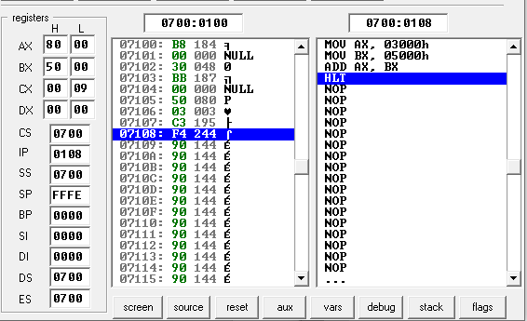

**Fig. 1.** Execution result of addition using immediate addressing mode of 8086 emulator.

From this result I have observed……

|  |  |
| --- | --- |
| **Input:** | **Output:** |
| |  |  |  | | --- | --- | --- | | **Sl. No.** | **Memory Location** | **Operand (Data)** | | **1** |  |  | | **2** |  |  | | **…** |  |  | | |  |  |  | | --- | --- | --- | | **Sl. No.** | **Memory Location** | **Operand (Data)** | | **1** |  |  | | **2** |  |  | | **…** |  |  | |

**IV. CONCLUSION**

**V. POST LAB**

1. Analyze the following code and find out the value of registers.

MOV AX, 4246H

MOV BX, 123FH

AND AX, BX

ADD AX, BX

ROR AX, 02H

INC BX

INC BX

MOV [BX], AX

HLT

1. Division of two 16-bit numbers without using DIV instruction in direct addressing mode.