IT 315
9490 - Technopreneurship

Development and Implementation of a Minimum Viable Product for Hirayag: A Mobile Application for Families with Special Needs

Members:
Aguilan, Jecquar Ravent C.
Aoay, Michael Vincent V.
Aquino, Dustin Piou
Argao, Jeiloyd S.
Facun, Jared Eizen B.
Piamonte, Malech Dangyan L.
Talavera, Adrian F.

Submitted On:
November 29, 2025
Table of Contents
I. Introduction 3
a. Background of the Study 3
b. Problem Statement 4
c. Objective of the Study 4
d. Significance of the Study 4
e. Scope of the Study 5
f. Overview of methodology 7
II. Methodology 8
a. Research Design 8
b. System Development Framework 9
c. Tools and Technologies 11
d. Datasets 11
e. System Architecture 12
f. Evaluation Methods 17
III. Results and Discussion 19
a. System Technical Performance Evaluation 19
b. User Test Results and Accuracy Metrics 20
c. Summarizing Results Using Screenshots 22
IV. Analysis 28
a. Discussion of Findings in Context of Related Works 28
b. Challenges Encountered During Development 29
V. Conclusion and Recommendations 32
a. Summary of Findings and System Capabilities 32
b. Limitations of the Study 32
c. Recommendation for future work 32
References: 34

Introduction
This study addresses the ongoing problems faced by families in Baguio City in accessing trained caregivers and educators, despite the presence of SPED programs and related services. Current caregiving applications remain too general and do not meet the specific needs of children needing specialized care. To respond to this gap, the study proposes the development of a dedicated platform that connects families with verified and qualified service providers. This initiative aims to improve access to reliable support while creating opportunities for skilled caregivers and educators in the community.

Background of the Study
In 2022, an estimated 1.6 million Filipino Children were identified as having special needs, including Autism, ADHD, and various sensory impairments (UNICEF, 2022). Although parents strive to provide appropriate care, many struggle due to limited knowledge of their child’s condition and the demands of sustaining their livelihood (Ghavi et al., 2023). Existing caregiving applications in the Philippines, such as Babysits, offer general services but do not guarantee caregivers with specialized skills required for these children. In Baguio City, SPED programs and facilities, including the Inclusive Learning Resources Center of the Department of Education-CAR, are available, however, the shortage of SPED teachers and trained personnel continues to limit facilities access to reliable support. Despite these challenges, no dedicated platform currently exists to connect families with qualified caregivers and educators, highlighting the need for a specialized application that can address these gaps.

The development of an application may bridge the gap between these families and could provide practical solutions for the problems they are facing. By including features such as verified caregiver and educator profiles, a reliable communication tool, and AI functionalities such as an AI-powered chatbot and filtering system for quick service provider matching, such an application can help countless families have safe and proper support and could also help service providers looking for opportunities to earn a living.

Problem Statement
Despite the presence of SPED programs and general caregiving applications, families still face difficulties in accessing trained and experienced caregivers and educators for children with special needs. This study will, in general, address this gap by developing a dedicated application and will, in particular, seek to answer the following specific questions:
- How can dedicated applications improve access to trained and experienced caregivers and educators for families in Baguio City?
- What features should the application include to effectively match families with service providers based on their child’s specific needs?
- How can the application ensure the reliability and verification of caregivers and educators listed in the platform?
- What impact could such an application have on the daily care and support received by children with special needs in Baguio City?

Objective of the Study
The primary objective of this study is to develop the mobile application Hirayág to facilitate connections between families of children with special needs and qualified caregivers and educators who possess the necessary skills and experience to support their development. Specifically, the study aims to:
- Determine how a dedicated mobile application can improve access to trained and experienced caregivers and educators for families in Baguio City.
- Identify the essential features that the applicant should include to effectively match families with service providers based on the specific needs of their children.
- Establish mechanisms within the application that ensure the reliability, credibility, and proper verification of caregivers and educators listed on the platform
- Access the potential impact of the application on the daily care, support, and overall well-being of children with special needs in Baguio City.

Significance of the Study
The study addresses the current challenge being faced by families with children with special needs when it comes to accessing trained and experienced caregivers and educators within Baguio City. By developing a mobile application that connects these families with different qualified service providers, the project aims to provide the solution for these families by offering a safer and more convenient way to find the proper support they need.

Parents
The application will be a platform where parents can easily find service providers according to their specific criteria or needs. This can help parents reduce their stress, save a lot of time, and ensure that they get the proper support and care their child needs whenever they cannot attend to them.

Caregivers and Educators
The application will be a platform that offers opportunities for these caregivers and educators who are looking to earn a living with their skills and experience. The application can help increase their employment opportunities and help them reach more families in Baguio City.

SPED Institutions and Healthcare Providers
Different schools, health centers, and other related institutions can use the platform in order to recommend more verified service providers to families. The application can provide more available services in Baguio City and can work alongside existing programs from these institutions to better support families with children with special needs.

Scope of the Study
The design, development, and preliminary assessment of Hirayag, a mobile application meant to connect Baguio City families with special needs to certified tutors and babysitters, are the main topics of this study. Long-term tracking or evaluation of alterations in the behavioral, educational, or developmental outcomes of children with special needs utilizing the services made possible by the application is not covered by the study. Furthermore, it excludes extensive implementation or deployment outside of Baguio City.

- Location
- The scope of the application is strictly limited to Baguio City. This means that all users involved in the study, including families, tutors, and babysitters must either reside within or primarily conduct their services in the city. The system’s features, service availability, and assessment activities focus solely on the geographical context of Baguio City. It does not include deployment, testing, or service extension to nearby towns, provinces, or other regions. By limiting the location, the study ensures that the development and evaluation processes are tailored to the unique community structure, accessibility needs, and demographic characteristics of Baguio City.
- User/Beneficiaries
Parents: These are caregivers of children with special needs, such as those with autism spectrum disorders, developmental delays, ADHD, or learning disabilities who require specialized attention at home. The application allows them to conveniently search, book, and communicate with qualified tutors or babysitters who understand the unique needs of their children. It also helps parents ensure safety, transparency, and credibility through the app’s verification and matching system.
Tutors: These are certified professionals, therapists, SPED teachers, or individuals with relevant training and experience in handling children with special needs. The platform provides them with opportunities to connect with families needing specialized care or academic support. The system also helps them showcase their credentials, availability, and service offerings while fostering trust through verified profiles and reviews.

Institution: The application acts as a supplementary tool for institutions dealing with special education. By connecting families with qualified external support, the app helps alleviate manpower shortages, reduce workload on existing staff, and extend support to students beyond classroom hours. SPED centers and organizations may also recommend the platform as an additional resource for families needing consistent and reliable assistance.

- Application Development
Operating Systems: The application will be developed exclusively for Android and iOS devices. These platforms are chosen due to their widespread use and accessibility among families and service providers in Baguio City. No web-based or desktop versions are included in the current scope.

User Creation and Login: The app features a secure and role-based authentication system that allows both parents and service providers to create accounts, log in, and manage their profiles. Parents may input child-related information for better service matching, while tutors/babysitters upload credentials, certifications, and availability. Security measures such as password recovery and profile verification are also part of this system.

Management Features: The application includes internal management tools that allow users to monitor and organize service interactions. Parents can track bookings, check tutor/babysitter profiles, view service histories, and manage ongoing sessions. Likewise, service providers can manage their schedules, update availability, accept or decline service requests, and maintain records of completed sessions. Administrative oversight, such as credential verification, issue handling, and profile moderation is also part of the management component but is limited to basic functionality relevant to the preliminary version of the application.

Overview of methodology
The Modified Waterfall Model integrates sequential phases with limited iteration to improve efficiency in software development. The process begins with requirements gathering, where functional and non-functional needs are identified through interviews, observations, and documentation. This is followed by the design phase, which establishes the system architecture, data structures, interfaces, and component specifications.

In the implementation phase, developers translate the approved design into source code, integrating and documenting system modules. The testing phase then conducts unit, integration, and system testing to verify that the software meets requirements and functions correctly. Finally, during operation and maintenance, the deployed system is monitored, updated, and corrected to ensure long-term performance and user satisfaction.

Unlike the traditional Waterfall Model, the Modified Waterfall allows iterative adjustments within phases, enabling teams to address urgent changes and ensure alignment with user requirements. It offers greater structure and documentation than Agile methods but provides less continuous customer feedback. While it shares characteristics with incremental and spiral models, the Modified Waterfall maintains a more disciplined and sequential phase structure (Pal, 2025).

Methodology
The methodology for this study outlines the systematic approach employed to evaluate the developed system and gather user feedback. It describes the research design, sampling methods, and data collection procedures used to ensure that the study produces reliable and meaningful insights regarding system usability and performance.

Research Design
This study employed a Qualitative research design to obtain an in-depth understanding of user experiences and perceptions regarding the developed system. A qualitative approach was deemed appropriate as it facilitates the exploration of user interactions, subjective evaluations, and the overall usability of the system in a naturalistic manner.

A convenience sampling method was utilized in selecting participants, allowing the researchers to gather data from individuals who were readily accessible and willing to participate. User testing was conducted among Information Technology students of Saint Louis University, who served as representative users for evaluating the system’s functionality and interface design. To ensure consistency and comparability of responses, all participants were presented with an identical set of questions during the evaluation process.

This research design enabled the systematic collection of detailed, experience-based feedback, which is essential for guiding system refinement, enhancing user interface components, and ensuring the system’s alignment with user needs and expectations.

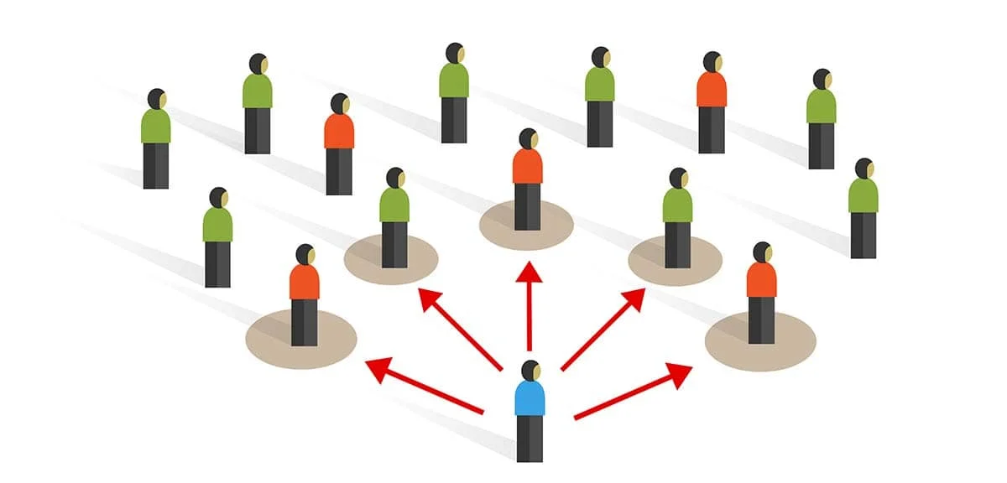

Figure 1. Convenience Sampling Method

System Development Framework
The development of our mobile application Hirayag will make use of the Modified Waterfall Model as its software development framework. This approach will provide a structured and sequential approach whilst allowing the ability to revisit earlier phases whenever necessary to address issues or necessary additions to the system (Diaz et al., 2020). For clarity and visualization, Figure 1 illustrates the Modified Waterfall Model applied in this project, showing the sequence of phases and feedback loops between them.
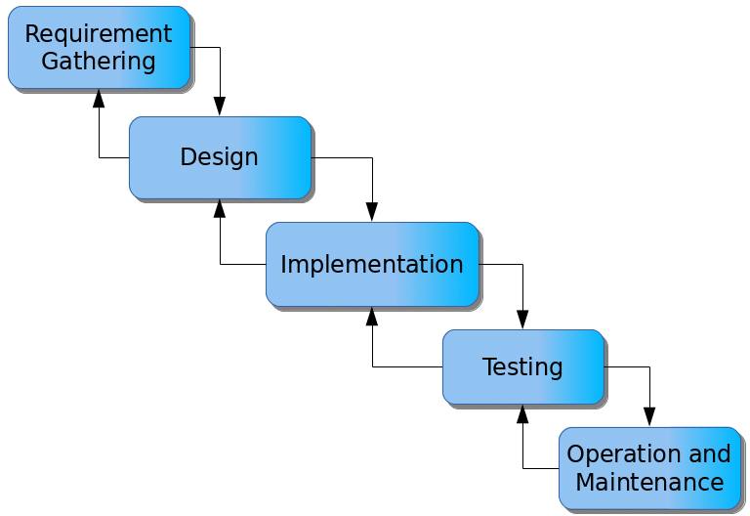

Figure 2. Modified Waterfall

In the development of this project, the process will be structured around five main phases, each representing a critical stage in the software development life cycle. These phases provide a systematic framework that ensures thorough planning, design, implementation, testing, and deployment of the system. By following this structured approach, the project team can maintain clarity of objectives, track progress effectively, and address potential issues at each stage, ultimately ensuring that the final product meets the specified requirements and user expectations.

Requirement Gathering
In this phase, the needs and requirements of the parents or guardians of children with special needs are assessed. Data will be gathered through a survey using Google Docs containing all the relevant information needed to build a mobile application suited for them. Functional and non-functional requirements will be identified during this phase.
Designing
This phase focuses on the creation of the architecture of the application. Wireframes and relevant diagrams will be developed to help in visualizing the user experience and the relationship between system components.

Implementation
This phase involves the development of the application itself, the application will utilize React Native (Expo) as its front-end and Firebase for its backend. There will be 2 main modules that will be coded in the application, the Service-Provider module and the User module.

User Testing
During this phase, unit and system testing will be performed to ensure that all application functionalities work as intended. User testing will also be performed to ensure usability and functionality of the application.

Operation and Maintenance
After deployment, the application will be made available for both parents and caregivers for usage. The mobile application will then be continuously monitored to fix bugs, update features, and improve performance based on user feedback

Tools and Technologies
The development of the mobile application made use of several tools and technologies to support its development. The main ones are as follows along with their corresponding usages:
- Tools
  - Figma: This tool was used to design the app’s layout and user interfaces before development as a basis of reference.
  - Intellij Webstorm: This tool was used for writing, editing and testing the application code. The built in version control and other additional features present within the IDE (Integrated Development Environment) were also used to streamline the development.
  - Google Forms: This tool was used to gather data and necessary information for the development of the application through the use of surveys created in the platform.
- Technologies
  - React Native Expo: A cross platform front end framework that allows the development for both IOS and Android devices using a single codebase. This simplifies the development process and marginally reduces the effort needed to create a cross platform mobile application
  - Firebase: A cloud based platform used for the backend of our application. It features services such as user authentication, Firestore Database, application hosting and more.

Datasets
The study made use of several datasets stored and managed in the Firebase Firestore Database to support the main functionalities of the mobile application. The following are the main datasets:
- Users
- Consists of information about the Parents and Guardians and it includes basic information such as the name, phone number, email address, location and profile picture.

- Providers
- Consists of information about the Service Providers that can either be a Tutor or a Babysitter. It includes information such as the name, phone number, email address, location, profile picture, bio, hourly rate, skills and availability

- Appointments
- Consists of information about the Appointments made within the application. One of the key fields is the appointment type which could either be a “schedule” or a “one time” appointment. Some of the other relevant fields are the duration, provider, user and schedule.

- Conversations
- Consists of information about the Conversations between a provider and a user. Some of the relevant fields are the participants(ID of the user and the provider), and information regarding the last messages.

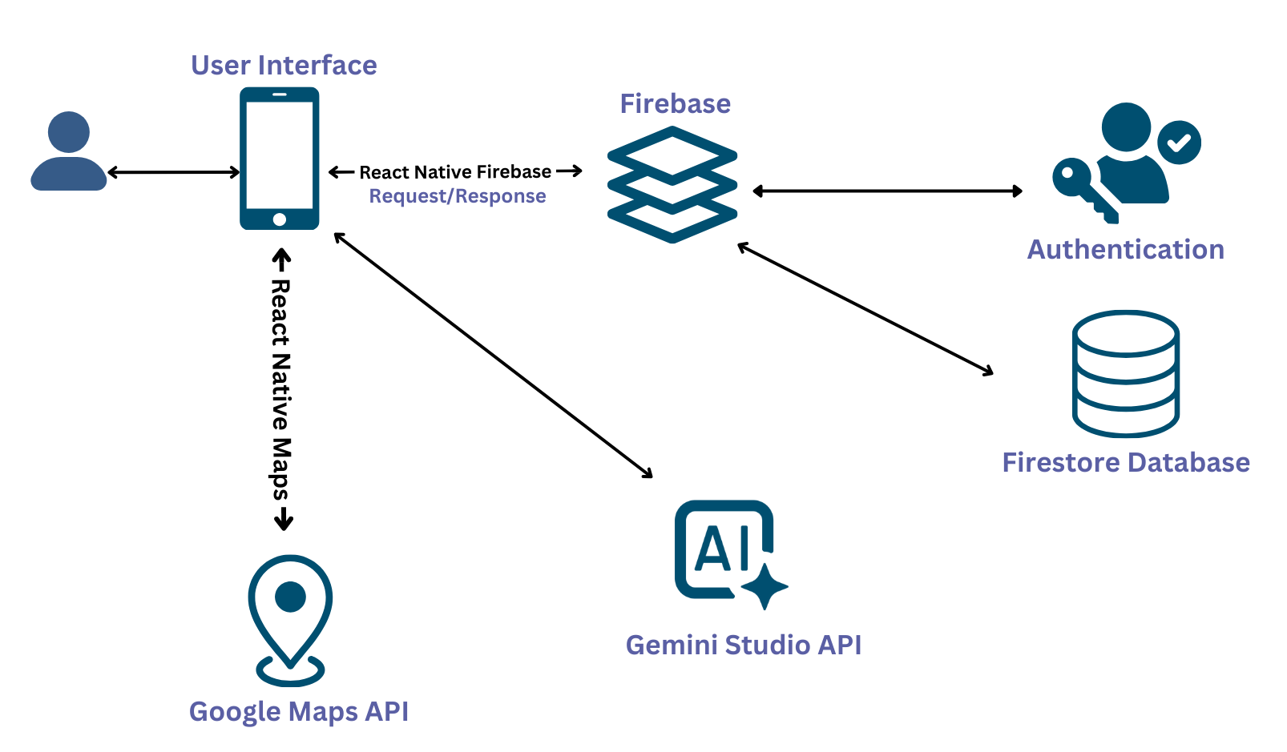
System Architecture

Figure 3. System Architecture
The system architecture illustrated in Figure 3 presents a mobile application ecosystem developed using React Native, integrated with several cloud-based services to enable authentication, real-time data management, geolocation features, and AI-driven functionalities. The architecture is composed of five primary components: the User Interface, Firebase Services, Authentication Module, Firestore Database, Google Maps API, and the Gemini Studio API. Each component interacts through well-defined communication pathways to ensure secure, efficient, and scalable operations.
User Interface Layer
The User Interface (UI), implemented in React Native, serves as the primary interaction point between the end-user and the system. This layer manages user inputs, displays real-time data, and renders map-based information using React Native Maps. All requests originating from the user are processed by the UI and dispatched to the corresponding backend services.

Firebase Integration Layer
The mobile application communicates with Firebase through the React Native Firebase SDK, enabling seamless request-and-response handling. Firebase acts as the central backend platform responsible for coordinating the following core services:
- Firebase Authentication
- Firebase Authentication manages all tasks related to user identity, including registration, login, session validation, and secure access control. The UI communicates with Firebase Authentication via secure channels, allowing users to authenticate before accessing application features.
- Firestore Database
- The Cloud Firestore database serves as the application's primary data storage solution. It maintains structured and semi-structured data such as user profiles, location records, application-generated metadata, and logs. Data is exchanged between the mobile application and Firestore through Firebase, ensuring low-latency synchronization and real-time updates.

Geolocation and Mapping Services
TThe mobile application integrates geolocation and mapping capabilities using the Google Maps API through the React Native Maps library. This component allows the system to render interactive map interfaces, retrieve precise geolocation coordinates, and support various spatial functionalities such as displaying the user’s current location, placing pins and markers, enabling route visualization, and facilitating user interactions including zooming and panning. All geospatial operations are executed directly between the mobile client and Google Maps services, ensuring accurate and real-time mapping performance.

Gemini Studio AI Integration
The system also incorporates the Gemini Studio API to provide advanced AI-driven functionalities. Through this integration, the application can perform natural language processing, interpret image-based inputs, generate predictive analytics, and deliver intelligent, context-aware recommendations. These capabilities enhance the overall system by enabling automated reasoning, improving decision-making processes, and supporting features that require adaptable and intelligent computational responses.

Data and Workflow Coordination
The system architecture facilitates a multi-directional flow of data and processes, enabling seamless coordination across all components. The User Interface transmits user-generated inputs to Firebase, which is responsible for managing authentication procedures, data retrieval, and real-time updates. Firebase further interacts with the Firestore Database to handle persistent data storage and synchronization. In parallel, the Google Maps API communicates directly with the UI to deliver geospatial functionalities independent of Firebase’s data pipelines. Additionally, the Gemini Studio API processes specialized application-level queries and returns AI-generated outputs to the UI, supporting intelligent and context-aware system behavior. This distributed design promotes modularity, scalability, and fault tolerance, as each subsystem operates autonomously while maintaining cohesive interaction, thereby ensuring efficient resource utilization and system maintainability.

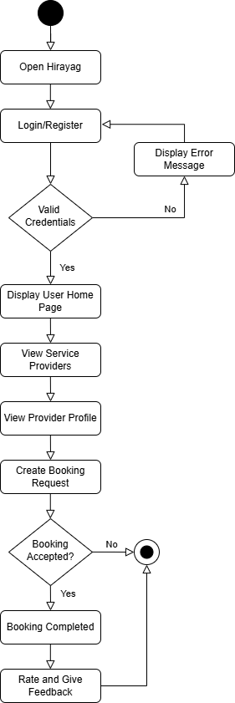

Figure 4: User Appointment Booking Flow Diagram

The user flow diagram illustrates the sequence of actions performed by the Parents or Guardians of children with special needs when accessing the Hirayag mobile application. It focuses on the booking and reviewing life cycle present within the application. The process begins with the Login or Registration, if the user is new they must fill out a registration form and submit their information, and if the user is not new they must login with valid credentials. Once logged in the user will be provided with the Home Page where they will be able to view several service providers. The user can then choose to view the profile of the service providers and decide whether or not they would like to create a booking request. If the service provider accepts the booking and the booking has been completed, the application will allow the user to rate the service to give feedback.

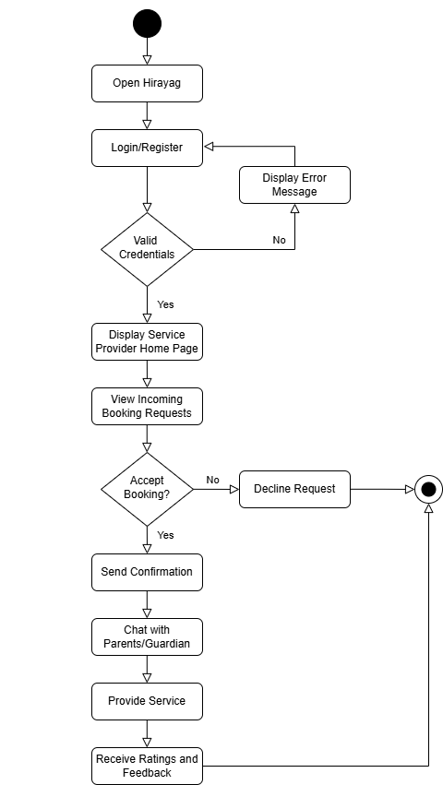
Figure 5: Service Provider Booking Management Flow Diagram
The Service Provider Booking Management Flow Diagram illustrates the sequence of actions taken by the Service Provider that can either be a Tutor or a Babysitter in order to accept the booking requests that they have received. The process begins with the Login or Registration, if the user is new they must fill out a registration form and submit their information, and if the user is not new they must login with valid credentials. Once logged in the user will be provided with the Home Page where they will be able to view several service providers.

Evaluation Methods
In order to further evaluate the feasibility and demand of the study in our local area Baguio City, an online survey was administered using Google Forms. The survey gathered crucial information such as possible Functional and Non-Functional Requirements, preferred features, common changes faced by parents or guardians of children with special needs and so on. It also collected demographic data and insights about their willingness to use a mobile application like Hirayag. The responses served as a core foundation when creating the mobile application, the following are some of the responses gathered from our online survey:
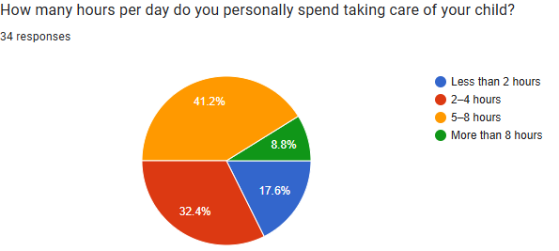

Figure 6: Hours per day spent on child care.
Figure 6 shows the average number of hours per day that parents or guardians spend taking care of their children, as reported in the survey. This information helps understand the daily time commitment and needs of caregivers in Baguio City.

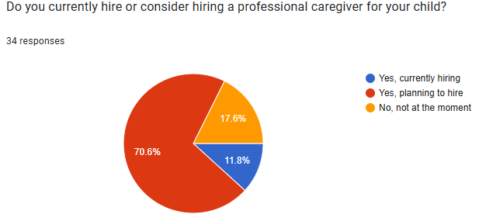

Figure 7. Hiring or considering a professional caregiver.
Figure 7 illustrates the responses of parents or guardians regarding their current use of, or consideration to hire, a professional caregiver for their child. This data provides insight into the reliance on external caregiving support, the level of involvement parents have in daily care, and the potential demand for services or applications that could assist in managing or supplementing childcare responsibilities in Baguio City. Understanding these patterns helps in identifying key user needs and preferences for the development of the Hirayag mobile application.
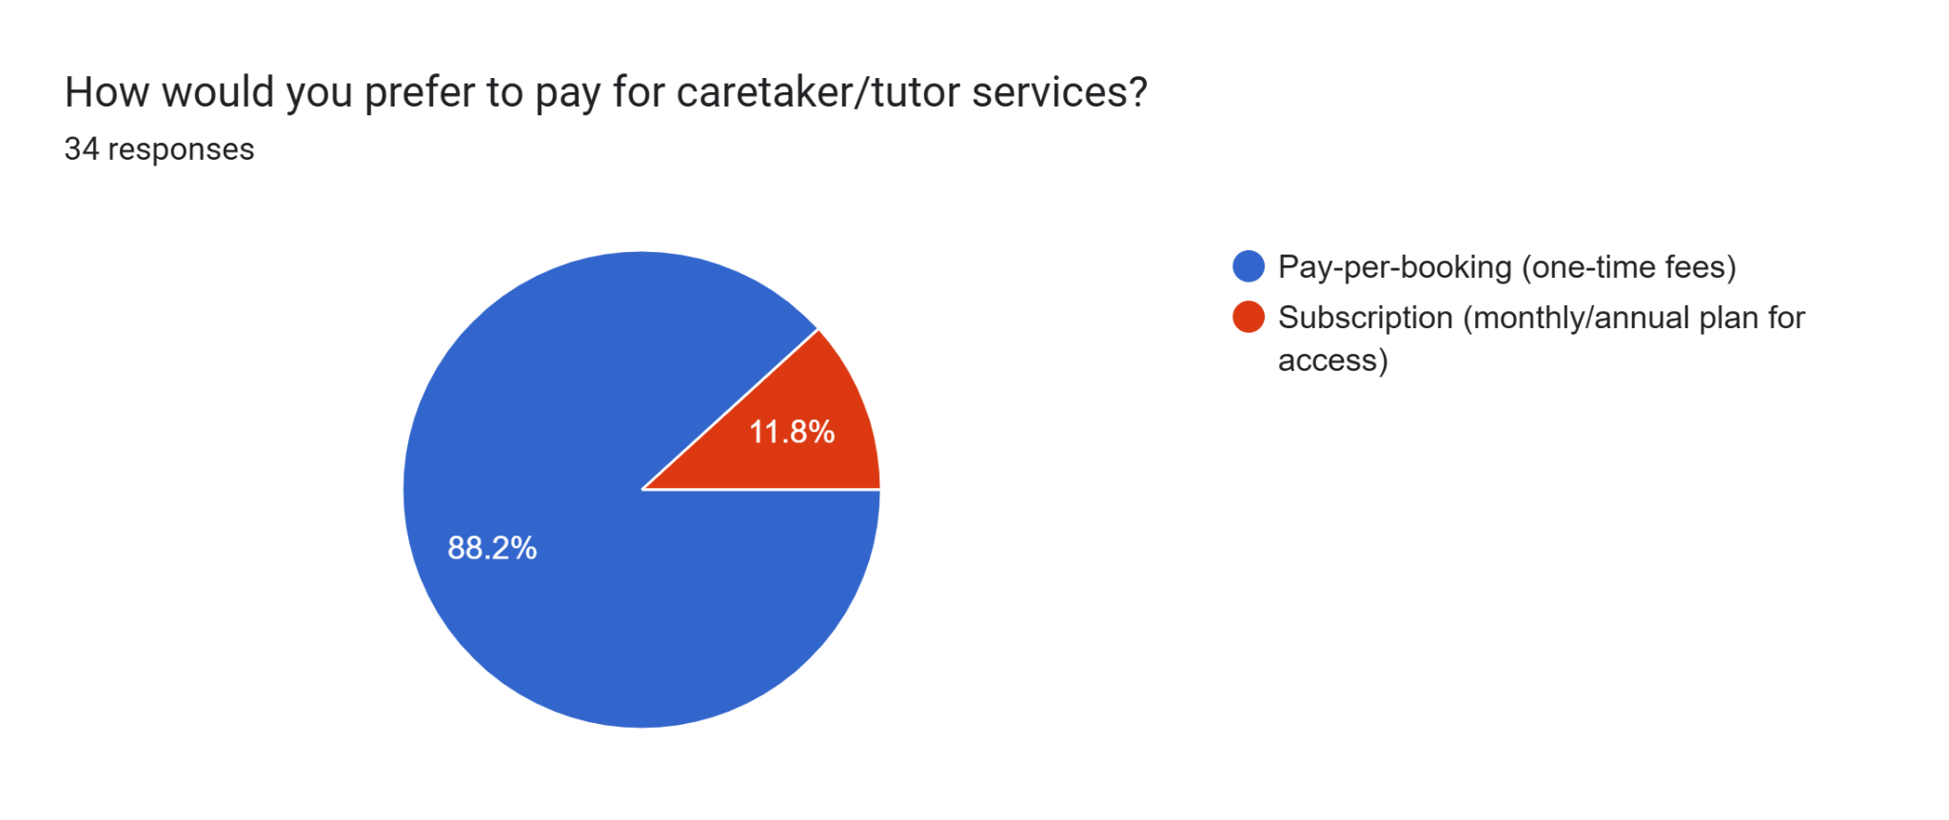

Figure 8. Preferred payment method for caretaker or tutor services.
Figure 8 presents the preferred payment methods of parents or guardians for caretaker or tutor services. The responses indicate how caregivers expect to handle financial transactions, which is essential for designing user-friendly and convenient payment features in applications like Hirayag. This insight helps ensure that the app aligns with the payment preferences and habits of its target users in Baguio City.

Results and Discussion
This chapter of the paper presents the tests and outcomes such as the performance, accuracy metrics, and test results done with the Hirayag mobile application. The implementation and testing of the application’s core features, results of the user testing and other significant findings such as survey results will be covered all throughout the chapter.

System Technical Performance Evaluation
One important evaluation the team considered is assessing Hirayag’s system performance which includes the mobile application’s stability and response time. Hirayag was tested using Expo Go on multiple iOS and Android devices over a 3-hour period with 10 concurrent users.

Performance Metric | Average Test Result | Interpretation
Application Stability / Application Crash Rate | 0% (No crashes all throughout the testing phase) | The result is excellent for a Minimum Viable Product. No crashes were witnessed all throughout the testing process.
Average Screen Data Load Time | 1.8 seconds | The result of the average screen data load time was satisfactory all throughout the testing with no major time wasted.
Memory Usage | 132.33 MB | The memory usage for a Minimum Viable Product is good considering it is also a modern mobile application.

Table 1. System Technical Performance Results
Hirayag’s performance showed satisfactory results for its technical performance. During the User Acceptance Testing phase and developer user testing, no major application crashes occurred with all tests being conducted with a time frame of 30 minutes in each user testing. Another metric tested was the average screen data load time which ranged from a quick 0.80 milliseconds to a long total of 3 seconds. The developers found that this metric was affected depending on the signal of the internet connection. During one of the tests, the home page loaded after 10 seconds due to the signal being weak but with a decent to strong internet signal, it ranged from 0.80 milliseconds to 3 seconds. The last metric tested was the memory usage the application takes on a user’s mobile device. The application was installed on 10 different devices with the mobile application taking 121 MB as the lowest memory storage and 158 mb as the highest memory.

User Test Results and Accuracy Metrics
The Hirayag mobile application is developed until the Minimum Viable Product stage for both iOS and Android platforms using React Native Expo. Core features were integrated into the application such as searching and booking verified service providers, filtering features for faster and better searching, and an AI chatbot are present as outlined in the objectives of the paper. Throughout the testing phase of the application, Hirayag’s performance was stable with user actions such as loading and viewing a service provider’s profile, applying search filters, and leaving a user review on a service provider’s profile all scored an average response time of under three seconds. The firebase used was reliable and had no errors when handling all data operations during the testing phase.

In evaluating Hirayag’s Usability and user demand, the developers used two primary methods which are the distribution of an online google form survey and conducting a face-to-face User Acceptance Testing which is a process in software development that tests the usability of a computer program by letting users have a first-hand feel of the program (Cser, 2024). User Acceptance testing also allowed the validation of both Hirayag’s functional and non-functional requirements and to gather different feedback to further improve the system (Dilmegani, 2025). The survey gathered 34 responses from parents and guardians with children with special needs in Baguio City which revealed that there was a significant demand for the platform. 70.6% of the respondents are considering hiring a caregiver. Challenges such as finding a trusty caregiver, managing time between work and taking care of their children, and emotional stress and fatigue are the three most voted challenges of parents and guardians when taking care of their children with all three scoring 20+ votes respectively. Lastly, parents and guardians have a difficulty trusting someone with their child and having a huge lack of qualified and trained caregivers are the two highest challenges in finding a caretaker with both scoring 20+ votes respectively.

Usability Metric | Task Description | Success Rate | Average Time Completion | Common Feedback from Users
User Registration | Create a new account for a parent or a service provider. | 100% | 1 minute and 24 seconds | The registration process was easy to follow, intuitive, straightforward and it was quite responsive. However, the keyboard covers some input fields and some UI elements were inconsistent. There was also no processing feedback when loading.
Service Provider Browsing and Filtering | Look for service providers (Both caregiver and tutor) and use the filter “Price: Low to High” and “Available” options. | 100% | 1 minute and 20 seconds | The filter was easy to understand and use and there were quite useful elements such as the “Close to you” section. It would be better if there were more filter options present and some of the design was “clunky” to use.
Book an Appointment | Book an appointment with any service provider. | 100% | 1 minute and 27 seconds | It was generally easy to navigate. The information presented for each service provider is really good and informative such as their ratings and location. It also held a much faster response time loading the available service providers. However, the booking options need slight improvement with additional features such as “minus” button in choosing the time. Some elements such as the military time were also confusing.
Logout | Logout of the account. | 100% | 15 seconds | Fast and easy once found. However, the button is not in the standard location, which is found in the profile.

Table 2. User Acceptance Testing Results

Summarizing Results Using Screenshots
Hirayag was turned into an Android Package Kit (APK) and was installed on different mobile devices. All pages found in the Hirayag application were also used for the User Acceptance Testing stage of the project with different performance and user metrics being tested throughout the testing stages. This section highlights the screenshots from the Hirayag mobile application which illustrates the key findings, interfaces, and functionalities of Hirayag.
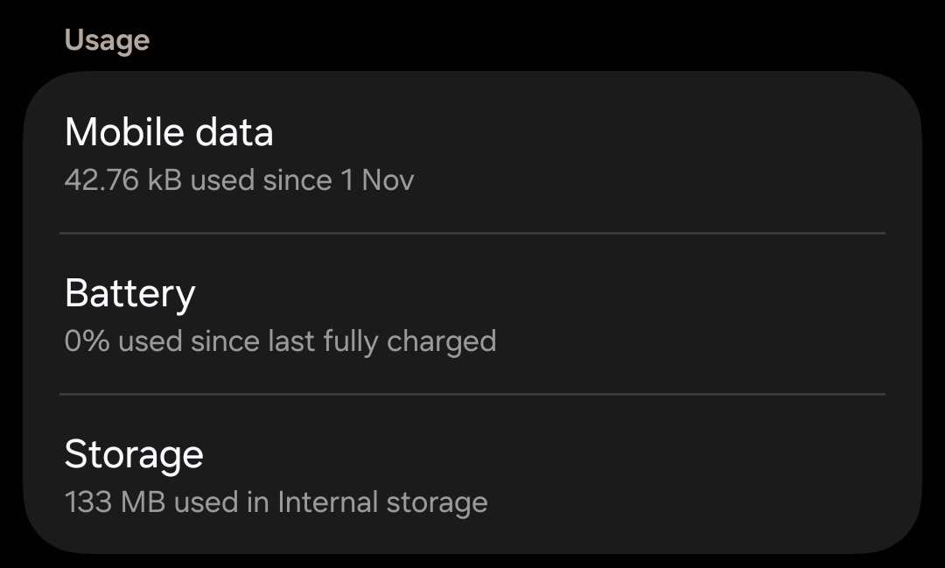

Figure 9. Hirayag’s Memory Usage on a Mobile Device
Hirayag’s memory usage was tested across ten different mobile devices to evaluate its performance and resource efficiency. The recorded memory consumption ranged from a minimum of 121 MB to a maximum of 158 MB, reflecting variations due to differences in device specifications and operating environments. By averaging these results, the application’s typical memory usage was determined to be approximately 132.33 MB. These findings demonstrate that Hirayag maintains a relatively moderate memory footprint across a variety of devices, indicating its suitability for deployment on most modern smartphones without causing significant performance issues.

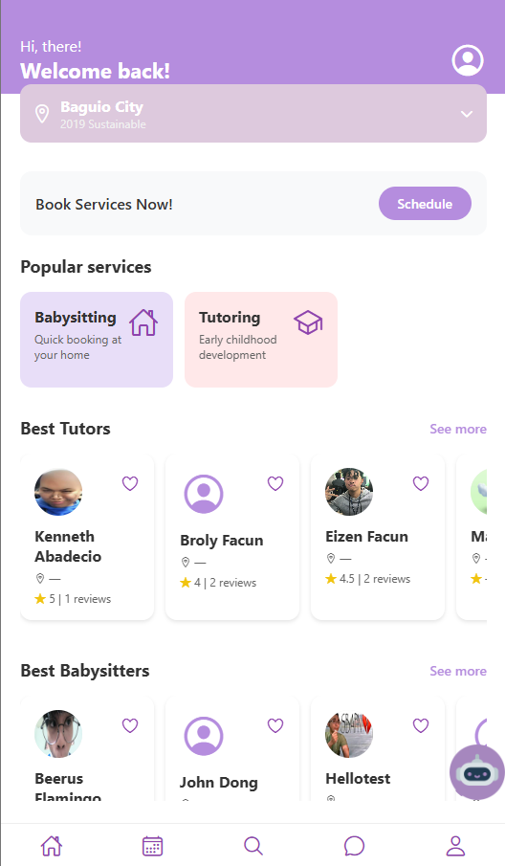

Figure 10. Hirayag’s Home Page
Hirayag’s home page was the primary focus for measuring the metric ‘Average Screen Data Load Time.’ Upon logging in, users with parent accounts are directed to the home page, which serves as the main interface for navigation. The load time of the home page varied depending on the strength and stability of the internet connection. Observations during testing indicated that once the home page resources were fully loaded, transitions to other pages within the application were consistently smooth, with delays not exceeding 1–2 seconds. These results suggest that Hirayag provides a responsive and user-friendly experience, with efficient page loading and minimal waiting time for users.

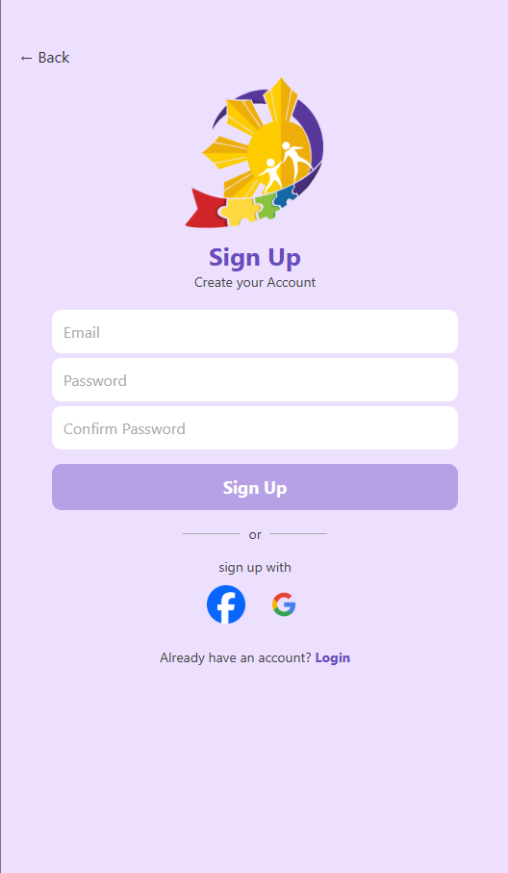

Figure 11. Hirayag’s Registration Page
During user testing, participants were required to complete the registration process of the Hirayag application. Overall, users found the registration process to be easy and straightforward, indicating good usability. However, some users provided feedback on specific aspects of the user interface (UI), including issues such as the keyboard blocking textboxes during input, buttons lighting up unexpectedly, and the border of the terms and conditions section obscuring the last sentence of the paragraph. These observations highlight areas for improvement in the UI design to enhance the overall user experience.

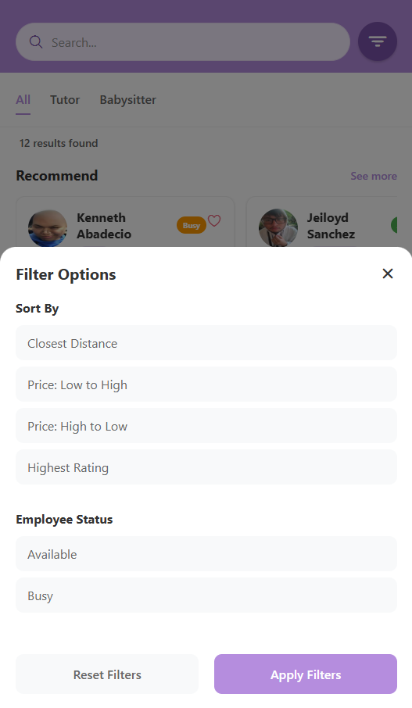
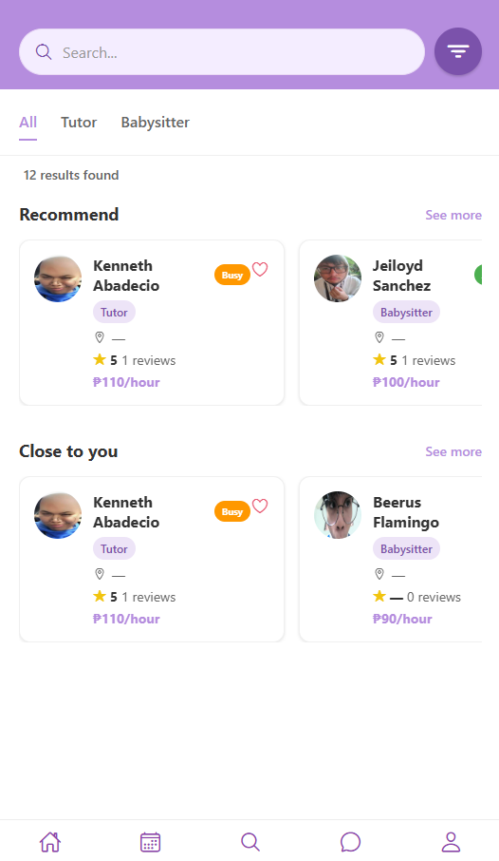

Figure 12. Hirayag’s Filter Feature and Search Page
Hirayag’s Filter Feature is located at the top-right corner of the Search Page, adjacent to the search bar. The ‘Sort By’ feature includes four filter options, while the ‘Employee Status’ filter offers two options. These filters are applied to both the ‘Recommended’ and ‘Close to You’ sections of the application. User feedback indicated general satisfaction with the functionality, noting that the filter was easy to use and helpful for narrowing down search results. However, some users felt that the available filter options were limited, and a few mentioned that the ‘Close to You’ section combined with the ‘Closest Distance’ filter appeared redundant. These insights provide valuable guidance for refining the filter functionality to improve usability and user experience.

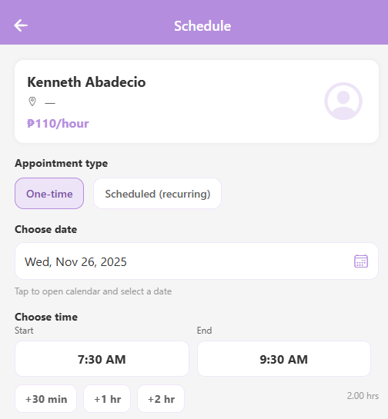

Figure 13. Hirayag’s Schedule Setting in the Booking Process
The development team received high levels of satisfaction from users regarding the design and usability of the booking process. Most users reported that the interface was intuitive and the booking steps were simple and easy to understand, particularly for new users. Despite this positive feedback, some users suggested enhancements, such as the ability to decrease hours and minutes in the ‘Choose Time’ section. Additionally, a few users experienced minor difficulties when attempting to book services on dates corresponding to a provider’s day off or unavailable periods, as they had to navigate back to the service provider’s information page to verify unavailable dates. These observations provide insights for refining the booking process to further improve user experience and efficiency

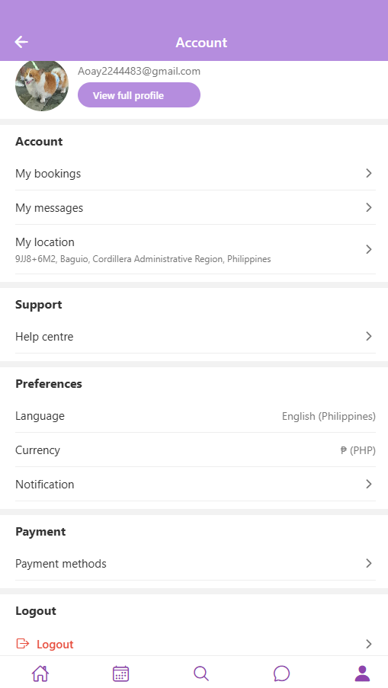

Figure 14: Hirayag’s Logout Feature
Hirayag’s logout button had to be readjusted due to users having such a difficult time locating it. In the previous logout button location, users would still need to click the “View Full Profile” button below the user’s email in order for the logout button to show which followed a 2-level log out menu (Falcone et al, 2023). In the User Acceptance Testing, over four (4) users took over 30 seconds to simply logout of the application. With the new changes to the button’s location, simply clicking the user profile and scrolling down will show the logout button allowing for faster and easier navigation.

- Results Interpretation Based on Research Objectives
The technical evaluation of Hirayág offers a convincing argument that the application not only supports but also enhances the primary goal of the project which is to give access to trained caregivers and educators for families of children with special needs residing in Baguio City. Rigorous system testing on a number of iOS and Android devices with ten users at the same time for a duration of three hours showed outstanding performance: no occurrences of crashing, an average of 1.8 seconds screen load time, and memory use of 121 MB to 158 MB. Hence, the application is verified to be stable, responsive, and efficient even at the Minimum Viable Product level. The basic functionalities of searching, filtering, viewing the provider's profile, and booking an appointment worked well with no errors when Firebase was responsible for all data operations. From the survey results, it can be interpreted that there is a strong demand for the platform as 70.6% of the respondents were considering hiring a caregiver and mentioned the following difficulties: handling time, emotional stress, and the struggle of finding caregivers who are both trustworthy and qualified.

The application's verification and trust mechanisms were proven to be operational by system stability, low crash rates, and fast response times, thus guaranteeing trust and reliability among users. Users' suggestions about providing more filter options, making time-selection changes, and upgrading the interface are very helpful for the platform's improvement, while the 100% task completion rate ensures that the main features are performing well. Ultimately, Hirayág offers a major opportunity to make daily caregiving easier, gain better access to specialists, and contribute to the health of children with disabilities in the neighborhood positively.

Analysis

Discussion of Findings in Context of Related Works
This research confirms that Hirayag has efficiently tackled the major problem of finding skilled caregivers and tutors for children with special needs in Baguio City, thus validating UNICEF's (2022) report on the country's lack of specialized support services. The survey data underlined the demand for a reliable platform, which is also voiced by Sawey (2024) who noted the struggles of parents trying to balance their jobs and care duties. The study also recognized the work of Salvador et al. (2025), stating that the unavailability of SPED professionals is an obstacle for families to get proper services, thus, the need for new digital solutions is emphasized. The app's dependability, as shown by its uptime and rare crashes, is in support of the iterative development model suggested by Diaz et al. (2019). The users' remarks about the platform's filtering and booking functionalities point to the fact that customization increases the advantage of making the right choice, which is crucial for promoting a fair and eco-friendly future. Not to mention, the AI-powered chatbot, if not already part of the family, facilitates the provision of updated information for families with special needs. A very secure verification process is there to ensure trust in the caregiver recruitment where it is thus necessary for the existence of such platforms. There are difficulties such as real-time synchronization and user interface development, which the app is facing, as both issues are crucial in mHealth applications. Conducting user acceptance testing has shown a high degree of usability, which is the implication that simple interfaces are very important to attract non-tech users. By concentrating only on Baguio City, the study upholds the claim that localized digital solutions are better than generic platforms, and in the end shows that an AI-based community framework makes it much easier for families with special needs to connect with qualified caregivers.

Challenges Encountered During Development
During the development of the Hirayag mobile application, the team encountered several challenges that impacted the project’s timeline and required additional effort to fully resolve. The following are the most notable challenges encountered during the development process:
- Technical Integration - The team was initially unfamiliar with the technologies to be implemented, specifically React Native and Firebase. Integrating these two technologies presented a significant challenge due to this unfamiliarity. However, through continuous practice, study of documentation, and consultation with resources, the team gradually overcame these obstacles.
- User Interface Design - Ensuring that the interface was accessible and user-friendly for parents or guardians who may not be tech-savvy required multiple revisions and iterations. The team focused on designing a layout that minimized cognitive load, avoided clutter, and employed a clear visual hierarchy, allowing users to easily navigate essential features such as booking, filtering, and messaging. Several iterations were needed to refine button placements, icon labels, and screen transitions. Although these adjustments extended the design phase, they were crucial for improving clarity, usability, and overall user experience.
- Survey Data Limitations - Collecting a sufficient number of responses for the online survey from the target community proved challenging due to limited access or connections to families with children with special needs. This restriction affected the breadth of feedback and required careful consideration when interpreting survey results.
- Security and Data Privacy Considerations - Since the application handles sensitive user information, including personal details, chat messages, and booking data, the team had to implement robust security measures. This included authentication safeguards, secure data storage, and privacy-focused design. Proper implementation of Firebase Authentication and Firestore security rules required meticulous planning and repeated validation to prevent unauthorized access and protect against potential security breaches.
- Real-Time Data Synchronization - Ensuring that data such as bookings, availability, and messages updated in real time was a challenge during development. Since the application relies on Firebase for backend operations, the team needed to implement efficient listeners and handle asynchronous updates to prevent delays or inconsistencies between user and provider screens. Additional testing was conducted to guarantee that changes were reflected immediately and accurately across all devices.
- Device Compatibility and UI Responsiveness - Creating a consistent user experience across various Android and iOS devices posed another challenge. Differences in screen sizes, operating system behaviors, and performance capabilities required the team to adjust layouts, test multiple screen resolutions, and optimize components to ensure smooth access to the app regardless of device.
- Network Dependency and Performance Optimization - As Hirayag relies heavily on internet connectivity for real-time updates and data retrieval, network instability or slow connections could affect performance. The team had to implement caching strategies, optimize API calls, and handle offline scenarios to maintain usability even under fluctuating network conditions. These measures ensured that the application remained functional and responsive for users in areas with varying internet speeds.
- Comparison with Existing Systems
Unlike general tutor or babysitting booking platforms that cater to a broader audience, Hirayag differentiates itself by focusing exclusively on providing services for families with children who have special needs. This specialization ensures that families have access to service providers who are qualified and trained to work with their children, thereby reducing the time, effort, and uncertainty involved in finding appropriate care.
A real-world example of a non-specialized platform is Facebook hiring groups, which many parents of children with special needs use to look for caregivers or tutors. While these groups can serve as a resource, they have several limitations. Caregiving remains one of the most in-demand training programs offered by the Technical Education and Skills Development Authority (TESDA, 2021), particularly for Overseas Filipino Workers. Despite this demand, many hiring groups feature only a few listings, and the majority do not provide verified caregiver profiles. This lack of verification means there is no assurance that applicants are legitimate or trained to handle children with special needs. Hirayag addresses these gaps by offering verified caregiver profiles, specialized filters that allow parents to select providers based on the type of special needs their child has, and assurance that applicants possess the necessary knowledge and training to provide safe, appropriate care.
Below is a summary of the comparisons between Hirayag and other general booking and service platforms:
Feature | Existing Systems | Hirayag
Target Users | Broad, not specialized | Families of children with special needs and verified service providers
Communication | Often external for example  email or messaging  applications | Built-in messaging system for direct communication
Local Relevance | Nationwide or global | Focused on Baguio City to match community needs

Table 3. Hirayag Comparison Table

Conclusion and Recommendations

Summary of Findings and System Capabilities
The Hirayág mobile application is capable of linking the families of special needs kids with the best caregivers and educators in Baguio City. The technical tests proved that the application is highly reliable and efficient through its 0% crash rate, fast screen loading times, and moderate memory usage. The User Acceptance Testing showed that all the main activities registration, browsing and filtering providers, booking appointments, and logging out were successfully completed in 100% of the cases. The surveys indicated a strong demand with 70.6% of the participants expressing willingness to hire caregivers through the platform. The app with its verified provider profiles, integrated filters, and AI chat support has become highly usable, responsive, and able to enhance the care and quality of life for the special needs children.

Limitations of the Study
The research came out with mainly positive findings; however, it was still constrained by various factors. The implementation of the system was only tested in one location, Baguio City, which means that the study’s conclusions cannot be applied to other areas. Only a group of 10 people participated in the usability testing, which might not give a proper reflection of the wide variety of parents and guardians of children with special needs. Some of the problems with the interface were identified, such as keyboard overlaps, lack of filtering options, and confusing methods of selecting time. Furthermore, internet access was slow at times and it hindered the loading of the data. Also, the current version of the system only accommodates caretakers and tutors but excludes other professionals such as therapists or psychologists, and the measurement of the long-term impact on the child's development was not included.

Recommendation for future work
Hirayág and its subsequent versions must not only enhance but also broaden their functionalities and user base. Some of the upgrade measures might be filtering options that are much more detailed, a user interface that reacts better on older gadgets, and more notifications while the data is being processed. Involvement of other professionals like therapists, psychologists, or behavioral interventionists could elevate the value of the platform. The real-time synchronization and security procedures need to be consistently improved in order to maintain the data’s integrity and confidentiality. Testing should be extended to more significant and varied user groups as well as to other cities, which could help in the development of a more scalable and generalizable product. One of the suggestions is to carry out longitudinal studies to measure the application’s impact over time on children’s development, caregiver satisfaction, and family well-being. Seeking partnership from SPED centers, local government offices and NGOs might facilitate the adoption and raise the community support wider.

References:
Caregiving remains most preferred TESDA training by OFWs. (n.d.). https://www.tesda.gov.ph/Media/NewsDetail/20024

Citaristi, I. (2022). United Nations Children’s Fund—UNICEF. In The Europa Directory of International Organizations 2022 (pp. 165–177). https://doi.org/10.4324/9781003292548-40

Cser, T. (2025, June 3). User Acceptance Testing: Complete Guide with Examples. https://www.functionize.com/automated-testing/acceptance-testing-a-step-by-step-guide

Diaz, G., Pablo Josue Rojas Yepes, Yepes, P. J. R., & Hernandez, C. J. B. (2020, January). Methodology for Tailored Linux Distributions Development for HPC Embedded Systems. ResearchGate. Retrieved November 25, 2025, from https://www.researchgate.net/publication/332095882_Methodology_for_Tailored_Linux_Distributions_Development_for_HPC_Embedded_Systems

Dilmegani, C. (2025, September 3). 10 User Acceptance Testing Best Practices & challenges. AIMultiple. https://research.aimultiple.com/user-acceptance-testing-best-practices/

Ghavi, A., Hassankhani, H., Powers, K., Sawyer, A., Karimi, B., & Kharidar, M. (2023). Parental supporter during pediatric resuscitation: Qualitative exploration of caregivers’ and healthcare professionals’ experiences and perceptions. International Emergency Nursing, 72, 101381. https://doi.org/10.1016/j.ienj.2023.101381

Pal, K. (2025). Innovative Service Oriented Computing Systems Architecture for Global Software Development. IGI Global. Retrieved November 27, 2025, from https://www.igi-global.com/chapter/innovative-service-oriented-computing-systems-architecture-for-global-software-development/373291

US Census Bureau. (2022, July 22). Mobile Survey Design Research Experiment 11: Logout button placement. Census.gov. https://www.census.gov/library/working-papers/2022/adrm/rsm2022-04.html

