**Class:** Final Year B.Tech(Computer Science and Engineering)

**Year:** 2025-26 **Semester:** 1

**Course:** High Performance Computing Lab

**PRN**: 22510021 **Batch:** B7

**Practical No. 1**

**Title of practical:** Introduction to OpenMP

Problem Statement 1 – Demonstrate Installation and Running of OpenMP code in C

Example:

* To run a basic Hello World,

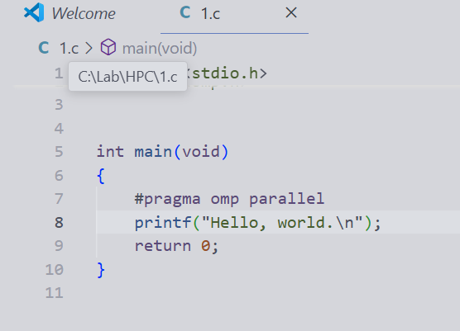

gcc -fopenmp test.c -o hello

.\hello.exe

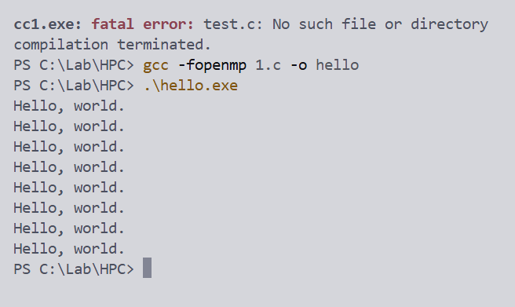

* 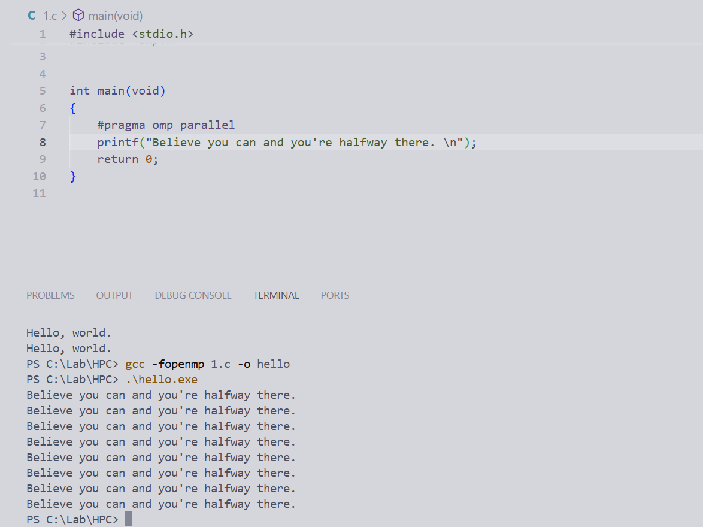

Problem Statement 2 – Print ‘Hello, World’ in Sequential and Parallel in OpenMP

We first ask the user for a number of threads – OpenMP allows us to set the threads at runtime. Then, we print the Hello, World in sequential – number of times of threads count and then run the code in parallel in each thread.

Code snapshot:

#include <stdio.h>

#include <omp.h>

int main(){

int n;

printf("Type number of threads = ");

scanf("%d", &n);

omp_set_num_threads(n);

printf("Normal Sequential printing. \n");

for(int i=0; i<n; i++){

printf("Hello, World!\n");

}

printf("Parallel Printing......\n");

#pragma omp parallel

{

printf("Hello World... from thread = %d\n",

omp_get_thread_num());

}

return 0;

}

Output snapshot: 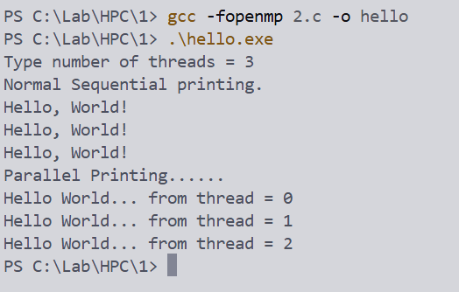

Analysis:

By using the omp set function we can set number of threads desired for out program

* omp_get_num_threds = sets how many threads OpenMP should create.
* #pragma omp parallel = initiates the parallel region.
* omp_get_num_threads = provides the thread ID during parallel execution.

GitHub Link: make a public repository upload code of an assignment and paste its link here.

Problem statement 3: Calculate theoretical FLOPS of your system on which you are running the above codes.

Intel(R) Core(TM) i5-10210u

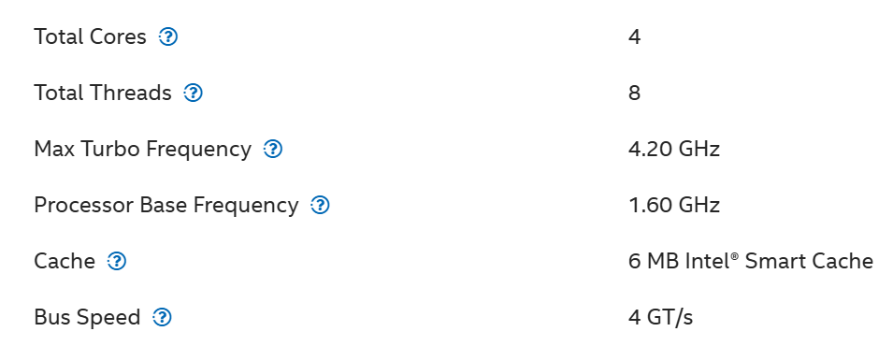

Elaborate the parameters and show calculation.

**Below is the formula to calculate FLOPS :**  
MAX FLOPS = (# Number of cores) * (Clock Frequency (cycles/sec) ) * (# FLOPS / cycle)

Number of cores = 4

Clock Frequency = 1.60 GHz (base freq is taken here)

FLOPS/cycle = 8

MAX FLOPS = (# Number of cores) * (Clock Frequency (cycles/sec) ) * (# FLOPS / cycle)

1. AT BASE

CLOCK MAX FLOPS = 4 * 1.60 GHz * 8

**51.2 GFLOPS**

1. AT BASE TURBO

MAX FLOPS = 4 * 4.20 GHz * 8

**134.4 GFLOPS**