# Data Structures and Algorithms

# INFO 6205

# Homework 12

1. Consider the following Ford-Fulkerson graph:pasted-image.tiff

a) What is the MaximumFlow in the graph, show ALL augmented paths step-by-step

b) What is the Time complexity and Space of the algorithm?

c) Write the Java code for the algorithm?

2. For the following Regular Expression (RE) Input Strings

a) Convert each RE to DFA

ab*a abc*|x+y w(x|y)*z a(xy)*

b) convert RE to NFA

a*bc a*|mn (w|x)*

c) Convert A(A|B)*|Z to NFA and then to DFA

d) convert the following NFA to DFA and then to RE

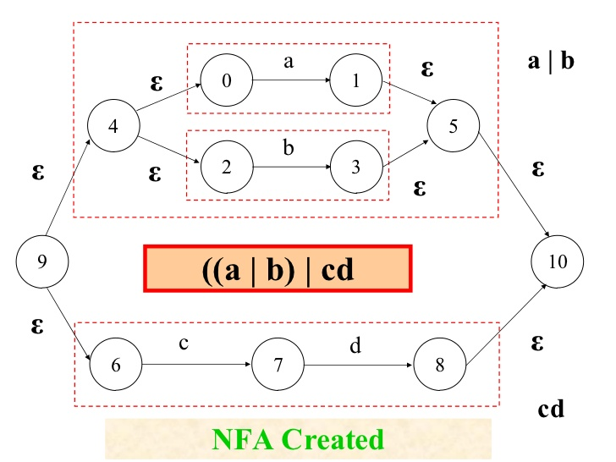

3. Boolean Satisfactory Problem

a) What is it? and why we are using it?

b) Describe this conjunctive normal form used in satisfactory problem:

(x1 ∨ x2 ∨ … ∨ xn) ∧

(y1 ∨ x2 ∨ … ∨ xn) ∧

(x1 ∨ y2 ∨ … ∨ xn) ∧

(y1 ∨ y2 ∨ … ∨ xn) ∧ ... ∧

(x1 ∨ x2 ∨ … ∨ yn) ∧

(y1 ∨ x2 ∨ … ∨ yn) ∧

(x1 ∨ y2 ∨ … ∨ yn) ∧

(y1 ∨ y2 ∨ … ∨ yn);

4. Describe the following:

NP-Hard, provide three examples

P, provide examples

NP

NP-Complete

Satisfiability Model, give example