Homework5：

1.Graph step by step：

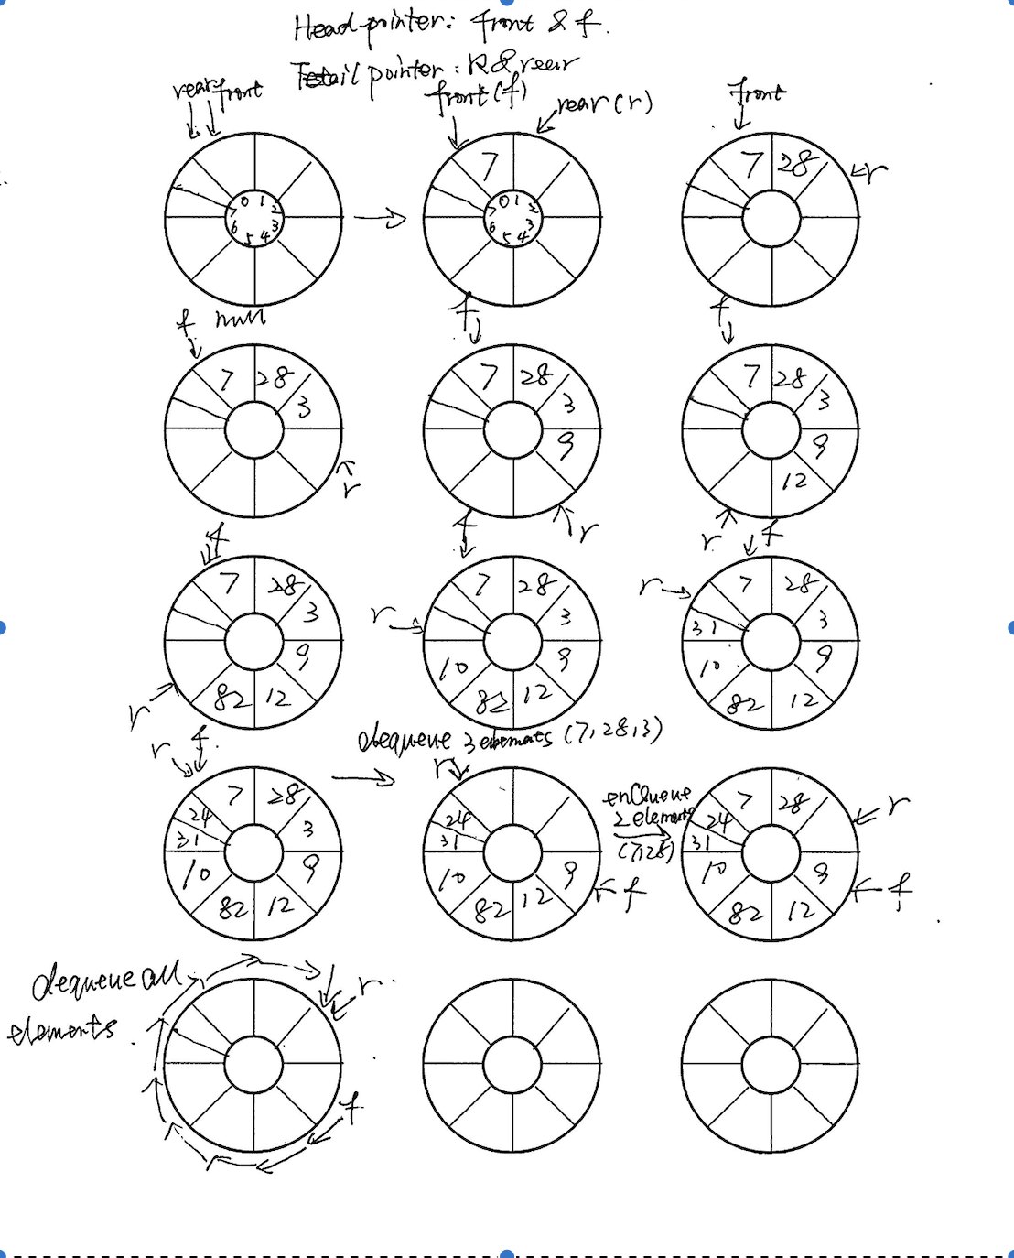

2.signed byte X’s range is [-128,127]

because 8 digits, the first digits is sign. if first digits is 1, it’s negative, computer read negative number by its complement code, 128 is 10000000. Inverted, it's 01111111, and adding one gets 10000000 again

Unsigned byte Y’s range is [0,255].Just binary value to decimal base.

3. 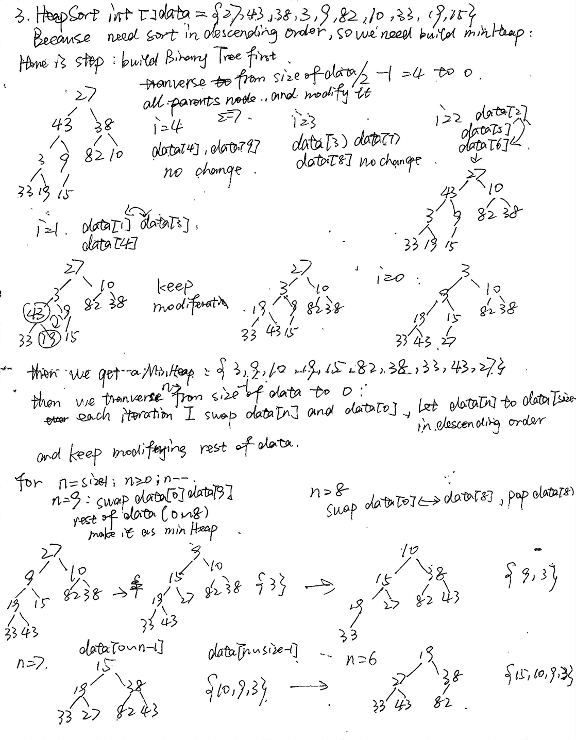

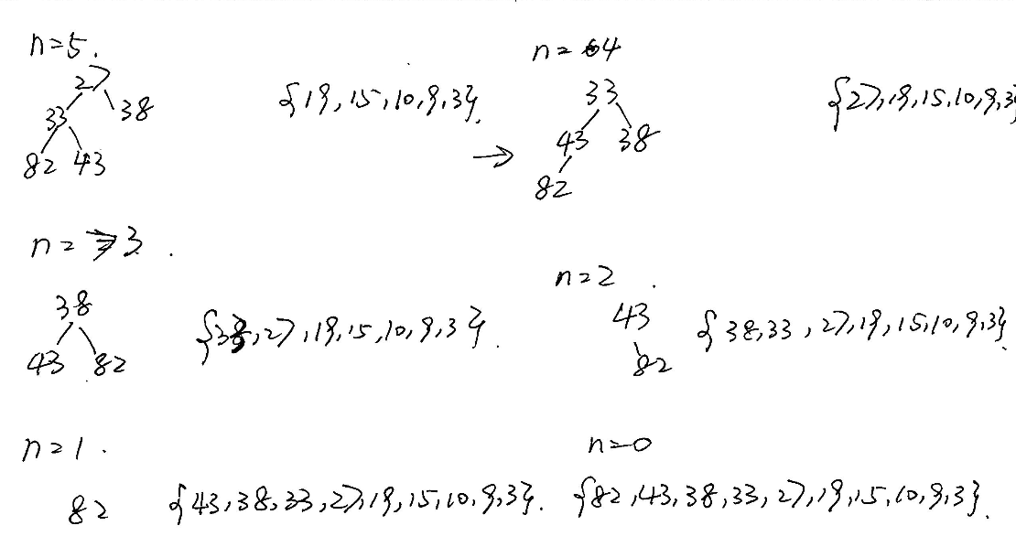

4. 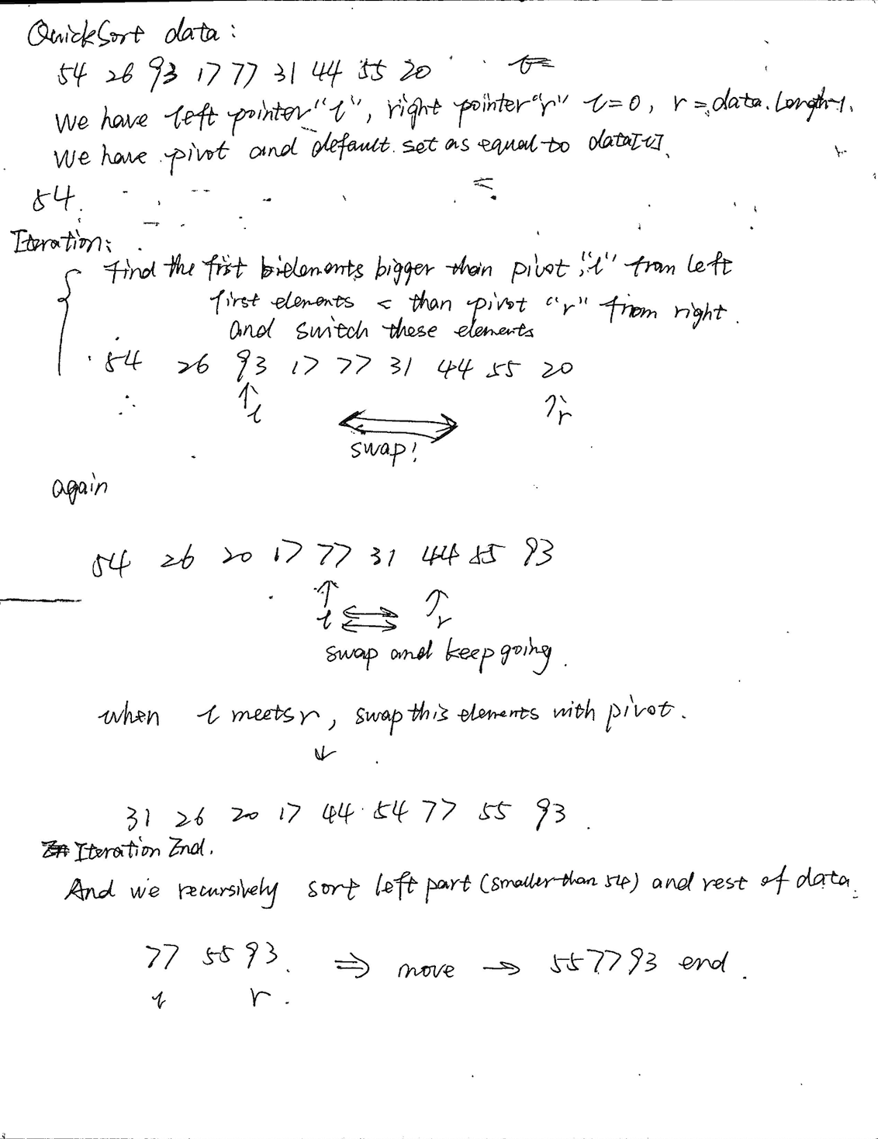

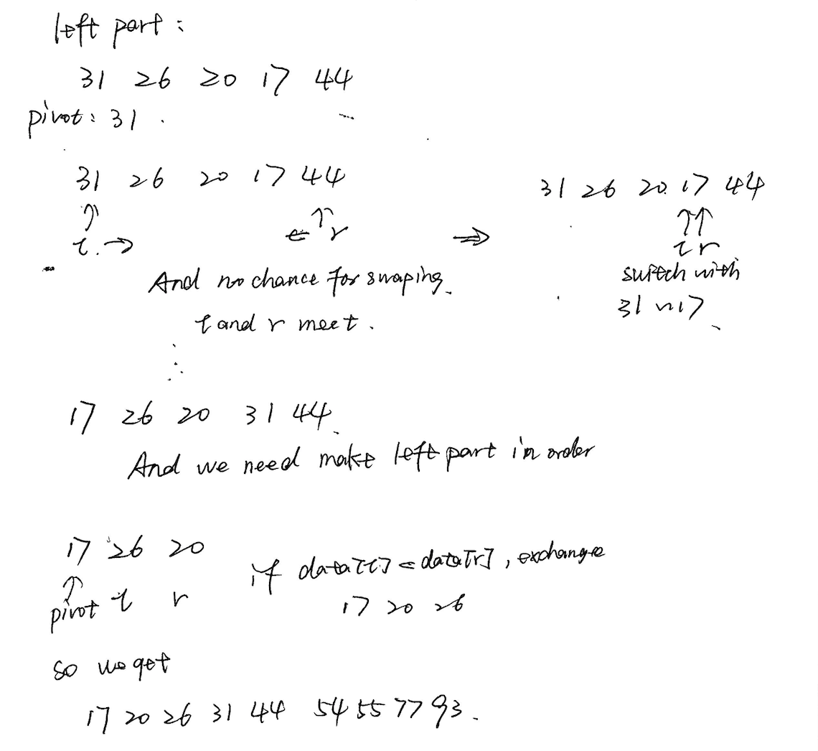

5. Time complexity: MergeSort:O(NlogN)

HeapSort:O(NlogN)

QuickSOrt: O(NlogN)

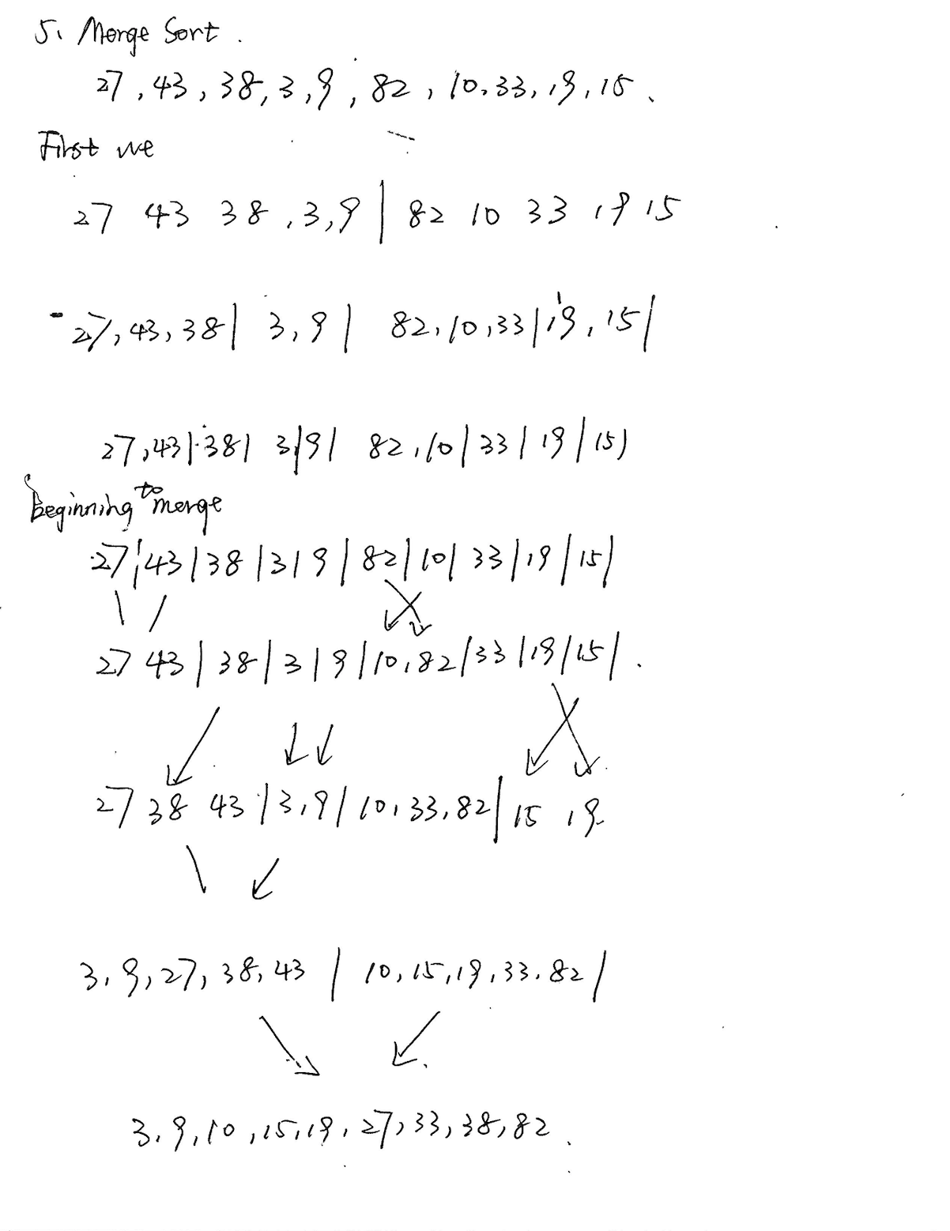

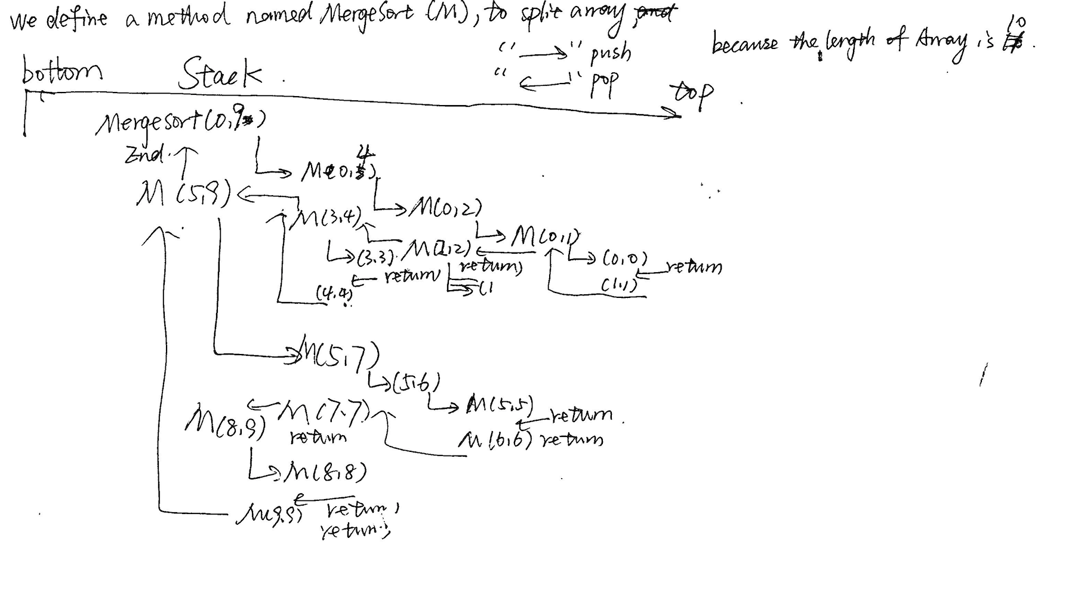

7.

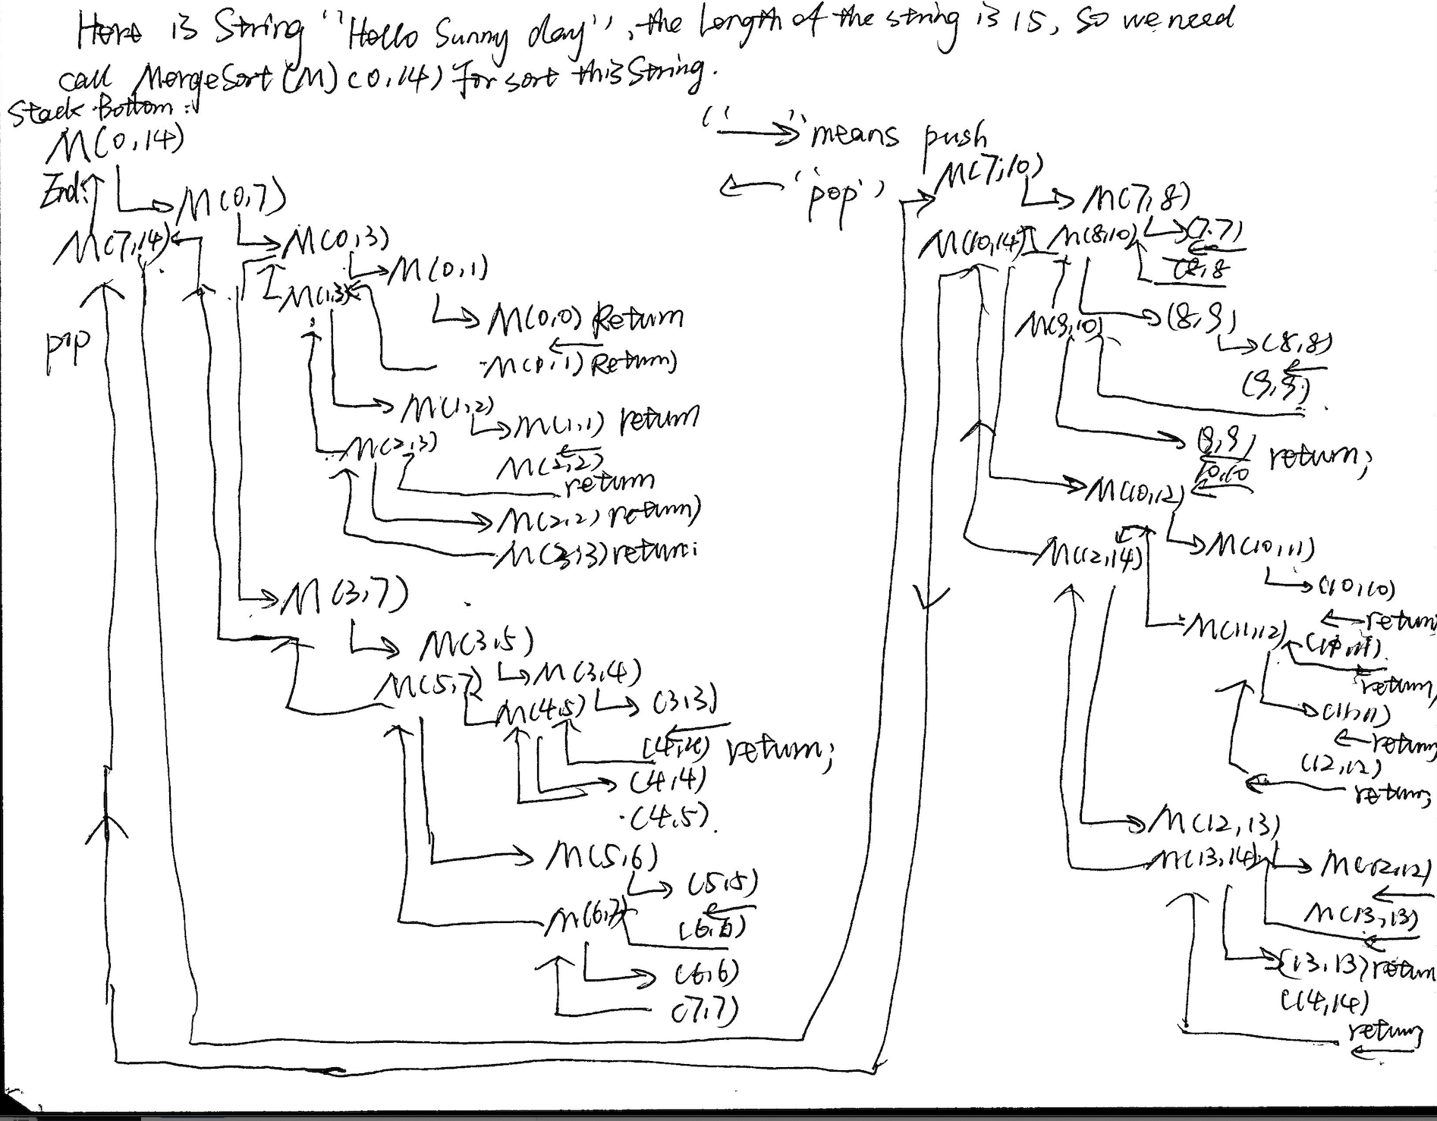

8.

