# Homework6

1. Balanced Tree is: if for each node it holds that the number of inner nodes in the left subtree and the number of inner nodes in the right subtree differ by at most 1.

Complete Tree is that every node has 0 or 2 children nodes.

Non-complete Tree is that there is a node in tree has one children node.



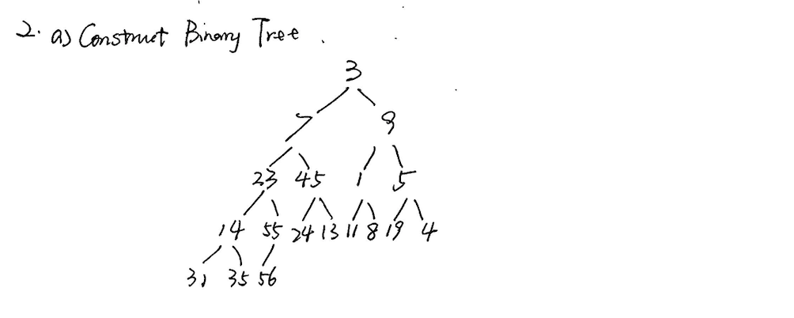

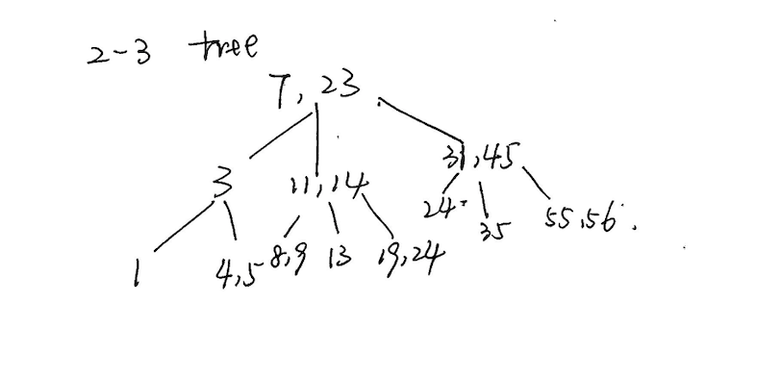

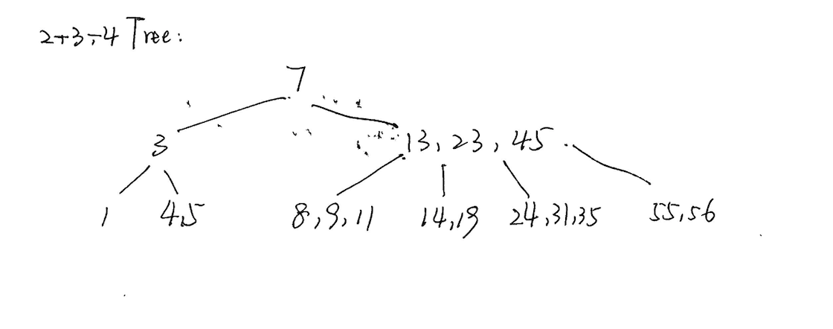

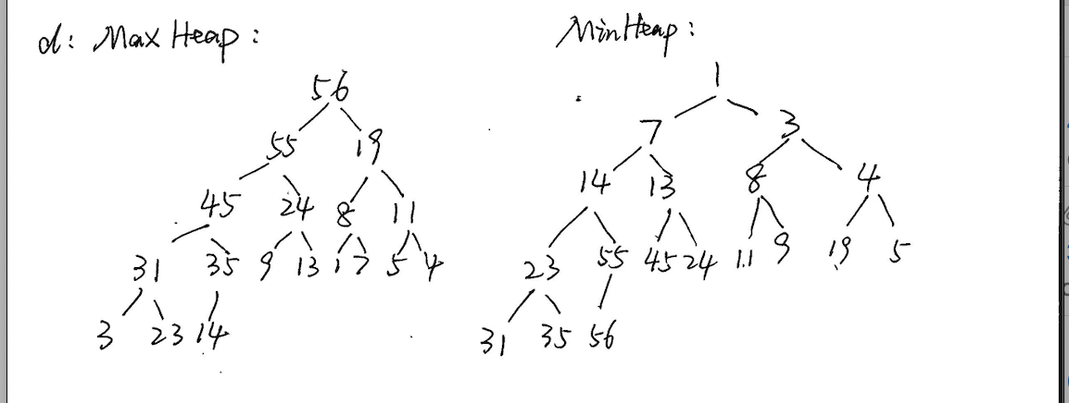

e:Time complexity:

a: O(N)

b: O(N)

c: O(N)

d: O(NlogN)

if I want find the nodes close to boundry(like max value or min value) I prefer Binary Heap Tree, and if I want to search the random nodes, I would use 2-3 tree, because it’s easier to implement than others and much efficienct.

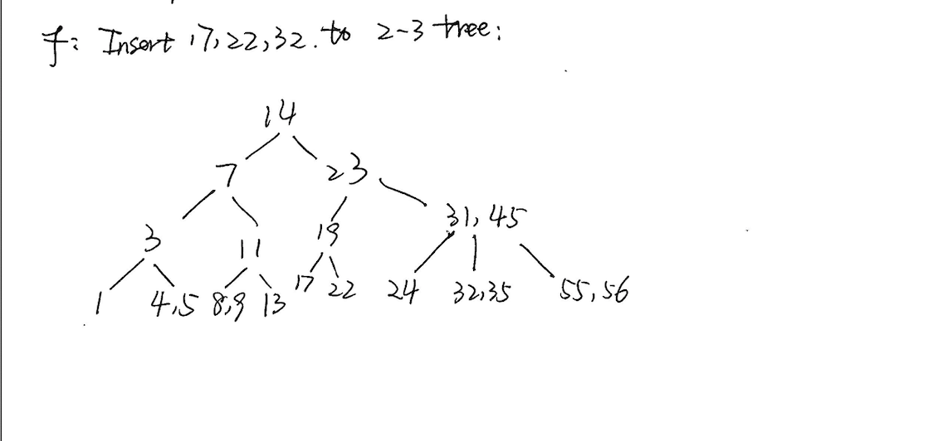

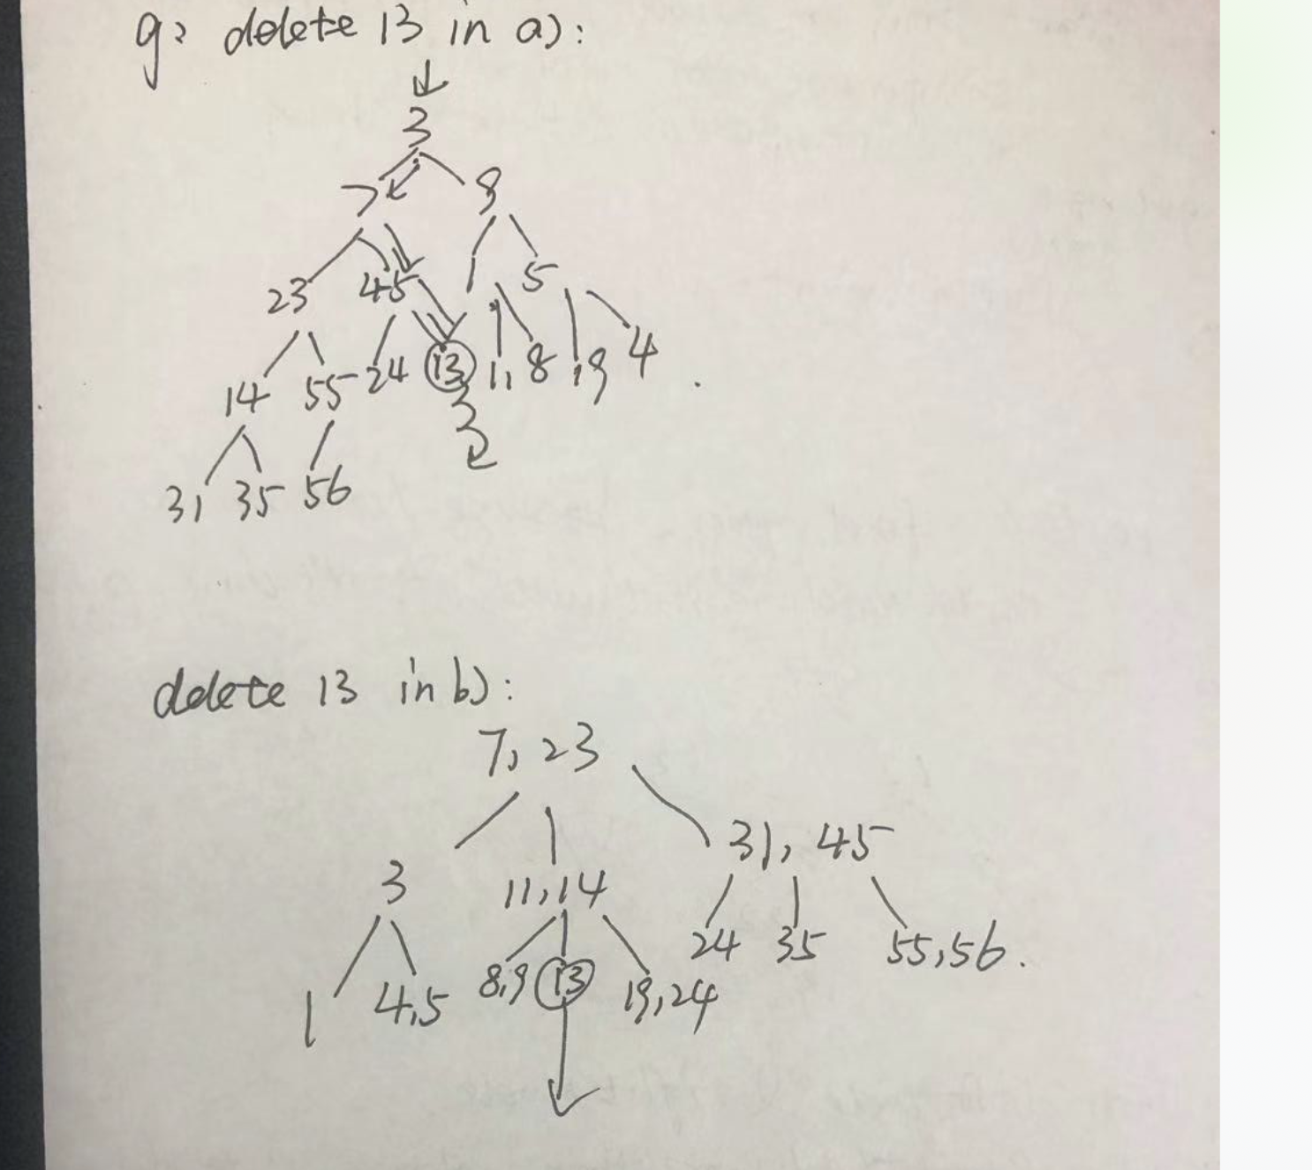

h):Height of a) is 5

b) is 3

c) is 3;

3.

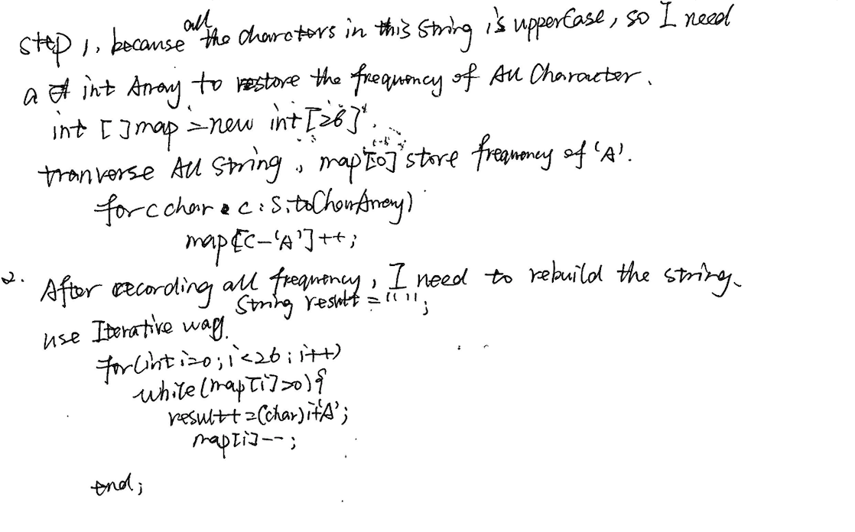

this algorithm’s time complexity is O(n), the that of selection sort is O(n^2)

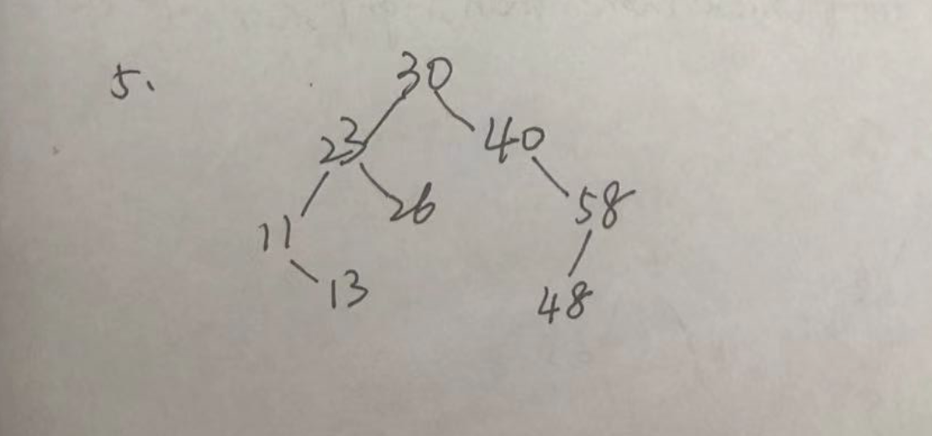

6.The possible maximum height of a binary search tree in problem-5 is 8. It could be formed as a linkedlist, just the node with the minimum value will be the root, and all of nodes will be set in its right side in ascending order.

The time complexity of the Tree I build is O(N).

Because everytime I insert number N nodes into the tree, so the time complexity is O(N).

7.

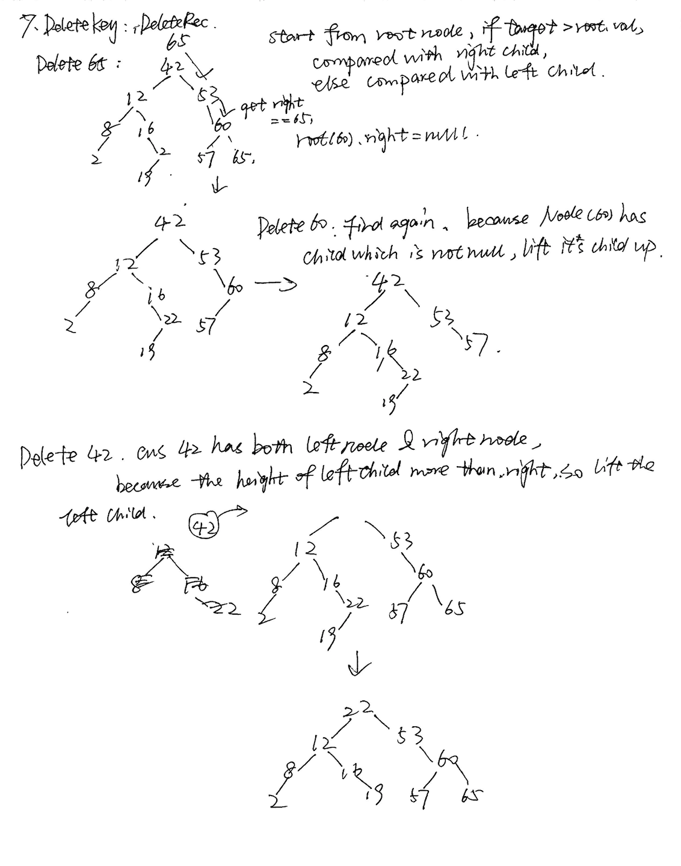

8.

